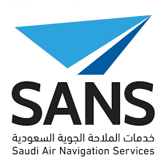

Web Development

CPCS 403

Ahmad Sait – 2036577

Abdullah AlOwais – 2036620

Table of Contents

SANS 3

Project Idea (Problem definition) 3

Recommended Solution 3

Storyboards 4

Sitemap 5

# SANS

The Saudi Air Navigation Services (SANS) is responsible for providing air navigation services in the Kingdom of Saudi Arabia, where they play an important role in the security and safety of airspace and aircraft movements. SANS manage one of the largest airspaces in the middle east and it is recognized regionally for its safety record, service excellence and technology innovation.

They offer air traffic management services, flight planning, aeronautical information management services, maintenance engineering services, engineering services, search & rescue services, weather briefings and we oversee air traffic through a sophisticated network of area control centers, air traffic control towers, flight information centers, maintenance centers, and navigation aids across the country.

Through their commitment “Managing skies, securing lives” the Saudi Air Navigation Services company is dedicated to enhance the safety, capacity and efficiency of air navigation services through innovative technologies, advanced solutions and expertise to lead the future of the aviation sector in the Kingdom.

# Project Idea (Problem definition)

SANS has a safety department that cares about the facilities, equipment, and most importantly, the safety of its employees in the workplace. Any change in the workplace, either minor or major, has to be analyzed and assessed to ensure all possible hazards are mitigated. This is called the Safety Risk Assessment.

When an incident happens that requires a safety risk assessment to take place, multiple forms are required to be filled out by subject-matter experts. These forms are then passed up to managers to be signed. This is where there is a big problem. The time it takes to collect signatures from all the required individuals takes an incredible amount of time that it significantly increases the risk of the incident causing a major hazard (assuming the incident actually can cause such major hazard).

# Recommended Solution

Instead of using paper and notifying the experts constantly (through email) to sign the papers, SANS want this process fully automated with a website.

The benefits of this provided solution is, of course, the huge amount of time not wasted mainly because the forms are not being signed in time. Plus, the website itself can constantly remind the subject-matter expert to sign what he needs to sign.

As for the author who starts the safety risk assessment, his/her job of filling the form becomes much easier. Drop-down lists, quick mapping of the classification matrix, and many more can be integrated into the website. This will ease the author’s way of filling the form, take less time, and encourage more safety risk assessments.

# Storyboards

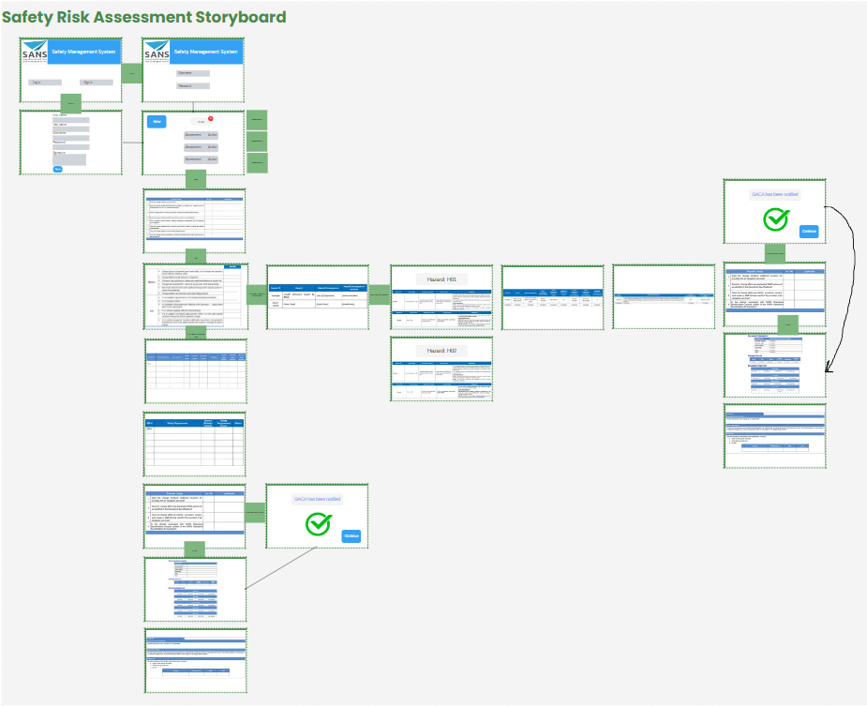

# Sitemap

<https://www.canva.com/design/DAFxVCZ_xVg/qIE0lPml3cYUuMzs56rxIg/edit?utm_content=DAFxVCZ_xVg&utm_campaign=designshare&utm_medium=link2&utm_source=sharebutton>