Table of Contents

Deployment manual 1

Introduction 3

System Requirements 4

System Requirements 5

Installation Procedures 6

Cloning Git Repository 8

Starting the server 10

Machine Learning API deployment… 12

Feedback and version information 13

|  |  |
| --- | --- |
| Introduction |  |
| Hello everyone, welcome to the deployment manual of our “FactFinder” application. This document is designed to provide a complete step by step solution for successful deployment of our software or webiste at your system/environment. It is meant for use by developers, advanced users, system administrators or simple end users.  Following topics will cover in this manual:   1. **System Requirements** – A part where we outline hardware/software requirements. 2. **Installation procedures** – A step by step guidance into how to install software in your own system. 3. **Troubleshooting** – Outline most common errors and issues that might arise. 4. **Support and resources** – We will be providing links to related resources to understand our stack in a better way. | Software Installation Images – Browse 743,695 Stock Photos ... |

Our software will run on major system operating systems without having a big impact on hardware components. Before attempting to install software components please make sure your system meets the following hardware requirements.

System Requirenments:

### Hardware requirements (Desktop) Processor (CPU):

Equivalent to AMD Ryzen 3 2.4Ghz (4-core)/ Intel Core i-3 2.6Ghz(4-core physical)/ Apple M1 (8-core)

#### Memory (RAM):

A minimum of 8 Gb DDR4 @ 4200 Mhz

#### Storage:

5 Gb of SSD space or equivalent for optimal performance

#### Screen Resolution:

1920 x 1080

#### Network Connectivity:

Minimum download speed of 1Mpbs

### Software requirements (Desktop)

#### Operating System:

Windows 8/10/11

MacOS Monterey/BigSur/Catalina/Mojave

Ubuntu Jammy Jellyfish/Mantic Minotaur

Installation Procedure**:**

Installing Visual Studio Code (VS Code):

1. **Download VS Code:**
   * Visit the official Visual Studio Code website at <https://code.visualstudio.com/>.
   * Click on the "Download" button to download the installer for your operating system (e.g., Windows, macOS, or Linux).

#### Install VS Code:

* + Once the installer is downloaded, run the installer executable.
  + Follow the on-screen instructions to install VS Code, including accepting the license agreement.
  + Choose your preferred installation settings and location (you can usually leave the default settings as they are).

#### Launch VS Code:

* + After installation, you can launch VS Code from your system's application menu or desktop shortcut.

#### Installing Node.js and npm:

1. **Download Node.js:**
   * Open your web browser and visit the official Node.js website at <https://nodejs.org/>.
   * On the website, you will see two versions: "LTS" (Long-Term Support) and "Current." It's generally recommended to install the LTS version for stability.
   * Click on the "LTS" or "Current" version, depending on your preference.

#### Install Node.js:

* + Once the installer is downloaded, run the installer executable.
  + Follow the installation wizard's instructions. You can typically use the default settings for a typical installation.
  + During the installation process, you may be asked to accept the terms and conditions, so be sure to review and agree if prompted.

#### Verify Node.js and npm Installation:

* + Open a command prompt or terminal window.
  + To verify that Node.js and npm have been successfully installed, type the following commands and press Enter:
  + node -v
  + npm -v
  + You should see the installed Node.js and npm versions displayed in the terminal.

1. That's it! You've now successfully installed Visual Studio Code and Node.js with npm. You're ready to start using these tools for your development projects.

# Download and Install Git :

Download and Install git in your local system before cloning the code. Following is the link from where you can have access to git to download:

<https://git-scm.com/download>

Cloning Git Repository:

### Open a Terminal or Command Prompt:

* On your local computer, open a terminal (Linux/macOS) or a command prompt (Windows). You'll use this to run Git commands.

### Navigate to the Directory Where You Want to Clone the Repository:

* Use the cd (change directory) command to navigate to the location where you want to clone the repository. For example, to clone the repository in your home directory.

### Clone the Repository:

* Use the git clone command followed by the GitHub repository. GitHub repository command will be:

*git clone https://github.com/htmw/2024S-JusticeLeague.git*

### Check the Cloned Repository:

* After the cloning process is complete, you'll have a local copy of the repository in a directory with the same name as the repository (e.g., "*2024S-JusticeLeague.git* "). You can navigate into this directory using the cd command.

Now, you have successfully cloned the Git repository from the provided GitHub URL. You can work with the repository's files and use Git to manage version control, such as making commits, branching, and pushing changes back to the remote repository on GitHub.

After successfully cloning git repository your VS code must look similar to the screenshot above.

Now run these commands:



Then run the following commands:



Note: **Make sure you have “API keys” in config.js file in components/firebase folder.**

**Once you start the react app your application should look like this:**

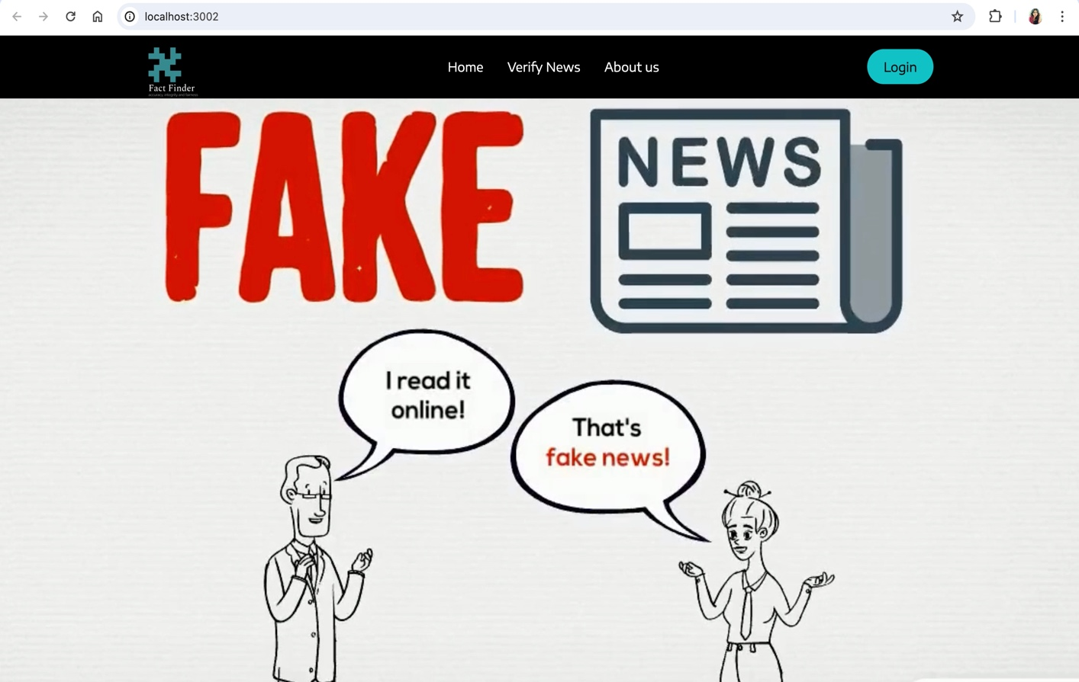

***Starting the server:***

# Machine Learning API deployment:

Download and Install Python :

# Following is the link to install python in your local system:

python link: https://www.python.org/downloads/

Split the Terminal:

Run following commands,

This command will create an environment instance in your source_code



This command will activate your env instance



Once your enter into flaskApp folder, install required libraries to run application smoothly



After this, run command : python3 main.py and you should see output like this:

Once you get the Warning: “This is a development server”, it means your application is ready to run on system.