**Using ES6 module for import and export:**

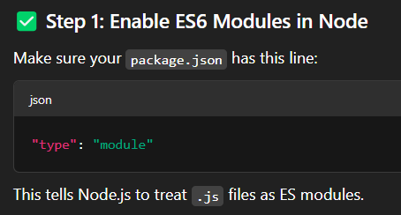

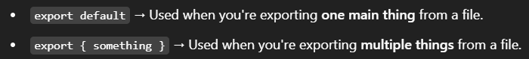

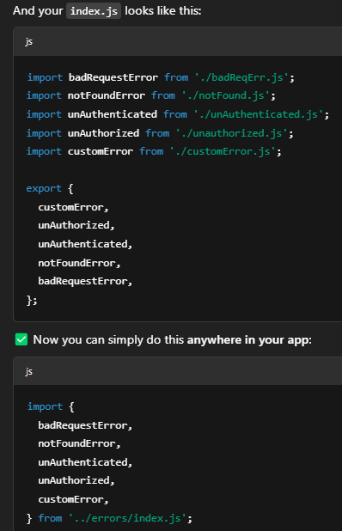

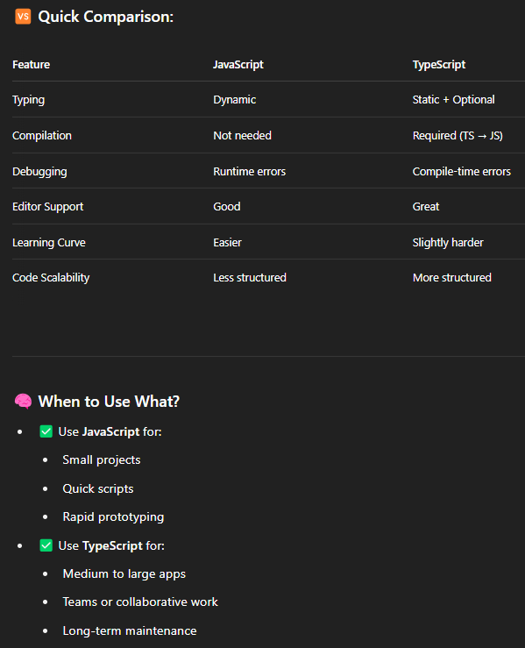

🡪I didn’t get the mongoose method suggestions by the vscode while typing . hence used the following snippet. It’s working fine now.

This worked because :

NOTE: we can find the type of error (error name) just by using .name property as every error has that property by default in node.js

🡪11000 error:

🡪**CORS error:**

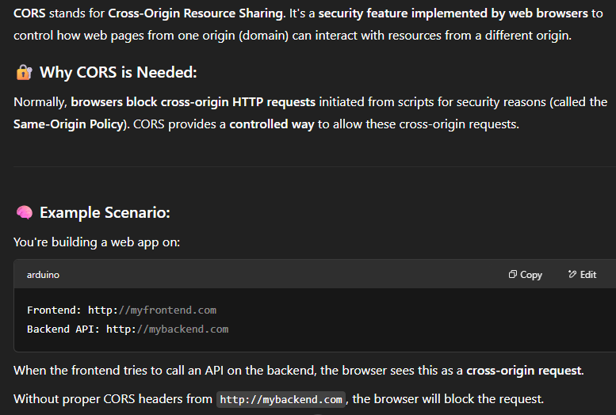

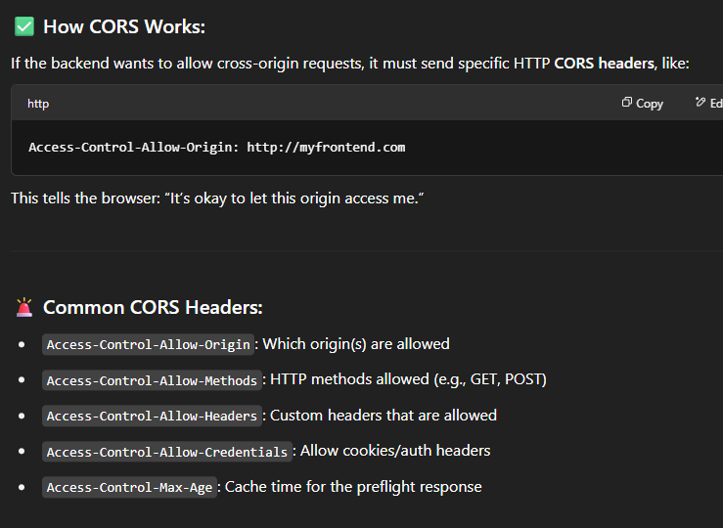

🡪Calling hooks from different folder:

🡪NOTE: useNavigate() should only be used inside the component

If I write this axios function that has useNavigate in separate file and if I pass this file to component

Its not gonna work because

🡪**Actual encounter of propdrilling:**

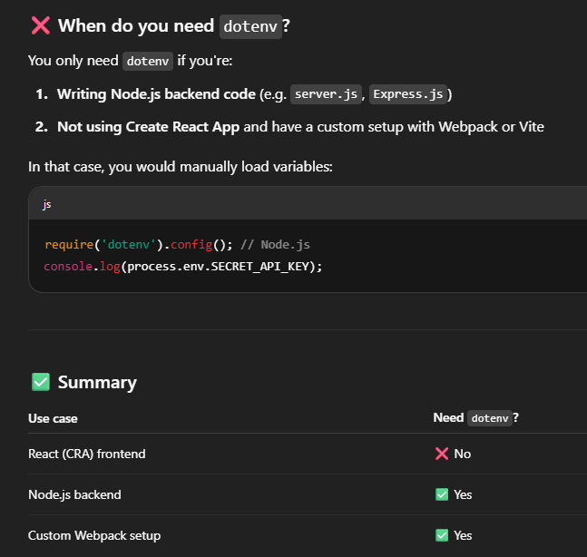

🡪CSS – Overflow

Overflow: Visible 🡪 it makes the content visible out of the box as well

Hidden🡪 it only shows the content that fits in the box and hides the rest

Auto🡪 it enables scroll bar but unable to scroll using mouse

Scroll🡪 enables the scroll using mouse

NOTE: An html tag can have multiple classes

🡪Adding the stocks to the Userdata base itself creating an array key in userschema vs creating the stocksschema separately and adding userid to track the users data

🡪Accessing the objects of data that is received:

🡪Dropdown implementation:

🡪NOTE: using ref while saving the parameter in DB  
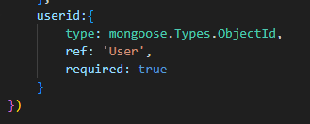

Even though this links the DBs if user is deleted all the records of the stocks associated to the user should be deleted manually

**NOTE:**

🡪**NOTE**: And another thing is while we are setting the data in the react like

**let data = {stockname, noOfStocks, price, Brokerage, stockSymbol}**

and we send it to the api directly we get the errors since it stores it in the form of  
**{stockname: 'Bajaj Finance Ltd', noOfStocks: '1100', price: '8000', Brokerage: 'Upstox', stockSymbol: 'BAJFINANCE'}**

But the api accepts   
**{"stockname":"Bajaj Finance** **Ltd","noOfStocks":"1100","price":"8000","Brokerage":"Upstox","stockSymbol":"BAJFINANCE"}**

To do that we need to use JSON.Stringify(data)



🡪If this is my useState



And if I use the setUserStocks function inside the useEffect hook and if I pass the userStocks inside the dependency array 🡪Its going to trigger infinite loop

