Course: DevOps Name: Billipati Sai Teja

Module: AWS and VPC Batch no: 115

Topic: VPC, Subnets and Internet gateway Assignment no: 07

Trainer Name: Mr. Madhukar sir Date of submission: 3rd – Feb – 2024

Mail-ID: ([BILLIPATISAITEJA@GMAIL.COM](mailto:BILLIPATISAITEJA@GMAIL.COM))

**Assignment: Implement the VPC using given details.**

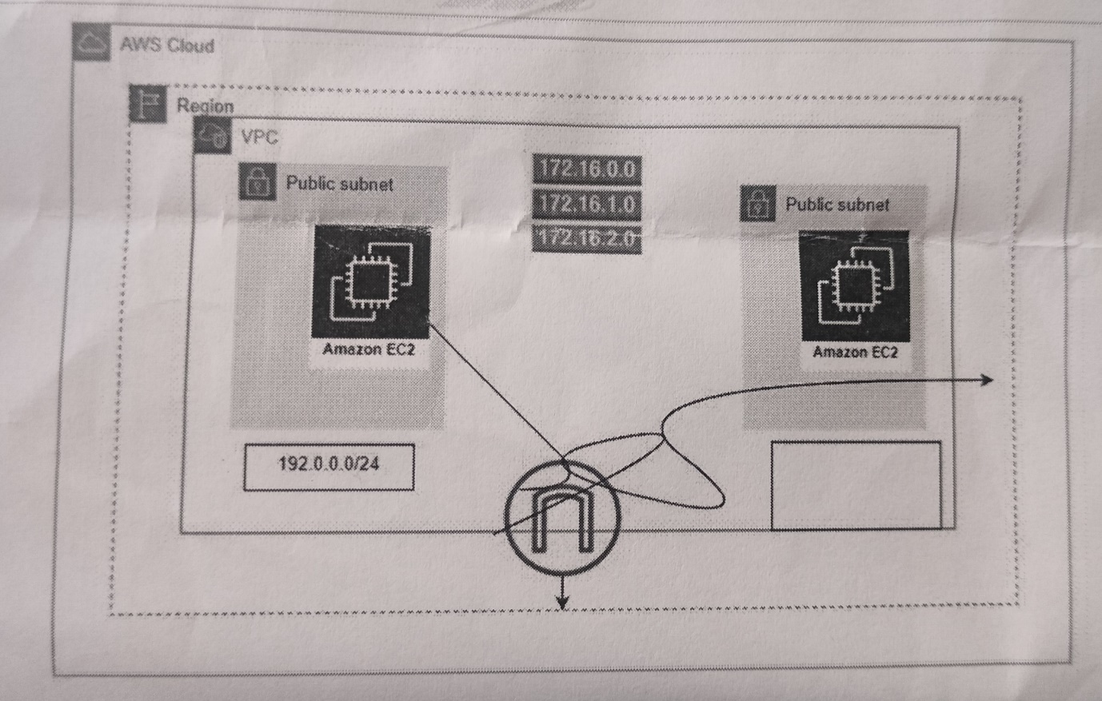

* Creating a VPC
* Creating a Subnets (172.16.0.0)
  + Public subnet (172.16.1.0/24)
  + Private subnet (172.16.2.0/24)
* Creating a Route table (public, private)
* Creating an Internet gateway
* Creating a Ec2 instance using VPC and Subnets.
* Creating a network for private subnets using NAT gateway with Elastic IP.

1. **Creating a VPC (Virtual Private Cloud):**
2. Create a VPC, go to services and type VPC.

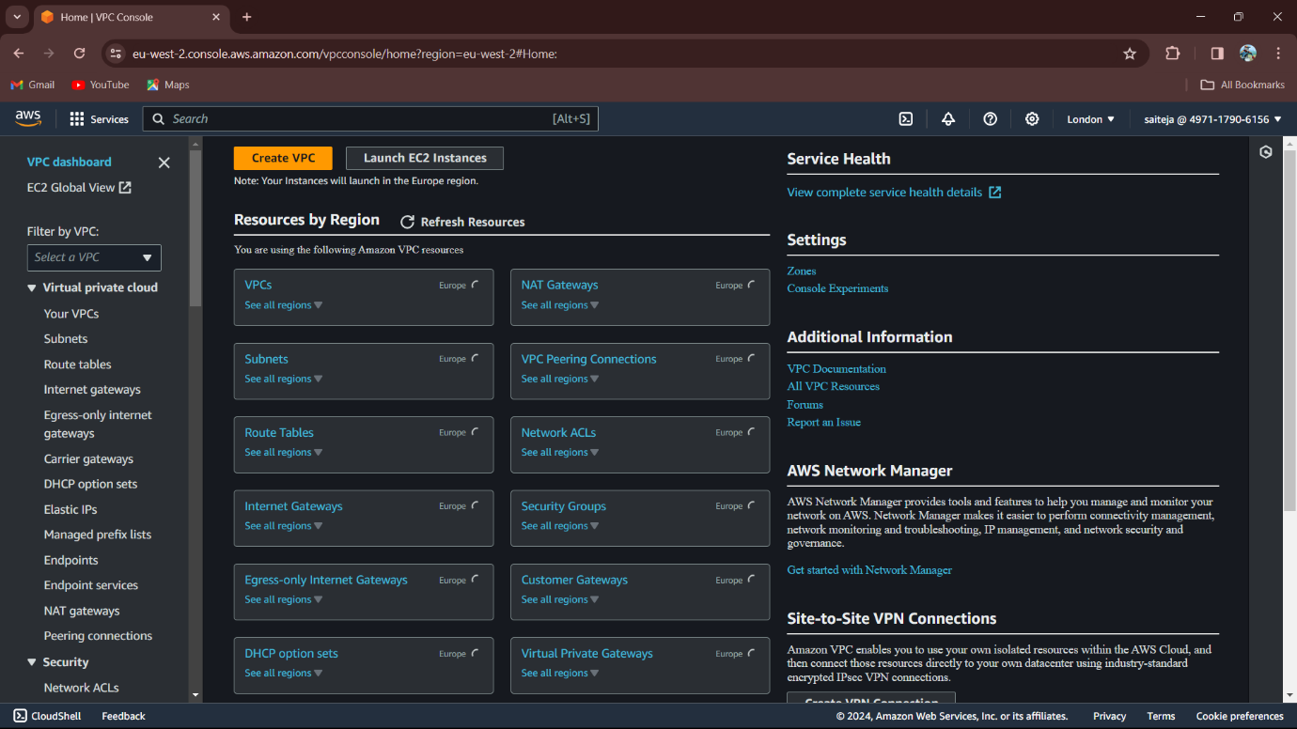

1. Click on Create VPC.

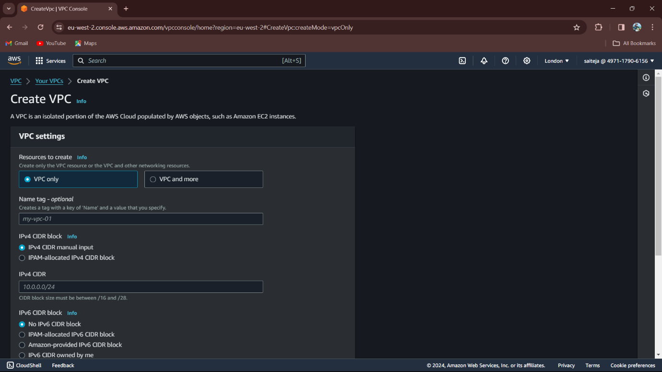

1. Resources to create: VPC only
2. Name tag: My Project VPC
3. IPv4 CIDR block: IPv4 CIDR manual Input
4. IPv4 CIDR: 172.16.0.0/16
5. VPC is Created then create the subnets
   1. Public and Private Subnets.

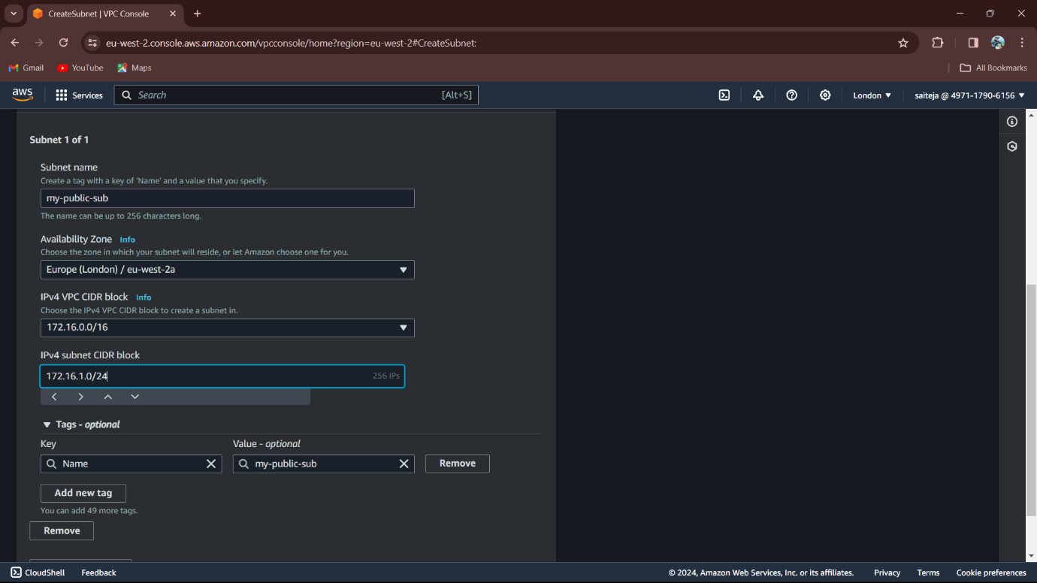

1. Public Subnet
   1. Subnet name: my-public-sub
   2. Availability Zone: Europe (London)/ eu-west-2a
   3. IPv4 VPC CIDR block: 172.16.0.0/16 (VPC IP address)
   4. IPv4 subnet CIDR block: 172.16.1.0/24
2. Private Subnet
   1. Subnet name: my-private-sub
   2. Availability Zone: Europe (London)/ eu-west-2c
   3. IPv4 VPC CIDR block: 172.16.0.0/16 (VPC IP address)
   4. 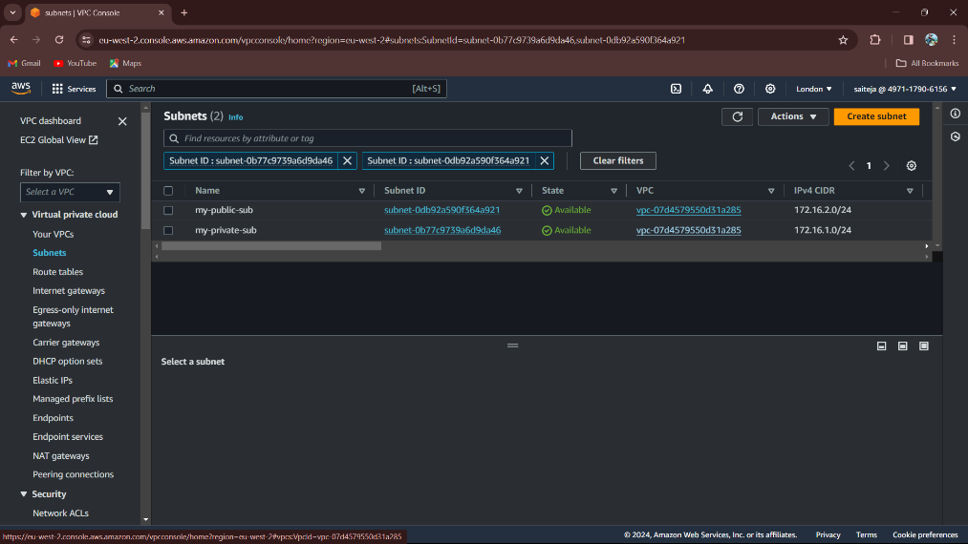IPv4 subnet CIDR block: 172.16.2.0/24

Subnets: Public &

Private

1. Create a Route table, to create the Route table click on the Route tables on the left of VPC dashboard.

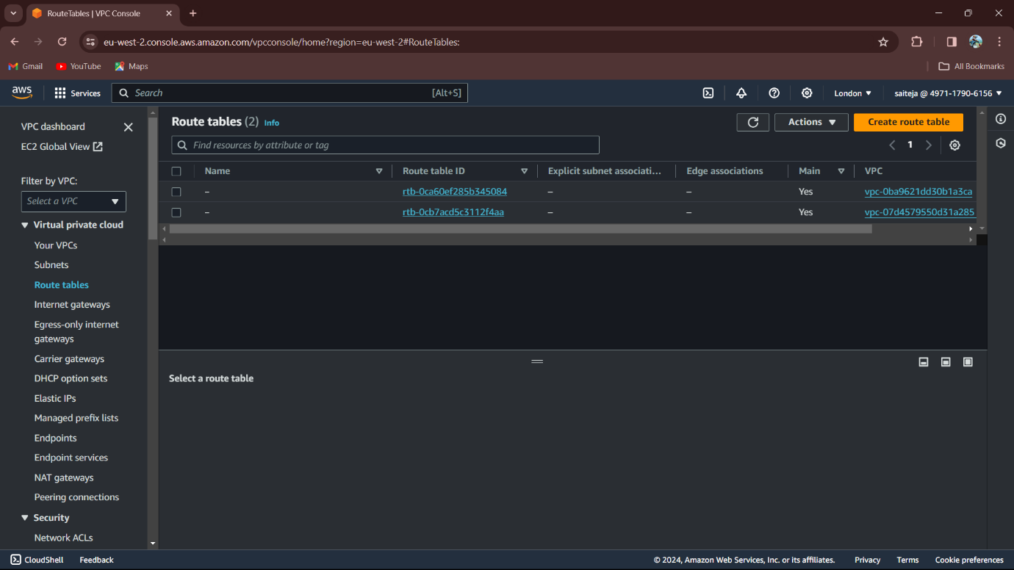

Click on the Create route table

1. Create a two Route tables
   1. Public Route tables (Associate Internet gateway)
   2. Private Route tables (Not Associate Internet gateway)

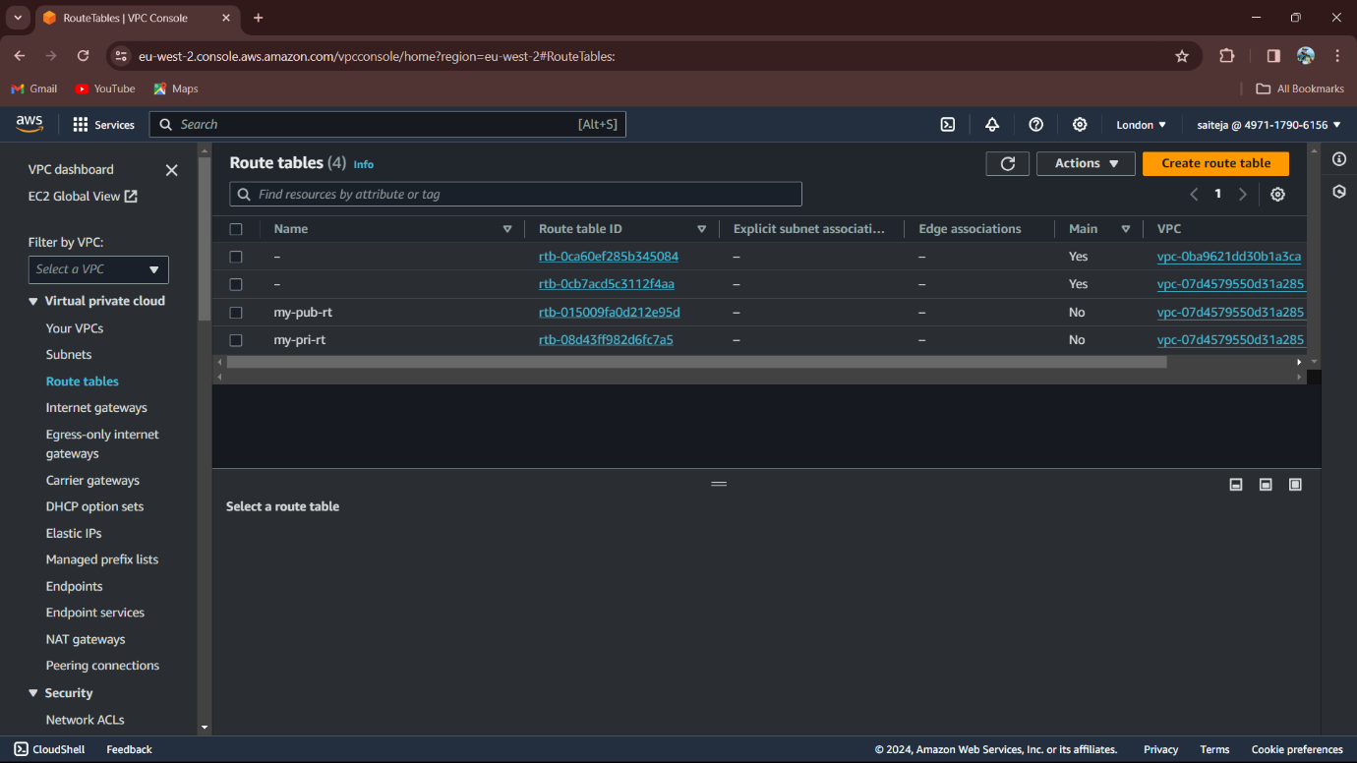

1. Route table name: my-pub-rt (Associate with Public Subnet)
2. Route table name: my-private-rt (Associate with Private Subnet)

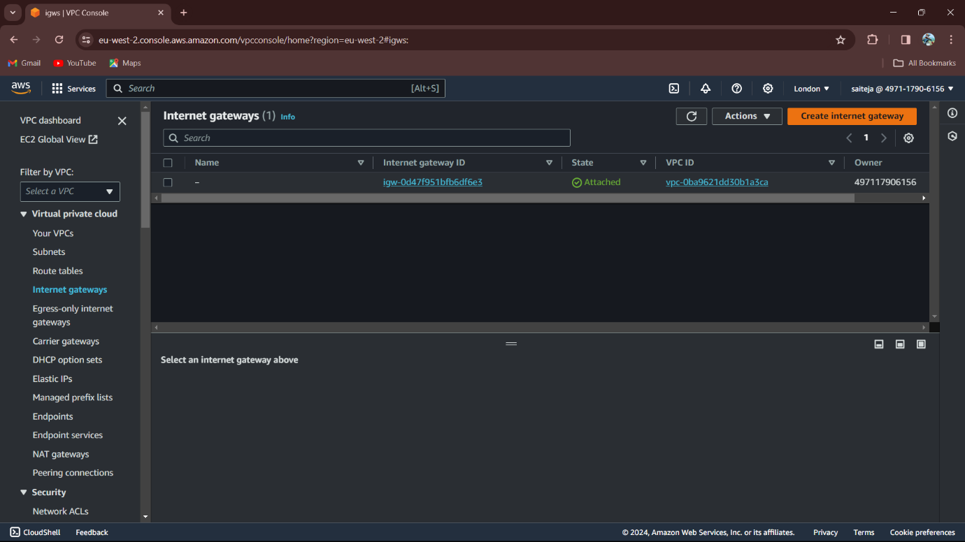

Click on Create Internet Gateway

1. After Creating Internet gateway, Attach with VPC (Which we create).

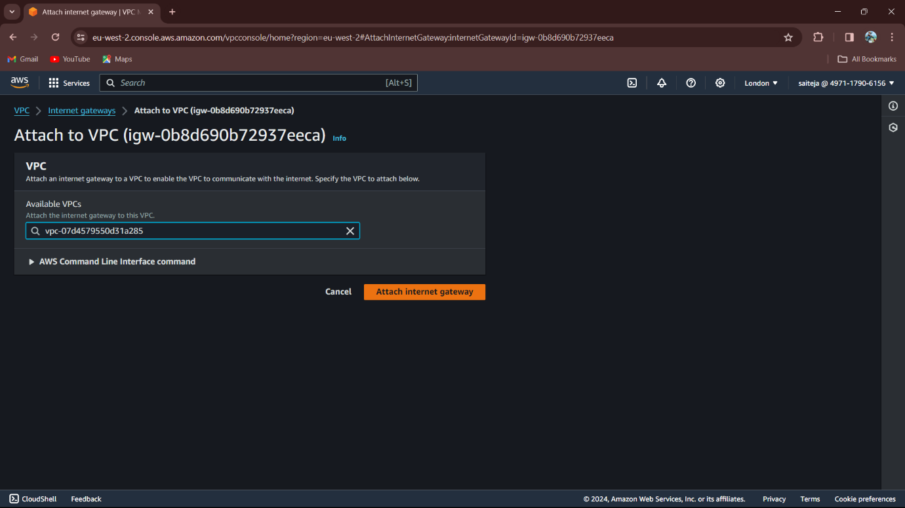

Click on the Attach Internet gateway

1. To connect Internet gateway for the Route table to make subnet public.
   1. Go to edit routes
   2. Connect the Internet Gateway with (0.0.0.0./0)

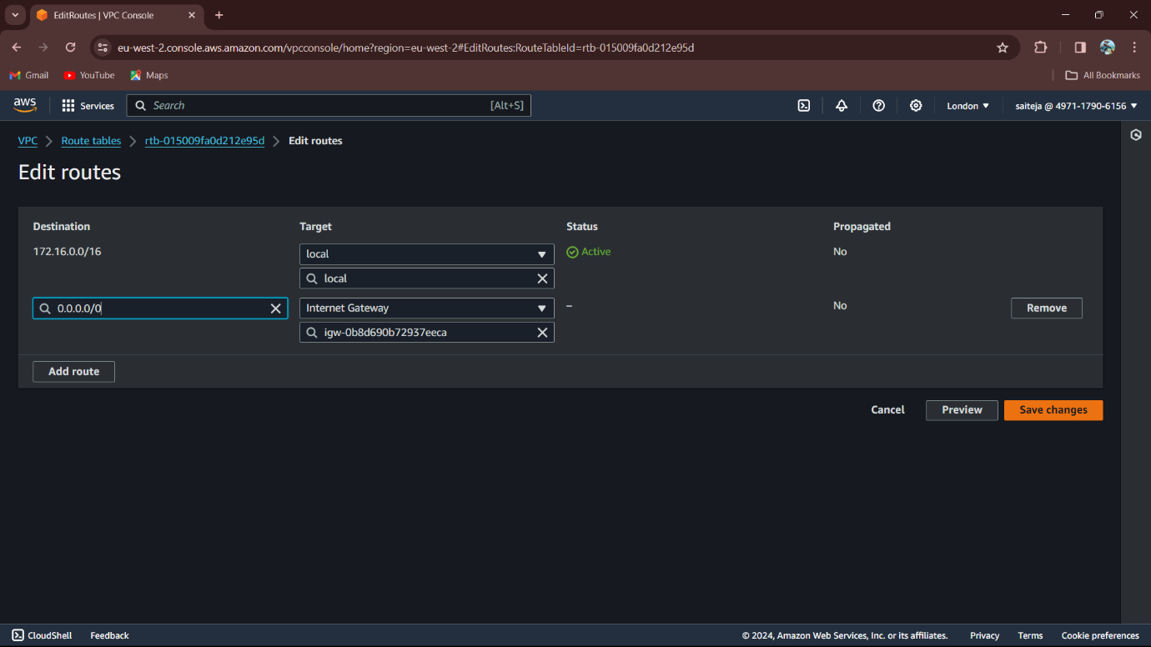

Click on Save Changes

1. Create EC2 instance using our own VPC.
2. Click on the Launch Instances

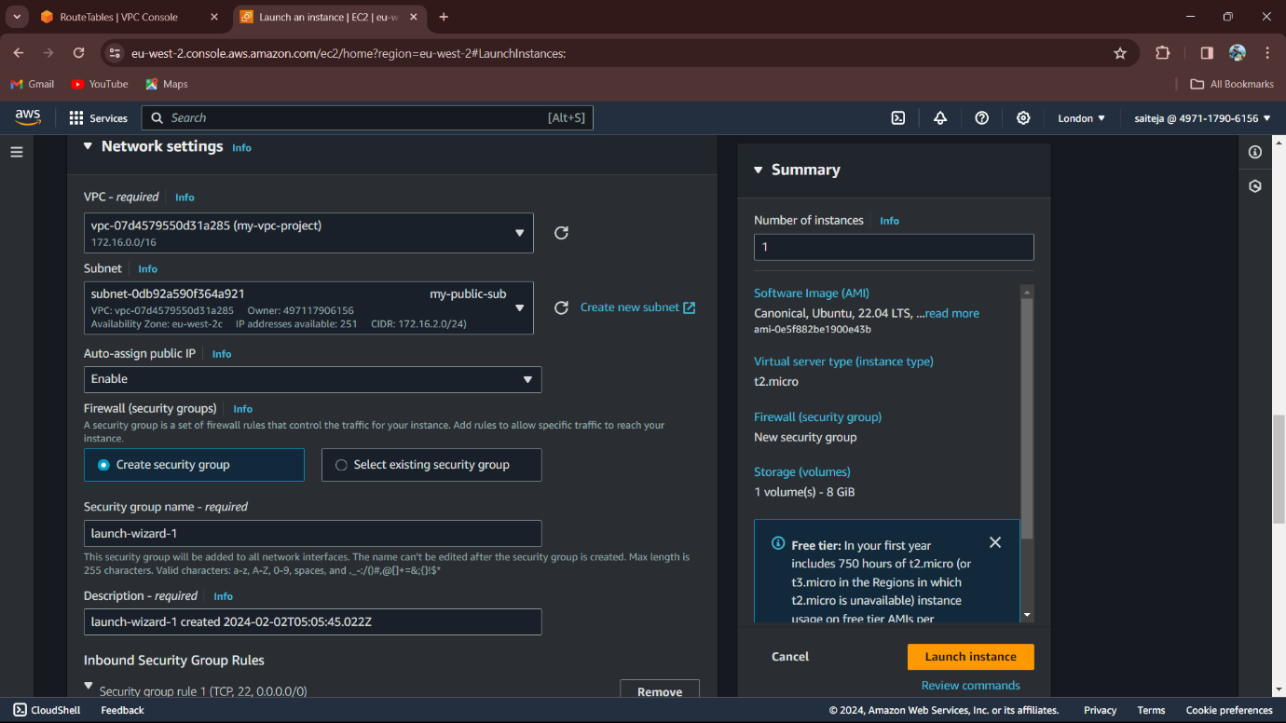

1. Click on edit VPC
   1. VPC Select our own VPC (my-vpc-project)
   2. Subnet: Attach the my-public-sub
   3. Auto-assign Public IP: Enable
   4. Click on Launch Instance

This instance is use for the public subnet.

1. Create another Instances for the Private Subnet.
   1. VPC Select our own VPC (my-vpc-project)
   2. Subnet: Attach the my-private-sub
   3. Auto-assign Public IP: Enable
   4. Click on Launch Instance.
2. Note: Use different KeyPairs.

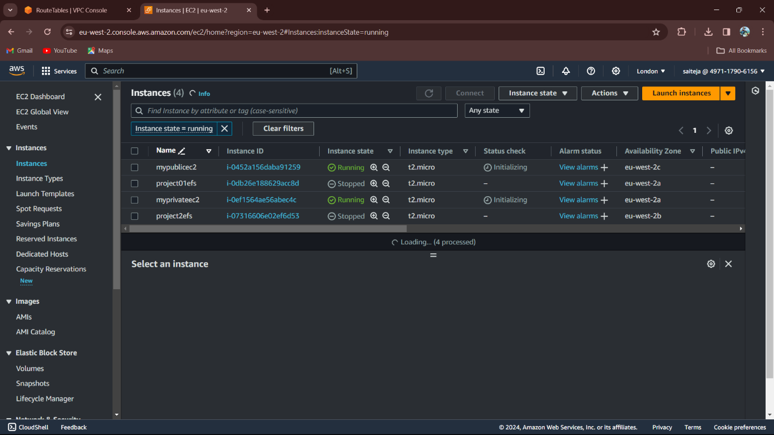

1. Instances were created
   1. For Public Instances: mypublicec2
   2. For Private Instances: myprivateec2
2. Open Instances and connect the EC2 sever to git bash.
3. We can open the Public Instances in the git bash, we can’t open Private instances in the git bash.
4. We should Connect the Private using the Public instances and we use the Private IPv4 to connect the sever to the git bash.

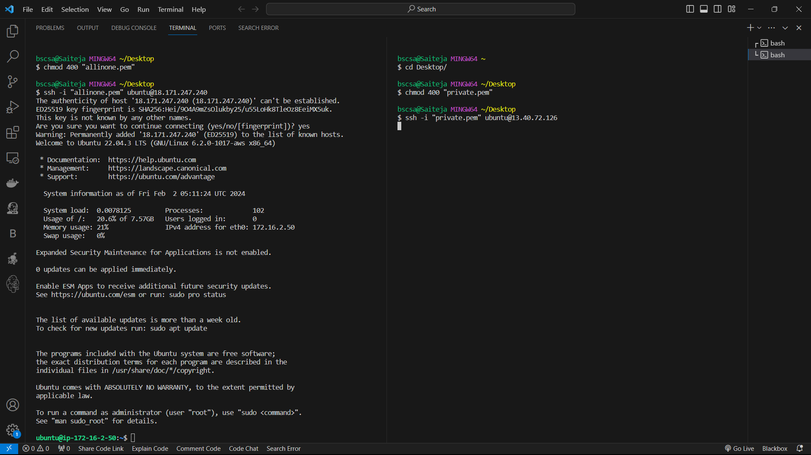

1. See in the Picture, we get the Public we can’t get the Private.
   1. So we should connect the first Public instances.
   2. Then we should copy the Private (Pem) to the Public instances.
   3. After copy Pem file of private, the use the command
      1. Chmod 400 (Private pem file name.pem)
   4. Connect the Private instances in the Public instances, using the Private IPv4 to connect.

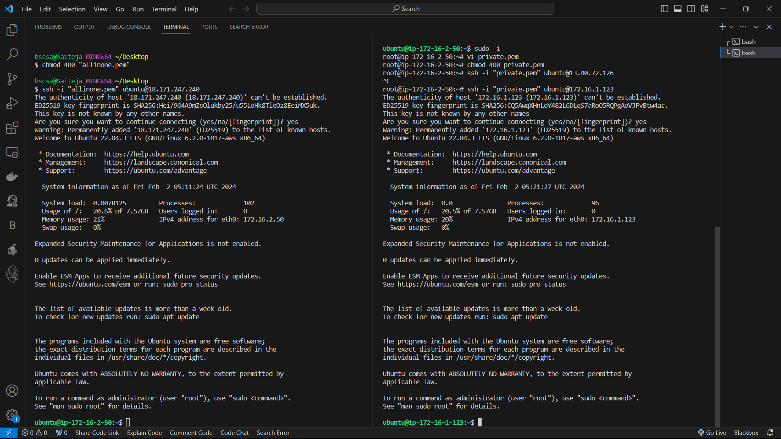----------------------------------------- END -----------------------------------------