Course: DevOps Name: Billipati Sai Teja

Module: Tomcat Mail-ID: ([BILLIPATISAITEJA@GMAIL.COM](mailto:BILLIPATISAITEJA@GMAIL.COM))

Topic: Deploy in Tomcat Batch no: 115

Trainer Name: Mr. Madhukar sir Assignment no: 02

Date of submission: 25th – Nov – 2023

* Project Deploy in Tomcat using Jenkins.
* About Jenkins.
* Installation and Setup of Jenkins and Tomcat.
* Build project using Pipeline.
* Configure of Project.
* Execution of build Project.
* Script of Connection Tomcat in Jenkins.
* Deployment in Tomcat.

---------------------------------------------- **Jenkins** ----------------------------------------------

* **Jenkins:** Jenkins is an open-source automation server. It helps automate the parts of software development related to building, testing, and deploying, facilitating continuous integration, and continuous delivery. It is a server-based system that runs in servlet containers such as Apache Tomcat. It is created using Java language, it executes the applications in Java language and also it can execute the all types of languages. To run Jenkins software, we need the Java software to be installed and maven software to be installed in the system.

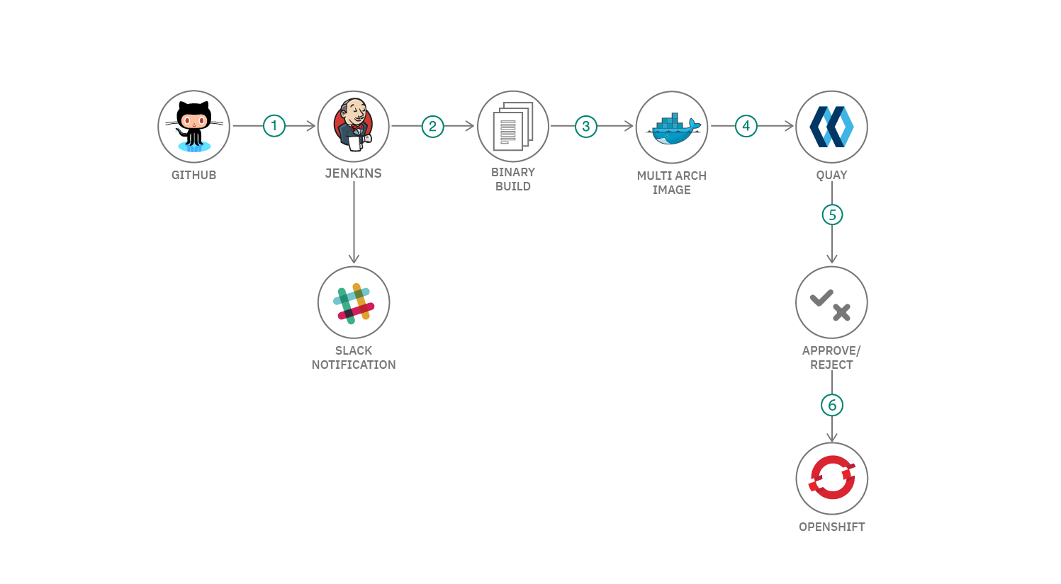**Architecture of Jenkins:**

--------------------------------- **Installation of Jenkins and Tomcat** ---------------------------------

* In AWS console open Terminal from the sever that created in the in AWS console.

1. Change user to root user using “Sudo -i”
2. Then update the system using “apt update -y”
3. After install Java jdk using command “apt install default-jdk -y”
4. Install Maven
5. Open the Jenkins webpage in the Google Search, open downloads and click ubuntu.
6. Then copy and paste given commands

sudo wget -O /usr/share/keyrings/jenkins-keyring.asc \

<https://pkg.jenkins.io/debian-stable/jenkins.io-2023.key>

1. Then add a Jenkins apt repository entry:

echo deb [signed-by=/usr/share/keyrings/jenkins-keyring.asc]

https://pkg.jenkins.io/debian-stable binary/ | sudo tee \

/etc/apt/sources.list.d/jenkins.list > /dev/null

1. Update your local package index, then finally install Jenkins:

sudo apt-get update

sudo apt-get install fontconfig openjdk-11-jre

sudo apt-get install jenkins

1. Check if we Java, Maven and Jenkins

Java --version

Maven --version

Jenkins –version

1. To install Tomcat use commands

<https://downloads.apache.org/tomcat/tomcat-9/v9.0.83/bin/apache-tomcat-9.0.83.tar.gz.sha512>

Install and Setup the Environment of Jenkins and Tomcat in the sever.

Open the Jenkins sever using the IP address and default port “8080”.

Create the Username and Password for the Jenkins. Open Jenkins dashboard.

Open the Tomcat sever using the Ip address and default port “8080”.

Open the Tomcat sever using preinstall username and password, it redirects to the interface of the Tomcat.

------------------------------------- **Build project using Pipeline** -------------------------------------

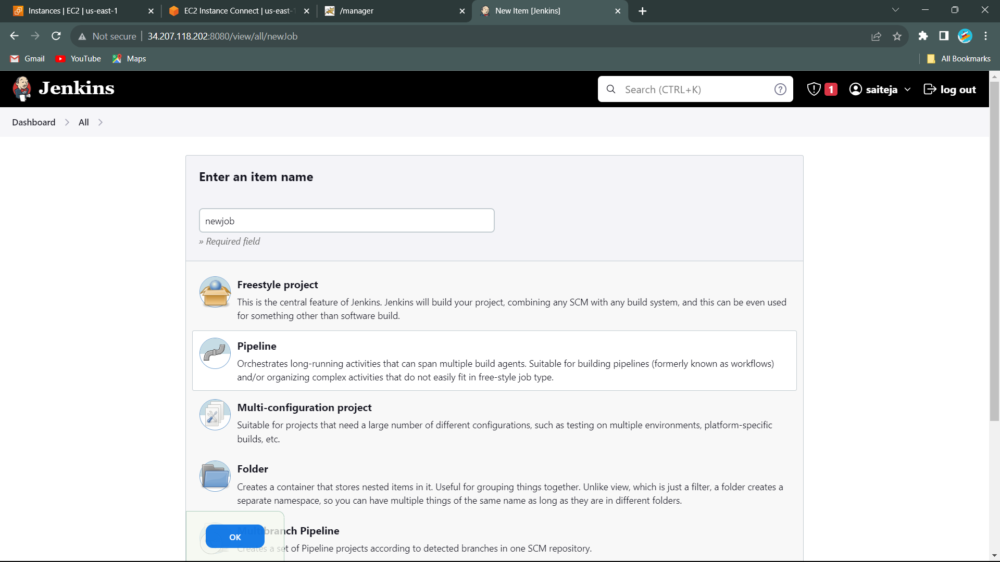

* Open Jenkins Dashboard Click on new,
* Give the item name Name: “Dockerfiles” and create project using Pipeline.
* Click on OK

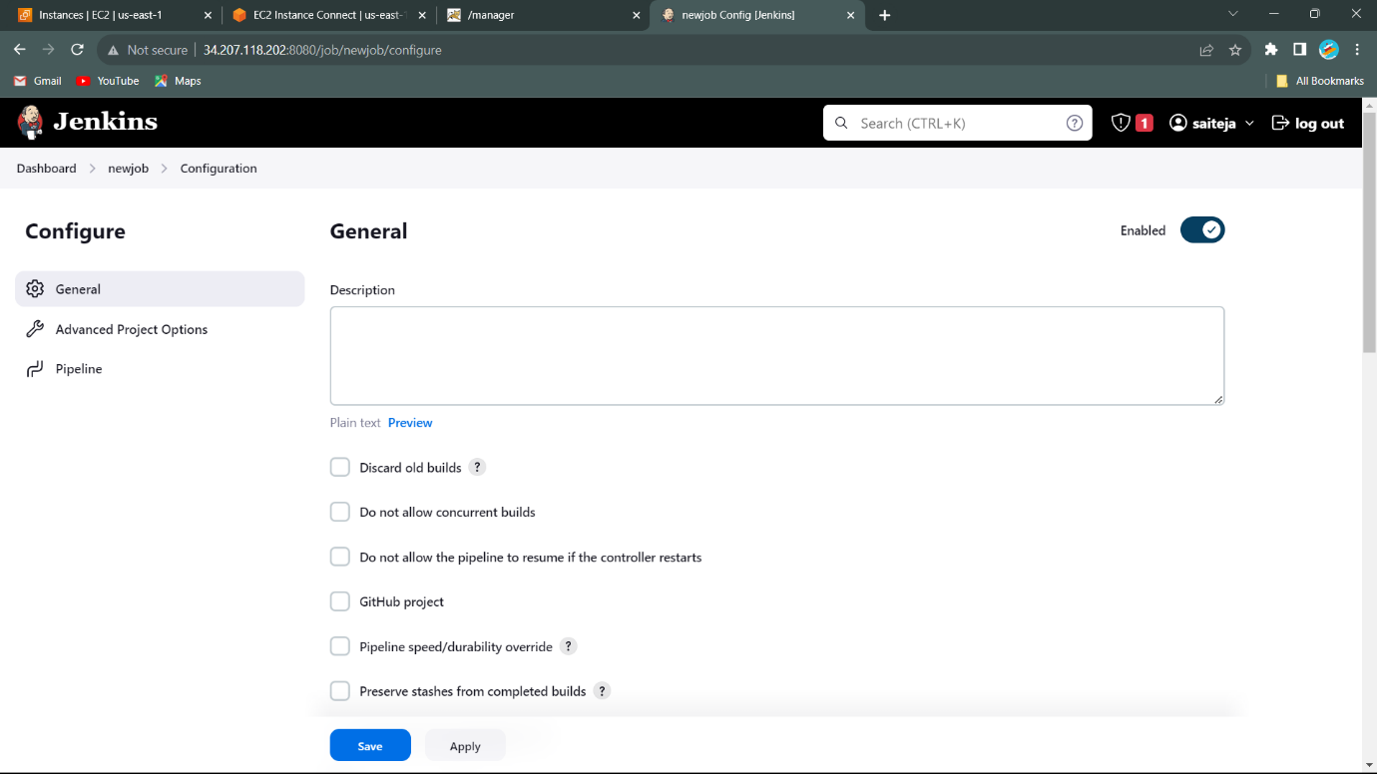

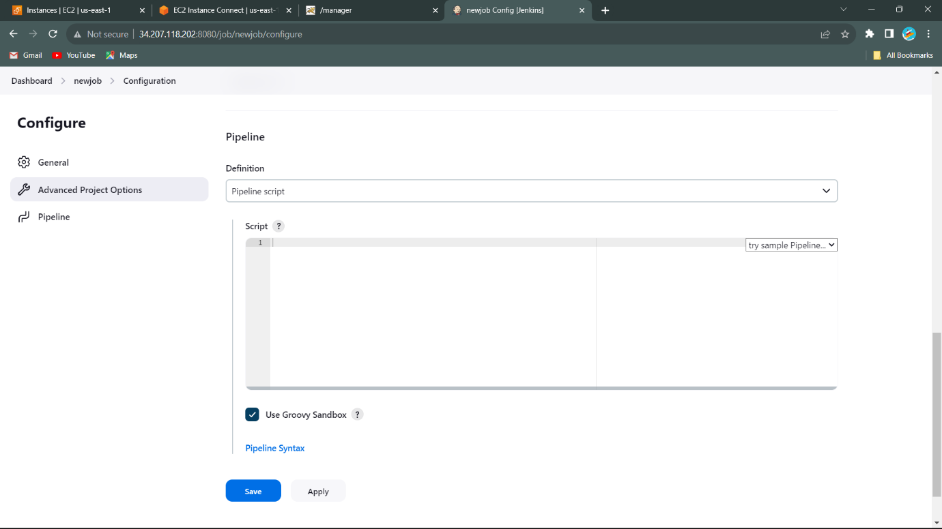

* We can see the Configure page.
* Use the GitHub link and Pipeline Script.

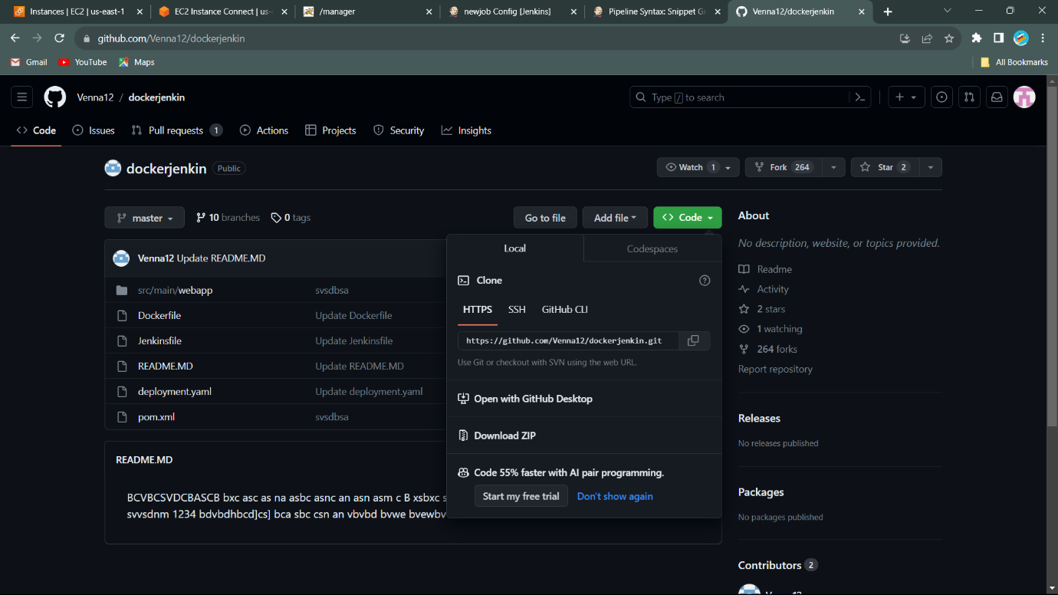

* Copy the link from GitHub.
* Address: <https://github.com/Venna12/dockerjenkin.git>
* Paste link in the GitHub coloum.

---------------------------------------- **Execution of Application** ---------------------------------------

* We should write script for the pipeline to build program, the script is

Script:

pipeline {

agent any

stages {

stage(‘Clone the Project’){

steps{

we get code from the pipeline syntax. Shown below.

}

}

stage(‘mvn validate’){

steps{

sh ‘mvn validate’

}

}

stage(‘mvn compile’){

steps{

sh ‘mvn compile’

}

}

stage(‘mvn test’){

steps{

sh ‘mvn test’

}

}

stage(‘mvn package’){

steps{

sh ‘mvn package’

}

}

}

}

We should build the code and run the code.

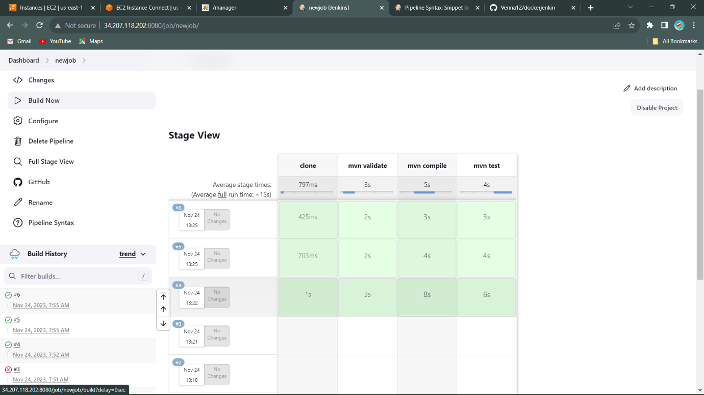

* Application successfully build.

>>>Install plugin for the deployment in the tomcat.

* Deploy Container

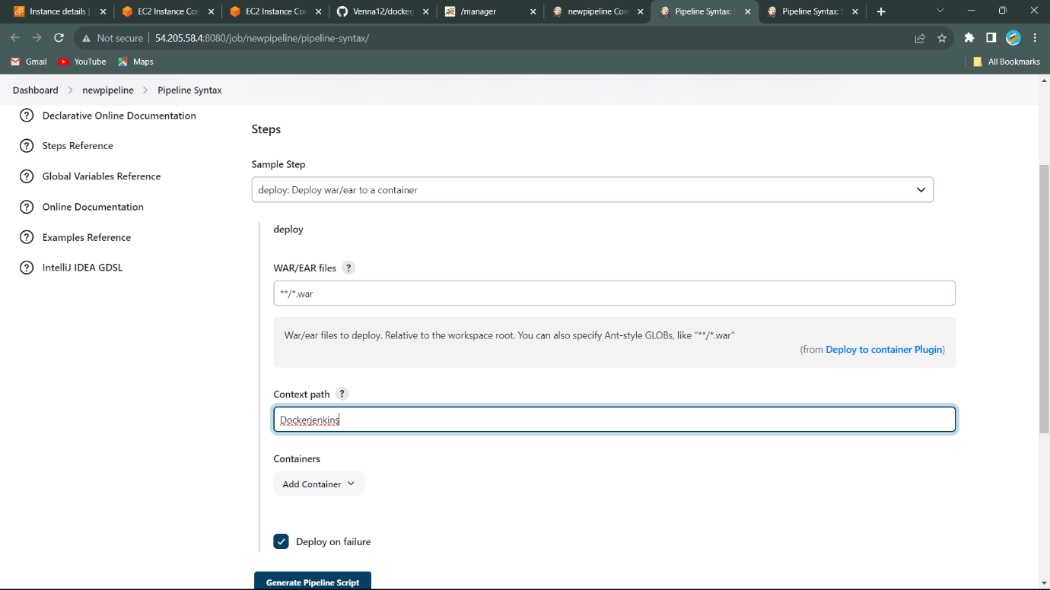To get tomcat script, we use pipeline syntax

* Create Jenkins id and password, it is add to the container.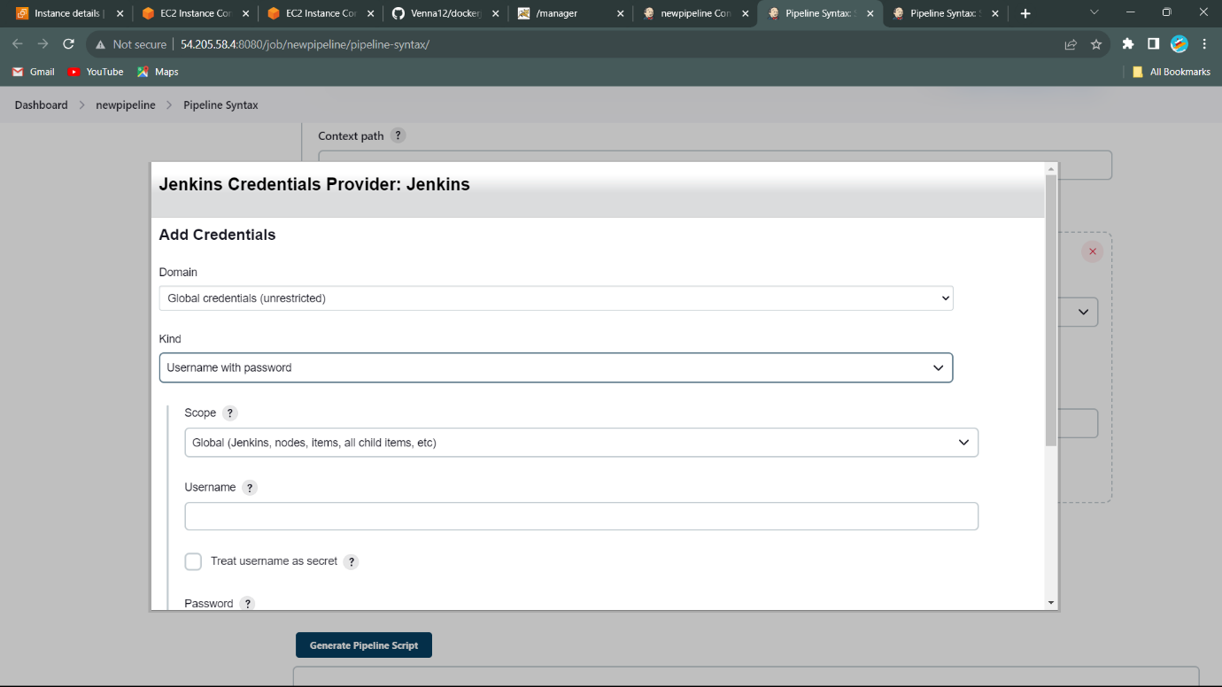
* Open the Tomcat and host manager. It seems like that

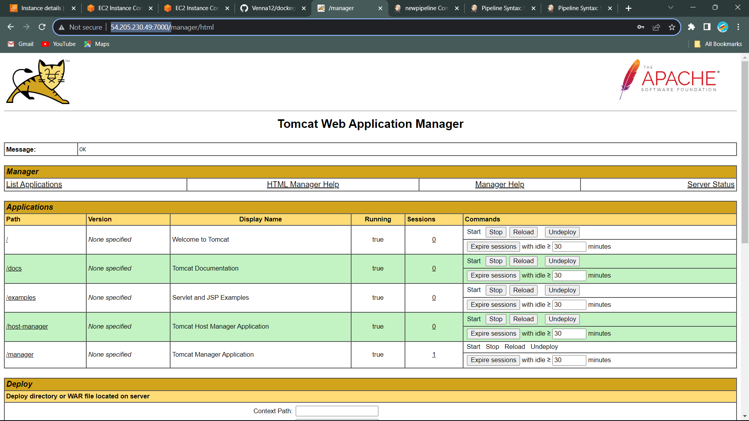

* Copy the URL of the Tomcat with Ip address and port number. Copy the link address to the given box and we got script and copy the script the and add to the script to configure pipeline.

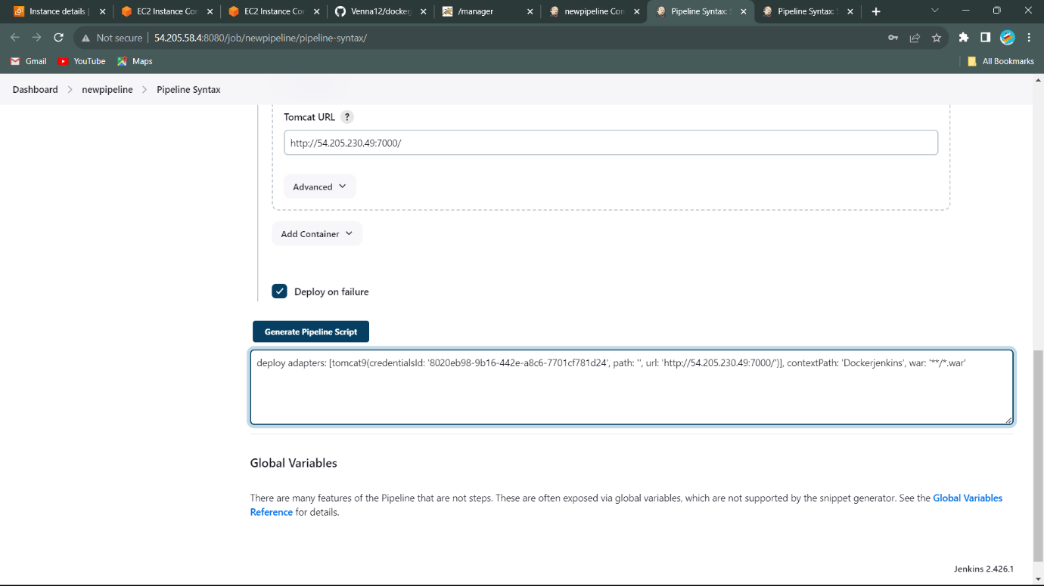

* Script add to pipeline script

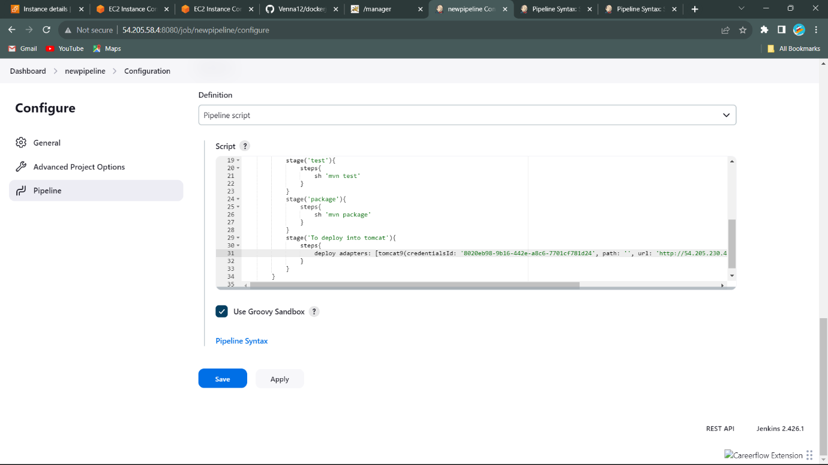

* 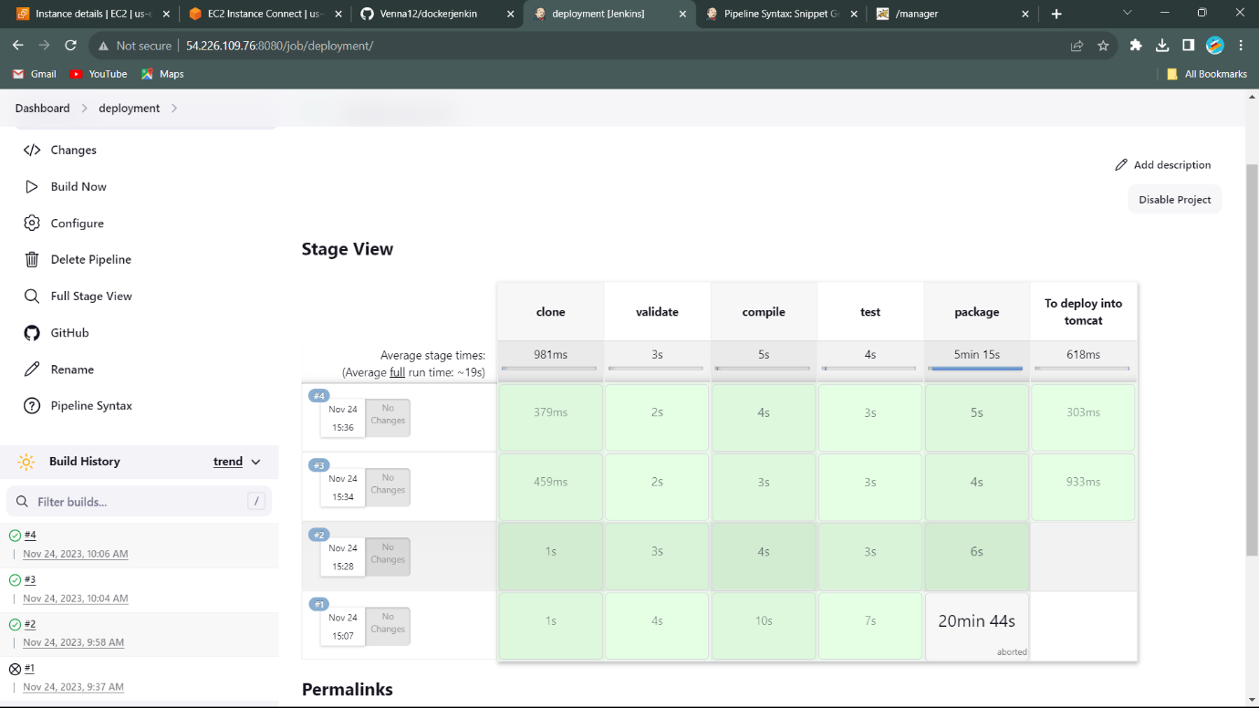Console Output: To see the output build Pipeline.

>>>> We will see the application the host manager. Name is the “Dockerfile”.

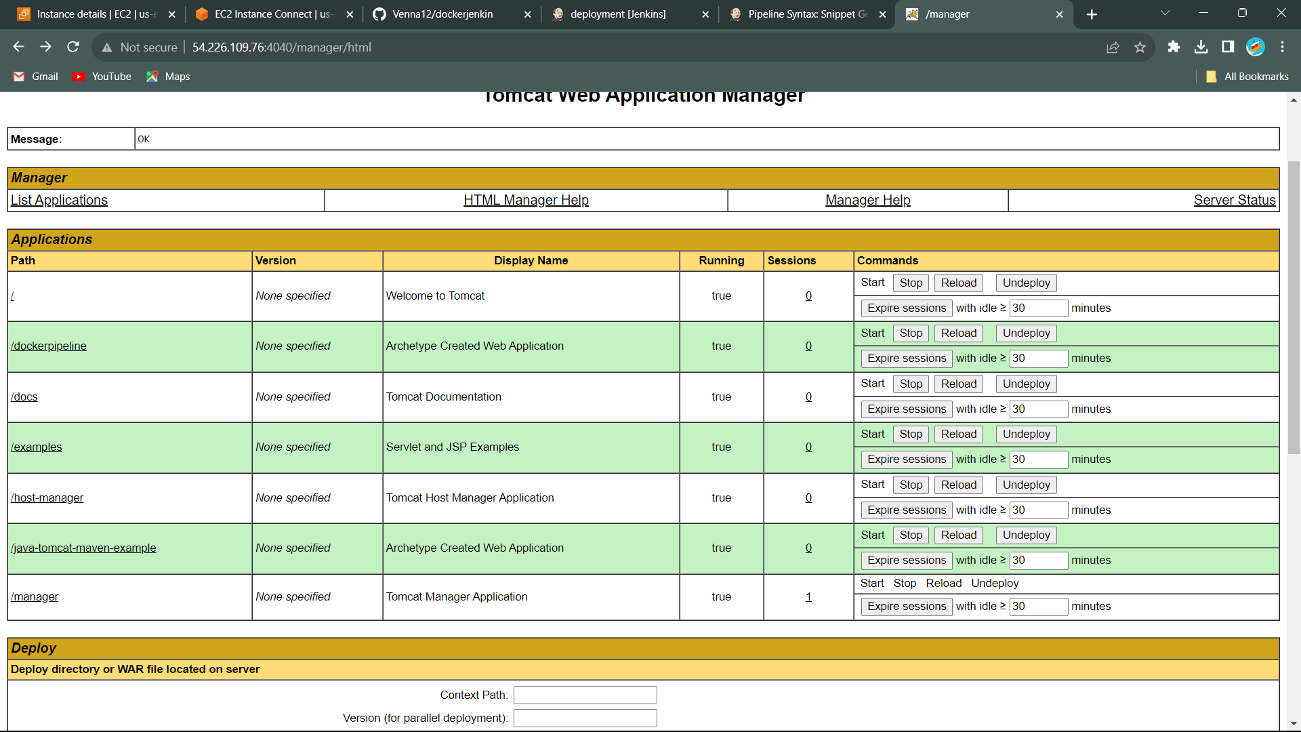

* Click on the Dockerfile. We get this output……………………………………..

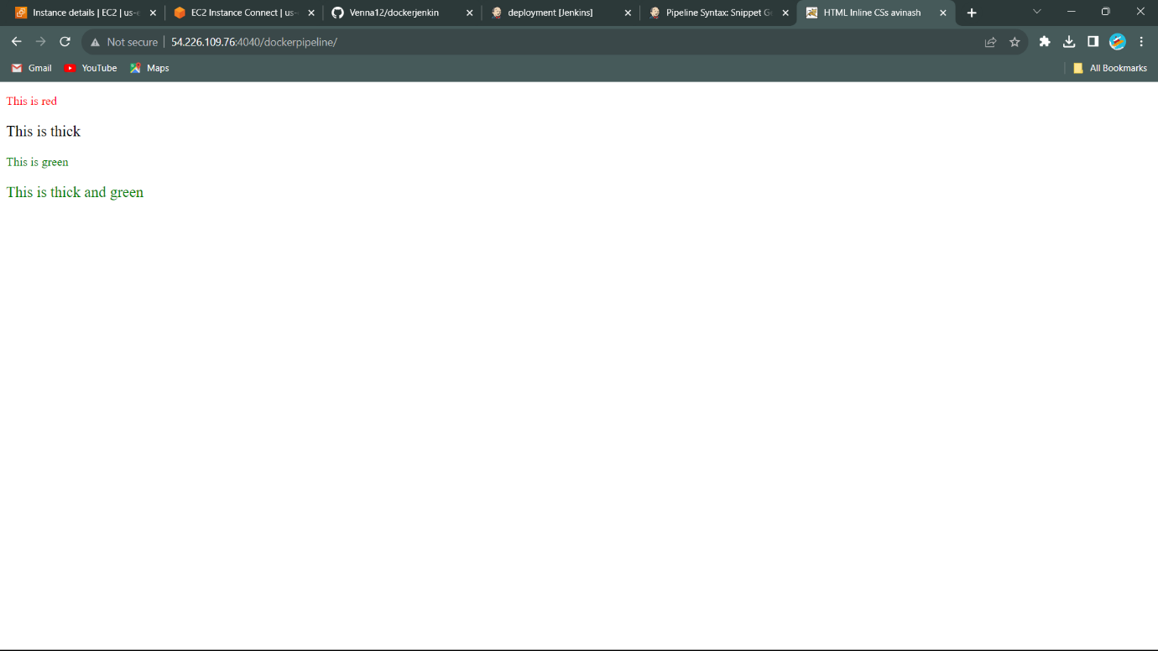

* The Application is successfully Deployment in the Tomcat using Jenkins.

-------------------------------------O-------------------------------------