Module 3, Session 1: Introduction to Version Control with Git

Duration: 1 hour

Session Objectives:
- Understand the need for version control in software development.
- Set up Git on the local machine.
- Learn the basics of Git, including push, pull, cloning, forking, creating repositories, and merging.

Student Capability After the Session:
- Ability to articulate the importance of version control in collaborative software development.
- Proficiency in setting up Git on the local machine.
- Understanding of fundamental Git commands for version control.
- Capability to create repositories, clone, fork, and perform basic merging operations.

Agenda:

1. Welcome and Overview (10 mins)
- Introduction to the session objectives.
- Overview of the importance of version control in a collaborative coding environment.

2. Understanding Version Control (10 mins)
- Explanation of version control and its significance.
- Discussion on challenges without version control in a team setting.

3. Git Setup (15 mins)
- Step-by-step guide on installing and configuring Git.
- Verification of the Git installation.

4. Basics of Git (15 mins)
- Introduction to Git commands: init, add, commit, status.
- Overview of the Git workflow.

5. Push and Pull Operations (10 mins)
- Explanation of pushing changes to a remote repository.
- Understanding pulling changes from a remote repository.

6. Basics of Cloning and Forking (20 mins)
- Definition and practical demonstration of cloning a repository.
- Explanation of forking and its use in collaborative development.

7. Creating a Repository (10 mins)
- Step-by-step guide on creating a new repository.
- Understanding repository settings.

8. Merging Repositories (20 mins)
- Basics of merging branches and repositories in Git.
- Conflict resolution in merges.

9. Interactive Demonstration (10 mins)
- Live demonstration of Git commands and workflows.
- Q&A session for clarification.

10. Q&A and Discussion (10 mins)
- Addressing questions from participants.
- Facilitating a discussion on the covered topics.

Practice Questions for Students:
- Create a new Git repository on your local machine and make an initial commit.
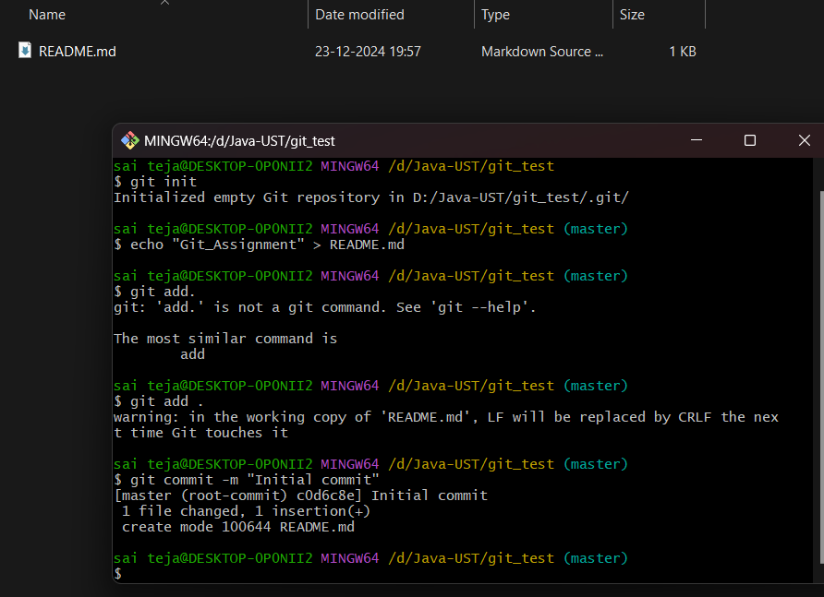

- Push the changes from your local repository to a remote repository on a hosting platform (e.g., GitHub).
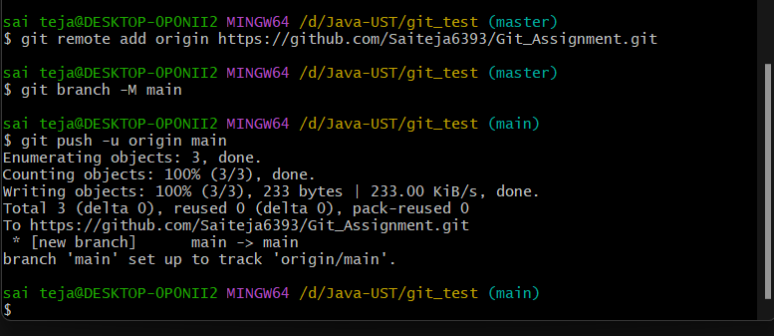
- Clone an existing repository from a remote source to your local machine.
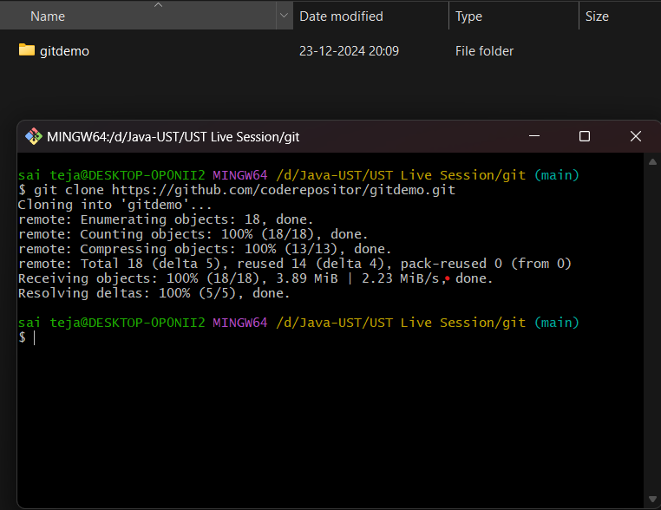

- Fork a repository on GitHub, make changes, and submit a pull request.
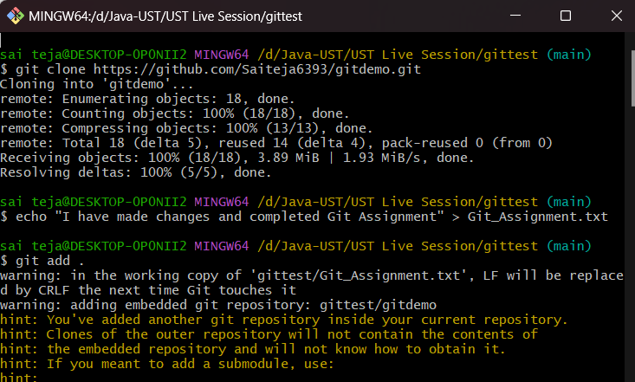
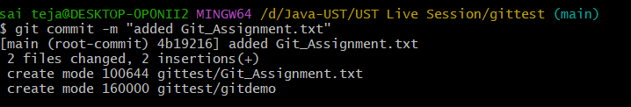
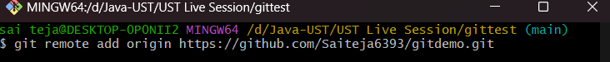
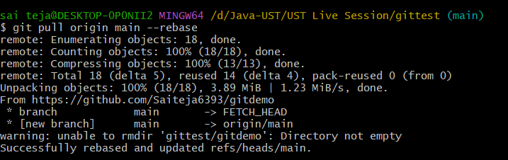
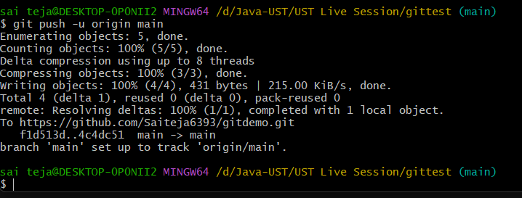
- Perform a basic merge operation, resolving any conflicts that arise.
