Module 3, Session 1: Introduction to Version Control with Git

Duration: 1 hour

Session Objectives:

- Understand the need for version control in software development.

- Set up Git on the local machine.

- Learn the basics of Git, including push, pull, cloning, forking, creating repositories, and merging.

Student Capability After the Session:

- Ability to articulate the importance of version control in collaborative software development.

- Proficiency in setting up Git on the local machine.

- Understanding of fundamental Git commands for version control.

- Capability to create repositories, clone, fork, and perform basic merging operations.

Agenda:

1. Welcome and Overview (10 mins)

- Introduction to the session objectives.

- Overview of the importance of version control in a collaborative coding environment.

2. Understanding Version Control (10 mins)

- Explanation of version control and its significance.

- Discussion on challenges without version control in a team setting.

3. Git Setup (15 mins)

- Step-by-step guide on installing and configuring Git.

- Verification of the Git installation.

4. Basics of Git (15 mins)

- Introduction to Git commands: init, add, commit, status.

- Overview of the Git workflow.

5. Push and Pull Operations (10 mins)

- Explanation of pushing changes to a remote repository.

- Understanding pulling changes from a remote repository.

6. Basics of Cloning and Forking (20 mins)

- Definition and practical demonstration of cloning a repository.

- Explanation of forking and its use in collaborative development.

7. Creating a Repository (10 mins)

- Step-by-step guide on creating a new repository.

- Understanding repository settings.

8. Merging Repositories (20 mins)

- Basics of merging branches and repositories in Git.

- Conflict resolution in merges.

9. Interactive Demonstration (10 mins)

- Live demonstration of Git commands and workflows.

- Q&A session for clarification.

10. Q&A and Discussion (10 mins)

- Addressing questions from participants.

- Facilitating a discussion on the covered topics.

Practice Questions for Students:

1. **Create a new Git repository on your local machine and make an initial commit.**

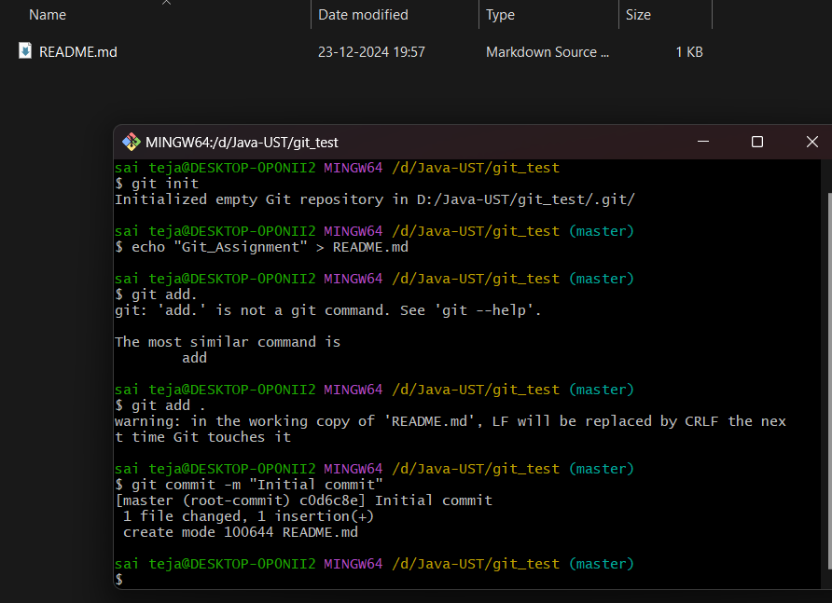

1. **Push the changes from your local repository to a remote repository on a hosting platform (e.g., GitHub).**

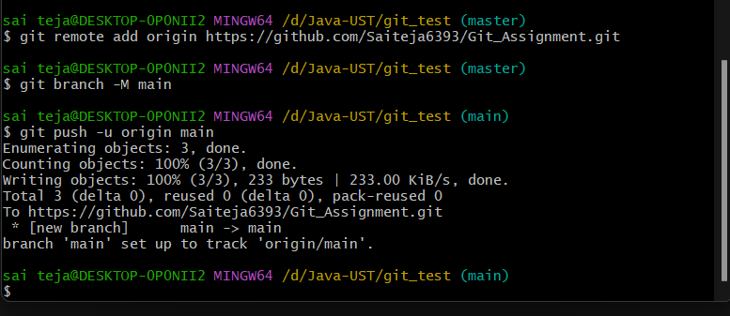

1. **Clone an existing repository from a remote source to your local machine.**

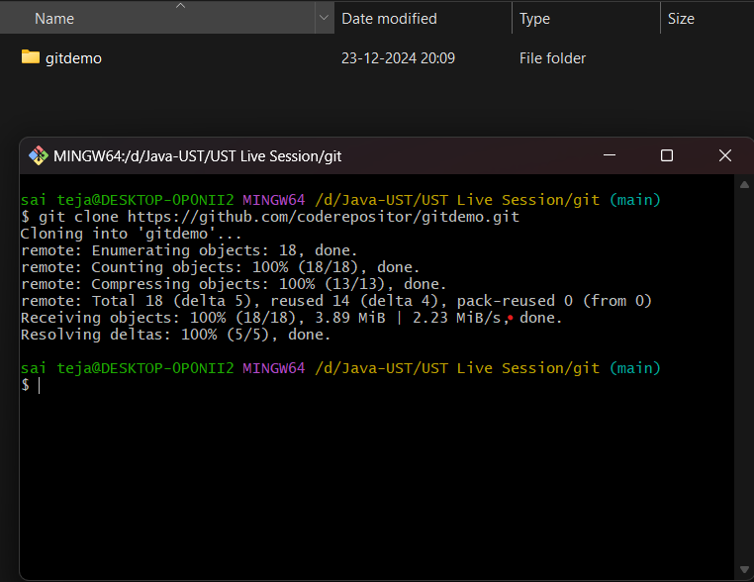

1. **Fork a repository on GitHub, make changes, and submit a pull request.**

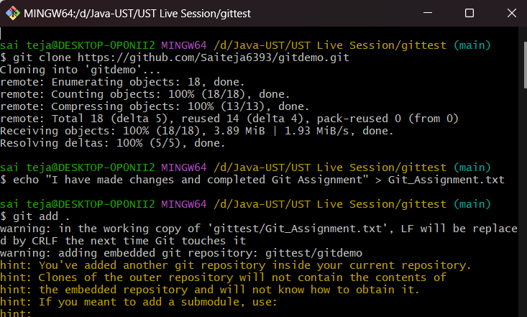

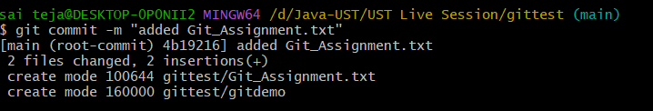

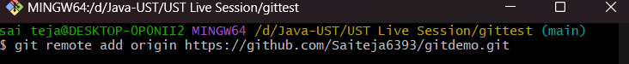

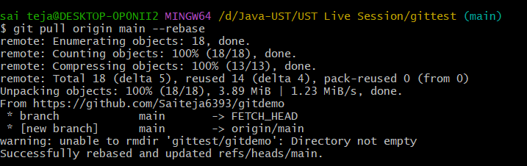

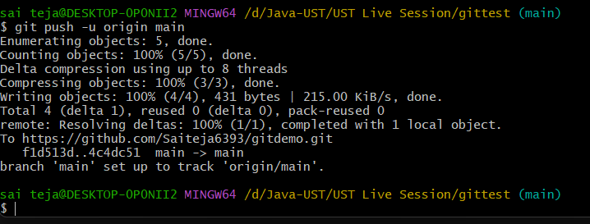

1. **Perform a basic merge operation, resolving any conflicts that arise.**

