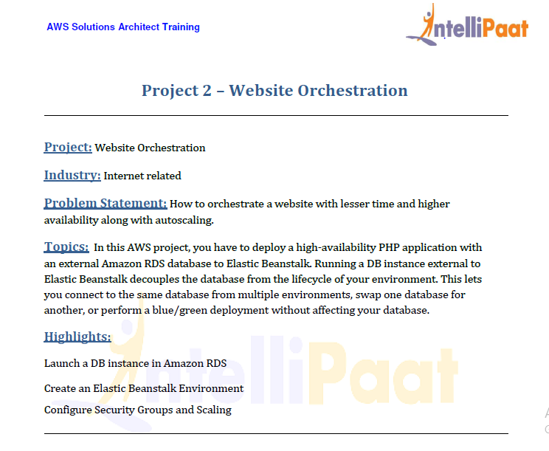

* First we Create a RDS instance.
* We can us multi AZ DB for high availability

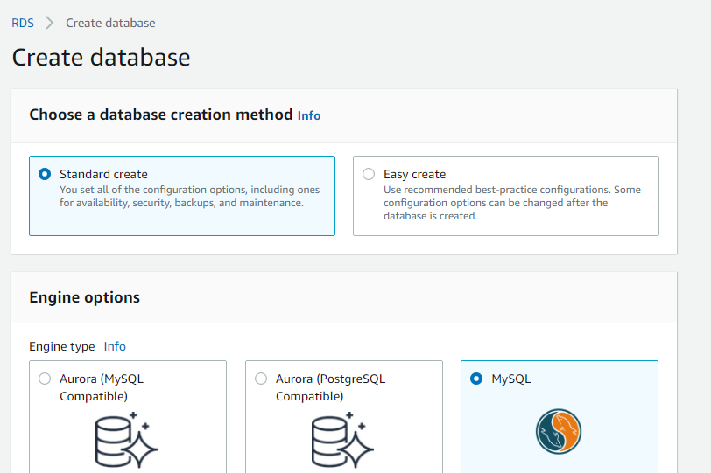

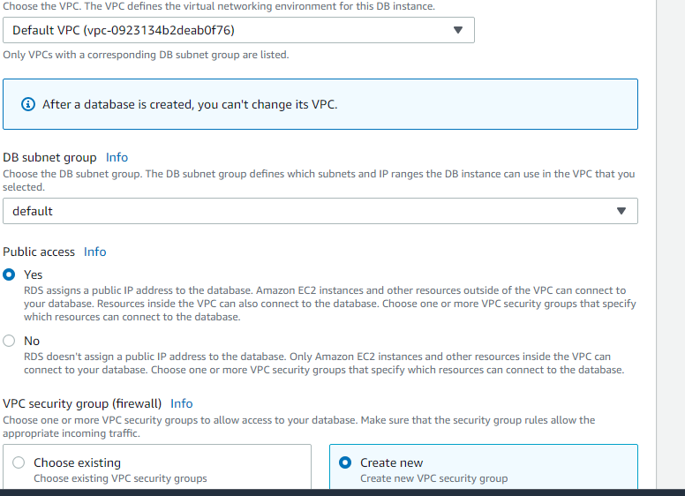

* Create a Elastic beanstalk application.
* Chose a PHP Environment.
* We can upload the code while creation or we after creation.

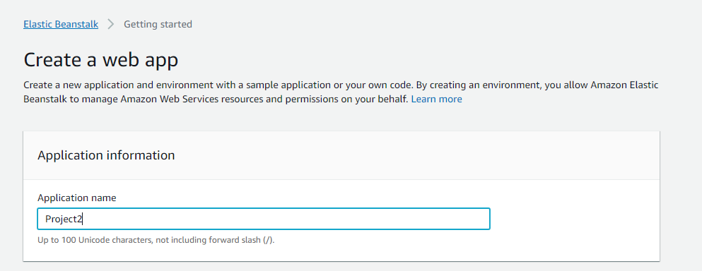

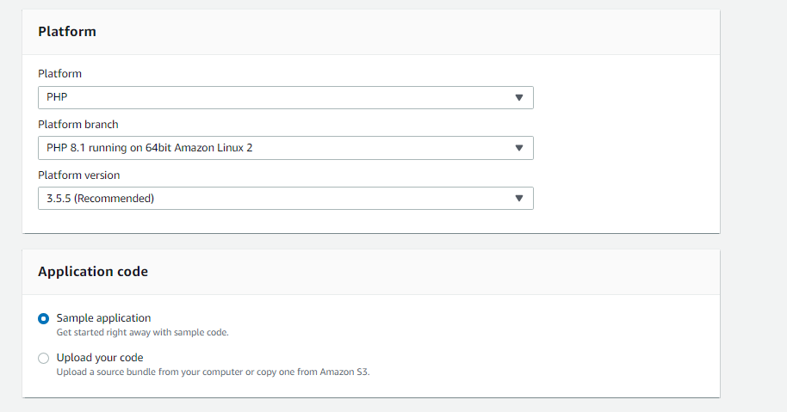

* Go to configure more options in order to connect to RDS
* We can select the security group of our customization in the security system.
* And for the high availability go to capacity and in the Environment type select load balanced
* And select the min and max required according to the usage
* As of now I am using single instance
* Go to Databases > To add an database we can either use snapshots created from existing RDS instance or create a RDS snapshots

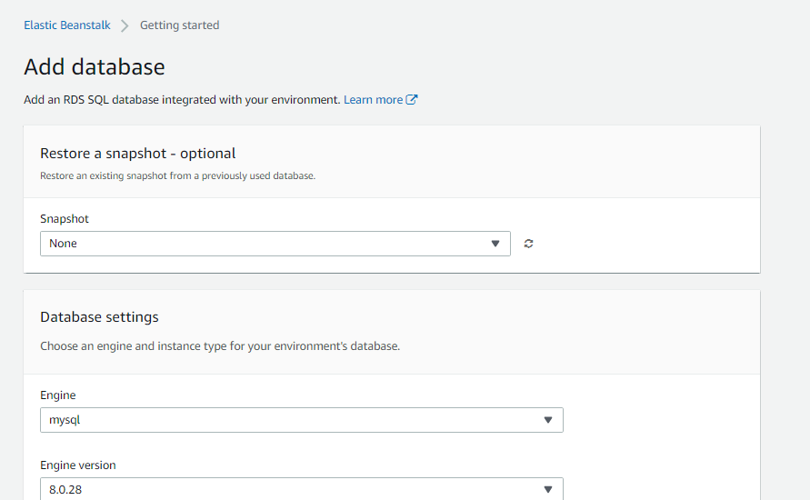

* Then click on create app

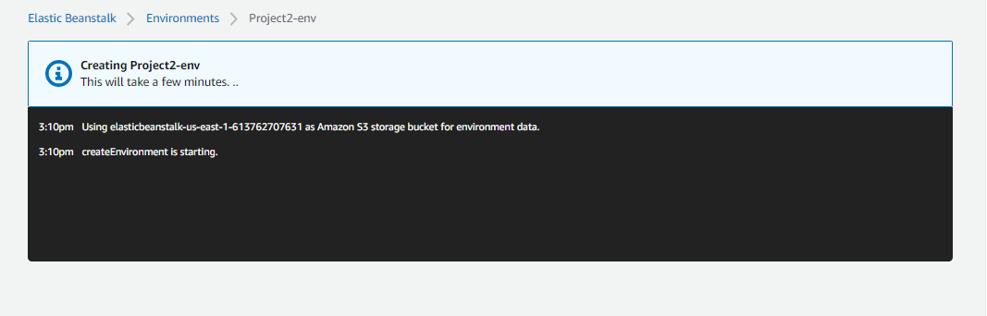

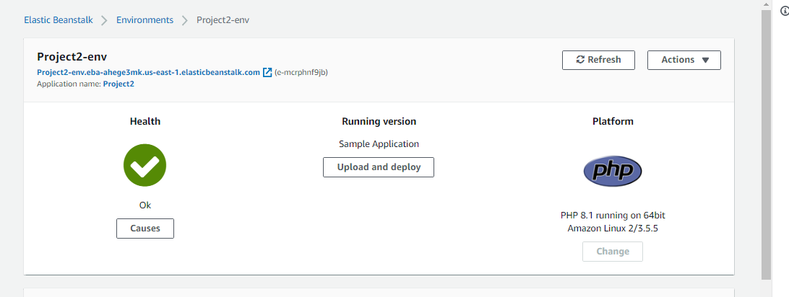

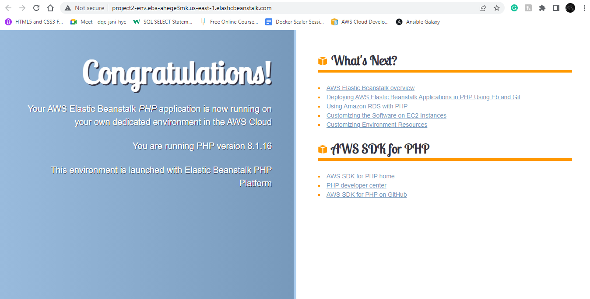

* We can see a sample application has been deployed now we upload the file

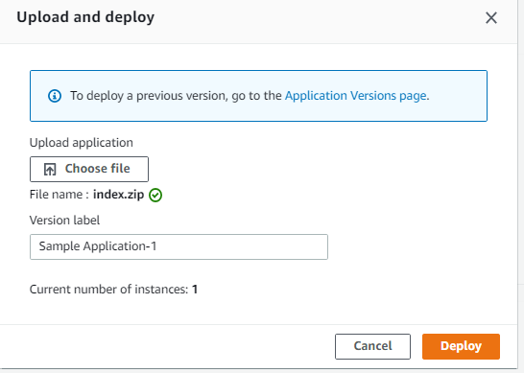

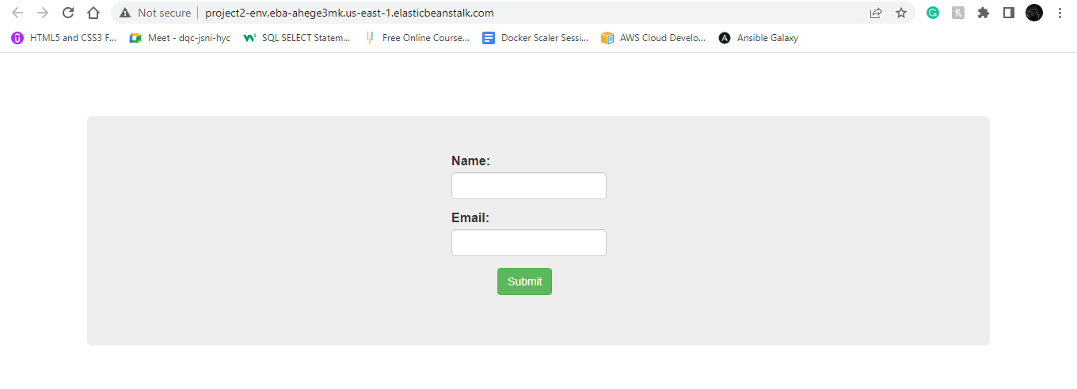

* Therby we have deployed the application using EBS