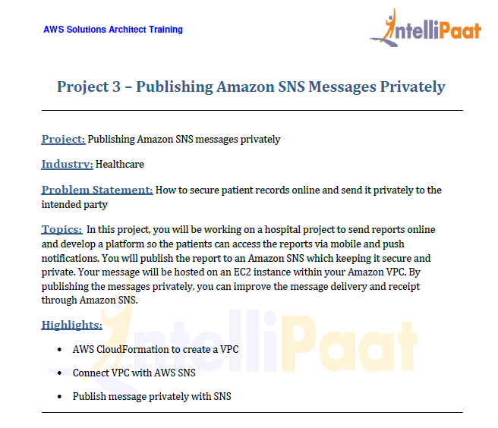

* In order to send the message to the client privately, the hosted EC2 instance need to internet free
* And the message need to sent using VPC endpoint.
* First we upload the Cloud formation template to S3.

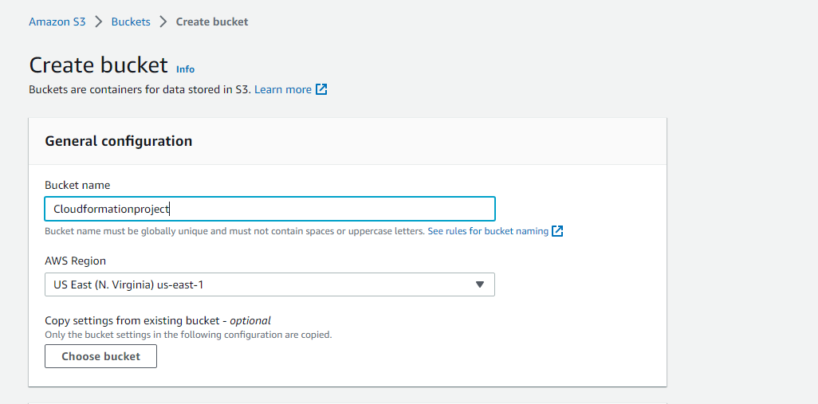

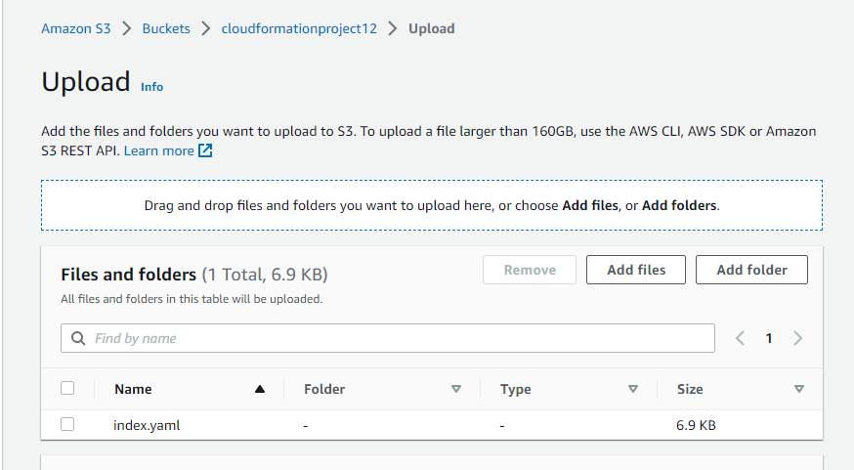

* Now copy the URL of the object and paste in the cloudformation

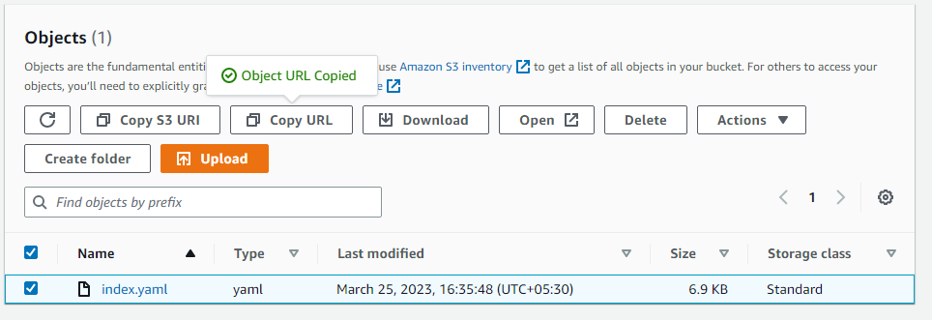

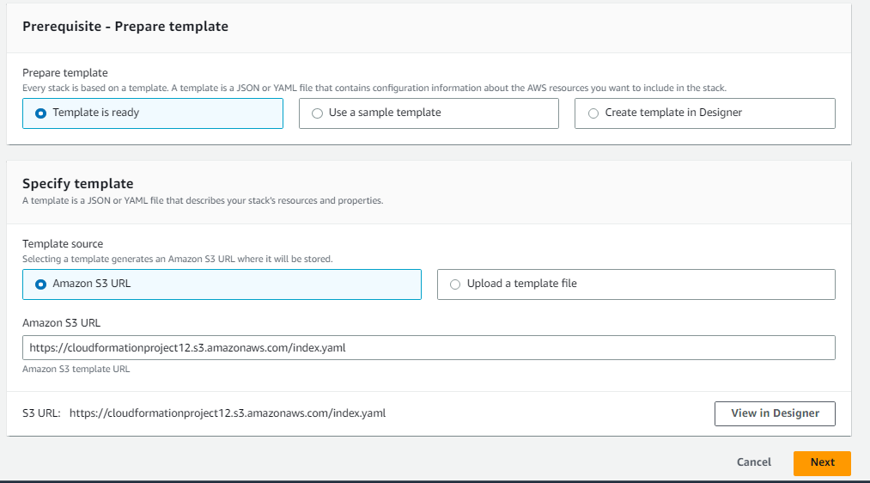

* Give the stack details

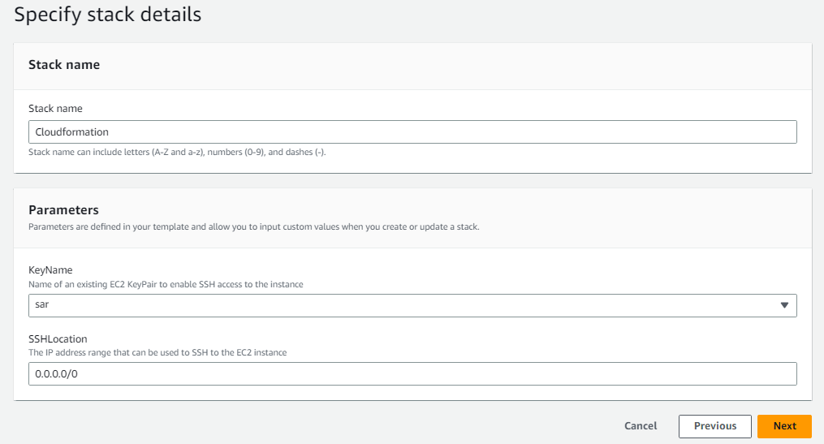

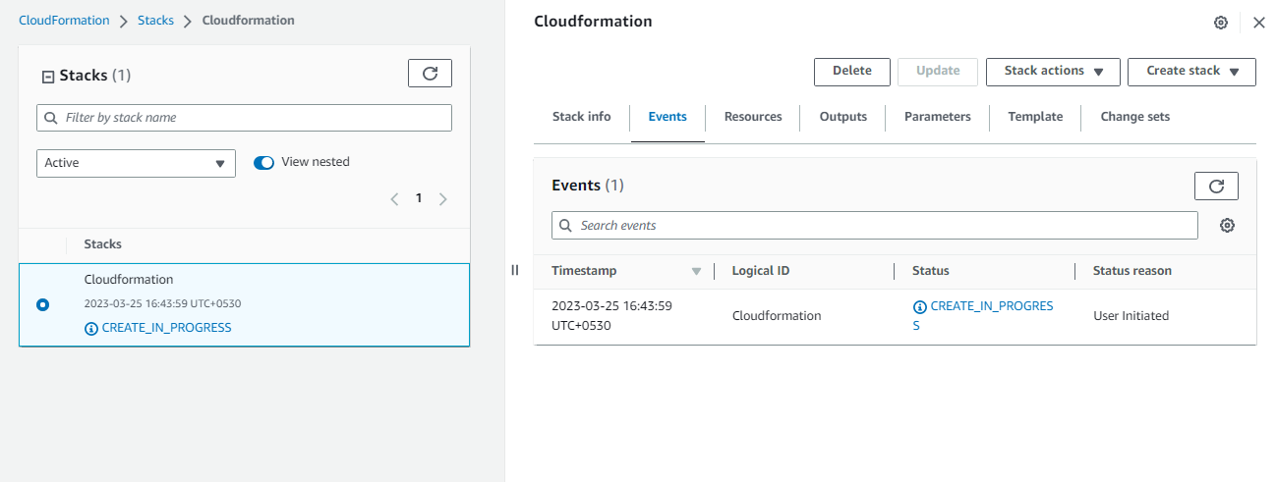

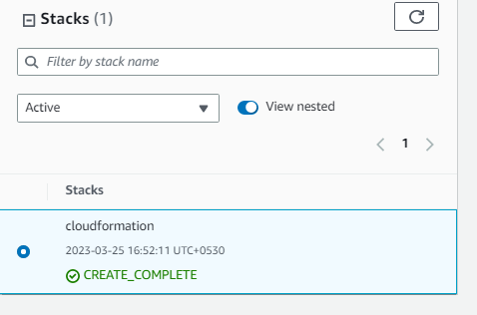

* As it is a private instance we cannot establish a public connection
* In order to communicate with SNS we need to create a VPC endpoint

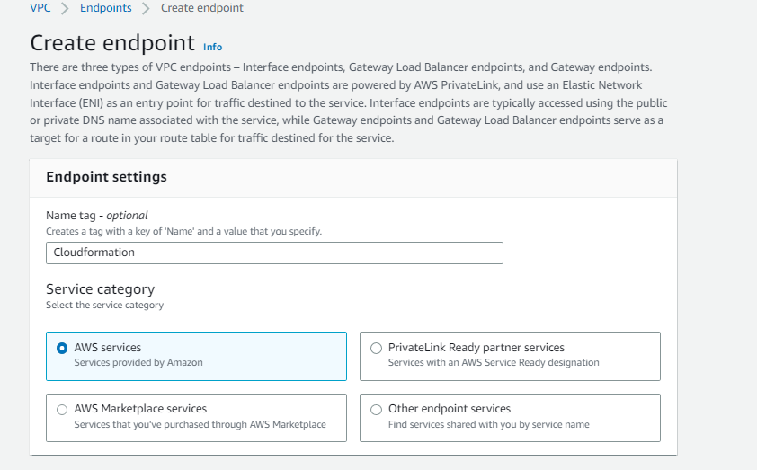

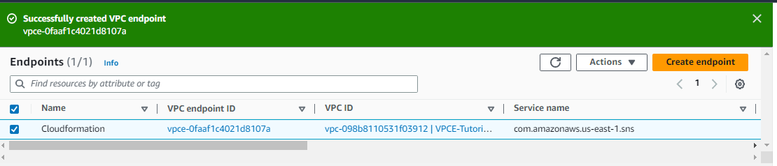

* Connect to the instance
* And now let us send a message
* “aws sns publish --region us-east-1 --topic-arn arn:aws:sns:us-east-1:613762707631:VPCE-Tutorial-Topic --message "Hello" ”

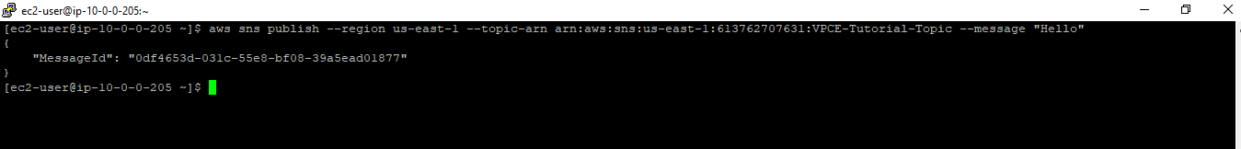

* The topic created can be associated with queue and email services