**ABSTRACT**

Fake news has emerged as a major issue today. Fake news has the potential to change people's opinions and facts, and it is the most dangerous weapon for influencing society. Everyone relies on various online news sources in our modern era, where the internet is ubiquitous. With the increased use of social media platforms such as Facebook, Twitter, and others, news spreads quickly among millions of users in a noticeably short period. The spread of fake news has far-reaching consequences, such as the formation of biased opinions to sway election outcomes in favour of certain candidates.

Moreover, spammers use appealing news headlines to generate revenue using advertisements via click-bait. In this project, we aim to perform binary classification of various news articles available online using Artificial Intelligence, Natural Language Processing, and Machine Learning concepts. We hope to give users the ability to classify news as fake or real, as well as check the legitimacy of the website that is publishing the news. It is impossible to accurately determine whether a piece of news is true or false. As a result, the proposed project employs datasets trained using the count vectorizer method for the detection of fake news, and its accuracy will be evaluated using machine learning algorithms.

**1.INTRODUCTION**

* 1. **GENERAL**

As more of our lives are spent interacting online through social media platforms, an increasing number of people seek out and consume news from social media rather than traditional news organisations. The reasons for this shift in consumption habits are inherent in those social media platforms: I consume news on social media more frequently than traditional journalism, such as newspapers or television; and (ii) it is easier to share, discuss, and discuss the news with friends or other readers on social media. It was also discovered that social media now outperforms television as the primary news source. Despite the benefits of social media, the quality of stories on social media is lower than that of traditional news organisations. However, because it is cheap to supply news online and far faster and easier to spread through social media, large volumes of fake news, i.e., news articles with intentionally false information, are produced online for a variety of reasons, including financial and political gain. The widespread dissemination of fake news can have serious consequences for individuals and society. For starters, fake news can disrupt the news ecosystem's authenticity equilibrium; for example, during the 2016 U.S. presidential election, the most popular fake news was even more widely shared on Facebook than the most widely accepted genuine mainstream news. Second, fake news purposefully leads consumers to accept biases or false beliefs. Propagandists typically manipulate fake news to convey political messages or influence. For example, some reports indicate that Russia has created fake accounts and social bots to spread false stories. Third, fake news alters how people interpret and respond to real news. For example, some fake news is simply created to instil distrust and confusion in people, making it difficult for them to distinguish what is true from what is not. to help mitigate the negative effects of fake news (both for the public and the news ecosystem). It is critical that we develop methods for automatically detecting fake news on social media.

A. Characteristics of Fake News:

They frequently make grammatical errors. They are frequently emotionally coloured. They frequently attempt to sway readers' opinions on various topics. Their information is not always accurate. They frequently use attention-grabbing words, news formats, and click-bait. They appear to be too good to be true. Most of the time, their sources are not reliable.

* 1. **MACHINE LEARNING**

Machine learning (ML) is the scientific study of algorithms and statistical models used by computer systems to perform a specific task without explicit instructions, instead relying on patterns and inference. It is thought to be a subset of artificial intelligence. Machine Learning algorithms create a mathematical model based on sample data training, without being explicitly programmed to make predictions or decisions carry out the task. Machine learning and computational statistics are closely related which focuses on using computers to make predictions. Mathematical optimization research provides methods, theory, and application domains to the field of machine learning. "With respect to some class of tasks T and performance measure P, a computer programme is said to learn from experience E if its performance at tasks in T, as measured by P, improves with experience E." This is how Alan Turing defined machine learning.

Deep learning is a type of machine learning algorithm that employs a hierarchical layer of artificial neural networks to carry out the machine learning process. Artificial neural networks are built in the same way that the human brain is, with neuron nodes linked together like a web. While traditional programmes construct data analysis in a linear fashion, the hierarchical function of deep learning systems allows machines to process data in a nonlinear fashion.

The term "deep learning" refers to how many levels of transformation the data goes through. Deep learning systems specifically have a significant credit assignment path (CAP) depth. The series of transformations leading from input to output makes up the CAP. CAPs describe the relationships between input and output that might be causative. The depth of the CAPs for a feedforward neural network is equal to the network's depth and is equal to the number of hidden layers plus one (as the output layer is also parameterized). The CAP depth is conceivably limitless for recurrent neural networks, where a signal may pass through a layer more than once.

In fields like computer vision, speech recognition, natural language processing, audio recognition, social network filtering, machine translation, bioinformatics, drug design, medical image analysis, material inspection, and board game programming, deep learning architectures like deep neural networks, deep belief networks, recurrent neural networks, and convolutional neural networks have produced results like and, in some cases, superior to traditional methods.

* 1. **NATURAL LANGUAGE PROCESSING**

A branch of computer science and artificial intelligence called natural language processing, or NLP, is interested in how computers interact with human (natural) languages, especially how to programme computers to efficiently process lots of natural language data. The study of how computers interact with human (natural) languages is known as natural language processing (NLP), and it is a subfield of linguistics, computer science, information engineering, and artificial intelligence. Its focus is on how to programme computers to process and analyse large amounts of natural language data.

* + 1. **STAGES IN NLP**
       1. LEXICAL ANALYSIS

In lexical analysis, words are identified, and their structures examined. A language's vocabulary is comprised of the entire corpus of words and expressions. By lexical analysis, the entire body of text is broken down into paragraphs, phrases, and words.

* + - 1. SYNTACTIC ANALYSIS

In syntactic analysis, words in the sentence are examined for grammar and arranged in a way that demonstrates how they relate to one another. The English syntactic analyser rejects sentences like "The school travels to boy."

* + - 1. SEMANTIC ANALYSIS

Semantic analysis extracts the text's precise meaning or dictionary definition. The text is examined for relevance. It is accomplished by translating the task domain's objects to syntactic structures. Sentences like "heated ice-cream" are disregarded by the semantic analyser.

* 1. **MOTIVATION OF WORK**

The growth of fake news during the 2016 U.S. Presidential Election brought to light both the risks associated with false news' consequences and the difficulties associated with trying to distinguish between fake and legitimate news. Even though the phrase "fake news" may be new, the phenomenon is not. In theory, fake news has existed at least since partisan, one-sided publications became prevalent in the 19th century. But today's fake news is being distributed more widely than ever thanks to technological advancements and the use of various media outlets. As a result, the consequences of fake news have multiplied recently, and something needs to be done to stop this from happening in the future.

There are two ways that algorithms might try to outperform humans in tackling the fake news problem. The first is that machines are more adept than people at spotting and tracking statistics. For instance, a machine may more easily recognise that the most often used verbs are "suggests" and "implies" as opposed to "says" and "proves." Furthermore, machines might be more effective in searching through a knowledge base to identify all pertinent articles and provide answers based on those numerous sources. Either of these approaches might be effective at identifying fake news, but we chose to concentrate on how supervised learning, which only extracts features from the language and content of the source in question and does not use a fact-checker or knowledge base, can help a computer solve the fake news problem. A "fake" article published by a reliable author through a reliable source would not be detected by several fake news detection systems. This strategy would counteract the "false negative" labelling of incorrect information. In essence, without internet access or outside understanding of the issue, the work would be like what a human would encounter while reading a physical copy of a newspaper article (versus reading something online where he can simply look up relevant sources). Like the person in the coffee shop, the machine will only have access to the words in the article and will need to employ methods that do not rely on author and source blacklists. A "blacklist" of authors and sources who are known to produce fake news serves as the foundation for many of the automated solutions now being used to address this issue. But what if the creator is anonymous or if false information is disseminated via a generally trustworthy source? In these situations, determining whether a news piece is fake requires relying solely on its content. It should be able to categorise phoney news articles with some degree of accuracy by gathering examples of both true and fake news and training a model. Using machine learning algorithms, including but not limited to convolutional neural networks and recurrent neural networks, this study seeks to determine the efficacy and limitations of language-based strategies for fake news detection. By examining patterns in the text and being oblivious to outside knowledge about the outside world, the project's outcome should be able to estimate how much can be accomplished in this endeavour.

* 1. **PROBLEM STATEMENT**

Consuming news has both benefits and drawbacks. On the one hand, consumers seek for and consume news because it is inexpensive, simple to use, and quickly disseminated. It makes it possible for "fake news," or low-quality news containing blatantly erroneous facts, to proliferate widely. The widespread dissemination of fake news has the potential to have very detrimental effects on people and society. As a result, the detection of fake news has recently been a rapidly developing field of study. First, it is challenging and nontrivial to identify fake news based solely on the content because it is purposefully designed to encourage readers to believe incorrect information.

Utilizing machine learning methods, a system for detecting fake news will be created using natural language processing. In a specific situation, the algorithm must be able to identify fake news.

**2. LITERATURE REVIEW**

Significant research on the automatic classification of true and false news has fallen into two categories:

In the first category, conceptual techniques are used to distinguish between three sorts of fake news: serious lies (which includes news about inaccurate and untrue events or information like famous rumours), tricks (such as giving false information), and jokes (e.g., funny news, which is an imitation of real news but contains bizarre content).

The real and fake contents of the second category are compared on a practical level using linguistic approaches and reality consideration procedures. Linguistic techniques look for text characteristics such as writing styles and topics that can be used to identify fake news. The primary tenet of this technique is that while linguistic activities like the use of marks, word choice, and labelling of lecture segments are generally inadvertent, the author is not particularly concerned with them. Therefore, linguistic tools can reveal hopeful outcomes in the detection of fake news with the proper intuition and evaluation.

In their research, Mykhailo Granik provided a straightforward method for identifying false news using a naive Bayes classifier. This strategy was put into practise as a software system and evaluated using a set of Facebook news postings as the test set. They were gathered from three sizable left-leaning and right-leaning Facebook pages as well as three sizable mainstream political news pages (Politico, CNN, and ABC News). They succeeded in classifying objects with an accuracy of about 74%. Fake news classification accuracy is marginally worse. The dataset's skewness—only 4.9% of it contains bogus news—could be to blame for this.

Based on a sample of comparison news (The Onion and The Beaverton) and real news (The Toronto Star and The New York Times) in the four categories of civic, science, trade, and everyday news, Rubin investigated the differences between the contents of actual and comic news using multilingual features. With a collection of features including unrelated, marking, and grammar, she was able to identify fake news the most.

Shloka Gilda provided a notion of how NLP can be used to identify false information. They have employed probabilistic context-free grammar (PCFG) detection and temporal period frequency-inverse record frequency (TFIDF) of bi-grams. To determine the best model, they looked at their dataset using multiple classes of techniques. They discover that the TFIDF of bi-gram’s fed into a stochastic gradient descent model correctly detects untrustworthy sources with a 77% accuracy rate.

A technique for automated fake news identification on Twitter was developed by Cody Buntain. They used this technique on tweets that were taken from Buzzfeed's fake news dataset. Additionally, using non-professional, crowdsourced individuals rather than journalists offer a valuable and significantly less expensive alternative to quickly classifying legitimate and fraudulent tweets.

In a paper, Marco L. Della explained how social networks and machine learning (ML) techniques could be applied to the detection of fake news. They created a ground-breaking machine learning (ML) fake news detection technique, implemented it in a Facebook Messenger chatbot, and validated it with a real-world application, achieving an accuracy of 81% in the detection of false information.

**2.1 RELATED WORK**

At least in the context of spam detection, which employs statistical machine learning techniques to categorise text (such as tweets or emails) as spam or valid, the problem of identifying unreliable sources of information through content-based analysis is thought to be solvable. These methods include text pre-processing, feature extraction (i.e., bag of words), and feature selection based on which features produce the best results on a test dataset.

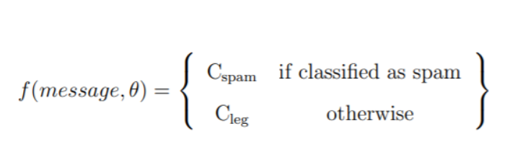

Once these features have been gathered, they can be categorised using classifiers such as Nave Bayes, Perceptron, TF-IDF, or SGD classifier. In order to learn the function where m is the message to be classified and is a vector of parameters, and Cspam and Cleg are, respectively, spam and lawful messages, these classifiers all share the characteristics of supervised machine learning. The task of identifying fake news is comparable to and almost analogous to the task of identifying spam in that both seek to distinguish between instances of legitimate text and instances of illegitimate, malicious text.

**3.PROPOSED APPROACH**

**3.1 PROPOSED SYSTEM**

The new articles are classified as true or fake by the current data supplied by the suggested system when applied to a scenario of a series of news items. The system uses the connections between articles to make this prediction. The suggested system includes a Count Vectorizer for determining the relationship between words, and using the knowledge of the pre-existing relationships, the new articles are separated into bogus and authentic news.

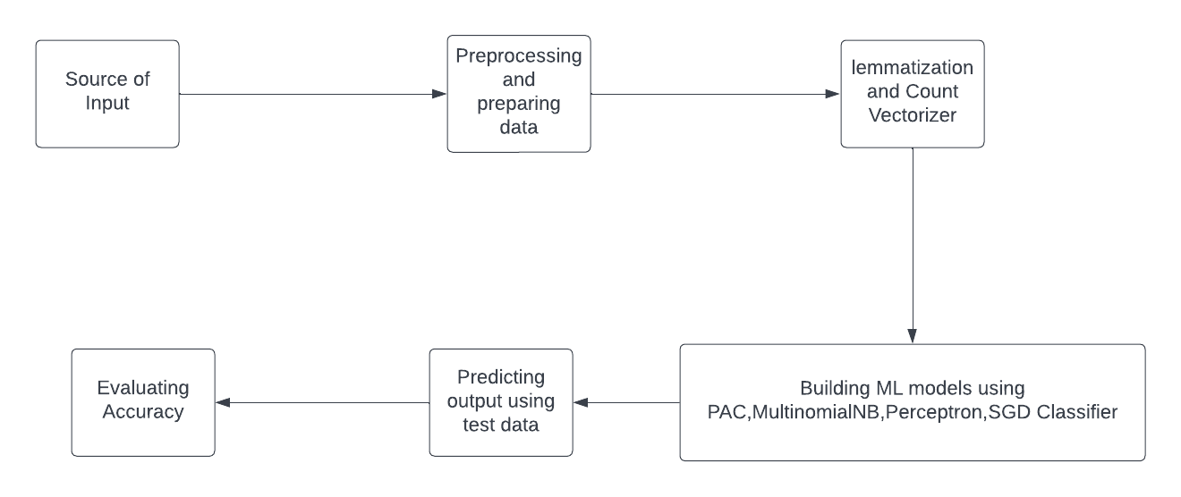

Datasets contain input gathered from a variety of sources, including newspapers and social media. The computer will use datasets as input. Pre-processing involves stripping out extraneous material from datasets and, if necessary, changing the data types of the columns. The previous step uses a Jupyter notebook and Python libraries. The first stage involves the usage of a count vectorizer. We need to train the machine using data in order to recognise fake news. Before beginning the fake news identification process, the complete dataset is split into two datasets. The ratio is 80/20, with 20 percent going toward testing. Four different Machine Learning approaches are used. Testing involves predicting the outcome after receiving the test dataset as input. Following the testing period, the confusion matrix is used to compare the expected and actual outputs. The confusion matrix provides data on the proportion of accurate and incorrect predictions for both legitimate and false news. The formula No. of Correct Predictions/Total Test Dataset Input Size is used to determine accuracy.

**3.3 ALGORITHM FOR PROPOSED SYSTEM**

1. Input is collected from various data sources and compiled into true and fake news datasets respectively.
2. Dataset is cleaned and prepared i.e., lemmatised.
3. Dataset is split into subsequent chunks to reduce the RAM usage.
4. Each dataset is divided into training and testing data.
5. Count Vectorizer technique is used to convert the training data into numerical so that we can obtain some relationship.
6. The system trains the training data with Passive Aggressive Classifier, Multinomial Naïve Bayes, SGD classifier, Perceptron Machine Learning models.
7. The accuracy for each model is evaluated and compared.

**4. DATASETS**

**4.1 EXISTING DATASETS FOR THIS SYSTEM.**

For the development of computationally demanding, text-based models that address a wide range of topics, the lack of manually labelled fake news datasets is undoubtedly a constraint. Because the dataset for the fake news challenge only includes associations between texts and not whether the texts themselves are true or false assertions, it is not appropriate for our purposes. We require a series of news stories that are categorically categorised for our purposes (i.e., real vs. fake, or real vs. parody, vs. clickbait, vs. propaganda). There is a tonne of labelled data from many sources, such as Twitter, Amazon Reviews, and IMDb Reviews, for more basic and typical NLP classification tasks, such as sentiment analysis. Finding tagged items of bogus and legitimate news is, sadly, not as easy. This is a problem for academics and data scientists who wish to investigate the matter using supervised machine learning methods. I have investigated the datasets that can be used to classify sentences at the sentence level, as well as approaches to combining datasets to produce complete sets that include both positive and negative examples for document-level classification.

**4.2 PROPOSED DATASETS USED:**

For the categorization of fake news at the document level, there is no dataset of comparable quality to the Liar Dataset. I could have created a hybrid dataset of tagged false and real news pieces, or I could have used the headlines of papers as statements. This demonstrates an informal and exploratory study performed by integrating two datasets that each contain both positive and unfavourable examples of fake news. Genes builds a model using a particular subset of the Kaggle dataset as well as information from the NYT and the Guardian. The themes used for training and testing in his experiment are limited to U.S. news, politics, business, and world news. He neglects to consider the different date range between the two datasets, which undoubtedly introduces a further level of topic bias based on themes that are popular at times. The way we gathered the data was like Genes', but we were more cautious and tried to account for more sources and themes' bias. Source bias would be counterproductive to the purpose of our experiment, which was to identify linguistic patterns indicative of true or false news. The algorithm would be able to learn to correlate sources with real/fake news labels if we included any source bias in our dataset, such as patterns unique to NYT, The Guardian, or any other fake news website. Learning to identify certain linguistic idioms and grammatical patterns as fake or real news is more difficult than learning to identify sources as fake or real. In order to force our model to learn something more significant and generalizable, we made a great effort to exclude as many of the 15 source-specific patterns as we could. We acknowledge that the Kaggle dataset, which is based on a list of suspicious websites, likely contains examples of true news and that there are undoubtedly cases of fake news in the New York Times. We anticipate that the model will learn from most articles that are consistent with the source label because these occurrences are the exception rather than the rule. Furthermore, rather than trying to train a model to learn facts, we are trying to train it to learn deliveries. To be more specific, even if false news items published by the New York Times contain fictitious information, they should still exhibit delivery and reporting mechanisms that are more typically seen in real news.

**5. DEFINITION AND DETAILS**

**5.1 PREPROCESSING**

Most social media data is casual conversation with typos, slang, and poor grammar, among other things. As a result, it has become essential to establish methods for resource use to make informed judgments because of the quest for improved performance and reliability. Before using the data for predictive modelling, the data must be cleaned to produce better insights. Basic pre-processing was applied to the news training data for this reason. Data pre-processing is the stage of any machine learning process when the data is modified or encoded to make it easier for the computer to parse. In other words, the algorithm can now quickly interpret the data's features. Pre-processing is a crucial step in this fake news identification process. First, as the data dataset is compiled from numerous sources, it is required to remove any extraneous information, convert it to lower case, eliminate punctuation, symbols, and stop words. This step was comprised of-

* Data cleansing: During data reading, we get data in both organized and unorganized formats. When compared to unstructured material, a structured format has a clear pattern while the latter lacks one. A semi-structured format, which is comparable to a better structured format than an unstructured format, sits between the two structures.
* To emphasize qualities that we want our machine learning system to notice, the text data must be cleaned. Usually, there are several procedures involved in cleaning (or pre-processing) the data.
* Text normalization is the process of converting a piece of text into a single canonical form. Before storing or processing text, normalizing it enables the system to separate the necessary data from the rest, allowing it to deliver consistent data as an input to the other steps of the algorithm.
* Stop Word: A Stop Words, like "a, an, the, for, is, was, which, are, were, from, do, with, and, so, very, that, this, no, yourselves, etc.," are frequently employed in natural languages. These Stop Words will occur frequently, so they should be removed from the calculation of word frequency to give other essential factors precedence. Stop word removal is one such pre-processing step that eliminates these stop words, assisting with subsequent processes and speeding up processing time due to the drastic reduction in document size.

Think about a sentence.

"This is a sample sentence demonstrating the elimination of the stop word."

["sample", "sentence", "showing", "stop", "word", "removal"] is the output after the stop word is removed. Although stop words are the most frequently used terms in each language, different tools employ different stop words, so there is no single universal list of stop words.

* STEMMING: A pre-processing step in text mining applications that is a common prerequisite for Natural Language Processing (NLP) operations. In fact, it plays a crucial role in the majority of information retrieval systems. The basic goal of stemming is to reduce a word's grammatical forms, such as nouns, adjectives, verbs, and adverbs, to its root form. Stemming aims to condense a word's inflectional forms and occasionally derivatively related forms to a basic form that is used frequently. For instance, an English stemmer should recognize the strings "cats," "catlike," and "catty" as deriving from the root "cat."

RULES OF SUFFIX STRIPPING STEMMERS

1. still, remove the' ed', If the word ends in' ed'.

2. still, remove the' ing', If the word ends in' ing'.

3. still, remove the' ly', If the word ends in' ly'.

5.2.3.2 RULES OF SUFFIX SUBSTITUTION STEMMERS

1. If the word ends in ‘ies’ cover ‘ies’ with ‘y ’.

Generally, this stemmer is used because of some words like families, etc.

* Count Vectorizer performs very basic pre-processing, such as removing punctuation, changing all the words to lowercase, etc., along with tokenizing (tokenization implies breaking down a sentence, paragraph, or any text into words). A lexicon of recognized words develops and is later utilized to encode unread text. The full vocabulary's length and an integer count of how many times each word appears in the text are both included in an encoded vector that is returned.

Input to count vectorizer:

Document having 3 sentences  
Sam Sam is super happy  
Sam Sam is very sad  
Sam Sam is scary angry

|  |  |  |  |  |  |  |  |  |
| --- | --- | --- | --- | --- | --- | --- | --- | --- |
|  | angry | happy | is | sad | Sam | scary | super | very |
| 0 | 0 | 1 | 1 | 0 | 2 | 0 | 1 | 0 |
| 1 | 0 | 0 | 1 | 1 | 2 | 0 | 0 | 1 |
| 2 | 1 | 0 | 1 | 0 | 2 | 1 | 0 | 0 |

* Vectorizing Data: For machine learning algorithms to interpret our data, we must vectorize it, which is the act of encoding text as integers, or numeric form.

Data Vectorization: TF-IDF

It calculates a word's "relative frequency" based on how frequently it appears in various documents. The relative weight of a term in the text and throughout the corpus is represented by the TF-IDF. The term frequency is referred to as TF. It determines the number of times a term appears in a document. A phrase might appear more frequently in a long text than in a short one because document sizes vary. As a result, term frequency is frequently divided by document length.

Note: Used for document clustering, text summarization, and search engine ranking.

𝑇𝐹(𝑡, 𝑑) = (𝑁𝑢𝑚𝑏𝑒𝑟 𝑜𝑓 𝑡𝑖𝑚𝑒𝑠 𝑡 𝑜𝑐𝑐𝑢𝑟𝑠 𝑖𝑛 𝑑𝑜𝑐𝑢𝑚𝑒𝑛𝑡 ′𝑑′) /(𝑇𝑜𝑡𝑎𝑙 𝑤𝑜𝑟𝑑 𝑐𝑜𝑢𝑛𝑡 𝑜𝑓 𝑑𝑜𝑐𝑢𝑚𝑒𝑛𝑡 ′𝑑′)

IDF stands for Inverse Document Frequency, which states that a word is not very useful if it appears in every document. In a paper, certain words like "a," "an," "the," "on," "of," etc. repeatedly appear yet have little meaning. IDF increases the relevance of uncommon terms while decreasing the importance of common terms. The word's uniqueness increases with IDF value.

𝐼𝐷𝐹 (𝑡, 𝑑) = (𝑇𝑜𝑡𝑎𝑙 𝑛𝑢𝑚𝑏𝑒𝑟 𝑜𝑓 𝑑𝑜𝑐𝑢𝑚𝑒𝑛𝑡𝑠)/ (𝑁𝑢𝑚𝑏𝑒𝑟 𝑜𝑓 𝑑𝑜𝑐𝑢𝑚𝑒𝑛𝑡𝑠 𝑤𝑖𝑡ℎ 𝑡𝑒𝑟𝑚 𝑡 𝑖𝑛 𝑖t)

The relative count of each word in the sentences is recorded in the document matrix after TF-IDF is applied to the body text.

𝑇𝐹𝐼𝐷𝐹(𝑡, 𝑑) = 𝑇𝐹(𝑡, 𝑑) ∗ 𝐼𝐷𝐹(𝑡)

**5.2 BRIEF INTRODUCTION TO THE ALGORITHMS**

1. Naïve Bayes Classifier: This method of classification is based on the Bayes theorem, which holds that the presence of one characteristic in a class does not depend on the presence of any other features. It gives instructions on how to calculate the posterior probability.

𝑃(c/𝑥) = 𝑃(𝑐) ∗ 𝑃 (𝑥 /𝑐)/𝑃(𝑥)

P(c|x) = posterior probability of class given predictor

P(c)= prior probability of class

P(x|c) = likelihood (probability of predictor given class)

P(x) = prior probability of predictor

1. Passive Aggressive Classifier: For large-scale learning, passive-aggressive algorithms are typically used. It belongs to the small group of "online-learning algorithms." Unlike batch learning, which uses the full training dataset at once, online machine learning algorithms update the machine learning model step-by-step as the input data is received in sequential order. This is especially helpful in scenarios when the amount of data is so large that training the full dataset would be computationally impossible. In a nutshell, an online learning algorithm will acquire a training example, update the classifier, and then discard the example.
2. SGD Classifier: Some users could believe that SGD is a classifier based solely on the name Stochastic Gradient Descent - Classifier (SGD-Classifier). Not the case, though! The SGD Classifier is a linear classifier (SVM, logistic regression, etc.) that has been enhanced by the SGD. Using a single sample, stochastic gradient descent (SGD) calculates the gradient. Finally, mini-batch gradient descent combines the best of both worlds by updating for each mini-batch of n training instances.

where α>0 is a non-negative hyperparameter that regulates the regularization strength and L is a loss function that assesses model (mis)fit and R is a regularization term (also known as a penalty) that penalizes model complexity.

1. PERCEPTRON: The perceptron is a technique for supervised learning of binary classifiers in machine learning. Using a vector of integers as input, a binary classifier is a function that can determine whether the input belongs to a particular class. [1] It is a particular kind of linear classifier, or an algorithm for classifying data that bases its predictions on a linear predictor function that combines a set of weights with the feature vector.

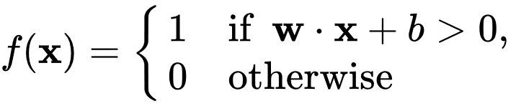

where {\displaystyle \mathbf {w} }**w** is a vector of real-valued weights, {\displaystyle \mathbf {w} \cdot \mathbf {x} }**w.x** is the dot product ∑wixi  {\displaystyle \sum _{i=1}^{m}w_{i}x_{i}}, where *m* is the number of inputs to the perceptron, and *b* is the *bias*. The bias shifts the decision boundary away from the origin and does not depend on any input value.

**5.3 EVALUATION MEASURES**

Every time we create a machine learning model, we require a metric to assess the model's efficacy. Though the term "goodness" of a model can be interpreted in a variety of ways, in a machine learning environment, we typically refer to a model's performance on new instances that weren't included in the training data.

Confusion Matrix: A classification model's (or "classifier's") performance on a set of test data for which the true values are known is frequently described using a confusion matrix, a table. It makes it possible to see how well an algorithm is performing. The expected outcomes for a classification task are summarized in a confusion matrix. With count values, the number of accurate and inaccurate predictions is tallied and separated by each class. The confusion matrix's secret lies in this. The confusion matrix demonstrates the various ways in which your classification model generates incorrect predictions. It provides information on both the kinds of errors a classifier makes and, more crucially, the kinds of errors that are being made.

True Positive (TP): when predicted fake news pieces are classified as fake news.

True Negative (TN): when predicted true news pieces are classified as true news.

False Negative (FN): when predicted true news pieces are classified as fake news.

False Positive (FP): when predicted fake news pieces are classified as true news.

|  |  |  |
| --- | --- | --- |
| Total | Class1(predicted) | Class2(predicted) |
| Class1(Actual) | TP | FN |
| Class2(Actual) | FP | TN |

ACCURACY: Every time the accuracy metric is used, our goal is to determine how closely a measured value resembles a known value. Therefore, it is frequently employed when the output variable is discrete or categorical. Specifically, a classification task

Accuracy = |𝑇 𝑃|+|𝑇 𝑁|

|𝑇 𝑃|+|𝑇𝑁|+|𝐹 𝑃|+|𝐹 𝑁|

RECALL: The number of positive labels that the model correctly classified as positive is known as recall, and it evaluates how effectively the model can remember the positive class.

Recall = |𝑇 𝑃|

|𝑇 𝑃|+|𝐹 𝑁|

PRECISION: When the accuracy of the model's predictions is an issue, we would utilize Precision. The precision metric would tell us how many positive labels are assigned in relation to the instances that the classifier assigned a positive label to.

Precision = |𝑇 𝑃|

|𝑇 𝑃|+|𝐹 𝑃|

**5.4 SNAPSHOTS OF SYSTEM WORKING**



(i)Home screen



(ii) Training and Predicting output

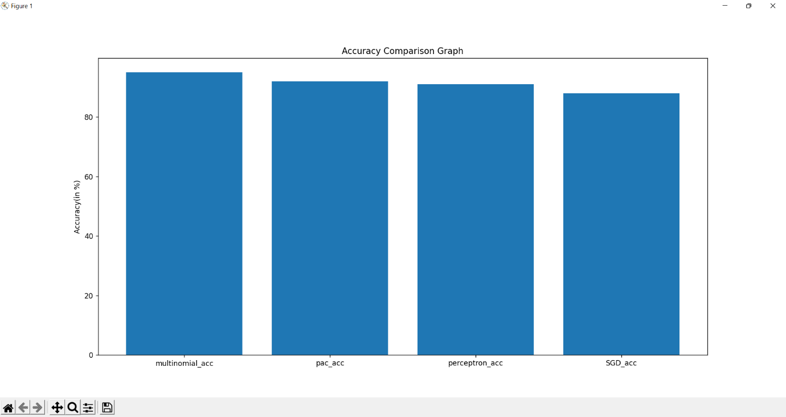

(iii) Accuracy comparison graph



(iv) Accuracies of Different Models

**6. RESULTS**

The algorithms with vector features—Count Vectors at Word Level—were used for implementation. All models were found to be accurate. To increase the models' efficacy, we applied the K-fold cross validation technique.

**Classification reports for each Algorithm:**

1. Multinomial Naïve Bayes -

precision recall f1-score support

0 0.93 0.95 0.94 40

1 0.97 0.95 0.96 60

accuracy 0.95 100

macro avg 0.95 0.95 0.95 100

weighted avg 0.95 0.95 0.95 100

1. Passive Aggressive Classifier –

precision recall f1-score support

0 0.85 0.97 0.91 40

1 0.98 0.88 0.93 60

accuracy 0.92 100

macro avg 0.91 0.93 0.92 100

weighted avg 0.93 0.92 0.92 100

1. Perceptron –

precision recall f1-score support

0 0.82 1.00 0.90 40

1 1.00 0.85 0.92 60

accuracy 0.91 100

macro avg 0.91 0.93 0.91 100

weighted avg 0.93 0.91 0.91 100

1. SGD Classifier –

precision recall f1-score support

0 0.78 0.97 0.87 40

1 0.98 0.82 0.89 60

accuracy 0.88 100

macro avg 0.88 0.93 0.88 100

weighted avg 0.90 0.91 0.88 100

**7. CONCLUSION AND FUTURE WORK**

**7.1 CONCLUSION**

Most tasks are completed online in the twenty-first century. Applications like Facebook, Twitter, and online news stories are replacing newspapers, which were formerly favoured as tangible copies. The forwards on WhatsApp are another important source. Fake news, a problem that is only becoming worse, complicates matters and seeks to influence or sway people's attitudes toward using digital technologies. When a person is misled by the genuine news, one of two things may occur: First, they may begin to believe that their impressions of a certain subject are accurate.

In this project, we use the relationship between the words to determine whether a piece of writing is authentic or not. The accuracy for the proposed system is 95%

**7.2 FUTURE WORK**

* We intend to employ web scraping to independently collect data from numerous social media platforms and websites for usage in our system.
* Additionally, we wish to increase accuracy through query optimization.
* We want to create our own dataset that will be updated regularly with the most recent information. A database using a web crawler and an online database will be used to store all the most recent information and live news.

SOURCE CODE:

# Importing requirements

import pandas as pd

import numpy as np

import gc

import nltk

import re

import itertools

from sklearn.feature_extraction.text import TfidfVectorizer

from nltk.corpus import stopwords

from nltk.stem import WordNetLemmatizer

from sklearn.model_selection import train_test_split

from sklearn.naive_bayes import MultinomialNB

from sklearn.linear_model import PassiveAggressiveClassifier

from sklearn.linear_model import LogisticRegression

from sklearn.metrics import accuracy_score,classification_report,confusion_matrix

import joblib

import warnings

warnings.filterwarnings('always')

# Dataset importing

True_news=pd.read_csv('True.csv')

Fake_news=pd.read_csv('Fake.csv')

l=[i for i in range(6000,21417)]

True_news.drop(index=l,inplace=True)

k=[i for i in range(3936,21417)]

Fake_news.drop(index=k,inplace=True)

True_news['label']=0

Fake_news['label']=1

dataset1=True_news[['text','label']]

dataset2=Fake_news[['text','label']]

print(dataset1)

print(dataset2)

df=pd.concat([dataset1,dataset2])

del True_news

del Fake_news

del dataset1,dataset2

gc.collect()

df=df.sample(frac=1,random_state=0)

#Preprocessing

ps=WordNetLemmatizer()

stop_words = stopwords.words('english')

nltk.download('wordnet')

dataset=df.iloc[:1000,:]

dt1=df.iloc[1000:2000,:]

dt2=df.iloc[2000:3000,:]

def cleaning_data(row):

row=row.lower()

row=re.sub('[^a-zA-Z]',' ',row)

tokens=row.split()

news = [ps.lemmatize(word) for word in tokens if not word in stop_words]

cleaned_news=' '.join(news)

return cleaned_news

dataset['text']=dataset['text'].apply(lambda x: cleaning_data(x))

dt1['text']=dt1['text'].apply(lambda x:cleaning_data(x))

dt2['text']=dt2['text'].apply(lambda x:cleaning_data(x))

vectorizer=TfidfVectorizer(max_features=50000,lowercase=False,ngram_range=(1,2))

#Data splitting

X=dataset.iloc[:,0]

y=dataset.iloc[:,1]

X1=dt1.iloc[:,0]

y1=dt1.iloc[:,1]

X2=dt2.iloc[:,0]

y2=dt2.iloc[:,1]

train_data,test_data,train_label,test_label=train_test_split(X,y,test_size=0.2,random_state=0)

train_data1,test_data1,train_label1,test_label1=train_test_split(X1,y1,test_size=0.2,random_state=0)

train_data2,test_data2,train_label2,test_label2=train_test_split(X2,y2,test_size=0.2,random_state=0)

vec_train_data=vectorizer.fit_transform(train_data)

vec_train_data1=vectorizer.fit_transform(train_data1)

vec_train_data2=vectorizer.fit_transform(train_data2)

vec_test_data=vectorizer.transform(test_data)

vec_test_data1=vectorizer.transform(test_data1)

vec_test_data2=vectorizer.transform(test_data2)

vec_train_data=vec_train_data.toarray()

vec_test_data=vec_test_data.toarray()

training_data=pd.DataFrame(vec_train_data,columns=vectorizer.get_feature_names())

testing_data=pd.DataFrame(vec_test_data,columns=vectorizer.get_feature_names())

vec_train_data1=vec_train_data1.toarray()

vec_test_data1=vec_test_data1.toarray()

training_data_1=pd.DataFrame(vec_train_data1,columns=vectorizer.get_feature_names())

testing_data_1=pd.DataFrame(vec_test_data1,columns=vectorizer.get_feature_names())

vec_train_data2=vec_train_data2.toarray()

vec_test_data2=vec_test_data2.toarray()

training_data_2=pd.DataFrame(vec_train_data2,columns=vectorizer.get_feature_names())

testing_data_2=pd.DataFrame(vec_test_data2,columns=vectorizer.get_feature_names())

#pac

pac=PassiveAggressiveClassifier(max_iter=50,random_state=0)

pac.fit(training_data,train_label)

pac.partial_fit(training_data_1,train_label1)

pac.partial_fit(training_data_2,train_label2)

y_pred=pac.predict(testing_data)

y_pred1=pac.predict(testing_data_1)

y_pred2=pac.predict(testing_data_2)

print(classification_report(test_label,y_pred))

print(classification_report(test_label1,y_pred1))

print(classification_report(test_label2,y_pred2))

#Multinomial Naive Bayes

clf=MultinomialNB()

clf.fit(training_data,train_label)

clf.partial_fit(training_data_1,train_label1)

clf.partial_fit(training_data_2,train_label2)

y_pred=clf.predict(testing_data)

y_pred1=clf.predict(testing_data_1)

y_pred2=clf.predict(testing_data_2)

print(classification_report(test_label,y_pred))

print(classification_report(test_label1,y_pred1))

print(classification_report(test_label2,y_pred2))

confusion_matrix(test_label,y_pred)

#perceptron

from sklearn.linear_model import Perceptron

model=Perceptron()

model.fit(training_data,train_label)

model.partial_fit(training_data_1,train_label1)

model.partial_fit(training_data_2,train_label2)

y_pred=model.predict(testing_data)

y_pred1=model.predict(testing_data_1)

y_pred2=model.predict(testing_data_2)

print(classification_report(test_label,y_pred))

print(classification_report(test_label1,y_pred1))

print(classification_report(test_label2,y_pred2))

del y_pred,y_pred1,y_pred2

gc.collect()

#Sgd

from sklearn.linear_model import SGDClassifier

sgd=SGDClassifier(random_state=0)

sgd.fit(training_data,train_label)

sgd.partial_fit(training_data_1,train_label1)

sgd.partial_fit(training_data_2,train_label2)

y_pred=sgd.predict(testing_data)

y_pred1=sgd.predict(testing_data_1)

y_pred2=sgd.predict(testing_data_2)

print(classification_report(test_label,y_pred))

print(classification_report(test_label1,y_pred1))

print(classification_report(test_label2,y_pred2))

del y_pred,y_pred1,y_pred2

gc.collect()