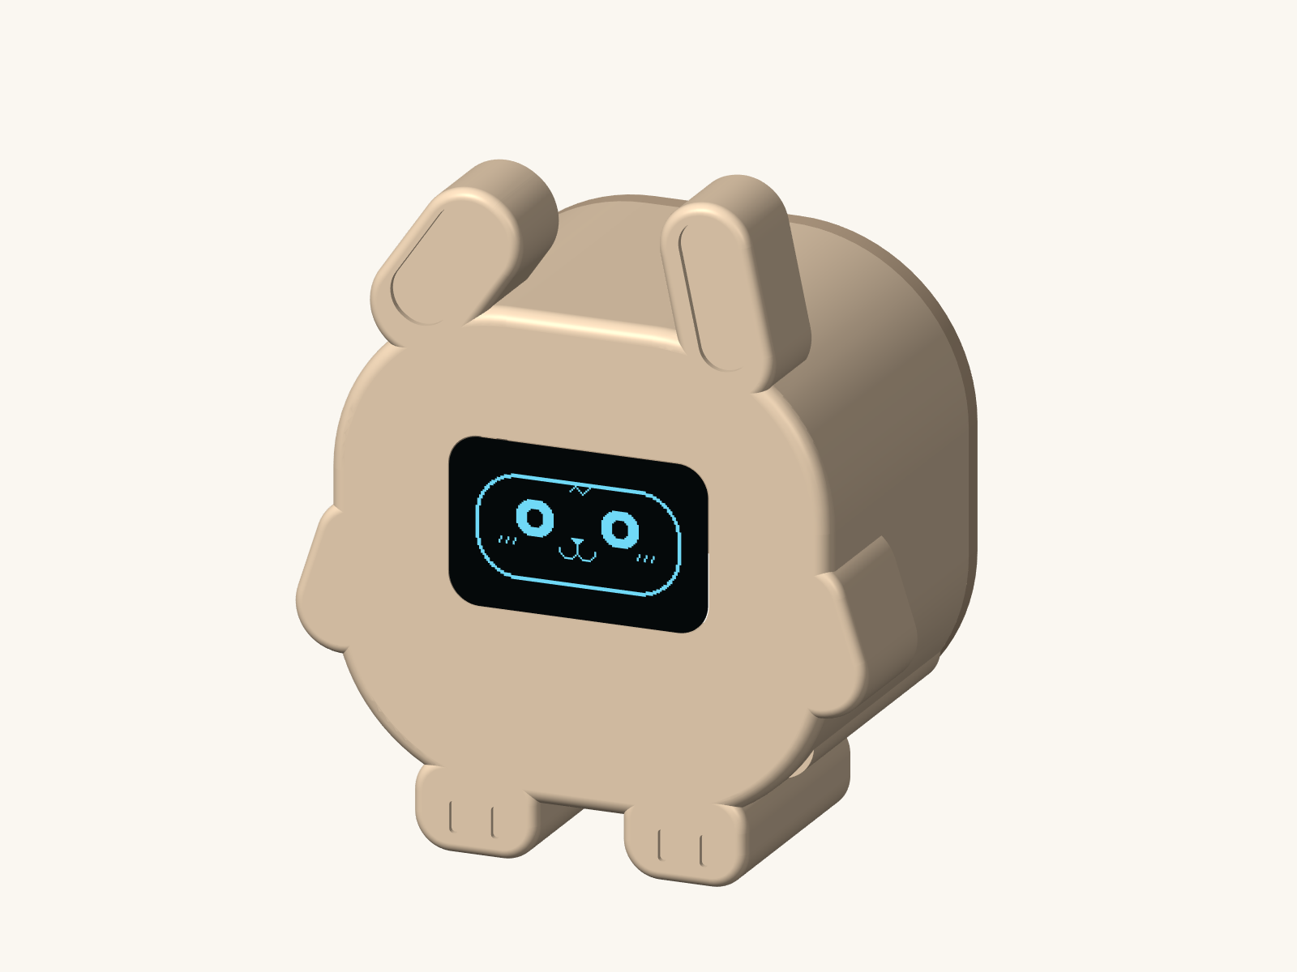

Piku desk robot
A tiny bunny desk friend  Shopping and build guide |  | About 55 mm wide and 64 mm tall  September 2026
Meet Piku, a sleepy little bunny with one tilted ear and tiny paws. Its OLED shows a whole face: eyes, nose, mouth and cheeks. Tap for a smile, double-tap for hearts, or hold a touch for a shy wink. Piku naps after a quiet minute.
This guide covers the shopping links, wiring, printing and assembly. You need three small boards, two printed parts and USB power. Piku stays still. The picture is a CAD preview; test the electronics on the table before assembly.

Buy these little parts
Buy one of each board below. The product names are clickable. Prices are the listings seen on 11 September 2026; confirm tax, delivery and stock at checkout.
Part to buy | Listed INR | Shopping link
ESP32 C3 SuperMini HW 466AB  USB C board with soldered headers | 274 | Buy the ESP32
0.96 inch OLED  SSD1306 128 by 64 with four I2C pins | 144 | Buy the OLED
TTP223 red touch module  15 by 11 mm PCB with three pins | 30 | Buy the touch sensor
The three boards total INR 448. The ESP32 listing had limited stock. If it is unavailable, look for the same ESP32 C3 SuperMini layout; a full-size ESP32 board will not fit this shell.

Also gather
A USB A to USB C data cable; a 10 cm female-to-female jumper set; a little thin hookup wire; two M2 by 6 mm self-tapping screws; thin double-sided tape; electrical tape; and two small non-slip pads for the feet.
Browse jumper wires | Browse USB cables
Reuse a known data cable and a normal 5 V USB charger if you have them. Budget about INR 1,000 to 1,500 with self-printed parts and delivery. Tools and outsourced printing cost extra.

Before ordering
The display must say 0.96 inch, SSD1306, 128 by 64 and four-pin I2C. The linked one has blue pixels; a white version works if its board fits. Avoid seven-pin SPI and 1.3 inch displays. Use the small red touch board; larger blue touch boards do not fit the crown recess.
Borrow a soldering iron, solder, cutters and a small screwdriver. Some modules arrive with loose headers. The shared power wires also need two small soldered joins; the finished build is not completely solder-free.

Wire it and print the shell
Unplug USB while wiring. Match the printed pin labels, not the order of pins in a photo. Both modules use the ESP32 board’s 3V3 output.
Module | Its pin | ESP32 connection
OLED | VCC or VDD | 3V3
OLED | GND | GND
OLED | SDA | GPIO4
OLED | SCL or SCK | GPIO5
Touch module | VCC | 3V3
Touch module | GND | GND
Touch module | OUT or I/O | GPIO3
Make one short Y-shaped lead from 3V3 to both VCC pins, and another from GND to both ground pins. Solder and insulate each join. Do not squeeze two jumper sockets onto one pin. Nothing connects to the ESP32 5V pin.

Print two parts
In the ZIP, open cad/piku_body.stl and cad/piku_back.stl in your slicer. Print one of each in PLA at 100% scale using millimetres. Use a 0.4 mm nozzle, 0.2 mm layers, three walls and 15% infill.
The files already lie flat: body face down with its open back upward; lid exterior down with its locating lip upward. Supports should not be needed in these orientations. The shell is about 55 mm wide, 34 mm deep and 64 mm tall, including ears and paws.
Use cream or pastel PLA. Paint the inner ear recesses pink if you like. The thin patch between the ears, toward the back of the crown, is the touch area; leave it unpainted.
Fit check: the OLED board is roughly 27 by 27 mm. Generic boards vary, so measure yours before printing and align the lit screen by hand. The shell deliberately uses tape instead of fixed PCB mounting holes. Its CAD and STL geometry were checked; physical fit has not been tested.

Bring Piku to life
1 Install Arduino IDE and the esp32 package by Espressif Systems in Boards Manager. If the package is missing, follow the linked installation instructions below.
2 Install Adafruit SSD1306 and Adafruit GFX Library in Library Manager, with their dependencies. Extract the ZIP and open firmware/Piku/Piku.ino. Keep piku_faces.h in that same folder.
3 Select ESP32C3 Dev Module, 4 MB flash, USB CDC On Boot Enabled, and the connected port. Upload with the data cable. If needed, hold BOOT, tap RESET, release BOOT, select the port again and upload.
Arduino IDE | ESP32 installation help | USB upload help

Put the boards inside
Test the face and touch sensor on the table first. Keep the touch board in active-high momentary mode: its output should be high only while touched, not latched on after a tap.
Unplug USB. Tape the OLED behind the opening, fixing its PCB edges without pressing on the glass. Place the ESP32 on insulating tape at the bottom, with USB facing the rear opening. Check cable access before securing it.
Attach the touch board’s sensing side snugly beneath the thin crown patch. Use thin tape at its edges and keep an air gap out of the sensing area. Keep loose wires away from it. Insulate exposed joints, tuck in short leads, and close the lid with the two screws. Tighten gently.
Plug in and leave the head untouched for two seconds. Tap for a smile; double-tap for hearts; hold for two seconds for a shy wink. Piku sleeps after 60 seconds and wakes with a surprised face. Piku-face-expressions.png shows all nine frames.

If something does not work
Blank screen: check 3V3, GND and pins 4 and 5; the sketch tries both 0x3C and 0x3D. Upside down: change setRotation(0) to setRotation(2). Touch stuck on: check momentary mode and move wires away. No USB port: try a data cable and the BOOT sequence.
The starter sketch is source-reviewed but has not been compiled or run on a physical board here. Start with the bench test before sealing the shell. Wi-Fi, an account and a battery are not needed.

