**FX RATES OUTBOUND EXTRACT FROM PEOPLESOFT**

**Abstract:** This document discusses the reusable PeopleCode solution to extract data from PeopleSoft currency table in a specified file format (.csv) and place it in a specified directory folder (for external application to pick it up) on a periodical basis.

**INFOSYS LIMITED**

**Bangalore**

|  |  |  |  |
| --- | --- | --- | --- |
| Document No. |  | Ver. Rev.: | **1.0** |
| Authored by: | |  | | --- | | **Saithalir V** | | Date: | **22-06-2022** |
| Reviewed by: | |  | | --- | | **Tapan Vakil** | | Date: |  |

**COPYRIGHT NOTICE**

©2021 Infosys Limited, Bangalore, India. All rights reserved. Infosys believes the information in this document is accurate as of its publication date; such information is subject to change without notice. Infosys acknowledges the proprietary rights of other companies to the trademarks, product names & such other intellectual property rights mentioned in this document. Except as expressly permitted, neither this document nor any part of it may be reproduced, stored in a retrieval system, or transmitted in any form or by any means, electronic, mechanical, printing, photocopying, recording or otherwise, without the prior permission of Infosys Limited and/or any named intellectual property rights holders under this document.

Infosys Limited

Hosur Road

Electronic City, 3rd Cross

Bangalore 560 100

India.

Telephone: (91) (80)28520 261-270

Fax: (91) (80) 8520 362

Website: <http://www.infosys.com>

**Table of Contents**

1. Problem Overview 3

2. Solution 3

**i.** **Code to get the file path to write the output file** 3

**ii.** **Code to extract FX Rates based on Specified FX Rates Type(s) and Maximum Effective Date Criteria** 4

**iii.** **Code to Generate Log File with Extracted Data Row Count** 4

3. Custom Objects: 4

4. Benefits 5

1. **Problem Overview:**

There was a business requirement to extract FX Rates from Peoplesoft FSCM periodically and send it to another application in csv file format. There is no PeopleSoft FSCM delivered process to extract FX rates in a specific file format.

1. **Solution:**

Peoplesoft custom Application Engine program was created to extract FX Rates from a specific table (Currency rate table) based on Maximum Effective date condition and for a specific FX Rate Type. Once the csv output file is generated, process checks for the file path to place the generated output file and log file based on specified input parameters. Success or No Success email is triggered once the process runs to Success/No Success

1. **Code to get the file path to write the output file:**

|  |
| --- |
|  |

1. **Code to extract FX Rates based on Specified FX Rates Type(s) and Maximum Effective Date Criteria**

|  |
| --- |
|  |

1. **Code to Generate Log File with Extracted Data Row Count**

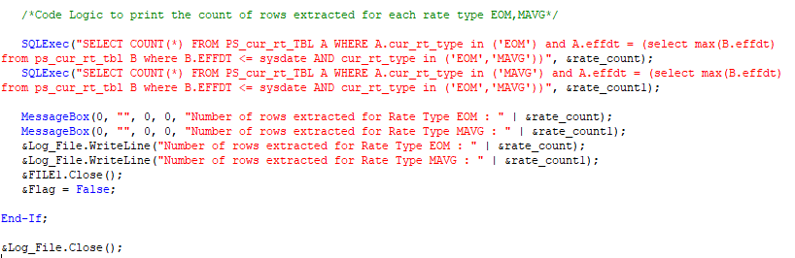

1. **Custom Objects:**

The following custom objects were created and been used in the code

* Record – PS_XX_GL_FILE_TBL

The above record is used to get the path to place the output and log file.

1. **Benefits:**

* No need of any hard coded path.
* Reusable code.
* Output Filename containing the date time stamp is very useful for easy retrieval of files.
* Log file that provides useful information of the number of rows of data extracted.
* Email message triggered to specified recipients after the process runs to Success / No Success.