AI ASSISTED CODING
LAB ASSIGNMENT-15

Name: C.Sai vamshi
HT NO: 2303A52238
Batch: 35

Lab 16 – Database Design and Queries (AI Assisted)

Lab Objectives
- Use AI to assist in designing and implementing fundamental data structures in Python
- Learn prompt-based structure creation, optimization, and documentation
- Improve understanding of Lists, Stacks, Queues, Linked Lists, Graphs, and Hash Tables
- Enhance readability and performance with AI-generated suggestions

Task 1 – Student Information System Schema

1. AI Prompt Used

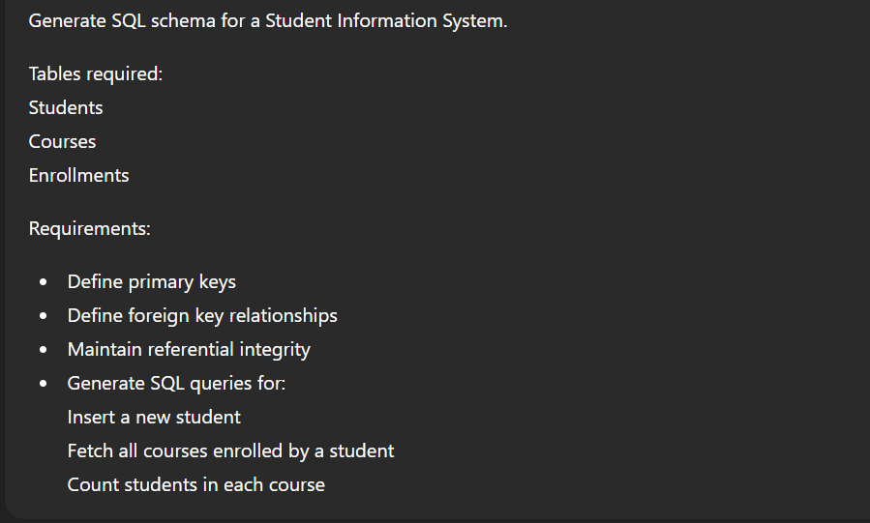
CODE and OUTPUT:
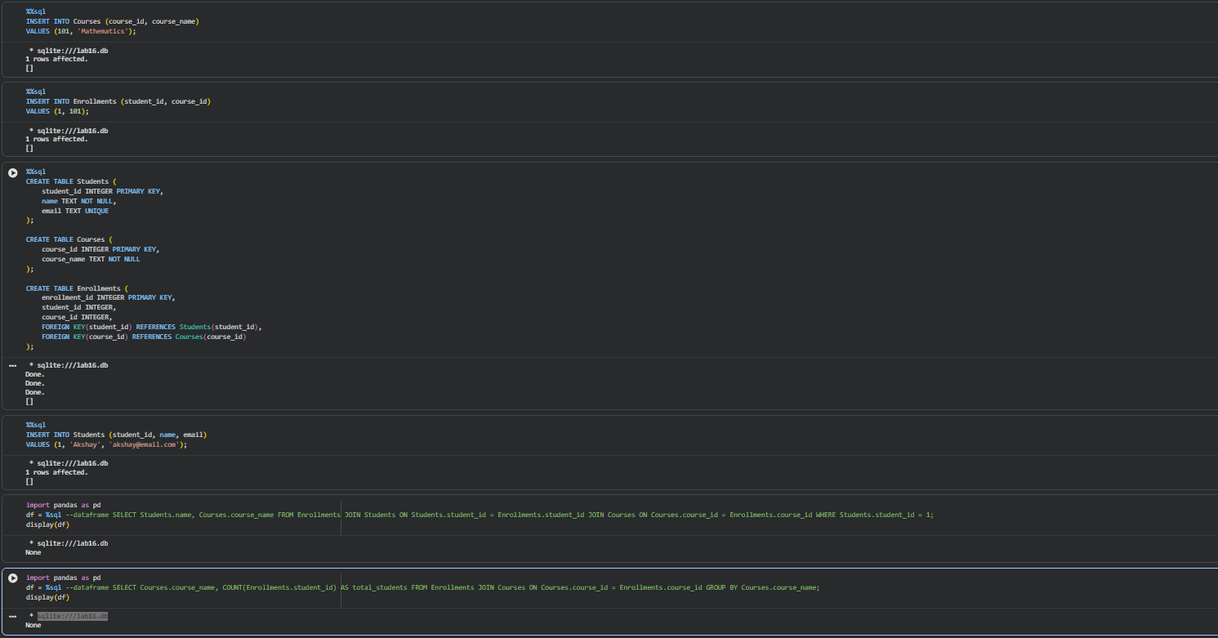
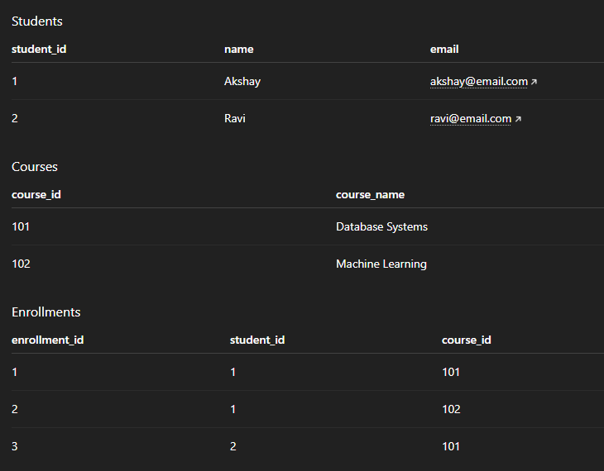

Task 2 – Hospital Management Database
AI Prompt:
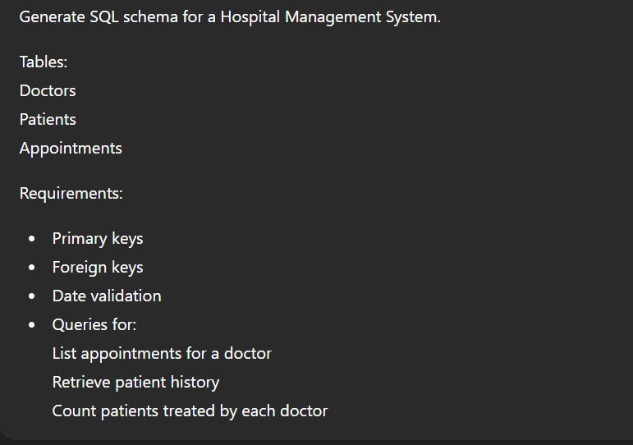
Schema AND Output:
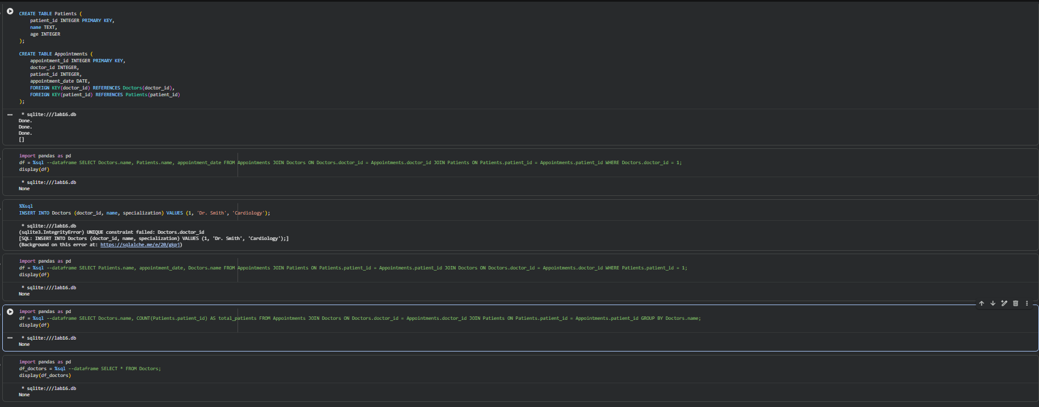
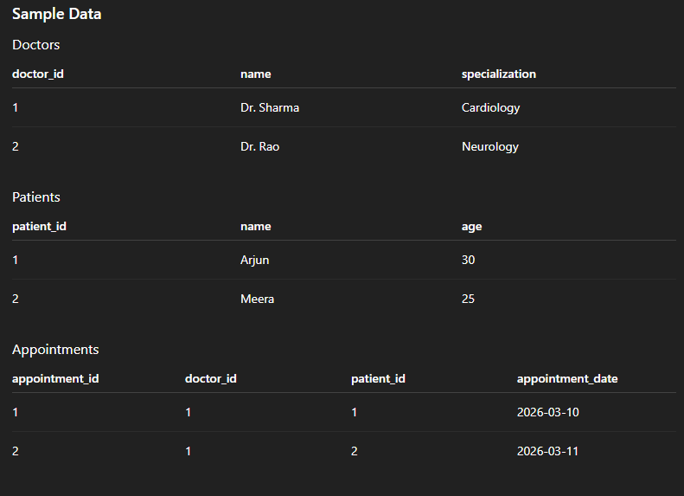

Task 3 – Library Database
AI Prompt:
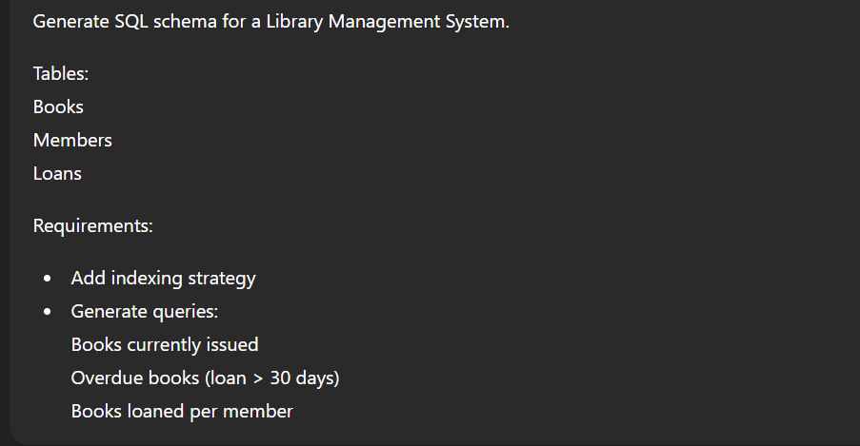
CODE and OUTPUT:
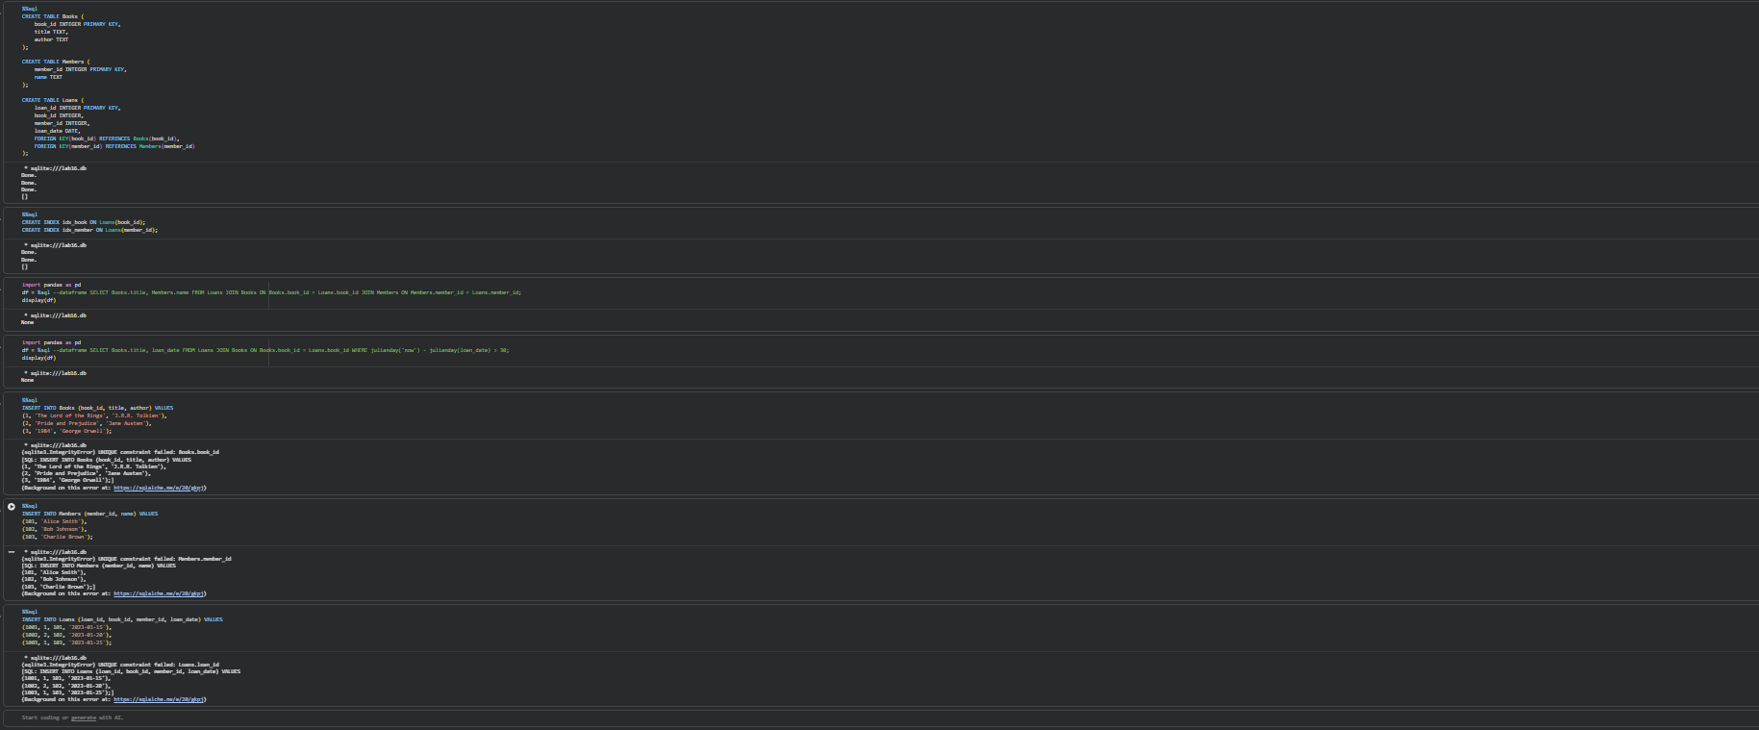
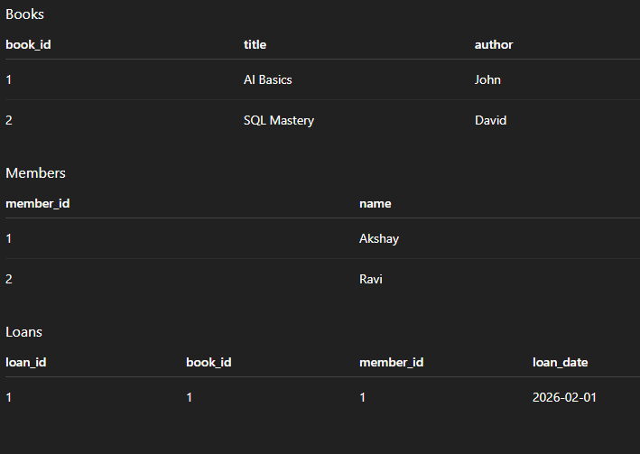

Task 4 – Online Shopping Database
AI Prompt:
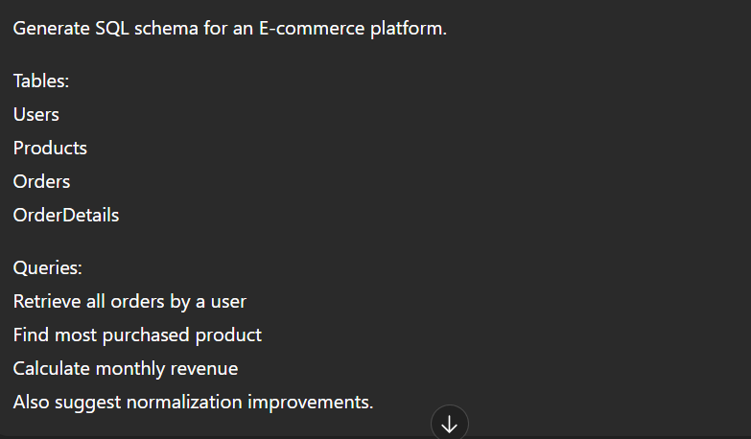
CODE and OUTPUT:
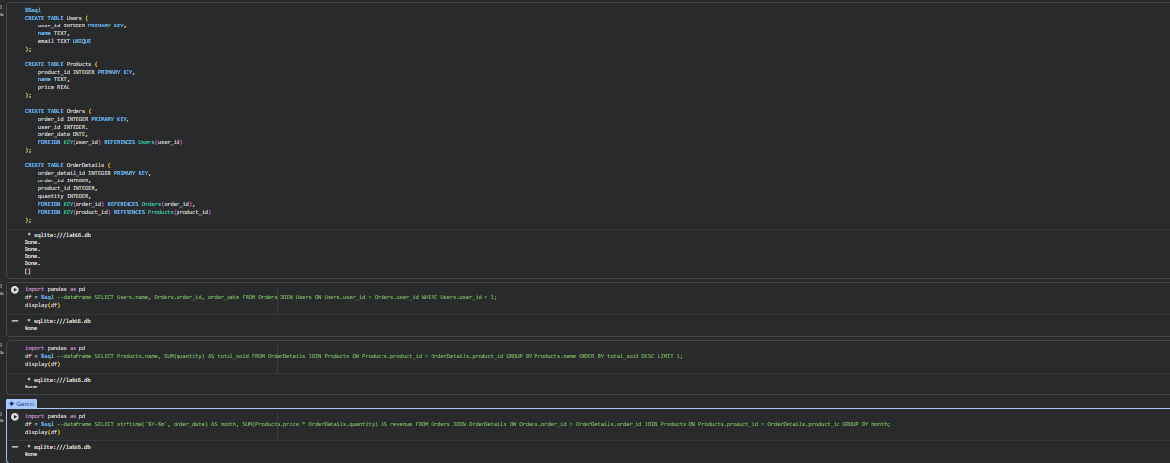
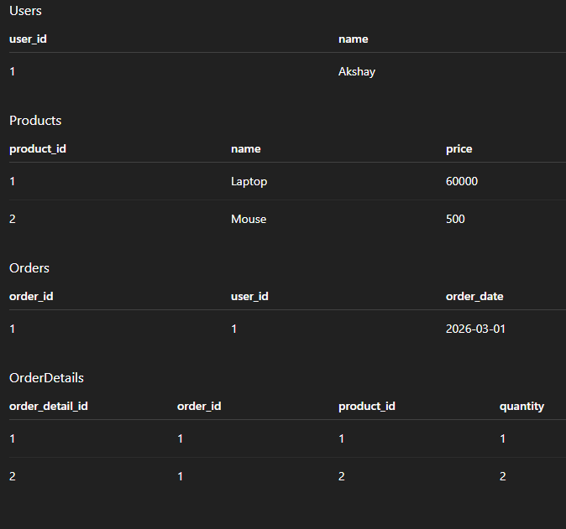

Task 5 – University Examination Database
AI Prompt:
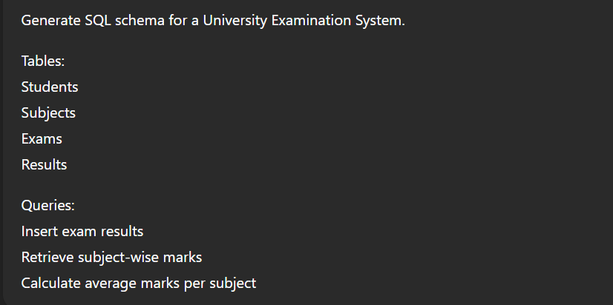
CODE and OUTPUT:
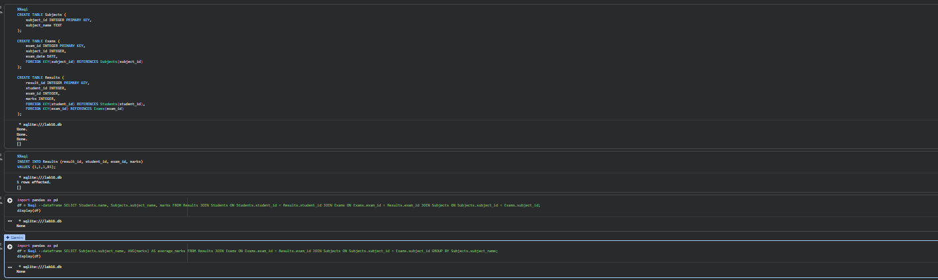
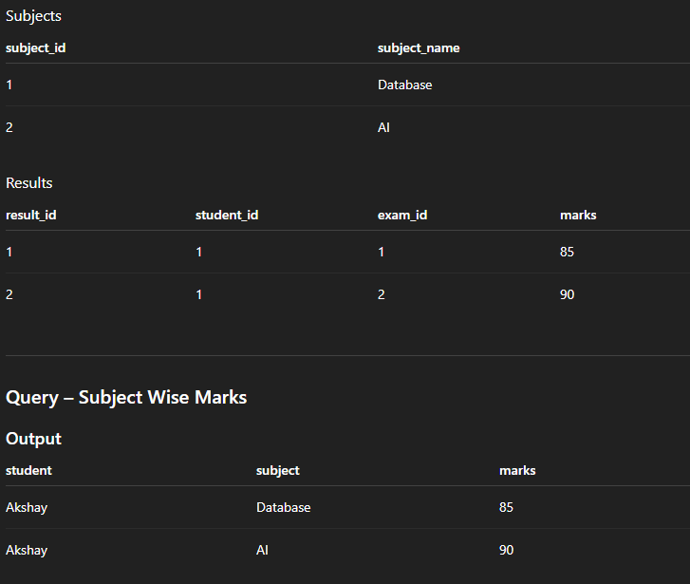

Final Analysis :
The experiment demonstrated how AI can assist in designing relational database schemas and generating SQL queries. Multiple database systems were modeled including Student Information Systems, Hospital Management Systems, Library Systems, E-commerce platforms, and University Examination Systems. SQL queries demonstrated CRUD operations, joins, and aggregate functions. Normalization principles and indexing strategies were applied to improve data integrity and query performance.

