A Project Report

On

Community Service

Submitted in partial fulfillment of the requirements for the award of

degree of BBA

A Project Report

On

Community Service

Submitted in partial fulfillment of the requirements for the award of

degree of BBA

A Project Report

On

Community Service

Submitted in partial fulfillment of the requirements for the award of

A Project Report

On

Community Service

Submitted in partial fulfillment of the requirements for the award of

degree of BBA

A Project Report

On

Community Service

Submitted in partial fulfillment of the requirements for the award of

degree of BBA

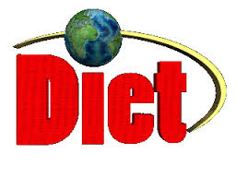

**DADI INSTITUTE OF ENGINEERING AND TECHNOLOGY**

**(Affiliated to Jawaharlal Nehru Technology University)**

**DEPARTMENT OF COMPUTER SCIENCE AND ENGINEERING**

A Project Report On

Community Service

Submitted in partial fulfilment of the requirements for the award of degree of

BACHELOR OF TECHNOLOGY

SUBMITTED BY

BATCH NO : 8

Enrolment No’s -- 21U41A0569 [I.PAVAN VARMA]

21U41A0560 [B.TEJA]

21U41A0586 [P.SAI VARDHAN]

21U41A0579 [S.RAJU]

21U41A0580 [K.HARINADH REDDY]

Under the Supervision of V.MANASA



DADI INSTITUTE OF ENGINEERING &TECHNOLOGY

(Approved by A.I.C.T.E., New Delhi & Permanently Affiliated to JNTUK, Kakinada)

**NAAC Accredited Institute and Inclusion under Section 2(f) & 12(B) of UGC Act**

An ISO 9001:2015, ISO 14001:2015 & ISO 45001:2018 Certified Institute.

**NH-16, Anakapalle – 531002, Visakhapatnam, A.P.**

**Mobile: +91 9963981111, Website: www.diet.edu.in, E-mail: info@diet.edu.in**

Declaration

I hereby declare that the project report entitled “Community service project” submitted by me to MR.

Sandeep Sir; Programme Incharge; Department of Management; Jagannath Institute of Management

Science; in partial fulfillment of the requirement for the award of the degree of BBA. In Management

department is a record of actual project work carried out by me under the guidance of Ms. Minakshi

Chhikara. I further declare that the work reported in this project has not been submitted and will not be

submitted, either in part or in full, for the award of any other degree in this institute or any other institute or

universi

**COMMUNITY SERVICE PROJECT**

***A Project Report submitted in partial fulfilment of the requirements for the award of the Degree of***

**BACHELOR OF TECHNOLOGY**

**IN**

**COMPUTER SCIENCE AND ENGINEERING**

*Submitted by*

I.PAVAN VARMA 21U41A0569

B.TEJA 21U41A0560

P.SAI VARDHAN 21U41A0586

S.RAJU 21U41A0579

K.HARINADH REDDY 21U41A0580

*Under the Esteemed Guidance of*

**MS.VELAMURI MANASA**

Asst.Professor, Department of CSE



**DADI INSTITUTE OF ENGINEERING & TECHNOLOGY**

**(Approved by A.I.C.T.E, New Delhi & Affiliated to JNTU, Kakinada)**

**NAAC Accredited Institute & Inclusion u/s 2(f) & 12(B) of the UGC Act**

**NH-5, Anakapalle-531002, Visakhapatnam, A.P.**

**2022**

**Day :4 ( 01/09/2022) : HOME SURVEY**

As we planed to reduce the usage of plastic in the anakapallezone and we started the survey and observed the domestic usage of bags and we have came to know that the usage of plastic is low and the common people was aware of plastic and its problems of usage of plastic , though we have explaned detail about the plastic and its decomposition

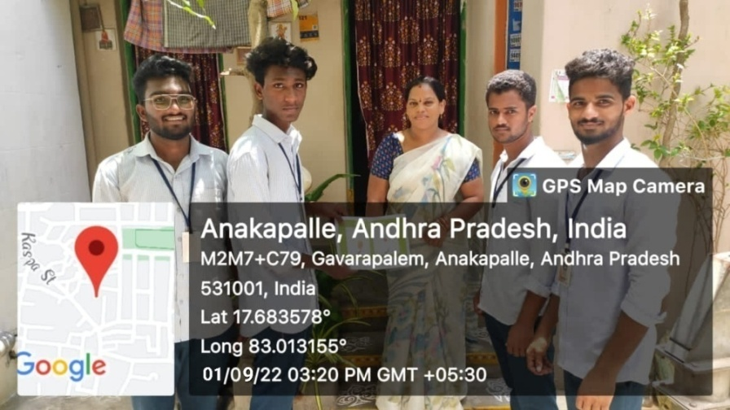

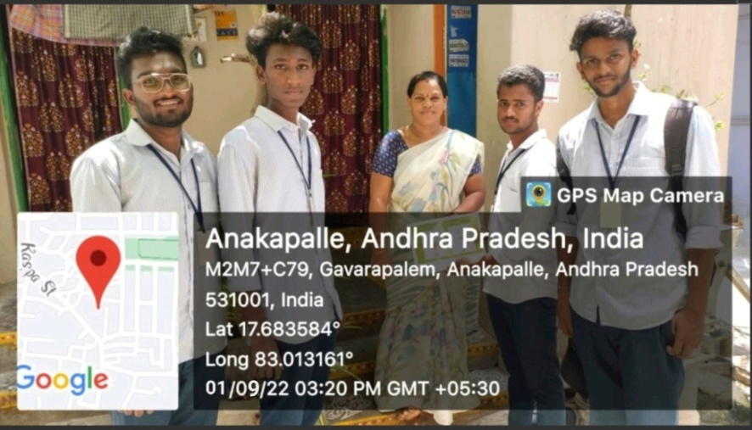

**Day 5 (02/09/2022) :**

**AWARENESS ON PLASTIC :-**

Plastic pollution is emerging as a top threat to ocean ecosystems. By 2025, there could be 1 ton of plastic for every 3 tons of fish in the ocean. Plastic debris affects nearly 700 species worldwide through entanglement and ingestion, alters natural biological and chemical processes, provides a means for the introduction of toxins into the food web, and costs the U.S. economy millions of dollars annually. The majority of this debris comes from land-based sources (e.g., plastic manufacturers, processors, landfills, sewage overflows, litter). With only 14% of plastic packaging and containers recycled in the U.S., 75% of leakage is due to uncollected waste.

As we planed to reduce the usage of plastic in the anakapalle zone and we started the survey and observed the domestic usage of bags and we have came to know that the usage of plastic is low

In many people’s daily lifestyle we use plastic for various purposes and to stop the use of plastic globally is tough, but it’s not impossible.

To completely stop the use of plastic is going to take long years and to avoid use of plastic somebody need to develop product which replaces plastic.

Plastic can be recycled, but it’s not a working way to say no to plastic. We must have alternative products which take the place of plastic, so in future we will see a declining graph of plastic use.

#### ****Ways to say no to plastic****

**1) Use cloth and paper carry bags**

Plastic bags are used in huge amounts as carry bags where people carry their materials in it.

And the biggest source of plastic bags are the shops where when customers brought something in shop, they gave them their plastic bag to carry the materials they brought.

We use these plastic made carry bags and after our done with plastic bags we throw it as waste. And these plastic bags waste are harmful to the environment.

And to solutions to that, some shopkeepers have already started giving cloth or paper bags to their customers, but still not enough to avoid the use of plastic. Every shop should start giving cloth, carry bags or paper made carry bag.

When we’re going to buy anything in a shop, we should carry a non-plastic carry bag and don’t take plastic bags from the shopkeeper.

So this is a great way to say no to plastic and as we all start using paper or cloth carry bags, we will be able to contribute to environmental conversion.

As early as we switch to non-plastic bags, the more chances that we can control harmful effects of it on the environment.

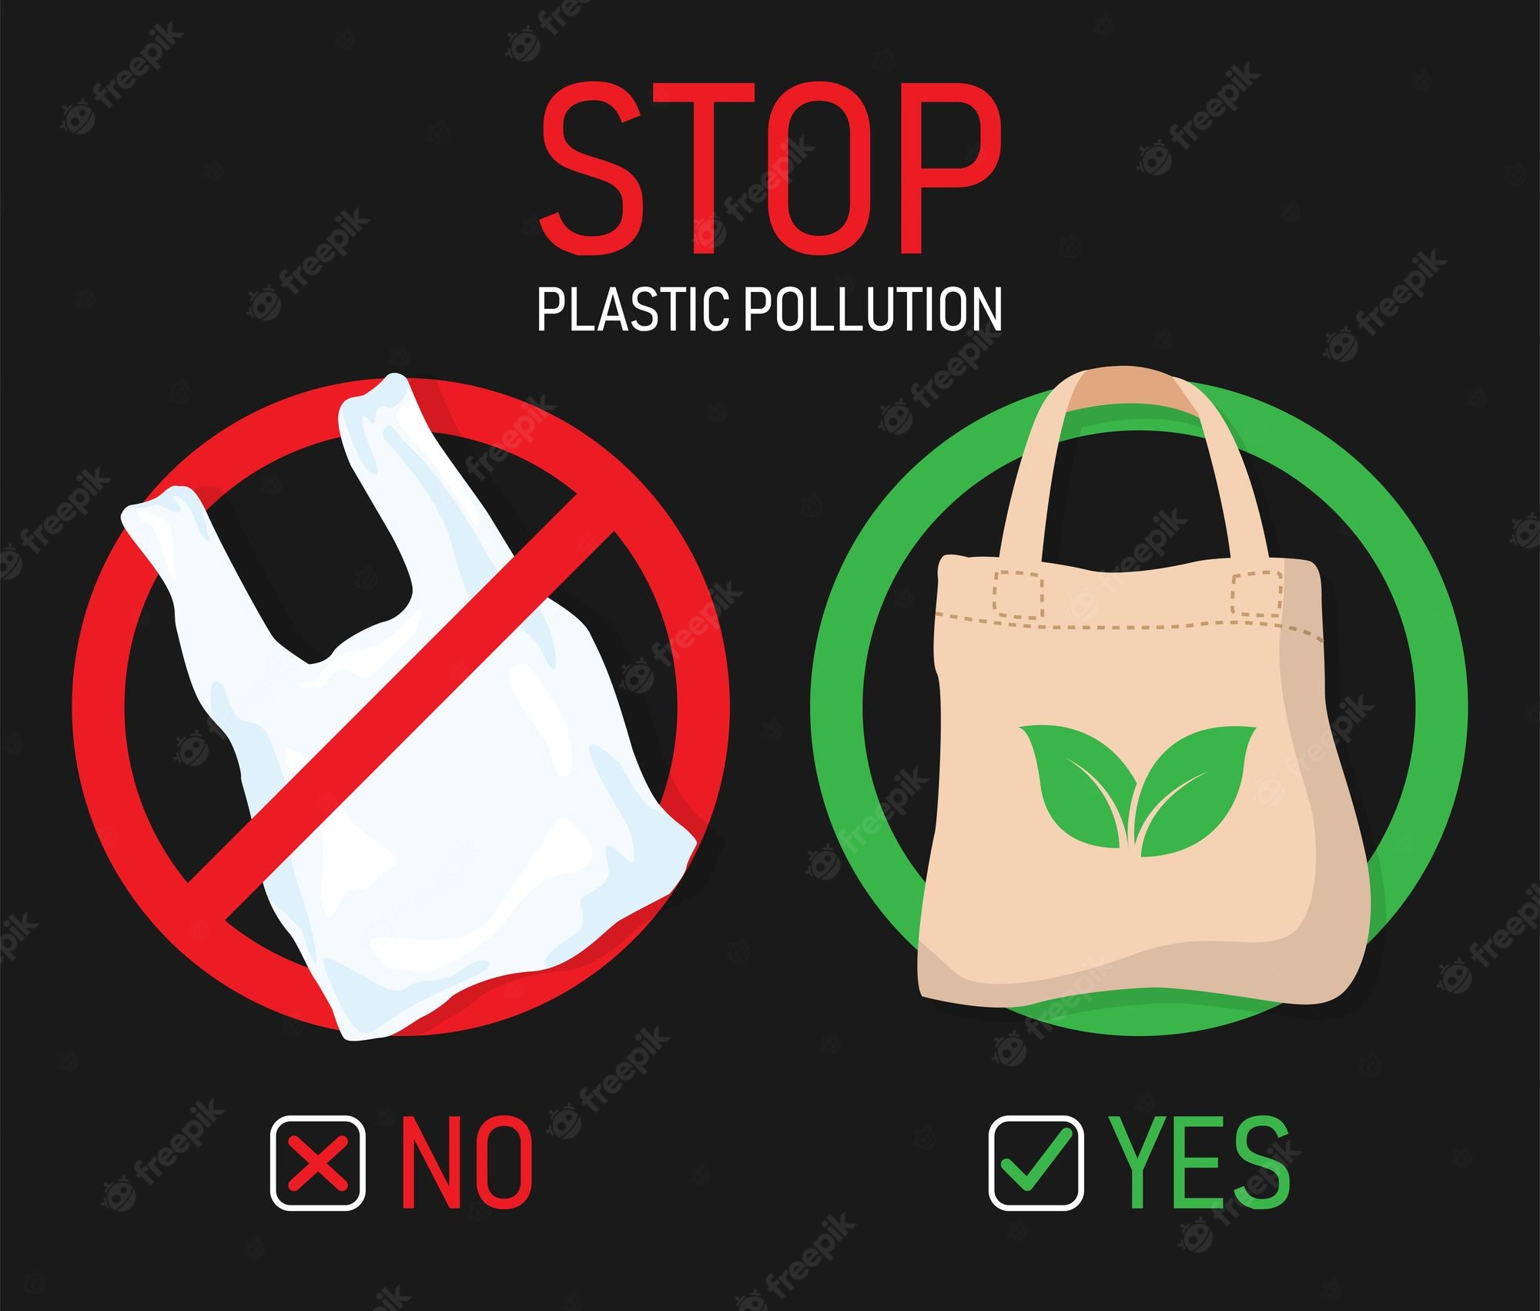

**2) Start using wooden bottles**

Another way to say no to plastic to start using wooden-made environmental friendly bottles.

Often we encounter people using a lot of plastic bottles more precisely when buying water we receive it in plastic made bottles, for that we should start using wooden bottles.

As mentioned earlier plastic bottles can be recycled, but we need a permanent solution for it in coming years we would have bottles which can be replaced with plastic bottles.

Start-to-use bottles made from environmentally friendly materials are essential to controlling plastic pollution.

Use plastic free carry bags and bottles are two main ways to say no to plastic.

#### ****What’s the impact of plastic on the environment?****

Plastic has a bad impact on the environment and use of genuinely dangerous for our environment.

As we already know plastic is not environment friendly and it remains on the surface of the planet our longer periods.

After taking use of plastic materials, this goes into the ocean via rain water and goes to stomach different aquatic animals like fishes. And many aquatic animals have been harmed due to that.

Along with that, when plastic is burnt it releases harmful gases into the atmosphere, which are ultimately harmful to humans.

Overall it is very dangerous to use plastic on daily basis, we have to switch to non-plastic things so we can control future impacts of plastic on environment.

**Plastic bags refer to a bag which is made of a thin plastic material**. Some also define plastic bags as bags which are made of a flimsy and flexible plastic material. Plastic bags are also referred to as pouches, poly bags, etc.

A plastic bag is basically a kind of packaging used essentially for containing and transporting goods of all kinds. These plastic bags are mostly heat sealed together. **Plastic bags can be made from various kinds of material like Polyethylene, laminates, and co-extrusions**. These plastic bags come in various design options with varying degree of strength.

In the past, people used to use clay, glass jars, cloths and paper bags for storing and carrying food items and other products. This was difficult to handle and carry around easily. Now, there is a huge change in the way people carry products and goods. People prefer to use plastic bags for carrying their groceries.

It makes the whole process of shopping much easier. They can carry these bags and other goods in the car and the grocery store. They can also carry it in their hand and carry it from the market to their homes. This makes it convenient and easy for them.

However, plastic bags are not only a convenience but they are a major source of plastic pollution. As they are not recyclable, they don’t degrade easily and remain in the environment for a long time, that’s why **say no to plastic** and.

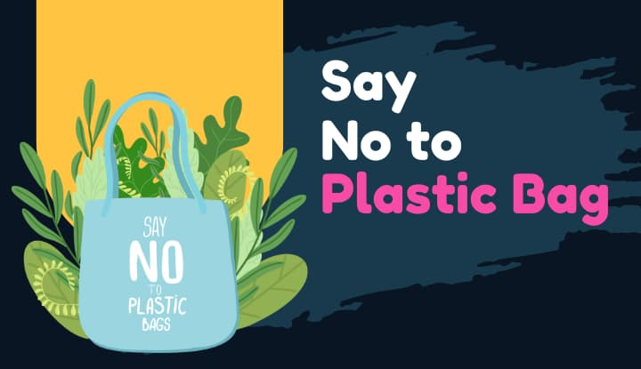

## ****2. Stop Using Plastic Bags****

There are many reasons for why we should stop using plastic bags. Plastic bags are one of the top contributors to pollution, along with automobiles and other items that create a negative effect on the environment.

There is enough evidence available to show that plastics pollute the land, water, and food chain of our planet via enteric fermentation or leaching into water resources.”

The plastic bag is a way to hold loose items like your lunch or books. The problem is that these bags do not degrade and cause serious problems for the environment. Plastic bags are produced by a variety of plastics, including polyethylene, polypropylene and polyvinyl chloride (PVC).

These bags do not biodegrade but rather break down into smaller pieces. Experts estimate that [around 500 billion plastic bags are used worldwide every year](https://dpw.lacounty.gov/epd/plasticbags/articles/googobits_07-21-05.pdf),. 500,000,000,000. Five hundred followed by  
nine zeros. That’s a lot of bags So many that over one million bags are being used every minute and they’re damaging our environment.

### 1. Plastics are Dangers to Sea Life

Plastic is very common in the sea, Every year, [8 million tons of plastic enter the ocean](https://chinadialogueocean.net/en/pollution/14200-how-does-plastic-pollution-affect-the-ocean/) and it goes on a long and destructive journey. The plastic that enters the ocean can be carried vast distances by currents to all parts of the world.

Plastics pollution has a direct and[deadly effect on sea and wild life](https://www.biologicaldiversity.org/campaigns/ocean_plastics/). Thousands of seabirds and sea turtles, seals and other marine mammals [are killed each year](https://www.sas.org.uk/our-work/plastic-pollution/plastic-pollution-facts-figures/) after ingesting plastic or getting entangled in it.

### 2. Burning plastics cause air pollution.

When plastic wastes are burned, it releases a lot of harmful chemicals. These chemicals make the air toxic. When this happens, people living near the burning site suffer from health issues.

Many people suffer from asthma and other respiratory problems because of the air pollution. People who work in the areas of burning plastic waste often complain about eye irritation and breathing problems. They also have a difficult time breathing in the winter. This causes them to cough and wheeze. Add to this the fact that carbon dioxide and other GHGs released into the air. GHGs contribute to global warming.

### 3. Plastic bags pollute the soil-

As they are made of synthetic materials which pollute the soil. They are made of polyethylene, polypropylene and polyester. These chemicals can cause a lot of problems. For instance, they can be absorbed into the soil and can kill the microbes in the soil.

It can be inferred that the plastic pollution is highly poisonous and devastating for the environment of the globe which may even disrupt the hormonal balance in the humans. It is a severe threat to the marine life that completely disturbs the ecological balance of the oceans, and the only way to fight against it is using paper bags instead of plastics.

### 4. Plastic Bags can spoil the quality of foods

Studies have shown how plastic bags can spoil the quality of foods. Experts think this is even more of a problem because the plastic typically used in bottles, bags and food containers contains chemical additives such as endocrine disruptors, which are associated with negative health in [humans and wildlife](https://www.biologicaldiversity.org/programs/population_and_sustainability/sustainability/references.html#eight).

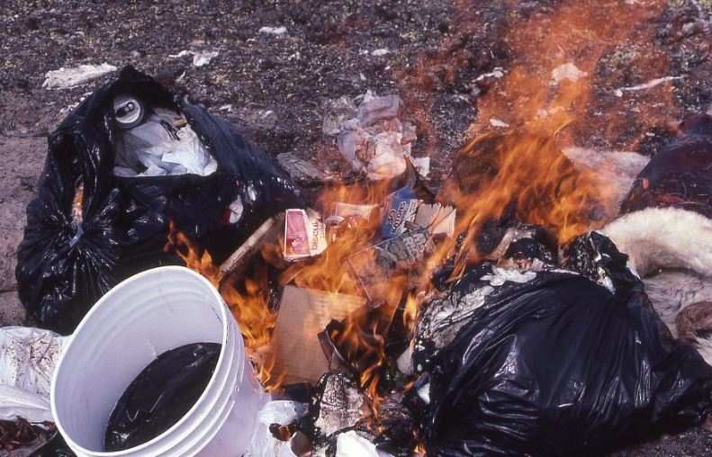

# How Long Does It Take for Plastic to Decompose?

Plastic is both a blessing and a curse. It has revolutionized the way we live for the better, but it also presents us with a big problem. Namely, what do we do with it and where does it go once we’re finished using it? Every toothbrush, drinking straw, Styrofoam clamshell and pen you’ve ever used is still on this earth — either in its original form, recycled into another product or slowly breaking down into tiny pieces called microplastics.

Plastic is everywhere, and by design, it’s made to last decades, if not hundreds of years. It’s incredibly useful, but it’s bad in terms of the waste created. The truth is we really don’t know how long plastic lasts. Plastic has only been in circulation since 1907, and experts estimate that some plastics can last hundreds of years before they finally break down. And it keeps piling up in the strangest of ways, like the [Great Pacific garbage patch](https://www.nationalgeographic.org/encyclopedia/great-pacific-garbage-patch/) just floating in the middle of the ocean.

## How Long Does It Take for Plastic to Decompose?

Plastics can take anywhere from 20 to 500 years to decompose, depending on the material and structure. Additionally, how fast a plastic breaks down depends on sunlight exposure. Like our skin, plastics absorb ultraviolet (UV) radiation from the sun, which breaks down the molecules. This process is called photodegradation, and it’s why landfills often expose plastic waste to the sun to accelerate the breakdown process.

For example, single-use plastic grocery bags take about two decades to break down. In contrast, plastic water bottles made with polyethylene terephthalate (PET), a common type of plastic, are estimated to take approximately 450 years to fully break down.

Here’s are the estimated decomposition timelines for common plastic waste products:

| Material | Estimated Decomposition |
| --- | --- |
| Cigarette butts | 5 years |
| Plastic bags | 20 years |
| Plastic-lined coffee cups | 30 years |
| Plastic straws | 200 years |
| Soda can rings | 400 years |
| Plastic bottles | 450 years |
| Toothbrushes | 500 years |
| Disposable diapers | 500 years |
| Styrofoam | 500 years |
| Fishing line | 600 years |
| Glass | Unknown |

## Why is Plastic So Difficult to Degrade Anyway?

It’s simple — plastic isn’t natural. Although it is derived from petroleum, which is processed from naturally occurring crude oil, plastic does not occur in nature. There’s lots of science behind it, but it mostly involves the chemical bonds of plastic vs. the molecular bonds of organic matter like an apple. Plastic’s carbon bonds aren’t the same as the chemical bonds found in nature, making it harder and more energy-intensive to break them down.

Moreover, as plastic degrades, it can leak toxins into the soil around it, leading to a whole host of other issues researchers must tackle.

## From Plastic-Eating Bacteria to Biodegradables

There are, however, new kinds of plastic on the market: Biodegradable plastics, or bioplastics. While bioplastics aren’t derived from nature, they get their name by their ability to easily biodegrade. It involves those chemical bonds we talked about earlier.

Some scientists have created plant-based plastics using corn or sugarcane as a base material. Other scientists have tweaked the chemical bonds of petroleum-based plastics so it’s easier for nature to break them down. The other and final category is some combination of the two: plant-based and fossil-fuel-based plastics.

Another — and very recent — innovation is the [discovery of plastic-eating bacteria](https://www.edf.org/blog/2018/07/13/are-plastic-eating-bacteria-solution-ocean-pollution-its-not-simple-science-shows). Researchers discovered the species at a dumpsite and learned that it uses plastic as food. Moreover, it can survive the toxic chemicals that could be released from the breakdown process.

## How You Can Keep Plastic Waste Out of Landfills and Oceans

If you’re reading this, chances are you want to leave this world better than you found it. We’ve got just the right resources for you. From learning how to recycle plastic (the right way) and reducing your plastic pollution to learning how to compost, reduce your food waste, and shrink your carbon footprint, we have the answers to your eco-friendly living questions.

Get started on your path to greener living with these articles on recycling, sustainability and downright responsible living!

* [Your Gateway Guide to Green Living](https://chariotenergy.com/sustainable-living/)
* [How to Recycle (and Do it Right)](https://chariotenergy.com/chariot-university/how-to-recycle-properly/)
* [Tips to Reduce Your Plastic Pollution](https://chariotenergy.com/chariot-university/how-to-reduce-plastic-pollution/)
* [Thing You Might Be Recycling Wrong](https://chariotenergy.com/blog/things-you-might-be-recycling-wrong/)
* [The Four Essential R’s of Sustainability](https://chariotenergy.com/blog/reduce-reuse-recycle-repurpose/)

## Rooftop Solar from Chariot

By turning to our next chapter – we are turning to you – our most valuable asset. You and our other past and present Chariot Energy customers will receive a free one-of-a-kind experience to go solar and keep your home energized…even when the grid is not.

We’ve seen energy prices skyrocket over the past year and many of us have experienced the volatility of our grid and the devastation it can bring when it’s  
down.

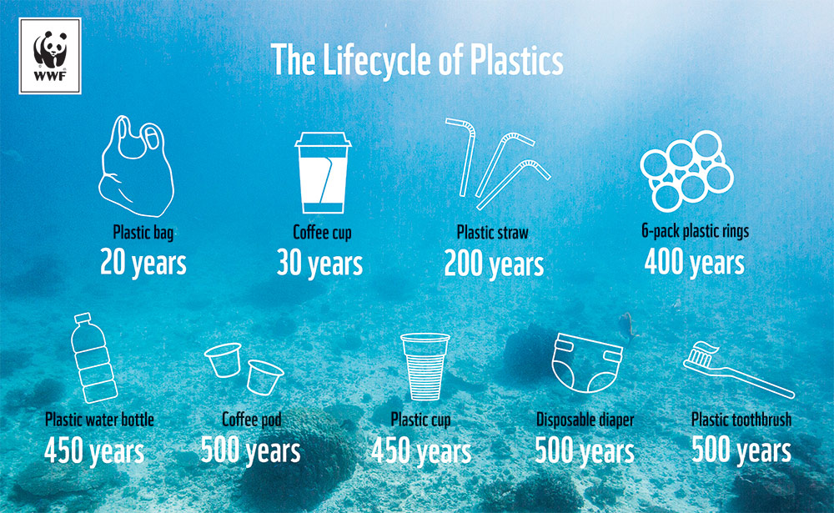

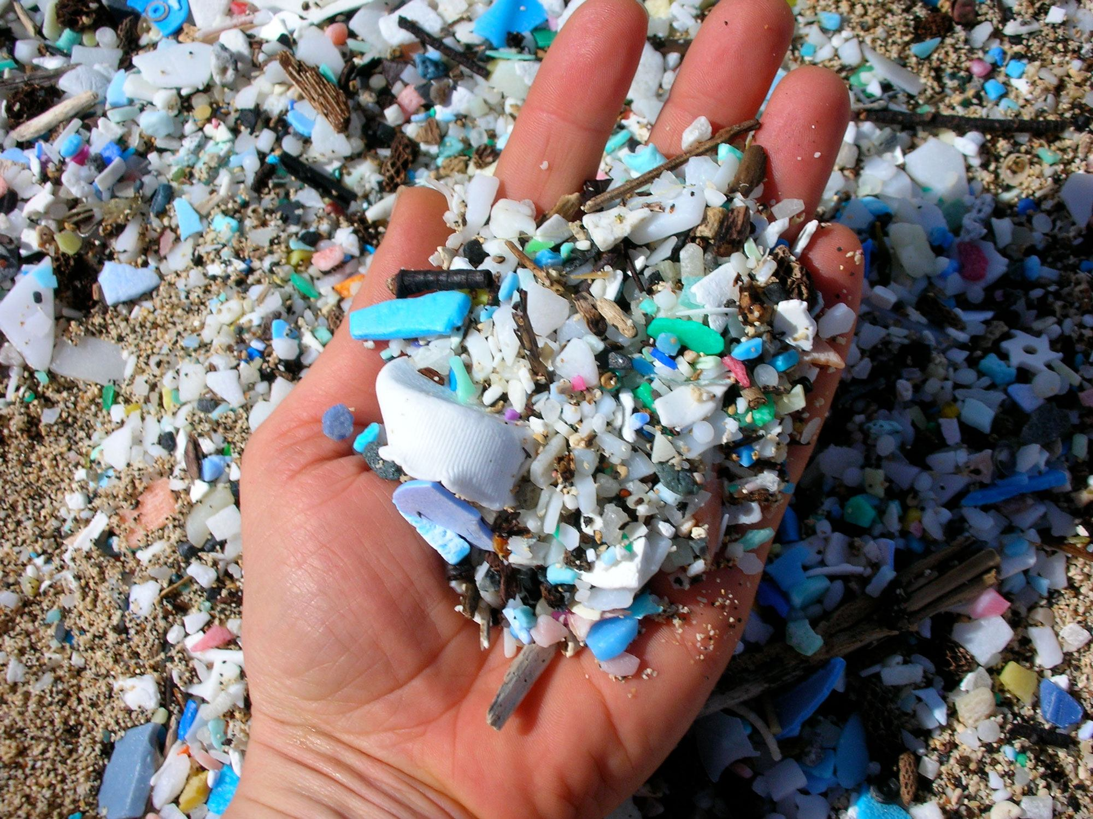

### Our plastic waste has a devastating impact on marine life.

Most people don’t realise that we have an incredible array of wildlife on our doorstep in the UK, including seals, dolphins, turtles whales and even sharks! There are**over 30,000 species** in UK waters and we have ecosystems that are as diverse as the Amazon Rainforest!

This means that the scenes we see of animals being harmed by our plastic are not happening far away, they’re happening right here in the UK.

**In fact, scientists recently found that 100% of animals washed up on British shores had plastic in their stomachs.**

**Every year, plastic kills 1 million sea birds and 100,000 sea mammals, turtles and fish.**

Plastic pollution is devastating to wildlife because it doesn’t simply disappear. It can take hundreds of years to break down into smaller and smaller pieces which can be easily ingested. Plastic is toxic and can kill wildlife or make them more susceptible to disease.

Animals can become trapped and injured by plastic and it disrupts habitats, making it hard for some species to live and breed naturally, leading to depletions in populations.

Plastic affects all life, from microscopic animals right up the food chain to large predators and even humans. Recent studies have shown traces of microplastics in people too, meaning that this is a problem that affects us all.

**We all have a stake in healthier seas and a part to play in the solution.**

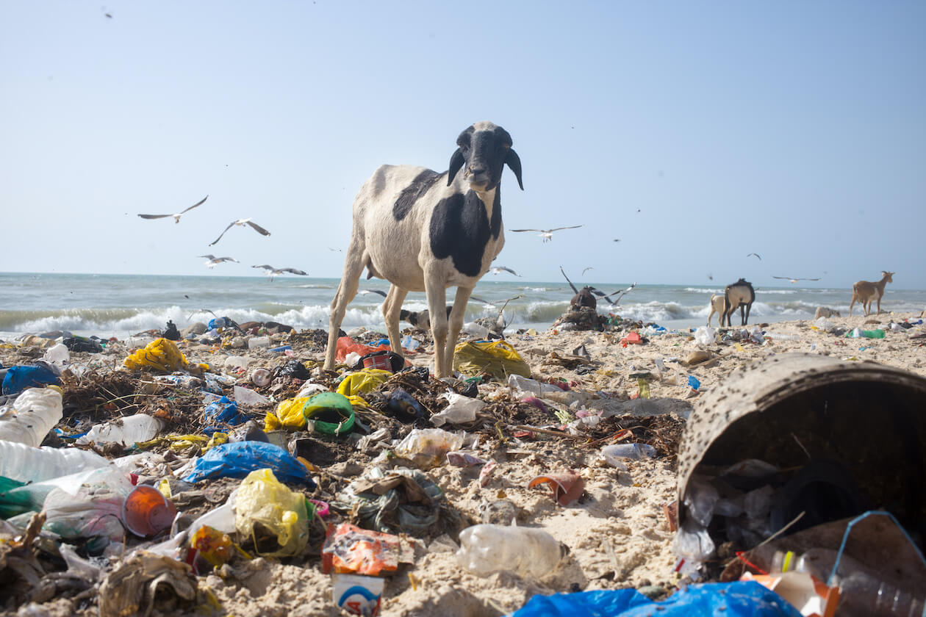

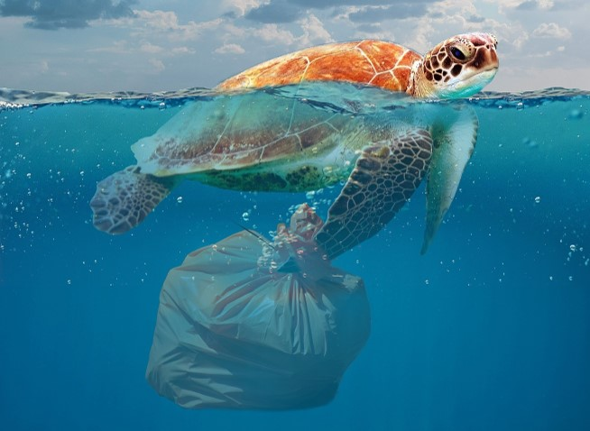

## Plastic’s Impact On Wildlife Is Alarming

Plastic pollution has such a far reaching impact, but the effect on wildlife is alarming and sad. There are so many ways plastic pollution can happen; from people carelessly tossing an item on the ground to the wind lifting items from recycling bins or landfills. Whether intentional or not, pollution happens.

Plastic pollution is especially perilous for wildlife. Discarded plastic trash can be mistaken for food, especially by marine animals when the litter is floating in water. Plastic pollution can also damage animals habitats and if wildlife becomes entangled in garbage they are unable to fend for or defend themselves. What makes plastic pollution so unfortunate is that it is completely preventable. The negative impact [plastic bags have on animals and wildlife](https://www.factorydirectpromos.com/blog/how-plastic-bag-use-impacts-wildlife/) can be detrimental to their ecosystem.

## The Hazards of Animals Consuming Plastic Pollution

Plastic pollution does not biodegrade, so once it is there it is there pretty much forever. Thin plastic, like single-use plastic shopping bags can resemble jellyfish and this is a serious problem for marine animals that eat jellyfish since this honest mistake can have dire consequences. When large pieces of plastic are consumed they can essentially clog the animal’s digestive system, which can lead to death, or the plastic pollution will take up space, giving the animal a false sense of fullness. Both of these scenarios can lead to a painful and uncomfortable death.

## The Impact of Pollution on the Food Chain

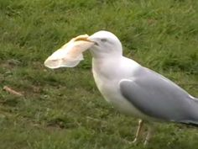

When exposed to the elements for enough time, plastic can break apart into smaller pieces. These tiny fragments are easier for marine animals to consume, since they may not even realize they are doing so. The smaller plastic pieces are less likely to block the digestive system, but they are still incredibly dangerous.

Studies have shown that chemicals from the plastic have leached into the flesh of the animal, so when an animal eats plastic elements of the plastic can be absorbed into the animal’s body. This is concerning since it can potentially cause problems for the animal, and the species as a whole, but it is also an issue for animals further up the food chain. The animal that eats the prey with plastic in it will absorb the plastic tainted flesh, and this is even a concern for animals several steps away on the food chain since the plastic compounds will be passed along.

## Plastic Pollution Can Entangle Animals

Eating plastic is a major distress, but plastic pollution is dangerous even if it is not eaten. Animals can become tangled in plastic and this can lead to all sorts of problems. If an animal is snarled in a disposable plastic bag they may not be able to breath or eat, and this can clearly lead to death. In other instances an animal may not be able to defend themselves or their young. There are documented cases of animal’s becoming stuck in plastic trash that cuts into their skin, which can cause severe health problems.

## Effect of Pollution Is Widespread

The impact of plastic pollution on wildlife is so concerning because it can have such a massive reach. There is no such thing as isolated instances of plastic pollution because even if one animal eats some discard plastic or becomes lodged in a disposable shopping bag that changes the natural order of things and that can set of a change reaction that has awful consequences.

# HARMFUL EFFECTS OF PLASTIC ON DAIRY CATTLE.

Being a veterinarian and a responsible citizen, Today on 5th june on the occasion of world environment day, i thought to bring the burning issue of plastic menace in cows to notice before the common people for general awareness.We as a vet come across with plastic related cases in cows particularly in urban areas.  
We everyone knows how hazardous plastic is for the environment. Whenever we throws something like paper, food etc in the environment, there are some bacteria which grows on it, and covert this food, papers into something which mixes into the environment, some turning into useful for growing of trees, we call those items as biodegradable items. Biodegradable items are capable of being decomposed by bacteria or other living organisms and thereby avoiding pollution.  
Whereas Plastic is a “Non-Biodegradable” item. Non-biodegradable waste is a type of waste that can not be broken down into its base compounds by micro-organisms, air, moisture or soil in a reasonable amount of time. Non-biodegradable waste is an environmental concern, as it threatens to overwhelm landfills and create disposal problems.

Cattle also represent prosperity and abundance in the Indian community. They are the farmers’ backbone. They substitute for human or mechanical labor on the farms, provide nourishing milk, their dung is used as fuel, and their urine is a powerful organic pesticide. So it is not strange that we worship them, and slaughtering them is considered a moral and legal crime.  
Today in this changing world, their neglect is almost astonishing. Globalization has forced farmers to give up on traditional farming practices, and the prominence of these animals has diminished. The festivities moved to the cities, and idols of the animals replaced the actual ones, to be more convenient for people. But things changed so gradually that no one noticed when they started following just the rituals without their actual purpose. Now, these animals are left on the roads to fend for themselves.  
The open garbage system in India is a huge menace to the well-being of stray animals. I have seen stray cows and bulls on the roads, chewing on something from the open garbage bins and looking for anything edible to survive. My uncle was even in an accident when his car struck one of these stray cows, a common occurrence.

The plight of these animals has become a major concern to society. They are discarded, and then people discard waste in plastic bags, and the animals searching for food consume the plastic, along with the leftover food materials. The plastic gets accumulated in their rumens and becomes hard. These animals look healthy, but that is just an illusion — they often die a slow and a painful death due to starvation.  
The government of India has banned plastic carry bags below 50 microns, and has come up with stringent waste-responsibility laws in the new plastic waste management rules. This has resulted in stores charging extra money for plastic carry bags in order to encourage customers to bring their own shopping bags. However, these measures haven’t resulted in the significant impact that India really needs.  
The real change can only be brought about when consumers are made aware of the amount of plastic entering the environment every day and how their refusal to buy or use plastic products is the ultimate solution. A new law to govern the handling of electronic waste by bringing the producers of electronic goods under “extended producer responsibility” sounds promising. However, the law should be imposed on not just electronic companies, but companies producing plastic carry bags, water bottles and any single-use plastic products. This will ensure that there is a proper take-back mechanism and that the waste is reduced considerably.

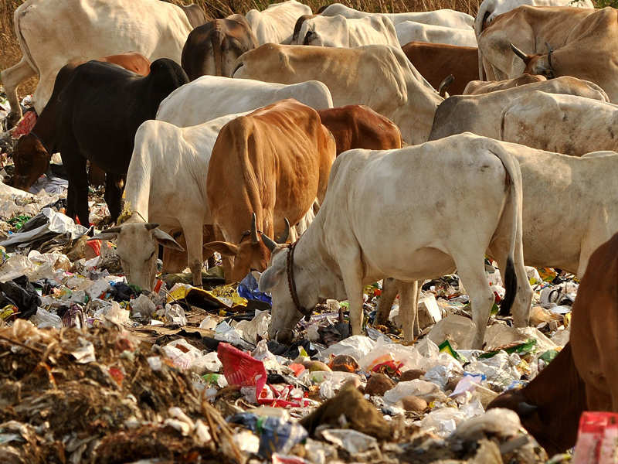

Harmful Effects of Plastic on Cows—

Rumen impaction due to plastics or rexins are referred as “ Non penetrating Foreign Body Syndrome”. Over a period of time, these materials make large tight balls inside the rumen leading to anorexia, decreased production and progressive loss of body condition (Tyagi and Jitendra Singh 1993., Kohli et al., 1998). It is a common menace in most of the major cities in India where plastic is used abundantly. Though, there is no such systematic study on polythene and plastic induced pathological lesions in animals.

However, there are scattered reports in literature and that too in popular media. It has been recorded that 95% of urban stray cattle in India suffering from various ailments due to hazardous material inside their abdomen, out of them 90% are plastic bags. Sometimes, higher incidence of 96.02% was noticed in adult cows (Vanitha et al., 2010).

The dairy and cattle owners are responsible for the plights of cows after milking them in the morning. They allow the cows and virtually push them out of shelters to find food available in dumps of debris lying around the city. Stray cows are generally seen on the roadsides eating away the plastic bags and their contents in search of food items.

The ingested polythene hinders the process of fermentation and mixing of contents leading to indigestion. They also obstruct the orifice between reticulum and omasum. If not removed though surgery, polythenes may become fatal. The plastic bags cannot be digested or passed as such through faeces by an animal. They stay in the gut causing pain and death. When dead animal decay, the bags are freed and often eaten again by other animals and this cycle may continue for many years to come.

The toxic contents of plastic may also enter in man through milk produced by such cows. The foreign bodies like hard metal needles, wires, nails, etc. are also disposed along with other house waste in polythene bags, which after consuming by cows may settle in reticulum giving rise to a condition “Tranmatic Reticulo Pericarditis (TRP)”.

One can see many stray cows found on roadsides with TRP where in their foreleg portion is found swollen.

Various pathological conditions are encountered due to plastic and polythene in animals.

1. Indigestion: The polythenes and other plastic material do not degrade in rumen/reticulum and remain as such causing hindrance in orifice. When it is mixed with feed, the ingredients are also trapped in between polythenes which becomes tight due to ruminal movements. This whole process also affects the rumen microflora leading to indigestion of feed.

2. Impaction: Rumen becomes impacted due to presence of large quantities of polythene bags/plastics in rumen accumulated over a period of time. This leads to rumenatony and decrease in rumen motility.

3. Tympany: When polythenes present in rumen and reticulum, they partially or completely occlude the orifice of reticulum and omasum leading to accumulation of gases in rumen. The situation becomes worsen if such animal is fed with legumes or other gas forming feed/ concentrates. Accumulation of gases in rumen give rise to bloat or tympany which becomes fatal, if the gases are not properly removed. Sometimes the poly bags present in rumen may also occlude oesophageal orifice leading to hindrance in eructation. This gives rise to dyspnoea and death.

4. Polybezoars: There will be formation of stones in digestive tract and around polythenes will also be observed. Such hard mass not only causes hindrance in food passage but also leads to pain and inflammation of rumen.

5. Immunosuppression: It has been observed that cows with polythenes in their stomach also suffer from immunosuppression that leads to increased sensitivity to various infections particularly of haemorrhagic septicemia (Pasteurellosis).  
Besides, due to lack of proper nutrition, animal becomes weak and immunodeficient. Such animals are also prone to development of cancer. The presence of toxic chemicals may also damage epithelial lining that leads to urolithiasis particularly in kidneys.

Plastic industry contributes nearly 1/10 of toxic releases in the environment. Significant releases of toxic chemicals included: Tri chloro ethane, Acetone, Methylene chloride, Methyl ethyl ketone, Styrene, Toluene,Benzene, 1,1,1,Trichloroethane. Other major emissions form plastics production process include sulphur oxides, Nitrous oxides, Methanol,Ethylene oxide and volatile organic compounds which are highly toxic to cattle (Khurshaid Anwar et al., 2013)

Rumen impaction is a condition which results from the accumulation of the indigestible materials in the rumen which interferes with the flow of ingesta leading to distension of the rumen and passing of scanty or no feces (Abdullahi et al., 1984). Clinical rumen IFB (indigestible foreign body) impaction is characterized by pale mucous membrane, complete cessation of rumination, impacted rumen, atony, reduced rumen motility, absence of stratification, hard pellet mucous coated dung and inappetance (Vanitha et al., 2010; Prahlad Boodur et al., 2008).

Rumenotomy along with transplantation of fresh ruminal qud is the best technique of restoration of normal ruminal function at the field level for treatment of chronic rumenal impaction due to plastics in cattle and buffaloes ( Prahlad Booder et al., 2008). In the present case, animal showed recurrent bloat since two months along with anorexia and cessation of rumination. Rumenotomy followed with transplantation of fresh ruminal qud, rumenotorics and probiotics helped in uneventful recovery (Bhupendra Singh,2005).

Hence, it is most important to save the holy cows from the deleterious effects of the plastics. In this regard, a big campaign is organized by Shri Ramachandrapuramath, Hosanagar in association with Indian Buitricians Association, Department of Animal Husbandry and Veterinary Services, Government of Karnataka, Karnataka Veterinary Animal and Fisheries Sciences University, Bidar and many other organizations.

A campaign is organized in the name of “Mangala Gouyatra” which is for creating awareness among the people about the toxic effects of consumption of plastic by cows and thus to stop the use of plastics.

The skilled veterinarians are to identify the plastic consumed cows and going to conduct rumenotomy operations in various parts of Karnataka and other surrounding States. Cow with plastic will be exhibited by Shri Shri Raghaveshwara Bharati Swamiji during his spiritual talk. This is a unique effort to make the cows free from plastic and to create awareness among the people not to use plastic materials.