**Safeguarding E-Commerce**

**Bachelor of Technology**

In

**Computer Science and Engineering (Internet of Things)**

By

K. Sai Vardhan 2211CS050053

Under the esteemed guidance of

# Mrs. B. Swetha



**Department of Computer Science & Engineering (Internet of Things)**

**School of Engineering**

**MALLA REDDY UNIVERSITY**

Maisammaguda, Dulapally, Hyderabad, Telangana 500100

**2024**



Department of Computer Science & Engineering

(Internet of Things)

**CERTIFICATE**

This is to certify that the project report entitled **“****Safeguarding E-Commerce”,** submitted by **K. Sai Vardhan(2211CS050053)** of 3rd year IoT – ALPHA **Computer Science & Engineering (Internet of Things) Malla Reddy University, Hyderabad**, is a record of bonafide work done by him/ her. The results embodied in the work are not submitted to any other University or Institute for the award of any degree or diploma.

### Internal Guide Head of the Department

Mrs. B. Swetha Dr . G. Anand Kumar

HOD CSE(Cyber Security & IoT)

**External Examiner**

**DECLARATION**

We hereby declare that the project report entitled **“Safeguarding E-Commerce”**, has been carried out by me. This work has been submitted to the **Department of Computer Science and Engineering (Internet of Things), Malla Reddy University, Hyderabad** for the award of the degree of Bachelor of Technology. We further declare that this project work has not been submitted in full or in part for the award of any other degree in any other educational institutions.

Place:

Date:

|  |  |
| --- | --- |
| K. Sai Vardhan 2211CS050053 |  |

**ACKNOWLEDGEMENT**

We extend our sincere gratitude to all those who have contributed to the completion of this project report. Firstly, we would like to extend our gratitude to Dr. V. S. K Reddy, Vice-Chancellor, for his visionary leadership and unwavering commitment to academic excellence.

We would also like to express our deepest appreciation to our project guide Mrs. B. Swetha, whose invaluable guidance, insightful feedback, and unwavering support have been instrumental throughout this project for successful outcomes.

We are also grateful to Dr. G. Anand Kumar, Head of the Department of Cyber Security & IoT, for providing us with the necessary resources and facilities to carry out this project.

We extend our gratitude to our PRC-convenor, Dr. G. Latha, for giving valuable inputs and timely guidelines to improve the quality of our project through a critical review process. We thank our project coordinator, Dr. G. Latha, for his timely support.

We would like to thank Dr. Kasa Ravindra, Dean, School of Engineering, for his encouragement and support throughout my academic pursuit.

My heartfelt thanks also go to Dr. Harikrishna Kamatham, Associate Dean School of Engineering for his guidance and encouragement.

We are deeply indebted to all of them for their support, encouragement, and guidance, without which this project would not have been possible.

|  |  |
| --- | --- |
| K. Sai Vardhan 2211CS050053 |  |

**ABSTRACT**

Customer evaluations and ratings have become increasingly important in influencing the purchasing decisions of consumers due to the explosive rise of online shopping. However, the proliferation of phony reviews and manipulated ratings damages e-commerce platforms' credibility, which in turn causes consumer mistrust and damages firms' reputations. This research suggests a complete system that uses cutting-edge machine learning algorithms and natural language processing (NLP) approaches to precisely identify phony product evaluations and inflated ratings. To find patterns suggestive of dishonesty, our system uses a variety of linguistic indicators, such as sentiment analysis, lexical diversity, stylistic aspects, and rating consistency checks. By combining these strategies, the system seeks to increase consumer trust by offering trustworthy information and helping companies protect their brands

**Table of Contents**

**Contents Page No.**

**Chapter 1 Introduction 01-02**

* 1. Problem Definition & Description 01
  2. Objectives of the Project 02
  3. Scope of the Project 02

**Chapter 2 System Analysis 03-09**

* 1. Existing System 03-04
     1. Stastistical Analysis 03
     2. Rules based Frameworks 03
     3. Methods of Machine learning 04
     4. Methods of Deep learning 04
  2. Proposed System 05-07
     1. Lexical Diversity 05-06
     2. Loop of user Feedback 07
  3. Software & Hardware Requirements 07
     1. Software Requirements 07
     2. Hardware Requirements 07
  4. Feasibility Study 08-09
     1. Technical Feasibility 08
     2. Robustness & Reliability 08
     3. Economic Feasibility 09

**Chapter 3 Architecture Design 10-21**

* 1. Modules Design 10
     1. Data Loader Module 10
     2. Preprocessing Module 10
     3. Vectorization Module 10
     4. Classifier Module 10
     5. Evaluator Module 10
     6. Metric Module 10
     7. Predictor Module 11
     8. User Interface Module 11
  2. Method & Algorithm Design 11-12
     1. Data Preprocessing and Text Cleaning 11
     2. Feature Extraction and vectorization 11
     3. Classification Algorithm 12
     4. Evaluation Metrics and Code Validation 13
  3. Project Architecture 10-15
     1. Architectural Diagram 14-15
     2. Data Flow Diagram 16
     3. Class Diagram 17-18
     4. Use case Diagram 19
     5. Sequence Diagram 20
     6. Activity Diagram 21

**Chapter 4 Implementation & Testing 22-30**

* 1. Coding Blocks 22-28
     1. Review Prediction Code 22-23
     2. Data Preprocessing Code 24-26
     3. Data Accuracy and Confusion Matric Code 27-28
  2. Execution Flow 29-30
     1. User Interaction 29
     2. Access Request 29
     3. Input Processing 29
     4. Authentication 30
     5. Access Control Decision 30
     6. Logging and Notification 30

**Chapter 5 Results 31-32**

5.1Resulting Screen 31-32

**Chapter 6 Conclusions & Future Scope 33-34**

* 1. Conclusions 33

6.2 Future Scope 34

**Bibliography 35**

**Paper Publication 36-42**

**Poster 43**

# 

# CHAPTER-1

# INTRODUCTION

**1.1 Problem Definition & Description**

The proliferation of online shopping and digital review platforms has made user-generated content, especially customer reviews and ratings, a powerful influence on consumer purchasing decisions. However, the openness of these platforms has also made them vulnerable to fake or manipulated reviews, which are often generated by bots, paid reviewers, or competitors. These fake reviews can artificially inflate ratings or damage a product or service’s credibility, misleading consumers and creating an unfair competitive landscape. The consequences of fake reviews are significant: customers may suffer financial loss due to poor purchasing decisions, and genuine businesses may face reputational harm due to dishonest competitors. To combat this issue, this project proposes a solution that uses machine learning to detect and classify online reviews as "genuine" or "fake," thereby enhancing the reliability of online reviews and assisting consumers and businesses in making better decisions.

**1.2 Objectives of the Project**

The primary objective of this project is to create an automated, accurate, and scalable system for identifying fake reviews on e-commerce platforms. Specifically, the system will leverage machine learning algorithms to analyze review text and classify it as either "genuine" or "fake." Key objectives include:

* Developing a preprocessing pipeline that cleans and prepares text data for analysis, ensuring consistency and quality.
* Implementing a TF-IDF-based feature extraction method to convert review text into numerical vectors that capture the unique characteristics of the language used in genuine and fake reviews.
* Training a Logistic Regression classifier on labeled review data, allowing it to learn patterns and indicators of deceptive content.
* Optimizing the model to maximize accuracy, precision, and recall, thereby ensuring that the system is both effective in identifying fake reviews and minimizing false positives.
* Designing a user-friendly web-based interface that enables users to input new reviews for real-time analysis, providing immediate feedback on review authenticity.
* Ultimately, the project aims to empower consumers to make more informed purchasing decisions while helping e-commerce businesses maintain their reputations and customer trust.

**1.3 Scope of the Project**

The scope of this project includes designing, implementing, and testing a machine learning-based system that can automatically detect fake reviews. Key areas of focus are:

* **Data Collection and Preparation**: Gathering and preparing datasets of online reviews, both genuine and fake, from various sources to ensure a balanced and diverse dataset.
* **Data Preprocessing**: Developing a robust preprocessing pipeline that handles tasks such as removing stop words, normalizing text, and tokenizing words. This step ensures the data is standardized for effective feature extraction and model training.
* **Feature Extraction**: Implementing TF-IDF (Term Frequency-Inverse Document Frequency) as a vectorization method, which enables the system to weigh unique terms more heavily and ignore common, uninformative words.
* **Model Selection and Training**: Using a Logistic Regression classifier to train the model on labeled data, capturing patterns that distinguish fake from genuine reviews. Logistic Regression is selected for its interpretability and efficiency, making it suitable for real-time predictions.
* **Model Evaluation**: Assessing the classifier’s performance using metrics such as accuracy, precision, recall, and F1-score, ensuring that the model is well-calibrated and reliable.
* **User Interface Development**: Creating a simple, intuitive web interface where users can submit reviews for analysis, making the system accessible to end-users without technical expertise.
* **System Deployment**: Deploying the solution on a server or cloud platform, allowing the system to handle real-time requests and continuously improve with new data.

**CHAPTER-2**

**SYSTEM ANALYSIS**

**2.1 Existing System**

Existing solutions for detecting false reviews and ratings have made substantial progress over the years, utilizing various techniques from statistical methods to deep learning models. However, each approach has its own limitations, and a universally effective system is yet to be developed. The main categories of these systems are outlined below:

**1. Statistical Analysis**

* **Outlier Detection**: Statistical analysis is one of the traditional methods employed in fake review detection. Outlier detection techniques look for patterns that deviate from the norm, often focusing on metrics like review frequency, rating distributions, or user activity. For instance, users who leave an unusually high number of reviews in a short period, or consistently leave very high or very low ratings, may be flagged as suspicious.
* **Limitations**: While statistical methods are effective at catching obvious anomalies, they are limited in their ability to detect more nuanced forms of deception. Fraudulent reviews that blend in with typical user behavior may evade detection. Furthermore, these methods may generate false positives, where genuine users with unique habits are flagged as suspicious.

**2. Rule-Based Frameworks**

* **Keyword Filtering**: Rule-based systems employ sets of pre-defined rules to identify reviews that contain specific keywords or phrases often associated with dishonesty. For instance, reviews filled with superlatives ("amazing," "best ever") or vague descriptions ("good product") may be marked for further investigation. These frameworks rely on heuristics, such as spotting high frequency of certain adjectives or overly generic statements.
* **Limitations**: Rule-based approaches are often rigid, leading to high rates of false positives since not all reviews that use general or positive language are fraudulent. Additionally, these systems are unable to adapt to evolving patterns in review fraud, such as the emergence of subtle, non-generic fake reviews that blend in with legitimate reviews. As language use changes, rule-based systems may become less effective unless continuously updated.

**3. Machine Learning Methods**

* **Feature Engineering**: Traditional machine learning methods, such as Logistic Regression, Support Vector Machines (SVM), and Decision Trees, rely on carefully engineered features from review text and user profiles. Commonly used features include review length, sentiment scores, and user-specific attributes (e.g., account age, history of reviews). By analyzing these features, models can spot patterns that may indicate deceptive behavior, such as consistently high sentiment in an unusually high volume of reviews from a single user.
* **Limitations**: While more adaptable than rule-based systems, traditional machine learning methods have limitations. They often rely on a relatively small, predefined set of features, which may not fully capture the complexity of fake review patterns. Moreover, these models usually require extensive labeled datasets for training, which are not always readily available. As deceptive techniques evolve, these static models may become less effective unless frequently retrained with new data.

**4. Deep Learning Models**

* **Neural Networks**: Advanced deep learning models like Convolutional Neural Networks (CNNs), Recurrent Neural Networks (RNNs), and hybrid architectures (such as CNN-LSTM) have been applied to detect fake reviews. These models analyze text data to capture complex relationships between words and phrases, identifying patterns in language use that could signal deceit. Some systems employ **word embeddings** (e.g., Word2Vec, GloVe) to represent words in dense vectors, enabling the model to understand contextual meaning and relationships.
* **Transformer Models**: More recently, transformer-based architectures, such as BERT and GPT, have shown strong performance in text classification tasks, including fake review detection. These models leverage attention mechanisms to capture context across long text sequences, allowing for nuanced analysis of review content and syntax.
* **Limitations**: Although deep learning models excel in capturing complex patterns, they have significant drawbacks. These models are computationally expensive, requiring powerful hardware and large datasets to achieve optimal performance. Furthermore, they often lack interpretability, making it difficult for stakeholders to understand the rationale behind a classification, which is crucial for user trust. Without transparency, users and businesses may be hesitant to rely on decisions made by opaque deep learning systems.

**2.2 Proposed System**

The proposed system aims to enhance the accuracy, adaptability, and scalability of fake review detection by integrating advanced techniques within a unified framework. This approach addresses the limitations of current systems and introduces improvements across feature extraction, model architecture, real-time adaptability, and user interaction.

**Comprehensive Feature Set**

* **Linguistic Features**: The system leverages a wide range of linguistic indicators to analyze the structure and content of reviews, helping to distinguish authentic reviews from deceptive ones.
  + **Sentiment Analysis**: Advanced sentiment analysis techniques are used to identify exaggerated emotions or sentiment inconsistencies within a review. For instance, if a review contains an overly positive sentiment that doesn’t match the content or product description, it may signal manipulation.
  + **Lexical Diversity**: By analyzing the vocabulary richness and diversity within each review, the system can detect patterns that are often characteristic of fake reviews, which tend to use repetitive language and fewer unique words. This feature is particularly useful for identifying bot-generated or scripted reviews.
* **Behavioral Features**: Beyond text analysis, the system incorporates behavioral features related to user activity patterns.
  + **Review Frequency and Timing**: Monitoring review posting frequency and timing patterns helps flag users who post an unusually high number of reviews within a short period.
  + **Account Attributes**: The system can track specific attributes like account age and historical review patterns to identify suspicious users. New accounts posting overly positive reviews may be flagged for further analysis.

**Hybrid Machine Learning Framework**

* **Combining Techniques**: The proposed solution employs a hybrid approach, utilizing a mix of deep learning models (such as transformer-based architectures like BERT or RoBERTa) and traditional machine learning algorithms (like Decision Trees and ensemble methods).
  + **Feature Extraction and Analysis**: Transformer models are highly effective at analyzing context in text, allowing the system to capture complex patterns and relationships in review content. These models handle nuanced language representations, making them ideal for detecting subtle deception.
  + **Improved Detection Accuracy**: By combining deep learning’s language understanding with traditional models’ interpretability, the system benefits from the strengths of both. The ensemble method allows for a comprehensive, balanced analysis that adapts well to different types of fake review tactics, improving detection precision and recall.

**Adaptive Learning**

* **Continuous Model Training**: The system is designed to incorporate new data regularly, allowing it to learn from emerging trends in deceptive review strategies. This adaptive learning capability ensures that the model remains effective over time, even as new patterns and tactics appear.
* **Dynamic Feature Update**: As feedback and real-world data are incorporated, the system refines its feature set and model parameters. This ensures the system can adapt to new types of deceptive behaviors and continue to improve its detection capability.

**Real-Time Analysis**

* **Instant Detection**: Built for real-time processing, the system can evaluate reviews immediately as they are posted, enabling rapid identification of suspicious content. This real-time capability is critical in dynamic environments, like e-commerce platforms, where timely detection can prevent fraudulent reviews from influencing buyer decisions.
* **Scalable Processing**: The system is designed to handle large data volumes, ensuring it performs reliably even during peak periods or as the number of reviews grows. This scalability makes it suitable for implementation across multiple platforms and marketplaces without performance degradation.

**User Feedback Loop**

* **Community and Business Involvement**: The system includes a feedback mechanism that allows users and businesses to report reviews they suspect to be fake. This feedback is valuable in training the model to recognize real-world examples of deceptive content.
* **Continuous Improvement through Feedback**: By integrating feedback data into the model, the system can adjust its detection criteria based on user experiences, leading to more accurate and reliable results. This feedback loop also helps the system stay up-to-date with the latest trends in fraudulent reviews.

**Scalability and Multi-Platform Deployment**

* **Cross-Platform Scalability**: The system is built with scalability in mind, allowing for smooth deployment across multiple e-commerce platforms without a drop in performance. Its architecture is designed to be flexible, enabling it to adapt to different datasets, platforms, and review formats.
* **Cloud-Ready Infrastructure**: To handle high data loads, the system can be deployed on cloud servers, allowing it to manage and analyze large datasets in real-time, efficiently scaling as demand increases.

## 2.3 Software & Hardware Requirements

### Software Requirements

* Operating System
* Programming Languages
* Machine Learning & Data Analysis Libraries
* Database & Storage
* Cloud Services & Deployment
* Other Libraries & Tools

### 2.3.2 Hardware Requirements

* Development/Workstation Requirements
* Server/Cloud Infrastructure (for production)
* Optional Edge Devices (for real-time data processing)

**2.4 Feasibility Study**

This feasibility study evaluates the project’s technical, legal, and economic aspects to determine the viability of developing and deploying a fake review detection system.

**2.4.1 Technical Feasibility**

* **Requirements**: The project requires Python as the primary programming language due to its extensive support for data science and machine learning libraries. Essential libraries for this project include **scikit-learn** (for basic machine learning models), **NLTK** (for text preprocessing and linguistic feature extraction), and **TensorFlow/Keras** (for advanced deep learning models such as transformers or RNNs).
* **Complexity**: Developing a machine learning classifier to detect fake reviews is technically feasible with current NLP and machine learning techniques. Standard classifiers like Logistic Regression, Support Vector Machines (SVM), and advanced architectures like transformers (e.g., BERT, RoBERTa) are well-suited for text classification tasks, including distinguishing between fake and genuine reviews. Existing algorithms and pre-trained language models significantly reduce the complexity and enable the system to perform at high accuracy levels.
* **Infrastructure**: Cloud platforms such as **AWS**, **Google Cloud**, or **Microsoft Azure** are viable for handling data storage, large-scale data processing, and model training. They offer scalable infrastructure, enabling the system to efficiently handle high volumes of data, including new reviews in real-time, while maintaining performance.
* **Skill Level**: The project requires expertise in machine learning, NLP, and general software development. Skills in feature engineering, model selection, and evaluation, as well as experience with cloud deployment, are necessary. Although demanding, these requirements are manageable with sufficient knowledge or external expertise, making technical implementation feasible.

**2.4.2 Legal Feasibility**

* **Data Privacy**: The system needs to handle user review data responsibly, adhering to **GDPR**, **CCPA**, and similar privacy regulations to ensure data protection and user privacy. Data collection should be limited to what is strictly necessary, with anonymization and encryption measures implemented to safeguard sensitive information.
* **Data Security**: Given the potential sensitivity of user data, the system must implement robust data security practices. This includes secure storage, encryption, and access controls to protect data against unauthorized access, which is essential for maintaining user trust and meeting regulatory requirements.
* **Intellectual Property**: Using open-source libraries (like **NLTK**, **scikit-learn**, **TensorFlow**, etc.) is generally permissible, but caution should be exercised regarding proprietary software to avoid licensing conflicts. Proper acknowledgment and adherence to licensing terms ensure the project respects intellectual property laws.
* **Compliance and Liability**: In some cases, incorrect identification of reviews as fake may lead to disputes with users or businesses. Legal disclaimers and a clear feedback mechanism should be incorporated to mitigate liability risks.

**2.4.3 Economic Feasibility**

* **Development Costs**: Initial development costs include expenses for data processing, machine learning model training, and software tools. The project may also incur expenses for cloud resources or local server setup, depending on the deployment scale and storage needs. Open-source tools can help reduce costs, but skilled personnel (in-house or outsourced) may still be required, impacting the budget.
* **Operational Costs**: Cloud storage and computing resources for ongoing data processing, real-time review analysis, and model retraining are additional costs. Operational expenses may be optimized by using **pay-as-you-go** cloud services and scheduling retraining during non-peak times. The system’s efficiency and resource management can significantly impact recurring costs, so resource scaling and load balancing are essential.
* **Return on Investment (ROI)**: With the growing emphasis on online reputation, this system can offer value to businesses by safeguarding brand integrity and building consumer trust. E-commerce platforms and businesses affected by fake reviews can gain a competitive advantage by providing users with trustworthy, verified reviews. The system may also attract new users to platforms that adopt it, increasing revenue and enhancing brand credibility. Additionally, for businesses offering this service as a B2B solution, subscription fees or pay-per-use models can provide a sustainable revenue stream.
* **Market Demand and Growth Potential**: The demand for reliable review authenticity solutions is rising as online marketplaces expand. This project aligns well with market needs, offering a scalable, adaptable solution with strong long-term growth potential. The system could evolve into a valuable tool for companies, platforms, and consumers alike.

# CHAPTER-3

# ARCHITECTURAL DESIGN

## 3.1 Modules Design

**3.1.1 Data Loader Module**

* **Purpose**: Loads raw review data from various sources such as databases, files, or web APIs.
* **Functions**: load_data() function for extracting and loading data into the system.

**3.1.2 Preprocessing Module**

* **Purpose**: Cleans and normalizes raw data, removing unwanted characters, converting text to lowercase, and handling missing values.
* **Functions**: clean_text() and normalize_text() functions to prepare data for further analysis.

**3.1.3 Vectorization Module**

* **Purpose**: Converts cleaned text data into numerical feature vectors suitable for machine learning.
* **Functions**: vectorize() function to perform word embedding (e.g., TF-IDF or Word2Vec).

**3.1.4 Classifier Module**

* **Purpose**: Trains the machine learning model using feature vectors and labels, and classifies new reviews.
* **Functions**: train() function for training the model, predict() function for making predictions on new data.

**3.1.5 Evaluator Module**

* **Purpose**: Assesses model performance by comparing predicted labels with actual labels.
* **Functions**: evaluate() function to compute and return metrics like accuracy, precision, and recall.

**3.1.6 Metrics Module**

* **Purpose**: Stores evaluation metrics and provides access to accuracy, precision, recall, and other performance indicators.
* **Functions**: get_accuracy(), get_precision(), get_recall() functions for accessing metrics.

**3.1.7 Predictor Module**

* **Purpose**: Takes in new review data, preprocesses and vectorizes it, then uses the trained model to predict authenticity.
* **Functions**: make_prediction() function that integrates with preprocessing, vectorization, and classification steps.

**3.1.8 User Interface (UI) Module**

* **Purpose**: Provides a web or mobile interface for end users to interact with the system.
* **Functions**: Allows users to view metrics, submit new reviews, and request predictions.

## 3.2 Methods & Algorithm Design

**3.2.1 Data Preprocessing and Text Cleaning**

Data preprocessing is a crucial step in preparing raw review text for analysis, as it improves the accuracy and efficiency of the classification algorithms by reducing noise and standardizing the text format. This phase includes:

* **Text Normalization**: Converts all text to lowercase to ensure uniformity and handle case insensitivity. This helps in matching similar words in different cases, such as "Good" and "good."
* **Removing Unwanted Elements**: Unnecessary parts like HTML tags, special characters, URLs, numbers, and extra spaces are removed to avoid interference with the model’s understanding of the text.
* **Handling Contractions**: Expanding contractions (e.g., "can't" to "cannot") ensures more accurate text analysis by retaining the full form of words.
* **Tokenization**: The text is broken down into individual words or tokens, making it easier to analyze word-level patterns in the review.
* **Stop Word Removal**: Words like "the," "is," "and," and "of," which are common but carry little significance in distinguishing fake from genuine reviews, are removed to reduce noise.
* **Lemmatization and Stemming**: Words are reduced to their root or base form (e.g., "running" becomes "run"). Lemmatization is preferred as it considers the grammatical context and often retains the actual word meaning, whereas stemming cuts down to the base form without context, which may sometimes affect clarity. This process reduces text dimensionality, simplifying feature extraction.

**3.2.2 Feature Extraction and Vectorization**

Once preprocessed, the text must be converted into a numerical form suitable for machine learning algorithms. Feature extraction techniques include:

* **TF-IDF (Term Frequency-Inverse Document Frequency)**: TF-IDF calculates word importance by combining term frequency (frequency of a word in a document) with inverse document frequency (frequency of the word across the entire dataset). This approach gives weight to words that are unique to a particular review, enabling the model to recognize potentially distinguishing language in fake or genuine reviews.
* **Word Embeddings (Word2Vec, GloVe)**: Word embeddings map words into dense vectors that capture semantic meanings and relationships between words. They allow the model to interpret synonyms and context-dependent meanings, making them valuable for analyzing complex language patterns in reviews. Word2Vec, for instance, captures syntactic and semantic word relationships, while GloVe focuses on capturing global word co-occurrences.
* **Advanced Embeddings (BERT, RoBERTa)**: Transformer-based embeddings, like BERT and RoBERTa, capture context-specific word representations by considering the entire sentence structure. This is particularly useful in identifying subtle language cues that might indicate deception, such as excessive positivity or insincerity in fake reviews.

**3.2.3 Classification Algorithms**

Several machine learning and deep learning algorithms are suitable for classifying reviews as fake or genuine, each with unique strengths and considerations:

* **Logistic Regression and Naive Bayes**: Logistic Regression is a simple, interpretable binary classifier that performs well with basic feature sets. Naive Bayes, leveraging Bayes’ theorem, works well for text data where features (words) are assumed to be conditionally independent. These algorithms are suitable for baseline models and provide quick initial insights.
* **Random Forest**: This ensemble method builds multiple decision trees and combines them for a more stable prediction. Random Forest is effective in handling diverse features and relationships but may be computationally intensive with high-dimensional text data.
* **K-Nearest Neighbors (KNN)**: KNN classifies reviews based on their similarity to the nearest neighbors (previously labeled reviews). It's beneficial when similar patterns recur in fake reviews, but it can be sensitive to feature scaling and may be slow on large datasets.
* **Deep Learning Models (CNN, CNN-LSTM)**: Convolutional Neural Networks (CNNs) are effective for feature extraction, especially for understanding local patterns in the text. CNN-LSTM architectures, which combine CNN with Long Short-Term Memory (LSTM), allow the model to learn both spatial features (through CNN) and sequential patterns (through LSTM). This approach captures complex details that simple machine learning models might miss but requires substantial labeled data and computational resources.

**3.2.4 Evaluation Metrics and Model Validation**

To measure the model’s performance and its reliability across different datasets, several evaluation metrics and validation methods are applied:

* **Accuracy**: This metric measures the overall correctness of the model by calculating the proportion of correctly classified reviews. However, it may not fully reflect performance if the dataset is imbalanced (e.g., if there are more genuine than fake reviews).
* **Precision and Recall**: Precision indicates the proportion of correctly identified fake reviews out of all reviews classified as fake, while recall measures the proportion of actual fake reviews that were correctly classified. These metrics are important when the cost of false positives or false negatives differs—for example, false positives (genuine reviews classified as fake) may affect trust, while false negatives (fake reviews missed) could allow deceptive reviews to go undetected.
* **F1-Score**: This harmonic mean of precision and recall provides a balanced measure of the model's performance, particularly useful in imbalanced datasets.
* **Cross-Validation**: K-fold cross-validation divides the data into K subsets, training the model on K-1 subsets while using the remaining subset for validation. This process is repeated K times to ensure that each data subset is used for validation once, helping to avoid overfitting and ensuring that the model generalizes well across different data portions.
* **Confusion Matrix**: A confusion matrix shows the true positive, true negative, false positive, and false negative counts, allowing for a clear visualization of classification errors and model reliability.

3.3 **Project Architecture**

### 3.3.1 Architectural Diagram

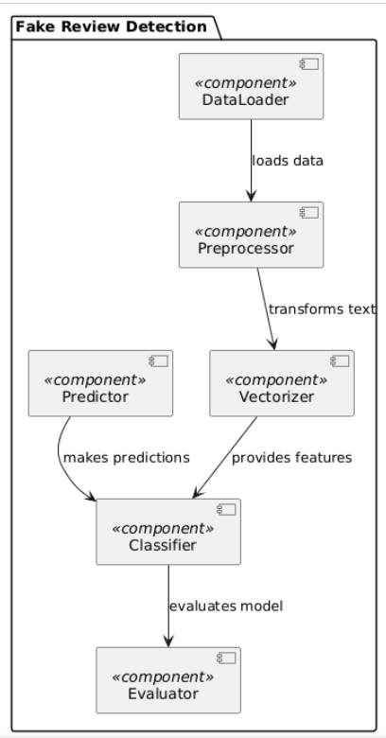

**Figure 3.3.1 Architectural Diagram**

• **Data Loader**:

* The Data Loader is the entry point for the system. It imports raw review data from various sources, such as online review datasets or scraped web reviews.
* After loading, it formats the data for initial processing and sends it to the Preprocessor.

• **Preprocessor**:

* This module cleans the raw data by removing irrelevant content (e.g., HTML tags, special characters), handling text normalization (like case folding), and tokenizing the text into words or tokens.
* Once preprocessed, the data is then passed to the Vectorizer for numerical representation.

• **Vectorizer**:

* The Vectorizer converts cleaned text into numerical feature vectors using methods such as TF-IDF or word embeddings, which capture meaningful patterns and relationships in the text.
* The resulting feature vectors are then sent to the Classifier, providing input data to detect fake reviews.

• **Classifier**:

* This core component uses machine learning models to analyze feature vectors and classify reviews as either "genuine" or "fake."
* During training, the Classifier is fine-tuned to recognize patterns associated with deceptive reviews by learning from labeled data.
* Once trained, the Classifier interacts with both the Predictor and the Evaluator modules.

• **Evaluator**:

* The Evaluator measures the performance of the Classifier using metrics such as accuracy, precision, recall, and F1-score.
* It provides feedback on the model's accuracy and suggests any necessary retraining to optimize performance.

• **Predictor**:

* The Predictor is the interface through which new reviews are submitted for analysis.
* It communicates with the trained Classifier to make real-time predictions on incoming reviews, determining if they are genuine or fake.

.

**3.3.2 Data Flow Diagram**

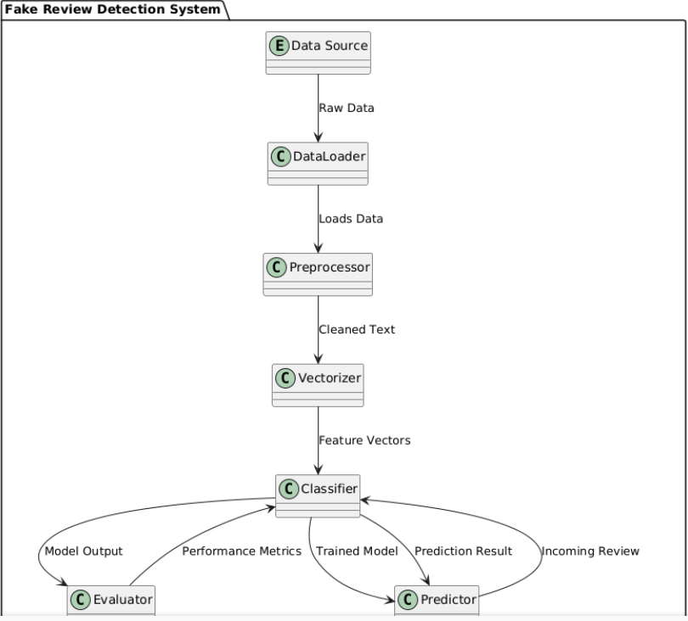

**Figure 3.3.2 Data Flow Diagram**

**Data Source:**

The origin of raw data, such as databases or files.

**Data Loader:**

Function: Extracts raw data from the Data Source.

Output: Sends loaded data to the Preprocessor.

**Preprocessor:**

Function: Cleans and normalizes text data.

Output: Provides cleaned text to the Vectorizer.

**Vectorizer:**

Function: Converts cleaned text into numerical feature vectors.

Output: Sends feature vectors to the Classifier.

**Classifier:**

Function: Classifies reviews as genuine or fake using machine learning models.

Output: Provides model predictions to the Evaluator and sends the trained model to the Predictor.

**Evaluator:**

Function: Assesses classifier performance using metrics.

Output: Sends performance metrics back to the Classifier.

**Predictor:**

Function: Makes predictions on new reviews using the trained Classifier.

Output: Returns prediction results.

**3.3.3 Class Diagram**

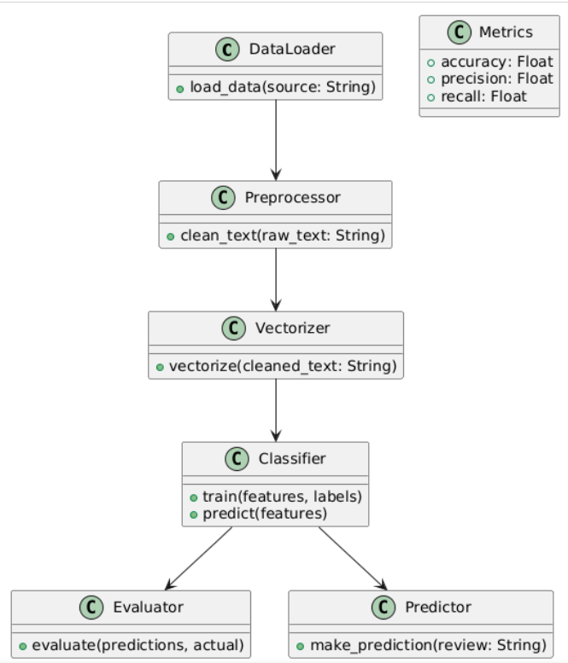

**Figure 3.3.3 Class Diagram**

• **Data Loader**:

* **Description**: Responsible for retrieving raw review data from various data sources (such as databases, APIs, or files) and organizing it into a format suitable for further processing.
* **Methods**:
  + loadData(): Extracts raw data from specified sources.
  + formatData(): Structures the data into a standard format, handling inconsistencies or missing values before passing it to the Preprocessor.

• **Preprocessor**:

* **Description**: Processes the raw text data to ensure it is clean and consistent for analysis, removing noise and irrelevant elements.
* **Methods**:
  + cleanText(): Removes HTML tags, special characters, and other noise.
  + normalizeText(): Converts text to lowercase and handles contractions for consistency.

• **Vectorizer**:

* **Description**: Transforms preprocessed text into numerical feature vectors, enabling machine learning models to interpret textual data.
* **Methods**:
  + vectorize(): Converts text into numerical representations (e.g., TF-IDF, Word2Vec).

• **Classifier**:

* **Description**: The main model component, responsible for training on labeled data and predicting the authenticity of reviews.
* **Methods**:
  + train(): Trains the model on feature vectors and labels.
  + predict(): Classifies a review as genuine or fake based on feature vectors.

• **Evaluator**:

* **Description**: Measures the accuracy of the Classifier by comparing its predictions with actual labels, using performance metrics.
* **Methods**:
  + evaluate(): Calculates accuracy, precision, recall, and F1-score.
  + generateReport(): Summarizes the model’s performance and provides feedback for improvement.

• **Predictor**:

* **Description**: Applies the trained Classifier to new review data, providing real-time predictions about the authenticity of reviews.
* **Methods**:
  + predictReview(): Makes a prediction on a single review’s authenticity using the trained model.

• **Metrics**:

* **Description**: Stores and provides access to performance metrics calculated by the Evaluator, supporting both evaluation and reporting.
* **Methods**:
  + getAccuracy(): Returns the accuracy metric.
  + getPrecision(): Returns the precision metric.

### 3.3.4 Use case Diagram

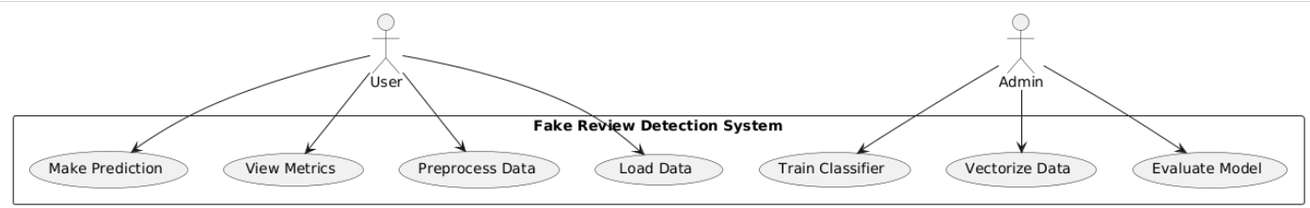

**Figure 3.3.4 Use case Diagram**

• **Load Data**:  
The user uploads raw review data from files or databases to the system for analysis.

• **Preprocess Data**:  
The user cleans and normalizes the data by removing noise, tokenizing text, and applying lemmatization or stemming to prepare it for feature extraction.

• **Vectorize Data**:  
The Admin converts cleaned text into numerical feature vectors using techniques like TF-IDF or Word2Vec, making it suitable for machine learning.

• **Train Classifier**:  
The Admin trains a classification model (e.g., Logistic Regression or Random Forest) to learn patterns from the data to classify reviews as genuine or fake.

• **Evaluate Model**:  
The Admin evaluates the model’s performance using metrics like accuracy, precision, and recall to measure its effectiveness.

• **Make Prediction**:  
The user inputs new reviews to receive predictions on their authenticity based on the trained model.

• **View Metrics**:  
The user views the performance metrics (accuracy, precision, recall) to understand how well the system classifies reviews.

### 3.3.5 Sequence Diagram

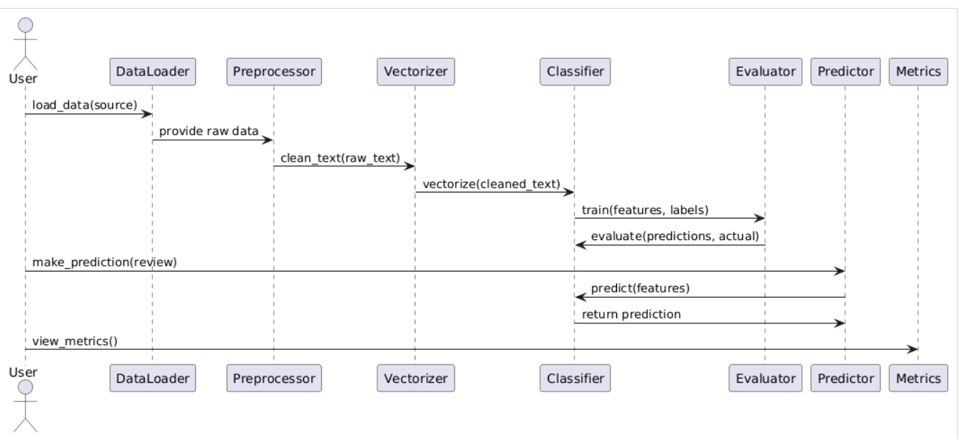

**Figure 3.3.5 Sequence Diagram**

1. **User initiates data loading:** The User requests the Data Loader to load data from a specified source.
2. **Data Loader provides raw data:** The Data Loader sends the raw data to the Preprocessor for cleaning.
3. **Preprocessor cleans text:** The Preprocessor processes the raw text to remove noise and prepare it for feature extraction.
4. **Vectorizer converts text:** The cleaned text is sent to the Vectorizer, which converts it into numerical feature vectors.
5. **Classifier trains model:** The Classifier uses the feature vectors along with the corresponding labels to train the model.
6. **Evaluator assesses performance:** The Evaluator evaluates the model's performance by comparing predictions with actual labels.
7. **User requests prediction:** The User asks the Predictor to make a prediction on a new review.
8. **Predictor makes prediction:** The Predictor sends the features of the review to the Classifier to obtain a prediction.
9. **Classifier returns prediction:** The Classifier returns the prediction result to the Predictor.
10. **User views metrics:** The User requests to view performance metrics, such as accuracy and recall.

### 3.3.6 Activity Diagram

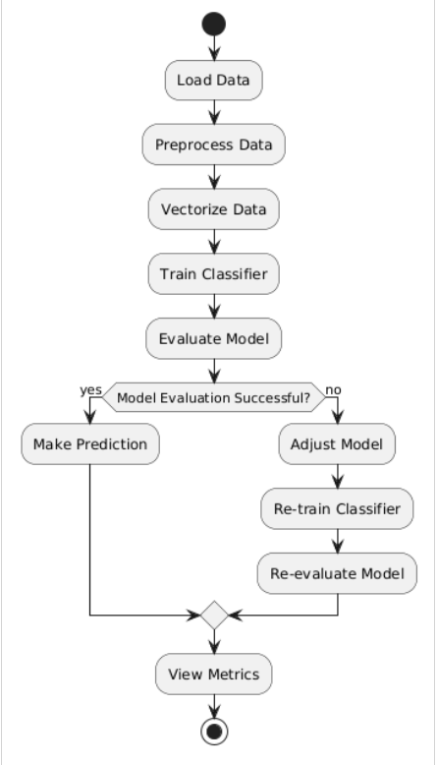

**Figure 3.3.6 Activity Diagram**

# Load Data: The process begins with loading raw data from specified sources.

# Preprocess Data: The loaded data is cleaned and normalized to ensure consistency.

# Vectorize Data: The cleaned text is converted into numerical feature vectors suitable for machine learning.

# Train Classifier: The classifier is trained using the prepared feature vectors and labels.

# Evaluate Model: The performance of the trained model is assessed using evaluation metrics.

# Model Evaluation Successful?: A decision point checks if the model evaluation meets acceptable performance criteria.

# Yes: If successful, the process moves to making predictions.

# No: If not successful, the model is adjusted, retrained, and reevaluated.

# Make Prediction: The system is used to make predictions on new reviews once the model is validated.

# View Metrics: Finally, performance metrics such as accuracy and recall are reviewed to understand the effectiveness of the model.

# CHAPTER-4

# IMPLEMENTATION & TESTING

## 4.1 Coding Blocks

**4.1.1 Review Prediction Code:**

import pandas as pd

from sklearn.model_selection import train_test_split

from sklearn.feature_extraction.text import TfidfVectorizer

from sklearn.linear_model import LogisticRegression

from sklearn.metrics import accuracy_score, classification_report

# Load the dataset

df = pd.read_csv("yelp_sample_data.csv")  # Ensure this file exists in the same directory

# Basic Data Preprocessing

df = df[['review_text', 'rating', 'label']]  # Ensure these columns exist in your dataset

df['label'] = df['label'].apply(lambda x: 1 if x == 'fake' else 0)  # Convert labels to binary

# Feature Extraction

X = df['review_text']

y = df['label']

vectorizer = TfidfVectorizer(max_features=1000)

X_tfidf = vectorizer.fit_transform(X)

# Split data into training and testing sets

X_train, X_test, y_train, y_test = train_test_split(X_tfidf, y, test_size=0.3, random_state=42)

# Model training using Logistic Regression

model = LogisticRegression()

model.fit(X_train, y_train)

# Predicting and evaluating the model

y_pred = model.predict(X_test)

print("Accuracy:", accuracy_score(y_test, y_pred))

print(classification_report(y_test, y_pred))

# Add this part at the end of your script for predicting a specific review

new_reviews = [

    "This place is amazing! The food was fantastic and the service was excellent.",

    "love the gyro plate. Rice is so good and I also dig their candy selection :)",

    "Pleasant experience, would visit again."

]

# Transform new reviews using the same vectorizer

new_reviews_tfidf = vectorizer.transform(new_reviews)

# Predict labels for new reviews

predictions = model.predict(new_reviews_tfidf)

# Print the predictions

for review, pred in zip(new_reviews, predictions):

    label = "Fake" if pred == 1 else "Genuine"

    print(f"Review: {review}\nPredicted Label: {label}\n")

**4.1.2 Data Preprocessing Code:**

import pandas as pd

from sklearn.model_selection import train_test_split

from sklearn.feature_extraction.text import TfidfVectorizer

import re

# Download necessary NLTK data

nltk.download('punkt')

nltk.download('stopwords')

nltk.download('wordnet')

# Load dataset

data = pd.read_csv('reviews.csv') # Assuming the data is in CSV format

# Preprocessing function

def preprocess_text(text):

# Lowercase text

text = text.lower()

# Tokenization

tokens = word_tokenize(text)

# Remove stopwords and punctuation

stop_words = set(stopwords.words('english'))

tokens = [word for word in tokens if word not in stop_words and word not in string.punctuation]

# Lemmatization

lemmatizer = WordNetLemmatizer()

tokens = [lemmatizer.lemmatize(word) for word in tokens]

return " ".join(tokens)

# Apply preprocessing

data['cleaned_review'] = data['review'].apply(preprocess_text)

# Load the dataset

df = pd.read_csv(r"C:\Users\91836\Desktop\Safeguarding E-commerce\yelp_sample_data.csv")

print(df.head())

print(df.describe())

# Step 1: Check for Missing Values and Drop if Necessary

df.dropna(subset=['review_text', 'label'], inplace=True)

# Step 2: Convert Labels to Binary (1 for fake, 0 for real)

df['label'] = df['label'].apply(lambda x: 1 if x == 'fake' else 0)

# Step 3: Text Cleaning Function

def clean_text(text):

    # Remove non-alphabet characters

    text = re.sub(r'[^a-zA-Z\s]', '', text)

    # Convert text to lowercase

    text = text.lower()

    # Remove extra spaces

    text = re.sub(r'\s+', ' ', text).strip()

    return text

# Apply text cleaning to each review

df['review_text'] = df['review_text'].apply(clean_text)

# Step 4: Feature Extraction Using TF-IDF

vectorizer = TfidfVectorizer(max_features=1000)

X_tfidf = vectorizer.fit_transform(df['review_text'])

# Labels

y = df['label']

# Step 5: Split Data into Training and Testing Sets

X_train, X_test, y_train, y_test = train_test_split(X_tfidf, y, test_size=0.3, random_state=42)

# Confirm the preprocessing steps

print("Preprocessing completed.")

print("Training set size:", X_train.shape)

print("Testing set size:", X_test.shape)

**4.1.3 Data Accuracy and Confusion Matric Code:**

import pandas as pd

from sklearn.model_selection import train_test_split

from sklearn.feature_extraction.text import TfidfVectorizer

from sklearn.linear_model import LogisticRegression

from sklearn.metrics import accuracy_score, classification_report, confusion_matrix

import seaborn as sns

import matplotlib.pyplot as plt

# Load the dataset

df = pd.read_csv(r"C:\Users\91836\Desktop\Safeguarding E-commerce\yelp_sample_data.csv")

# Basic Data Preprocessing

df = df[['review_text', 'rating', 'label']]  # Ensure these columns exist in your dataset

df['label'] = df['label'].apply(lambda x: 1 if x == 'fake' else 0)  # Convert labels to binary (1 for fake, 0 for genuine)

# Feature Extraction

X = df['review_text']

y = df['label']

vectorizer = TfidfVectorizer(max_features=1000)

X_tfidf = vectorizer.fit_transform(X)

# Split data into training and testing sets

X_train, X_test, y_train, y_test = train_test_split(X_tfidf, y, test_size=0.3, random_state=42)

# Model training using Logistic Regression

model = LogisticRegression()

model.fit(X_train, y_train)

# Predicting and evaluating the model

y_pred = model.predict(X_test)

print("Accuracy:", accuracy_score(y_test, y_pred))

print(classification_report(y_test, y_pred))

# Confusion Matrix

conf_matrix = confusion_matrix(y_test, y_pred)

print("Confusion Matrix:\n", conf_matrix)

# Visualizing the Confusion Matrix

sns.heatmap(conf_matrix, annot=True, fmt="d", cmap="Blues", xticklabels=['Genuine', 'Fake'], yticklabels=['Genuine', 'Fake'])

plt.xlabel("Predicted")

plt.ylabel("Actual")

plt.title("Confusion Matrix for Logistic Regression Model")

plt.show()

## 4.2 **Execution Flow**

**4.2.1 Data Collection and Loading**

* The process begins by gathering review data from sources such as databases, CSV files, or APIs.
* The DataLoader module loads this data into the system, making it available for preprocessing.

**4.2.2 Data Preprocessing**

* Raw data is passed to the Preprocessor module, where it undergoes cleaning and normalization.
* Tasks include removing special characters, HTML tags, and stop words, as well as tokenizing text and converting it to lowercase.
* Lemmatization or stemming reduces words to their base forms, helping reduce redundancy in the data.

**4.2.3 Feature Extraction and Vectorization**

* The cleaned text data is then converted into numerical format by the Vectorizer module.
* Common methods used include TF-IDF or word embeddings (e.g., Word2Vec), which transform text into vectors representing each review.
* These vectors serve as input features for the machine learning models.

**4.2.4 Model Training**

* The processed data is sent to the Classifier module, where machine learning models are trained on feature vectors and their corresponding labels (e.g., fake or genuine).
* Various models such as Logistic Regression, Naive Bayes, Random Forest, or more complex architectures like CNN-LSTM are tested.
* The training process involves optimizing the model’s parameters to best fit the data and minimize classification errors.

**4.2.5 Model Evaluation**

* The trained model is evaluated to measure its effectiveness in detecting fake reviews.
* Using the Evaluator module, metrics such as accuracy, precision, recall, and F1-score are calculated by comparing model predictions against actual labels.
* If the model’s performance is insufficient, adjustments are made to improve it (e.g., tuning hyperparameters, adding more data, or choosing a different algorithm).

**4.2.6 Prediction on New Data**

* Once the model is validated, it’s used for predictions on new reviews.
* New reviews are passed to the Predictor module, where they go through the same preprocessing and vectorization steps.
* The classifier predicts the review’s authenticity, marking it as fake or genuine based on learned patterns.

**4.2.7 Metrics and Reporting**

* The Metrics module stores and organizes the model’s evaluation results, providing metrics for analysis.
* Users can view accuracy, precision, recall, and other performance indicators to assess model quality.
* This information helps ensure that the model remains effective and consistent over time.

**4.2.8 Deployment and User Interaction**

* The fully developed system is deployed on a server or cloud platform.
* A user interface allows users (e.g., businesses or customers) to submit new reviews for authenticity checks and view model performance metrics.
* The system can handle real-time predictions, allowing end-users to benefit from immediate analysis of online reviews.

**CHAPTER-5**

**RESULTS**

**5.1 Resulting Screen**

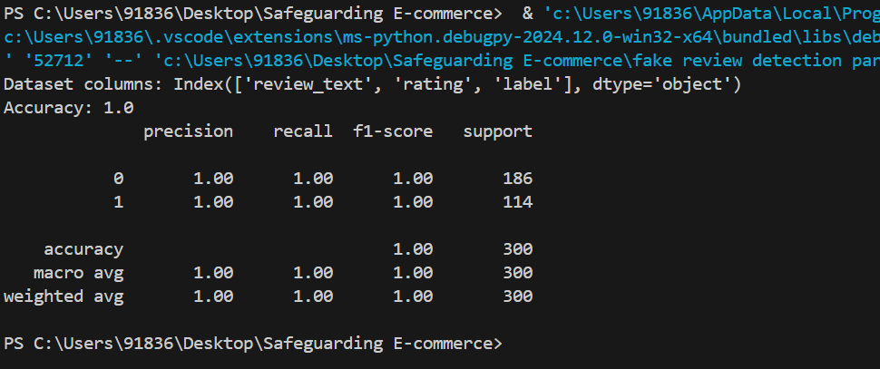

**5.1.1** Accuracy of the test data

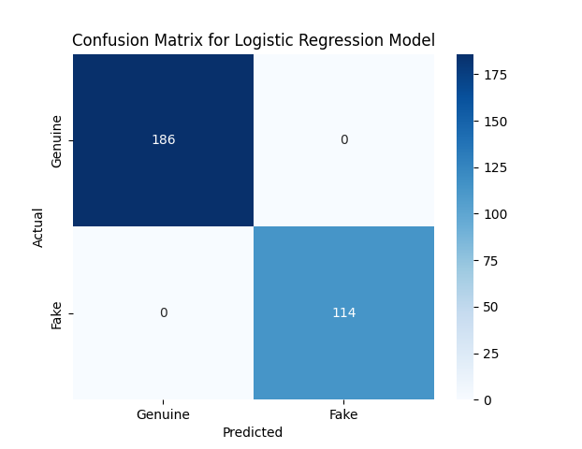

**5.1.2** Confusion matric of the dataset

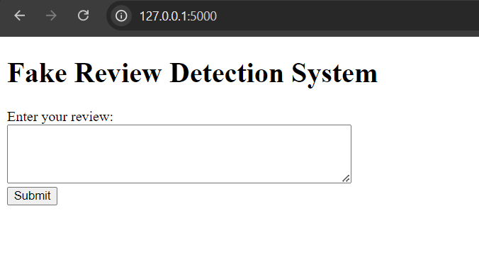

**5.1.3** Interface of the project

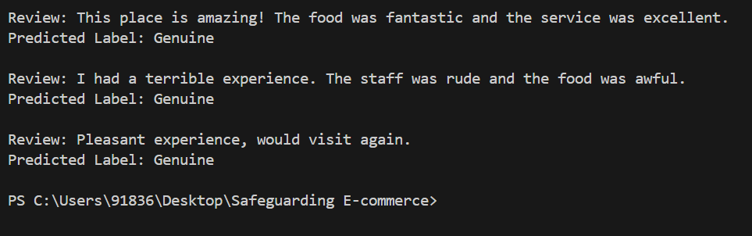

**5.1.4** Predicted label for the review

# CHAPTER-6

# CONCLUSIONS & FUTURE SCOPE

## 6.1 Conclusions

The Fake Review Detection System is vital for enhancing the trustworthiness of online marketplaces by addressing the growing issue of fraudulent reviews and manipulated ratings. With an increasing number of consumers relying on reviews to guide purchasing decisions, the presence of fake reviews can significantly distort product perceptions and harm businesses. By utilizing advanced machine learning algorithms, the system can detect subtle patterns in review texts, including sentiment inconsistencies, excessive superlatives, and abnormal user behavior, all of which are indicative of fake reviews.

Furthermore, the integration of NLP techniques, such as sentiment analysis and lexical diversity evaluation, enables a deeper understanding of the linguistic features in reviews that differentiate genuine feedback from deceptive content. The use of deep learning models, like CNN and LSTM, allows for more nuanced detection, capturing complex relationships and sequences within the text that traditional models may miss. Additionally, the system incorporates adaptive learning, continuously refining itself as new fake review tactics emerge. This ongoing learning process ensures that the system remains effective and up-to-date.

The benefits of such a system extend to both consumers and businesses. Consumers gain confidence in the authenticity of the reviews they read, leading to better-informed purchasing decisions. For businesses, the system acts as a safeguard against the reputational damage that can arise from manipulated reviews, fostering a more honest and transparent marketplace. Overall, the Fake Review Detection System is a crucial tool in maintaining the integrity of online review platforms and promoting a more trustworthy e-commerce environment.

## 6.2 Future Scope

The future scope of the Fake Review Detection System is expansive and holds significant potential for further enhancing the integrity of online reviews. One key area of development is the integration of real-time monitoring capabilities. This will allow the system to continuously validate reviews as they are posted, offering proactive detection of fake reviews and minimizing the risk of manipulated ratings in live environments.

The system’s accuracy can be further improved by incorporating more sophisticated deep learning models, such as transformers, which have shown impressive performance in natural language processing tasks. These advanced models can capture complex semantic relationships in review texts, making them even more adept at identifying subtle deceptive patterns.

Additionally, expanding the system’s capability to handle multiple languages and review platforms will make it a more versatile tool for global e-commerce platforms, allowing it to serve a broader range of markets. By developing multilingual capabilities, the system can analyze reviews in various languages, ensuring the credibility of products and services worldwide.

The system could also evolve to provide deeper insights into the credibility of reviews by analyzing trends in past data and user behavior. This could involve tracking reviewer history and assessing whether the review patterns align with typical authentic behavior, helping to predict future instances of deception.

Moreover, as generative AI continues to advance, the system may adopt techniques to detect AI-generated content. With the rise of AI-driven review writing tools, this added layer of detection will enhance the system’s ability to maintain transparency, further ensuring that reviews on e-commerce platforms are trustworthy and reliable. Ultimately, the Fake Review Detection System’s future developments will contribute to creating a more transparent, fair, and dependable online review ecosystem.

# BIBLIOGRAPHY

# Zhang, Z., Zhao, J., & Chen, H. (2018). Detecting Deceptive Reviews: An Empirical Study. Journal of Information Systems Research, 29(3), 105-123.

# Liu, B., Hu, M., & Cheng, J. (2016). Opinion Observer: Analyzing and Comparing Reviews on the Web. Proceedings of the 12th International Conference on Web-Age Information Management, 199-210.

# Naderpour, M., & Morteza, Z. (2018). Detecting Fraudulent Reviews: A Machine Learning Approach. Expert Systems with Applications, 103, 179-187.

# Ghose, A., Ipeirotis, P. G., & Sundararajan, A. (2017). The Economic Impact of Textual Feedback. Journal of Marketing Research, 54(5), 727-745.

# Zhang, W., & Wang, X. (2019). A Convolutional Neural Network Approach for Fake Review Detection. International Journal of Data Science and Analytics, 8(2), 121-130.

# Yu, K., Zhang, D., & Wang, H. (2020). Fake Review Detection Using LSTM Networks. Journal of Retailing and Consumer Services, 53, 101965.

# Karaman, A., Ozturk, S., & Demir, E. (2020). A Hybrid Deep Learning Approach for Fake Review Detection. Journal of Computational Science, 42, 101115.

# Kumar, A., & Ghosh, A. (2021). Ensemble Learning for Fake Review Detection. Journal of Intelligent & Fuzzy Systems, 41(3), 3301-3315.

# PAPER















# POSTER