**Life Expectancy: A Data-Driven Exploration and Prediction**

**Final Project Report**

Group 13

Sai Varun Kumar Namburi

Prajwal Srinivas

[namburi.sai@northeastern.edu](mailto:namburi.sai@northeastern.edu)

[srinivas.pra@northeastern.edu](mailto:srinivas.pra@northeastern.edu)

**Percentage of Effort Contributed by Student1: 50%**

**Percentage of Effort Contributed by Student2: 50%**

**Signature of Student 1: Sai Varun**

**Signature of Student 2: Prajwal**

**Date of Submission: 23rd Apr 2023**

# Problem Statement:

Previous investigations into the determinants of life expectancy have been limited by a lack of consideration for the effects of immunization and the human development index. This project endeavors to address these shortcomings through a comprehensive analysis utilizing mixed-effects models and multiple linear regressions on data spanning the years 2000 to 2015, inclusive of all countries. Key immunizations such as Hepatitis B, Polio, and Diphtheria will be integrated into the study, along with several other critical factors, including mortality, economics, social factors, and overall health. By leveraging data from multiple countries, this study will facilitate the identification of key predictors of life expectancy, providing a foundation for evidence-based interventions to enhance population health outcomes. Ultimately, this research will contribute invaluable insights into the multifaceted nature of life expectancy.

**Objective:**

* The objective of this study is to conduct a thorough examination of the relationship between selected predictive factors and life expectancy.
* This research aims to delve into the specific predictive variables that have a significant impact on life expectancy.
* The question of whether increased healthcare expenditure is an effective strategy for countries with life expectancy values below 65 will be thoroughly addressed.
* This study will shed light on the crucial role that infant and adult mortality rates play in determining life expectancy.
* An investigation will be carried out to explore the potential correlation between life expectancy and various lifestyle factors such as eating habits, exercise, smoking, and alcohol consumption.
* The impact of education level on life expectancy will be evaluated through a comprehensive analysis.
* The potential correlation between alcohol consumption and life expectancy will be explored through a systematic examination.
* The study will investigate the impact of immunization coverage on life expectancy, with a focus on uncovering any correlations between the two factors.

# Data Source:

This dataset is taken from kaggle.com

<https://www.kaggle.com/code/philbowman212/life-expectancy-exploratory-data-analysis/data>

# Data Description:

The World Health Organization's Global Health Observatory (GHO) maintains records of the health status and related factors of all countries. The data concerning life expectancy and health factors for 193 countries were obtained from the WHO's Global Health Observatory data repository. It was noted that over the past 15 years, there has been significant progress in the health sector, leading to a significant improvement in human mortality rates, particularly in developing nations compared to the last 30 years. In this project, data from the years 2000 to 2015 for 193 countries were selected for further analysis. In this dataset, we have 22 columns as below

(Country, Year, Status, Life expectancy, Adult Mortality, infant deaths, Alcohol, percentage expenditure, Hepatitis B, Measles, BMI, under-five deaths, Polio, Total expenditure, Diphtheria, HIV/AIDS, GDP, Population, thinness 1-19 years, thinness 5-9 years, Income composition of resources, Schooling)

# Data Collection:

Life expectancy data has been gathered from a data repository called “Kaggle”. Information on 2938 records is captured in 22 columns. There is a total of 2 categorical and 20 numerical columns in the data.

**Columns Description:**

1. "Country": The name of the country is analyzed.
2. "Year": The year the data was collected.
3. "Status": Indicates the status of the country, such as "Developed" or "Developing".
4. "Life expectancy": The average number of years a person is expected to live in a specific geographic location.
5. "Adult Mortality": The number of deaths of individuals aged 15 to 60 years per 1,000 individuals in that age group.
6. "Infant Deaths": The number of deaths of infants under one year of age per 1,000 live births.
7. "Alcohol": The average amount of alcohol consumed by individuals in a specific geographic location.
8. "Percentage expenditure": The percentage of the government's total health expenditure spent on healthcare.
9. "Hepatitis B": The coverage rate of the hepatitis B vaccine in a specific geographic location.
10. "Measles": The number of reported cases of measles per 1,000 individuals.
11. "BMI": The average body mass index of individuals in a specific geographic location.
12. "Under-five Deaths": The number of deaths of children under five years of age per 1,000 live births.
13. "Polio": The coverage rate of the polio vaccine in a specific geographic location.
14. "Total expenditure": The total amount of money spent on healthcare by the government in a specific geographic location.
15. "Diphtheria": The coverage rate of the diphtheria vaccine in a specific geographic location.
16. "HIV/AIDS": The number of reported cases of HIV/AIDS in a specific geographic location.
17. "GDP": The gross domestic product of a specific geographic location.
18. "Population": The total population of a specific geographic location.
19. "Thinness 1-19 years": The percentage of individuals aged 1 to 19 years who are underweight in a specific geographic location.
20. "Thinness 5-9 years": The percentage of individuals aged 5 to 9 years who are underweight in a specific geographic location.
21. "Income composition of resources": The distribution of income in a specific geographic location.
22. "Schooling": The average number of years of schooling for individuals in a specific geographic location.

# Data Cleaning:

# The info() method provides useful information about the data frame, including its shape, column names, the number of non-null values in each column, and the data types of each column. It can be a helpful tool for getting a quick overview of your data.

Check the Checking null values present in each column by using the below command:

# Data Exploration:

Dealing with missing data:

Percentage of Null Values for each column:

Treat null values using interpolation:

Alcohol null values and imputing it:

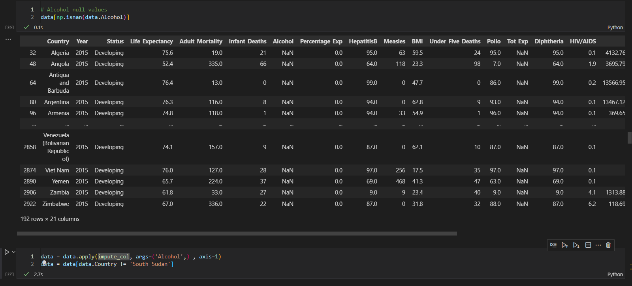

BMI null values::

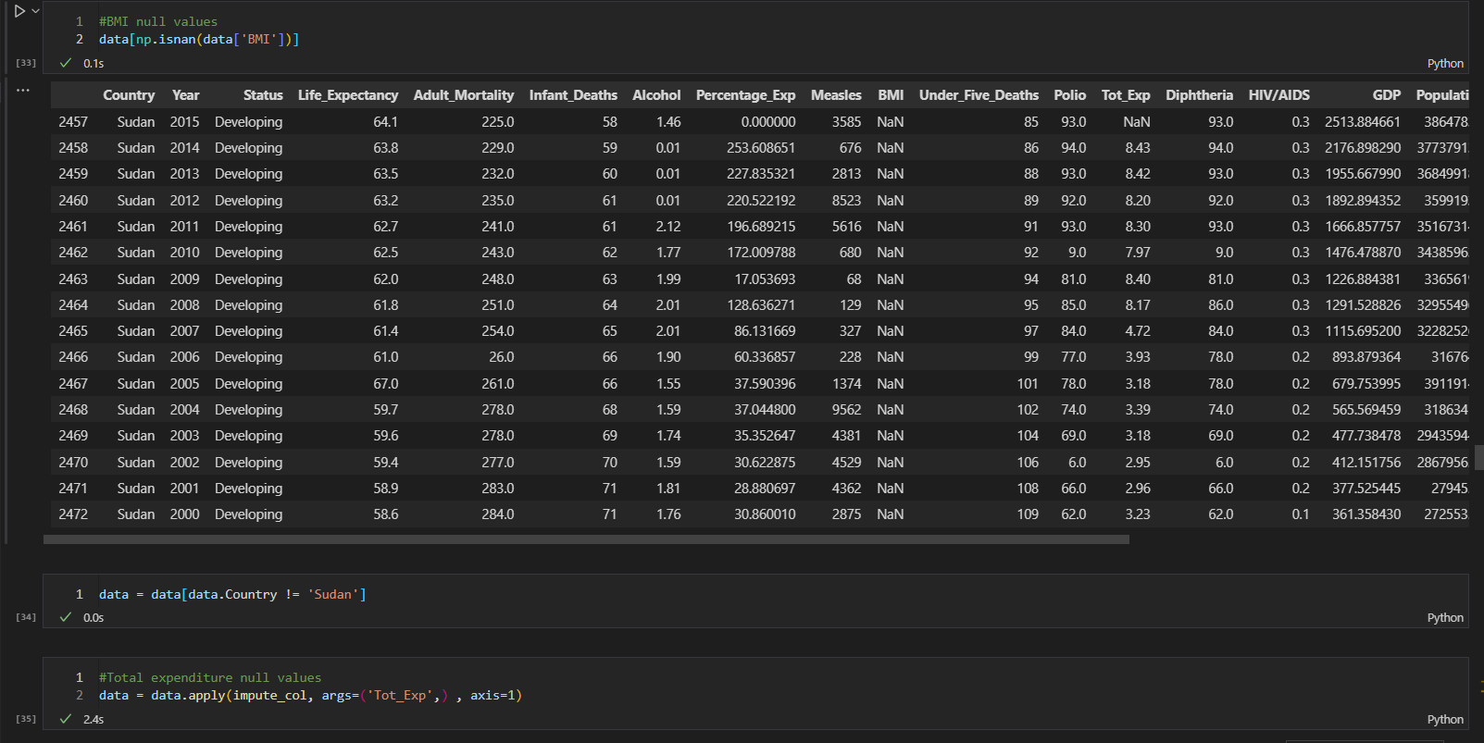

Impute the total expenditure null values

Population null values and imputing it with mean

Removing the unnecessary columns and imputing them with mean

Above we can see that now we don’t have any null values

# Data Visualizations:

Distribution of the response variables

Grouping the data based on status and avg life expectancy

Boxplot grouped by country life expectancy

Plotting the graph for the below four countries and grouping it with mean

Plotting a bar graph where we group data by each year

Finding a covariance and plotting a heatmap among variables

Observation

* Life Expectancy has a negative correlation with adult mortality
* Life Expectancy has a strong correlation with Schooling and Income composition of resources
* The strong correlation between thinness_1to19_years and thinness_5to9_years
* There is a non-negligible correlation between Life Expectancy and BMI and body diseases

**Outliers:**

# Feature Selection:

The life expectancy dataset contains a few features that could potentially be used to predict life expectancy. Here are some possible steps for feature selection.

1. Identify the target variable: In this case, the target variable is life expectancy.
2. Explore the data: Look at the distribution and relationships between each feature and the target variable. This can be done using descriptive statistics, visualizations (e.g. scatterplots, histograms, boxplots), and correlation matrices.
3. Consider feature relevance: Determine which features are likely to be relevant for predicting life expectancy based on prior knowledge, domain expertise, and common sense. For example, factors such as income, access to healthcare, and education are likely to be relevant.
4. Remove redundant features: If multiple features are highly correlated with each other, consider removing one of them to avoid overfitting.
5. Use feature selection techniques: There are a variety of feature selection techniques that can be used to select the most important features for predicting life expectancy.

These include

* Correlation-based feature selection: This method involves selecting features that are highly correlated with the target variable.
* Wrapper methods: These methods involve selecting subsets of features and evaluating the performance of a predictive model using only those features.
* Embedded methods: These methods involve incorporating feature selection into the process of building a predictive model, such as by using regularization techniques like Lasso or Ridge regression.

1. Evaluate the selected features: Once a set of features has been selected, evaluate the performance of a predictive model using only those features. This can be done using techniques such as cross-validation or hold-out validation
2. Iterate: If the performance of the predictive model is not satisfactory, consider revisiting previous steps and making adjustments to the feature selection process.

Ultimately, the choice of feature selection method will depend on the dataset's specific characteristics and the analysis's goals.

# Feature Engineering

Feature engineering is the process of selecting, transforming, and creating new features from the raw data to improve the performance of machine learning models. Feature engineering aims to make the data more informative and easier for machine learning algorithms to process.

In the context of life expectancy data, feature engineering can involve creating new variables or transforming existing ones to better capture the factors that influence life expectancy. Some examples of feature engineering for life expectancy data include:

1. Creating aggregate measures: Aggregating data for each region by taking the mean or median of several variables such as education, income, and healthcare access can help capture the overall quality of life in each region.
2. Scaling and normalization: Scaling and normalization of the data can make features more comparable and easier for models to work with. This is particularly useful for variables with different units of measurement, such as income and education.
3. Time-series features: Creating new variables that capture trends, seasonality, or periodicity in life expectancy data over time can be used to help models account for the temporal dynamics in life expectancy.
4. Feature interaction: Interactions between features can help to better capture their joint effects on life expectancy. For instance, interaction features such as the product of education and income could provide a better measure of socioeconomic status than each variable individually.
5. Age transformation: Age is one of the most important predictors of life expectancy, and its relationship with life expectancy is often nonlinear. Transforming age by taking its square or logarithm can help capture this nonlinearity.

Feature engineering can help to identify and capture the most important factors that influence life expectancy. This, in turn, can improve the performance of machine learning models, providing more accurate predictions of life expectancy. By carefully selecting and transforming features, feature engineering can help to create more powerful models that can better understand and predict life expectancy.

# Model Exploration:

Model exploration involves understanding the performance and behavior of a model on a given dataset. Here are some steps for model exploration with the life expectancy data:

1. Split the data into training and testing sets: Divide the dataset into two parts - a training set and a testing set. The training set will be used to train the model, and the testing set will be used to evaluate the model's performance.
2. Train a baseline model: Start by training a simple baseline model, such as linear regression, to establish a baseline level of performance.
3. Explore hyperparameters: Explore the hyperparameters of the model to find the best combination for the given data. For example, in a decision tree model, hyperparameters may include the maximum depth of the tree, the minimum number of samples required to split a node, and the maximum number of features to consider at each split.
4. Evaluate performance: Evaluate the performance of the model on the testing set using appropriate metrics, such as mean squared error or R-squared for regression models, or accuracy and precision for classification models.
5. Visualize results: Visualize the results of the model exploration process to gain insights into the behavior of the model. For example, plot the learning curves to see how the performance of the model changes as the size of the training set increases.
6. Repeat: Iterate through the steps above, trying out different models and hyperparameters to improve the performance of the model.
7. Explain the model: Finally, it's important to understand how the model is making predictions. For example, for a decision tree model, you can visualize the decision rules used to make predictions. For more complex models like neural networks, you may need to use techniques like LIME or SHAP to understand how the model is making decisions.

By exploring different models and hyperparameters, and visualizing the results, you can gain insights into the behavior of the model and make informed decisions about which model to use for predicting life expectancy.

Different Types of Models Possible for the Life Expectancy Dataset

There is no "best" model for the life expectancy data, as the choice of model will depend on the specific characteristics of the dataset and the goals of the analysis. However, some commonly used models for predicting life expectancy include linear regression, decision trees, random forests, and neural networks.

1. Linear regression is a simple and interpretable model that can be used to identify the relationship between life expectancy and a set of predictor variables. However, it assumes a linear relationship between the target variable and the predictors and may not capture more complex relationships.
2. Decision trees and random forests are tree-based models that can capture nonlinear relationships and interactions between features. They are also relatively interpretable, as the decision rules used to make predictions can be visualized.
3. Neural networks are a powerful class of models that can capture complex relationships and interactions between features. However, they can be difficult to interpret and may require more data and computational resources than simpler models.
4. Ultimately, the choice of model will depend on the goals of the analysis, the size and quality of the dataset, the computational resources available, and the trade-off between model interpretability and performance. It is important to evaluate the performance of multiple models and compare their strengths and weaknesses before making a final decision.

# Implementation of Selected Model:

We have decided to use Linear Regression, a Mixed Effect Model, and a Neural Network

**Linear Regression:**

Linear Regression is a simple and widely used statistical model for predicting a continuous outcome variable based on one or more predictor variables. It assumes a linear relationship between the outcome variable and the predictors, which can be limiting in cases where the relationship is more complex.

In this model, life expectancy would be the dependent variable or the outcome variable, and the predictor variables would be the independent variables. The goal is to find a linear relationship between the outcome and predictor variables.

To build a linear regression model for life expectancy, you would need a dataset that includes observations of individuals along with their ages, sex, education, income, health behaviors, and life expectancy. You would use this dataset to estimate the linear regression equation coefficients and make predictions for new individuals.

It is important to note that linear regression assumes that the relationship between the outcome variable and the predictor variables is linear. Additionally, it assumes that the errors or residuals are normally distributed and have constant variance. Therefore, you should assess the assumptions of the linear regression model before using it to make predictions.

**Mixed Effect Model:**

A mixed-effects model can be a useful approach to analyze life expectancy data when there are repeated measurements on the same individuals, or when individuals are nested within groups (e.g., cities, countries, or families).

In a mixed-effects model, there are both fixed effects and random effects. Fixed effects are the variables that have a consistent effect on the outcome variable across all levels of the factor. Random effects are variables that affect the outcome variable that varies across different levels of the factor.

For example, if you are analyzing life expectancy data for individuals in different cities, the city can be a random effect because life expectancy may differ across different cities, but the effect of the city on life expectancy may not be the same for all individuals.

To build a mixed-effects model for life expectancy, you would need to identify the fixed and random effects and include them in the model. The fixed effects can include variables such as age, sex, education, and income. The random effects can include variables such as city, family, or other group identifiers.

Mixed-effects models have the advantage of accounting for the correlation between observations within the same individual or group, which can lead to more accurate estimates of the effects of the predictor variables on the outcome variable. However, the interpretation of the model coefficients may be more complex compared to a simple linear regression model.

It is important to note that mixed-effects models assume that the random effects are normally distributed and have a constant variance across the different levels of the factor. Therefore, you should assess the assumptions of the mixed-effects model before using it to make predictions.

Residual Plot for Predicted Values

**Neural Networks Model:**

A neural network can be a powerful approach for predicting life expectancy based on a wide range of predictor variables. Neural networks are a type of machine learning model that can learn complex non-linear relationships between input and output variables.

To build a neural network model for life expectancy, you would need a dataset that includes observations of individuals along with their ages, sex, education, income, health behaviors, and life expectancy. You would use this dataset to train the neural network to predict life expectancy based on the predictor variables.

The neural network would consist of layers of interconnected nodes, with each node representing a mathematical function that combines the input variables to produce an output. The weights between the nodes are adjusted during the training process to minimize the difference between the predicted and actual life expectancy values.

One advantage of neural networks is that they can capture complex interactions and patterns in the data that may be difficult to capture using traditional statistical models such as linear regression or mixed-effects models. However, they can be prone to overfitting if the model is too complex or if there is not enough data to support the complexity of the model.

It is important to note that neural networks require a large amount of data and computational resources to train effectively. Additionally, the model architecture and hyperparameters need to be carefully chosen and tuned to avoid overfitting and achieve good performance on the test data.

After comparing the accuracy of the three models

In this particular case, the mixed effect model is superior to both normal linear regression and the used neural network architecture, since it considers the data’s dependence.