PRECISION API BDD AUTOMATION FRAMEWORK
A. PROJECT OVERVIEW & OBJECTIVE
This project focuses on building a robust and scalable API automation framework to test the functionalities of the Swagger Petstore API. The primary objective is to validate various RESTful operations such as Create, Read, Update, and Delete (CRUD), along with advanced validations like data consistency and negative testing.
The framework is designed using a Hybrid approach that integrates Behavior-Driven Development (BDD) principles with a service-based architecture. This ensures readability, maintainability, and scalability of test cases.
Key objectives of the project include:
- Automating API test scenarios using industry-standard tools
- Validating end-to-end workflows across multiple endpoints
- Ensuring data consistency between APIs
- Implementing negative testing for error handling
- Building a reusable and modular framework

B. TOOLS & TECHNOLOGIES USED
The project leverages modern tools and technologies widely used in the software testing industry:
🔧 Core Technologies
- Java – Primary programming language for test implementation
- Maven – Build and dependency management tool
- REST Assured – API testing library for validating REST services
- Cucumber (BDD) – For writing human-readable test scenarios
- JUnit – Test execution and assertion framework
🧩 Supporting Components
- Hybrid Framework – Combines BDD + Service Layer + Utilities
- JSON – Used for request and response payload handling
- Properties File – For configuration management (base URL, environment)
🛠 IDE
- IntelliJ IDEA (Recommended for better Maven & Cucumber support)

C. FRAMEWORK ARCHITECTURE
The framework follows a Hybrid Architecture combining BDD and Service-Oriented Design.
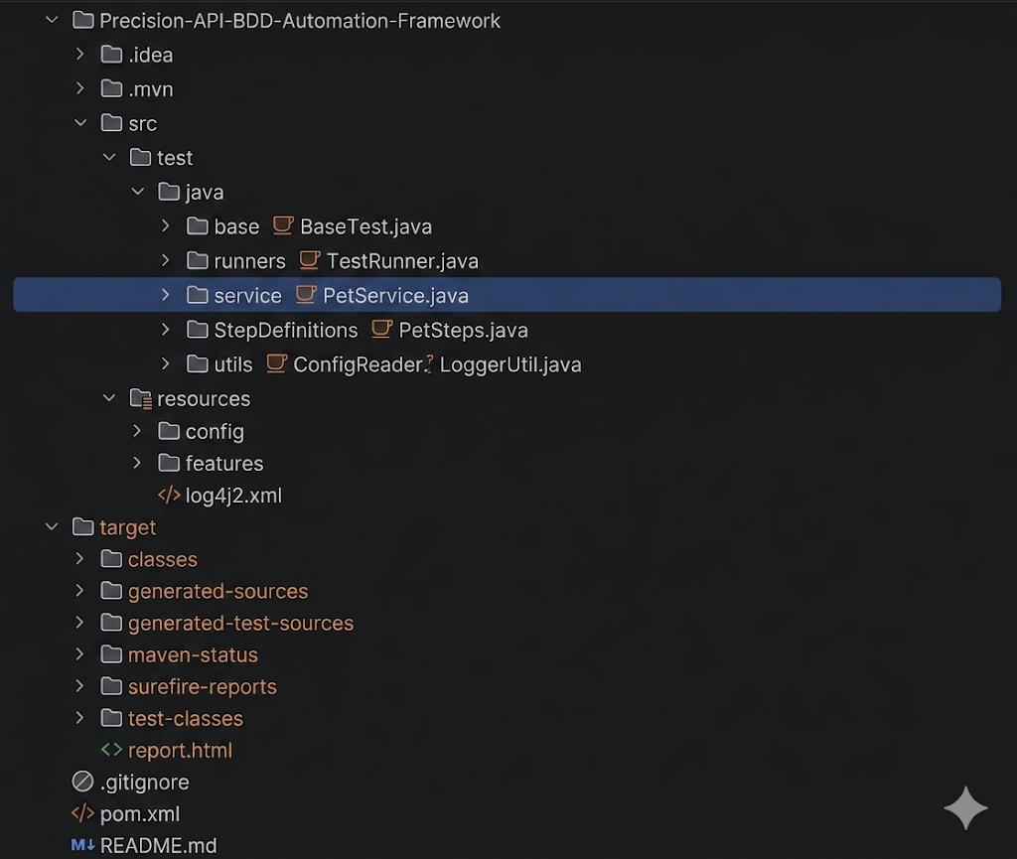
🔁 Flow of Execution
- Feature file defines the scenario in plain English
- Step Definitions map each step to Java methods
- Service Layer handles API calls using REST Assured
- Utilities manage reusable logic (test data, config, retry)
- Assertions validate the API responses
- Test Runner executes all scenarios
🧠 Architecture Benefits
- Clear separation of concerns
- High reusability of API methods
- Easy to maintain and extend
- Scalable for large test suites
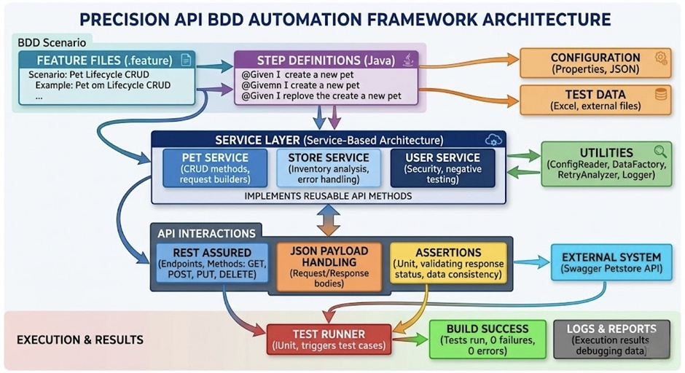

D. TEST SCENARIOS & TEST CASES
The framework includes the following test scenarios:
✅ Test Case 1: Pet Lifecycle (CRUD Operations)
- Create a new pet
- Retrieve pet details
- Update pet status
- Delete the pet
- Validate deletion (404 response)

✅ Test Case 2: Inventory Analysis
- Fetch inventory details
- Retrieve pets by status
- Compare counts for consistency

✅ Test Case 3: User Security & Error Handling
- Create user with invalid email
- Fetch non-existing user
- Perform login with invalid credentials
- Validate error responses

✅ Test Case 4: Cross-Endpoint Data Consistency
- Create pet with specific category
- Update status to "sold"
- Fetch inventory
- Fetch sold pets list
- Validate if created pet exists in sold list

E. EXECUTION STEPS AND RESULTS
▶️ Steps to Execute
- Install Java (JDK 17 or above)
- Install Maven and set environment variables
- Import project into IntelliJ IDEA
- Update dependencies using:
- mvn clean install
- Run test cases using:
- mvn test

📊 Execution Results
- All test scenarios executed successfully
- API responses validated using assertions
- Retry mechanisms handled API inconsistencies
- Logs printed for better debugging

✅ Expected Output
BUILD SUCCESS
Tests run: 4, Failures: 0, Errors: 0

🔗 Postman API Collection
To test all backend APIs, use the Postman collection below:
Redirected-Link

F. CHALLENGES FACED & SOLUTIONS

⚠️ Challenge 1: API Inconsistency
Issue: Immediate GET requests returned 404 after creation
Solution: Implemented retry mechanism with delay

⚠️ Challenge 2: Data Not Reflecting in Real-Time
Issue: Updated data not visible instantly
Solution: Added polling logic to wait for API consistency

⚠️ Challenge 3: Dynamic Data Handling
Issue: Static IDs caused conflicts
Solution: Used dynamic ID generation using timestamps

⚠️ Challenge 4: Type Casting Errors
Issue: Long vs Integer mismatch in response parsing
Solution: Used appropriate data types ( Long.class )

G. Conclusion & Future Enhancements
🎯 Conclusion
The project successfully demonstrates a scalable and maintainable API automation framework using modern testing tools and practices. It validates critical functionalities of REST APIs and ensures robustness through positive and negative testing.
The hybrid framework design improves code organization, reduces redundancy, and enhances test coverage.

🚀 Future Enhancements
- Integration with Extent Reports for advanced reporting
- Adding Log4j logging for better debugging
- CI/CD integration (Jenkins/GitHub Actions)
- Environment-based execution (Dev, QA, Prod)
- Data-driven testing using external files (Excel/JSON)
- Integration with API mocking tools

🔥 Final Impression
This project reflects:
- Strong understanding of API testing
- Practical knowledge of automation frameworks
- Ability to handle real-world API challenges
- Industry-level coding and structuring practices

