DBMS Holiday Assignment Name: Sai venkat
Roll no: 2311CS020416(omega) TASK FROM LEETCODE:
1.Game Play Analysis (Solve it in LeetCode)
Table: Activity

Create a Activity table and Insert the given below values and Write a Query for below question
:-

- Write a solution to find the first login date for each player from table .

- Return the result table in any order

The result format is in the following example.
Example 1:
Input:
y table:
+ + + + +
+ r_id | device_id | event_date | games_played |
+ + + +
| 2 | 2016-03-01 | 5 |
| 2 | 2016-05-02 | 6 |
| 3 | 2017-06-25 | 1 |
| 1 | 2016-03-02 | 0 |
+------- | 4 | 2018-07-03 | 5 |
| + + + +

Ans:
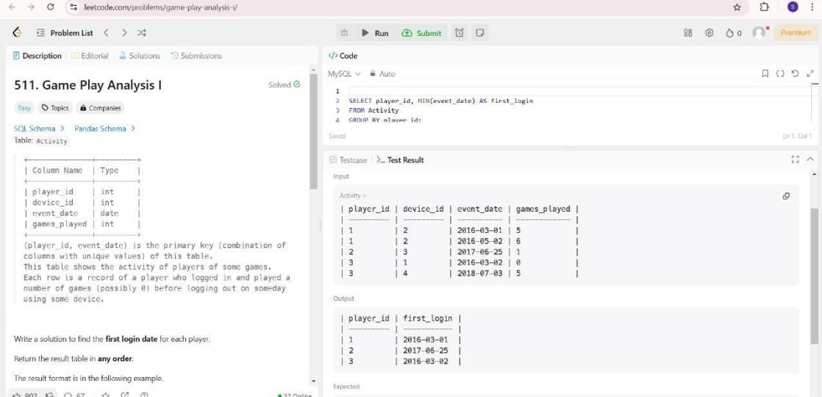
TASK-2

Find Customer Referee((Solve it in LeetCode)
Find the names of the customer that are |  |  |  | not referred by | the customer with id = 2.
Return the result table in |  | any order | .
Input:
+----+  +----+  3 | | er table:  + +  me | referee_id |  + +  ill | null |  ne | null |  ex | 2 |  ll | null |  ck | 1 |  ark | 2 |

Ans.
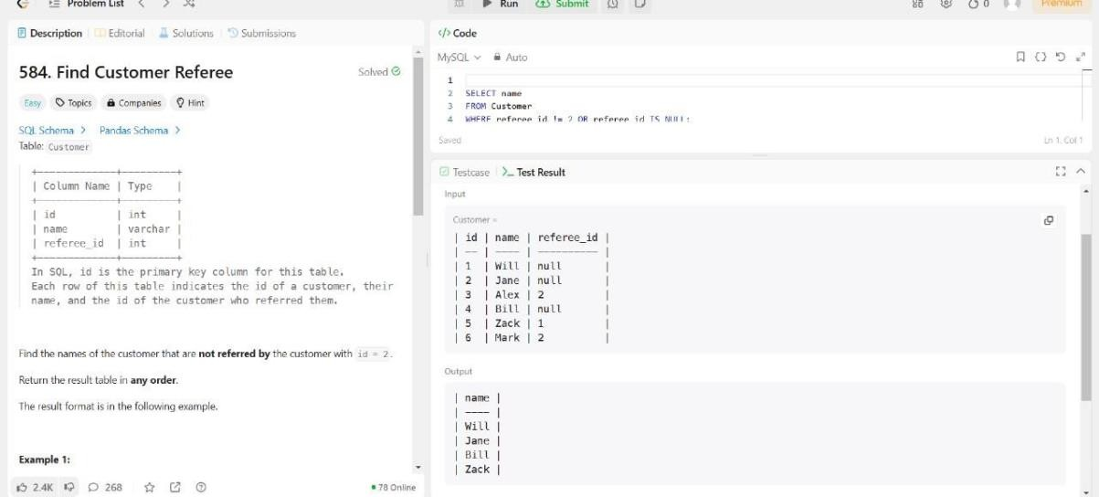
TASK-3

Big Countries (Solve it in LeetCode)
if:
- it has an area of at least three million (i.e., 3000000 km2), or
- it has a population of at least twenty-five million (i.e., 25000000). Write a solution to find the name, population, and area of the .
Return the result table in
.
World table:
+
| name
+
+
+
+
+
+
| continent | area | population | gdp
|
+
+
+
+
+
| Afghanistan | Asia | 652230 | 25500100 | 20343000000 |
Input:
any order
big countries
big
A country is

| Albania
| Algeria
| Andorra
| Angola
+
| Europe | 28748 | 2831741 | 12960000000 |
| Africa | 2381741 | 37100000 | 188681000000 |
| Europe | 468
| 78115
| 3712000000 |
| Africa | 1246700 | 20609294 | 100990000000 |
+
+
+
+
+

Ans.
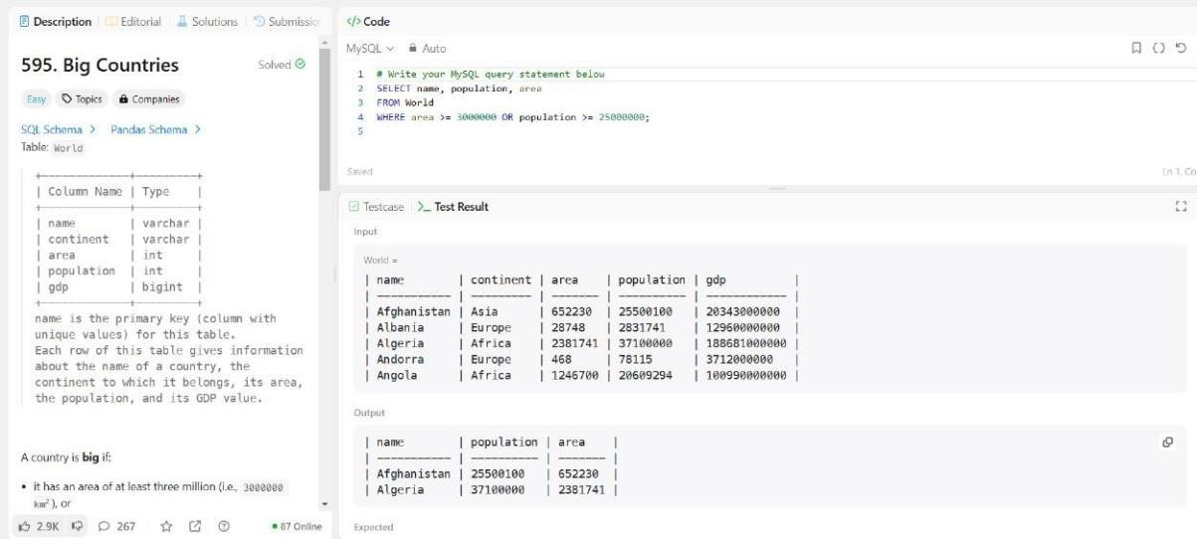

TASK-4

Recyclable and low fat products (Solve it in LeetCode)

Write a solution to find the ids of products that are both low fat and recyclable.
Return the result table in |  | any order | .
Input:
cts table:
+ + + +
ct_id | low_fats | recyclable |
+ + + +
| Y | N |
| Y | Y |
| 2 | N | Y |
| Y | Y |
| N | N |
+ + + +

Ans.

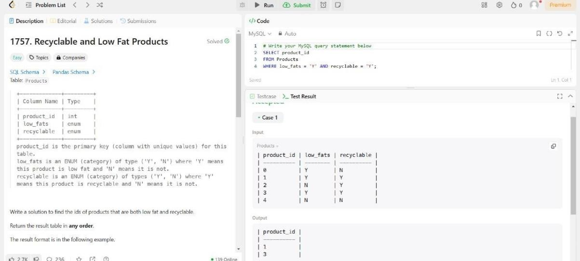

TASK-5

Write a solution to find the IDs of the invalid tweets. The tweet is invalid if the number of characters
used in the content of the tweet is |  | strictly | than | 15.
 |  | greater
Input:
s table:
+ + +
_id | content |
+ + +
| Let us Code |
| More than fifteen chars are here! | +-----------------------------------
+ +

Ans.
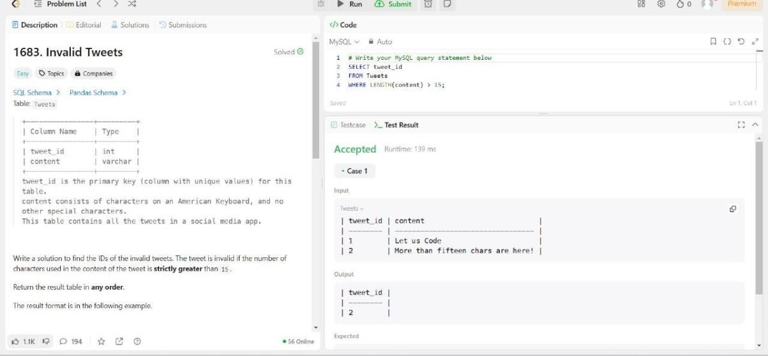

Case Study Question: School Database

Scenario:
You are tasked with designing a database for a small school. The school has students, teachers, and classes. The database should help manage the following information:

- Students' details: Unique ID, name, age, and grade level.
- Teachers' details: Unique ID, name, and subject specialization.
- Classes: Each class has a unique ID, subject name, and a teacher assigned.
- Enrollments: Students enrolled in specific classes.

Tasks:

- ER Diagram: Design an ER diagram showing the relationships between Students, Teachers, Classes, and Enrollments.(Use SmartDraw Tool)

Schema Design:
Write SQL to create the following tables:
  - Students (StudentId, Name, Age, GradeLevel) o
Teachers (TeacherId, Name, SubjectSpecialization)
  - Classes (ClassId, SubjectName, TeacherId) o
Enrollments (EnrollmentId, StudentId, ClassId)

Ans. 1)
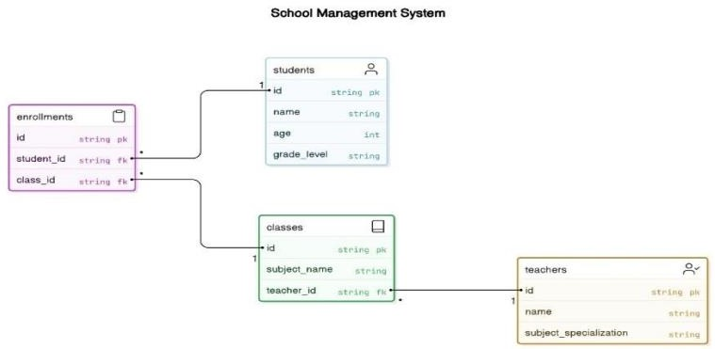
2)

