HOW TO CREATE GITHUB ACCOUNT:

STEP 1: Go to **Github.com**.



STEP 2: Click on **Sign up forGithub.**

Enter your Email and password.

Enter Username

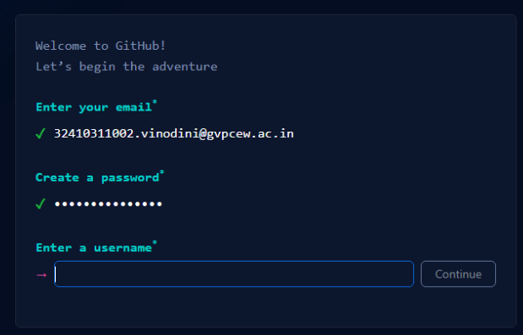

STEP 3: Do the verification process by solving puzzles.

STEP 4: Ener your email/username and password to enter into your Github account.