Saivya Singh
CSE D 44
220905370

Q1. S→a | > | ( T )
T→T, S|S

Left Recursion Removed :

S → a | > | ( T )
T → S T'
T' → , S T' | ε
Code :

#include <stdio.h>
#include <stdlib.h>
#include <string.h>
int curr = 0;
char str[100];
// -----------------------------------------------------------------------------------------------------------------------
void S();
void T();
void Tprime();
// -----------------------------------------------------------------------------------------------------------------------
void invalid()
{
printf("-----------------ERROR!----------------\n");
exit(0);
}
void valid()
{
printf("----------------SUCCESS!---------------\n");
exit(0);
}
// -----------------------------------------------------------------------------------------------------------------------
void S()
{
if(str[curr] == 'a'){
curr++;
}
else if(str[curr] == '>'){
curr++;
}
else if(str[curr] == '('){
curr++;
T();

if(str[curr] == ')'){
curr++;
}
else{
invalid();
}
}
else{
invalid();
}
}
// -----------------------------------------------------------------------------------------------------------------------
void T()
{
S();
Tprime();
}
// -----------------------------------------------------------------------------------------------------------------------
void Tprime()
{
if(str[curr] == ','){
curr++;
S();
Tprime();
}
}

// -----------------------------------------------------------------------------------------------------------------------
int main()
{
printf("Enter String: ");
scanf("%s", str);
S();
if (str[curr] == '$')
valid();
else
printf("%c\n", str[curr]);
invalid();
}
Output :

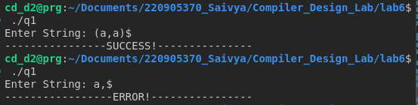

Q2. S→UVW
U →(S) | aSb | d
V → aV | ε
W → cW | ε 𝜖

Code :

#include <stdio.h>
#include <stdlib.h>
#include <string.h>

int curr = 0;
char str[100];

// -----------------------------------------------------------------------------------------------------------------------

void S();
void U();
void V();
void W();
void invalid();
void valid();

// -----------------------------------------------------------------------------------------------------------------------

void invalid()
{
printf("-----------------ERROR!----------------\n");
exit(0);
}

void valid()
{
printf("----------------SUCCESS!---------------\n");
exit(0);
}

// -----------------------------------------------------------------------------------------------------------------------

void S()
{
U();
V();
W();
}

// -----------------------------------------------------------------------------------------------------------------------

void U()
{
if (str[curr] == '(')
{
curr++;
S();
if (str[curr] == ')')
{
curr++;
}
else
{
invalid();
}
}
else if (str[curr] == 'a')
{
curr++;
S();
if (str[curr] == 'b')
{
curr++;
}
else
{
invalid();
}
}
else if (str[curr] == 'd')
{
curr++;
}
else
{
invalid();
}
}

// -----------------------------------------------------------------------------------------------------------------------

void V()
{
if (str[curr] == 'a')
{
curr++;
V();
}
}

// -----------------------------------------------------------------------------------------------------------------------

void W()
{
if (str[curr] == 'c')
{
curr++;
W();
}
}

// -----------------------------------------------------------------------------------------------------------------------

int main()
{
printf("Enter String: ");
scanf("%s", str);
S();
if (str[curr] == '$')
valid();
else
invalid();
}

Output :

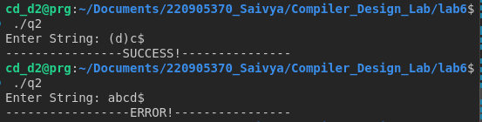

Q3.S→aAcBe
A→Ab|b
B→d
Left Recursion Removed :

S → aAcBe
A → bA'
A' → bA' | ε
B → d
Code :

#include <stdio.h>
#include <stdlib.h>
#include <string.h>

int curr = 0;
char str[100];
// -----------------------------------------------------------------------------------------------------------------------
void S();
void A();
void Aprime();
void B();
void invalid();
void valid();
// -----------------------------------------------------------------------------------------------------------------------
void invalid()
{
printf("-----------------ERROR!----------------\n");
exit(0);
}

void valid()
{
printf("----------------SUCCESS!---------------\n");
exit(0);
}
// -----------------------------------------------------------------------------------------------------------------------

void S()
{
if (str[curr] == 'a')
{
curr++;
A();
if (str[curr] == 'c')
{
curr++;
B();
if (str[curr] == 'e')
{
curr++;
}
else
{
invalid();
}
}
else
{
invalid();
}
}
else
{
invalid();
}
}
// -----------------------------------------------------------------------------------------------------------------------

void A()
{
if (str[curr] == 'b')
{
curr++;
Aprime();
}
else
{
invalid();
}
}
// -----------------------------------------------------------------------------------------------------------------------
void Aprime()
{
if (str[curr] == 'b')
{
curr++;
Aprime();
}
}
// -----------------------------------------------------------------------------------------------------------------------

void B()
{
if (str[curr] == 'd')
{
curr++;
}
else
{
invalid();
}
}
// -----------------------------------------------------------------------------------------------------------------------
int main()
{
printf("Enter String: ");
scanf("%s", str);
S();
if (str[curr] == '$')
valid();
else
invalid();
}
Output :

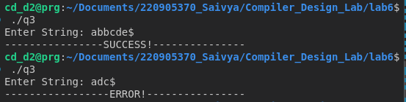

Q4. S →(L) | a
L → L,S | S

Left Recursion Removed :

S →(L) | a
L → SL'
L' → ,SL' | ε

Code :

#include <stdio.h>
#include <stdlib.h>
#include <string.h>
int curr = 0;
char str[100];
// -----------------------------------------------------------------------------------------------------------------------
void S();
void L();
void Lprime();
// -----------------------------------------------------------------------------------------------------------------------
void invalid()
{
printf("-----------------ERROR!----------------\n");
exit(0);
}
void valid()
{
printf("----------------SUCCESS!---------------\n");
exit(0);
}
// -----------------------------------------------------------------------------------------------------------------------
void S()
{
if(str[curr] == '('){
curr++;
L();
if(str[curr] == ')'){
curr++;
}
else{
invalid();
}
}
else if(str[curr] == 'a'){
curr++;
}
else{
invalid();
}
}
// -----------------------------------------------------------------------------------------------------------------------
void L()
{
S();
Lprime();
}
// -----------------------------------------------------------------------------------------------------------------------
void Lprime()
{
if(str[curr] == ','){
curr++;
S();
Lprime();
}
}

// -----------------------------------------------------------------------------------------------------------------------
int main()
{
printf("Enter String: ");
scanf("%s", str);
S();
if (str[curr] == '$')
valid();
else
printf("%c\n", str[curr]);
invalid();
}

Output :

