Saivya Singh
CSE D 44
220905370

Q1. Count the number of vowels and consonants in the given input.
Code :

%{
#include <stdio.h>
#include <ctype.h>

int vowels = 0;
int consonants = 0;
int yywrap() { return 1; }
%}

%%
[aAeEiIoOuU] { vowels++; }
[bcdfghjklnmpqstvwxyzBCDFGJKLNMPQSTVWXYZ] { consonants++; }
[ \t\n]
%%

int main() {
printf("Enter a string:\n");
yylex();
printf("vowels: %d\n", vowels);
printf("consonants: %d\n", consonants);
return 0;
}

Output:

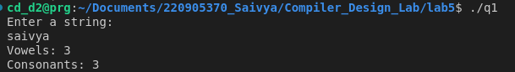

Q2. Count the number of words, characters, blanks and lines in a given text.

Code:

%{
#include <stdio.h>
#include <ctype.h>

int w = 0;
int c = 0;
int blank = 0;
int line = 0;
int yywrap() { return 1; }
%}

%%
\n { line++; }
[ \t] { blank++; }
[a-zA-Z0-9]+ { w++; c += yyleng; }
. { c++; }
%%

int main() {
yylex();
printf("words: %d\n", w);
printf("characters: %d\n", c);
printf("blanks: %d\n", blank);
printf("lines: %d\n", line);
return 0;
}
Output:

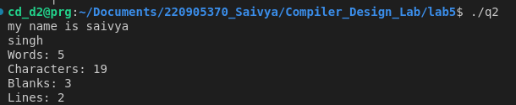

Q3. Find the number of positive integer, negative integer, positive floating positive number and negative floating point number

Code:

%{
#include <stdio.h>

int pos_int = 0;
int neg_int = 0;
int pos_fl = 0;
int neg_fl = 0;
int yywrap() { return 1; }
%}

%%
[0-9]+ { pos_int++; }
-[0-9]+ { neg_int++; }
[0-9]+\.[0-9]+ { pos_fl++; }
-[0-9]+\.[0-9]+ { neg_fl++; }
%%

int main() {
yylex();
printf("positive integers : %d\n", pos_int);
printf("negative integers : %d\n", neg_int);
printf("positive floating point numbers : %d\n", pos_fl);
printf("negative floating point numbers : %d\n", neg_fl);
return 0;
}

Output:

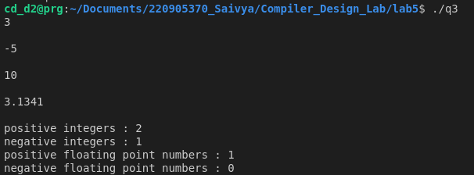

Q4. Given a input C file, replace all scanf with READ and printf with WRITE statements also find the number of scanf and printf in the file.

Code:

%{
#include <stdio.h>

int scanf_count = 0;
int printf_count = 0;

int yywrap() {
return 1;
}
%}

%%
scanf { printf("READ "); scanf_count++; }
printf { printf("WRITE "); printf_count++; }
. { printf("%s", yytext); }
%%

int main() {

FILE *input = fopen("input.c", "r");

yyin = input;

yylex();

fclose(input);

printf("\nnumber of scanf: %d\n", scanf_count);
printf("number of printf: %d\n", printf_count);

return 0;
}

Input:

#include <stdio.h>

int main() {
int a;
scanf("%d", &a);
printf("Value: %d\n", a);
return 0;
}

Output:

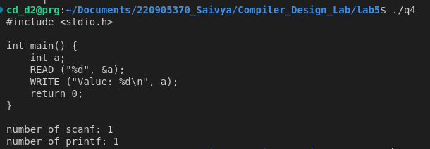

Q5. That changes a number from decimal to hexadecimal notation.

Code:

%{
#include <stdio.h>
#include <stdlib.h>

int yywrap() { return 1; }
%}

%%
[0-9]+ {
int num = atoi(yytext);
printf("Hexadecimal: 0x%x\n",num);
}

. { }

%%

int main() {
printf("enter a number: ");
yylex();
return 0;
}

Output:

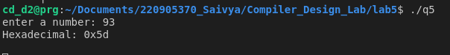

Q6. Convert uppercase characters to lowercase characters of C file excluding the characters present in the comment.

Code:

%{
#include <stdio.h>
#include <ctype.h>

int yywrap() {
return 1;
}

%}

%%
"//".* { }
"/*"[^*]*"*/" { }
[A-Z] { printf("%c", tolower(yytext[0])); }
. { printf("%s", yytext); }
%%

int main() {

FILE *input = fopen("input.c", "r");

yyin = input;

yylex();

fclose(input);

return 0;
}

Input:

#include <stdio.h>

int main() {
int a;
scanf("%d", &a);
// THis is a comment
/*This is also a commment*/
PRINTF("Value: %d\n", a);
return 0;
}

Output:

