WEEK 4
Machine Learning Model
Development and Evaluation
A Python-Based Classification Study Using Scikit-learn

Dataset: Breast Cancer Wisconsin Diagnostic Dataset

Prepared as a Week 4 academic submission

Executive Summary
This report presents a complete machine learning development and evaluation workflow implemented in Python using the Breast Cancer Wisconsin Diagnostic dataset available through Scikit-learn. The purpose of the study was to demonstrate how a classification model can be developed responsibly from data preparation through final evaluation, while also examining where and why a model can make mistakes.
Two supervised classification algorithms were developed: Logistic Regression and Decision Tree. Logistic Regression was used as a strong, interpretable baseline, while the Decision Tree provided a contrasting non-linear approach and an opportunity to examine feature importance. The models were evaluated using accuracy, precision, recall, F1-score and ROC-AUC, supported by confusion matrices, an ROC curve, model comparison visualisation and five-fold stratified cross-validation.
The results favoured Logistic Regression. It achieved 98.25% test accuracy and a ROC-AUC of 0.9954, compared with 92.11% and 0.9163 for the Decision Tree. The Logistic Regression model also showed a much smaller training-testing accuracy gap, suggesting better generalisation in this experiment.

Report at a Glance
Item | Result
Dataset | Breast Cancer Wisconsin Diagnostic
Observations | 569
Predictor variables | 30 numerical features
Target | Benign / Malignant
Models | Logistic Regression; Decision Tree
Preferred model in this experiment | Logistic Regression
Best test accuracy | 98.25%
Best ROC-AUC | 0.9954
Cross-validation | 5-fold Stratified Cross-Validation
Visualisations | 8 figures

1. Introduction
Machine learning is most useful when it is treated as a complete analytical process rather than simply as an algorithm that produces predictions. A reliable workflow begins by understanding the data, checking its quality, preparing suitable inputs, selecting an appropriate model, and then evaluating that model using measures that reflect the actual objective.
For this Week 4 task, the project uses a supervised binary classification problem. The model receives numerical diagnostic measurements and predicts whether an observation belongs to the benign or malignant class. The project therefore provides a clear setting in which model accuracy, error types, generalisation and model comparison can all be demonstrated.
The report is written to document the reasoning behind the development process, not just the final numbers. This is important because a high evaluation score should be supported by evidence that the modelling decisions were deliberate, the results were checked, and the limitations were recognised.

2. Objectives
- Build a basic supervised machine learning classification pipeline in Python.
- Use a publicly available dataset and perform appropriate data-quality checks.
- Prepare the features and target variable for machine learning.
- Select and justify suitable classification algorithms.
- Train and compare Logistic Regression and Decision Tree models.
- Evaluate the models using multiple complementary metrics.
- Use visualisations to communicate model performance clearly.
- Assess false positives, false negatives and possible overfitting.
- Use cross-validation to examine performance stability.
- Discuss limitations and realistic opportunities for model improvement.

3. Dataset Description
The project uses the Breast Cancer Wisconsin Diagnostic dataset provided through Scikit-learn. The dataset contains 569 observations and 30 numerical diagnostic measurements. The target variable contains two classes, represented in the original dataset as 0 and 1 and converted in the analysis into the more readable labels Malignant and Benign.
Data characteristic | Observed value
Number of observations | 569
Number of predictor features | 30
Target classes | 2
Missing values | 0
Duplicate rows | 0
Malignant observations | 212
Benign observations | 357

The absence of missing values and duplicate rows meant that no imputation or duplicate-removal operation was necessary. This is an important preprocessing decision: cleaning was based on the actual quality of the dataset rather than applying transformations simply for the sake of having a cleaning step.

4. Data Preparation and Preprocessing

4.1 Data Quality Assessment
The dataset was first inspected using Pandas to review its dimensions, data types, sample records and descriptive statistics. Missing-value counts, duplicate rows and unique-value counts were also checked. All 569 observations were complete across the 30 numerical predictors and the target variable.

4.2 Target Preparation
The original target values were retained for modelling and additionally mapped to readable labels. A value of 0 was interpreted as Malignant and a value of 1 as Benign. The class-distribution check showed more benign than malignant observations, so stratification was used during the train-test split.

4.3 Train-Test Split
The data was divided into training and testing subsets using an 80:20 split with random_state=42 and stratification. Stratification helps preserve the proportion of the two target classes in both subsets, making the evaluation more representative of the original data distribution.

4.4 Feature Scaling
StandardScaler was used for Logistic Regression because the diagnostic variables have different numerical scales. The scaler was fitted only on the training data and then applied to the test data. This approach avoids allowing information from the held-out test set to influence the preprocessing parameters.
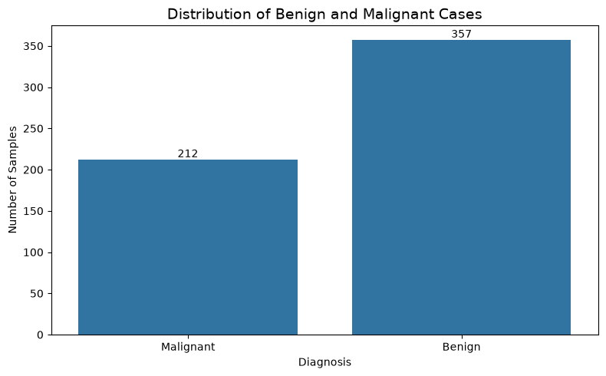
Figure 1. Class distribution of the observations.

5. Exploratory Analysis
Exploratory analysis was included before model evaluation to provide context for the classification problem. The class-distribution chart confirms that the two classes are not equally represented. This does not prevent modelling, but it is relevant when interpreting accuracy and makes metrics such as precision, recall and F1-score particularly useful.
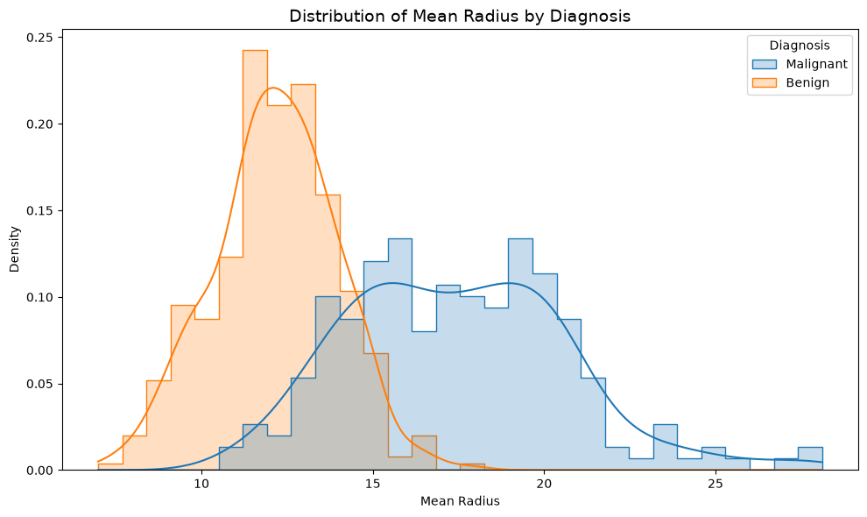
Figure 2. Distribution of mean radius by diagnosis.
The mean-radius distribution illustrates that diagnostic measurements contain useful information about the target classes. However, the project does not rely on one feature alone; all available numerical predictors are considered by the models.
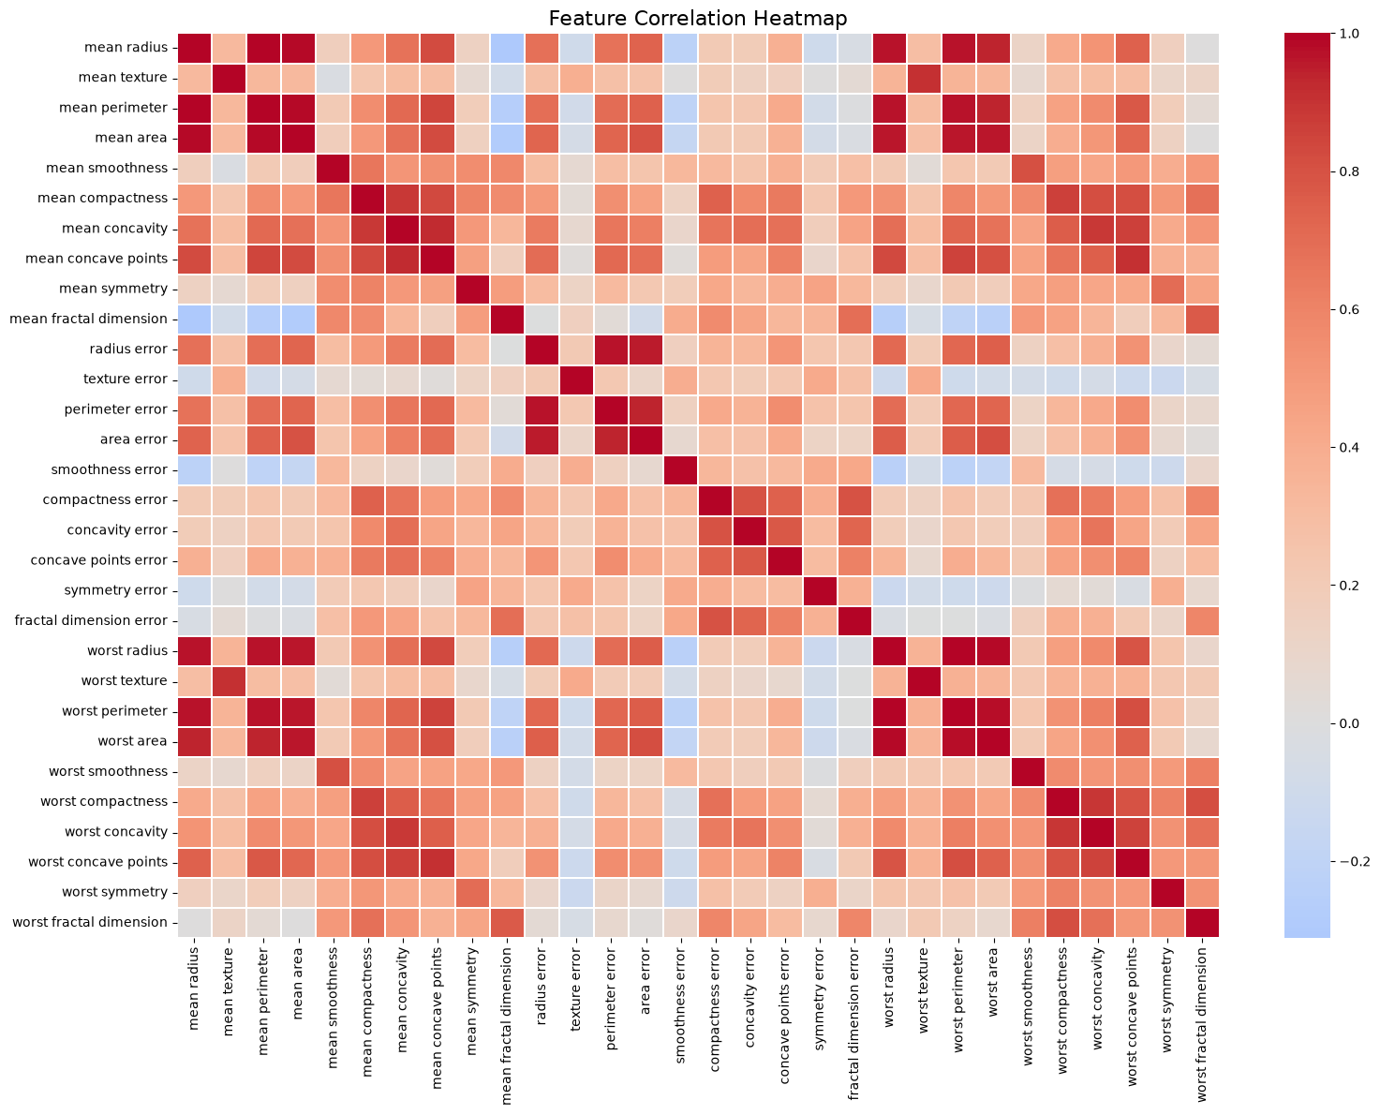
Figure 3. Correlation structure among numerical diagnostic features.
The correlation heatmap shows that several features are strongly related to one another. This is relevant to model interpretation because highly related measurements may carry overlapping information. The analysis therefore evaluates the models as predictive systems rather than interpreting a single correlation as evidence of causation.

6. Model Selection and Rationale

6.1 Logistic Regression
Logistic Regression was selected as the baseline model because it is a standard and relatively interpretable method for binary classification. It provides a useful reference point against which a more flexible tree-based model can be compared. Feature scaling was used because the predictor variables have different ranges.

6.2 Decision Tree
Decision Tree was selected as the second model because it can represent non-linear decision rules and is easy to explain visually. A maximum depth of 5 was used to control complexity and reduce the likelihood of an unnecessarily deep tree memorising the training data.

6.3 Why Compare Two Models?
Using two algorithms makes the evaluation more meaningful. A model should not be selected simply because it is easy to train. Comparing a linear baseline with a non-linear tree model allows performance, error patterns and generalisation behaviour to be considered together.

7. Model Evaluation Methodology
The models were evaluated on the held-out test set using five complementary metrics. Accuracy measures the proportion of all predictions that were correct. Precision measures how often predicted positive cases were actually positive. Recall measures how many actual positive cases were identified. F1-score balances precision and recall. ROC-AUC measures the model's ability to rank the two classes across classification thresholds.
In addition to the test-set evaluation, five-fold Stratified Cross-Validation was performed on the training data. The mean and standard deviation of cross-validation accuracy were used to examine whether performance was reasonably stable across folds.

8. Results
Model | Accuracy | Precision | Recall | F1 | ROC-AUC
Logistic Regression | 0.9825 | 0.9861 | 0.9861 | 0.9861 | 0.9954
Decision Tree | 0.9211 | 0.9565 | 0.9167 | 0.9362 | 0.9163

Logistic Regression performed better across every reported test metric. Its 98.25% accuracy means that only a small number of the held-out observations were classified incorrectly. Its ROC-AUC of 0.9954 also indicates very strong separation between the two classes in this experiment.
The Decision Tree still performed reasonably well, but it was consistently below Logistic Regression. The difference is especially visible in ROC-AUC, where the tree achieved 0.9163 compared with 0.9954 for Logistic Regression.
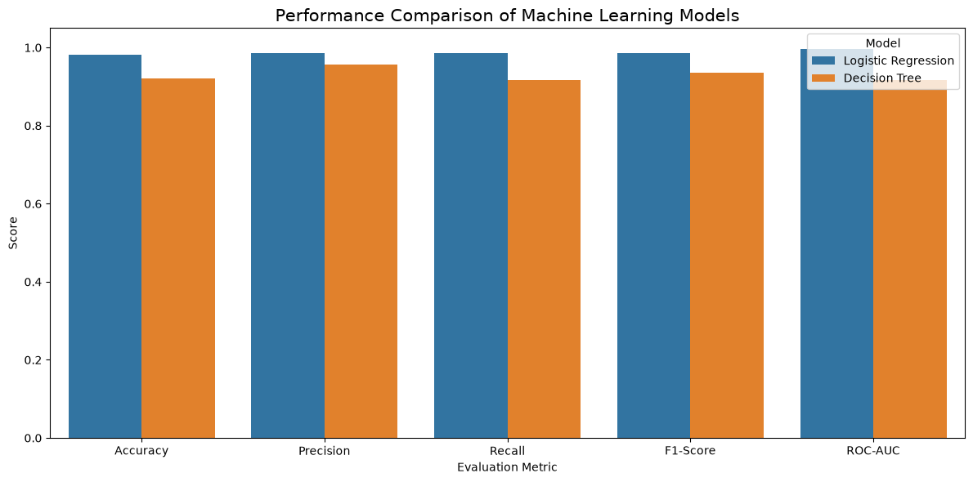
Figure 4. Comparative performance of the two classification models.
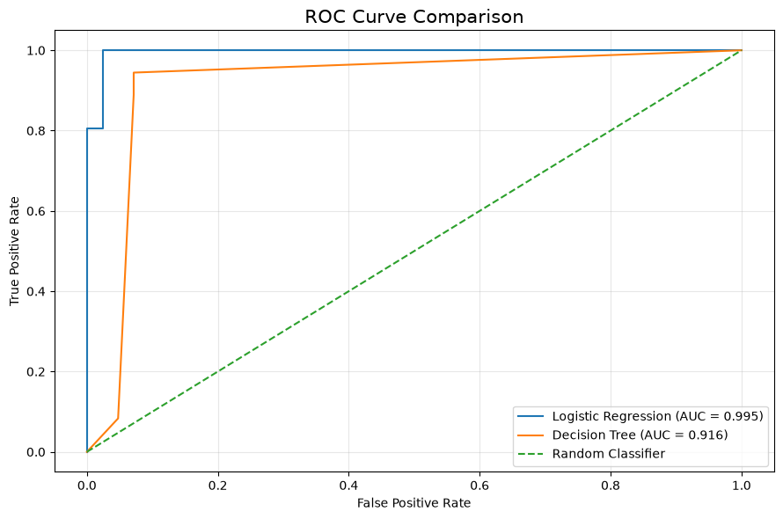
Figure 5. ROC curve comparison.

9. Confusion Matrix and Error Analysis
A confusion matrix is useful because overall accuracy does not show which type of mistake a classifier makes. For this project, a false negative means that a malignant observation was predicted as benign, while a false positive means that a benign observation was predicted as malignant.
Model | True Negative | False Positive | False Negative | True Positive | Total Errors
Logistic Regression | 41 | 1 | 1 | 71 | 2
Decision Tree | 39 | 3 | 6 | 66 | 9

The Logistic Regression model made only two errors in the test set: one false positive and one false negative. The Decision Tree made nine errors, including six false negatives. Because false negatives can be particularly important in a diagnostic-style classification problem, recall deserves attention alongside accuracy.
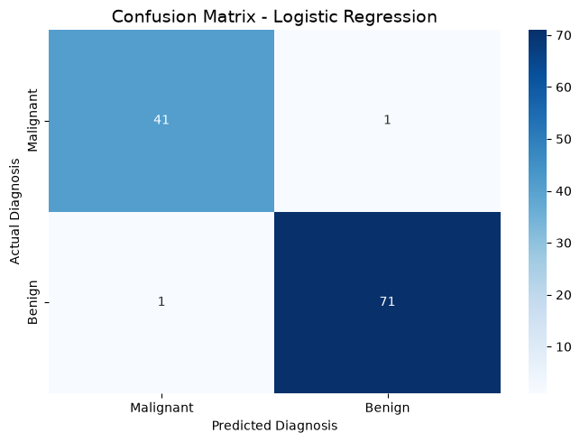
Figure 6. Logistic Regression confusion matrix.
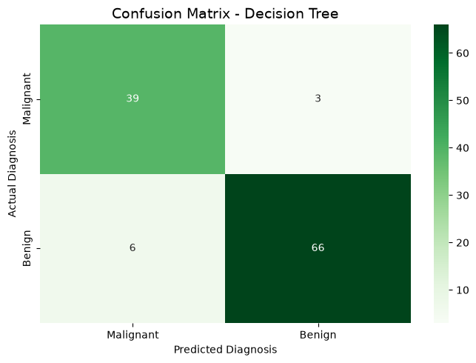
Figure 7. Decision Tree confusion matrix.

10. Cross-Validation and Generalisation
Model | Training Accuracy | Test Accuracy | Train-Test Gap | Mean 5-Fold CV Accuracy | CV Std
Logistic Regression | 0.9890 | 0.9825 | 0.0066 | 0.9780 | 0.0098
Decision Tree | 0.9934 | 0.9211 | 0.0724 | 0.9231 | 0.0120

The training-testing comparison provides useful evidence about generalisation. Logistic Regression has a small gap of approximately 0.0066, meaning that its test performance remained close to its training performance. The Decision Tree has a considerably larger gap of approximately 0.0724, suggesting greater overfitting pressure.
Cross-validation provides a second perspective. Logistic Regression achieved a mean five-fold accuracy of 0.9780, while the Decision Tree achieved 0.9231. The relatively small standard deviations indicate that both models were reasonably stable across folds, although Logistic Regression remained the stronger performer.

11. Feature Importance
The Decision Tree provides feature-importance values that help explain which variables were most useful to its fitted decision structure. In this model, worst radius was the dominant feature, with an importance of approximately 0.7143. Other influential variables included worst concave points, texture error, worst texture and worst concavity.
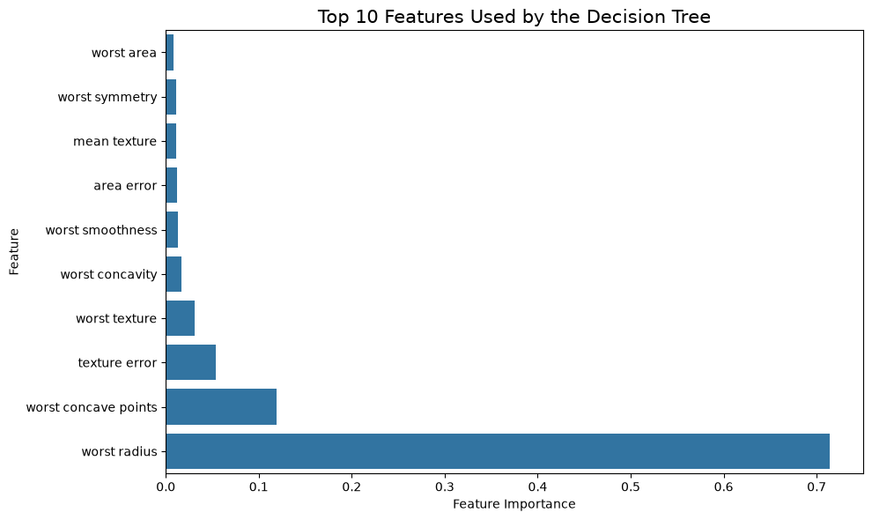
Figure 8. Top features according to Decision Tree feature importance.
These importance values should be interpreted carefully. They describe how the fitted tree used the variables for prediction; they do not establish that an individual feature causes the diagnosis.

12. Critical Evaluation

12.1 Strengths of the Approach
- The workflow covers the complete model-development process requested in the Week 4 task.
- Data-quality decisions are explicitly based on observed missing-value and duplicate checks.
- Two algorithms were compared rather than reporting only one model.
- Multiple performance metrics reduce the risk of drawing conclusions from accuracy alone.
- Confusion matrices make the practical error types visible.
- ROC analysis and ROC-AUC provide threshold-independent discrimination information.
- Stratified five-fold cross-validation provides additional evidence about performance stability.
- Training-versus-testing comparison supports the discussion of overfitting and generalisation.

12.2 Potential Sources of Error
- The test set is relatively small, so individual observations can noticeably affect the reported metrics.
- The dataset represents a benchmark collection and may not reflect every real-world population or measurement environment.
- False positives and false negatives remain possible even when the overall accuracy is high.
- The models use only the variables contained in the dataset and do not include wider clinical context.
- A model that performs strongly on this dataset may not perform equally well on an independent external dataset.

12.3 Overfitting and Underfitting
The Decision Tree's higher training accuracy combined with lower test accuracy is consistent with overfitting. The selected maximum depth of 5 already acts as a basic complexity constraint, but the remaining gap indicates that further tuning could be beneficial. Logistic Regression shows a much smaller gap and therefore provides stronger evidence of generalisation in this experiment.
There is no strong evidence that Logistic Regression is severely underfitting: it performs very well on both training and testing data and also maintains strong cross-validation performance.

12.4 Recommended Improvements
- Perform systematic hyperparameter tuning using GridSearchCV or RandomizedSearchCV.
- Compare additional algorithms such as Random Forest, Support Vector Machine and Gradient Boosting.
- Investigate feature selection and dimensionality reduction where appropriate.
- Add Precision-Recall curves and class-specific error analysis.
- Validate the selected model using an independent external dataset.
- Use model-explanation methods such as permutation importance or SHAP for deeper interpretation.
- For any real clinical use, evaluate calibration, fairness, external validity and human-in-the-loop decision processes.

13. Practical and Scientific Implications
From a scientific perspective, the results demonstrate that model development is a sequence of connected decisions. Data quality, preprocessing, model assumptions, evaluation metrics and validation strategy all influence the conclusions that can be drawn from a machine learning experiment.
From a practical perspective, the preferred model should be selected according to the intended use and the cost of different errors. In this experiment Logistic Regression provides the strongest overall performance and the smallest generalisation gap. However, high benchmark performance alone is not enough to justify real-world deployment, particularly in a medical context.

14. Conclusion
This Week 4 project successfully developed and evaluated a supervised machine learning classification pipeline using Python and Scikit-learn. The process included data inspection, quality assessment, target preparation, stratified train-test splitting, feature scaling, model selection, training, multi-metric evaluation, cross-validation, visual analysis and error investigation.
Between the two evaluated models, Logistic Regression was the stronger model in this experiment. It achieved 98.25% test accuracy, 98.61% precision, 98.61% recall, 98.61% F1-score and 0.9954 ROC-AUC. Its mean five-fold cross-validation accuracy was 97.80%. The Decision Tree achieved 92.11% test accuracy and 0.9163 ROC-AUC, with a larger training-testing gap.
The results support Logistic Regression as the preferred model for this particular dataset and experimental setup. More importantly, the project demonstrates the full development cycle required by the Week 4 task and shows why model evaluation should include both quantitative metrics and critical reasoning about errors, generalisation and limitations.
Finally, the models presented here are intended for academic learning and demonstration. They should not be interpreted as clinical diagnostic tools or used for medical decision-making without extensive external validation, regulatory review and professional oversight.

15. Week 4 Deliverable Checklist
Deliverable | Included in This Project
DOC report | Yes – this professional report
Data preparation | Yes
Algorithm selection and justification | Yes
Python implementation | Yes – accompanying notebook
Evaluation metrics | Yes
At least two performance visualisations | Yes – eight figures included
Error discussion | Yes
Overfitting / underfitting discussion | Yes
Improvement recommendations | Yes
Strengths and limitations | Yes
Conclusion | Yes

16. References
- Scikit-learn. Breast Cancer Wisconsin Diagnostic dataset documentation.
- Scikit-learn. LogisticRegression documentation.
- Scikit-learn. DecisionTreeClassifier documentation.
- Scikit-learn. StandardScaler documentation.
- Scikit-learn. train_test_split and StratifiedKFold documentation.
- Scikit-learn. Classification metrics and ROC-AUC documentation.
- Pandas documentation for data manipulation and analysis.
- Matplotlib and Seaborn documentation for data visualisation.

Author's Note
This report was prepared from the executed Week 4 Python notebook and presents the observed results from that analysis. The narrative has been written in a clear academic style so that the development decisions, evidence and limitations can be understood by both technical and non-technical readers.

