WEEK 2 DATA SCIENCE PROJECT
Advanced Data Visualization and Storytelling with Python
Online Retail II Dataset

Prepared as a Week 2 Data Science Visualization Submission

Dataset | Online Retail II
Tools | Python, Pandas, Matplotlib, Seaborn
Visualizations | 6
Estimated Workload | 34 hours

Executive Summary
This project uses the Online Retail II dataset to turn a large collection of retail transactions into a visual story that can be understood without a technical background. The analysis looks at sales over time, the countries that contribute revenue, the products that generate the most sales, when customers are most active, how customer purchasing behaviour varies, and how transaction values are distributed.
Six visualizations were developed using Matplotlib and Seaborn. Rather than treating the charts as separate outputs, the analysis connects them: first asking when revenue changes, then where revenue comes from, what products drive it, when customers are active, how customers differ, and finally whether unusual transactions are affecting the overall picture.
The results show strong concentration in the United Kingdom, clear differences in monthly revenue, a small group of high-revenue products, concentrated daytime activity, substantial variation in customer value, and a highly right-skewed transaction-revenue distribution with extreme high-value transactions.

1. Introduction
This project focuses on advanced data visualization and data storytelling using the Online Retail II dataset. The aim is not simply to produce attractive charts, but to use visual evidence to explain what is happening in the data and why the findings may matter to a business audience.
The dataset contains transaction-level information such as invoices, products, quantities, prices, dates, customer identifiers, and countries. Because the raw data contains a very large number of transactions, visualization provides a practical way to move from individual records to broader patterns and decisions.

2. Objectives
- Analyse the Online Retail II dataset using Python.
- Prepare transaction data for visualization and analysis.
- Develop at least five meaningful visualizations using Matplotlib and Seaborn.
- Identify trends, patterns, concentration, and unusual observations.
- Explain why each visualization was selected.
- Communicate findings in a clear way for a non-technical audience.
- Discuss potential business implications of the findings.
- Build a coherent story across the different visualizations.
- Document the complete work in a structured final report.

3. Dataset and Methodology

3.1 Dataset
The Online Retail II dataset was used for this analysis. The workbook contains two yearly sheets, "Year 2009-2010" and "Year 2010-2011". The two sheets were combined into one dataframe before the visualization work was performed.
Variable | Meaning
Invoice | Invoice or transaction identifier
StockCode | Product code
Description | Product description
Quantity | Number of units in the transaction
InvoiceDate | Transaction date and time
Price | Unit price
Customer ID | Customer identifier
Country | Customer's country

3.2 Data Preparation
InvoiceDate was converted to datetime format so that month, day, and hour could be extracted. A Revenue column was created as Quantity multiplied by Price. For the main sales analysis, records with positive Quantity and positive Price were retained. This keeps the revenue-focused analysis centred on positive sales transactions.
The notebook reports 1,067,371 original rows and 1,041,671 valid sales rows. The resulting positive-sales dataset produced total revenue of approximately £20.97 million.
For customer-level RFM analysis, records without a Customer ID were not included because a customer identifier is required to calculate Recency, Frequency, and Monetary measures reliably.

3.3 Analytical Approach
- Monthly revenue aggregation to understand change over time.
- Country-level revenue aggregation to compare geographic contribution.
- Product-level revenue aggregation to identify high-revenue products.
- Day-and-hour transaction counts to understand customer activity patterns.
- RFM-style customer analysis using Recency, Frequency, and Monetary value.
- Transaction-level revenue distribution and outlier analysis.

4. Key Results at a Glance
Metric | Result
Original transaction rows | 1,067,371
Valid positive-sales rows | 1,041,671
Total positive-sales revenue | £20,972,968.14
Highest monthly revenue | £1,509,496.33 — November 2011
Lowest monthly revenue | £523,631.89 — February 2011
Top country | United Kingdom — approximately £17.87 million
Top product | REGENCY CAKESTAND 3 TIER — £344,563.25
Customers in RFM analysis | 5,878
Average customer recency | 201.33 days
Average purchase frequency | 6.29 invoices
Average monetary value | £3,018.62
Median transaction revenue | £9.96
Maximum transaction revenue | £168,469.60

5. Visualization 1 – Monthly Revenue Trend

Business Question
How does revenue change over time?

Why This Visualization?
A line chart is a natural choice for time-based data because it makes month-to-month movement, peaks, and lower periods easy to follow.
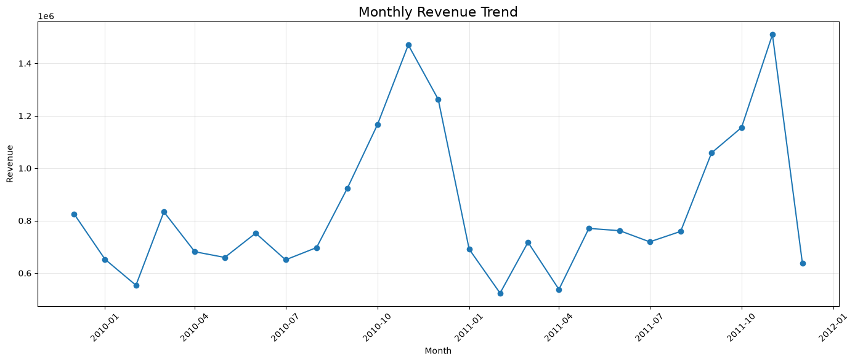
Figure 1. Monthly revenue trend across the analysis period.

Key Observation
November 2011 recorded the highest monthly revenue at approximately £1.51 million, while February 2011 recorded the lowest at approximately £0.52 million. The movement between these points shows that sales performance was not constant throughout the period.

Business Implication
Historical changes in monthly revenue can support planning for inventory, staffing, promotions, and other operational activities.

6. Visualization 2 – Top 10 Countries by Revenue

Business Question
Which countries contribute the most revenue?

Why This Visualization?
A horizontal bar chart makes category-to-category comparison straightforward and keeps longer country names readable.
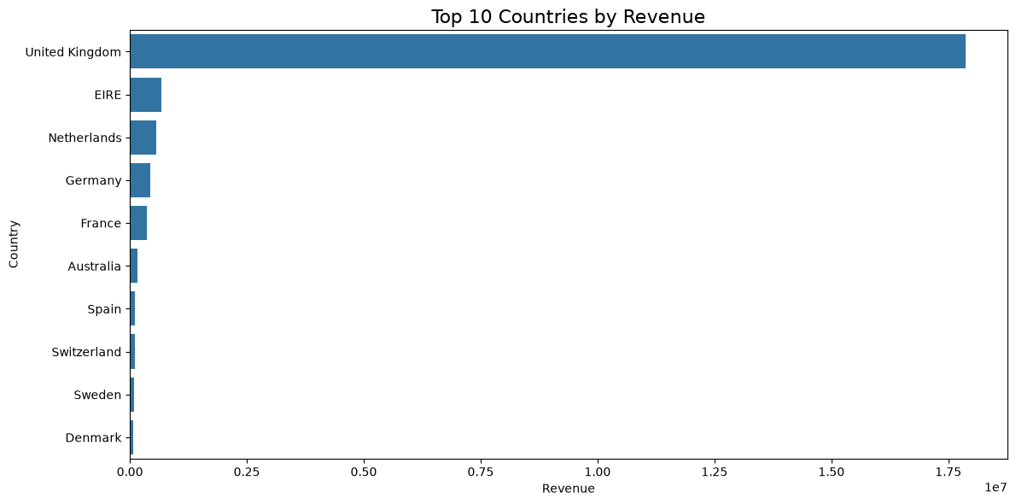
Figure 2. Top 10 countries ranked by total positive transaction revenue.

Key Observation
The United Kingdom generated approximately £17.87 million in revenue, far more than the other countries in the top five. EIRE contributed approximately £0.66 million, followed by the Netherlands, Germany, and France.

Business Implication
The dataset shows strong geographic concentration in the United Kingdom while also revealing additional markets that contribute meaningful revenue.

7. Visualization 3 – Top 10 Products by Revenue

Business Question
Which products generate the highest revenue?

Why This Visualization?
A horizontal bar chart provides a direct comparison of product-level revenue and makes the product names easier to read than a vertical layout.
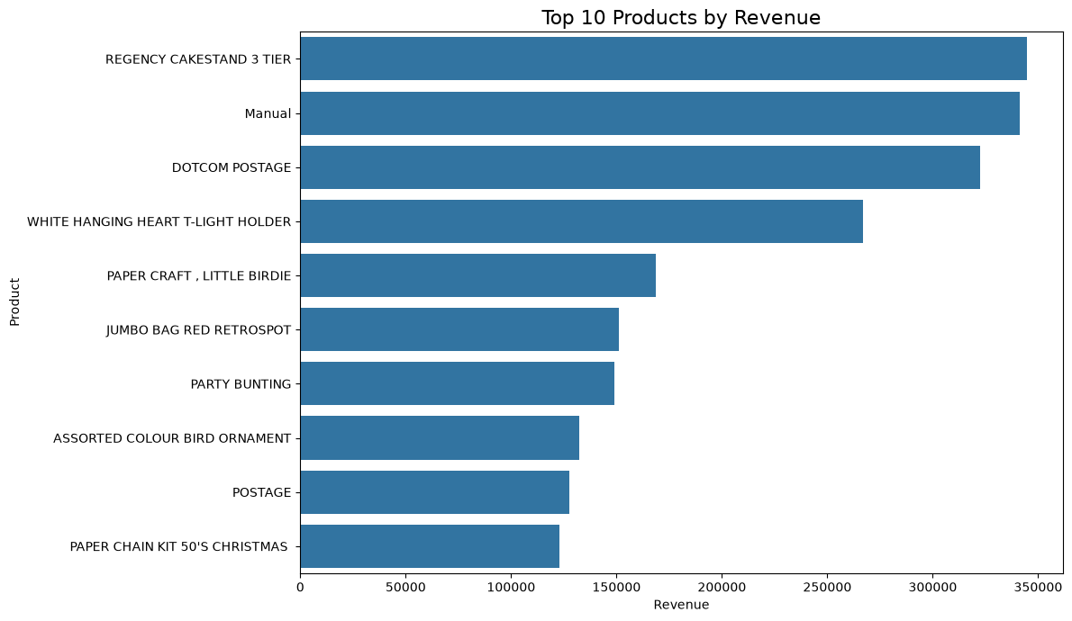
Figure 3. Top 10 products ranked by total positive transaction revenue.

Key Observation
REGENCY CAKESTAND 3 TIER generated the highest product revenue at £344,563.25, followed by Manual at £341,104.90 and DOTCOM POSTAGE at £322,657.48.

Business Implication
High-revenue products deserve attention in inventory monitoring, product availability, and sales planning because a relatively small set of products contributes substantial revenue.

8. Visualization 4 – Customer Activity by Day and Hour

Business Question
When are customers most active?

Why This Visualization?
A heatmap is useful here because it shows two dimensions at the same time: day of week and hour of day. The intensity of each cell represents the number of transactions.
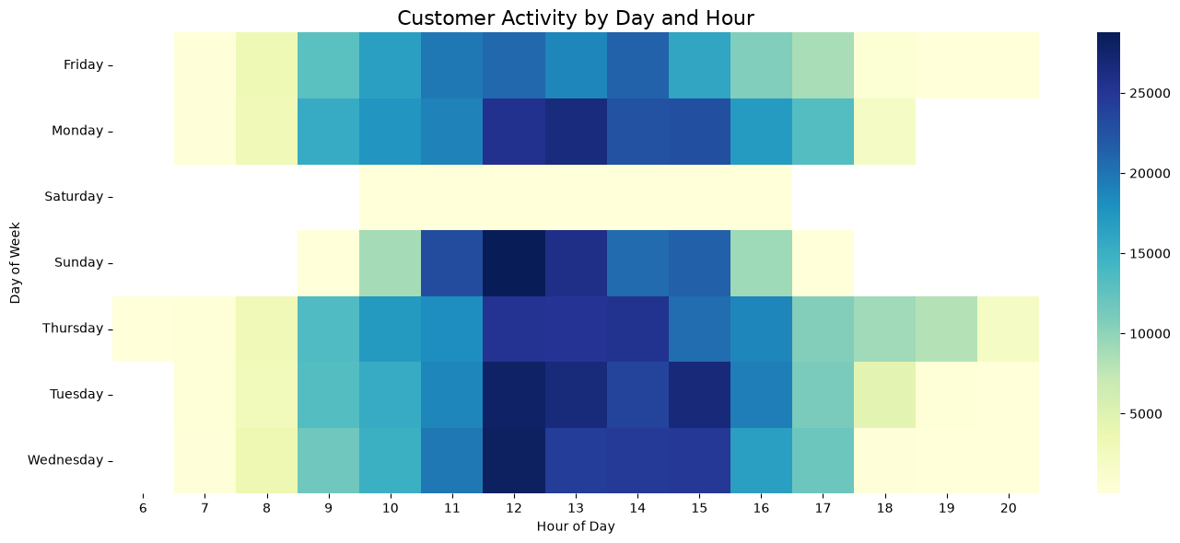
Figure 4. Heatmap of transaction activity across days and hours.

Key Observation
Activity is concentrated mainly during daytime hours, with particularly strong activity around the middle of the day. The pattern also varies across days of the week.

Business Implication
Knowing when transaction activity is concentrated can support staffing, customer-service coverage, operational scheduling, and the timing of promotional activities.

9. Visualization 5 – Customer Frequency vs Monetary Value

Business Question
How does purchase frequency relate to customer spending?

Why This Visualization?
A scatter plot allows two numerical customer-level measures to be viewed together. Each point represents one customer, making differences in customer behaviour visible.
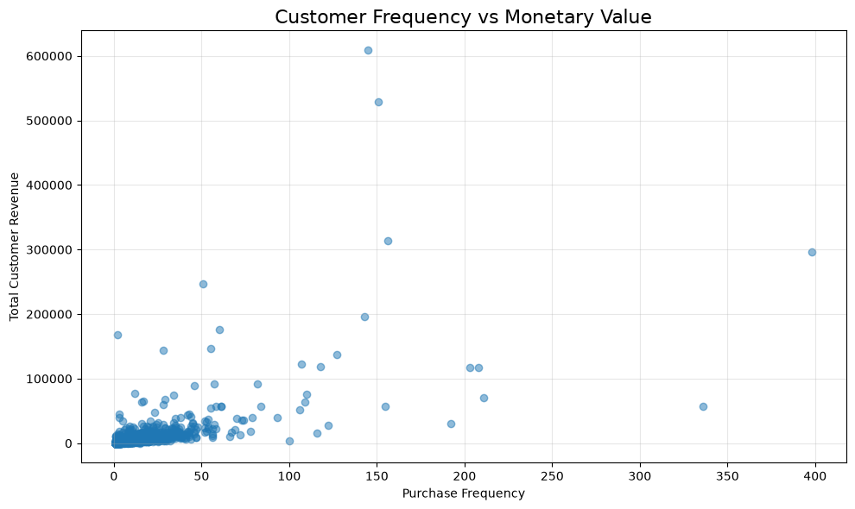
Figure 5. Relationship between customer purchase frequency and total monetary value.

Key Observation
Most customers are concentrated in the lower-frequency and lower-spending region. A smaller number of customers show much higher frequency or monetary value, creating a long spread of customer behaviour.

Business Implication
Customers do not contribute equally to revenue. Customer-level analysis can therefore support targeted retention and engagement strategies for higher-value segments.

10. Visualization 6 – Transaction Revenue Distribution

Business Question
How are transaction revenues distributed, and are there unusually large transactions?

Why This Visualization?
A box plot summarizes the central distribution and highlights potential outliers. A logarithmic scale was used because transaction values span a very wide range.
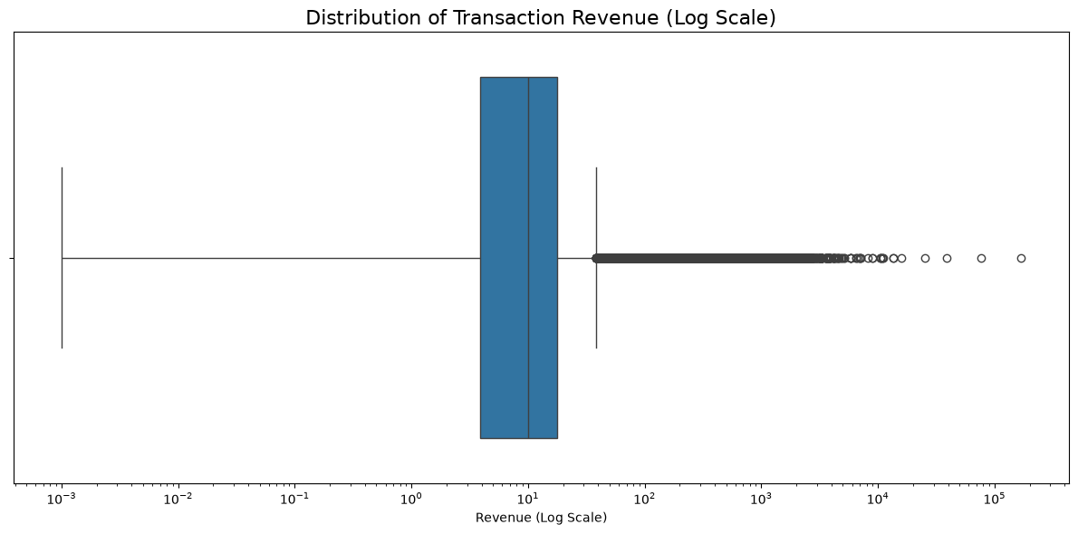
Figure 6. Transaction revenue distribution using a logarithmic scale.

Key Observation
The median transaction revenue is approximately £9.96, while the maximum reaches £168,469.60. The large gap between the typical transaction and the maximum shows the presence of extreme high-value transactions.

Business Implication
Unusually large transactions can materially affect total revenue and may represent bulk purchases, special orders, or other exceptional purchasing behaviour that deserves separate investigation.

11. Overall Data Story
The six visualizations work together as a single story rather than as isolated charts. The first question is when the business generates revenue, followed by where that revenue comes from and which products contribute to it. The analysis then moves closer to customer behaviour by asking when transactions happen and how customer purchasing patterns differ. Finally, the transaction-level distribution highlights how a small number of unusually large values can sit alongside a much larger number of small transactions.
The strongest overall pattern is concentration. Revenue is heavily concentrated in the United Kingdom, a subset of products contributes a large share of product revenue, and customer spending varies widely. At the same time, sales activity is concentrated in particular periods of the day. These findings suggest that the business can learn more by looking beyond total revenue and understanding the specific markets, products, customers, and operating periods behind that total.

12. Business Implications
Area | Potential implication
Sales Planning | Monthly revenue patterns can support inventory, staffing, and promotional planning around higher- and lower-performing periods.
Geographic Strategy | The strong contribution from the United Kingdom identifies the main revenue market in this dataset, while other countries provide additional markets for investigation.
Product Management | High-revenue products can be monitored closely for stock availability and purchasing decisions.
Operational Planning | The day-and-hour activity pattern can inform staffing and customer-service coverage.
Customer Engagement | Differences in RFM measures suggest that customer groups can be analysed differently for retention and engagement.
High-Value Transactions | Extreme transaction values should be reviewed separately because they can materially influence total revenue.

13. Limitations
- The analysis is based on historical transaction data and describes past purchasing behaviour rather than guaranteeing future behaviour.
- The analysis focuses mainly on revenue and purchasing activity; factors such as marketing campaigns, product costs, profit margins, customer demographics, and external economic conditions were not included.
- The RFM analysis describes customer behaviour but does not establish a causal relationship between purchase frequency and spending.
- Potential outliers were identified, but individual extreme transactions were not manually investigated to determine the exact reason for each value.

14. Conclusion
This project demonstrates how visualization can transform a large retail transaction dataset into a clear and understandable business story. Six different visualization techniques were used to examine the data from multiple perspectives: time, geography, products, customer activity, customer behaviour, and transaction distribution.
The analysis found that monthly revenue varied substantially, with November 2011 recording the highest monthly revenue. The United Kingdom was the largest revenue-generating country, while a smaller group of products contributed substantial product revenue. Customer activity was concentrated during particular hours, customer spending varied considerably, and the transaction distribution contained a small number of very large values.
The main lesson from the project is that effective data storytelling is more than producing charts. The value comes from connecting each visual to a clear question, explaining what the audience should notice, and discussing why the finding may matter. This approach makes the analysis easier for non-technical audiences to understand and provides a stronger foundation for business discussion.

15. Estimated Workload and Time Allocation
The project was structured as a practical visualization and storytelling exercise. The estimated effort was approximately 34 hours, which is within the assignment's requested 30–35 hour range.
Activity | Hours
Data preparation and validation | 4
Planning visualization questions and chart selection | 3
Monthly revenue and country analysis | 4
Product and customer activity visualizations | 5
RFM customer analysis | 5
Revenue distribution and outlier analysis | 3
Data storytelling and interpretation | 4
Report preparation and formatting | 4
Final review and corrections | 2
Total | 34

16. References
- Online Retail II dataset, publicly available through the UCI Machine Learning Repository.
- Pandas documentation for data manipulation and aggregation.
- Matplotlib documentation for data visualization.
- Seaborn documentation for statistical visualization.

17. Submission Checklist
- ✓ Public dataset selected.
- ✓ Dataset prepared for visualization.
- ✓ Revenue analysis completed.
- ✓ Six visualizations created.
- ✓ Multiple visualization types used.
- ✓ Each visualization explained.
- ✓ Chart-selection reasoning documented.
- ✓ Captions provided.
- ✓ Business implications discussed.
- ✓ Overall data story developed.
- ✓ Limitations documented.
- ✓ Conclusion included.
- ✓ Estimated 30–35 hour workload documented.
- ✓ References included.
- ✓ Final DOCX report prepared.

