WEEK 1 DATA SCIENCE TASK
Data Acquisition, Cleaning, and Exploratory Data Analysis
Online Retail II Dataset

Prepared as a Week 1 Data Science Foundation Report
Dataset provided by the student | Python, Pandas, NumPy, Matplotlib, Seaborn

1. Introduction
For this Week 1 task, I worked with the Online Retail II dataset because it represents a real business transaction environment rather than a small classroom example. The dataset contains invoice-level sales information such as products, quantities, prices, dates, customers, and countries. This makes it useful for practising the complete first stage of a data science project: understanding the data, identifying quality problems, cleaning it carefully, and then looking for meaningful patterns.
I used the Excel workbook provided for this assignment. It contains two sheets covering the periods 2009–2010 and 2010–2011. Instead of treating the two sheets as separate datasets, I combined them into one analysis table so that the overall business pattern could be studied consistently.

2. Objective
The main objective of this work is to understand what happens to a dataset before it is ready for modelling. The process includes data acquisition, initial inspection, missing-value analysis, duplicate checking, data-type conversion, handling unusual transactions, feature creation, exploratory analysis, visualization, and documenting the reasoning behind each decision.

3. Dataset Description
The uploaded workbook contains two sheets: 'Year 2009-2010' and 'Year 2010-2011'. Each sheet contains the same eight main fields: Invoice, StockCode, Description, Quantity, InvoiceDate, Price, Customer ID, and Country.
Dataset Overview
Item | Details
Raw rows | 1,067,371
Columns | 8
Sheets | 2
Date field | InvoiceDate
Main numerical fields | Quantity, Price
Main categorical fields | Invoice, StockCode, Description, Customer ID, Country

The combined workbook contains more than one million transaction lines, which makes it a useful example of real-world data processing. Because of its size, the analysis focuses on practical checks and aggregated views rather than printing the entire dataset.

4. Tools and Technologies
- Python – the main programming language used for the analysis.
- Pandas – used for reading Excel sheets, combining data, cleaning columns, grouping data, and calculating summaries.
- NumPy – used for numerical calculations and data handling.
- Matplotlib – used to create the main charts.
- Seaborn – used where statistical-style visualizations are helpful.
- python-docx – used to prepare the final report.

5. Data Acquisition and Loading
The workbook supplied for the assignment was loaded directly using Pandas. Since the workbook has two year-based sheets, both sheets were read and then concatenated into a single DataFrame.
import pandas as pd
file_path = "online_retail_II.xlsx"
df_2009 = pd.read_excel(file_path, sheet_name="Year 2009-2010")
df_2010 = pd.read_excel(file_path, sheet_name="Year 2010-2011")
df = pd.concat([df_2009, df_2010], ignore_index=True)
print(df.shape)
print(df.head())
print(df.info())
The two sheets contained 525,461 and 541,910 rows respectively, giving a combined raw dataset of 1,067,371 rows and 8 columns.

6. Initial Data Inspection
Before changing anything, I checked the shape of the dataset, column names, missing values, duplicates, dates, and unusual numerical values. This step is important because cleaning decisions should be based on what is actually present in the data.
Initial Data Quality Summary
Check | Result
Rows | 1,067,371
Columns | 8
Duplicate rows | 34,335
Missing Description | 4,382
Missing Customer ID | 243,007
Negative quantities | 22,950
Negative prices | 5
Cancellation invoices | 19,494

7. Data Cleaning

7.1 Missing Values
The missing-value check showed that Description and Customer ID require the most attention. Customer ID is important when analysing individual customers, but a missing customer identifier does not make the transaction itself unusable for product or sales-level analysis. Therefore, I did not remove all rows with missing Customer ID.
Missing-Value Summary
Column | Missing Records | Missing %
Customer ID | 243007 | 22.77
Description | 4382 | 0.41

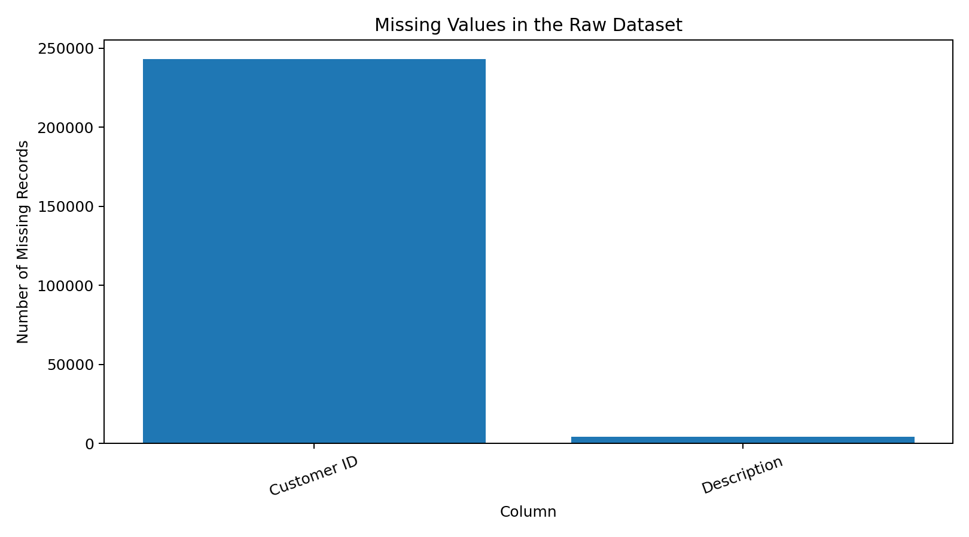
Figure 1. Missing values in the raw Online Retail II dataset.

7.2 Handling Missing Descriptions
A missing product description does not change the numerical transaction fields. Instead of deleting those records immediately, I used a neutral label, 'Unknown product description', so that the transaction remains available for numerical analysis while the missing information is clearly identified.
df["Description"] = df["Description"].fillna("Unknown product description")

7.3 Handling Customer ID
Customer ID is different from Description because it identifies the customer rather than the transaction. Rows without Customer ID were retained for transaction-level analysis. When the analysis specifically requires customer-level metrics, such as total revenue per customer, only records with a known Customer ID are used.

7.4 Duplicate Records
The duplicate check returned 34,335 repeated rows. Duplicate rows can artificially increase sales totals, so they should be removed before calculating final transaction-level metrics.
df = df.drop_duplicates()

7.5 Date Conversion
InvoiceDate was converted from its original Excel representation into a proper Pandas datetime format. This is necessary for monthly trends, day-based analysis, and any future time-series modelling.
df["InvoiceDate"] = pd.to_datetime(df["InvoiceDate"], errors="coerce")

7.6 Negative Quantities and Cancelled Invoices
The dataset contains 22,950 rows with negative quantities and 19,494 invoices whose invoice number begins with 'C'. These records should not simply be deleted without understanding them. In retail data, negative quantities commonly represent returned or cancelled goods. For the main sales-trend analysis in this report, I use positive-quantity and positive-price transactions so that the revenue charts represent completed sales rather than mixing sales with returns.
sales = df[(df["Quantity"] > 0) & (df["Price"] > 0)].copy()
sales["Revenue"] = sales["Quantity"] * sales["Price"]

8. Feature Creation
A useful derived variable for this dataset is Revenue. It is calculated at transaction-line level as Quantity multiplied by Price. This turns the raw quantity and price fields into a business measure that can be aggregated by month, country, product, or customer.
df["Revenue"] = df["Quantity"] * df["Price"]
For this report, positive-sales revenue is calculated from transactions where Quantity and Price are both positive. This makes the main EDA easier to interpret.

9. Exploratory Data Analysis

9.1 Overall Dataset Scale
After combining the two sheets, the workbook contains 1,067,371 raw transaction lines. The analysis period runs from 01 December 2009 to 09 December 2011. The positive-sales subset contains 1,041,671 transaction lines. It covers 43 countries and 4,917 distinct stock codes.
Key Descriptive Metrics
Metric | Value
Positive-sales revenue | 20,972,968.14
Units sold | 11,420,306
Unique invoices | 40,078
Unique customers (including missing ID excluded) | 5,878
Unique products/stock codes | 4,917
Countries | 43

9.2 Monthly Revenue Trend
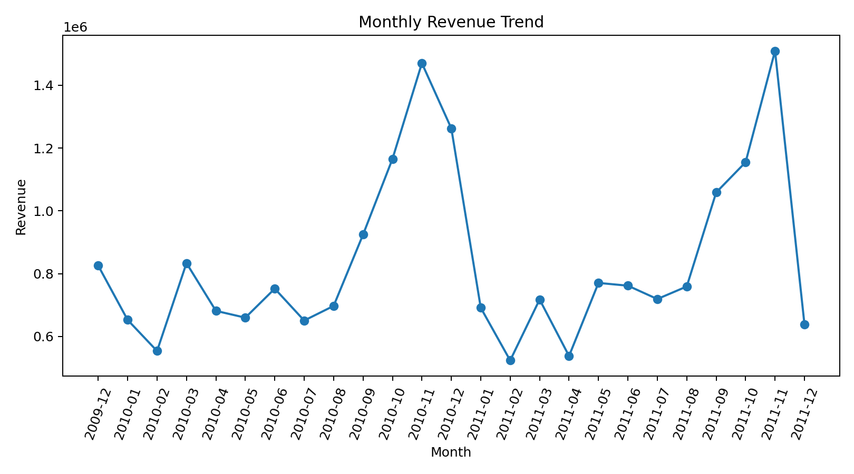
Figure 2. Monthly revenue trend based on positive sales.
The monthly revenue chart shows how sales activity changes over the two-year period. The highest monthly revenue in this analysis occurred in 2011-11, at approximately 1,509,496.33. The lowest positive-sales month was 2011-02, at approximately 523,631.89. Looking at the series month by month is more informative than relying only on the overall total because it shows seasonality and changes in transaction activity.

9.3 Revenue by Country
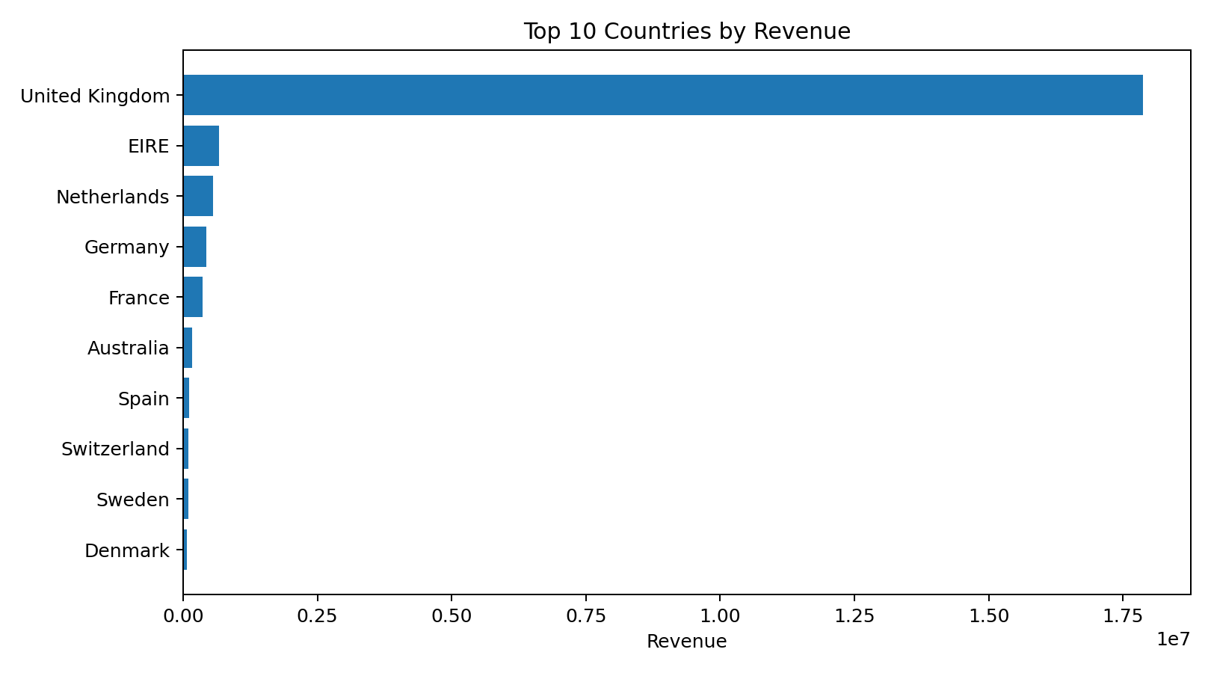
Figure 3. Top 10 countries by positive-sales revenue.
The country analysis shows that United Kingdom contributes the largest amount of positive-sales revenue among the countries in the dataset. The chart is intentionally limited to the top ten countries so that the differences are readable. This type of analysis can help identify the main geographical markets before carrying out more detailed customer or product segmentation.

9.4 Top Products by Revenue
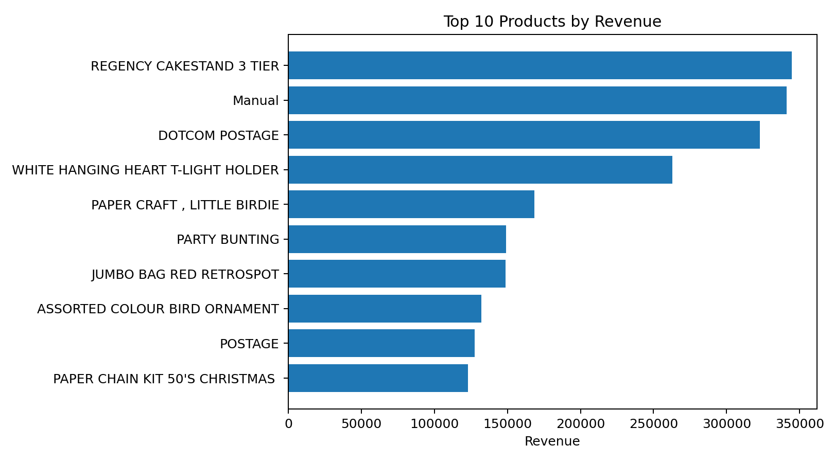
Figure 4. Top 10 products by positive-sales revenue.
The product-level analysis shows that revenue is not evenly distributed across all stock codes. A relatively small group of products contributes a noticeable share of transaction revenue. Product-level concentration is worth investigating further using both revenue and quantity because a high-revenue product is not necessarily the product with the highest sales volume.

9.5 Quantity Distribution
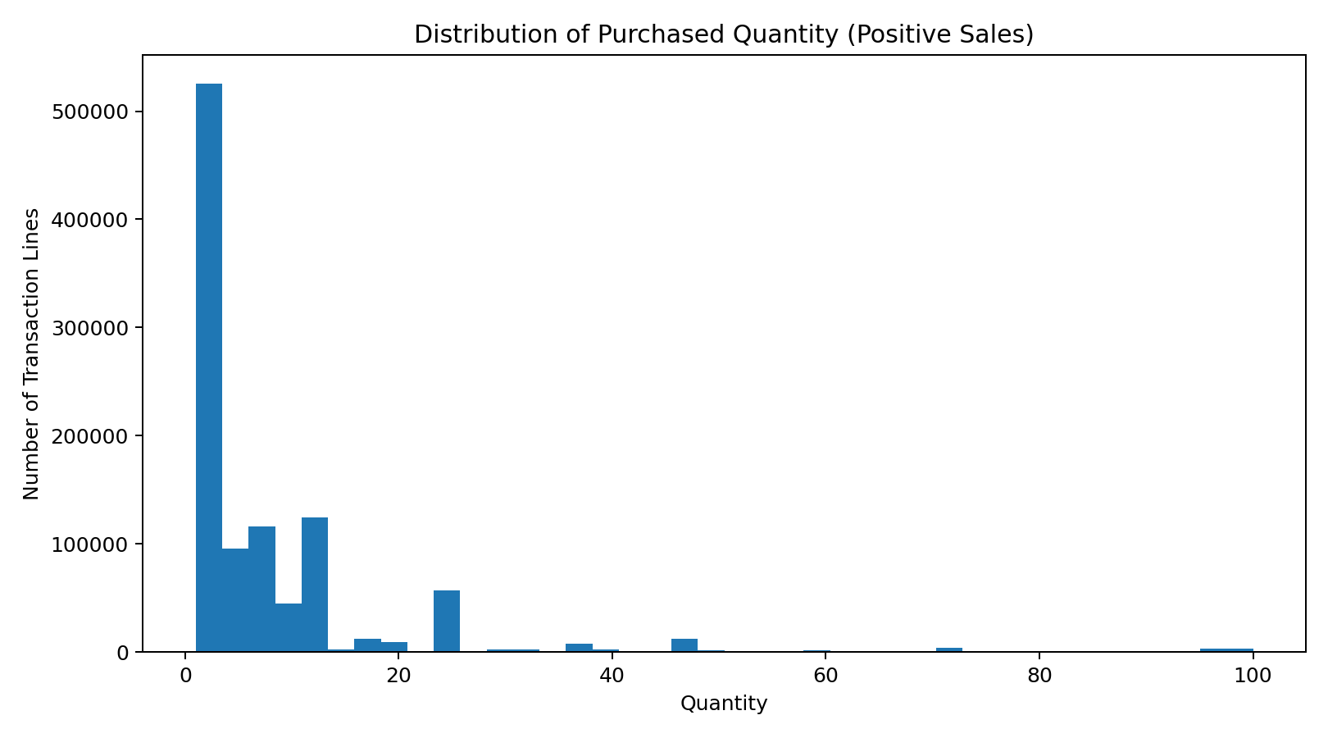
Figure 5. Distribution of purchased quantity after restricting to positive sales.
The quantity distribution is strongly concentrated toward smaller transaction quantities, while a smaller number of transaction lines contain much larger quantities. This is a common pattern in transaction data and is one reason why summary statistics alone can be misleading. For visualization, the chart limits the displayed range to the 99th percentile so that extreme quantities do not hide the main pattern.

9.6 Line Revenue Distribution
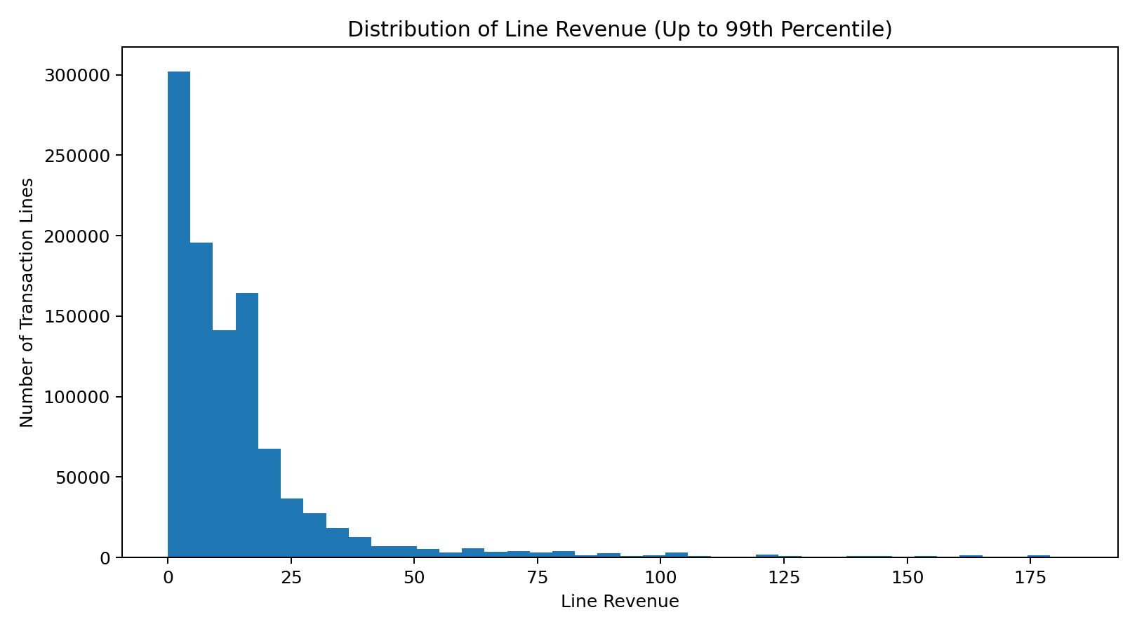
Figure 6. Distribution of transaction-line revenue up to the 99th percentile.
The revenue distribution is also right-skewed: many transaction lines have relatively small values, while a smaller number have much larger revenue. This suggests that median, percentile, and log-transformed measures could be useful in later customer and product analysis.

10. Main Insights from the EDA
- The workbook is large, with 1,067,371 transaction lines across two yearly sheets, making it closer to a real business dataset than a small demonstration dataset.
- Missing Customer ID values should not automatically lead to deleting transactions because those rows can still be useful for product, country, and time-based analysis.
- Missing product descriptions can be retained with an explicit placeholder rather than silently removing the transactions.
- Negative quantities and cancellation invoices indicate that the dataset contains returns or cancelled transactions, so sales analysis needs a clearly defined transaction filter.
- Revenue changes from month to month, which means time-based analysis can reveal patterns that are hidden by an overall total.
- Revenue is concentrated across a smaller set of countries and products, suggesting that segmentation and concentration analysis could be useful next steps.
- Quantity and revenue distributions are right-skewed, so medians and percentiles may provide more useful summaries than means alone.

11. Limitations and Important Notes
This report is an exploratory analysis rather than a final business performance study. In particular, the positive-sales filter is used to make revenue trends easier to interpret, but returns and cancellations are important business events and should be analysed separately in a complete project. Also, missing Customer ID means customer-level totals do not represent every transaction. Finally, the analysis describes patterns in the dataset and does not by itself explain why those patterns occurred.

12. Complete Python Code
import pandas as pd
import numpy as np
import matplotlib.pyplot as plt
import seaborn as sns
# Load both sheets
file_path = "online_retail_II.xlsx"
df_2009 = pd.read_excel(file_path, sheet_name="Year 2009-2010")
df_2010 = pd.read_excel(file_path, sheet_name="Year 2010-2011")
# Combine
df = pd.concat([df_2009, df_2010], ignore_index=True)
# Initial checks
print(df.shape)
print(df.isnull().sum())
print("Duplicates:", df.duplicated().sum())
# Cleaning
df["Description"] = df["Description"].fillna("Unknown product description")
df["InvoiceDate"] = pd.to_datetime(df["InvoiceDate"], errors="coerce")
df = df.drop_duplicates()
# Feature engineering
df["Revenue"] = df["Quantity"] * df["Price"]
# Sales subset
sales = df[(df["Quantity"] > 0) & (df["Price"] > 0)].copy()
# Monthly revenue
sales["Month"] = sales["InvoiceDate"].dt.to_period("M").astype(str)
monthly = sales.groupby("Month")["Revenue"].sum()
# Country analysis
country_revenue = sales.groupby("Country")["Revenue"].sum()
print(country_revenue.sort_values(ascending=False).head(10))
# Product analysis
product_revenue = sales.groupby(
["StockCode", "Description"], dropna=False
)["Revenue"].sum()
print(product_revenue.sort_values(ascending=False).head(10))
# Visualizations
plt.figure(figsize=(10,5))
monthly.plot()
plt.title("Monthly Revenue Trend")
plt.show()
plt.figure(figsize=(10,5))
country_revenue.sort_values(ascending=False).head(10).sort_values().plot(kind="barh")
plt.title("Top 10 Countries by Revenue")
plt.show()
plt.figure(figsize=(10,5))
sales["Quantity"].clip(upper=sales["Quantity"].quantile(.99)).hist(bins=40)
plt.title("Quantity Distribution")
plt.show()

13. Conclusion
Working with the Online Retail II dataset gave me a practical understanding of why data preparation is such an important part of data science. The original workbook contains a large number of transaction records, missing customer information, missing product descriptions, duplicate records, and negative quantities associated with returns or cancellations. Instead of applying the same cleaning rule everywhere, I treated each issue according to its meaning.
The exploratory analysis then converted the cleaned transaction data into business-friendly measures such as revenue and monthly sales. The visualizations show changes over time, differences between countries and products, and the highly skewed nature of transaction quantities and revenue. Overall, this exercise helped connect basic Python and Pandas operations with a realistic data-analysis workflow. The cleaned dataset could now be used for more advanced work such as customer segmentation, sales forecasting, product analysis, or predictive modelling.

14. Future Scope
- Perform RFM (Recency, Frequency, Monetary) analysis for customer segmentation.
- Identify repeat customers and customer lifetime value.
- Study returns and cancellations as a separate business problem.
- Build monthly sales forecasts using time-series models.
- Analyse product pairs and frequently purchased combinations.
- Compare domestic and international customer behaviour.
- Build an interactive dashboard using Power BI, Tableau, or Streamlit.

15. Submission Checklist
✓ Dataset acquired and loaded from the supplied Excel workbook
✓ Both year sheets combined into one analysis dataset
✓ Missing values identified and handled with reasons
✓ Duplicate records checked and removed
✓ Date field converted to datetime
✓ Returns/cancellations identified and discussed
✓ Revenue feature created
✓ More than 3 visualizations included
✓ EDA insights documented in simple language
✓ Complete Python code included
✓ Future analysis areas discussed

