WEEK 3 PROJECT REPORT
Statistical Analysis and Hypothesis Testing
Online Retail II Dataset

Prepared using Python, Pandas, NumPy, SciPy, Matplotlib and Seaborn

1. Introduction
This week’s project focused on using statistical analysis to answer practical questions from real transaction data. Instead of only looking at totals, averages, or charts, the aim was to check whether the patterns seen in the data were strong enough to be supported by statistical evidence.
The Online Retail II dataset was continued from the previous weeks of the project. It contains transaction-level information from an online retail business, including invoice numbers, products, quantities, prices, dates, customer identifiers and countries. This made the dataset suitable for asking questions about purchasing behaviour, revenue differences and cancellations.
Three different statistical tests were selected for this work. A Welch independent t-test was used to compare UK and Non-UK transaction revenue. A One-Way ANOVA was used to compare revenue across five selected countries. Finally, a Chi-Square Test of Independence was used to investigate whether country and cancellation status were related.
A significance level of 0.05 was used throughout the analysis. The results were also supported with visualizations so that the statistical findings could be understood more easily by a non-technical reader.

2. Dataset and Preparation
The dataset was loaded from the two yearly sheets of the Online Retail II workbook and combined into one DataFrame. The InvoiceDate column was converted into datetime format so that it could be handled correctly in Python.
A new Revenue column was created using the simple calculation Revenue = Quantity × Price. For the revenue-based analysis, transactions with non-positive quantity or price were removed. This produced the sales dataset used for the t-test and ANOVA.
For the cancellation analysis, the original dataset was retained because removing cancelled transactions would have made it impossible to study cancellation behaviour. An invoice beginning with the letter 'C' was treated as a cancelled transaction.

3. Research Questions and Hypotheses
The analysis was built around three clear questions.
Research question | Null hypothesis (H₀) | Alternative hypothesis (H₁) | Test
Do UK and Non-UK transactions have different mean revenue? | Mean revenue is the same. | Mean revenue is different. | Welch t-test
Do the selected countries have different mean transaction revenue? | All country means are the same. | At least one mean is different. | One-Way ANOVA
Is cancellation status related to country? | Country and cancellation status are independent. | Country and cancellation status are associated. | Chi-Square

4. Statistical Methodology
The Welch version of the independent t-test was selected for the first comparison because it does not require the two groups to have equal variances. This is useful for retail transaction data, where group sizes and variability can be very different.
For the ANOVA, the five selected countries were United Kingdom, EIRE, Netherlands, Germany and France. Transaction revenue was strongly right-skewed, with some transactions much larger than the typical transaction. To reduce the influence of these extreme values, log(1 + Revenue) was used for the ANOVA analysis.
The Chi-Square Test of Independence was performed on a country-by-cancellation contingency table. The expected frequencies were also inspected as part of the analysis.
The statistical decisions were based on α = 0.05. When a p-value was below 0.05, the null hypothesis was rejected. When it was not below 0.05, the correct interpretation would be to fail to reject the null hypothesis rather than to claim that the null hypothesis had been proven true.

5. Test 1 – UK vs Non-UK Transaction Revenue
The first question was whether the average transaction revenue was different for the United Kingdom compared with all Non-UK transactions. This is a useful business question because the UK represents the main market in the dataset, while the Non-UK group represents international transactions.
The Welch t-test produced a test statistic of -47.4265. The p-value was reported as 0.0 by the Python output. At the 5% significance level, this provides statistically significant evidence against the null hypothesis of equal mean revenue.
The 95% confidence interval for the difference in mean revenue (UK minus Non-UK) was approximately -19.4185 to -17.8772. The interval is entirely below zero, which is consistent with the direction of the observed difference in the sample means.
A box plot with a logarithmic y-axis was used to support this comparison. The log scale is important because retail transaction revenue is highly skewed and a small number of very large transactions can otherwise dominate the visual.

6. Test 2 – One-Way ANOVA Across Countries
The second analysis looked at whether transaction revenue varied across five selected countries: United Kingdom, EIRE, Netherlands, Germany and France. ANOVA was chosen because it allows more than two groups to be compared in one overall statistical test.
The ANOVA produced an F-statistic of 9855.8207, with a p-value reported as 0.0. At α = 0.05, the null hypothesis that all five country means are equal was rejected.
In practical terms, the result means that the analysed country groups do not all have the same average log-transformed transaction revenue. The ANOVA result does not, by itself, tell us which particular pairs of countries are different. A post-hoc analysis would be needed to answer that more specific question.
The country box plot and the average log-revenue bar chart were used to make the differences between the groups easier to see. These charts complement the ANOVA by showing the distribution and average level of the transformed revenue.
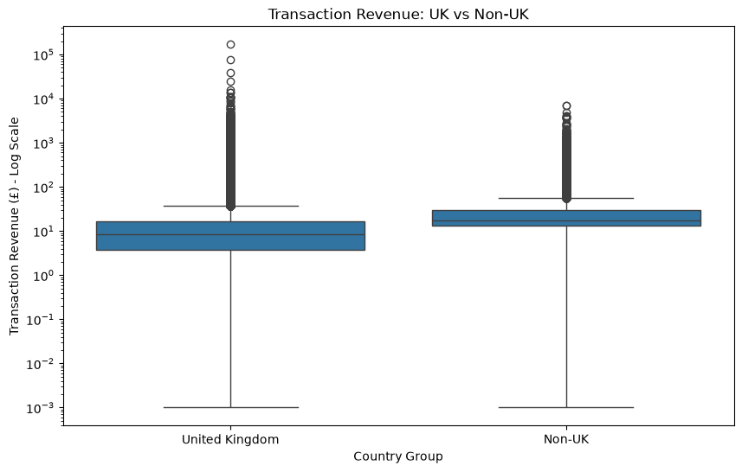
Figure 2. Transaction revenue distribution across selected countries.
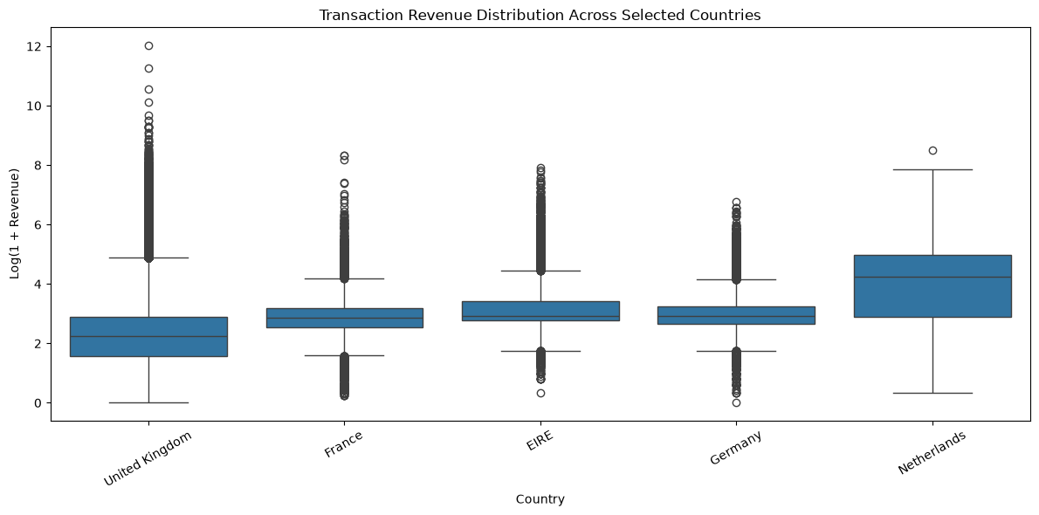
Figure 2. Transaction revenue distribution across selected countries.
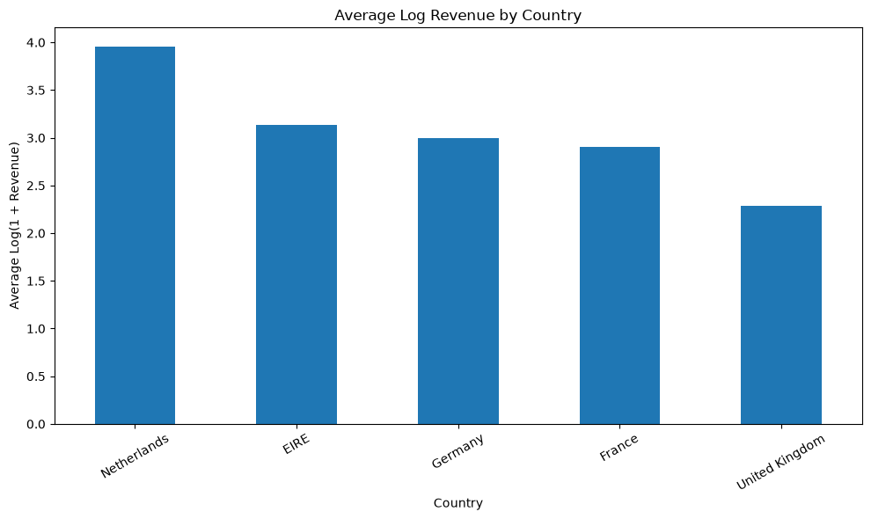
Figure 2. Average log-transformed transaction revenue by selected country.

7. Test 3 – Country and Cancellation Status
The third question was whether cancellation behaviour was independent of country. This analysis used the original transaction data so that both cancelled and non-cancelled records were available.
The Chi-Square test produced a statistic of 1444.0929 and a p-value of approximately 1.8983e-311. This is far below the 0.05 significance level, so the null hypothesis of independence was rejected.
The result provides statistically significant evidence that country and cancellation status are associated in the selected data. It is important to interpret this correctly: the test identifies an association, not a cause-and-effect relationship. The analysis cannot by itself explain why cancellation patterns differ.
A cancellation heatmap was created to make the observed counts easier to compare across countries. Cancellation rates were also calculated so that countries with different transaction volumes could be considered on a percentage basis.
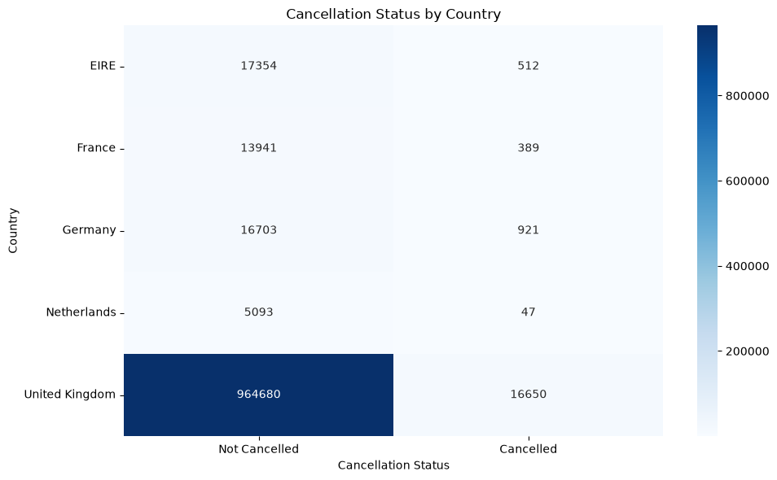
Figure 3. Cancellation status by country.

8. Combined Results
The three tests answer different questions, so they should not be treated as interchangeable. The t-test compares two groups, ANOVA compares several group means, and the Chi-Square test examines the relationship between categorical variables.
Analysis | Statistic | p-value | Decision at α = 0.05 | Plain-English interpretation
Welch t-test | t = -47.4265 | 0.0 | Reject H₀ | There is statistical evidence of a difference in UK and Non-UK mean transaction revenue.
One-Way ANOVA | F = 9855.8207 | 0.0 | Reject H₀ | There is statistical evidence that the selected country means are not all the same.
Chi-Square | χ² = 1444.0929 | 1.8983e-311 | Reject H₀ | There is statistical evidence of an association between country and cancellation status.

9. What These Results Mean for the Business
From a business point of view, the first result suggests that the domestic UK market and the international market should not automatically be treated as having identical transaction-value behaviour. Further segmentation could help the business understand what is driving the difference.
The ANOVA result suggests that transaction-value behaviour varies across the selected countries. A sensible next step would be to investigate the individual markets in more detail, including product mix, order size, customer behaviour and purchasing frequency.
The Chi-Square result indicates that cancellation patterns are not distributed independently of country in the analysed data. This could be useful for operational investigation. For example, the business could examine whether delivery, availability, customer expectations or order-processing issues differ between markets. The statistical test itself does not identify which of these explanations is responsible.

10. Statistical Limitations and Assumptions
- Transaction revenue is strongly right-skewed and contains extreme values. A log transformation was therefore used for ANOVA.
- The dataset is very large, so very small differences can produce very small p-values. Statistical significance should not automatically be treated as practical importance.
- ANOVA shows that at least one group differs but does not identify the exact country pairs responsible for the difference. Post-hoc testing would be required.
- The Chi-Square test establishes statistical association, not causation.
- The country-based ANOVA and Chi-Square analyses were intentionally limited to selected countries rather than every country in the dataset.
- Missing Customer ID values can limit customer-level analyses, although the main tests in this report were transaction- and country-based.
- The conclusions describe the evidence in this dataset and should not automatically be generalised to every online retail business.

11. Overall Conclusion
This project showed how statistical testing can be used to turn observations from a retail dataset into evidence-based findings. Rather than relying only on charts and averages, the analysis used formal hypothesis tests to examine whether the observed patterns were statistically supported.
All three tests produced p-values below the chosen 0.05 significance level. The Welch t-test provided evidence of a difference between UK and Non-UK mean transaction revenue. The ANOVA provided evidence that the selected country means were not all equal after log transformation. The Chi-Square test provided evidence of an association between country and cancellation status.
At the same time, the results should be interpreted carefully. A statistically significant result does not automatically mean that the difference is large in business terms, and none of these tests by themselves proves causation. The strongest use of these findings is as a starting point for deeper business investigation.

12. Estimated Workload
The overall estimated workload for this Week 3 project is approximately 32–35 hours. This includes understanding and preparing the dataset, formulating hypotheses, selecting suitable statistical methods, implementing the tests in Python, calculating the confidence interval, creating supporting visualizations, interpreting the outputs, checking limitations, and preparing the final documentation.

13. References
- UCI Machine Learning Repository – Online Retail II Dataset.
- Pandas Documentation – Python data manipulation and analysis.
- SciPy Documentation – Statistical tests and probability distributions.
- Matplotlib Documentation – Visualization in Python.
- Seaborn Documentation – Statistical data visualization.

Appendix – Python Analysis Covered
The accompanying Jupyter Notebook contains the complete executable workflow used for this report. It includes data loading, preprocessing, revenue calculation, hypothesis formulation, Welch's t-test, confidence interval calculation, One-Way ANOVA, Chi-Square testing, visualizations, decision rules, statistical summaries, limitations and conclusions.

