COMPREHENSIVE DATA SCIENCE
PROJECT REPORT
From Data Preparation to Statistical Analysis,
Visualization, Machine Learning and Strategic Recommendations

FINAL WEEK — WEEK 5

Prepared By | Academic Program | Institution | Year
Vechham Sai Yaswin | B.Tech – Artificial Intelligence & Machine Learning | Vel Tech Rangarajan Dr. Sagunthala R&D Institute of Science and Technology | 2026

Document Control and Source Basis
This final Week 5 report was prepared by synthesising the seven source files supplied for the internship: four weekly reports and three executed Python notebooks. The weekly reports provide the documented methodology, interpretation and visual evidence, while the notebooks provide the underlying analytical workflow and code used for Weeks 2–4.
Source | Type | Role in Week 5 synthesis
Week 1 Data Acquisition, Cleaning and EDA report | DOCX | Data preparation, quality assessment, EDA and retail baseline findings
Week 2 Advanced Data Visualization and Storytelling report | DOCX | Six visual narratives, business interpretation and visualization rationale
Week 2 Advanced Data Visualization and Storytelling notebook | IPYNB | Executed visualization workflow and calculations
Week 3 Statistical Analysis and Hypothesis Testing report | DOCX | Hypotheses, statistical methodology, results and limitations
Week 3 Statistical Analysis and Hypothesis Testing notebook | IPYNB | Executed statistical tests and supporting plots
Week 4 Machine Learning Model Development and Evaluation report | DOCX | Model methodology, evaluation, error analysis and interpretation
Week 4 Machine Learning Model Development and Evaluation notebook | IPYNB | Executed machine-learning pipeline and evaluation code

Source consistency note
The uploaded Week 1 filename contains the word “Titanic”, but the actual report content identifies the Online Retail II dataset throughout. This final report follows the actual analytical content rather than the filename.

Executive Summary
This final report consolidates the analytical work completed across Weeks 1–4 into one end-to-end data science project narrative. The work progressed from data acquisition and cleaning, through exploratory and advanced visualization, into formal statistical hypothesis testing and finally supervised machine learning model development. The result is a practical demonstration of how raw data can be converted into evidence, interpreted for decision-making, and extended into predictive modelling.
Weeks 1–3 used the Online Retail II transaction dataset as the main business analytics case. The combined workbook contained 1,067,371 raw transaction lines across two yearly sheets. After preparing the data and focusing the main sales analysis on positive quantity and price transactions, the work identified £20.97 million in positive-sales revenue, 43 countries, 4,917 stock codes and 40,078 unique invoices. The analysis showed strong revenue concentration in the United Kingdom, noticeable month-to-month variation, concentration among high-revenue products, unequal customer value, and a strongly right-skewed transaction-revenue distribution.
Week 3 converted several visual observations into formal statistical evidence. A Welch independent t-test found a statistically significant difference between UK and Non-UK mean transaction revenue (t = -47.4265, p reported as 0.0). One-way ANOVA found statistically significant differences among the selected country groups (F = 9855.8207, p reported as 0.0). A Chi-Square test found a statistically significant association between country and cancellation status (χ² = 1444.0929, p ≈ 1.8983 × 10⁻³¹¹). These results were interpreted as statistical evidence within the analysed dataset, not as proof of causation.
Week 4 demonstrated a separate supervised machine-learning track using the Breast Cancer Wisconsin Diagnostic dataset. Two models were compared: Logistic Regression and a controlled-depth Decision Tree. Logistic Regression achieved 98.25% test accuracy, 98.61% precision, 98.61% recall, 98.61% F1-score and 0.9954 ROC-AUC, while the Decision Tree achieved 92.11% accuracy and 0.9163 ROC-AUC. Five-fold stratified cross-validation also favoured Logistic Regression, supporting the conclusion that it generalised more consistently in this experiment.
The strategic recommendations in this final report therefore focus on five practical themes: segmenting high-value customers, managing country-specific opportunities, investigating cancellation drivers, using dashboards for recurring decision support, and validating predictive models before real-world deployment. The report also recognises important limitations, including skewed transaction values, missing customer identifiers, statistical significance versus practical significance, dataset-specific conclusions, and the need for external validation of machine-learning models.

Report Map
- Executive Summary
- 1. Introduction and Project Context
- 2. Internship Objectives and End-to-End Workflow
- 3. Week 1 – Data Acquisition, Cleaning and Exploratory Analysis
- 4. Week 2 – Advanced Data Visualization and Storytelling
- 5. Week 3 – Statistical Analysis and Hypothesis Testing
- 6. Week 4 – Machine Learning Model Development and Evaluation
- 7. Integrated Key Findings Across the Internship
- 8. Strategic Recommendations
- 9. Business and Research Impact
- 10. Limitations and Risk Considerations
- 11. Future Improvement Roadmap
- 12. Technical Implementation and Code Highlights
- 13. Conclusion
- 14. References and Source Files
- 15. Final Week 5 Requirement Checklist

1. Introduction and Project Context
The purpose of the final week is to integrate the practical skills developed throughout the internship into a coherent data science workflow. Rather than treating each weekly assignment as an isolated exercise, this report connects the work through a common analytical logic: first understand and prepare data, then communicate patterns visually, test important observations statistically, and finally demonstrate predictive modelling using an appropriate supervised learning problem.
The business analytics portion of the internship used the Online Retail II dataset. The Week 1 report describes the dataset as a real transaction environment containing invoices, products, quantities, prices, dates, customer identifiers and countries. The combined workbook contains more than one million transaction lines, making it suitable for realistic data-quality and aggregation exercises.
The machine-learning portion in Week 4 used the Breast Cancer Wisconsin Diagnostic dataset available through Scikit-learn. This was intentionally treated as a separate predictive-modelling case rather than being mixed with the retail business analysis. The separation allows the final report to demonstrate two complementary capabilities: business-oriented descriptive/statistical analytics and predictive machine learning.
Across the project, Python and its data-science ecosystem provided the core implementation environment. Pandas and NumPy supported data preparation and numerical analysis; Matplotlib and Seaborn supported visual communication; SciPy supported statistical testing; and Scikit-learn supported preprocessing, model development, cross-validation and evaluation.

2. Internship Objectives and End-to-End Workflow
The final project demonstrates the following learning outcomes:
- Acquire and understand structured public or supplied datasets.
- Identify and treat missing values, duplicates, invalid or unusual observations with justified decisions.
- Create business-relevant derived measures such as transaction revenue.
- Perform exploratory analysis to identify trends, concentration and unusual observations.
- Design visualizations that answer clear analytical questions and communicate findings to non-technical readers.
- Formulate testable hypotheses and select statistical methods appropriate to the question.
- Interpret p-values, confidence intervals and statistical associations correctly.
- Develop and compare supervised machine-learning models using multiple evaluation metrics.
- Use cross-validation and error analysis to examine generalisation rather than relying on a single accuracy value.
- Translate analytical evidence into practical recommendations, while recognising uncertainty and limitations.

2.1 End-to-End Workflow
Stage | Main activity | Evidence produced
1. Data acquisition | Load and combine source data | Structured DataFrame and dataset profile
2. Data quality | Check missingness, duplicates, dates and unusual values | Data-quality summary and cleaning decisions
3. Feature preparation | Create revenue and modelling-ready variables | Derived measures and prepared datasets
4. Exploratory analysis | Summarise patterns and distributions | Descriptive statistics and EDA charts
5. Visual storytelling | Answer business questions with charts | Six advanced visualizations
6. Statistical validation | Test selected hypotheses | t-test, ANOVA and Chi-Square results
7. Predictive modelling | Train and compare classifiers | Logistic Regression and Decision Tree
8. Evaluation | Measure performance and errors | Metrics, confusion matrices, ROC and cross-validation
9. Strategic synthesis | Convert evidence into actions | Recommendations, impacts and future roadmap

3. Week 1 – Data Acquisition, Cleaning and Exploratory Analysis
Week 1 established the foundation for reliable analysis. The Online Retail II workbook contained two year-based sheets, which were combined into one table so that the overall transaction pattern could be studied consistently. The report records 1,067,371 raw rows and eight principal columns.

3.1 Data Quality Assessment
Quality check | Observed result | Analytical response
Raw rows | 1,067,371 | Combined both yearly sheets before analysis
Duplicate rows | 34,335 | Removed duplicate rows before final transaction-level metrics
Missing Customer ID | 243,007 (22.77%) | Retained for transaction-level analysis; excluded where customer-level metrics required an ID
Missing Description | 4,382 (0.41%) | Replaced with a neutral 'Unknown product description' label
Negative quantities | 22,950 | Interpreted as returns/cancellations; excluded from positive-sales trend analysis
Cancellation invoices | 19,494 | Retained in cancellation analysis rather than deleting them
Negative prices | 5 | Excluded from positive-sales revenue analysis

The cleaning decisions were deliberately different for different variables. Customer IDs were not treated like ordinary missing values because a missing identifier prevents customer-level aggregation but does not automatically make the transaction useless. Likewise, cancellation and negative-quantity records were retained for analyses where their meaning was relevant. This distinction between 'invalid for one analysis' and 'invalid for all analyses' is an important data-science practice.
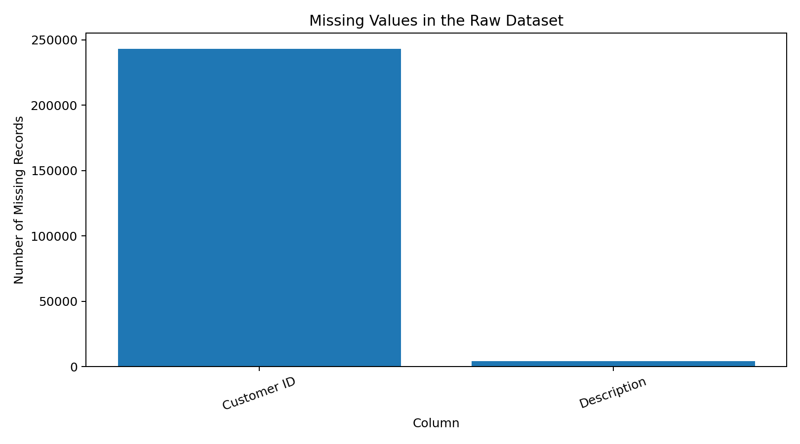
Figure 1. Missing-value profile from the Week 1 analysis.

3.2 Derived Business Measure and EDA
A Revenue variable was created as Quantity × Price. For the main sales analysis, transactions with positive Quantity and positive Price were retained. This produced 1,041,671 positive-sales lines and approximately £20.97 million in positive-sales revenue. The analysis covered 43 countries, 4,917 stock codes and 40,078 unique invoices.
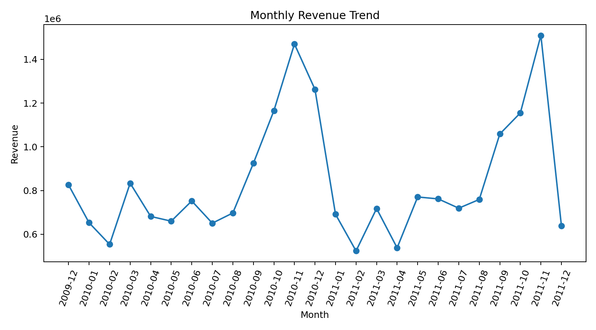
Figure 2. Monthly revenue trend from the Week 1 exploratory analysis.
The monthly pattern shows meaningful variation over time. November 2011 reached approximately £1.51 million, while February 2011 was the lowest positive-sales month at approximately £0.52 million. The pattern demonstrates why a single overall revenue figure is insufficient for operational planning.
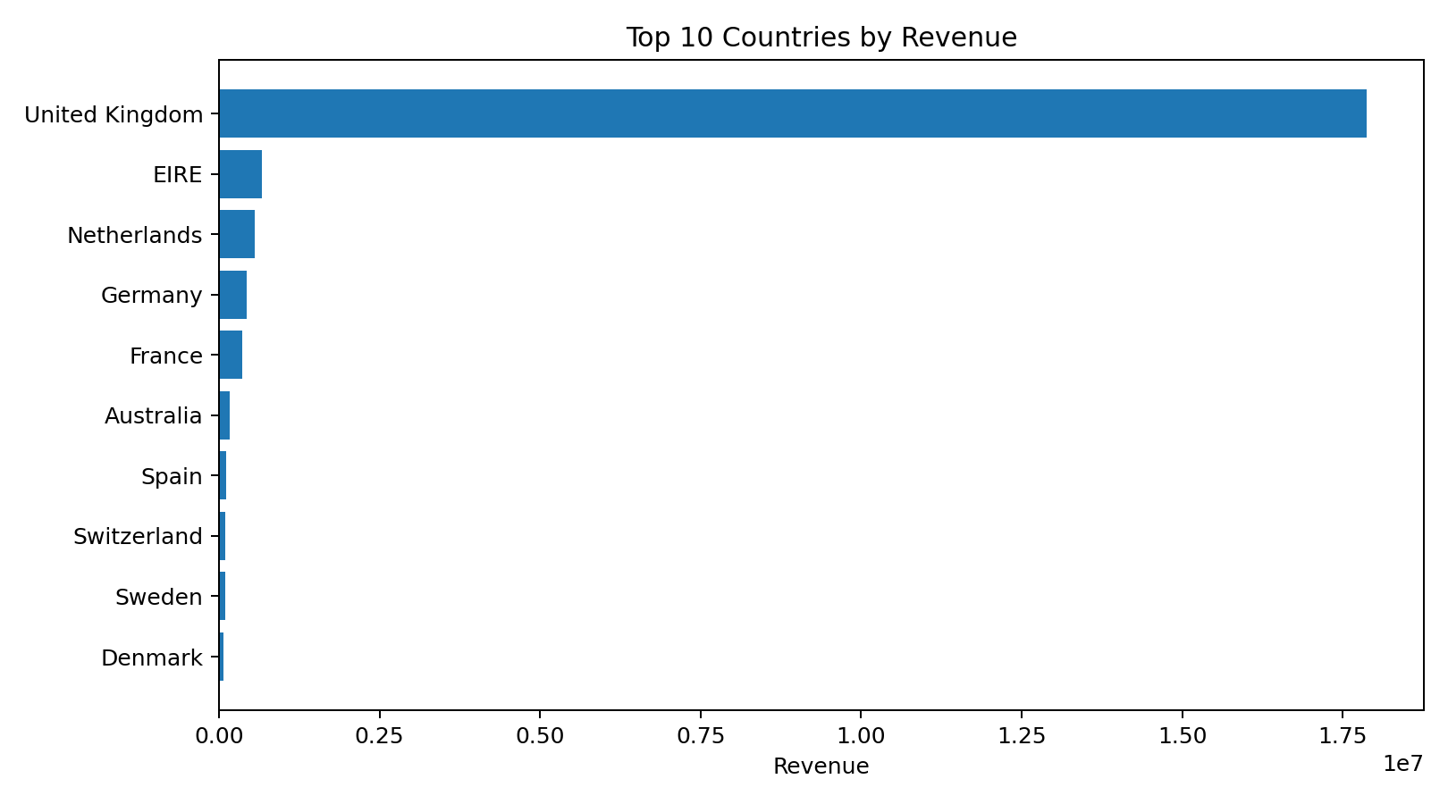
Figure 3. Top countries by positive-sales revenue.
The country analysis shows a very strong concentration in the United Kingdom. This observation becomes especially important in Week 3, where country-based statistical tests are used to determine whether observed differences are supported by statistical evidence.

3.3 Week 1 Key Learning
- Data cleaning should be driven by the analytical purpose of the field, not by a single blanket rule.
- Transaction-level data often contains returns, cancellations and extreme values that need to be interpreted rather than blindly deleted.
- Derived business measures such as Revenue make raw operational fields easier to aggregate and interpret.
- EDA provides hypotheses and questions for later statistical analysis; it does not by itself establish causation.

4. Week 2 – Advanced Data Visualization and Storytelling
Week 2 extended the retail analysis from basic EDA into a coherent visual narrative. Six visualizations were developed with Matplotlib and Seaborn. The report organised them as a connected story: when revenue changes, where it comes from, which products drive it, when customers are active, how customer value differs, and whether extreme transaction values influence the overall picture.

4.1 Core Findings
Indicator | Actual result | Interpretation
Positive-sales revenue | £20,972,968.14 | Large transaction base for business analysis
Highest revenue month | November 2011 — £1,509,496.33 | Important peak period for planning
Lowest revenue month | February 2011 — £523,631.89 | Substantial month-to-month variation
Top country | United Kingdom — ~£17.87 million | Very strong geographic concentration
Top product | REGENCY CAKESTAND 3 TIER — £344,563.25 | Small group of products drives notable revenue
RFM customers | 5,878 | Customer-level segmentation is feasible where IDs exist
Median transaction revenue | £9.96 | Typical transaction is far below extreme values
Maximum transaction revenue | £168,469.60 | Extreme transactions materially widen the distribution

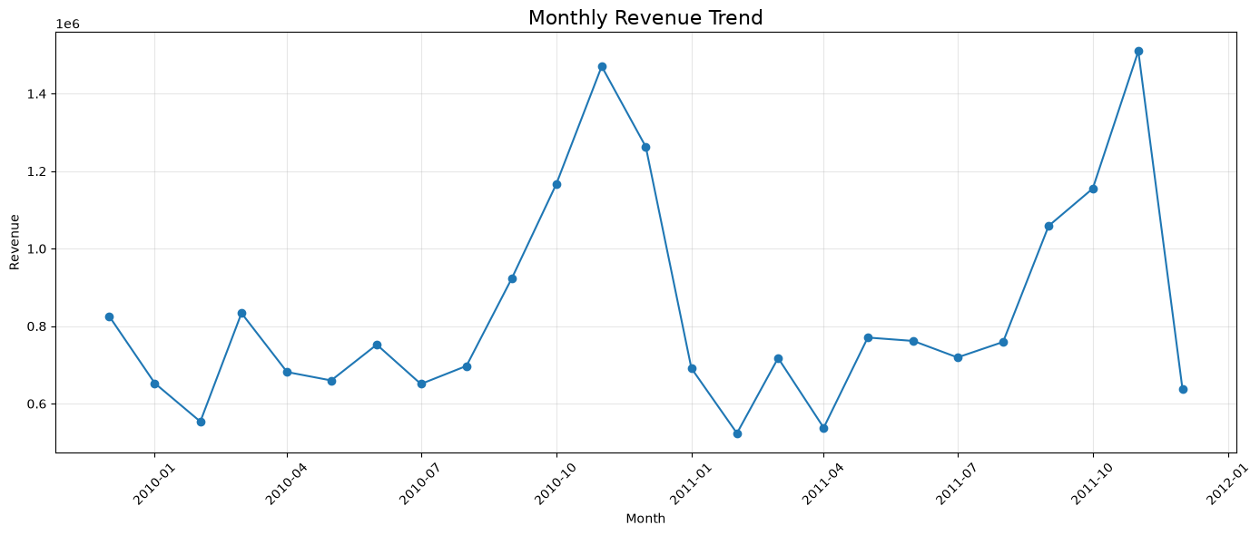
Figure 4. Monthly revenue trend used to identify peaks and lower-performing periods.
The line chart is effective because time is continuous and the main question is change. The November peak and February trough can be used as starting points for investigating seasonality, promotional effects, inventory availability or operational factors. The chart itself does not establish which factor caused the movement.
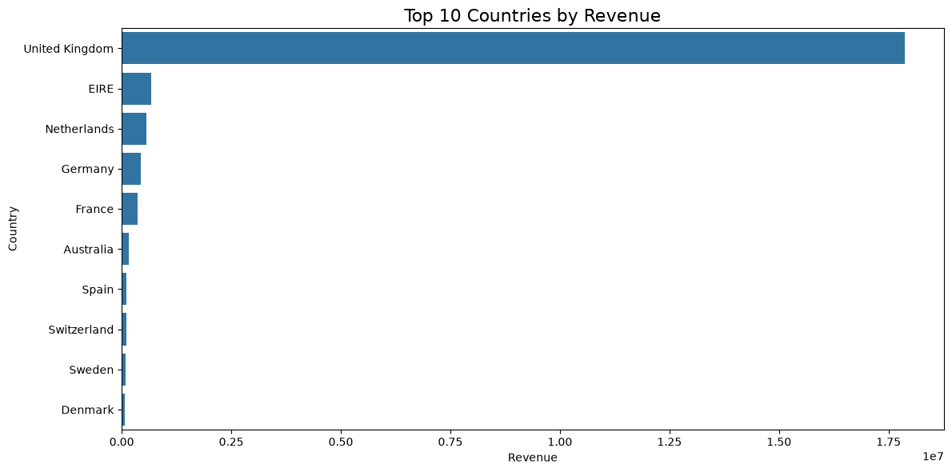
Figure 5. Top 10 countries by positive-sales revenue.
The country chart makes concentration immediately visible. The United Kingdom contributes approximately £17.87 million, substantially more than the other leading countries. This supports a differentiated regional strategy rather than assuming all markets behave similarly.
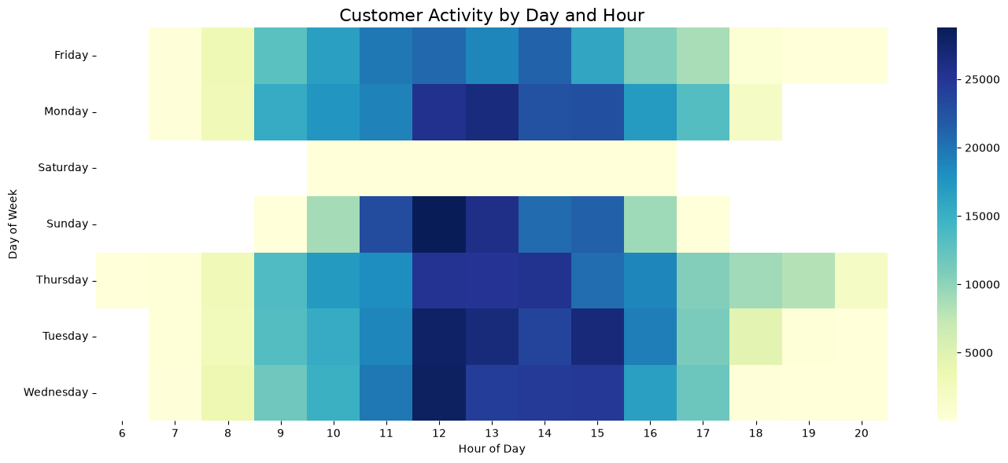
Figure 6. Customer activity by day and hour.
The heatmap shows that transaction activity is concentrated mainly during daytime hours, with stronger activity around the middle of the day. Such a pattern can inform customer-service coverage, staffing and the timing of promotional activity.
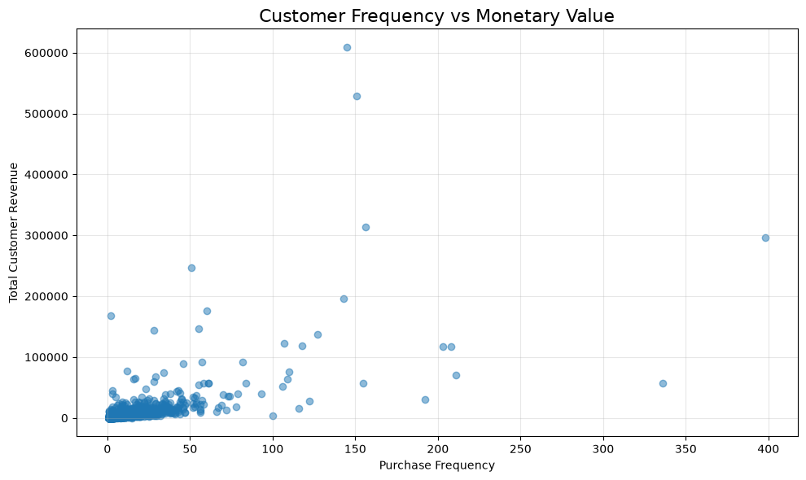
Figure 7. Customer purchase frequency versus monetary value.
The scatter plot shows that most customers occupy the lower-frequency and lower-spending region, while a smaller group displays much higher frequency or monetary value. This unequal distribution supports targeted retention and engagement strategies for high-value customer groups.
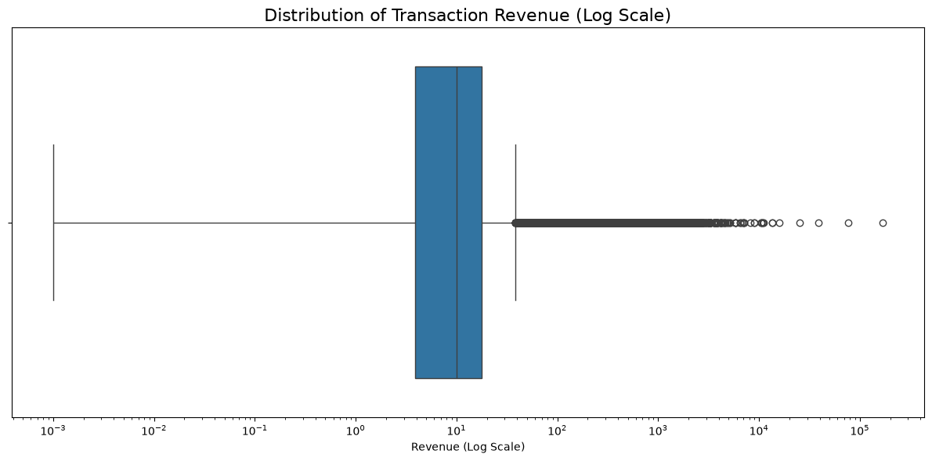
Figure 8. Transaction revenue distribution on a logarithmic scale.
The median transaction revenue is approximately £9.96, while the maximum reaches £168,469.60. The large gap demonstrates why the analysis uses log scales where appropriate and why mean-based summaries should be interpreted carefully in highly skewed transaction data.

5. Week 3 – Statistical Analysis and Hypothesis Testing
Week 3 moved from descriptive evidence to formal statistical validation. Three tests were chosen to answer three different business questions: Welch's independent t-test for two groups, one-way ANOVA for several country groups, and Chi-Square for the relationship between country and cancellation status. A significance level of α = 0.05 was used throughout.

5.1 Hypotheses and Test Results
Question | Test | Statistic | p-value | Decision | Meaning
UK vs Non-UK mean transaction revenue | Welch t-test | t = -47.4265 | 0.0 | Reject H₀ | Mean revenue differs statistically
Five selected country means | One-way ANOVA | F = 9855.8207 | 0.0 | Reject H₀ | At least one country mean differs
Country vs cancellation status | Chi-Square | χ² = 1444.0929 | 1.8983e-311 | Reject H₀ | Country and cancellation status are associated

5.2 Test 1 – UK versus Non-UK Revenue
The Welch t-test produced t = -47.4265 with the p-value reported as 0.0 by Python. The 95% confidence interval for the UK-minus-Non-UK mean difference was approximately -19.4185 to -17.8772, entirely below zero. This supports the conclusion that the two groups have different mean transaction revenue in the analysed sample.
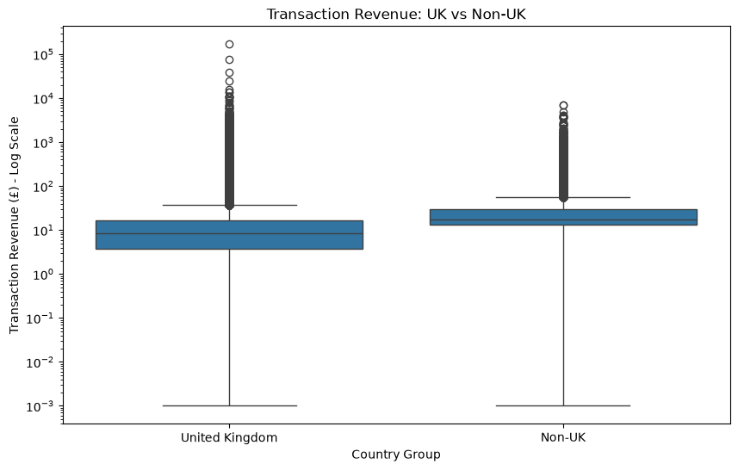
Figure 9. UK versus Non-UK transaction revenue distribution using a log scale.

5.3 Test 2 – Country Differences
The one-way ANOVA compared the United Kingdom, EIRE, Netherlands, Germany and France using log(1 + Revenue) to reduce the influence of extreme values. The F-statistic was 9855.8207 with a p-value reported as 0.0. The correct interpretation is that the selected country means are not all equal; ANOVA alone does not identify which individual pairs differ. A post-hoc analysis would be required for that more detailed question.
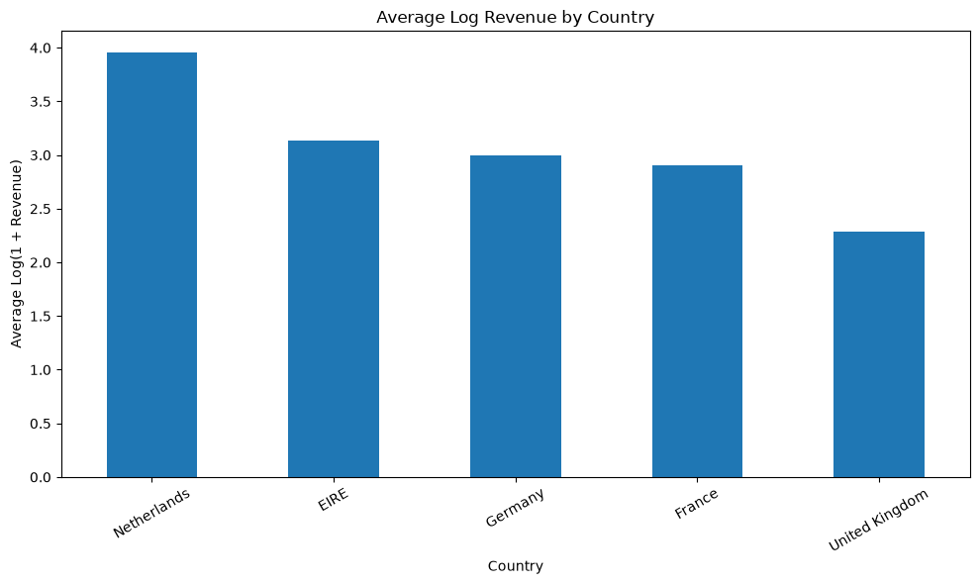
Figure 10. Average log-transformed transaction revenue by selected country.

5.4 Test 3 – Country and Cancellation
The Chi-Square test produced χ² = 1444.0929 and p ≈ 1.8983 × 10⁻³¹¹. The null hypothesis of independence was rejected. The result provides strong statistical evidence of an association between country and cancellation status in the selected data. Importantly, this is an association, not evidence that country causes cancellations.
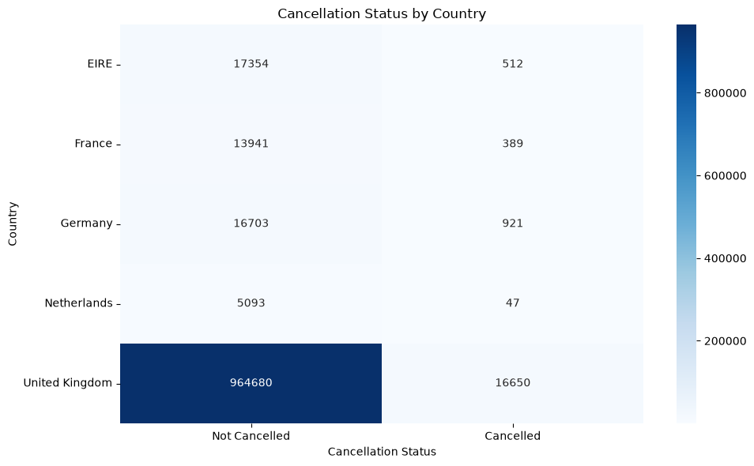
Figure 11. Cancellation status by country.

5.5 Statistical Interpretation and Limitations
- The very large dataset means even small differences can produce extremely small p-values; statistical significance should therefore be considered alongside practical importance.
- The ANOVA identifies that at least one group differs but requires post-hoc testing to identify the exact country pairs.
- The Chi-Square result establishes association, not causation.
- The conclusions are specific to the analysed dataset and should not automatically be generalised to every online retail business.
- The strong right-skew in transaction revenue justifies the use of a log transformation for the ANOVA analysis.

6. Week 4 – Machine Learning Model Development and Evaluation
Week 4 introduced a separate predictive modelling case using the Breast Cancer Wisconsin Diagnostic dataset from Scikit-learn. The dataset contains 569 observations, 30 numerical predictor variables and two target classes: Malignant and Benign. There were no missing values or duplicate rows, so preprocessing was based on actual data quality rather than forcing unnecessary cleaning operations.

6.1 Modelling Workflow
- Inspect the dataset and target distribution.
- Separate predictors from the target.
- Use an 80:20 stratified train-test split with random_state = 42.
- Standardise predictors for Logistic Regression using training data only.
- Train Logistic Regression as an interpretable baseline.
- Train a Decision Tree with max_depth = 5 to control complexity.
- Evaluate both models using Accuracy, Precision, Recall, F1-score and ROC-AUC.
- Use five-fold stratified cross-validation to examine stability.
- Inspect confusion matrices, ROC curves and Decision Tree feature importance.

6.2 Model Comparison
Metric | Logistic Regression | Decision Tree | Preferred
Accuracy | 0.9825 (98.25%) | 0.9211 (92.11%) | Logistic Regression
Precision | 0.9861 (98.61%) | 0.9565 (95.65%) | Logistic Regression
Recall | 0.9861 (98.61%) | 0.9167 (91.67%) | Logistic Regression
F1-score | 0.9861 (98.61%) | 0.9362 (93.62%) | Logistic Regression
ROC-AUC | 0.9954 | 0.9163 | Logistic Regression

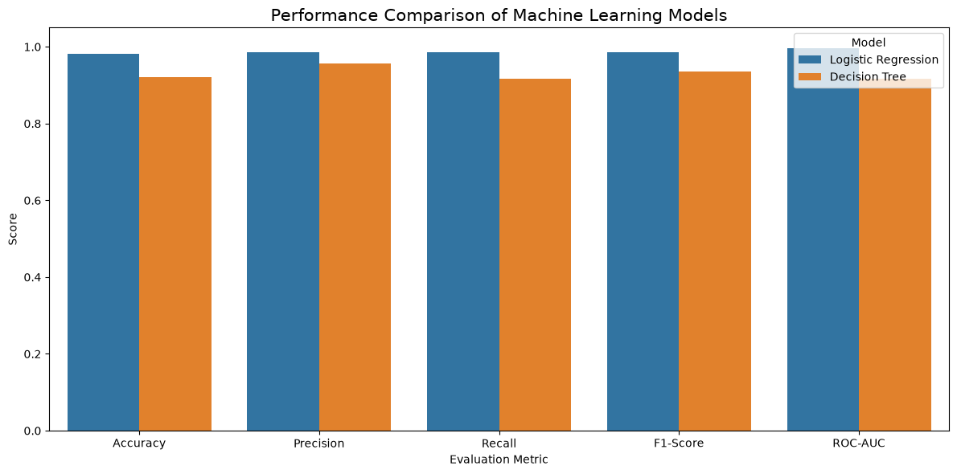
Figure 12. Test-set performance comparison between the two machine-learning models.
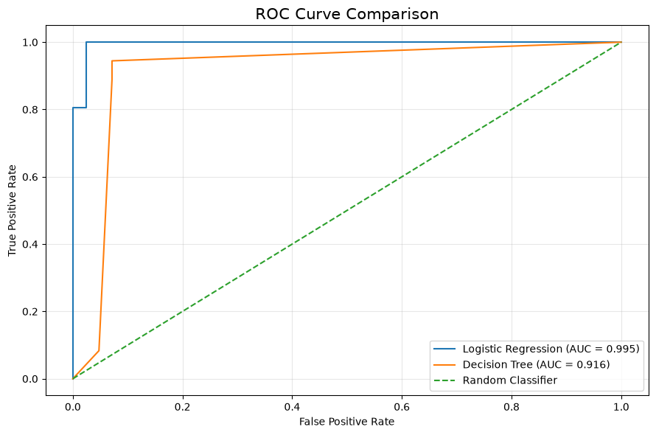
Figure 13. ROC curve comparison.
Logistic Regression was stronger across every reported test metric. Its ROC-AUC of 0.9954 indicates very strong class separation in this experiment. The Decision Tree remained useful as a contrasting non-linear model, but its performance was consistently lower.

6.3 Error Analysis and Generalisation
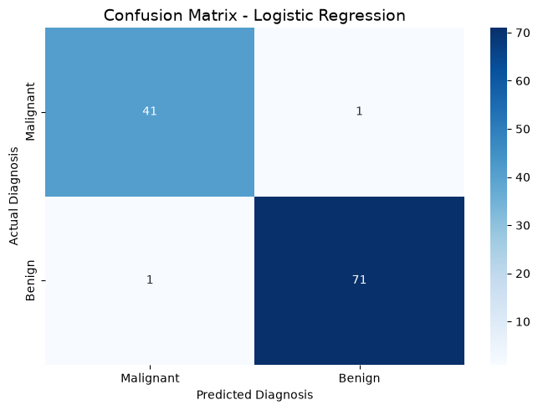
Figure 14. Logistic Regression confusion matrix.
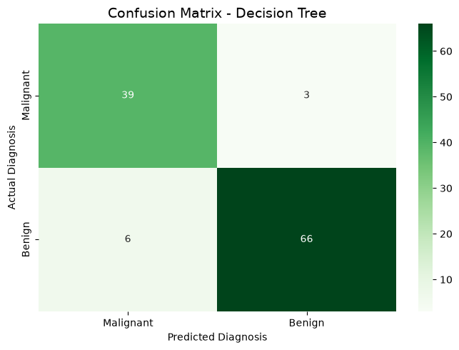
Figure 15. Decision Tree confusion matrix.
The Logistic Regression confusion matrix contains 41 true negatives, 1 false positive, 1 false negative and 71 true positives. The Decision Tree contains 39 true negatives, 3 false positives, 6 false negatives and 66 true positives. The error pattern therefore shows that Logistic Regression made only two test-set errors in this experiment, compared with nine for the Decision Tree.
The training-versus-test accuracy gap was approximately 0.0066 for Logistic Regression and 0.0724 for the Decision Tree. Together with five-fold stratified cross-validation, this indicates that Logistic Regression generalised more consistently in this experiment. The Week 4 analysis reported mean cross-validation accuracy of approximately 97.80% for Logistic Regression and 92.31% for the Decision Tree.
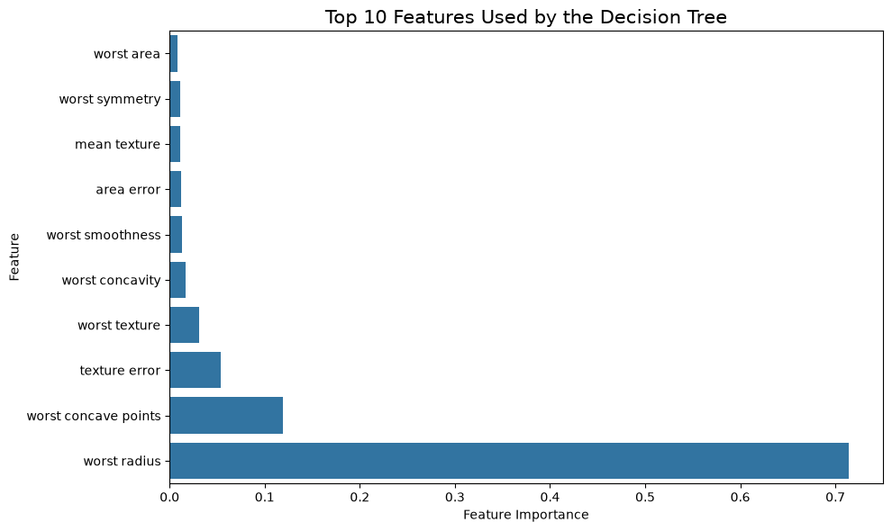
Figure 16. Decision Tree feature-importance ranking.
The Decision Tree feature-importance chart shows that worst radius was the dominant feature in that model, followed by other measurements such as worst concave points and texture-related variables. Feature importance is useful for interpretation, but it should not be treated as proof that an individual measurement causes the target outcome.
Important scope statement
The Week 4 model is an academic machine-learning exercise. Its performance should not be interpreted as evidence that the model is ready for clinical diagnosis or real-world medical deployment.

7. Integrated Key Findings Across the Internship
The strongest value of the Week 5 synthesis is not any single chart or model. It is the progression from observation to evidence and then to decision support. The following findings combine the weekly work without pretending that the retail and medical datasets are the same problem.
Integrated finding | Evidence from weekly work | Decision relevance
Revenue is geographically concentrated | UK contributed ~£17.87m of positive-sales revenue in Week 2. | Regional strategy should distinguish the core market from smaller international markets.
Revenue varies over time | Monthly revenue ranged from ~£0.52m to ~£1.51m in the analysed period. | Planning should consider seasonal/periodic demand rather than using one average month.
Customer value is uneven | RFM scatter showed a smaller high-value group and a large lower-value group. | Retention and engagement can be prioritised using customer value segments.
Country differences are statistically supported | Welch t-test and ANOVA both rejected their null hypotheses. | Regional performance deserves deeper segmentation and follow-up analysis.
Cancellation is associated with country | Chi-Square rejected independence with p ≈ 1.8983e-311. | Operations teams should investigate market-specific cancellation drivers.
Extreme transaction values matter | Median transaction revenue ~£9.96 versus maximum £168,469.60. | Robust summaries and log-scale visualisation are important for planning and modelling.
Logistic Regression generalised strongly in Week 4 | 98.25% test accuracy, 0.9954 ROC-AUC and ~97.80% mean CV accuracy. | A simple, interpretable baseline can outperform a more flexible tree model when the data structure supports it.

7.1 From Observation to Evidence
A useful pattern emerges across the internship. Week 1 identifies patterns through data preparation and EDA. Week 2 communicates those patterns visually. Week 3 asks whether selected differences are statistically supported. Week 4 demonstrates how a different dataset can be converted into a predictive classification workflow. This progression reflects a practical data-science mindset: do not jump directly to modelling; first understand the data, then validate and communicate the evidence.

8. Strategic Recommendations
The recommendations below are deliberately tied to evidence from the previous weeks. They are framed as decision-support actions rather than unsupported claims about causality.
Recommendation | Evidence | Action | Suggested KPI
1. Build a high-value customer retention strategy | RFM analysis shows substantial differences in purchase frequency and monetary value. | Create customer segments based on Recency, Frequency and Monetary value; prioritise retention offers and engagement for high-value or at-risk customers. | Retention rate; repeat purchase rate; customer lifetime value.
2. Develop country-specific performance playbooks | The UK contributes the majority of revenue, and Week 3 found significant differences among selected country groups. | Review product mix, order size, frequency, service levels and cancellation patterns by market rather than using one international strategy. | Revenue per market; order value; repeat rate; cancellation rate.
3. Investigate cancellation drivers by market | Chi-Square found a strong association between country and cancellation status, but did not establish the cause. | Conduct follow-up analysis using delivery time, stock availability, product category, order value and customer history. | Cancellation rate; reason mix; fulfilment delay; stock-out rate.
4. Use revenue and activity patterns for operational planning | Revenue varies by month and transaction activity is concentrated during particular day/hour periods. | Use historical patterns to support staffing, customer-service coverage, inventory planning and promotion timing. | Peak-period service level; inventory availability; revenue per active period.
5. Monitor high-revenue products separately | A small set of products contributes substantial revenue; REGENCY CAKESTAND 3 TIER leads the product analysis. | Create a high-revenue product watchlist covering availability, sales volume, margin where available, and cancellation/return behaviour. | Stock-out frequency; product revenue; units sold; return/cancellation rate.
6. Standardise decision-ready dashboards | Week 2 demonstrated that time, country, product, customer and activity views reveal different parts of performance. | Combine recurring indicators into an interactive dashboard with filters for time, country, product and customer segment. | Dashboard adoption; reporting time saved; KPI coverage.
7. Validate machine-learning models before real deployment | Week 4 Logistic Regression performed strongly, but the result comes from one academic dataset and controlled experiment. | Use external validation, broader data, hyperparameter tuning, calibration, model monitoring and domain review before production use. | External validation performance; calibration; error rate; model drift.

Strategic principle
Dashboards explain what is happening; statistical tests help establish whether selected differences are supported by evidence; predictive models estimate outcomes under a defined modelling problem. The strongest decision process uses all three appropriately.

9. Business and Research Impact

9.1 Business Impact
- Customer analytics can support targeted retention instead of treating all customers identically.
- Country-level analysis can help organisations prioritise markets and investigate differences in order behaviour.
- Cancellation analysis can guide operational investigation into fulfilment, availability and customer-experience issues.
- Time-based revenue and activity patterns can improve planning for staffing, inventory and promotions.
- A decision-ready dashboard can reduce the time required to repeatedly interpret raw transaction data.

9.2 Research and Analytical Impact
- The project demonstrates how exploratory findings can be followed by formal statistical validation.
- The use of log transformation illustrates how skewed transaction data can require thoughtful statistical preparation.
- The Week 4 modelling study demonstrates that model selection should consider multiple metrics and generalisation rather than accuracy alone.
- The project highlights the importance of separating association from causation and test performance from deployment readiness.

9.3 Stakeholder Value
Stakeholder | Useful insight | Potential decision
Business / Management | Revenue concentration and trends | Market, inventory and growth priorities
Marketing | Customer-value differences | Targeted retention and engagement
Operations | Activity and cancellation patterns | Staffing and fulfilment investigation
Product / Merchandising | High-revenue product concentration | Availability and product planning
Data / Analytics Team | Validated statistical and ML workflows | Reusable analytical pipelines
Research / Technical Team | Model comparison and limitations | Further validation and experimentation

10. Limitations and Risk Considerations

10.1 Retail Analytics Limitations
- The Online Retail II analysis is based on the supplied historical dataset and therefore describes the recorded period rather than current market conditions.
- A substantial number of Customer ID values are missing, limiting customer-level analysis to identified customers.
- Transaction revenue is strongly right-skewed and contains extreme values, which can affect averages and statistical tests.
- The selected-country ANOVA intentionally covers five countries; conclusions should not be extended automatically to every country.
- Statistical significance may be amplified by the very large sample size and should be interpreted alongside practical business importance.
- The Chi-Square test identifies association between country and cancellation status but does not establish causation.

10.2 Machine-Learning Limitations
- The Week 4 model was evaluated on a single held-out split supported by five-fold cross-validation; broader external validation would strengthen the evidence.
- The Breast Cancer Wisconsin Diagnostic dataset is an academic benchmark and does not represent the full complexity of a clinical environment.
- High test performance does not guarantee safe or reliable performance on a different population or measurement process.
- The Decision Tree was intentionally limited to max_depth = 5; other hyperparameter choices could change its performance.
- Additional models, feature-selection strategies and calibration analysis could provide a broader comparison.
- No production monitoring, data-drift analysis or clinical validation was performed.

10.3 Reporting Risk
A final report should avoid presenting every statistically significant result as a business opportunity. The recommended next step is often further investigation rather than immediate intervention. This distinction is especially important when the available evidence identifies a relationship but does not explain its underlying mechanism.

11. Future Improvement Roadmap
Priority | Improvement | Why it matters | Expected benefit
High | Post-hoc tests after ANOVA | Identify which country pairs differ | More precise regional decisions
High | Cancellation-driver analysis | Association alone does not explain causes | Operational root-cause insight
High | Customer segmentation | RFM values are uneven | More targeted retention
High | External validation of ML | Test generalisation beyond the benchmark dataset | More reliable deployment evidence
Medium | Interactive Power BI dashboard | Make recurring analysis accessible | Faster stakeholder decisions
Medium | Time-series forecasting | Use historical revenue trends | Forward-looking planning
Medium | Additional ML models | Compare alternative algorithms | More robust model selection
Medium | Hyperparameter optimisation | Reduce dependence on default settings | Potential performance improvement
Medium | Explainable AI and calibration | Improve model transparency and probability interpretation | Safer decision support
Low | Automated reporting pipeline | Reduce repetitive manual work | Scalable recurring analytics

11.1 Suggested Next-Phase Architecture
- Create a cleaned and documented analytical data layer.
- Automate recurring revenue, customer, product and cancellation KPIs.
- Publish an interactive dashboard for stakeholders.
- Add statistical monitoring for material changes in key KPIs.
- Develop predictive models only where a clearly defined decision problem exists.
- Validate models on new data and monitor drift after deployment.
- Create a feedback loop so business outcomes can be used to improve future models.

12. Technical Implementation and Code Highlights
The following excerpts are representative examples taken from the supplied notebooks. They are included to document the technical workflow rather than reproduce every line of the weekly notebooks.

12.1 Week 2 – Revenue and Visualization
df["Revenue"] = df["Quantity"] * df["Price"]
monthly_revenue = (
sales_df.groupby("Month")["Revenue"]
.sum()
.reset_index()
)
plt.figure(figsize=(14, 6))
plt.plot(monthly_revenue["Month"],
monthly_revenue["Revenue"],
marker="o")
plt.title("Monthly Revenue Trend")
plt.tight_layout()
plt.show()

12.2 Week 3 – Statistical Testing
t_stat, p_value = stats.ttest_ind(
uk_revenue,
non_uk_revenue,
equal_var=False
)
f_stat, anova_p_value = stats.f_oneway(
uk, eire, netherlands, germany, france
)
chi2_stat, chi2_p_value, degrees_of_freedom, expected = (
stats.chi2_contingency(contingency_table)
)

12.3 Week 4 – Train/Test Split and Models
X_train, X_test, y_train, y_test = train_test_split(
X, y,
test_size=0.20,
random_state=42,
stratify=y
)
logistic_model = LogisticRegression(
max_iter=5000,
random_state=42
)
decision_tree_model = DecisionTreeClassifier(
random_state=42,
max_depth=5
)

12.4 Evaluation Approach
metrics = {
"Accuracy": accuracy_score(y_test, y_pred),
"Precision": precision_score(y_test, y_pred),
"Recall": recall_score(y_test, y_pred),
"F1": f1_score(y_test, y_pred),
"ROC-AUC": roc_auc_score(y_test, y_prob)
}
These excerpts demonstrate the progression from business feature creation, to statistical inference, to predictive modelling and multi-metric evaluation. The complete code remains in the supplied notebooks.

13. Conclusion
The final Week 5 project demonstrates an end-to-end data science workflow rather than a collection of disconnected technical exercises. The internship began with the practical problem of preparing large, imperfect transaction data. It then moved into visual storytelling, where charts were used to turn millions of transaction lines into understandable business patterns. Statistical hypothesis testing added a stronger evidence layer by evaluating whether selected differences and associations were statistically supported. Finally, machine learning demonstrated how a clearly defined prediction problem can be addressed through preprocessing, model comparison, evaluation, cross-validation and error analysis.
The retail analysis produced several decision-relevant findings: revenue was strongly concentrated in the United Kingdom; revenue changed substantially over time; customer value was uneven; high-revenue products formed a meaningful concentration; transaction revenue contained extreme values; country groups differed statistically in the analysed sample; and country was associated with cancellation status. These findings support targeted customer strategies, market-specific investigation, operational monitoring and dashboard-based decision support.
The machine-learning study provided a complementary demonstration of predictive modelling. Logistic Regression achieved 98.25% test accuracy and a ROC-AUC of 0.9954, outperforming the controlled-depth Decision Tree and showing a smaller train-test gap. However, the report deliberately avoids treating this academic result as deployment-ready evidence. External validation, domain review, monitoring and further modelling work would be required before any real-world use.
Overall, the project demonstrates the core principle of data science: strong results come not only from algorithms, but from careful data preparation, appropriate analytical methods, clear communication, critical interpretation and responsible translation of evidence into decisions. This final report therefore brings together the technical, analytical and strategic skills developed throughout the internship.
Overall workflow
DATA → CLEAN → EXPLORE → VISUALISE → TEST → MODEL → EVALUATE → RECOMMEND → IMPROVE

14. References and Source Files
The Week 5 report is grounded primarily in the seven files supplied for the internship. The source materials below were reviewed as the basis for the synthesis.
- Week 1 – Data Acquisition, Cleaning, and Exploratory Data Analysis report, Online Retail II dataset.
- Week 2 – Advanced Data Visualization and Storytelling report, Online Retail II dataset.
- Week 2 – Advanced Data Visualization and Storytelling Python notebook.
- Week 3 – Statistical Analysis and Hypothesis Testing report, Online Retail II dataset.
- Week 3 – Statistical Analysis and Hypothesis Testing Python notebook.
- Week 4 – Machine Learning Model Development and Evaluation professional report, Breast Cancer Wisconsin Diagnostic dataset.
- Week 4 – Machine Learning Model Development and Evaluation Python notebook.

14.1 Main Technical Libraries Used
Library / Tool | Use in the project
Python | Primary programming environment
Pandas | Data loading, cleaning, grouping and summaries
NumPy | Numerical operations and transformations
Matplotlib | Core charts and visual communication
Seaborn | Statistical and categorical visualizations
SciPy | Welch t-test, ANOVA and Chi-Square testing
Scikit-learn | Dataset access, preprocessing, models, cross-validation and evaluation
python-docx | Professional report preparation

External documentation and dataset references are retained in the individual weekly reports. This final report intentionally uses the supplied internship files as its primary evidence base.

15. Final Week 5 Requirement Checklist
Week 5 requirement | Status | Evidence in final report
Comprehensive project report | ✓ | Weeks 1–4 integrated into one final narrative
Executive summary | ✓ | Included at the beginning of the report
Methodology | ✓ | End-to-end workflow and weekly methodologies documented
Detailed analysis | ✓ | Retail analytics, statistics and machine learning covered
Visualizations | ✓ | Actual visuals from weekly reports integrated and annotated
Code snippets | ✓ | Representative notebook excerpts included
Strategic recommendations | ✓ | Evidence-linked recommendations with suggested KPIs
Business/research impact | ✓ | Stakeholder and analytical impact discussed
Limitations | ✓ | Retail, statistical and ML limitations documented
Future improvements | ✓ | Prioritised improvement roadmap included
Conclusion | ✓ | Overall learning and project outcome summarised
Professional structure | ✓ | Cover, report map, headings, tables, figures and references
Integration of prior learning | ✓ | Weeks 1–4 explicitly connected
Workload evidence | ✓ | Weekly source reports retained as supporting evidence; Week 2 records an estimated 34 hours

Author's Final Note
This document is intended to present the internship work as a coherent professional data-science project. The findings are based on the supplied weekly reports and executed notebooks, and the recommendations are framed as evidence-informed next steps rather than unsupported claims.
Prepared by: Vechham Sai Yaswin
Final Week: Week 5 | Year: 2026

