WEEK 4 REPORT
Model Building and Predictive Analysis Using R
Binary Classification using the Iris Dataset

Student: Vechham Sai Yaswin
Program: B.Tech – Artificial Intelligence & Machine Learning
Week: 4
Tools: R / RGui
Models: Decision Tree and Linear Discriminant Analysis (LDA)

Prepared as part of the technical internship task

1. Introduction
For Week 4, the focus was on building predictive models in R and checking how well those models perform on data they have not seen during training. Instead of only training a model and looking at its output, I followed the complete workflow: defining the prediction problem, preparing the target variable, splitting the data into training and testing sets, training more than one model, generating predictions, calculating evaluation metrics, and using ROC curves and AUC for additional validation.
I used the well-known Iris dataset and converted the original three-species classification problem into a simple binary classification problem. The target was defined as 'Yes' for Iris setosa and 'No' for the other two species. This made it possible to demonstrate binary classification metrics such as precision, recall, F1-score and ROC-AUC in a clear way.

2. Problem Definition
The predictive problem in this project is to classify an Iris flower into one of two groups based on its four measured characteristics.
- Target = Yes → the flower is Iris setosa.
- Target = No → the flower belongs to another Iris species.
- Input variables = Sepal Length, Sepal Width, Petal Length and Petal Width.
- Problem type = supervised binary classification.
- Goal = train predictive models and evaluate their ability to correctly classify unseen test observations.

2.1 Dataset Background
The Iris dataset is a public dataset commonly used for demonstrating classification and statistical learning methods. The R version contains 150 observations with four numeric flower measurements and a Species variable. The dataset contains three species, with 50 observations from each species. For this task, Species was transformed into the binary Target variable described above.
Dataset source: UCI Machine Learning Repository – Iris Dataset: https://archive.ics.uci.edu/dataset/53/iris

3. Data Preparation and Target Construction
Before training the models, I created the binary target variable. This step was important because the evaluation requirements include binary-classification measures and ROC-AUC.
# Setosa = Yes, other species = No
iris_data$Target <- ifelse(
iris_data$Species == "setosa",
"Yes",
"No"
)
# Convert target into a factor
iris_data$Target <- as.factor(iris_data$Target)
# Check target distribution
table(iris_data$Target)
The target distribution was 100 observations in the No class and 50 observations in the Yes class. This means the binary dataset was not perfectly balanced, so checking the confusion matrix and class-specific metrics was useful rather than relying only on accuracy.

4. Train-Test Split and Validation Strategy
I used an 80:20 train-test split. A fixed random seed of 123 was used so that the same split could be reproduced. The training set contained 120 observations and the testing set contained 30 observations.
set.seed(123)
# Create an 80:20 train-test split
train_index <- sample(
1:nrow(iris_data),
size = 0.80 * nrow(iris_data)
)
train_data <- iris_data[train_index, ]
test_data <- iris_data[-train_index, ]
dim(train_data)
dim(test_data)
table(train_data$Target)
table(test_data$Target)
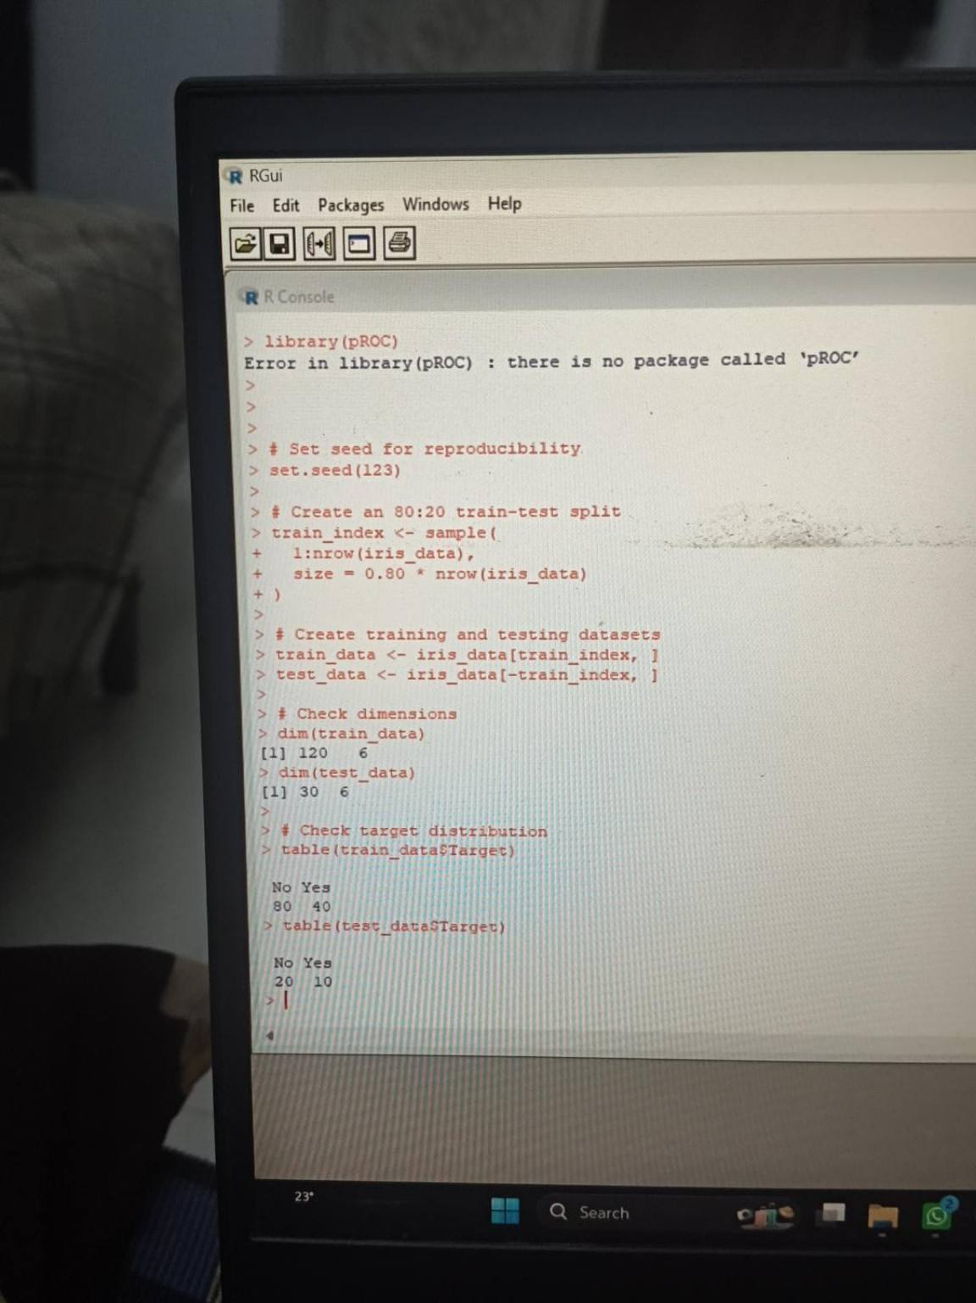
Figure 1. R console output showing the 80:20 split: 120 training observations and 30 testing observations.
The training set contained 80 No and 40 Yes observations, while the test set contained 20 No and 10 Yes observations. The same split was then used for both final models so that the comparison was based on the same unseen observations.

5. Model Selection
I selected two different classification approaches so that the project could compare a tree-based method with a statistical discriminant method.
Model | Why selected | Strengths | Limitations
Decision Tree | Easy-to-understand rule-based classifier and useful for seeing which variables create class splits. | Simple to interpret, handles nonlinear boundaries, gives variable-importance information. | Can overfit and can be sensitive to the selected split and tree complexity.
LDA | Provides a different modelling assumption and creates a linear discriminant boundary between the two classes. | Fast, interpretable and effective when class distributions can be reasonably separated by linear combinations. | Relies on assumptions about class distributions and covariance structure.

5.1 Logistic Regression Attempt
During the modelling stage, I also tried logistic regression. The R output showed convergence warnings and fitted probabilities close to 0 or 1. Because the model did not converge reliably for this particular binary setup, I did not use that attempt in the final model comparison. I continued with Decision Tree and LDA, which produced stable predictions and could be evaluated using the same test set.
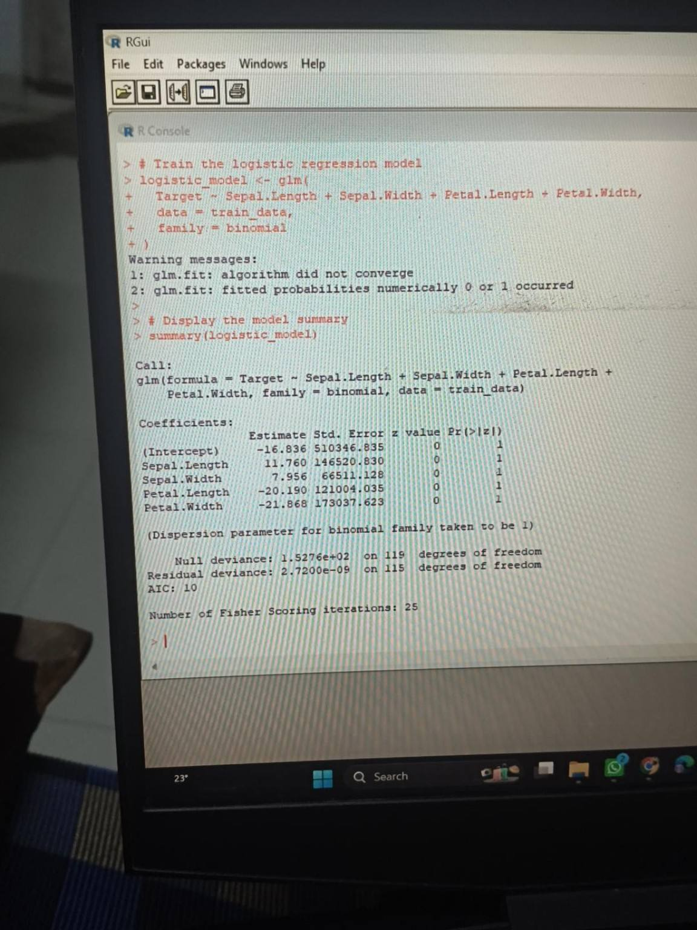
Figure 2. Initial logistic regression attempt showing convergence and fitted-probability warnings.

6. Model 1 – Decision Tree
The first final model was a classification decision tree. The model used the four flower measurements as predictors and Target as the response.
tree_model <- rpart(
Target ~ Sepal.Length + Sepal.Width +
Petal.Length + Petal.Width,
data = train_data,
method = "class"
)
summary(tree_model)
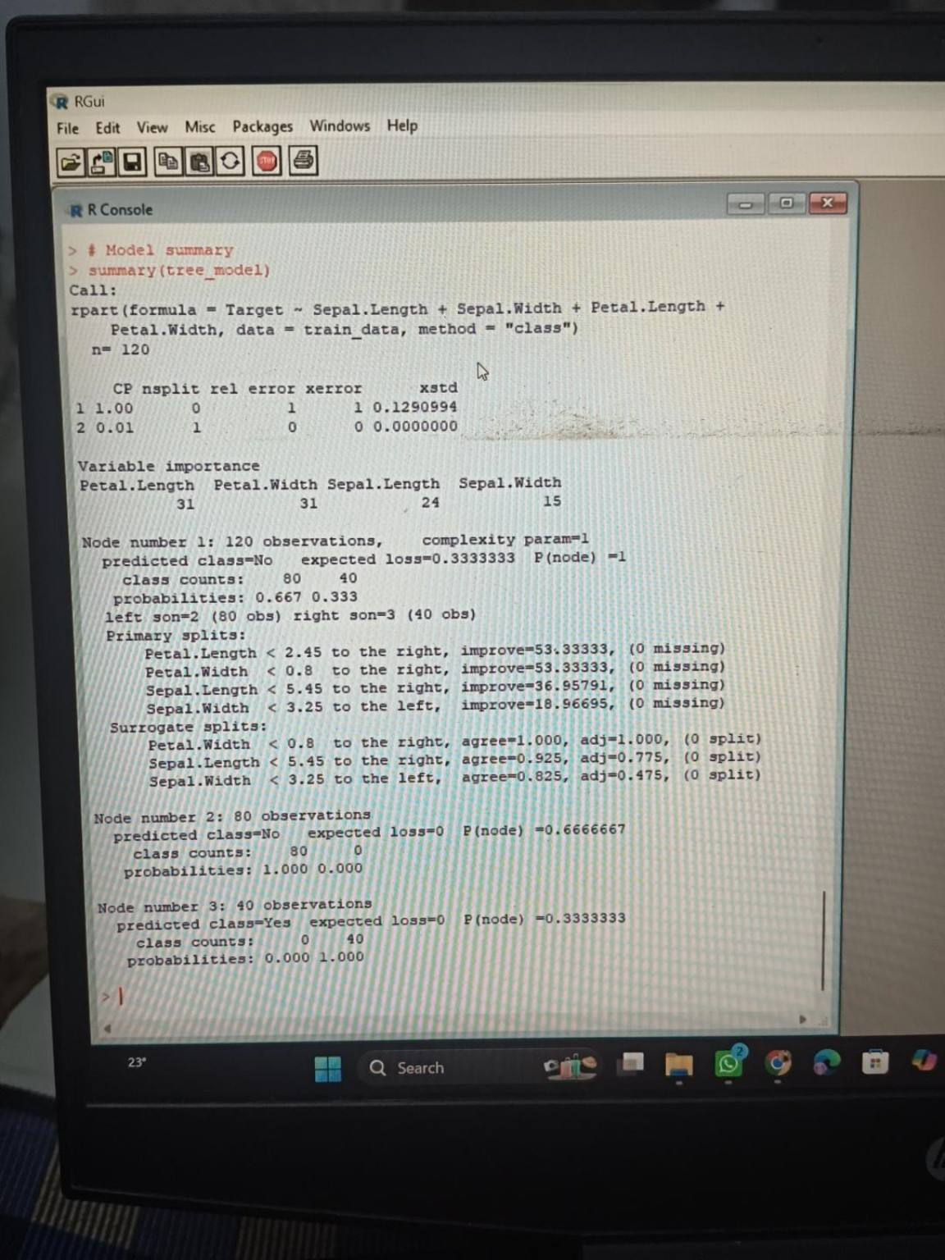
Figure 3. Decision Tree model summary from the R console.
The tree output shows that Petal Length and Petal Width were important splitting variables. The final tree separated the two target groups very clearly in the training data. The model therefore provided an easy-to-explain rule-based approach for the classification problem.

7. Decision Tree Predictions and Confusion Matrix
tree_pred <- predict(
tree_model,
test_data,
type = "class"
)
tree_cm <- table(
Actual = test_data$Target,
Predicted = tree_pred
)
tree_cm
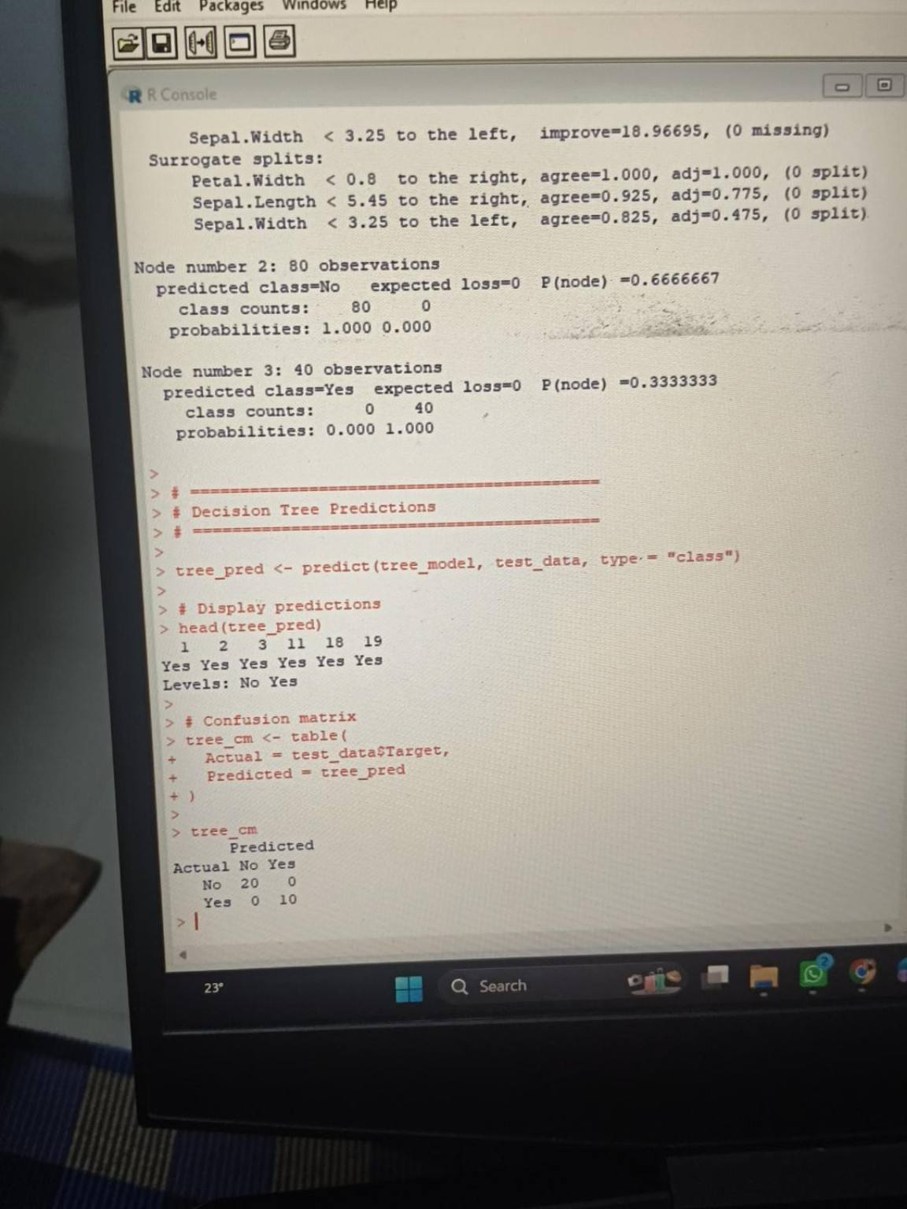
Figure 4. Decision Tree predictions and confusion matrix.
The confusion matrix contains 20 true negatives and 10 true positives, with zero false positives and zero false negatives. Therefore, every observation in the 30-row test set was classified correctly.

7.1 Decision Tree Performance Metrics
TP <- tree_cm["Yes", "Yes"]
TN <- tree_cm["No", "No"]
FP <- tree_cm["No", "Yes"]
FN <- tree_cm["Yes", "No"]
accuracy <- (TP + TN) / sum(tree_cm)
precision <- TP / (TP + FP)
recall <- TP / (TP + FN)
f1_score <- 2 * precision * recall / (precision + recall)
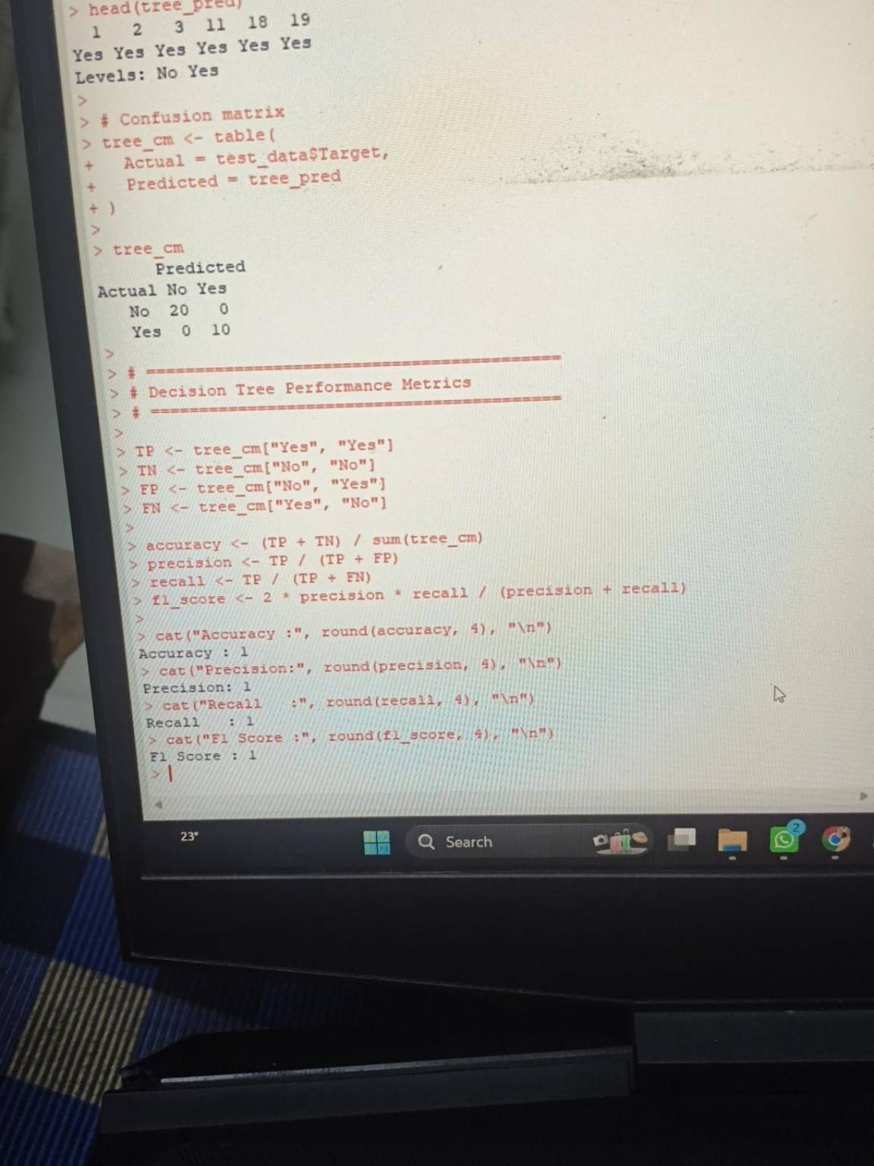
Figure 5. Decision Tree performance metrics from R.
The calculated test-set metrics were Accuracy = 1.00, Precision = 1.00, Recall = 1.00 and F1 Score = 1.00.

8. Model 2 – Linear Discriminant Analysis (LDA)
The second final model was Linear Discriminant Analysis. LDA was selected because it provides a different modelling approach from a decision tree. Instead of creating a sequence of decision rules, LDA finds a linear combination of predictors that separates the classes.
lda_model <- lda(
Target ~ Sepal.Length + Sepal.Width +
Petal.Length + Petal.Width,
data = train_data
)
lda_model
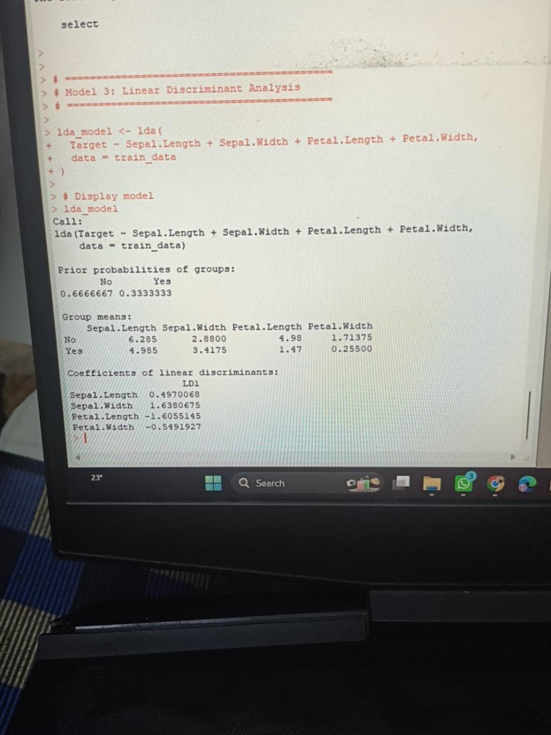
Figure 6. LDA model output showing group means and discriminant coefficients.
The LDA output showed clear differences between the class means, particularly for Petal Length and Petal Width. These differences support the strong separation observed in the classification results.

9. LDA Predictions and Confusion Matrix
lda_pred <- predict(lda_model, test_data)
lda_cm <- table(
Actual = test_data$Target,
Predicted = lda_pred$class
)
lda_cm
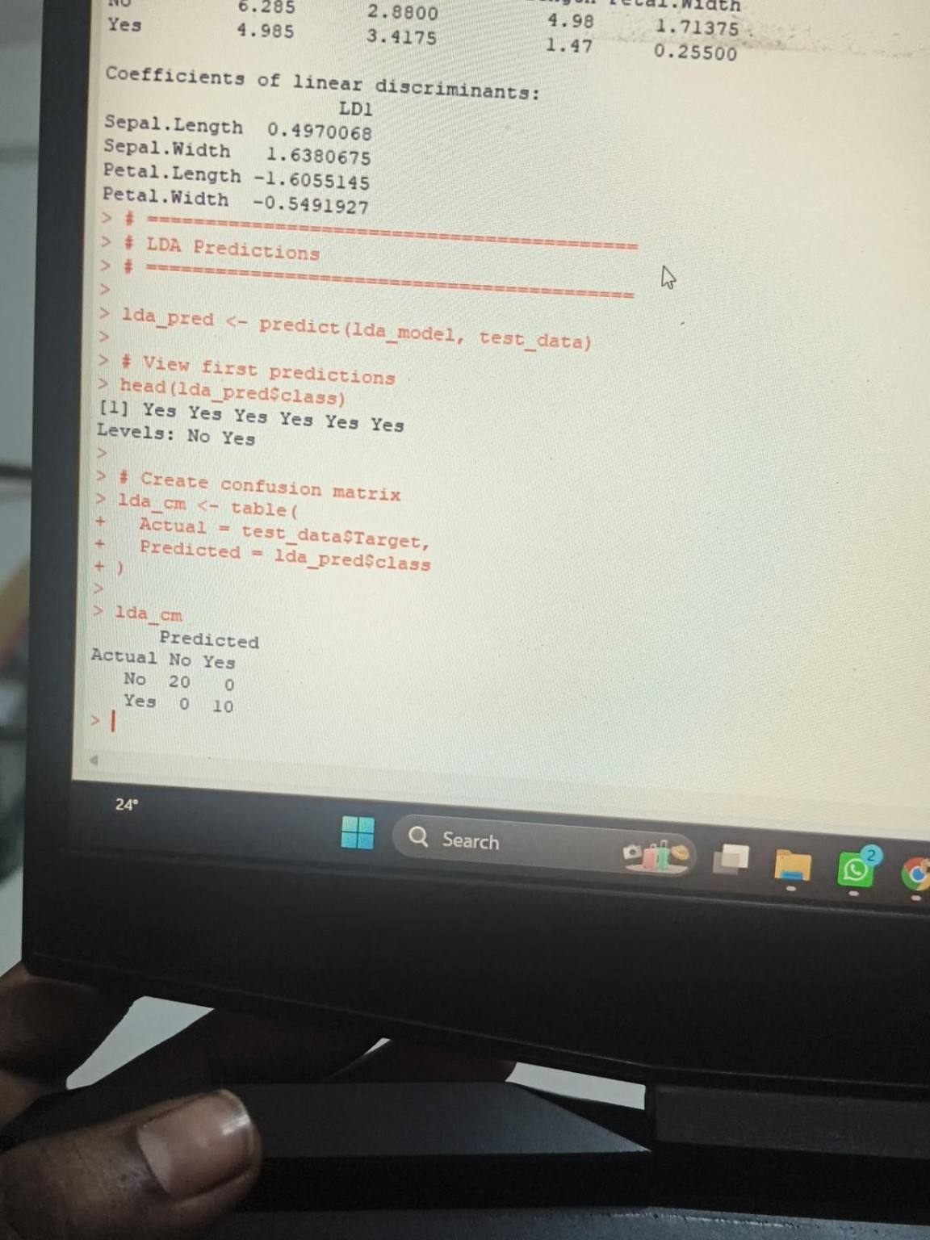
Figure 7. LDA predictions and confusion matrix.
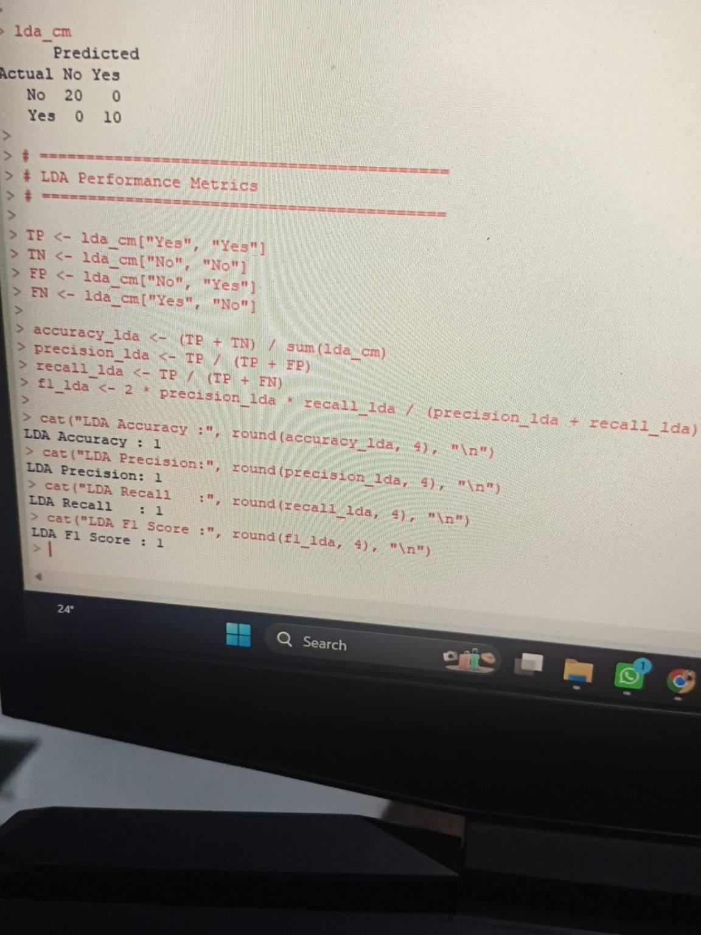
Figure 8. LDA confusion matrix and calculated performance metrics.
The LDA confusion matrix is also perfect on this test set: 20 No observations were correctly classified as No and 10 Yes observations were correctly classified as Yes. There were no false positives or false negatives.
The resulting LDA metrics were Accuracy = 1.00, Precision = 1.00, Recall = 1.00 and F1 Score = 1.00.

10. ROC Curve and AUC Analysis
Accuracy alone does not describe the full behaviour of a classifier. Therefore, I also calculated ROC curves and the Area Under the Curve (AUC). An AUC of 0.5 is approximately random discrimination, while an AUC closer to 1 indicates stronger separation between the classes.

10.1 Decision Tree ROC
tree_prob <- predict(tree_model, test_data, type = "prob")
tree_roc <- roc(
test_data$Target,
tree_prob[, "Yes"],
levels = c("No", "Yes"),
direction = "<"
)
tree_auc <- auc(tree_roc)
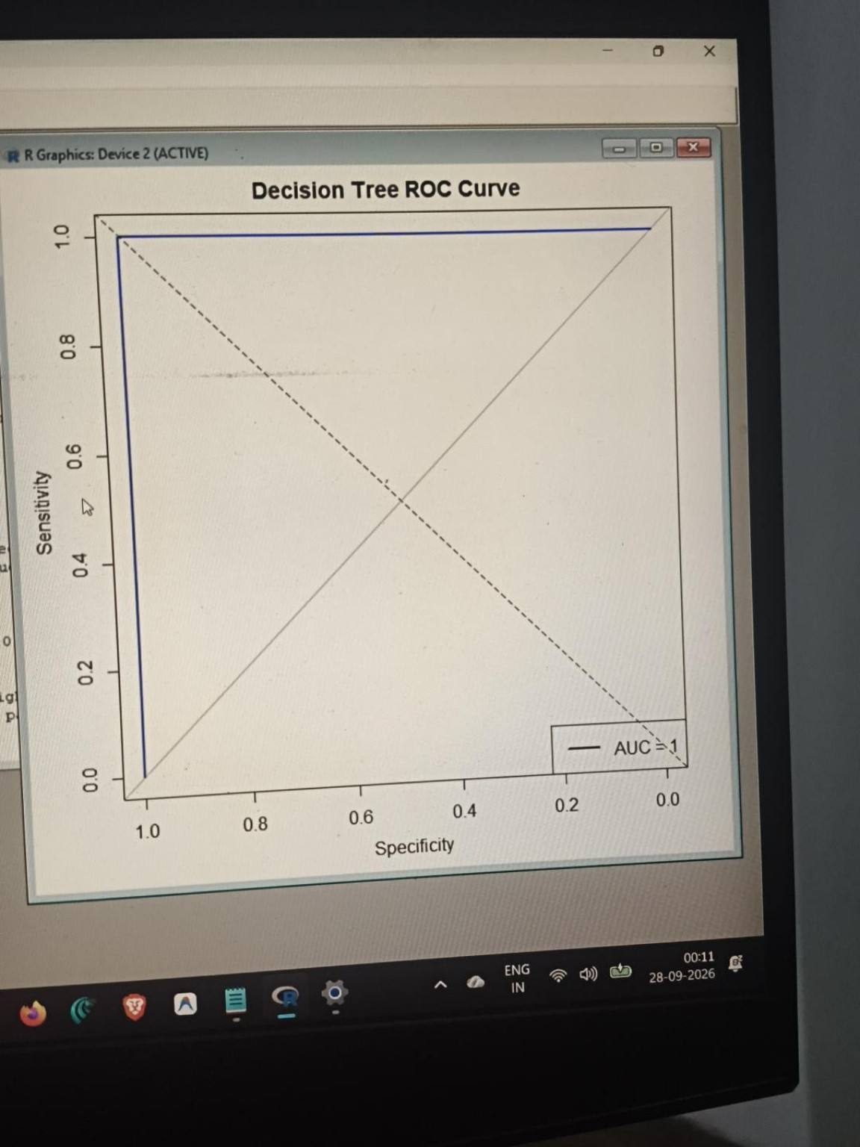
Figure 9. Decision Tree ROC curve. The R output reported AUC = 1.00.
The Decision Tree ROC curve produced an AUC of 1.00 for the selected test split, indicating complete separation of the two classes within these 30 test observations.

10.2 LDA ROC
lda_prob <- predict(lda_model, test_data)$posterior
lda_roc <- roc(
test_data$Target,
lda_prob[, "Yes"],
levels = c("No", "Yes"),
direction = "<"
)
lda_auc <- auc(lda_roc)
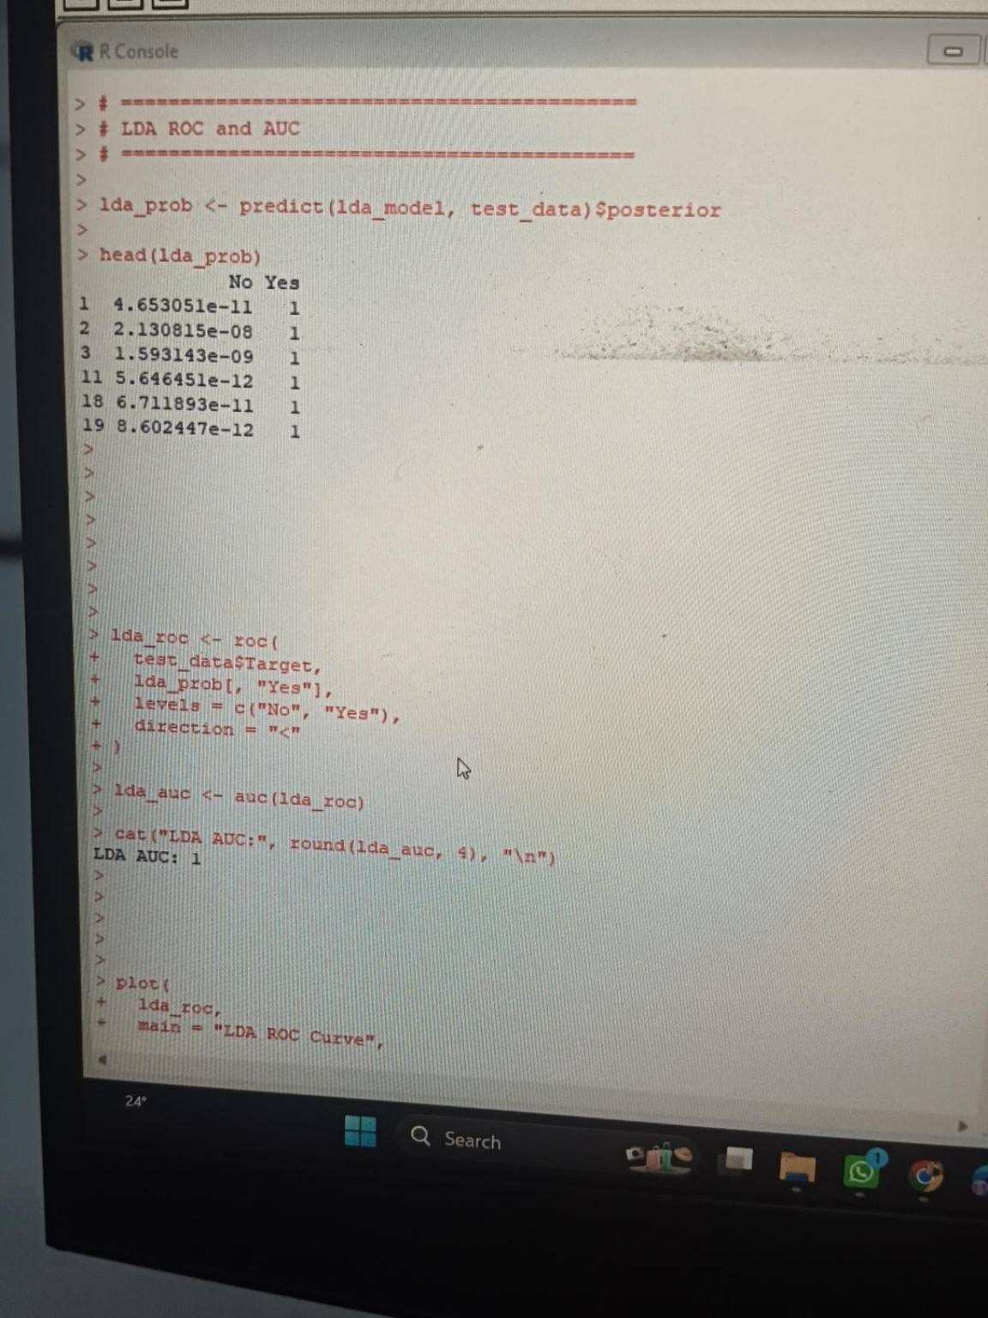
Figure 10. LDA ROC/AUC calculation. The R console reported LDA AUC = 1.00.
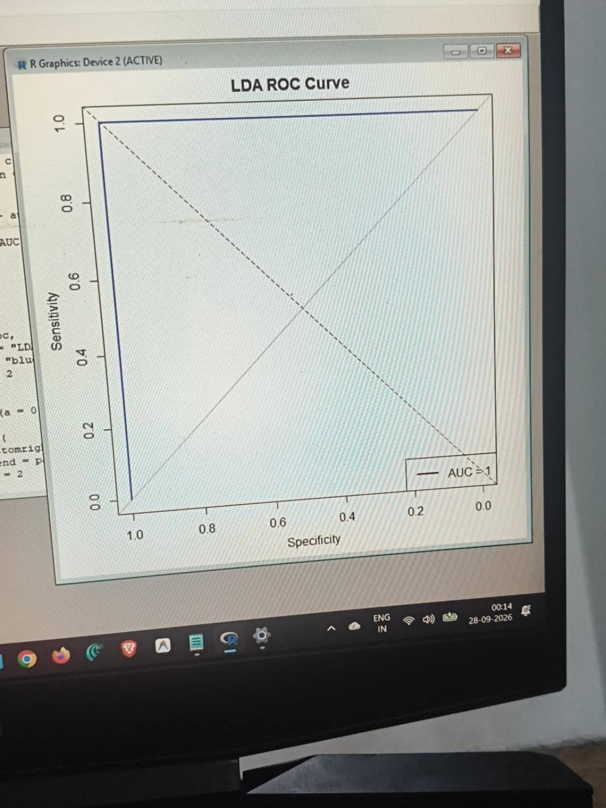
Figure 11. LDA ROC curve. The R output reported AUC = 1.00.

11. Final Model Comparison
After evaluating both models on the same test set, I created a final comparison table. Both models produced the same values for the selected test split.
Model | Accuracy | Precision | Recall | F1 Score | AUC
Decision Tree | 1.00 | 1.00 | 1.00 | 1.00 | 1.00
LDA | 1.00 | 1.00 | 1.00 | 1.00 | 1.00
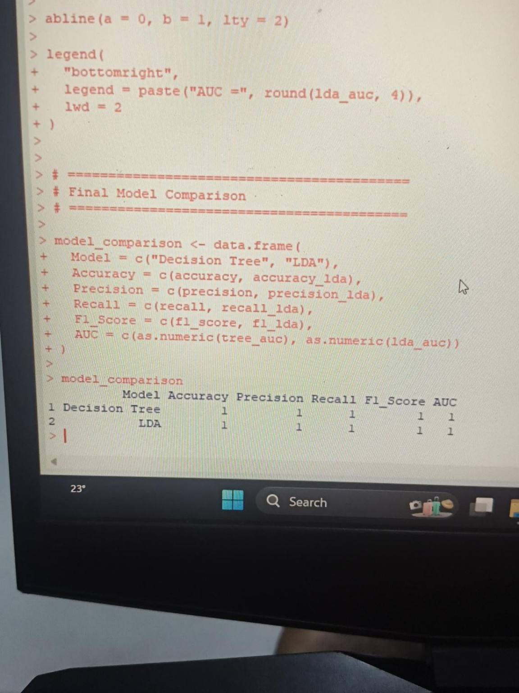
Figure 12. Final model comparison output from R.
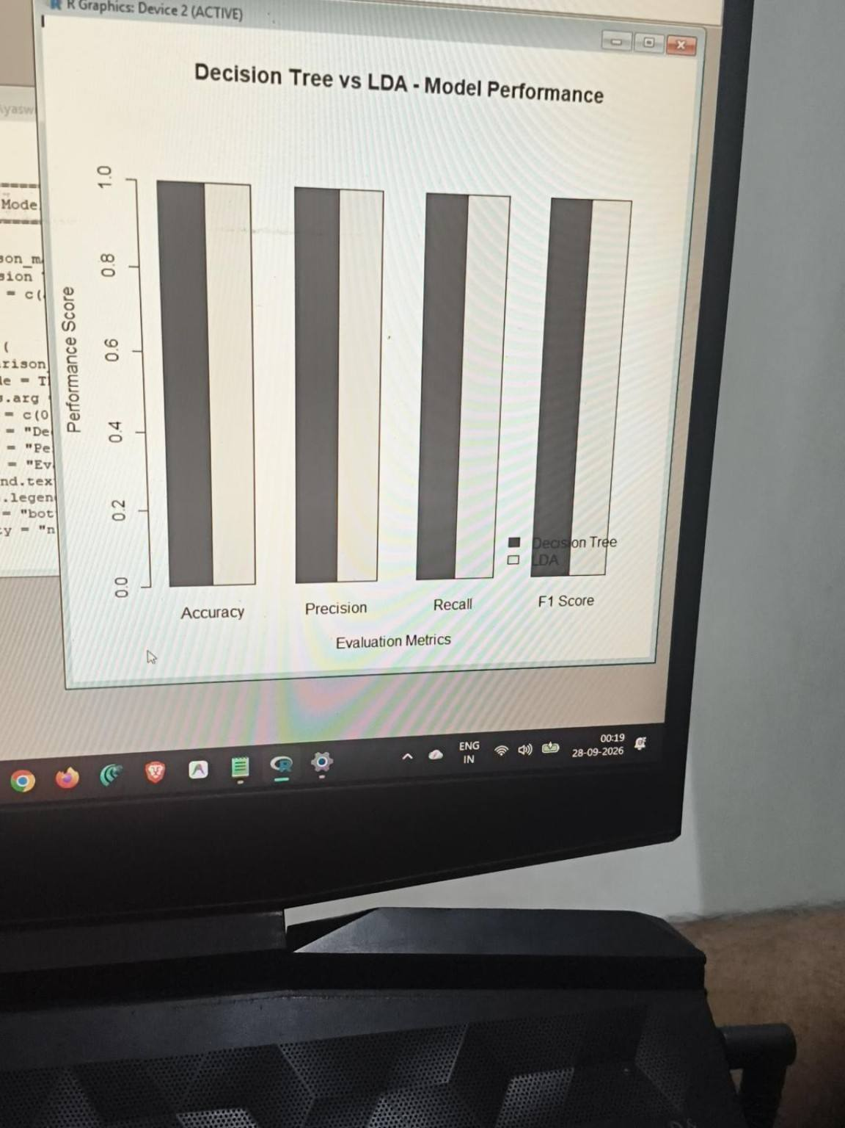
Figure 13. Final Decision Tree vs LDA performance comparison plot.
The graph shows both models reaching the same test-set score for every metric. Because the values are identical, the bars for the two models appear at the same height. This is a visual confirmation of the numerical comparison rather than a sign that one model performed differently.

12. Interpretation of Results
The most noticeable result from this experiment is that both final models achieved perfect scores on the test set. The confusion matrices explain why: all 30 test observations were classified correctly, with no false positives and no false negatives. The ROC curves also show complete separation for this particular split, giving an AUC of 1.00 for both models.
The result is understandable for the selected problem because Iris setosa is strongly separated from the other Iris species using the measured flower characteristics, especially petal measurements. The decision tree can express this separation through simple threshold rules, while LDA can capture it through a linear discriminant function.
At the same time, I would not treat the 1.00 scores as proof that either model will always achieve 100% accuracy on future datasets. The test set contains only 30 observations, and the classification task was simplified from three species into a binary setosa-versus-other problem. A different split or a larger external dataset could produce different results.

13. Biases, Limitations and Reliability
- The test set contains only 30 observations, so performance estimates can vary with a different random split.
- The Iris dataset is small and clean compared with many real-world datasets, so the experiment does not represent all practical classification problems.
- The original three-class species problem was converted into a binary problem, which is easier than predicting all three species separately.
- A single 80:20 split was used rather than repeated cross-validation. Repeated cross-validation would provide a more stable estimate of generalization performance.
- The perfect scores may partly reflect the strong natural separation of setosa from the other two species.
- The modelling experiment does not include external validation on a completely independent dataset.
These limitations are important because a model can look perfect on one test split and still perform differently on new data. For a production-level project, I would use repeated cross-validation, a separate hold-out dataset and, where possible, data from a different source.

14. Future Recommendations
- Use k-fold or repeated cross-validation to reduce dependence on one train-test split.
- Evaluate the original three-class Iris classification problem in addition to the binary experiment.
- Test the models on a larger and independently collected dataset.
- Tune decision-tree complexity and compare pruned and unpruned trees.
- Check LDA assumptions more formally before applying it to less-separated real-world data.
- Add other classification models such as Random Forest, KNN or SVM when the required packages are available.
- Report confidence intervals or variability across multiple resampling runs instead of only one point estimate.

15. Reproducibility
Reproducibility was considered throughout the project. The random seed was fixed at 123, the train-test split was explicitly coded, the target transformation was documented, and the same test set was used for both final models. The main R commands used in the experiment are included in the appendix so another student can follow the same workflow.

16. Estimated 30–35 Hour Work Plan
Activity | Estimated Hours | Work Completed
Problem definition and dataset understanding | 3 | Defined binary classification objective and reviewed variables.
Data preparation and target construction | 4 | Created Target and checked class distribution.
Train-test split and validation setup | 3 | Created reproducible 80:20 split using seed 123.
Model selection and study | 4 | Reviewed Decision Tree, LDA and logistic regression behaviour.
Decision Tree implementation | 5 | Trained model, generated predictions and confusion matrix.
LDA implementation | 5 | Trained model, generated predictions and confusion matrix.
Metrics and ROC/AUC analysis | 4 | Calculated Accuracy, Precision, Recall, F1 and AUC.
Comparison, interpretation and documentation | 4 | Compared models, reviewed limitations and prepared report.
Total | 32 | Within the requested 30–35 hour range.

17. Conclusion
This Week 4 task helped me understand the complete predictive-modelling workflow in R rather than treating model training as a single step. I defined a binary classification problem, prepared the target variable, created a reproducible train-test split, trained two different models, evaluated their predictions with multiple metrics, and used ROC curves and AUC for additional analysis.
Both the Decision Tree and LDA produced Accuracy, Precision, Recall, F1 Score and AUC values of 1.00 on the selected 30-observation test set. The results are consistent with the strong separation of Iris setosa from the other species, but the small test set and simplified binary target mean that the results should be interpreted carefully. The main learning from the exercise was not simply the perfect score, but understanding how model choice, validation strategy, confusion matrices and performance metrics work together when assessing a predictive model.

18. Appendix A – Main R Code
# Load dataset
data(iris)
iris_data <- iris
# Create binary target
iris_data$Target <- ifelse(
iris_data$Species == "setosa", "Yes", "No"
)
iris_data$Target <- as.factor(iris_data$Target)
# Reproducible train-test split
set.seed(123)
train_index <- sample(
1:nrow(iris_data),
size = 0.80 * nrow(iris_data)
)
train_data <- iris_data[train_index, ]
test_data <- iris_data[-train_index, ]
# Decision Tree
tree_model <- rpart(
Target ~ Sepal.Length + Sepal.Width +
Petal.Length + Petal.Width,
data = train_data,
method = "class"
)
tree_pred <- predict(tree_model, test_data, type = "class")
tree_cm <- table(
Actual = test_data$Target,
Predicted = tree_pred
)
# Decision Tree metrics
TP <- tree_cm["Yes","Yes"]
TN <- tree_cm["No","No"]
FP <- tree_cm["No","Yes"]
FN <- tree_cm["Yes","No"]
accuracy <- (TP + TN) / sum(tree_cm)
precision <- TP / (TP + FP)
recall <- TP / (TP + FN)
f1_score <- 2 * precision * recall / (precision + recall)
# LDA
lda_model <- lda(
Target ~ Sepal.Length + Sepal.Width +
Petal.Length + Petal.Width,
data = train_data
)
lda_pred <- predict(lda_model, test_data)
lda_cm <- table(
Actual = test_data$Target,
Predicted = lda_pred$class
)
# LDA metrics
TP <- lda_cm["Yes","Yes"]
TN <- lda_cm["No","No"]
FP <- lda_cm["No","Yes"]
FN <- lda_cm["Yes","No"]
accuracy_lda <- (TP + TN) / sum(lda_cm)
precision_lda <- TP / (TP + FP)
recall_lda <- TP / (TP + FN)
f1_lda <- 2 * precision_lda * recall_lda /
(precision_lda + recall_lda)
# Final comparison
model_comparison <- data.frame(
Model = c("Decision Tree", "LDA"),
Accuracy = c(accuracy, accuracy_lda),
Precision = c(precision, precision_lda),
Recall = c(recall, recall_lda),
F1_Score = c(f1_score, f1_lda),
AUC = c(as.numeric(tree_auc), as.numeric(lda_auc))
)
model_comparison
The following figures are screenshots from the R/RGui session used for this task. They are included to document the actual execution and outputs used in the analysis.

20. References
- UCI Machine Learning Repository. Iris Dataset. https://archive.ics.uci.edu/dataset/53/iris
- R Core Team. datasets package documentation – Iris. https://stat.ethz.ch/R-manual/R-devel/library/datasets/html/iris.html
- R documentation for rpart, MASS/lda and pROC functions used for classification and ROC analysis.

