WEEK 2 – EXPLORATORY DATA ANALYSIS
Exploratory Data Analysis and Visualization Using R
Dataset: Fisher / Anderson Iris Dataset
Tools: R, RStudio, ggplot2 and corrplot
Estimated effort: approximately 30–35 hours

1. Introduction
For Week 2, I carried out an exploratory data analysis (EDA) using the well-known Iris dataset. The purpose of this analysis is not just to create charts, but to understand the structure of the data, check its quality, summarize the variables, and identify relationships that may be useful for further analysis.
I selected the Iris dataset because it is small enough to understand clearly while still containing both continuous measurements and a categorical class variable. It is publicly documented, widely used for learning data analysis and classification, and is included in R's standard datasets package.

2. Dataset Description
Item | Description
Dataset | Iris / Fisher's Iris dataset
Observations | 150 flower samples
Predictor variables | Sepal Length, Sepal Width, Petal Length, Petal Width
Grouping variable | Species
Species | Setosa, Versicolor, Virginica
Measurement unit | Centimetres
Data type | Tabular; four numerical variables and one categorical variable
Missing values | None in the R version used
Purpose | Explore distributions and relationships between measurements and species

The UCI Machine Learning Repository describes Iris as a classic classification dataset with 150 instances, four features and three classes. R's documentation describes 150 cases and five variables, including the four measurements and Species.

2.1 Why I Selected This Dataset
- It is publicly documented and easy to reproduce in R.
- It contains several numerical variables for summary statistics and correlation analysis.
- It has a categorical species variable, allowing group comparisons.
- It is small enough to inspect carefully.
- It provides a clear example of how EDA can support later classification work.

3. Tools and R Packages
Tool / Package | Purpose
R | Data manipulation and statistical analysis
RStudio | Writing and running the analysis
ggplot2 | Histograms, scatter plots, box plots and bar charts
dplyr | Data preparation and grouped summaries
corrplot | Correlation matrix visualization

The analysis can be reproduced directly from R because the Iris dataset is included in the standard datasets package.

4. Data Cleaning and Preparation
Before creating visualizations, I first inspected the dataset. The main goal was to make sure the data types were appropriate and that there were no obvious missing or duplicate observations.

4.1 Initial Inspection
data(iris)
head(iris)
str(iris)
dim(iris)
summary(iris)
The dataset contains 150 rows and five columns. The four measurement columns are numeric and Species is a categorical variable, so the structure is suitable for numerical summaries and grouped visualizations.

4.2 Missing Values
colSums(is.na(iris_data))
Check | Result
Sepal.Length | 0
Sepal.Width | 0
Petal.Length | 0
Petal.Width | 0
Species | 0

No missing values were found, so no imputation was necessary. This means the summary statistics and visualizations can be produced without a missing-value treatment.

4.3 Duplicate and Type Checks
sum(duplicated(iris_data))
iris_data$Species <- as.factor(iris_data$Species)
I checked for duplicate rows and converted Species to a factor for categorical analysis. No additional transformation of the measurement values was required for this EDA.

5. Summary Statistics
Variable | Mean | SD | Minimum | Median | Maximum
Sepal.Length | 5.84 | 0.83 | 4.30 | 5.80 | 7.90
Sepal.Width | 3.06 | 0.44 | 2.00 | 3.00 | 4.40
Petal.Length | 3.76 | 1.77 | 1.00 | 4.35 | 6.90
Petal.Width | 1.20 | 0.76 | 0.10 | 1.30 | 2.50

The summary statistics show that petal measurements cover a wider range than the sepal measurements. Petal length ranges from 1.0 to 6.9 cm, while petal width ranges from 0.1 to 2.5 cm.

5.1 Species Distribution
Setosa: 50 observations
Versicolor: 50 observations
Virginica: 50 observations
The three species are evenly represented, which makes comparisons between groups straightforward.

6. Visual Exploratory Analysis
I created several visualization types so that the analysis does not depend on one chart alone. Each visualization answers a different question about the data.

6.1 Histogram – Petal Length
ggplot(iris_data, aes(x = Petal.Length)) +
geom_histogram(bins = 10, color = "black") +
labs(title = "Distribution of Petal Length",
x = "Petal Length (cm)", y = "Number of Flowers")
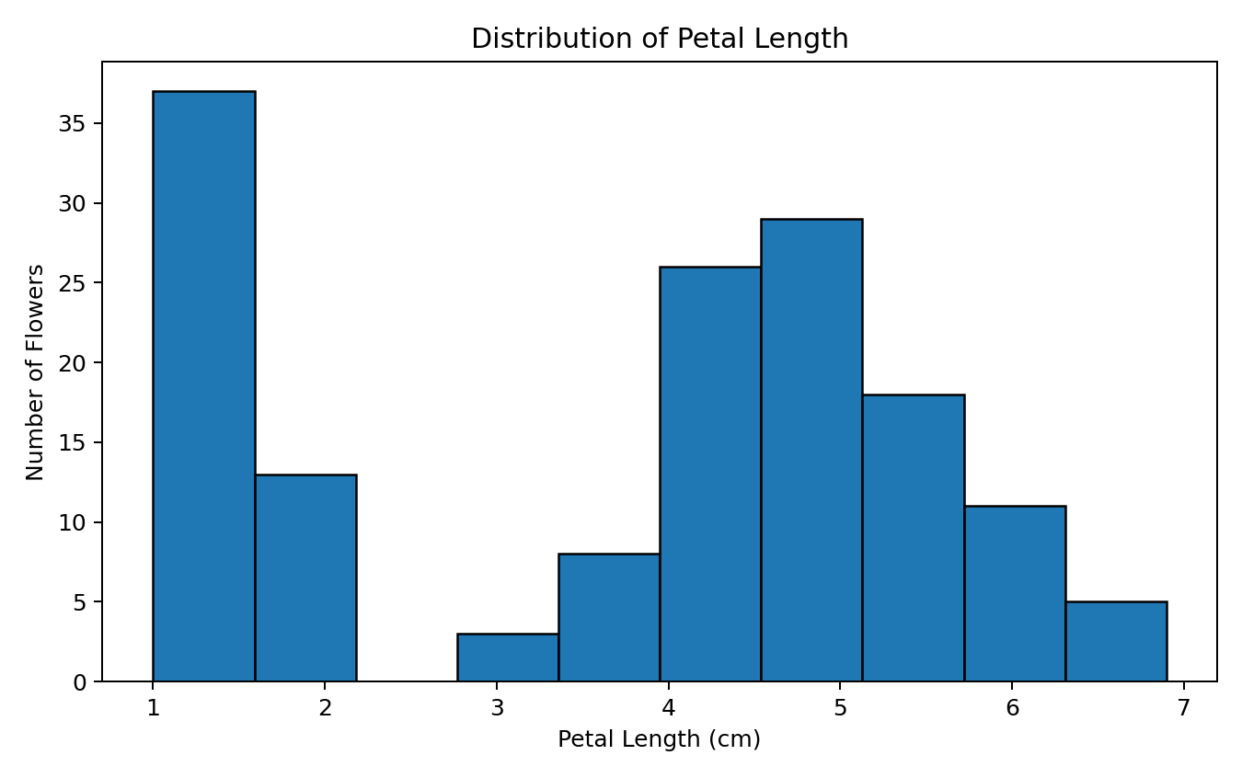
Figure 1. Distribution of petal length
The histogram shows that petal length is not spread evenly across one continuous range. Instead, the observations form distinct regions, which is consistent with the three species having different typical petal sizes. This suggests petal length may be useful for distinguishing species.

6.2 Scatter Plot – Petal Length vs Petal Width
ggplot(iris_data, aes(x = Petal.Length, y = Petal.Width, color = Species)) +
geom_point(size = 2.5) +
labs(title = "Petal Length vs Petal Width")
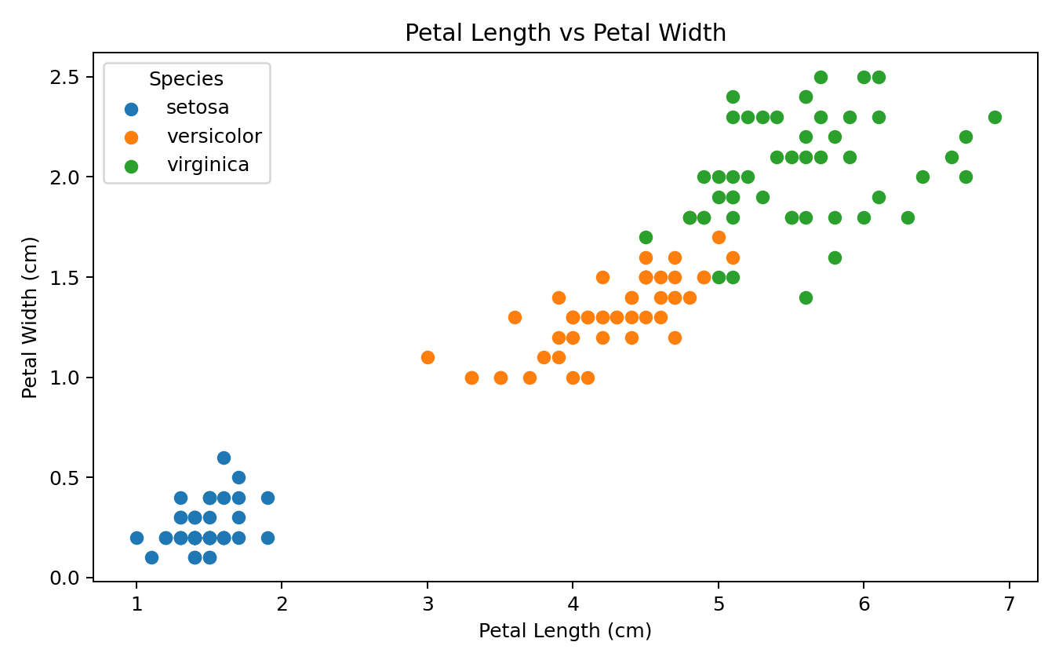
Figure 2. Relationship between petal length and petal width by species
The scatter plot shows a strong relationship between petal length and petal width. Setosa forms a clearly separated cluster with much smaller petals. Versicolor and virginica are closer to one another, although their typical petal measurements are still distinguishable. This is an important pattern for future classification work.

6.3 Box Plot – Sepal Length by Species
ggplot(iris_data, aes(x = Species, y = Sepal.Length)) +
geom_boxplot() +
labs(title = "Sepal Length by Iris Species")
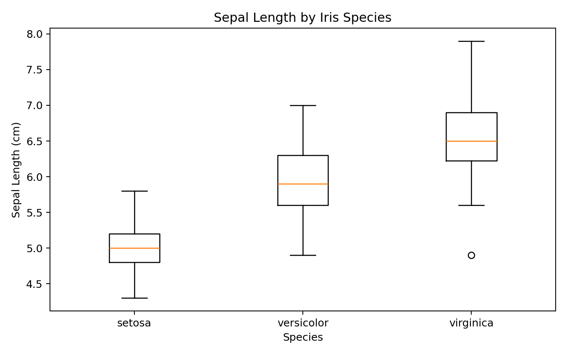
Figure 3. Distribution of sepal length across species
The box plot compares the centre and spread of sepal length across species. Setosa generally has shorter sepals, while virginica tends to have longer sepals. The groups overlap more than they do for petal measurements, so sepal length alone may not separate species as clearly.

6.4 Bar Chart – Species Counts
ggplot(iris_data, aes(x = Species)) +
geom_bar() +
labs(title = "Number of Observations by Species")
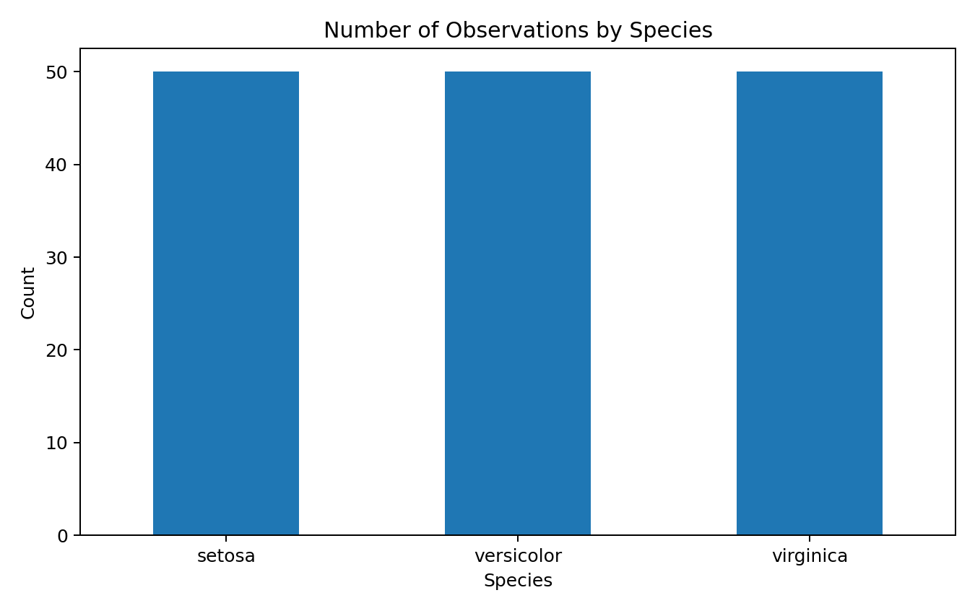
Figure 4. Number of observations in each species
The bar chart confirms that the dataset is balanced, with 50 observations in each species. Therefore, differences seen in the other charts are not caused by one class having substantially more observations.

6.5 Correlation Heatmap
cor_matrix <- cor(iris_data[, 1:4])
print(cor_matrix)
corrplot(cor_matrix, method = "color", addCoef.col = "black")
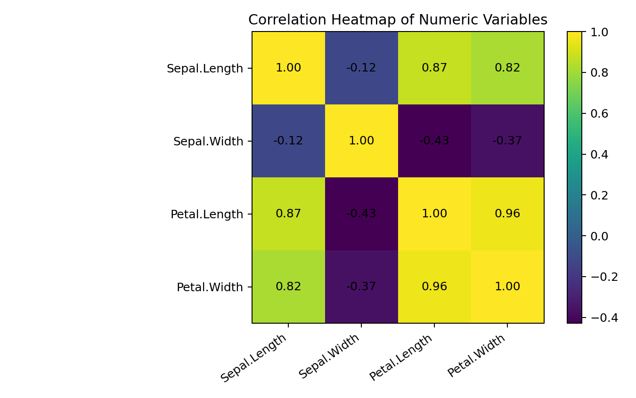
Figure 5. Correlation between numerical variables
The correlation matrix shows a very strong positive relationship between petal length and petal width. The petal variables are also strongly related to sepal length. Sepal width has weaker relationships with the other measurements. These patterns suggest that petal measurements contain closely related information and may be especially useful for distinguishing species.

7. Key Findings from the EDA
- The dataset contains 150 observations and is evenly divided among three species.
- No missing values were found, so no imputation was required.
- Petal measurements show clear differences between species.
- Petal length and petal width have a strong positive relationship.
- Setosa is much more clearly separated from the other two species using petal measurements.
- Versicolor and virginica overlap more than setosa, so they may be harder to distinguish.
- Sepal measurements show more overlap between species than petal measurements.
- The balanced class distribution makes group comparisons easier to interpret.

8. Anomalies and Data Quality Observations
The EDA did not reveal obvious data-quality problems such as missing values or extreme observations that would require removal. Some overlap between species is visible, especially for sepal measurements and between versicolor and virginica. This appears to be a characteristic of the dataset rather than an obvious data-entry error.

9. Transformations and Preparation Decisions
Step | Decision | Reason
Missing values | No imputation | No missing values were found
Species | Converted to factor | Needed for categorical/grouped analysis in R
Numeric measurements | No scaling for EDA | Original centimetre values are easy to interpret
Duplicates | Checked | To ensure repeated records were not distorting summaries
Outliers | Reviewed with box plot | No obvious erroneous observations were identified

10. How These Insights Can Guide Further Analysis
The EDA gives a clear direction for the next stage. The strong separation in petal measurements suggests these variables should be considered carefully in classification. The overlap between versicolor and virginica also shows why class-level evaluation is useful.
- Use petal length and petal width as important candidate predictors.
- Compare a simple baseline classifier with more flexible models.
- Use a confusion matrix to understand species-level errors.
- Check whether combining sepal and petal measurements improves classification.
- Use correlation results to understand relationships among predictors before modelling.

11. Reproducibility
The analysis is designed to be reproducible in R. The main R script is provided separately as `week2_eda.R`. The analysis starts with the standard R `iris` dataset, so an external download is not required to reproduce the basic results. A CSV copy is also provided for inspection.

12. Week 2 Work Plan – Approximately 30–35 Hours
Activity | Planned Time | Work Covered
Dataset selection and background research | 3–4 hours | Dataset source, purpose, variables and documentation
R environment and data loading | 2–3 hours | RStudio setup, package checks, loading and inspection
Data cleaning and preparation | 4–5 hours | Missing values, duplicates, types and quality checks
Summary statistics | 3–4 hours | Descriptive statistics and grouped summaries
Visualization development | 7–8 hours | Histograms, scatter plots, box plots, bar charts and heatmap
Interpretation | 4–5 hours | Explain patterns, distributions, relationships and anomalies
Documentation and screenshots | 3–4 hours | Code snippets, figures, captions and written explanations
Review and final formatting | 2–3 hours | Quality checks and final report preparation

13. Conclusion
This Week 2 analysis helped me move from simply having a dataset to understanding what is inside it. I checked the structure and quality, calculated summary statistics, and used different visualization types to look at distributions, group differences and relationships.
The strongest pattern was the separation created by petal measurements, especially for setosa. The analysis also showed that versicolor and virginica have more overlap, which is useful to keep in mind for future classification work. Overall, the EDA provides a practical foundation for the next stage because it identifies the variables and relationships that deserve more attention.

14. References
- UCI Machine Learning Repository. Iris Dataset, Dataset 53. https://archive.ics.uci.edu/dataset/53/iris
- R Core Team. R datasets documentation: Edgar Anderson's Iris Data. https://stat.ethz.ch/R-manual/R-devel/library/datasets/html/iris.html
- Fisher, R. A. (1936). The use of multiple measurements in taxonomic problems. Annals of Eugenics, 7(2), 179–188.

Appendix A – Main R Code
# Week 2 - Exploratory Data Analysis and Visualization
# Dataset: Fisher / Anderson Iris dataset
# Install packages once if needed:
# install.packages(c("tidyverse", "corrplot"))
library(tidyverse)
library(corrplot)
# 1. Load the public dataset included with R
data(iris)
iris_data <- iris
# 2. Basic inspection
head(iris_data)
str(iris_data)
dim(iris_data)
summary(iris_data)
# 3. Missing-value check
colSums(is.na(iris_data))
# 4. Check duplicates
sum(duplicated(iris_data))
# 5. Prepare the data
iris_data <- iris_data %>%
mutate(Species = as.factor(Species))
# 6. Summary statistics
iris_data %>%
summarise(
Mean_Sepal_Length = mean(Sepal.Length),
Mean_Sepal_Width = mean(Sepal.Width),
Mean_Petal_Length = mean(Petal.Length),
Mean_Petal_Width = mean(Petal.Width)
)
# 7. Species counts
count(iris_data, Species)
# 8. Histogram
ggplot(iris_data, aes(x = Petal.Length)) +
geom_histogram(bins = 10, color = "black") +
labs(title = "Distribution of Petal Length",
x = "Petal Length (cm)", y = "Number of Flowers") +
theme_minimal()
# 9. Scatter plot
ggplot(iris_data, aes(x = Petal.Length, y = Petal.Width, color = Species)) +
geom_point(size = 2.5) +
labs(title = "Petal Length vs Petal Width",
x = "Petal Length (cm)", y = "Petal Width (cm)") +
theme_minimal()
# 10. Box plot
ggplot(iris_data, aes(x = Species, y = Sepal.Length)) +
geom_boxplot() +
labs(title = "Sepal Length by Iris Species",
x = "Species", y = "Sepal Length (cm)") +
theme_minimal()
# 11. Species count bar chart
ggplot(iris_data, aes(x = Species)) +
geom_bar() +
labs(title = "Number of Observations by Species",
x = "Species", y = "Count") +
theme_minimal()
# 12. Correlation matrix
cor_matrix <- cor(iris_data[, 1:4])
print(cor_matrix)
corrplot(cor_matrix, method = "color", addCoef.col = "black")

Appendix B – Supporting Files
File | Purpose
Week_2_EDA_and_Visualization_R.docx | Main Week 2 report
week2_eda.R | R code for reproducing the EDA
iris_eda_dataset.csv | CSV copy of the cleaned Iris dataset
week2_figures/ | Five supporting visualization files

