WEEK 3 REPORT
Data Wrangling and Preprocessing using R
Fisher / Anderson Iris Dataset

Internship | Virtual Data Science with R – Apprentice Internship
Week | Week 3
Main Tool | R / RGui
Dataset | Fisher / Anderson Iris Dataset
Focus | Data inspection, cleaning, transformation, filtering, sorting, aggregation and export

Prepared based on the actual R console work and screenshots completed during Week 3.

1. Introduction
During Week 3, I worked on data wrangling and preprocessing in R using the built-in Fisher / Anderson Iris dataset. The main purpose of this week was not to build a machine learning model, but to understand how raw data can be inspected, checked, cleaned, restructured and prepared for later analysis. I worked through the process step by step in RGui and verified the results directly in the R Console.
I followed a practical workflow: first loading and inspecting the dataset, then checking its dimensions, data types, missing values and duplicate rows. After that, I created a clean working copy, selected the required columns, filtered observations based on petal length, sorted the data, created a new categorical feature called Petal.Size, calculated species-wise summary values, and finally exported the processed dataset as a CSV file.

2. Objectives of Week 3
- Understand the basic structure of a dataset in R.
- Inspect rows, columns, dimensions and summary statistics before transforming the data.
- Check missing values, duplicate rows, column names and data types.
- Create a clean working copy without unnecessarily changing the original dataset.
- Select relevant columns and filter observations using conditions.
- Sort observations to make the data easier to inspect.
- Create a new derived feature using conditional logic.
- Calculate grouped summary statistics by flower species.
- Export the final processed dataset for future analysis or modelling.
- Maintain a reproducible workflow using R commands that can be run again.

3. Dataset Used
The dataset used for this week was the Fisher / Anderson Iris dataset available directly in R as the built-in dataset named iris. It contains measurements of iris flowers across three species: setosa, versicolor and virginica. The four numerical measurements are Sepal.Length, Sepal.Width, Petal.Length and Petal.Width, with Species as the categorical variable.
The console output confirmed that the working dataset contained 150 observations and 5 original variables. Each species had 50 observations. Because the dataset is already clean and is directly available in R, it was suitable for demonstrating the main data-wrangling operations required in this week.

4. Tools and Environment
- R 4.6.1 / RGui
- R base functions for inspection and transformation
- tidyverse package loaded for the working environment
- CSV export using write.csv()
- R Console for verifying each operation

5. Initial Dataset Loading and Inspection
I started by loading the required package and the built-in Iris dataset. Instead of changing the original object directly, I created a separate working copy named iris_data. This made the workflow easier to follow and reduced the risk of accidentally modifying the original data.
library(tidyverse)
data(iris)
iris_data <- iris
head(iris_data)
str(iris_data)
dim(iris_data)
summary(iris_data)
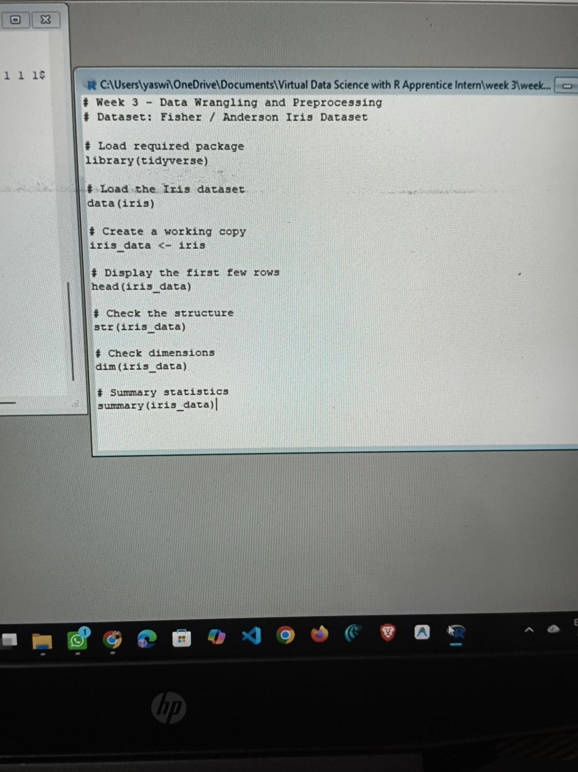
Figure 1. R script used to load the Iris dataset and perform the initial inspection.
The initial inspection helped me understand what I was working with before making any changes. The head() command displayed the first few rows, str() showed the structure and variable types, dim() confirmed the number of rows and columns, and summary() provided basic statistical information.

6. Dataset Dimensions and Summary
The dimension check returned 150 rows and 5 columns. The summary output also showed that the dataset was divided equally among the three species, with 50 observations each. The numerical variables were available for descriptive analysis through their minimum, quartiles, median, mean and maximum values.
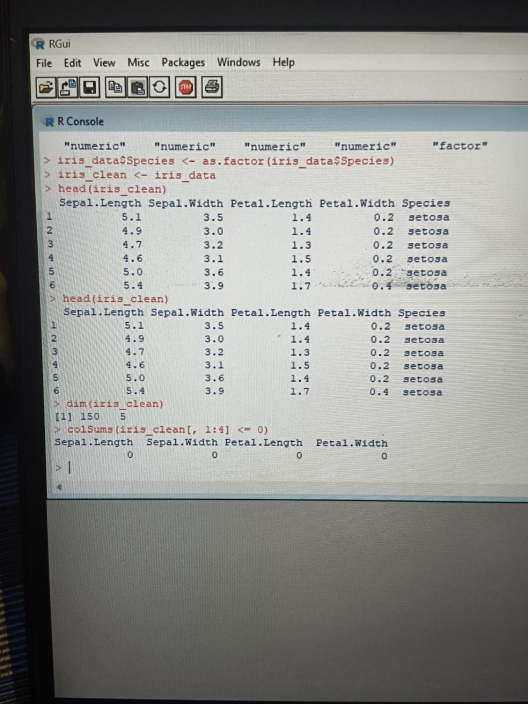
Figure 2. Console output showing the cleaned working copy, dimensions and missing-value check.

7. Data Quality Checks

7.1 Missing Values
I checked every column for missing values using is.na() and colSums(). The result was zero missing values for all five original variables. Therefore, no imputation or row deletion was required.
colSums(is.na(iris_data))

7.2 Duplicate Rows
I also checked for duplicate rows using duplicated(). The console returned 1 duplicated row occurrence. Since the objective of this exercise was to demonstrate and document wrangling operations, I did not blindly delete the row. Instead, I recorded the result and continued with a controlled working copy.
sum(duplicated(iris_data))

7.3 Column Names and Data Types
The column names were checked to make sure the variables were correctly identified. The four measurement variables were numeric and Species was a factor. I explicitly converted Species to a factor so that it was treated clearly as a categorical variable during later grouped operations.
colnames(iris_data)
sapply(iris_data, class)
iris_data$Species <- as.factor(iris_data$Species)
iris_clean <- iris_data
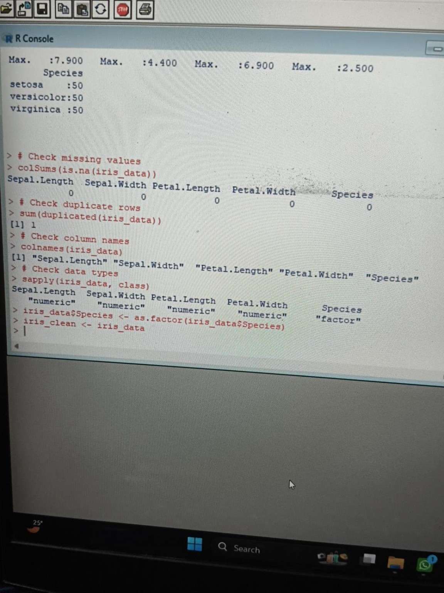
Figure 3. R Console showing missing-value, duplicate, column-name and data-type checks.

8. Creating the Clean Working Dataset
After completing the quality checks, I created iris_clean as the main working dataset. The purpose of this step was to keep a clear distinction between the original dataset and the version being prepared for the Week 3 tasks. I then checked the first rows, dimensions and numerical columns again to confirm that the working copy remained consistent.
iris_clean <- iris_data
head(iris_clean)
dim(iris_clean)
colSums(iris_clean[, 1:4] <= 0)
The dimensions remained 150 × 5 at this stage, and the four measurement columns contained no non-positive values. The first rows also matched the expected Iris observations.

9. Column Selection
I created a selected view containing the main measurement columns and Species. This is a simple but useful wrangling step because in a larger project I would normally work with only the variables needed for a particular analysis rather than carrying every available field.
iris_selected <- iris_clean[, c(
"Sepal.Length", "Sepal.Width",
"Petal.Length", "Petal.Width", "Species"
)]
head(iris_selected)

10. Filtering Observations
Next, I filtered the dataset to identify flowers with Petal.Length greater than 5 cm. This created a smaller subset called large_petal. The result contained 42 observations. This step demonstrates how a business or research question can be converted into a clear data condition.
large_petal <- subset(iris_clean, Petal.Length > 5)
head(large_petal)
nrow(large_petal)
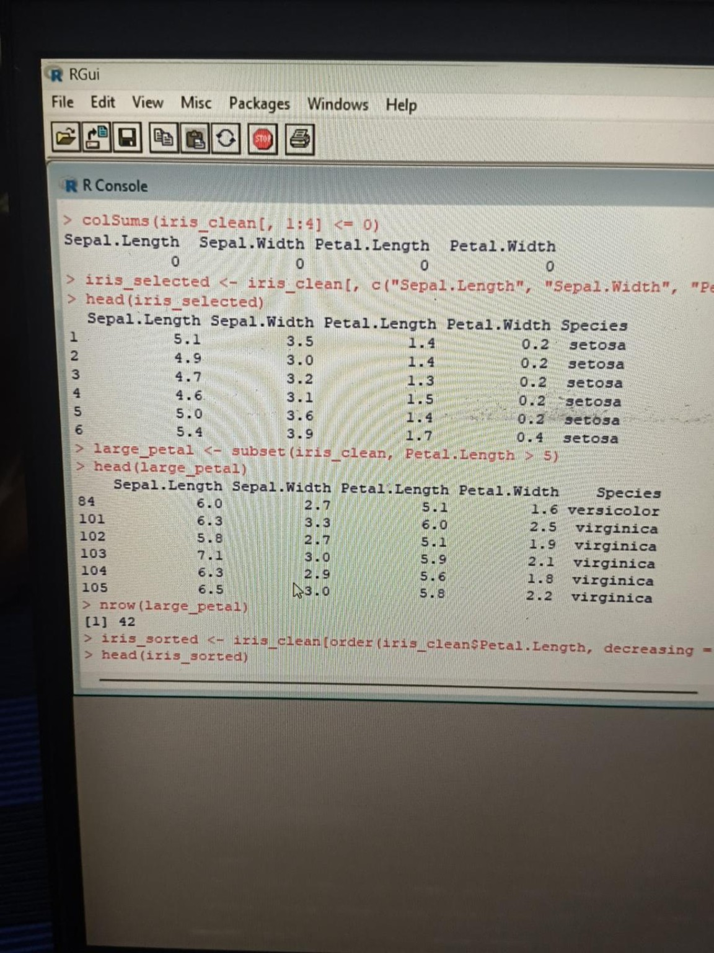
Figure 4. Filtering the Iris data for observations with Petal.Length greater than 5 cm.

11. Sorting the Dataset
I then sorted the working data in descending order of Petal.Length. This made it easy to see the observations with the largest petals first. The first rows after sorting were mainly virginica observations, which is consistent with the larger petal measurements observed for that species.
iris_sorted <- iris_clean[
order(iris_clean$Petal.Length, decreasing = TRUE), ]
head(iris_sorted)

12. Creating a New Feature: Petal.Size
To practise feature engineering, I created a new categorical variable named Petal.Size. The rule used was: Petal.Length below 2 cm was labelled Small, values below 5 cm were labelled Medium, and values of 5 cm or more were labelled Large. The resulting counts were 50 Small, 54 Medium and 46 Large observations.
iris_clean$Petal.Size <- ifelse(
iris_clean$Petal.Length < 2, "Small",
ifelse(iris_clean$Petal.Length < 5, "Medium", "Large")
)
table(iris_clean$Petal.Size)
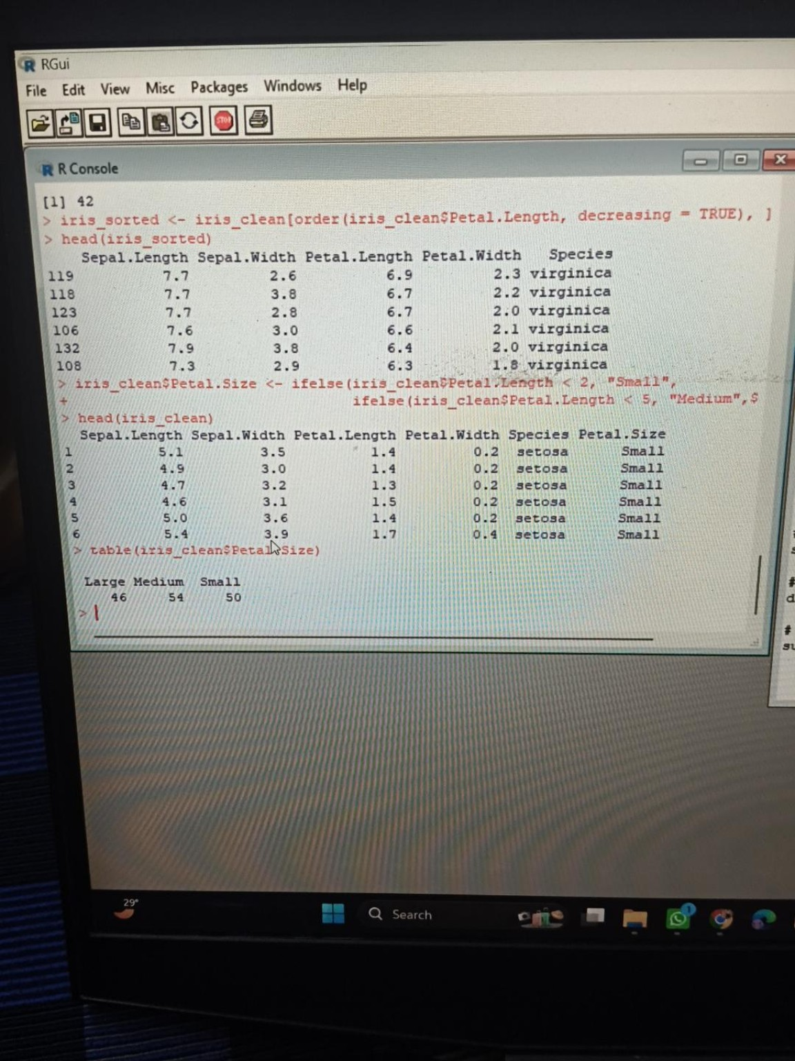
Figure 5. Sorted records and the newly created Petal.Size feature with its category counts.

13. Species-wise Aggregation
After transforming the data, I calculated average measurements for each species. This was useful for understanding how the groups differ without looking at all 150 individual rows. The species summary showed clear differences in petal measurements.
aggregate(Petal.Length ~ Species, data = iris_clean, mean)
aggregate(Petal.Width ~ Species, data = iris_clean, mean)
aggregate(Sepal.Length ~ Species, data = iris_clean, mean)
species_summary <- aggregate(
cbind(Sepal.Length, Sepal.Width, Petal.Length, Petal.Width)
~ Species,
data = iris_clean,
mean
)
species_summary
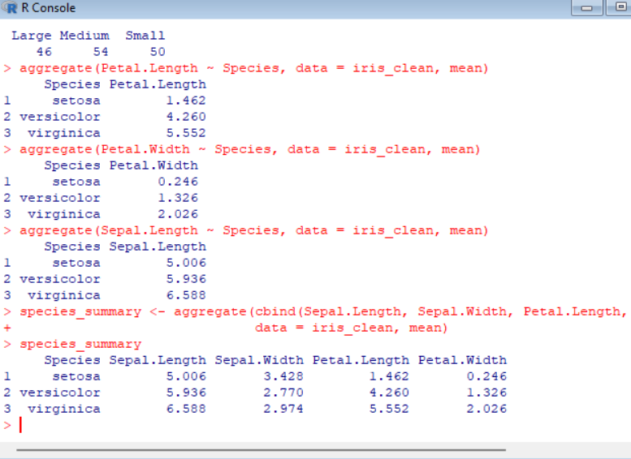
Figure 6. Species-wise mean values calculated from the processed Iris dataset.
The calculated averages were: setosa had mean Sepal.Length 5.006, Sepal.Width 3.428, Petal.Length 1.462 and Petal.Width 0.246. Versicolor had means of 5.936, 2.770, 4.260 and 1.326 respectively. Virginica had means of 6.588, 2.974, 5.552 and 2.026. These summaries give a compact view of the differences between species.

14. Final Dataset and Export
Once the wrangling steps were completed, I exported the final working dataset to a CSV file named iris_cleaned_week3.csv. The final dataset contained 150 rows and 6 columns, because the original five variables were retained and Petal.Size was added as the new derived feature.
write.csv(
iris_clean,
"iris_cleaned_week3.csv",
row.names = FALSE
)
file.exists("iris_cleaned_week3.csv")
dim(iris_clean)
head(iris_clean)
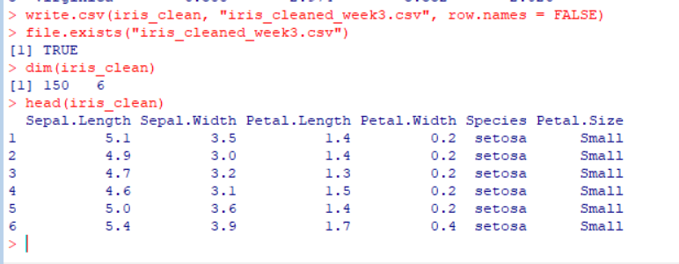
Figure 7. Final verification showing successful CSV export, 150 × 6 dimensions and the Petal.Size column.

15. Summary of the Wrangling Process
Stage | Operation | Result
1 | Load and inspect | 150 rows, 5 original columns
2 | Missing-value check | 0 missing values
3 | Duplicate check | 1 duplicated row occurrence identified
4 | Type check | 4 numeric variables + Species factor
5 | Create clean copy | iris_clean created
6 | Select variables | Measurement columns + Species
7 | Filter | 42 observations with Petal.Length > 5
8 | Sort | Sorted by Petal.Length descending
9 | Feature engineering | Petal.Size added
10 | Category counts | Small 50, Medium 54, Large 46
11 | Aggregation | Species-wise means calculated
12 | Export | iris_cleaned_week3.csv created; 150 × 6

16. Key Observations and Learning
- The Iris dataset was already well structured, so the main focus was controlled transformation rather than heavy cleaning.
- The missing-value check showed that no imputation was needed.
- The duplicate check identified one duplicated row occurrence, which was documented rather than removed without justification.
- Petal length provided a useful condition for filtering and also worked well for creating the Petal.Size feature.
- The derived Petal.Size variable converted a continuous measurement into an easy-to-understand categorical feature.
- Species-wise averages made the differences between the three species much easier to compare.
- The final CSV export makes the processed dataset reusable for later analysis or machine-learning work.

17. Why These Steps Matter in a Real Data Science Project
Although the Iris dataset is small, the same workflow is used in larger real-world projects. Before modelling, a data scientist needs to know whether columns have the correct types, whether missing values exist, whether duplicate records are present, and whether the values make sense. Filtering and sorting help investigate specific cases, while feature engineering can create variables that are easier for models or stakeholders to understand. Grouped aggregation is also commonly used in business reporting, customer analysis and exploratory analysis. Finally, exporting a clean dataset makes the work reproducible and easier to pass to the next stage of a project.

18. Reproducibility
One important part of this week's work was keeping the process reproducible. Instead of manually changing individual rows, I used R commands for every transformation. The same script can therefore be run again to recreate the cleaned dataset. The screenshots included in this report are from the actual R console work completed during the task and are included to show the intermediate results.

19. Approximate Week 3 Work Plan (30–35 Hours)
Activity | Approx. Hours | Work Completed
Understanding the task and dataset | 3 | Reviewed the Week 3 requirements and Iris structure
Initial inspection and summary | 4 | head(), str(), dim(), summary()
Data quality checks | 5 | Missing values, duplicates, names and data types
Cleaning and variable preparation | 4 | Created iris_clean and verified the data
Selection, filtering and sorting | 5 | Selected columns, filtered large petals and sorted records
Feature engineering | 4 | Created Petal.Size and checked category counts
Aggregation and interpretation | 4 | Species-wise mean calculations and interpretation
Export and verification | 2 | Created and verified iris_cleaned_week3.csv
Documentation and screenshots | 3 | Captured results and prepared the report
Total planned effort: approximately 34 hours. The plan reflects the complete workflow from understanding the dataset through final documentation and export.

20. Conclusion
Week 3 gave me practical experience with one of the most important parts of a data science workflow: preparing data before analysis or modelling. I learned how to inspect a dataset systematically, identify quality issues, preserve a clean working copy, filter and sort records, create a derived feature, calculate grouped statistics and export the final result. Working directly in R and checking the console after each operation also helped me understand what each command was actually doing instead of treating preprocessing as a black box.
The final output was a 150 × 6 processed dataset containing the original Iris measurements, Species and the newly created Petal.Size feature. The exported file iris_cleaned_week3.csv can now be used as a prepared input for future analysis or modelling tasks.

21. Appendix – Main R Code Used
# Week 3 - Data Wrangling and Preprocessing
# Dataset: Fisher / Anderson Iris Dataset
library(tidyverse)
data(iris)
iris_data <- iris
head(iris_data)
str(iris_data)
dim(iris_data)
summary(iris_data)
# Data quality checks
colSums(is.na(iris_data))
sum(duplicated(iris_data))
colnames(iris_data)
sapply(iris_data, class)
# Prepare working data
iris_data$Species <- as.factor(iris_data$Species)
iris_clean <- iris_data
head(iris_clean)
dim(iris_clean)
colSums(iris_clean[, 1:4] <= 0)
# Column selection
iris_selected <- iris_clean[, c(
"Sepal.Length", "Sepal.Width",
"Petal.Length", "Petal.Width", "Species"
)]
# Filtering
large_petal <- subset(iris_clean, Petal.Length > 5)
head(large_petal)
nrow(large_petal)
# Sorting
iris_sorted <- iris_clean[
order(iris_clean$Petal.Length, decreasing = TRUE), ]
head(iris_sorted)
# Feature engineering
iris_clean$Petal.Size <- ifelse(
iris_clean$Petal.Length < 2, "Small",
ifelse(iris_clean$Petal.Length < 5, "Medium", "Large")
)
table(iris_clean$Petal.Size)
# Aggregation
aggregate(Petal.Length ~ Species, data = iris_clean, mean)
aggregate(Petal.Width ~ Species, data = iris_clean, mean)
aggregate(Sepal.Length ~ Species, data = iris_clean, mean)
species_summary <- aggregate(
cbind(Sepal.Length, Sepal.Width, Petal.Length, Petal.Width)
~ Species,
data = iris_clean,
mean
)
species_summary
# Export
write.csv(
iris_clean,
"iris_cleaned_week3.csv",
row.names = FALSE
)
file.exists("iris_cleaned_week3.csv")
dim(iris_clean)
head(iris_clean)

22. Evidence Included in This Report
- R script screenshot showing the Week 3 loading and inspection commands.
- R Console screenshot showing the working data, dimensions and missing-value result.
- R Console screenshot showing duplicate, column-name and data-type checks.
- R Console screenshot showing column selection and filtering for Petal.Length > 5.
- R Console screenshot showing descending sorting and the Petal.Size feature.
- R Console screenshot showing species-wise aggregate means.
- R Console screenshot showing successful CSV export and final 150 × 6 dataset.

End of Week 3 Report

