**Building Interactive Visualizations with Streamlit**

**Electricity-Lebanon-2023 Dataset:**

1. Load the ‘electricity.csv’ file to display the dataset:

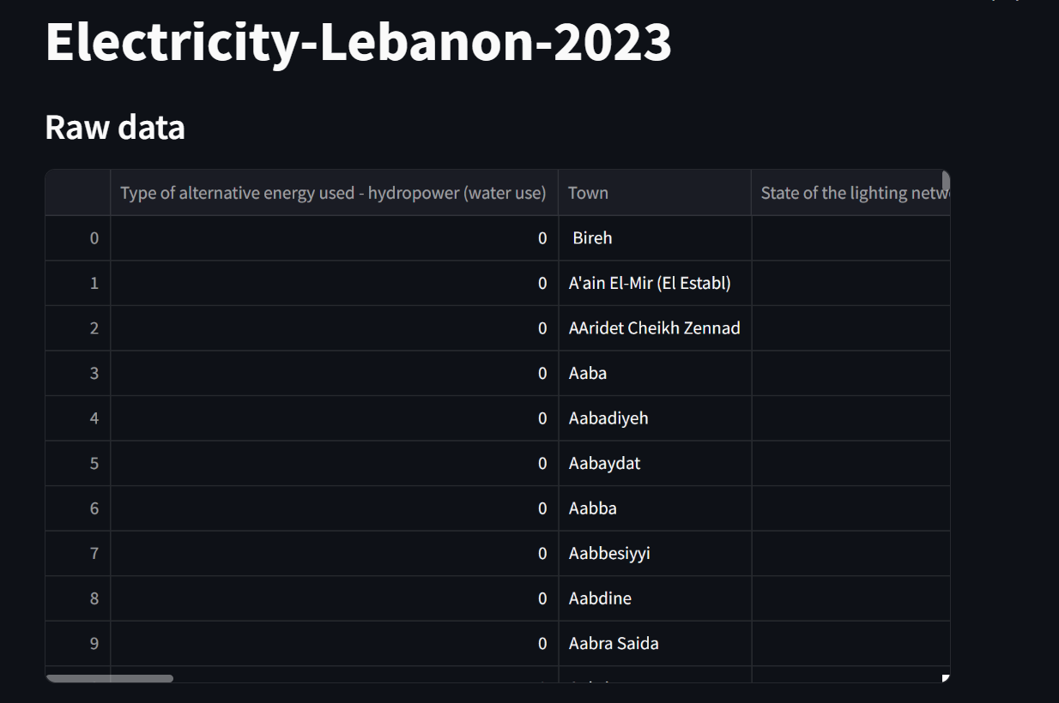

**Chart 1:**

In the following interactive chart using Streamlit, users can filter towns based on the existence of alternative energy and visualize the distribution of power grid or lighting network conditions.

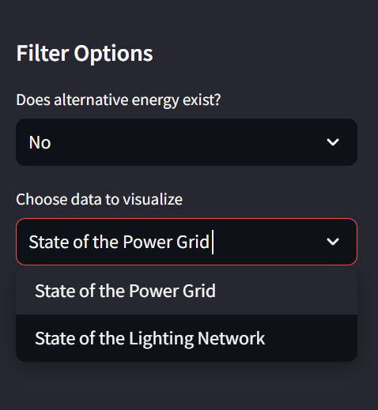

**Visualization**: Users can select between visualizing the status of the power grid or the lighting network in the towns, and the chart updates based on their selection.

**Filters**: Users can filter the data based on the existence of alternative energy using the sidebar. (Choose yes or no)

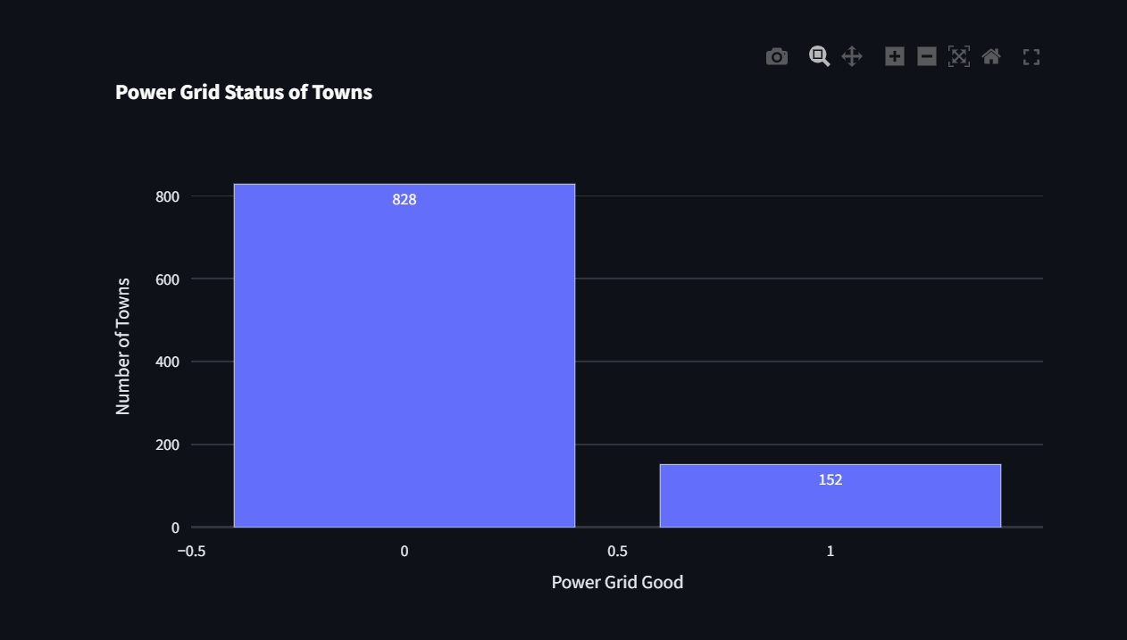

The chart shows the status of the power grid in various towns, with the majority (828 towns) having a bad or non-functional power grid. Only 152 towns report having a good power grid. This suggests widespread issues with the power infrastructure across most of the towns, which could drive the adoption of alternative energy sources.

The chart is interactive, allowing users to explore data dynamically.

**Chart 2:**

This chart using Streamlit , allows users to explore alternative energy usage in various towns. Users select a town from a dropdown menu, and checks if alternative energy exists in the chosen town.

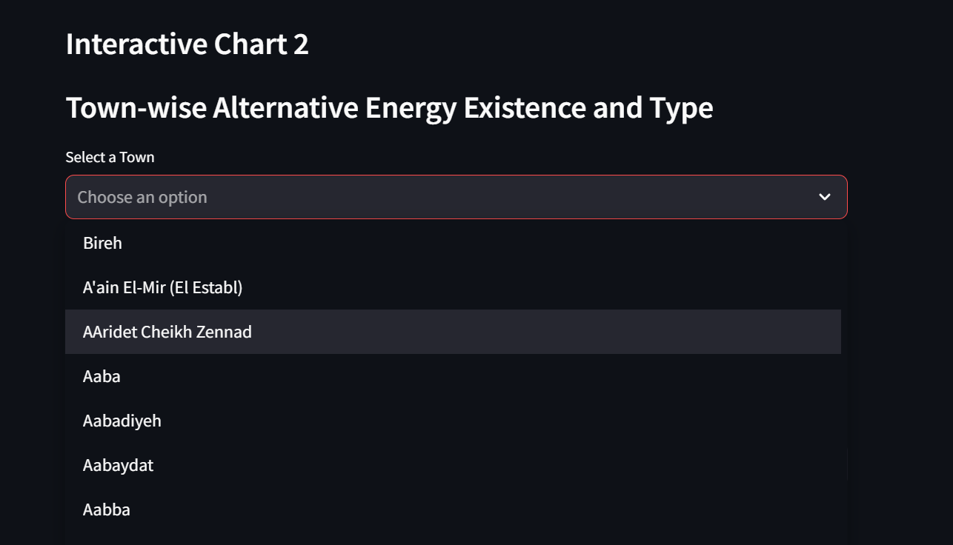

If it does, a **donut chart** visualizing the types of alternative energy used (Hydropower, Solar, Wind, or Other) is displayed.

If no energy types are used or alternative energy does not exist in that town, the user is informed with a corresponding message.

The chart and messages update dynamically based on the user's selection.

For instance, I will select “Deir Ntar” town:

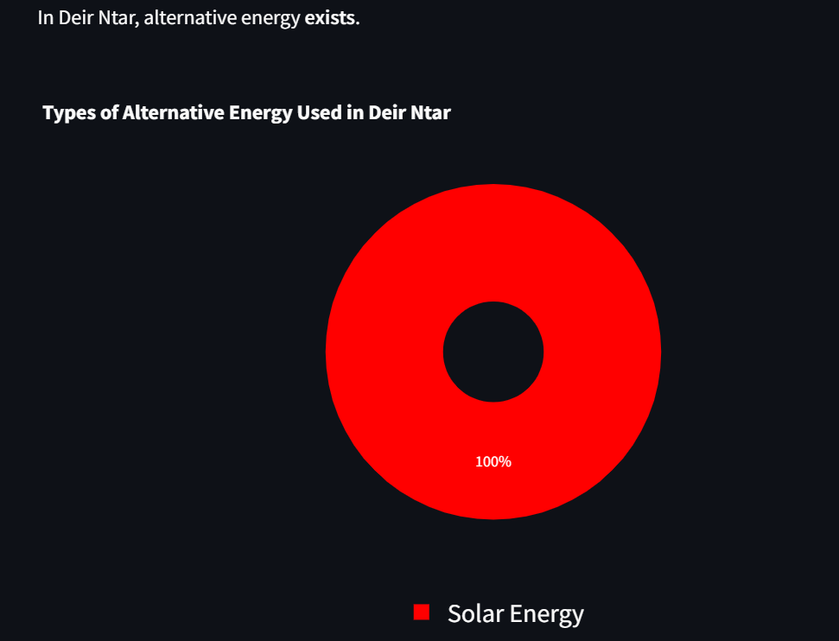

As shown, alternative energy exists in “Deir Ntar”, and the type of alternative energy used in “Deir Ntar” is solar energy only.

**Chart 3:** The following interactive bar chart in a Streamlit app, shows the distribution of alternative energy types for a selected reference area.

First, the user selects a reference area from a dropdown, and the dataset is filtered to include only data from that area. **We will choose “Akkar” as an example:**

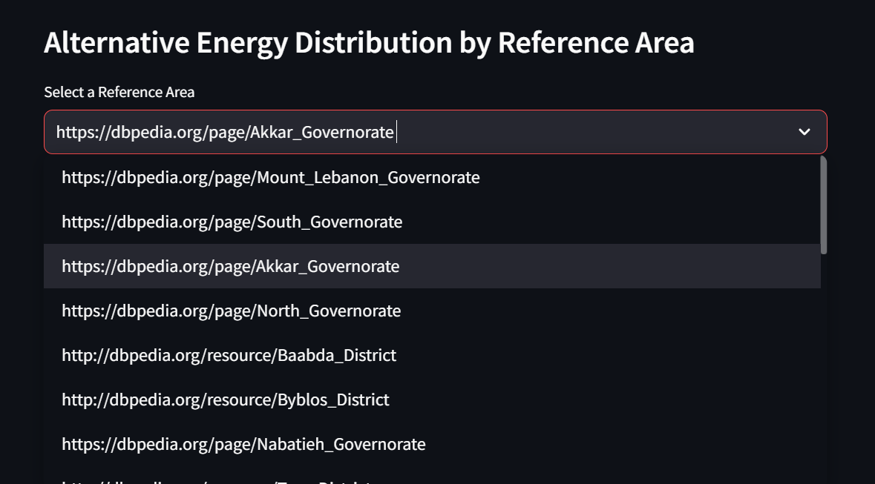

It then sums the counts of four alternative energy types (hydropower, solar, wind, and other) and displays them in a horizontal bar chart, with the energy types on the y-axis and their respective counts on the x-axis.

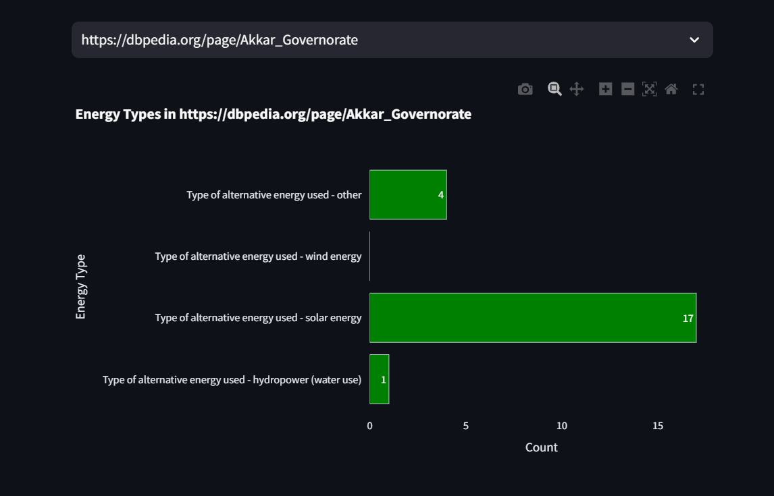

The chart displays the types of alternative energy used in the Akkar Governorate. Solar energy is the most used alternative energy, with 17 towns utilizing it. Wind energy is the second most used type with 4 towns, followed by other energy types in 4 towns and hydropower in just 1 town. This highlights a significant reliance on solar energy compared to other sources.

The chart is dynamically titled based on the selected area, and the counts are displayed directly on the bars for easy interpretation.

**Chart 4:**

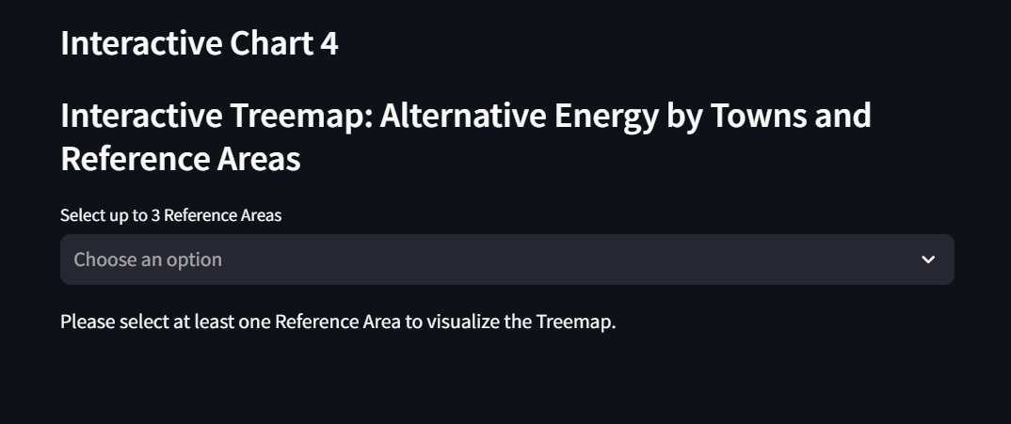

This chart is a treemap in Streamlit that allows users to explore alternative energy usage by towns and reference areas. Users can select up to three reference areas from a dropdown, and the dataset is filtered accordingly.

The treemap shows towns within the selected areas, using the size of each rectangle to represent the presence of towns and color to indicate whether alternative energy exists in each town. The chart dynamically updates based on user input and is customized for a larger display to fit within the Streamlit app.

I will choose 2 reference areas: South and Mount Lebanon as an example:

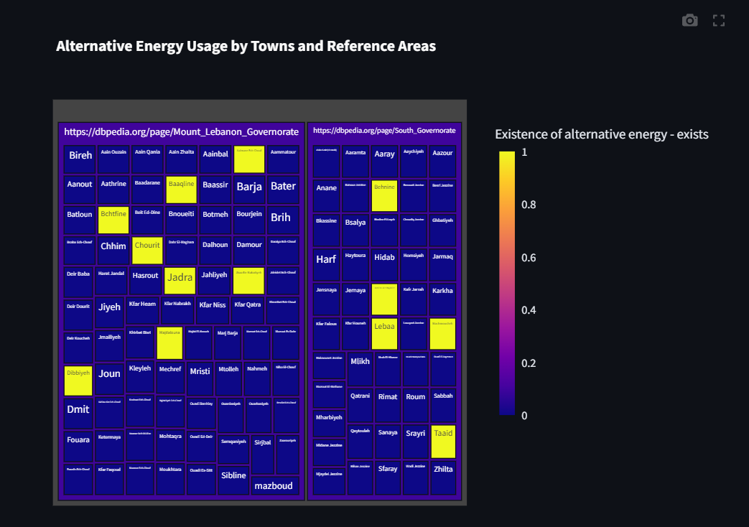

This treemap shows alternative energy usage in towns across two reference areas: Mount Lebanon and South Governorate. The towns are color-coded based on the existence of alternative energy, with yellow indicating towns where alternative energy is present and blue where it is not. From the chart, it's clear that most towns do not have alternative energy (dominated by blue), but there are a few towns in both areas (highlighted in yellow) that have adopted alternative energy solutions. The color scale on the right further confirms this binary distribution (0 for absence, 1 for presence).