How-to Guide for Using the Seismic Refraction Package of Sigkit

The Seismic refraction package of SIGKit provides the user with a simple interface for doing basic analysis of seismic data including:

* Picking first arrivals
* Simulate a 48-channel seismic array
* Estimation of velocities and 2 layer model structures for both single-shot and dipping layer models
* Forward modeling (Coming soon)

The following guide serves as a tutorial for analyzing a 24-channel seismic data file beginning from the launch of the SIGKit package and ending with the Estimate Velocity step.

# Launching the Seismic Refraction package

Clicking on the SIGKit.exe file will launch the entire toolkit. Simply click on the Seismic refraction button as shown on the image below to begin analyzing your seismic data. Adding **your data** to the **Seismics/Data** folder that is included with the toolkit will simplify your processing steps hence it is important to do this before you begin work!!!

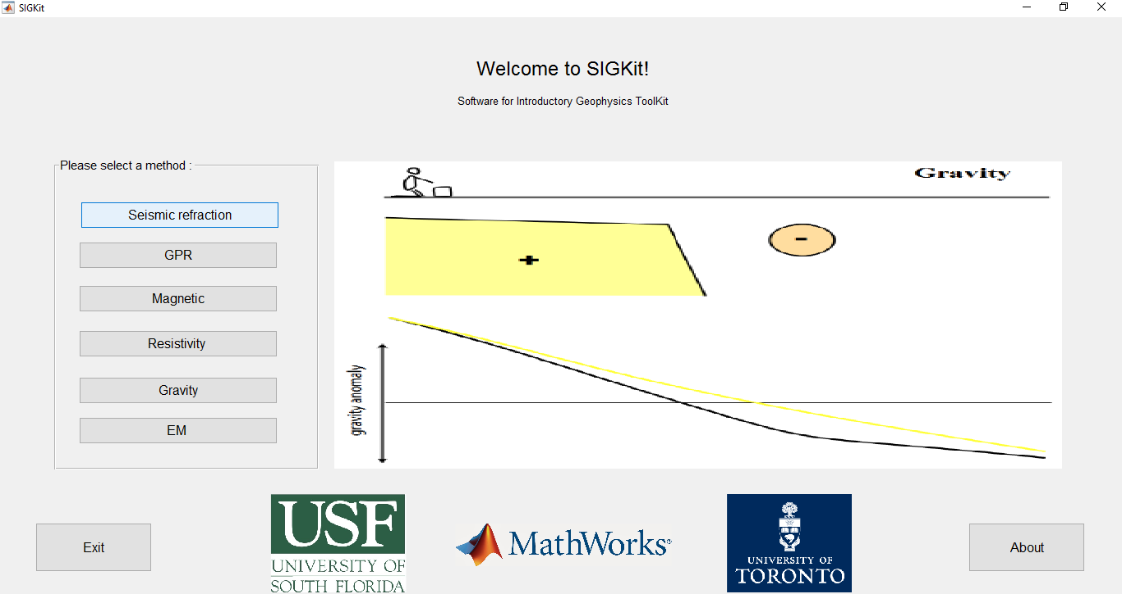

Figure 1. SIGKit GUI

The Seismic refraction button launches the Seismic GUI which is the front end program that allows for a few different analyses of seismic refraction data.

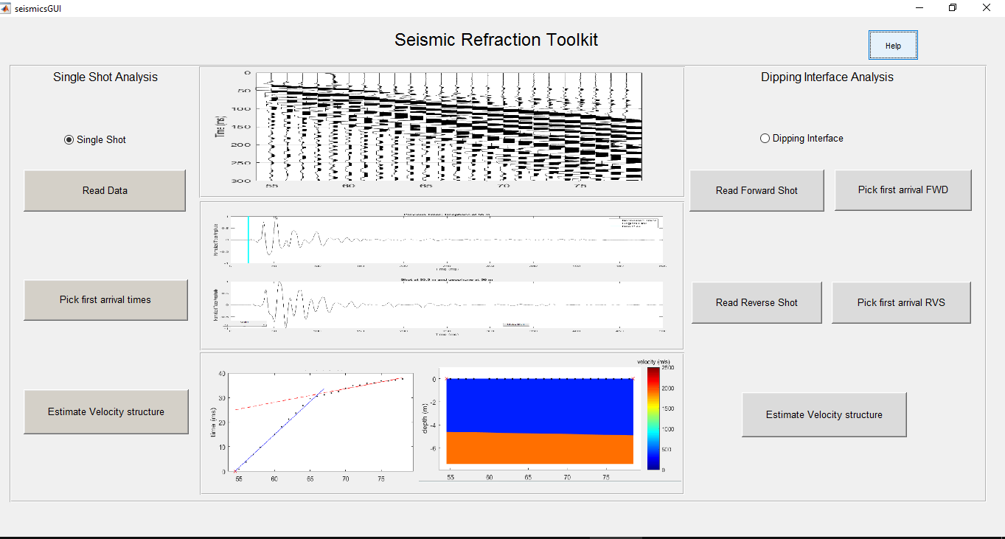

Figure 2. Seismic GUI

# Single-shot analysis

By default, the seismic GUI launches with the single-shot radio button already selected. This portion allows the user to read in a data file from a single acquisition or 2 files at if simulating a 48-channel array.

## Reading in the data

1. Clicking on the Read Data button will launch a new window that allows the user to navigate to their data folder. While the code has some flexibility, it works best when the data is stored in the Seismics/Data folder.
2. Click on the Seismics folder (Figure 3)
3. Select the data folder (Figure 4)
4. Here, all your data files (.dat files) will be displayed. Select the desired file and click open. When simulating a 48 channel array, select the first file then ctrl + click on the second file to select it.

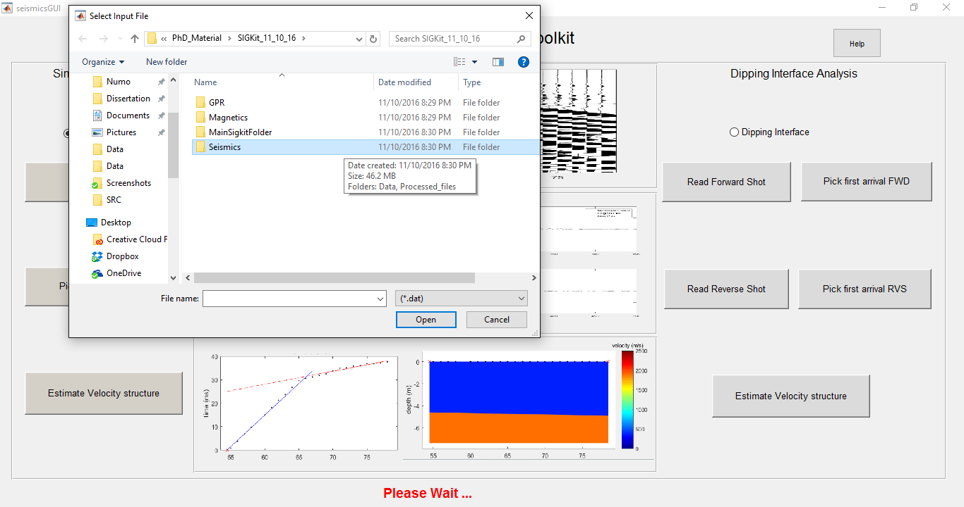

Figure 3. If you have placed your data into the Seismic/Data directory, navigate to this folder to begin analysis

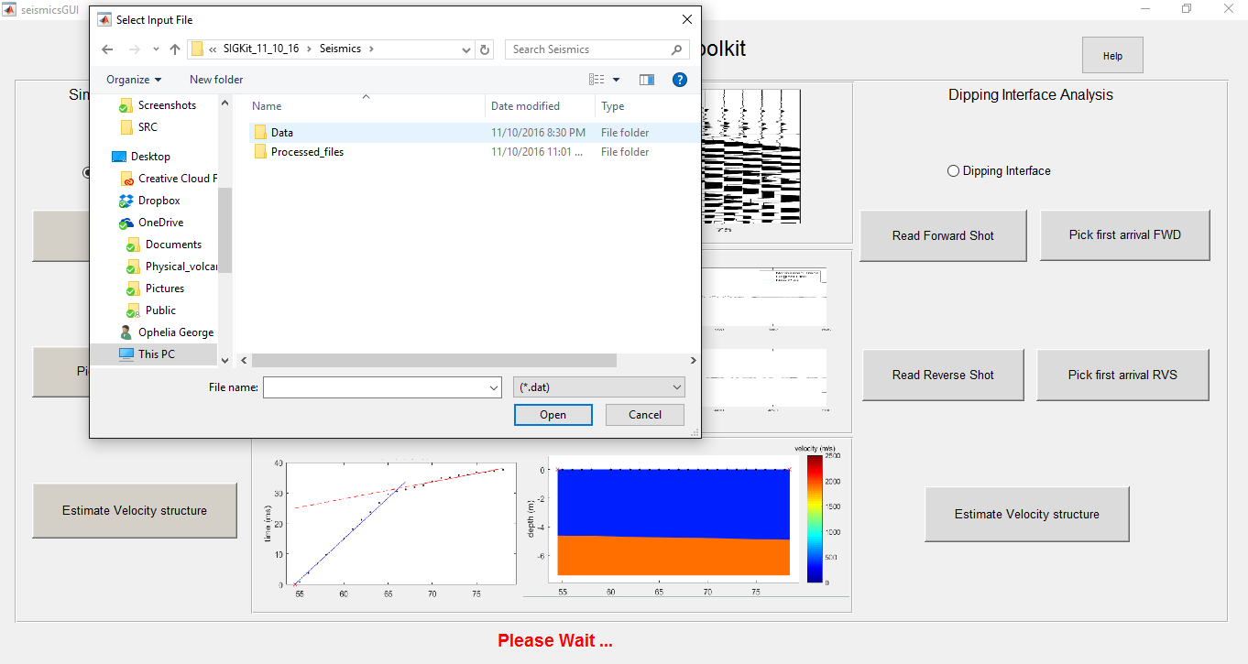

Figure Data folder selection.

Reading the data is the slowest portion of the seismic package because while converting the data to a format that is compatable with Matlab happens relatively fast, plotting the large amount of data contained within each seismic file is not. Please be patient while this is being done.

1. Once the data file has been read in and plotted, the user will be asked to verify that the information contained within the file is indeed correct. You will first be asked to verify the shot position, and then the receiver position before you can move on to picking first arrivals.

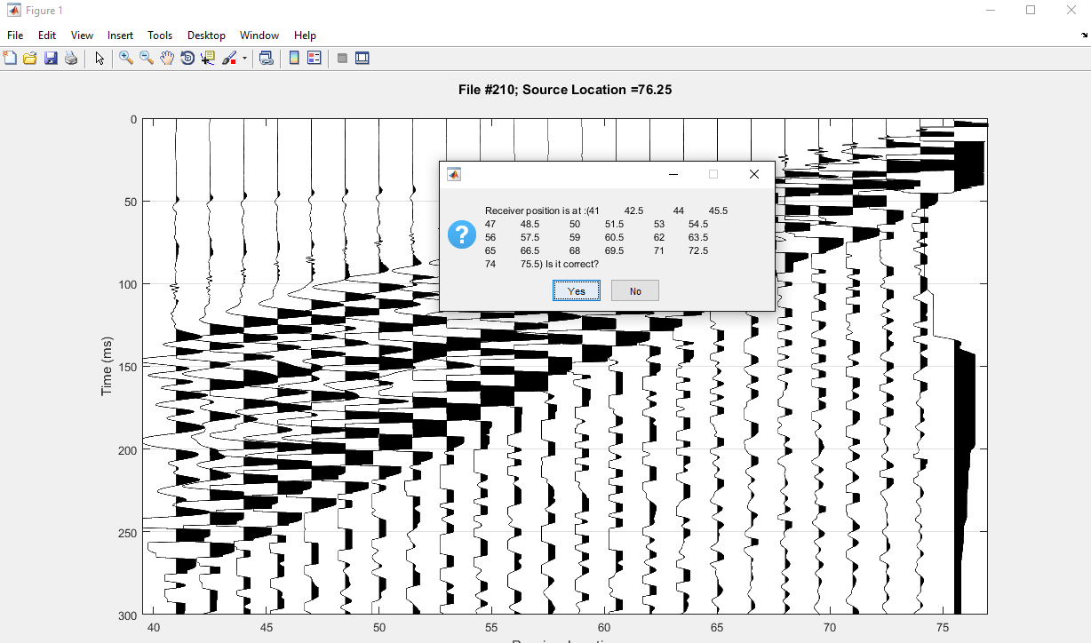

Figure Data verification phase

## Picking first Arrivals

After the data verification phase, the Seismic GUI will pop to the front; select the “Pick first arrivals button” to proceed to the next step. This will launch a new figure that allows you to either move on to the estimate velocity phase if you have already made picks on the file using the Seismic GUI (Go Back) or proceed with making first arrival picks (Continue).

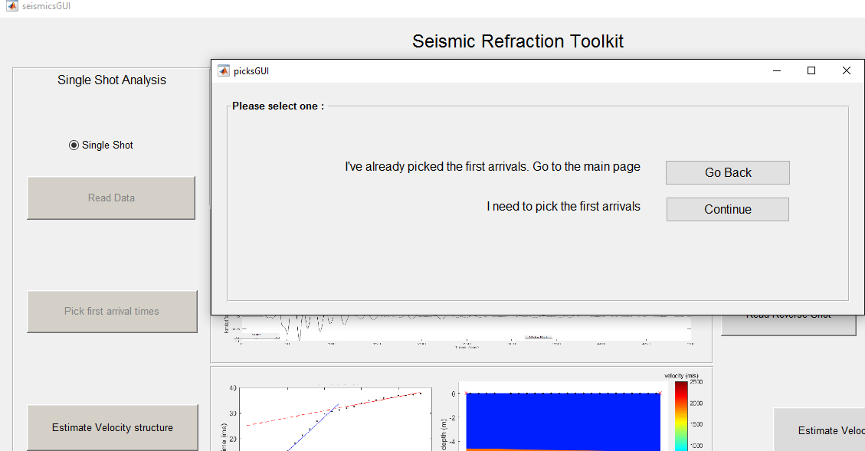

Figure 6. Launching the first arrival picking phase of the analysis

The process of picking first arrivals is a two part process in this program. The user is first allowed to make picks on Figure 1 which shows all 24 traces at the same time. This phase is launched immediately upon clicking the continue button in Figure 6.

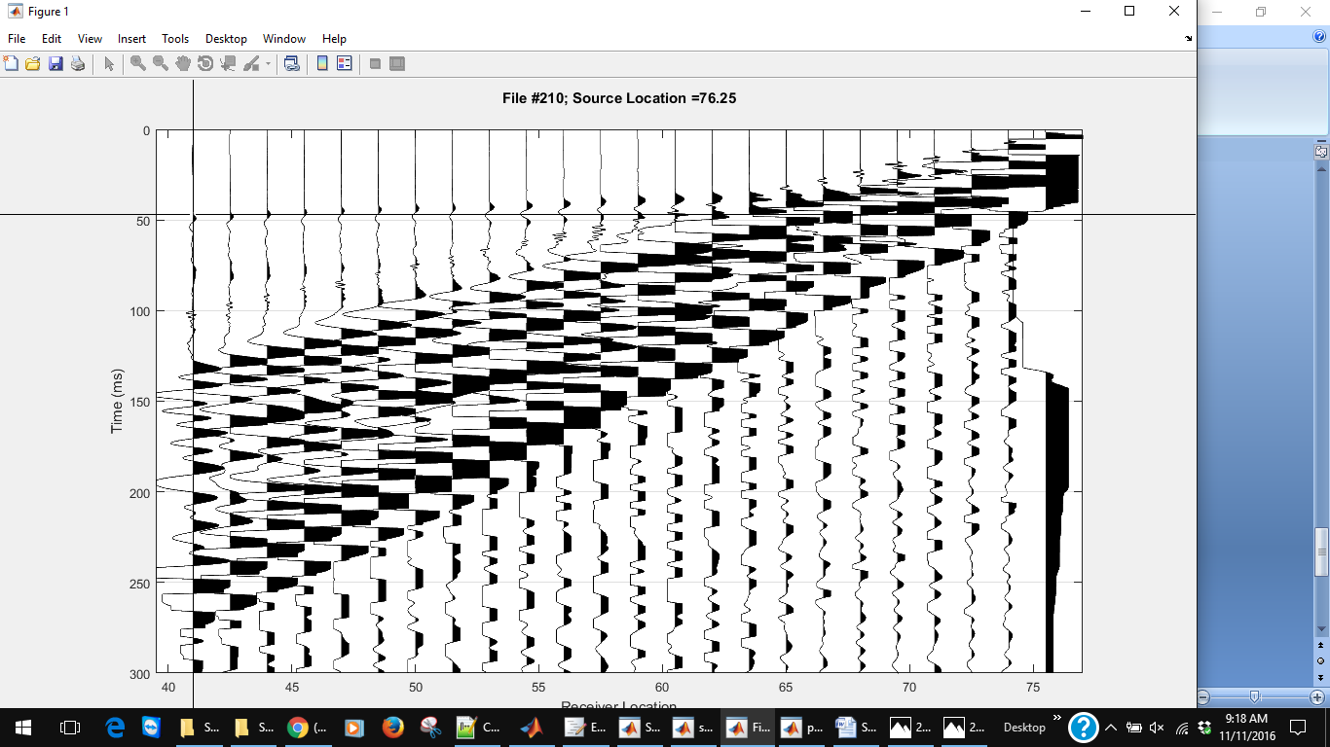

Figure Picking phase 1 allows the user to make picks while all 24 traces are displayed

The giant cross hairs that appear will mark the store the data points that the user selects as the first arrival for this file. If you are uncertain about a trace, you can skip it and move on to making picks on other traces. Once you have clicked on all the traces that you want to, hit enter to move on to the next step. This will launch the next phase of the picking process which allows the user to make picks on a single trace display (Figure 8). With the exception of the first trace, all subsequent figures will show the previous trace on the top and the current trace on the bottom.

In picking phase 2, there are 3 buttons and a slider bar included on the figure. The slider bar allows the user to adjust the gain as needed for making their best pick selection. Adjusting the gain MUST be done prior to any button selection as the program has limited options if any of the three buttons are pressed. The buttons allow the following actions:

* **Keep Pick**: Allows the user to keep the original pick time selected in picking phase one if they are happy with their selection.
* **Change Pick**: This launches the cross hairs seen during picking phase 1 which allows the user to click on a different position along the trace essentially changing their pick made in the first step
* **Skip Trace**: In some cases, a first arrival pick cannot confidently be made on a trace. Clicking on this button allows the user to throw out the data from this trace and move on to the next.

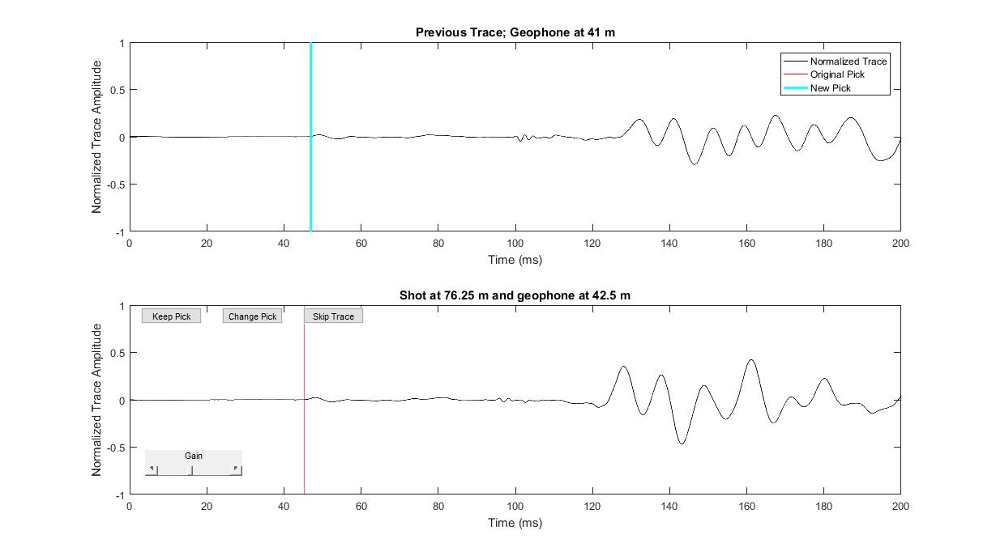

Figure Picking phase 2 allows the user a second opportunity to verify their picks while displaying the traces one at a time

After going through all 24 traces, the new picks are displayed on the original 24-trace pick figure in red. The user is then given a final opportunity to delete bad picks from the travel time curve that is displayed next.

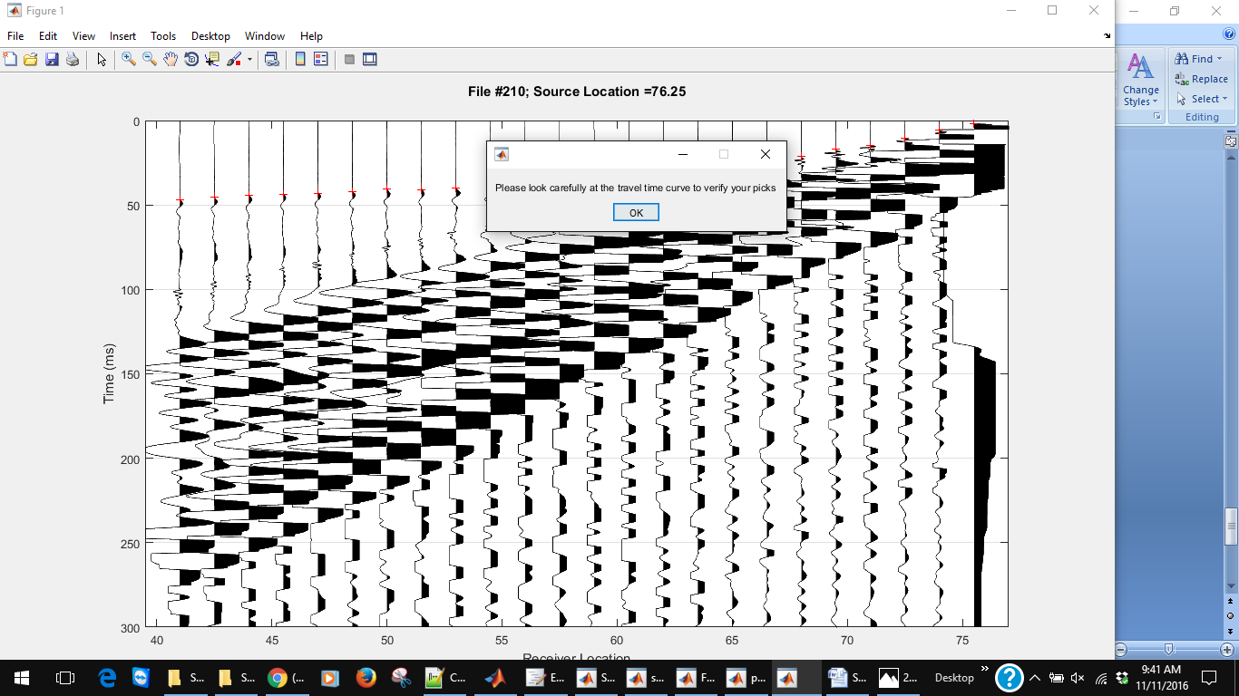

Figure 9. The user will now have a chance to delete bad picks or move on to the final phase – Estimate velocity.

## Estimate Velocity

Now that you have read in your data file and made first arrival picks, you are finally ready to estimate a velocity structure. Click on the Estimate Velocity button on the Seismic GUI to launch this portion of the program. A plot similar to the one displayed in the final step of the first arrival picking phase is displayed here.

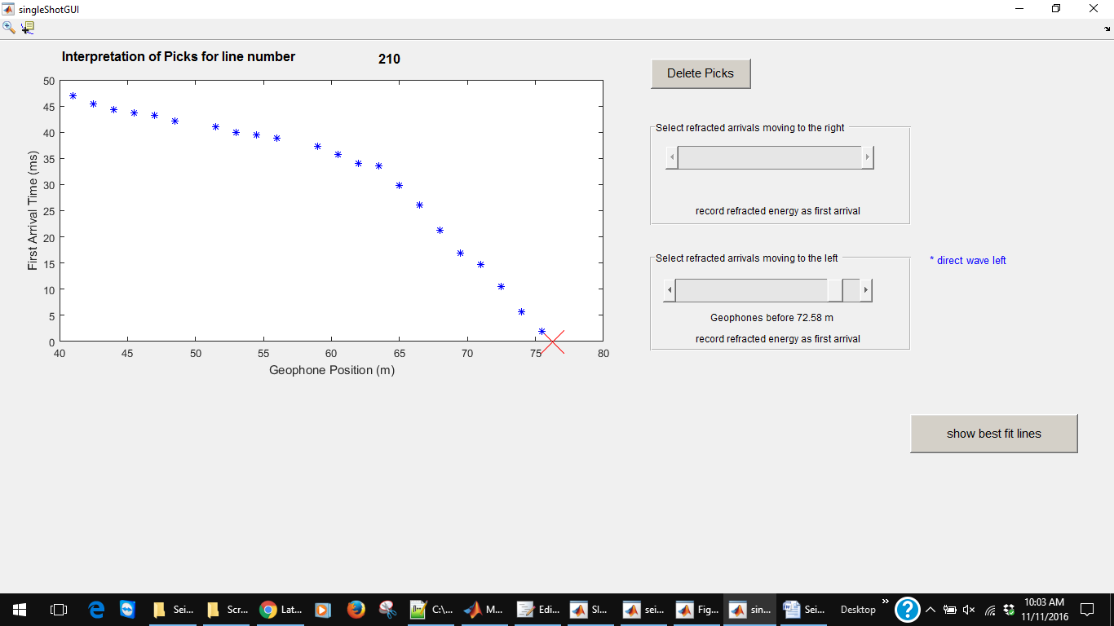

There are several important features displayed on this screen:

* There is once again a Delete Pick button that allows the user to remove bad picks from the analysis.
* There are two slider bars that allows the user to adjust which data points correspond to the refracted or direct wave either to the left or the right of the shot
* The “Show best fit lines” button fits a slope to the data points selected by the user. When clicked, this button will activate the “Show Structure and Rays” button and will display a velocities corresponding to the refracted and direct waves to the right (Figure 10).
* Clicking on the “Show structure and rays” will display a 2-D model of the surface beneath the seismic array and activate the “Save File” button.
* By default, the Save File button will save an image of the Estimate Velocity structure GUI and a text file that contains the data displayed in the **Structure Parameters** box of the **Estimate Velocity Structure** GUI. This is saved a processed file folder in your working directory (Figure 11).

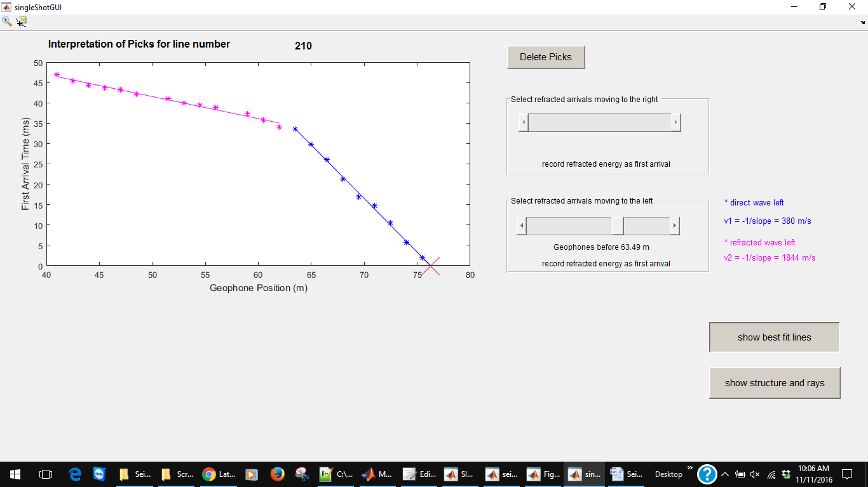

Figure Step 2 in the Estimate Velocity process

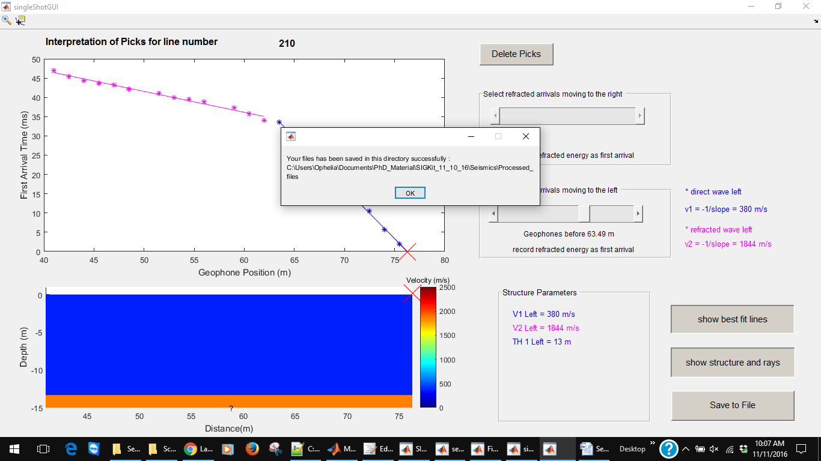

Figure Final step of the single-shot processing module saves the velocity structure image and data to a file in the working directory

You have now completed a velocity structure estimation for the region beneath the area surveyed during the acquisition of the file originally read in!!