**Prerequisite to run application:**

* AlphaClient Machines : Servers whose ssh attempts we want to track.
* AlphaServer Machine : Server to send & display real time ssh attempts of all AlplaClient machines.
* I used Azure for my testing purpose where my AlphaClient & AplhaServer machines are running.
* Terraform needed in case you don’t have AlphaServer and want to create new one.
* Need to create service principal if you want to create server using terraform script.

<https://docs.microsoft.com/en-us/azure/active-directory/develop/howto-create-service-principal-portal>

**Steps to Run application:**

1. Need to download [alphaClient.sh](https://github.com/SajalGolas/sshmonit/blob/master/alphaClient.sh) & [schedule.sh](https://github.com/SajalGolas/sshmonit/blob/master/schedule.sh) on each AlphaClient VM whose ssh attempts we want to track. Link : <https://github.com/SajalGolas/sshmonit.git>
2. Edit [schedule.sh](https://github.com/SajalGolas/sshmonit/blob/master/schedule.sh) scripts and replace the your AlphaServer machine credentials.
3. Make sure if you’re passing password in script then sshpass module should be available in AlphaServer machine if not then install by using **apt-get install -y sshpass.**
4. Run below command

**nohup ./schedule.sh** & or **./schedule.sh &** (Any to keep the script running in

background)

1. Login into your AlphaServer machine and see the output of real time ssh attempts(Successful & Failed both) of all AlphaClient machines with proper IP, Date & Time in output.txt file.

Command to see ssh report in AlphaServer machine :

**tail -f output.txt** or simple **cat output.txt**

Note : I used infinite while loop to keep the script running or you can also schedule

AlphaClient.sh script as cron job in AlphaClient machines.

**Steps to create server using Terrraform :**

1. Create service principal in Azure. (Follow above doc)
2. Go inside the [alphaServer.tf](https://github.com/SajalGolas/sshmonit/blob/master/alphaServer.tf) directory (Make sure replace your ssh key)
3. Terraform init
4. Terraform plan
5. Terrafrom apply.

Please refer attached snapshots for your reference,

Terraform plan

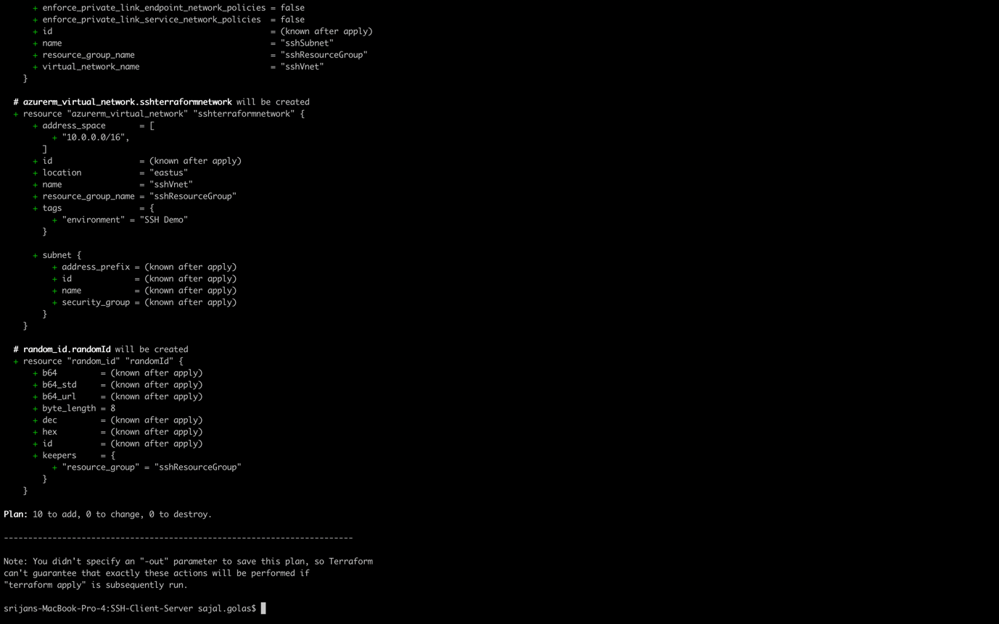

Terraform apply

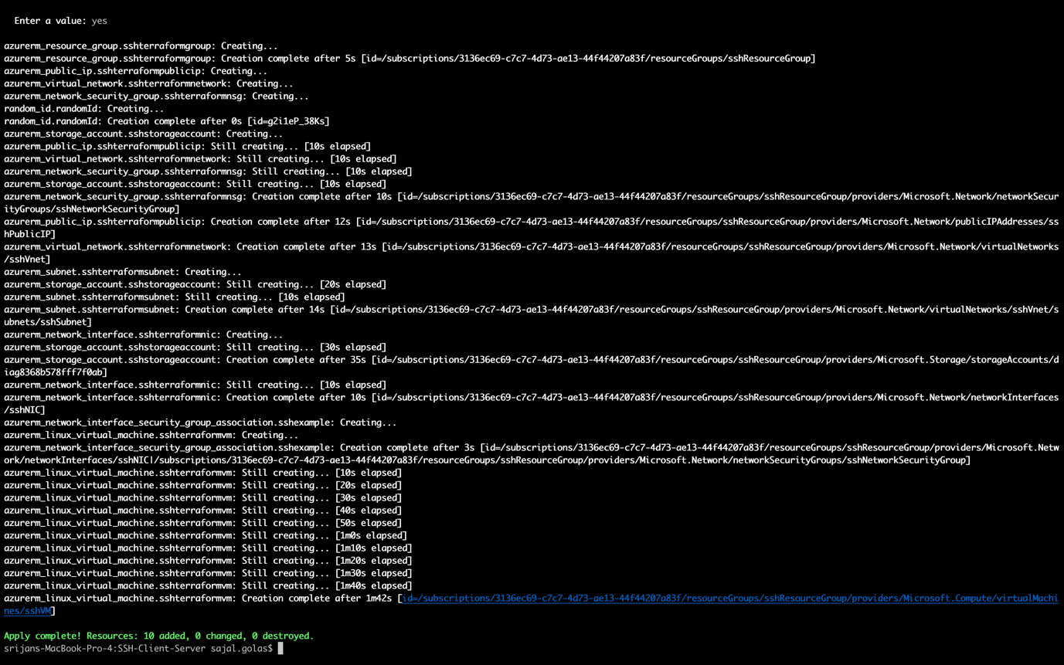

Now new VM you can see on Azure.