The Story of a Customer Segmentation
  - From a million messy receipts to who-to-spend-on — an illustrated, end-to-end readbook
Table of Contents

Preface
This is the story of the project, meant to be read cover to cover. It starts from nothing — a pile of raw sales receipts — and walks every step to the finish: a handful of customer groups, each with a predicted future value and a clear marketing action. Along the way you’ll see the actual figures we produced, the formulas behind each method, the reasoning for every decision, and a checkpoint after each chapter telling you exactly what we have so far.
No prior data-science knowledge is assumed. Where a concept appears for the first time, it’s explained in plain English before the maths. The recurring theme — the thing that makes this more than a button press — is honesty: at every step we validate what we found, compare alternatives, and admit what the data couldn’t support.
The whole journey on one line: clean a million transactions → describe each customer with a few numbers → group similar customers → predict each one’s future value → name the groups, prove they’re real, and decide what to do with each.

Chapter 1 — The Question and the Data
A UK online gift shop has two years of sales and a limited marketing budget. Right now every customer is treated the same. That’s wasteful: a loyal big spender and a one-time bargain hunter shouldn’t get the same email. We want to split customers into a few meaningful groups, predict who will be valuable, and spend the budget where the money actually is.
The raw material is the public “Online Retail II” dataset — about 1.07 million transaction lines, ~5,900 customers, a gift-ware retailer, December 2009 to December 2011. Real data is messy, and this is no exception:
- 22.8% of rows have no Customer ID — we can’t tie them to a person.
- ~19,000 rows are cancellations (the invoice number starts with “C”).
- Many rows are returns (negative quantities) or non-products (postage, fees, gift cards).
A crucial design choice up front: we will build two separate models — one that groups customers by behaviour (clustering), and one that predicts future value (CLV) — and only join them at the very end. Why separate? Because if “value” helped define the groups, we could never honestly say “this behaviour group turns out to be the most valuable.” Keeping them apart also buys a free check: if two independent models agree on who’s valuable, that’s strong evidence both are right.
📍 Checkpoint. We have a question (who’s valuable and what do we do about them?), a messy 1.07M-row dataset, and a plan: clean → features → (cluster ∥ value) → act.

Chapter 2 — Cleaning: One Trustworthy Row at a Time
Before we can ask “how much does each customer buy?”, every row must be real and attributable. Cleaning is not janitorial work — it’s a series of modelling decisions, each with consequences.
We made these calls (and recorded the reasoning in the design docs):
- Drop rows with no Customer ID — unattributable.
- Cancellations and returns: remove them from purchase counts, but keep a return-rate as a separate signal (a returns-heavy customer is meaningful, and we don’t want to lose that).
- Remove non-products (postage, bank charges, adjustments, gift cards) so that “Monetary” means genuine product spend.
After cleaning we had 790,704 clean transaction lines and 5,852 customers — and, importantly, the money still balanced. We always prove cleaning didn’t silently lose revenue with a reconciliation:
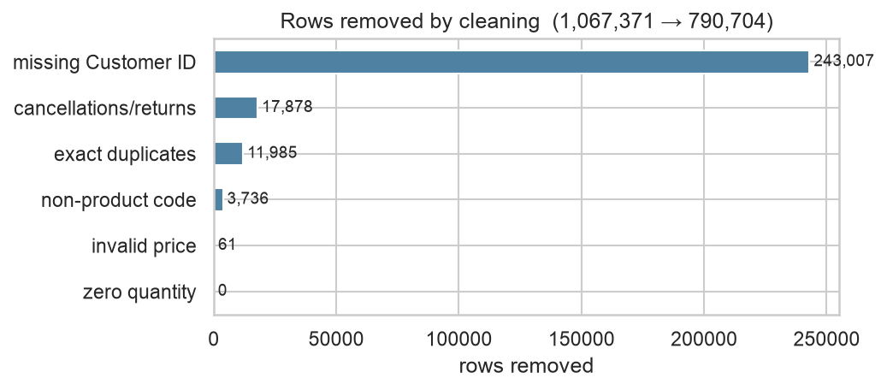
Reconciliation — every pound from the raw data is accounted for after cleaning (kept, or removed for a stated reason).
📍 Checkpoint. A clean transaction table: 790,704 rows, 5,852 customers, books balanced. Already a hint of trouble ahead — about 28% of customers bought only once.

Chapter 3 — Exploring: Letting the Data Set the Rules
Before modelling, we look. Exploratory analysis is where later decisions get justified by evidence rather than assumed. Four findings shaped everything downstream.
1) Value is wildly concentrated (the Pareto effect). The top 20% of customers drive about 77% of revenue. This single fact later tells us to budget by value, not by headcount.
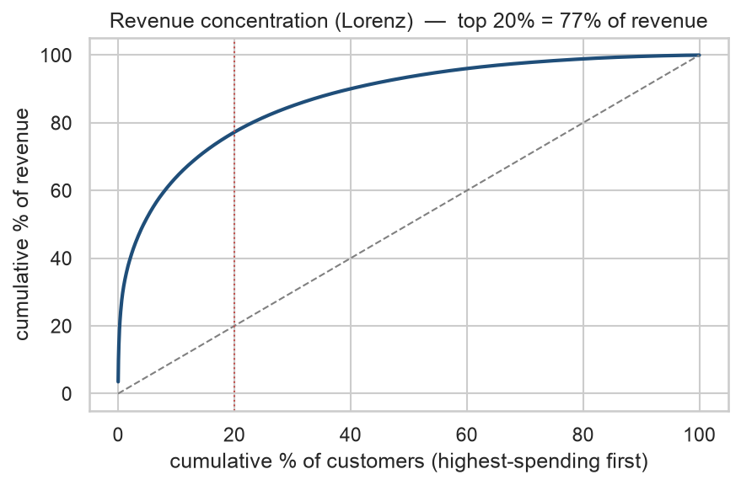
Revenue is concentrated — a small share of customers drives most of the money.
2) Spend is heavily right-skewed. Most customers spend modestly; a few spend enormously — like incomes, where the average is dragged far above the typical person. This is why we later prefer the median (the typical customer) and apply a logarithm to tame the long tail.
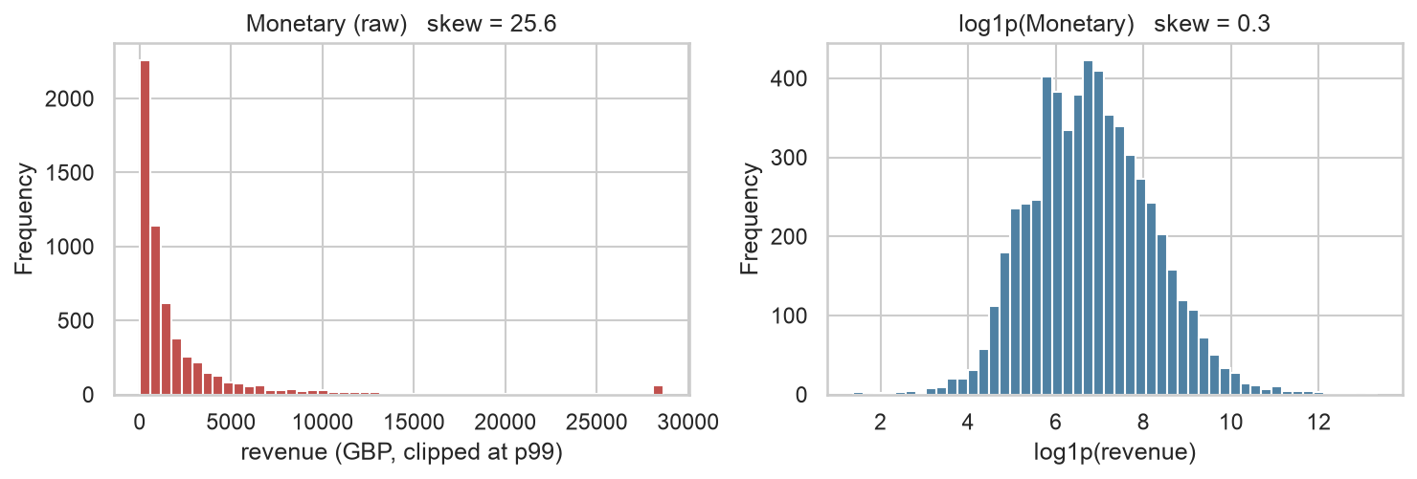
Monetary spend is heavily right-skewed; a log transform reshapes it into something a distance-based algorithm can handle.
3) There is strong seasonality. Being a gift retailer, sales spike before Christmas. This will come back to haunt the value model in Chapter 6 (which assumes a constant buying rate).
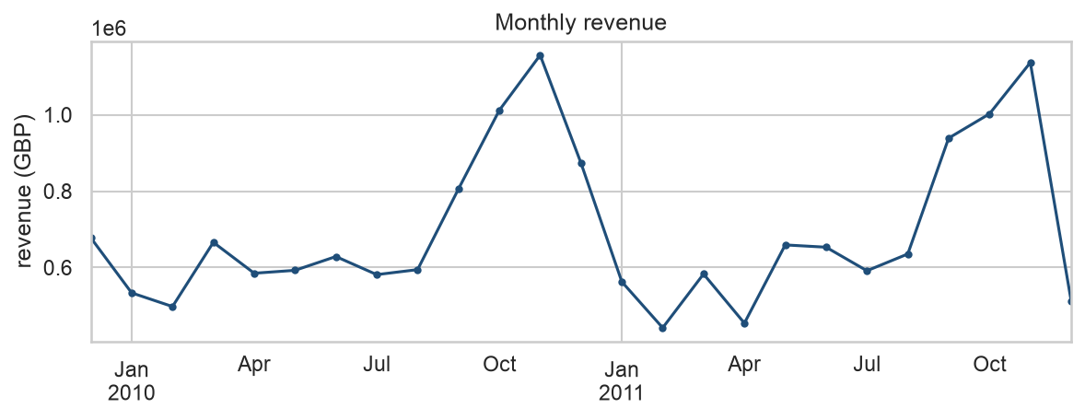
Monthly revenue shows a pronounced Christmas peak — seasonality the CLV model does not know about.
4) ~28% of customers bought only once. A large, distinctive group we’ll have to handle specially.
📍 Checkpoint. We understand the data’s shape: concentrated value (top 20% = 77% revenue), heavy skew (→ use median + log), Christmas seasonality (→ a known risk), and a big one-timer block.

Chapter 4 — Features: From Receipts to a Customer’s Fingerprint
Models need one row per customer, but the data is one row per sale. Feature engineering collapses each customer’s many transactions into a few descriptive numbers. The guiding rule: the columns are the problem — every feature must trace to a justified column.
We built the classic RFM + Tenure fingerprint:
- Recency — days since their last purchase (low = recently active).
- Frequency — how many separate purchases.
- Monetary — total spend.
- Tenure — days since their first purchase (how long they’ve been a customer).
Two treatment decisions, both made from the data:
- Log, then scale. The skew (Chapter 3) means a few whales would dominate any distance calculation. A $log(1+x)$ transform compresses the tail; scaling then puts features on a comparable range. We measured the skew and only logged the columns that needed it (Frequency and Monetary).
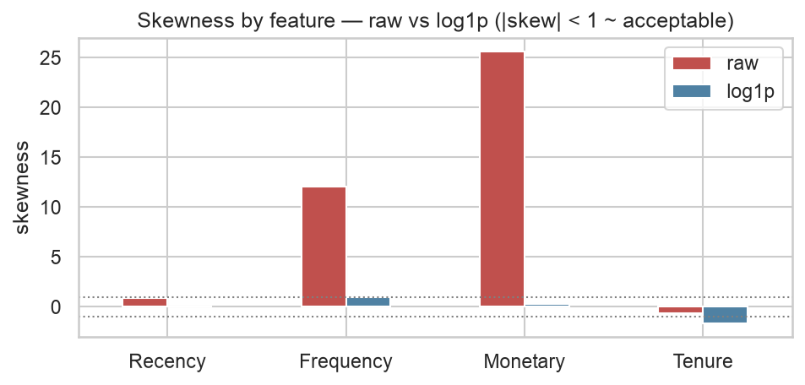
Skewness before vs after a log transform — Frequency and Monetary need it; Recency and Tenure do not.
- Drop AvgBasket from clustering. Average basket value is exactly Monetary ÷ Frequency, so feeding it alongside them adds zero new information — a redundancy, visible in the correlation map.
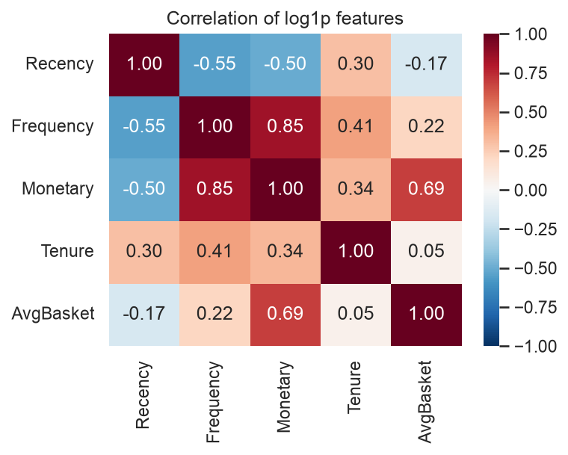
Correlation of the (log) features — AvgBasket is a deterministic function of Monetary and Frequency, so it is excluded from clustering.

A discovery hiding in the one-timers
Here the data revealed something elegant. For a one-time buyer, the first purchase is the last purchase — so Recency = Tenure exactly, and Frequency is always 1. Two of their four features carry no independent information. Mathematically, their feature covariance matrix is rank 2, not 4 — they collapse onto a flat 2-D sliver of the 4-D space. We proved it numerically:
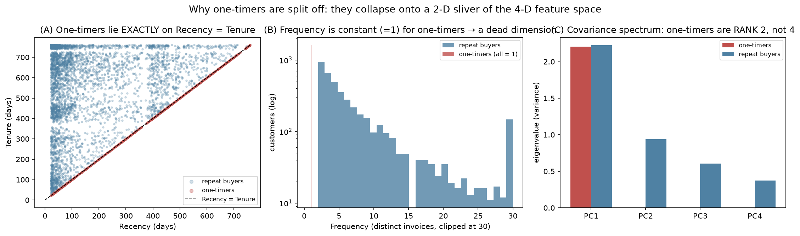
One-timers are degenerate: Recency exactly equals Tenure, Frequency is constant, and their feature covariance is rank-2 (two near-zero eigenvalues). There is nothing for a clustering algorithm to find among them.
This is why, in the next chapter, one-timers are set aside and handled as their own group rather than forced through clustering.
📍 Checkpoint. Each customer is now a point in 4-D space (scaled R/F/M/Tenure) plus separate value inputs and supporting variables. And we know one-timers are a degenerate special case.

Chapter 5 — Clustering: Finding the Groups
What clustering is. It automatically sorts items into groups so that members of a group are similar and different groups are dissimilar — without being told the groups in advance. Think of sorting laundry into darks/lights/colours, but in four dimensions and by algorithm.
We used three different methods on purpose. Each makes a different assumption, so when they agree, the structure is probably real; when they disagree, that itself is a finding.

Method 1 — K-Means (the workhorse)
K-Means picks $K$ “average customers” (centroids) and assigns everyone to the nearest, then repeats assign → move centroid until nothing changes. It minimises the within-cluster sum of squares:
J = k=1K x∈Ck​ x−μk2, μk=1|Ck|x∈Ck​x.
Watching it run makes it click — the centroids slide into place and the total tightness $J$ drops every step until it converges:
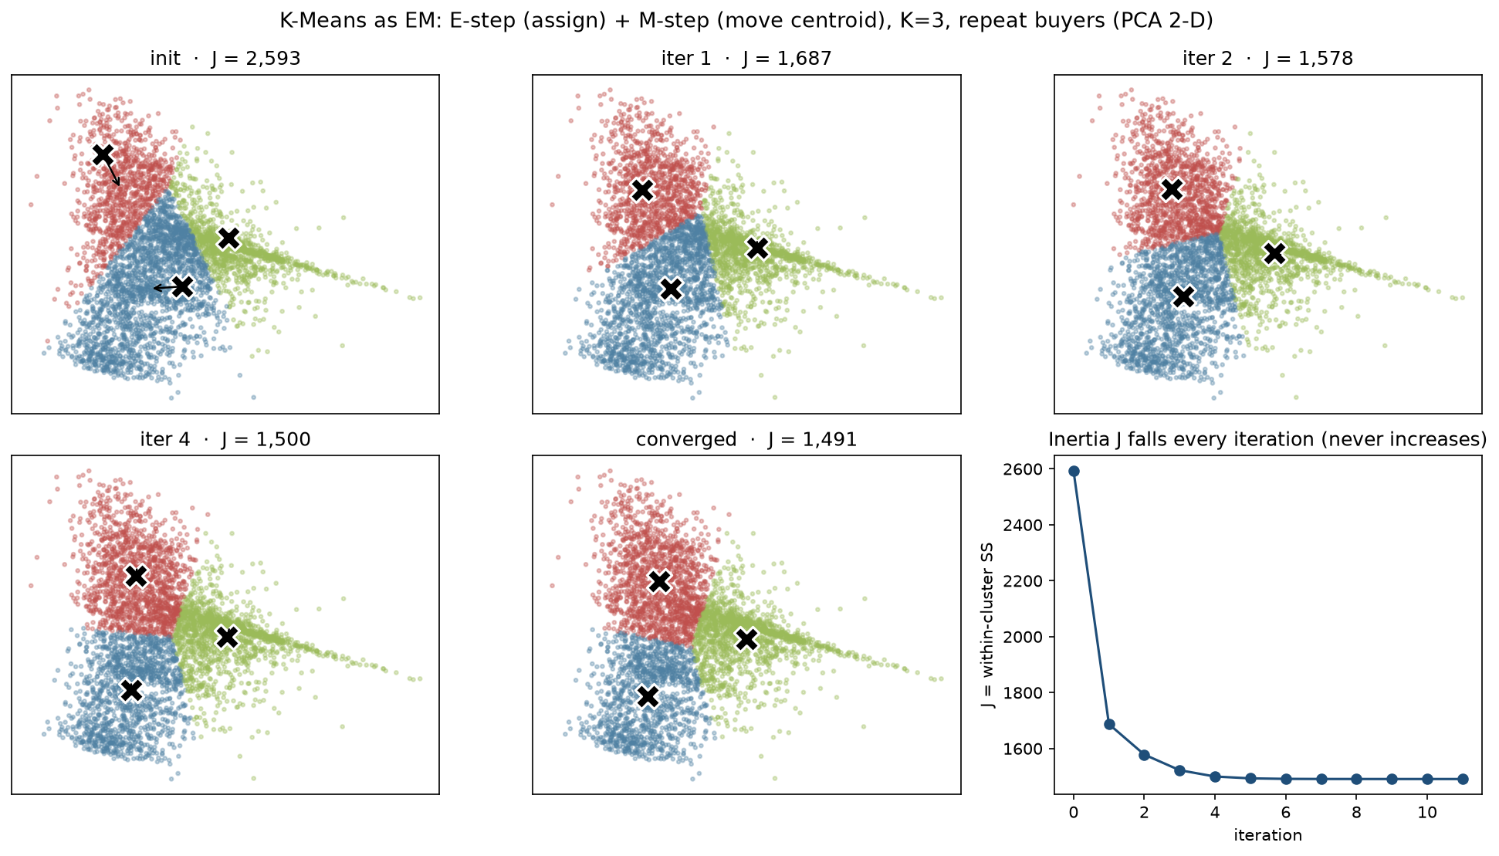
K-Means as an alternating algorithm: each step assigns points to the nearest centroid, then moves each centroid to its members’ mean. The inertia (tightness) falls monotonically to convergence.

Method 2 — Gaussian Mixture (the soft, oval version)
A Gaussian Mixture says each customer is a blend of $K$ “types,” and the types can be stretched, tilted ovals rather than circles:
p(x) = k=1Kπk N(x∣μk,Σk), k​πk=1.
It is fit by the EM algorithm, alternating between computing each point’s soft membership and re-estimating the ovals. Watching the ovals tilt and the points shade by membership:
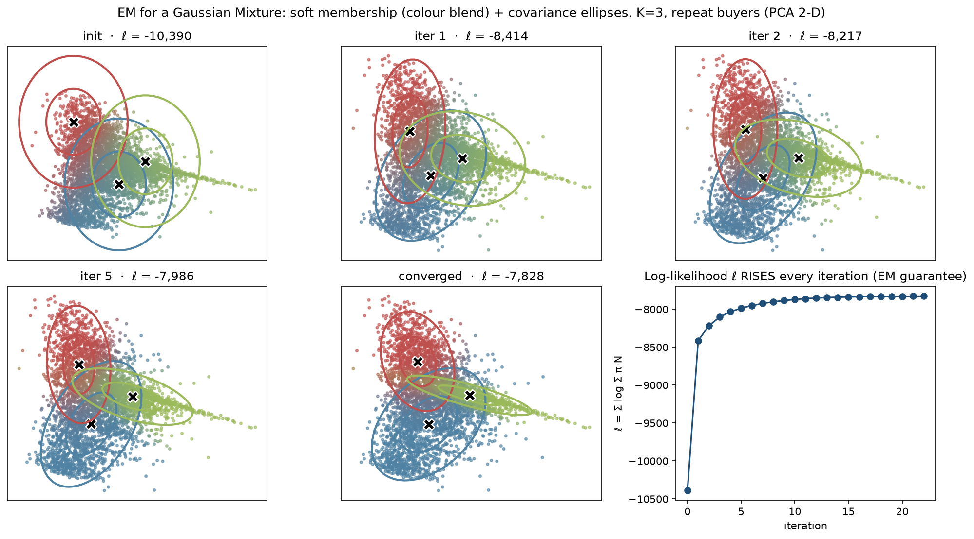
A Gaussian Mixture fit by EM: covariance ellipses stretch and tilt while points are shaded by soft membership. The log-likelihood rises every iteration.
(The third method, Ward hierarchical clustering, builds a merge-tree you cut at $K$ — useful for a visual narrative.)

Choosing K — the heart of the rigour
Nobody tells us how many groups exist, and “more clusters” always looks tighter, so we can’t simply minimise tightness. We triangulate several imperfect signals that fail in different ways:
- Silhouette — for each point, how much closer it is to its own group than the nearest other: $s(i)=\frac{b(i)−a(i)}{max(a(i),b(i))}$. Higher is better.
- Gap statistic — compares our tightness against random data; uniquely it can say “K = 1, no real clusters”: $Gap(k)=E_{\text{null}}[logW_{k}]−logW_{k}$.
- Elbow, Calinski–Harabasz, Davies–Bouldin — corroborating internal scores.
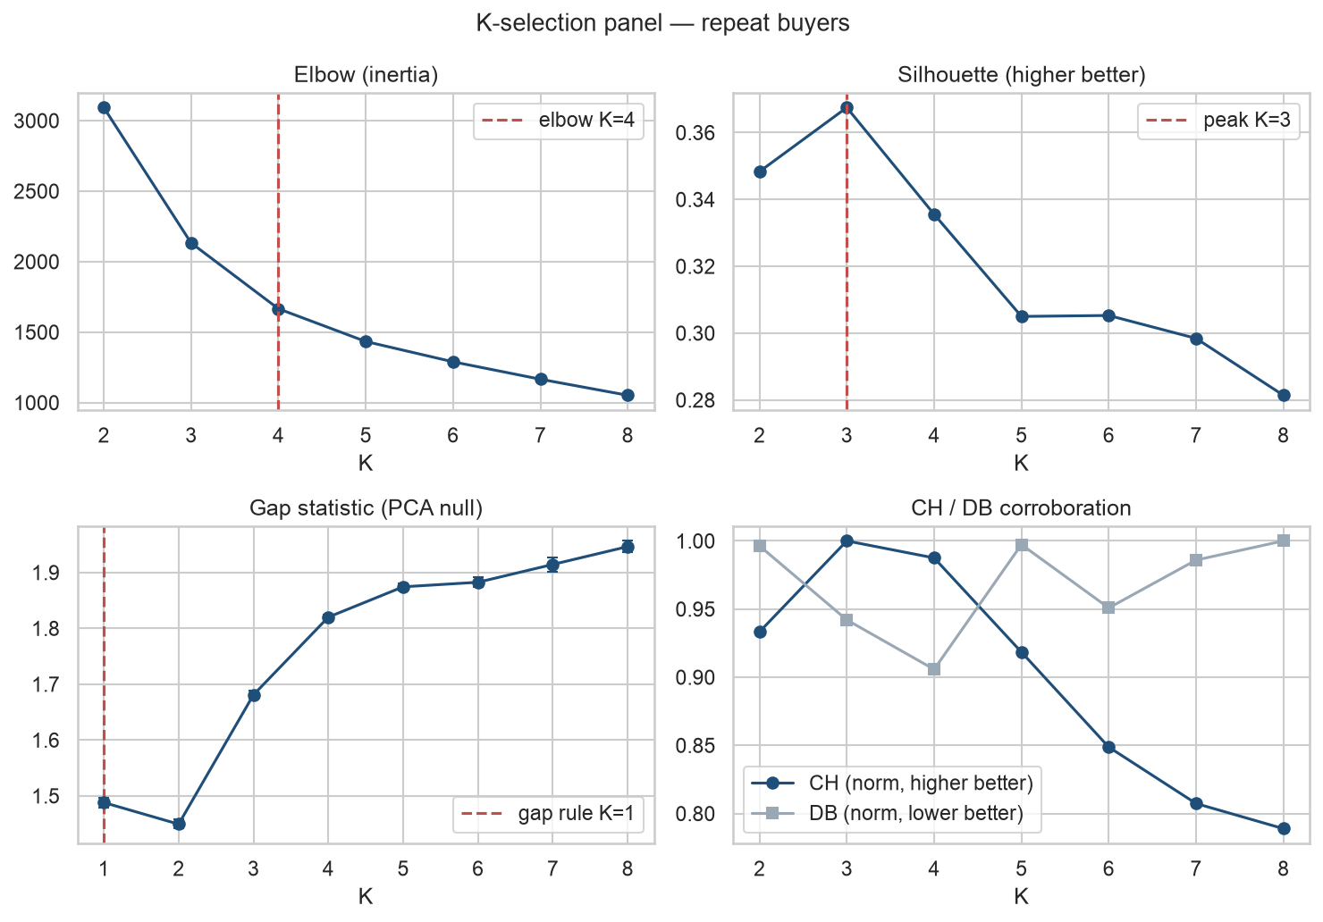
The K-selection panel: silhouette and Calinski–Harabasz peak at K=3, the elbow and Davies–Bouldin lean to 4. No index is decisive alone — we read them together.
Internal scores only say “how many blobs.” The decisive test is stability: re-cluster on random 80% subsamples and ask whether the same groups reappear. Real structure reproduces; artefacts dissolve. We measured each cluster’s survival with the Jaccard overlap $J(A,B)=\frac{|A∩B|}{|A∪B|}$, and K=3 was the most stable.
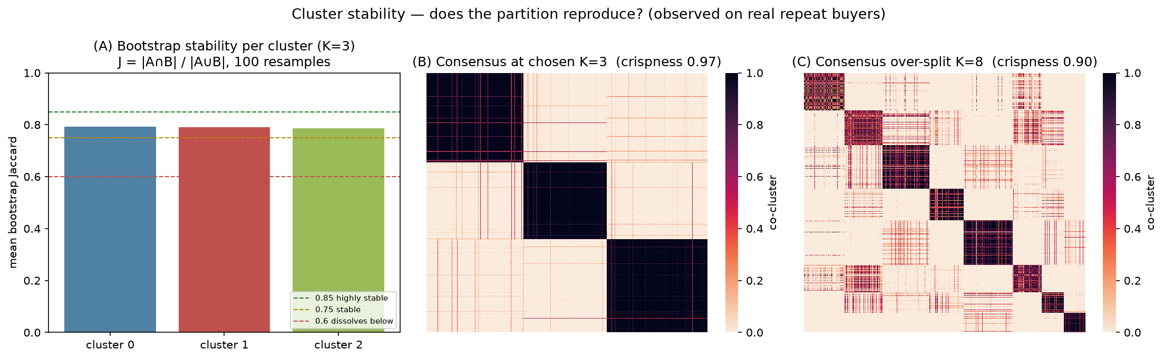
Stability: at K=3 every cluster survives resampling (Jaccard ≈ 0.79) and the consensus matrix is crisp; an over-split K smears.
The verdict: K = 3 for the repeat buyers — silhouette and CH peak there and it is the most stable. The one-timers (degenerate, Chapter 4) are set aside as their own group, giving 4 segments in total. Clustering everyone actually scored a higher silhouette, but only because the easy one-timer blob inflated it — a trap, not a better answer.

Do the methods agree?
We compared the three methods’ groupings with the Adjusted Rand Index (1 = identical, 0 = chance). They agree only moderately (K-Means ↔ Ward ≈ 0.61; the soft GMM diverges more).
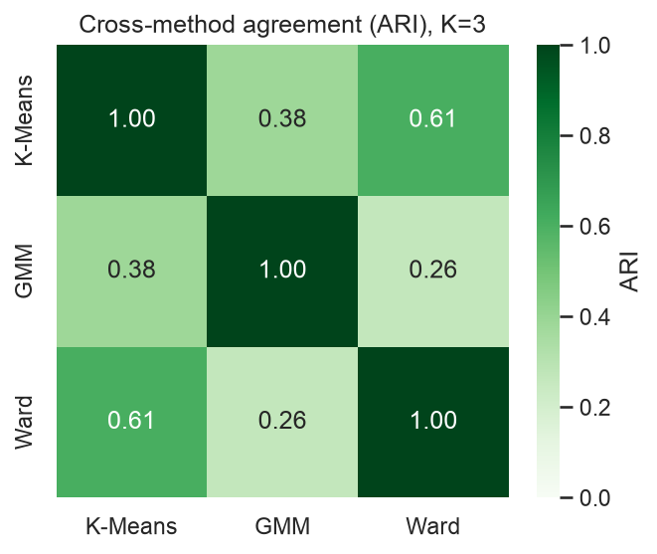
Cross-method agreement (ARI). Moderate, not unanimous — the honest signature of a continuum, where methods carve the boundaries of a gradient differently while agreeing on the cores.
That moderate agreement is not a failure — it is the most important honest finding of the project: customer behaviour is a continuum, not crisp islands. We therefore deploy K-Means and call the result a useful discretisation, not “natural kinds.”
📍 Checkpoint. 4 segments (3 repeat-buyer clusters + one-timers), chosen by triangulation and proven stable — with the honest caveat that the data is a gradient, not natural groups.

Chapter 6 — Customer Lifetime Value: Predicting the Future
Grouping tells us who’s who today. The second track predicts who will be worth what tomorrow.
The hard part: online retail is non-contractual — customers never announce they’ve left, they just go quiet. So “is this dormant customer gone, or just resting?” is a probability we must infer. And naive CLV (“sum their past spend”) is backward-looking; it can’t tell a loyal-but-dormant customer from a dead one. We need a forward-looking, probabilistic forecast, split into two questions:
$$\text{CLV} = \underset{\text{BG/NBD}}{\underset{⏟}{E[\text{future purchases}]}} × \underset{\text{Gamma-Gamma}}{\underset{⏟}{E[\text{value per purchase}]}}.$$

Part A — How many future purchases? (BG/NBD)
Each customer has two hidden habits: while active they buy at random at their own rate $λ$; and after each purchase they may quietly retire forever with probability $p$. Across the population these rates vary:
$$λ∼Gamma(r,α), p∼Beta(a,b).$$
The model learns the four numbers $(r,α,a,b)$ from everyone’s history, then for each person asks: given how they’ve behaved, are they probably still active? The beautiful consequence — recency drives churn, not raw frequency: a frequent buyer going quiet is alarming (low P(alive)); a naturally rare buyer going quiet is normal (high P(alive)). One picture shows the whole logic:
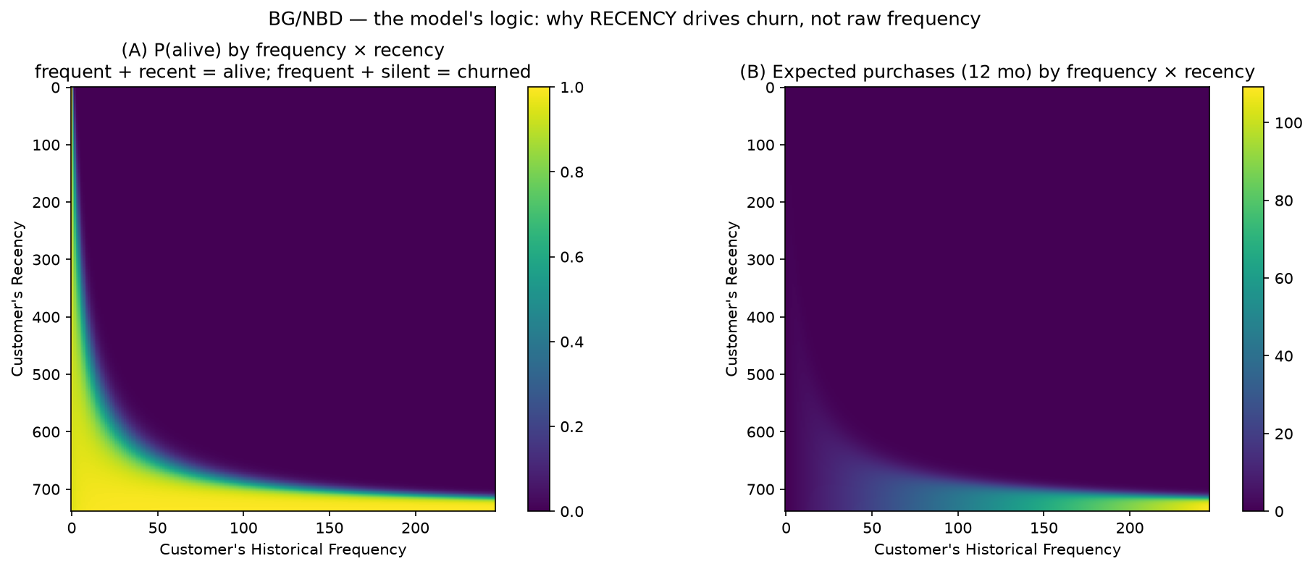
The model’s “brain”: P(alive) over (frequency, recency). A frequent buyer who has gone silent is judged likely-churned; a rare buyer who is quiet is fine. Recency, relative to a customer’s own pace, drives the churn signal.

Part B — How much per purchase? (Gamma-Gamma, with shrinkage)
We estimate each customer’s average order value — but without over-trusting thin evidence. One £900 order doesn’t make someone a “£900 customer.” So the estimate is shrunk toward the population mean, weighted by how much data we have:
$${\hat{s}}_{i} ≈ \frac{n_{i} {\overset{‾}{m}}_{i} + k {\overset{‾}{m}}_{\text{pop}}}{n_{i}+k}, n_{i}=\text{number of purchases}.$$
Many purchases → trust their own average; few → lean on the crowd. You can see the shrinkage — low-evidence customers are pulled toward the population mean line:
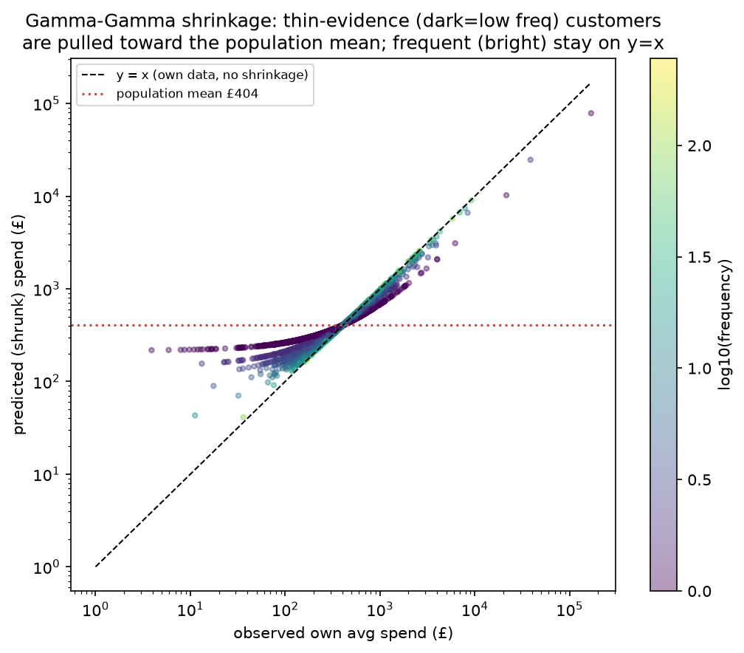
Gamma-Gamma shrinkage: thin-evidence (low-frequency, dark) customers are pulled toward the population mean; frequent (bright) customers keep their own average.
Multiplying the two halves gives each customer’s predicted CLV:
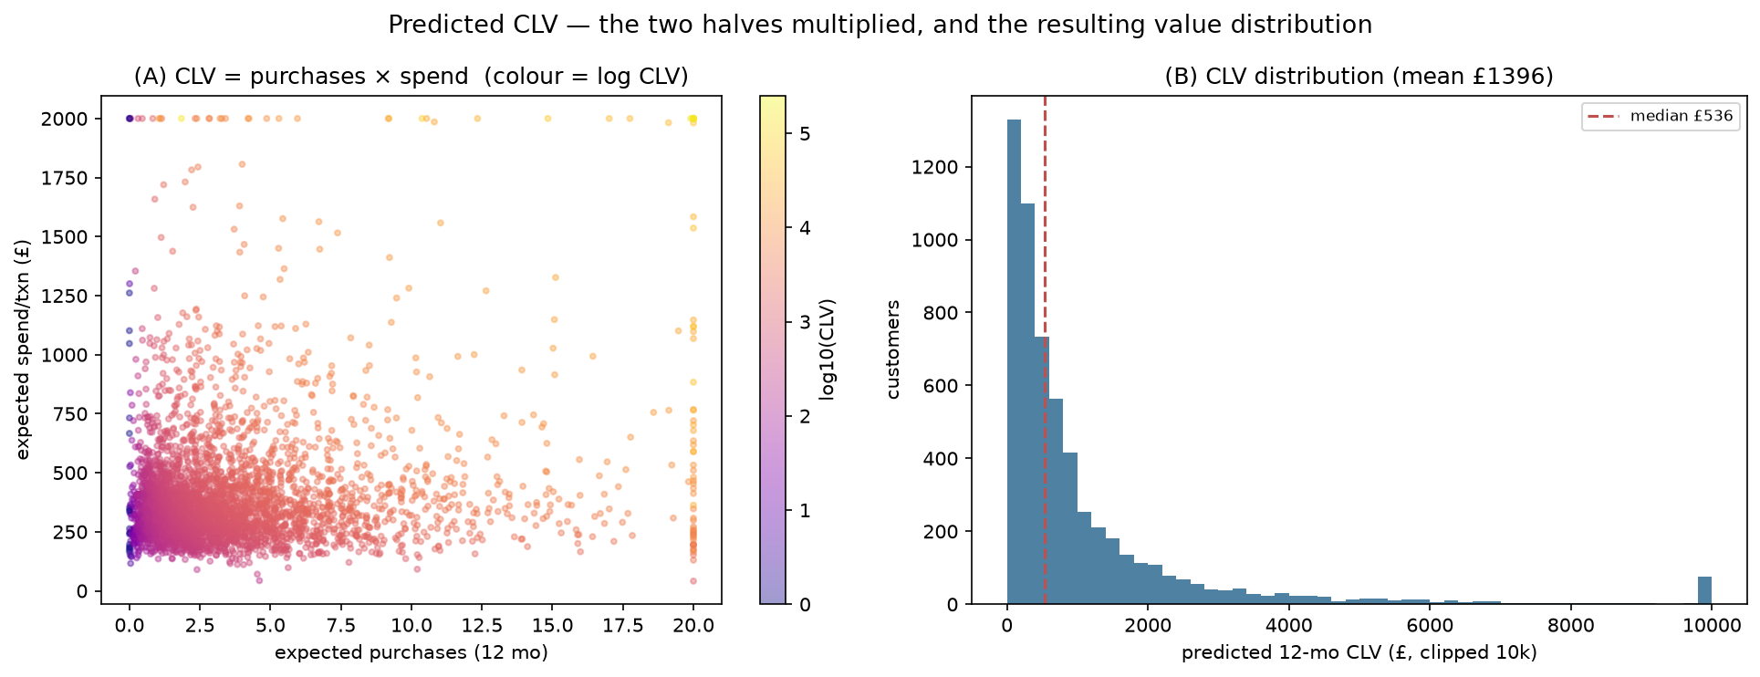
CLV = expected purchases × expected spend. The distribution is heavily skewed — most customers are modest, a few are very valuable.

Does it actually predict the future?
To trust a forecast, hide the future and check the guess. We split the timeline — fit on the past, predict the next 3/6/9 months, compare to what actually happened. The model’s ranking is excellent (predicted tracks actual across customer groups), but there is a vertical bias on short windows:
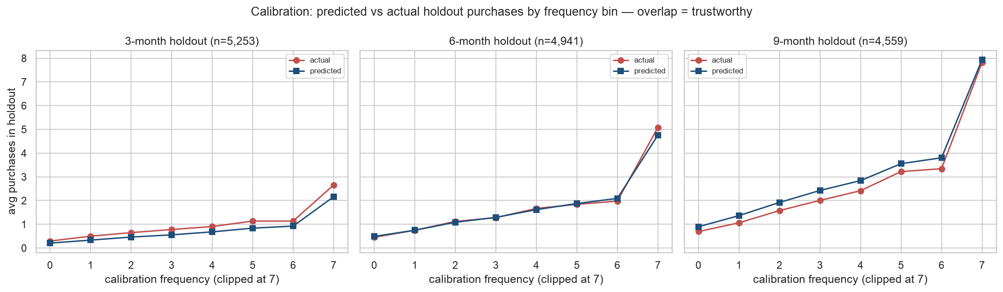
Calibration backtests at 3/6/9 months: the shape tracks well (good ranking), but a uniform vertical shift appears — the fingerprint of seasonality.
The honest finding: that bias is seasonality. BG/NBD assumes a constant buying rate, but this is gift-ware with a Christmas peak; a 3-month window ending in December is under-predicted. Over a full 12-month cycle it averages out — so the deliverable horizon is fit for purpose, and we named the limitation rather than hiding it.

Confidence: two kinds of uncertainty
We fit the final model with MCMC (which explores the whole range of plausible settings, not just the single best guess), giving every prediction a credible interval. A subtle but important distinction we were careful to separate:
- Estimation uncertainty — how sure we are of a customer’s expected value. With ~5,900 customers this is tight (±~2%), so our ranking is confident.
- Predictive uncertainty — how much an individual will actually spend. This is wide (±50–150%) and correctly shrinks as we gather more data on a customer.
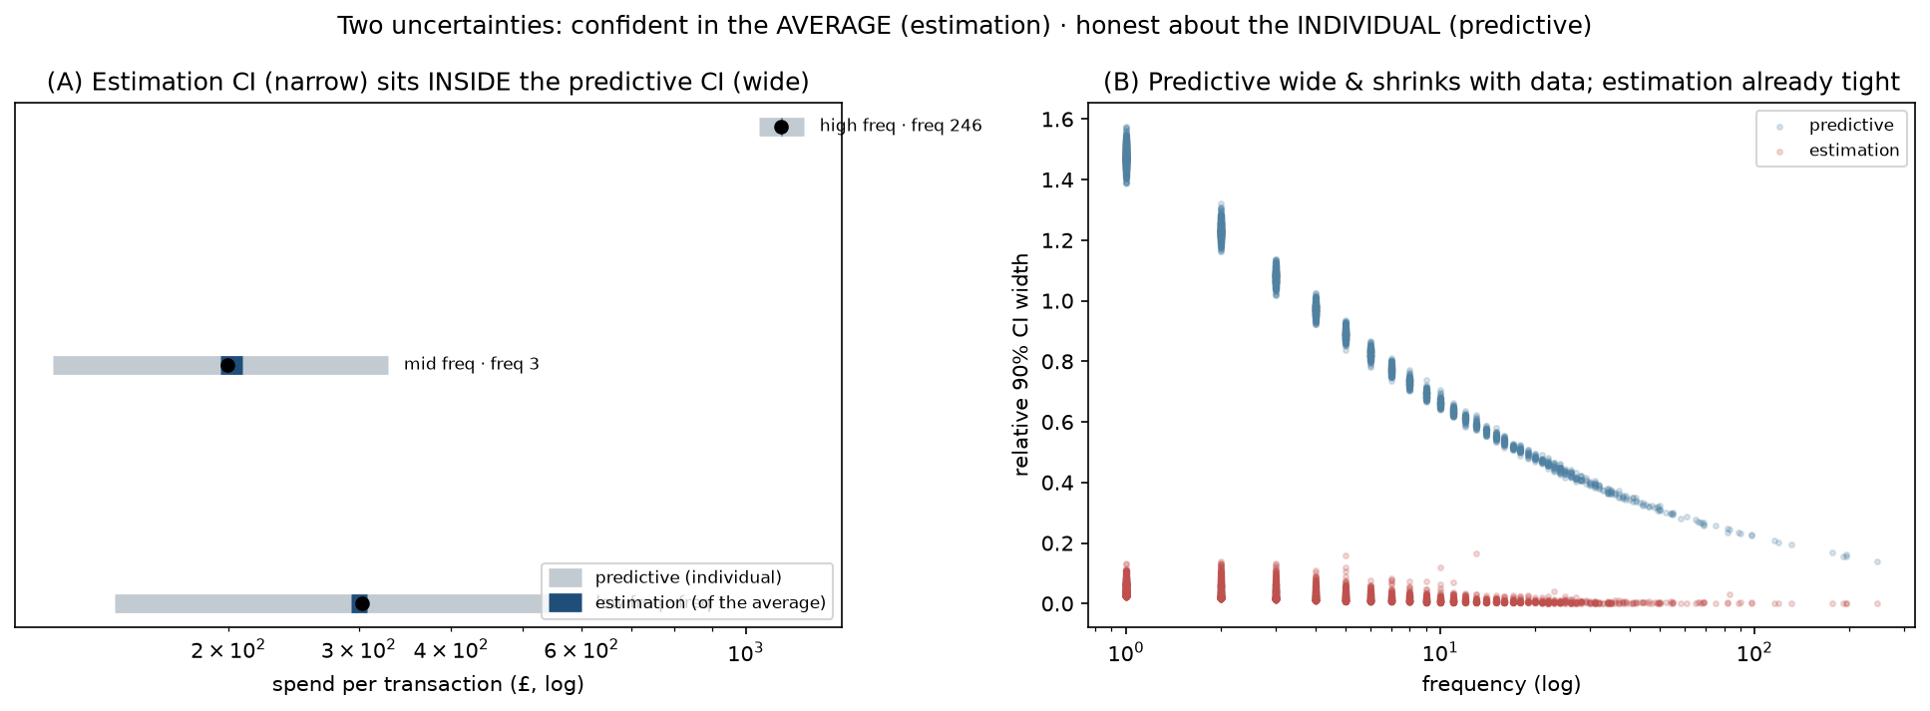
Two uncertainties: the credible interval on the expected value is tight (good ranking), while the spread of an individual’s actual outcome is wide and shrinks with frequency. Conflating them is a classic error.
📍 Checkpoint. Every customer now carries a predicted 12-month CLV and a P(alive), each with uncertainty — validated as a trustworthy ranking, with the seasonality caveat stated.

Chapter 7 — Personas, Proof, and Actions
Now the two tracks meet. We join each customer’s segment to their CLV and turn labels into a business answer.

Naming the segments (from evidence, not a textbook)
A cluster labelled “0/1/2” means nothing until described. We profiled each group in raw units (medians) and named it from its actual signature. Four clear personas emerged:
Persona | Signature | Revenue now | Future value
Champions | recent · frequent · high-spend · long-tenured | 80.7% | 71.7%
Rising | recent · newest · growing | 7.9% | 16.4%
At-Risk | established but lapsed ~1 year · P(alive) fallen | 8.1% | 5.7%
One-Timers | single purchase · low value | 3.2% | 6.2%
The “snake plot” shows each segment’s distinct shape, and the bars show the strategic signal — value now versus value in the future:
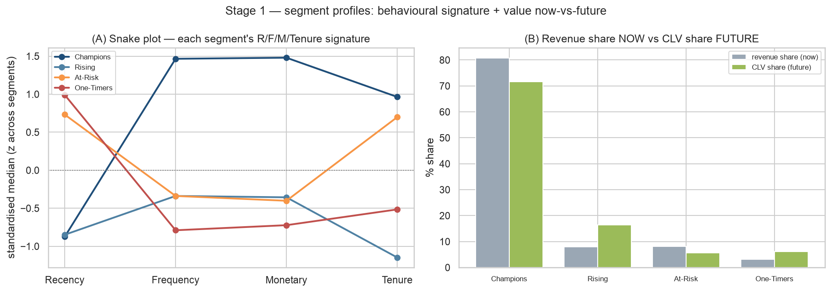
Left: each segment’s R/F/M/Tenure signature (a snake plot). Right: revenue share now vs CLV share future — Champions dominate, but Rising’s future share is double its current share.

Proving the segments are real (not just lines we drew)
Testing whether segments differ on the features we clustered on is circular. The real proof comes from variables the clustering never saw. We used effect sizes (not p-values — at ~5,900 customers everything is “statistically significant,” so size is what matters):
$$η_{H}^{2} = \frac{H−k+1}{N−k} ∈[0,1].$$
The gold-standard result: the segments differ strongly on predicted CLV ($η^{2}≈0.62$) — a variable built by an entirely separate model. Two independent methods agreeing on “who’s valuable” is powerful evidence the groups are real. We also reported the honest null: geography barely differs (the shop is 84% UK).
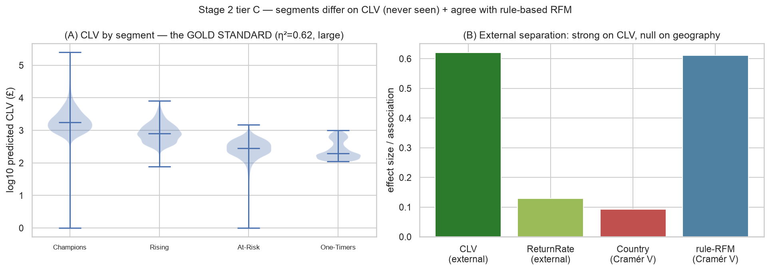
External validation (the gold standard): predicted CLV — never seen by the clustering — is cleanly ordered across segments, and effect sizes are strong on value but null on geography.

The action grid (spend where the money is)
One segment, one clear action. And crucially — budget follows value at stake, not headcount. The segments are roughly equal in size (21–28% each), but Champions hold ~80% of the value; spending equally would be a serious mistake.
Persona | Action | Why
Champions | Protect | retain, VIP, don’t discount — they’d buy anyway
Rising | Grow | nurture the newest high-potential into Champions
At-Risk | Win-back | reactivate the high-CLV lapsers first
One-Timers | Convert | cheap second-purchase nudge, don’t overspend
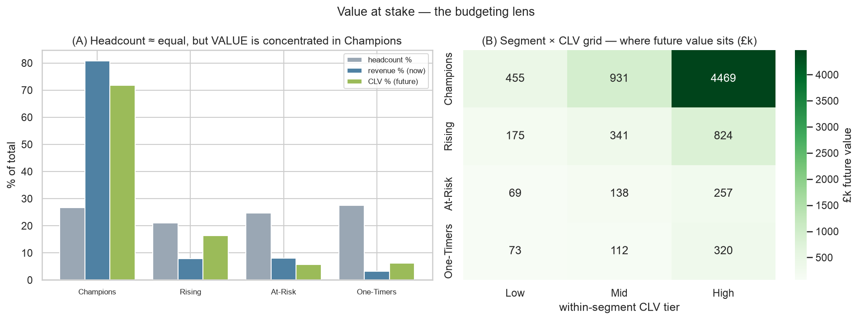
Value at stake: segments are near-equal in headcount but value is concentrated in Champions; the segment × CLV grid shows where the future money sits.
Within each segment, a customer’s CLV tier sets the intensity — a high-value At-Risk customer is the single best place to spend a retention pound; a low-value one is not worth chasing.
📍 Checkpoint — the finish line. A per-customer table mapping every customer → persona + predicted CLV + recommended action, with the segments proven to differ on independently-modelled value.

Chapter 8 — What This Story Was Really About
If you remember one thing, make it this: the value was never the clusters — it was the judgement.
- We validated, we didn’t just produce. Anyone can call KMeans(). We proved the result reproduces (stability) and is real (an external variable).
- We compared methods. Agreement across differently-biased methods is evidence; their disagreement told us the data is a continuum.
- We admitted the continuum. There were no crisp natural groups — and choosing a useful discretisation anyway, openly, is the mature move.
- We surfaced every limitation: the one-timer degeneracy, the CLV seasonality, the estimation-vs-predictive uncertainty, the geography null — all named, none buried.
- We chose honesty over flash. “Three robust segments plus one-timers that differ on CLV — here is each profile, action, and value at stake” is the successful result.
The one-sentence summary: We cleaned a million messy transactions, described customers by their behaviour, predicted each one’s future value with honest uncertainty, proved the groups were real by an independent measure, and turned it all into who-to-spend-on — admitting at every step that the data is a continuum, not neat boxes.

Companion materials: the TEACHING_HANDBOOK (instructor’s guide), the two mathematics references in planning/docs/, and the full code in src/ and notebooks/. Project repository: github.com/SajalHRX/customer-segmentation. Author: Sajal Singhal — MSc Statistics portfolio project.

