Traffic Simulation

Simulate the Flow of Vehicular Traffic Using Priority Queue



SPRING 2020  
COURSE

Program Structure and Algorithms (INFO 6205)

INSTRUCTOR

Dr. Robin Hillyard

PRESENTERS

Rituja Mahajan

(NUID 000000000)

Sajal Sood

(NUID 001054338)  
  
Naresh Agarwal  
(NUID 000000000)

Table of Contents

Chapter 1: Overview 3

Chapter 2: Objective 4

Chapter 3: Introduction 5

Chapter 4: Implementation 6

Chapter 5: Simulation 8

Chapter 6: References 9

# Chapter 1: Overview

Traffic and congestion phenomena belong to our everyday experience. Many factors can contribute to traffic congestion such as:

* Accidents and breakdowns
* Road construction and repair
* Harsh weather conditions

One can't always predict where these disturbances will occur, but they still heavily impact traffic flow.

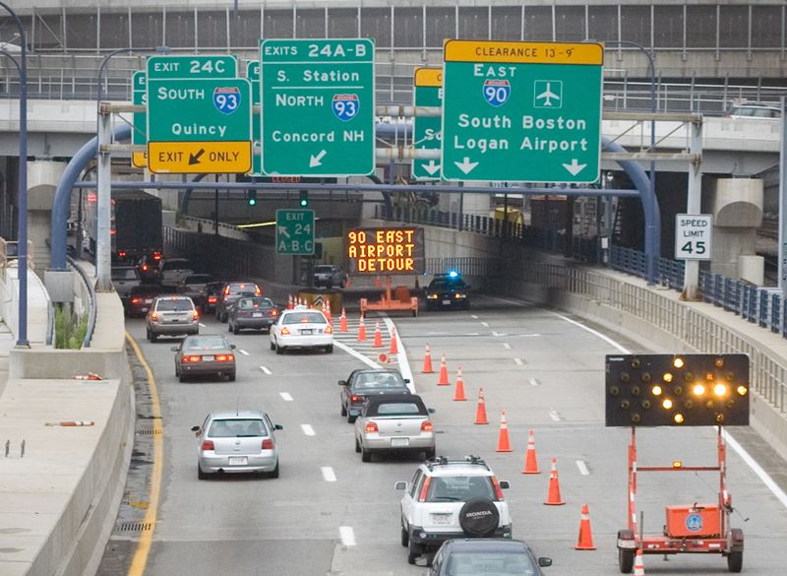

**Figure 1.1** Traffic Merge at I-90

# Chapter 2: Objective

To simulate a Traffic Model by considering how vehicles avoid each other.

* Dynamic management of vehicle traffic using priority queue.
* Generating steady Flow of vehicles around bottlenecks.

# Chapter 3: Introduction

Traffic simulation is the mathematical modeling of transportation-system, which is designed to predict the behavior and/or outcome of a real-world or physical system.

The below **Figure 3.1** shows the process of building a computer model, and the interplay between experiment, simulation, and theory.

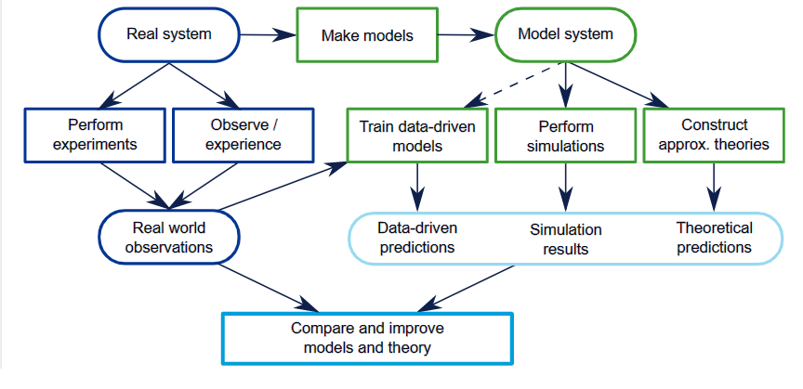

**Figure 3.1** Computer Model Process

**Traffic Model** is a mathematical model of real-world traffic, usually, but not restricted to, road traffic. Traffic modeling draws heavily on theoretical foundations like network theory and certain theories from physics like the kinematic wave model. The interesting quantity being modeled and measured is the traffic flow, i.e. the throughput of mobile units (e.g. vehicles) per time and transportation medium capacity (e.g. road or lane width).

Models can teach researchers and engineers how to ensure an optimal flow with a minimum number of traffic congestion.

Types of Traffic Model:

1. Microscopic
2. Macroscopic

# Chapter 4: Implementation

**Microscopic Traffic flow Model** is used, where traffic flow is assumed to depend on individual mobile units, i.e. cars or vehicle, which are explicitly determined as shown in **Figure 3.2** below:

**Figure 3.2** Car or Vehicle Class

The Traffic modeled in the simulation is based on the **Intelligent Driver Model (IDM).**

* The models introduced in this project are derived from assumptions about real driving behavior such as keeping a “safe distance” from the leading vehicle, driving at a desired speed, or preferring accelerations to be within a comfortable range.
* The acceleration is a strictly decreasing function of the speed. Moreover, the vehicle accelerates towards a desired *speed v0* if not constrained by other vehicles or obstacles.
* The acceleration is an increasing function of the *distance s* to the leading vehicle.

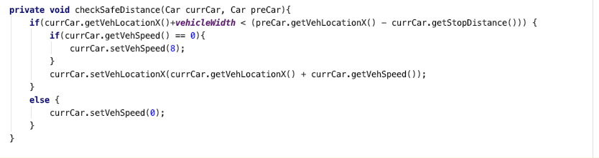

* If other Vehicles or obstacles are outside the interaction range of the vehicle then they do not influence the behavior of the vehicle.
* A minimum gap (bumper-to-bumper distance) s0 to the leading vehicle is maintained (also during a standstill). However, there is no backwards movement if the gap has become smaller than s0 by past events. The vehicle stops for the leading vehicle to be at a distance for the gap to be greater.
* Lane changes take place if there is no vehicle in another lane and the change can be performed safely (‘safety criterion’).
* The safety criterion is satisfied if the new follower of the target lane after a possible change does not exceed a certain limit, this means, the safety criterion fulfills.

# Chapter 5: Simulation

The simulation provides scenarios with Stationary Bottlenecks. Work zones (lane closing) at two lanes.

* With the initial settings of the simulation, traffic breaks down near the bottleneck region which, then, triggers upstream traffic.
* This scenario is taken care of by maintaining a priority queue.
* When the bottleneck is in the range of the vehicle’s safe distance, the vehicle halts.
* All the possible collisions in the current lane are added to the priority queue.
* The collision, which is expected to happen right after the current vehicle is stranded, has the highest priority.

# Chapter 6: References

Below are some References:

1. **Traffic Flow Dynamics**
2. **2. Understanding of the Simulation Model** -

<https://en.wikipedia.org/wiki/Traffic_model>