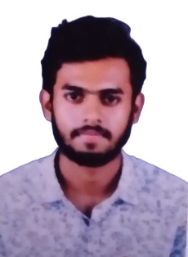

**Sajal Pt**

**Mobile: +**91-8129761214

**E-mail: ptsajal@gmail.com**

**Objective**

As a BCA student, I like to secure a challenging position where i can effectively contribute my skills as a software professional for growth of organization and myself. I desire to work in a company that uses my knowledge, talent, hard work, dedication and sincerity in a well manner.

**Education and Qualifications**

|  |  |  |  |  |  |
| --- | --- | --- | --- | --- | --- |
| **Course** | **Stream / Specialization** | **Institution** | **Board** | **Year of Completion** | **Marks in% or CGPA** |
| **BCA** | Computer applications | Yeldo mar baselious college ,kothamangalam | Mahatma Gandhi university | 2024 |  |
| **PLUS TWO** | Computer Science | St josephs BHSS, kozhikode | Kerala Board of Higher Secondary  Education | 2018 | 67 |
| **SSLC** | Kerala State(SCERT) | St josephs BHSS, kozhikode | Kerala State Educational Board | 2016 | 86 |

**Certifications and acheivements**

* Cloud computing course | present | (Red hat)
* Tcs NQT qualified (ID: 22071445919)
* Team leader (Mini project)

**Academic Project**

* **Online music store** : Enables users to study and purchase instruments and class related to music through online platform
* **Online library management** : To give an opportunity to access books through an online platform

**Technical Skills**

* Basic of coding
* Html5
* Css , javascripts
* Database (Mysql)
* Python
* Java
* Vs code

**Soft skills**

* Problem solving
* Communication skills
* Project management
* Adaptibility
* Team collabration

**Personal Information**

Father Name :Nishanth pt

Nationality : Indian

Language Known : English, Malayalam

Date of Birth : 14/12/2000

Gender : Male

Permenent Address : Souparnika(H), mencheriparamb,kommeri(PO)

Methottuthazham ,Calicut

**Declaration:**

I confirm that the information provided by me is true to the best of my knowledge and belief. Necessary documents will be produced as per the requirement.

SAJAL PT