|  |  |  |  |  |
| --- | --- | --- | --- | --- |
| **Working Title of the Project:** | | **COLOUR DETECTION** | | |
| **Project Site / Location** | | SRM University, Kattankulathur, Chengalpattu District-603203 | | |
| **Name and address of the company / organisation**  **(Applicable for projects with industry or industry support)** | | SRM University, Kattankulathur, Chengalpattu District-603203 | | |
| **Supervision Team** | | | | |
|  | **Supervisor** | | **Co-Supervisor** | **External Supervisor**  **(If applicable)** |
| **Name** | Dr.R Rajkamal | |  |  |
| **Designation** | Associate Professor | |  |  |
| **Department** | C.Tech | |  |  |
| **Campus** | Kattankulathur | |  |  |
| **Telephone** | 9176689008 | |  |  |
| **E-mail** | rajkamar@srmist.edu.in | |  |  |

|  |  |  |  |  |
| --- | --- | --- | --- | --- |
| **Name of student** | **Register Number** | **Department** | **Mobile Number** | **Email ID** |
| Ambuj Porwal | RA1911003010236 | CSE | 8433112578 | ap1684@srmist.edu.in |
| Sajal Tyagi | RA1911003010238 | CSE | 7017151358 | st8287@srmist.edu.in |

|  |  |  |  |
| --- | --- | --- | --- |
| **Degree/ program** | B.Tech | **Specialisation** | Computer Science & Engineering  **Project Batch ID**  **B269** |
| **Academic Year** | 2022-2023 (Odd) | **Semester** | 7 |
| **Course Code** | **18CSP107L/ 18CSP108L** | **Course Title** | Minor Project/Internship |
| Mission Statement | | | |
|  | | | |
| **Problem (or) Product Description:** | | | |
| This project need a picture for colour detection if that picture is not clear(bluish,greenish) then first it will remove and then it will detect colour and other mode is live mode it needs working camera for colour detection of any object infront of that camera. | | | |
|  | | | |
| **Assumptions and Constraints :** | | | |
| We assume that this project can really help colour blind and the data set we are using can be updated in future. So,if it build further that it can come out as an application. | | | |
|  | | | |
| **Stakeholders :** | | | |
| **Ambuj Porwal(Developer),Sajal Tyagi(Developer),Dr.R Rajkamal(Guide),Users** | | | |

**Division of work and contributors**

|  |  |  |  |  |
| --- | --- | --- | --- | --- |
| **Time period** | | **Activities or components of the project** | **Name/Register Number of the Individual Contributor** | **Names/Register Number of the Joint Contributors** |
| **From Date** | **To Date** |
| 1-08-22 | 6-08-22 | Research for project and deciding the topic | Ambuj porwal(Ra1911003010238) | Sajal tyagi(ra1911003010238) |
| 6-08-22 | 9-08-22 | Discussion about project and Preapare ppt for zeroth review. | Ambuj porwal(Ra1911003010238) | Sajal tyagi(ra1911003010238) |
| 9-08-22 | 9-08-22 | Zeroth review in college | Ambuj porwal(Ra1911003010238) | Sajal tyagi(ra1911003010238) |
| 10-08-22 | 25-08-22 | Searching base paper and other reference research papers for project | Ambuj porwal(Ra1911003010238) | Sajal tyagi(ra1911003010238) |
| 26-08-22 | 15-09-22 | Prepare model of the project and worked on it.  . | Ambuj porwal(Ra1911003010238) | Sajal tyagi(ra1911003010238) |
| 16-09-22 | 24-09-22 | Code for colour detection using python | Ambuj porwal(Ra1911003010238) | Sajal tyagi(ra1911003010238) |
| 24-09-22 | 25-09-22 | Prepare ppt and report for first review . | Ambuj porwal(Ra1911003010238) | Sajal tyagi(ra1911003010238) |
| 26-09-22 | 26-09-22 | First Review | Ambuj porwal(Ra1911003010238) | Sajal tyagi(ra1911003010238) |
| 27-09-22 | 11-10-22 | More research about new things which can be done in project.  Code for other part of project. | Ambuj porwal(Ra1911003010238) | Sajal tyagi(ra1911003010238) |

**Division of work and contributors**

|  |  |  |  |  |
| --- | --- | --- | --- | --- |
| **Time period** | | **Activities or components of the project** | **Name/Register Number of the Individual Contributor** | **Names/Register Number of the Joint Contributors** |
| **From Date** | **To Date** |
| 12-10-22 | 14-10-22 | Prepare mid report and ppt for second review and complete some remaining points of topic | Ambuj porwal(Ra1911003010238) | Sajal tyagi(ra1911003010238) |
| 15-10-22 | 27-10-22 | Complete and code all remaining things of project . | Ambuj porwal(Ra1911003010238) | Sajal tyagi(ra1911003010238) |
| 27-09-22 | 3-11-22 | Prepare final report and ppt for the project and make it ready for the final review. | Ambuj porwal(Ra1911003010238) | Sajal tyagi(ra1911003010238) |
| 04-09-22 | 05-11-22 | Final Review | Ambuj porwal(Ra1911003010238) | Sajal tyagi(ra1911003010238) |
|  |  |  |  |  |
|  |  |  |  |  |
|  |  |  |  |  |

**Summary record of major progress meetings with supervisors**

|  |  |  |  |  |
| --- | --- | --- | --- | --- |
| **Summary record of major progress meetings with supervisors** | |  | **Working title of dissertation/research project:** | |
| **Meeting date & supervisors present** | **Progress since last meeting** | **Agreed programme of work and target dates** | **Other issues, e.g. facilities, supervision, training needs, etc.** | **Date of next meeting** |
| 17 Aug 2022  Dr.R Rajkamal | - | Discussed on the colour detection . | Literature Survey. | 18 Sep 2022 |
| 18 Aug 2022  Dr.R Rajkamal | Started Working on ML algorithms which has to apply on our 1st module and adding data set. | Identify that colour detection is a important problem and first module 80% done. |  | 20 Sep 2022 |
| 20 Sep 2022  Dr.R Rajkamal | Almost completed and preparing for first review and started for second module. | Discussion about 1st review and Further discussion on next module. |  | 30 Sep 2022 |

**Summary record of major progress meetings with supervisors**

|  |  |  |  |  |
| --- | --- | --- | --- | --- |
| **Summary record of major progress meetings with supervisors** | |  | **Working title of dissertation/research project:** | |
| **Meeting date & supervisors present** | **Progress since last meeting** | **Agreed programme of work and target dates** | **Other issues, e.g. facilities, supervision, training needs, etc.** | **Date of next meeting** |
| 30 Sep 2022  Dr.R Rajkamal | This time we completed 50% of second module in which some calculations were left. | Further discussion about next module for our project. |  | 13 Oct 2022 |
| 13 Oct 2022  Dr.R Rajkamal | Implementation of image processing to enhance the given image and then colour detection will work. | Discussion for new module which is to be done on MATLAB , in that image will be enhance. |  | 5 Nov 2022 |
| 5 Nov 2022  Dr.R Rajkamal | 100% modules completion. |  |  | - |

**Worksheet / Data collection / Observation etc**

**Worksheet:** ¬ Import the modules necessary in solving the problem.

¬ Take the image path of which you want to find the colors in.

¬ Read the csv file in the hex code of colors is stored.

¬ Now calculate the minimum distance from all the color and get the most matching color using the get_color_name

¬ Make a function to get the x, y coordinates of the click point of mouse.

¬ Display image on the window with a pointer to select any point on image.

¬ Display the color name of the point along with the R, G, B values

**Data Collection:**

Dataset of colors:

Colors are made up of 3 primary colors; red, green, and blue. In computers, we define each color value within a range of 0 to 255. So in how many ways we can define a color? The answer is 256*256*256 = 16,581,375.

There are approximately 16.5 million different ways to represent a color. In our dataset, we need to map each color’s values with their corresponding names. But don’t worry, we don’t need to map all the values.

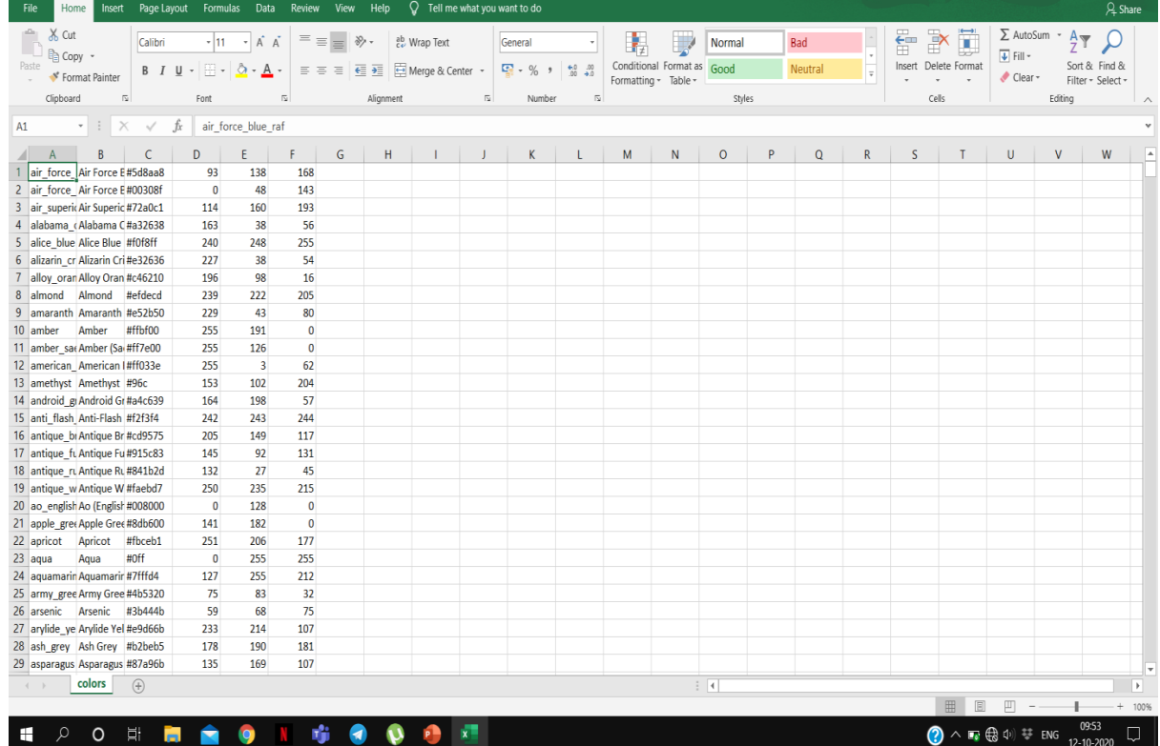

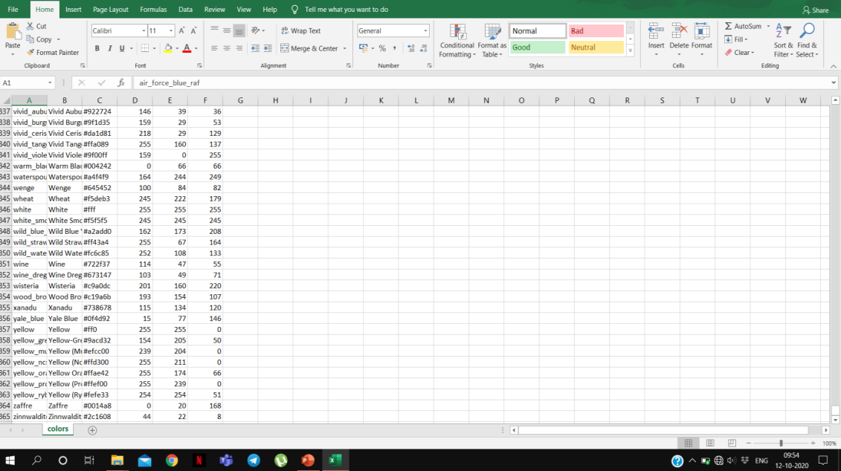

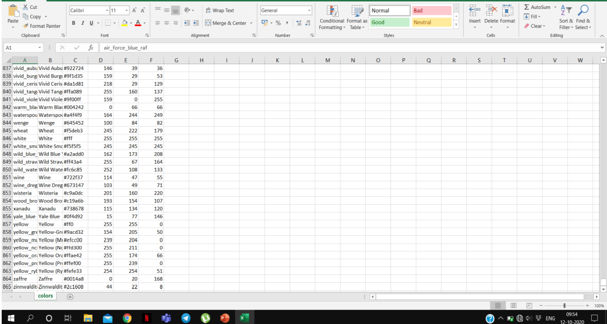

The above dataset contains 865 colors along with their R, G, B values we will be using this dataset only to get the colors for the mouse clicks.

**Journal Publication Details**