**NITTE MEENAKSHI INSTITUTE OF TECHNOLOGY**

(AN AUTONOMOUS INSTITUTION, AFFILIATED TO VISVESVARAYA TECHNOLOGICAL UNIVERSITY, BELGAUM, APPROVED BY AICTE & GOVT.OF KARNATAKA



**UEFA NEWS**

*Submitted in partial fulfillment of the requirement for the Java subject in IV sem*

*Bachelor of Engineering*

*in*

*Computer Science and Engineering*

*Submitted by:*

|  |  |
| --- | --- |
| SHIRSH AGRAWAL | 1NT18CS217 |
| SAJAN POUDEL | 1NT18CS202 |
| HARI OM NARAYAN | 1NT18CS050 |

Under the Guidance of

DR. MOHAN BA

PROFESSOR, Dept. of CS&E, NMIT



Department of Computer Science and Engineering

2019-20

**NITTE MEENAKSHI INSTITUTE OF TECHNOLOGY**

(AN AUTONOMOUS INSTITUTION, AFFILIATED TO VISVESVARAYA TECHNOLOGICAL UNIVERSITY, BELGAUM

, APPROVED BY AICTE & GOVT.OF KARNATAKA)

Department of Computer Science and Engineering

**(Accredited by NBA Tier-1)**



**CERTIFICATE**

This is to certify that the report on **UEFA News** is an authentic work carried out by SHIRSH AGRAWAL **(1NT18CS217)**, SAJAN POUDEL **(1NT18CS202)** andHARI OM NARAYAN **(1NT18CS050)** bonafide students of **Nitte Meenakshi Institute of Technology**, Bangalore in the partial fulfillment for the Course “Introduction to Java” in IV Sem of the degree of ***Bachelor of Engineering*** in COMPUTER SCIENCE AND ENGINEERING of Visvesvaraya Technological University, Belagavi during the academic year ***2019-20.*** It is certified that all corrections and suggestions indicated during the internal assessment has been incorporated in the report.

|  |  |  |  |  |  |
| --- | --- | --- | --- | --- | --- |
| **Internal Guide** | |  | | **Signature of the HOD** | |
|  | |  | |  | |
| Dr. Mohan B.A  professor, Dept. CSE,  NMIT Bangalore | |  | | Dr. Thippeswamy M. N.  Professor, Head, Dept. CSE, NMIT Bangalore | |
| **Signature of Examiners** | | | |
|  | |  | |
|  | |  | |

**ACKNOWLEDGEMENT**

The satisfaction and euphoria that accompany the successful completion of any task would be incomplete without the mention of the people who made it possible, whose constant guidance and encouragement crowned our effort with success. I express my sincere gratitude to our Principal **Dr. H. C. Nagaraj**, Nitte Meenakshi Institute of Technology for providing facilities.

We wish to thank our HoD**, Dr. Thippeswamy M. N.** for the excellent environment created to further educational growth in our college. We also thank him for the invaluable guidance provided which has helped in the creation of a better project.

I hereby like to thank our **Dr. Mohan BA,** professor, Department of Computer Science & Engineering on his periodic inspection, time to time evaluation of the project and help to bring the project to the present form.

We take this opportunity to thank our Departmental Project coordinators. We also thank all our friends, teaching and non-teaching staff at NMIT, Bangalore, for all the direct and indirect help provided in the completion of the project.

|  |  |  |
| --- | --- | --- |
| **NAME** | **USN** | **Signature** |
| SHIRSH AGRAWAL | 1NT18CS217 |  |
| SAJAN POUDEL | 1NT18CS202 |  |
| HARI OM NARAYAN | 1NT18CS050 |  |

Date: 13/04/2020

**ABSTRACT**

For a football fan in India it is difficult to keep up with the European football competitions. With such a tight fixture schedule and so many matches happening together and mostly after midnight it is almost impossible to know everything that’s going on and that’s where our “ football news application” comes into play. Our application will have the following features:

• It will consist of an admin panel where by entering your login credentials you will be able to update the latest matchday info.

• It will also consist of a Europa league category where you will be displayed all the matches as per the matchdays and their respective scorelines along with the goal scorers.

• And finally it consists of a Champions league category where you will be displayed all the matches as per the matchdays and their respective scorelines along with the goal scorers.

These are some of the main features of our application “UEFA News”.

This application will be a huge help to all the football fans in India as they will be able to keep track of all the football matches going on and track their favourite teams performances as well as other teams.

**DECLARATION**

**ACKNOWLEDGEMENT**

**ABSTRACT**

**TABLE OF CONTENTS**

**CHAPTER 1: INTRODUCTION**

* 1. Overview
  2. Brief history of concept/league structure
  3. Brief info on the language used I.e the project domain I.e JAVA
  4. Applications
  5. Research motivation and Problem statement
     1. Statement of the Problem
     2. Research Motivation
  6. Research objectives
  7. Summary

**CHAPTER 2: LITERATURE SURVEY**

* 1. Introduction
  2. Related work
  3. Study of Tools/Technology
  4. Summary

**CHAPTER 3: SYSTEM REQUIREMENTS SPECIFICATIONS**

3.1 General Description

3.1.1 Product Perspective

3.2 System Requirements

3.2.1 Hardware Requirements

3.2.2 Software Requirements

3.3 Summary

**CHAPTER 4: DESIGN**

4.1 Architectural Design

4.2 Class Hierarchy Diagram

4.3 Activity Diagram

**CHAPTER 5: CONCLUSIONS**

**CHAPTER 6: REFERENCES**

# 1.INTRODUCTION

# 1.1)OVERVIEW

Football is one of the most popular and entertaining sports in the world. It is estimated that football has 3.5 Billion fans in the world, and most popular in Europe, Africa, Asia and South America . This project focuses on trying to eliminate the frustration of various fans on not being able to know the scoreline of various matches by combining all the information on one platform as well as admins able to update the information on the system by just entering their login credentials. All the information is available in a proper format which is very easy to access thus the project is a huge sigh of relief to various football fans out there.

**1.2)LEAGUE STRUCTURE**

Before we jump into the project itself, I would like to first explain how the different leagues are structured English Premier League, German First and Second Bundesliga, French League One and Two, Spanish Primera and Segunda Division, Italian Serie A, Portuguese Primeira Liga and Dutch Eredivisie.

All the teams in the league are playing against each other twice during a season which is (N-1)*2 games for each team where N is the number of teams in the league. The first division teams of each nation are fighting for first place (champion), Champions League and Europa League spots

and avoiding relegation. The second division teams are fighting for the first place (champion), promotion and again avoiding relegation.

Europa league and Champions league are both UEFA competitions. Here the top clubs from Europe fight against each other in a knockout tournament beginning with the group stages and in the end one winner emerges.

The knockout matchups are decided via draws staged at various locations at various different intervals of the tournament. Each match between the two teams is played over two legs one home and one away for each team and the winner is decided on terms of aggregate score. In terms of a draw in the knockout stages the winner will be the team scoring maximum away goals. If still the winner is not found penaly shootouts take place. The days on which the matches take place are known as matchdays eg matchday1, matchday2 etc.

Below are the groups of the ongoing Champions league and Europa league.

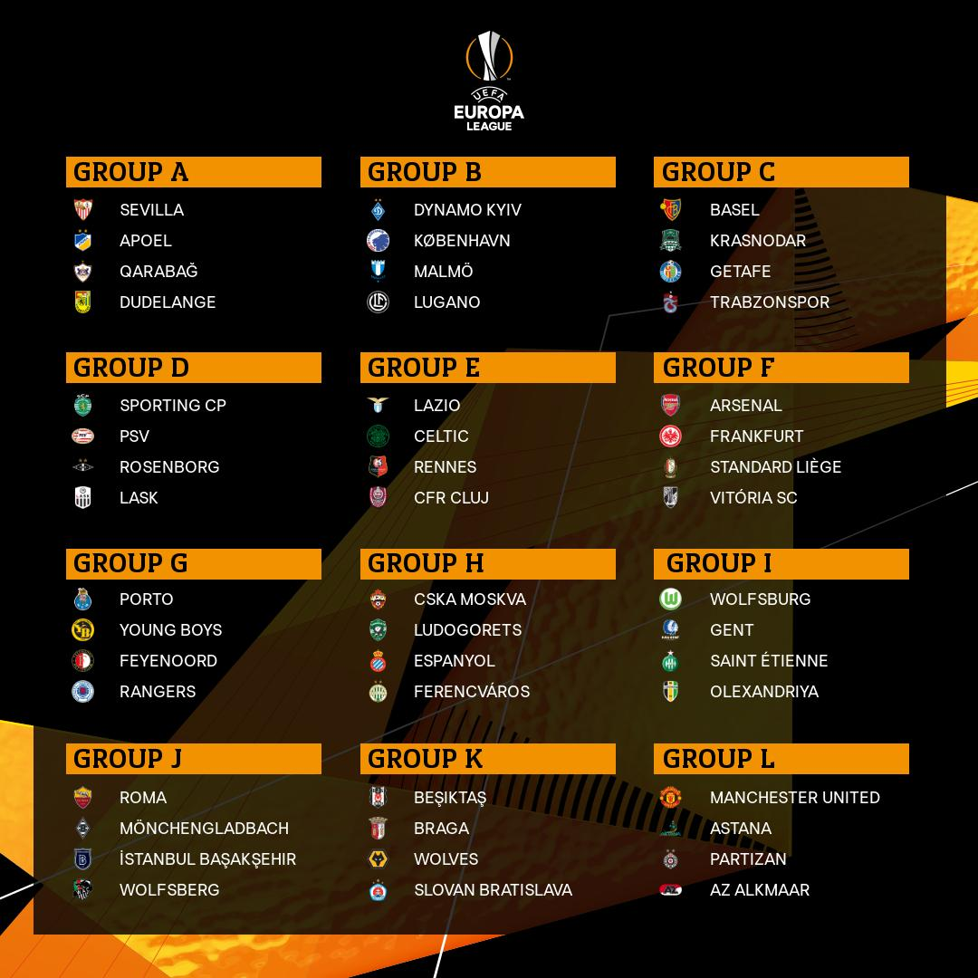

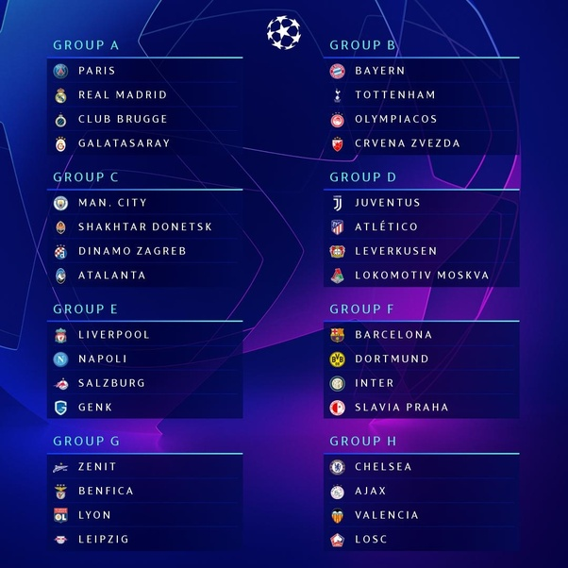

**1.3)JAVA**

**Java** is a general-purpose, concurrent, class-based, object-oriented computer programming language that is specifically designed to have as few implementation dependencies as possible. It is intended to let application developers "write once, run anywhere" (WORA), meaning that code that runs on one platform does not need to be recompiled to run on another. Java applications are typically compiled to byte code (class file) that can run on any Java virtual machine (JVM)

regardless of computer architecture. Java is, as of 2012, one of the most popular programming languages in use, particularly for client-server web applications, with a reported 10 million users .

Java was originally developed by James Gosling at Sun Microsystems (which has since merged into Oracle Corporation) and released in 1995 as a core component of Sun Microsystems' Java platform. The language derives much of its syntax from C and C++, but it has fewer low level facilities than either of them.

Java [3] can be used to write applications and applets. A Java application is similar to any other high-level language program: It can only be compiled and then run on the same machine. An applet is compiled on one machine, stored on a server in binary, and can be sent to another machine over the Internet to be interpreted by a Java-aware browser. Java comes with a large

library of ready-made classes and objects.

The key difference between Java 1.0 and 1.1 was in

this library. Similarly, Java 2.0 has a very much larger library for handling user interfaces (Swing by name) but only small changes to the core of the language.

**1.4)APPLICATIONS**

There are many applications of the project :

1. Through this app every football fan in India can become aware of the happenings in European football.
2. Every football fan will have a sound knowledge of European competitions despite being in India.
3. The latest news I.e match information will be provided as soon as possible.
4. Offline availability .
5. Huge database containing past as well as present match information facilitates large amount of matchdays to choose from.

**1.5.1)PROBLEM STATEMENT**

It is hard to keep up with European football I.e UEFA Competitions for everyone as there are a lot of matches going on at a time and mostly after the midnight in I.S.T. This is a huge problem for the football fans who seek reliable information at the earliest.

Lots of matches happen and have happened so to keep track becomes difficult and to get information in a sorted and a proper manner also becomes increasingly difficult if

specially the matches have already been played that is information on past matches.

**1.5.2)RESEARCH MOTIVATION**

The motivation behind the research was that for a football fan in India it is difficult to keep up with the European football competitions. With such a tight fixture schedule and so many matches happening together and mostly after midnight it is almost impossible to know everything that’s going on and that’s where our “ football news application” ‘UEFA News’ comes into play.

 This application will be a huge help to all the football fans in India as they will be able to keep track of all the

Football matches going on and track their favourite teams

performances as well as other teams.

**1.6)OBJECTIVES**

* To help the user to know all the goal scorers.
* To enable the admins to update the news anytime.
* User will be able to know about all the biggest matches in Europe.
* To pre-plan their activities accordingly to watch the match after seeing the schedule on our application.
* To enable the user to keep track of his favourite team.
* To help the user access the present as well as past matches virtue a large database.
* To facilitate offline viewing as well.

**1.7)SUMMARY**

UEFA NEWS is a Java project for 4th semester where we use JavaFX and MySQL to create an application for various football fans to keep them informed and updated on the current proceedings of the worlds biggest club competitions the UEFA Champions League and UEFA Europa League. The huge database also allows offline access as well as huge collection of matches to choose your results from.

Our application will have the following features:

1. It will consist of an admin panel where by entering your login credentials you will be able to update the latest matchday info.
2. It will also consist of a europa league category where you will be displayed all the matches as per the matchdays and their respective scorelines along with the goal scorers.
3. And finally it consists of a champions league category where you will be displayed all the matches as per the matchdays and their respective scorelines.
4. **LITERATURE SURVEY**

**2.1)Introduction**

In this project we have used javafx with the combination of scene builder which gives a perfect platform for building an application, i.e UEFA News which gives the idea about the main two competitions held in the world of football which is Europa league and the Champions league. This is like getting an overview of the matches held in the tournament in a very short moment of time.

So to perform this task we have used the java langauge with javafx platform and to enhance it scene builder is used with the help of Intellij IDE .

**2.2)Study of Tools/Technology**

Here is a little description of each component used in the project.

**Javafx**

JavaFX is a software platform for creating and delivering desktop applications, as well as rich Internet applications (RIAs) that can run across a wide variety of devices. JavaFX is intended to replace Swing as the standard GUI library for Java SE, but both will be included for the foreseeable future. JavaFX has support for desktop computers and web browsers on Microsoft Windows, Linux, and macOS. Since the JDK 11 release in 2018, JavaFX is part of the open-source OpenJDK, under the OpenJFX project.Oracle 'Premier Support' for JavaFX is also available, for the current long-term version (Java JDK 8), through March 2022.

Before version 2.0 of JavaFX, developers used a statically typed, declarative language called JavaFX Script to build JavaFX applications. Because JavaFX Script was compiled to Java bytecode, programmers could also use Java code instead. JavaFX applications could run on any desktop that could run Java SE or on any mobile phone that could run Java ME.[citation needed]. JavaFX 2.0 and later is implemented as a "native" Java library, and applications using JavaFX are written in "native" Java code. JavaFX Script has been scrapped by Oracle, but development is being continued in the Visage project.[6] JavaFX 2.x does not support the Solaris operating system or mobile phones; however, Oracle plans to integrate JavaFX to Java SE Embedded 8, and Java FX for ARM processors is in developer preview phase.

**JavaFX Scene Builder**

JavaFX Scene Builder is a visual layout tool that lets users quickly design JavaFX application user interfaces, without coding. Users can drag and drop UI components to a work area, modify their properties, apply style sheets, and the FXML code for the layout that they are creating is automatically generated in the background. The result is an FXML file that can then be combined with a Java project by binding the UI to the application’s logic.

**1. UI Layout Tool**

Scene Builder allows you to easily layout JavaFX UI controls, charts, shapes, and containers, so that you can quickly prototype user interfaces. Animations and effects can be applied seamlessly for more sophisticated UIs.

**2. FXML Visual Editor**

Scene Builder generates FXML, an XML-based

markup language that enables users to define an application’s user interface, separately from the application logic. You can also open and edit existing FXML files authored by other users.

**3. Integrated Developer Workflow**

Scene Builder can be used in combination with any Java IDE, but is more tightly integrated with NetBeans IDE. You can bind the UI to the source code that will handle the events and actions taken on each element through a simple process, run your application in NetBeans, and any changes to FXML in NetBeans will also reflect in your Scene Builder project.

**4. Preview Your Work**

At any time during the creation of your project, you can preview what the user interface will really look like when deployed, unencumbered by the tool’s menus and palettes.

**5. Cross Platform, Self Contained**

Scene Builder is written as a JavaFX application, supported on Windows, Mac OS X and Linux. It is the perfect example of a full-fledge JavaFX desktop application. Scene Builder is packaged as a self contained application, which means it comes bundled with its own private copy of the JRE.

**6. CSS Support**

You can apply the look and feel of your choice to your GUI layout by using style sheets. It’s as easy as selecting a GUI component, and pointing to the CSS file of your choice from the Properties Panel. The CSS analyzer allows you to understand how specific CSS rules can affect aspects of a JavaFX component.

**MySQL**

MySQL is written in C and C++.

Its SQL parser is written in yacc, but it uses a home-brewed lexical analyzer. MySQL works on many system platforms, including AIX, BSDi, FreeBSD, HP-UX, eComStation, i5/OS, IRIX, Linux, macOS, Microsoft Windows, NetBSD, Novell NetWare, OpenBSD, OpenSolaris, OS/2 Warp, QNX, Oracle Solaris, Symbian, SunOS, SCO OpenServer, SCO UnixWare, Sanos and Tru64. A port of MySQL to OpenVMS also exists.

The MySQL server software itself and the client libraries use dual-licensing distribution. They are offered under GPL version 2, or a proprietary license.

Support can be obtained from the official manual.Free support additionally is available in different IRC channels and forums. Oracle offers paid support via its MySQL Enterprise products. They differ in the scope of services and in price. Additionally, a number of third party organisations

exist to provide support and services, including MariaDB and Percona.

MySQL has received positive reviews, and reviewers noticed it "performs extremely well in the average case" and that the "developer interfaces are there, and the documentation (not to mention feedback in the real world via Web sites and the like) is very, very good". It has also been tested to be a "fast, stable and true multi-user, multi-threaded sql database server".

**IntelliJ IDEA**

IntelliJ IDEA is an integrated development environment (IDE) written in Java for developing computer software. It is developed by JetBrains (formerly known as IntelliJ), and is available as an Apache 2 Licensed community edition, and in a proprietary commercial edition. Both can be used for commercial development.

Technologies and frameworks

Supported in both Community and Ultimate Edition:

* Android
* Ant
* Gradle
* JUnit
* JavaFX
* Maven
* Python
* SBT[29]
* TestNG

**2.3)Summary**

This concludes that the use of the tools mentioned above helped in the project to have such platform to build a beautiful application for football lovers

so that it can provide them with sound knowledge of the ongoing news.

**3.SYSTEM REQUIREMENTS SPECIFICATIONS**

**3.1) General Description**

Ensure that your system meets the requirements listed in the JDK Certified System Configurations section of the Java SE Downloads page. JavaFX Scene Builder 2.0 supports the same Java 8, Standard Edition (Java SE 8) platforms that support JavaFX, with the exception of Linux ARM.

**3.1.1) Product Perspective**

Download JDK 8 from

<http://www.oracle.com/technetwork/java/javase/downloads/index.html> and install it to successfully run the JavaFX Scene Builder 2.0 samples.

Mysql jdbc driver:-

<https://dev.mysql.com/downloads/connector/j/>

Select the required option from the given site.

System requirements

Windows macOS Linux

OS Version Microsoft Windows 7 SP1 or later macOS 10.11 or later Any 64-bit distribution that supports Gnome or KDE. Latest version of Debian, Ubuntu, or RHEL are recommended.

RAM 2 GB minimum; 8 GB or more recommended for Android development and commercial production.

Disk space 1.5 GB hard disk space + at least 1 GB for caches

JDK Version JDK 1.8 since 2016.

JRE Version JRE 1.8 is bundled.

**3.2 System Requirements**



**3.2.1) Hardware Requirements**

**Windows**

Windows 10 (8u51 and above)

Windows 8.x (Desktop)

Windows 7 SP1

Windows Vista SP2

Windows Server 2008 R2 SP1 (64-bit)

Windows Server 2012 and 2012 R2 (64-bit)

Disk space: 124 MB for JRE; 2 MB for Java Update

Processor: Minimum Pentium 2 266 MHz processor

Browsers: Internet Explorer 9 and above, Firefox

**Mac OS X**

Intel-based Mac running Mac OS X 10.8.3+, 10.9+

Administrator privileges for installation

64-bit browser

A 64-bit browser (Safari, for example) is required to run Oracle Java on Mac.

**Linux**

Oracle Linux 5.5+1

Oracle Linux 6.x (32-bit), 6.x (64-bit)2

Oracle Linux 7.x (64-bit)2 (8u20 and above)

Red Hat Enterprise Linux 5.5+1, 6.x (32-bit), 6.x (64-bit)2

Red Hat Enterprise Linux 7.x (64-bit)2 (8u20 and above)

Suse Linux Enterprise Server 10 SP2+, 11.x

Suse Linux Enterprise Server 12.x (64-bit)2 (8u31 and above)

Ubuntu Linux 12.04 LTS, 13.x

Ubuntu Linux 14.x (8u25 and above)

Ubuntu Linux 15.04 (8u45 and above)

Ubuntu Linux 15.10 (8u65 and above)

Browsers: Firefox

Solaris System Requirements

See supported Java 8 System Configurations for information about supported platforms, operating systems, desktop managers, and browsers.

**3.2.2) Software Requirements**

Graphics Card Supported Graphics Processing Units (GPUs)

NVIDIA Mobile GPUs: GeForce 8M and 100M series or higher, NVS 2100M series or higher, and Mobility Quadro FX 300M series or higher.Desktop GPUs: GeForce 8 and 100 series or higher. Workstation GPUs: Quadro FX 300 series or higher

ATI Mobile GPUs: Mobility Radeon HD 3000, 4000, and 5000 series.Desktop GPUs: Radeon HD 2400, 3000, 4000, 5000, and 6000 series

Intel Mobile GPUs: GMA 4500MHD and GMA HD.Desktop GPUs: GMA 4500 and GMA HD

Screen resolution 1024×768 minimum screen resolution. 1920×1080 is a recommended screen resolution.

**3.3)Summary**

This concludes the basic requirements for a system to run the application efficiently on any platform with the concluded hardware and system requirements .

**4.DESIGN**

**4.1 Architectural Design**

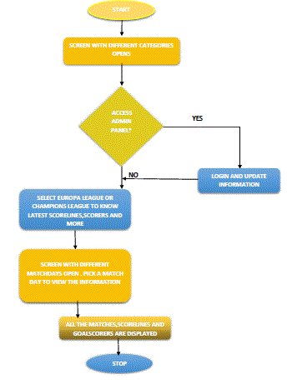

**4.3) Class Hierarchy Diagram**

class Main

class Sample2

class Sample class sample4 class Sample3

class Sample5

class Sample0

class Sample2

**4.4)Activity Diagram**



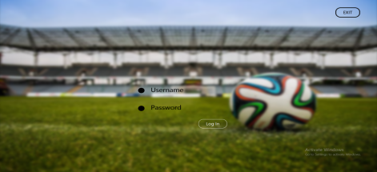 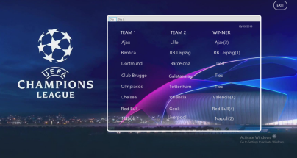 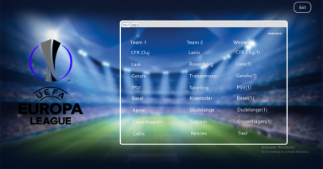

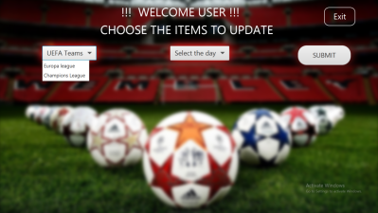



**6.CONCLUSION**

1. The aim of our project is to make every football fan in India aware of the happenings in European football.

2. We want every football fan to have a sound knowledge of European competitions despite being in India .

3. We want to eliminate all the difficulties faced by Indian fans and provide them with the news as soon as possible.

4. Through this project we were able to explore deeper which resulted in a greater understanding for each one of us and were able to achieve our target.