**Output**

**for**

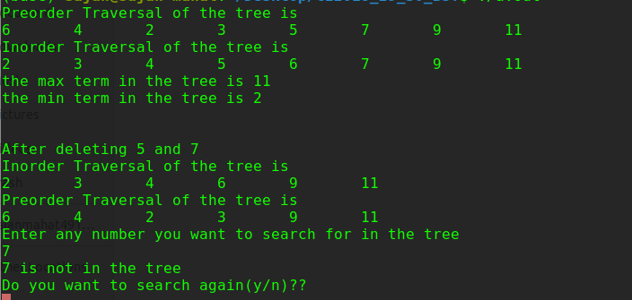**LinkedBST**

The attached cpp and header files are LinkedBST.cpp, LinkedBST.h and BinaryTree.h.