**Lab Sheet 2**

Q.1. Implement a singly linked list with the different operations. Displays the contents of the list Also, write a test program to check if the implementation works properly.

=> The included cpp and header files are singly_linked_list.cpp and singly_linked_list.h.

Output:

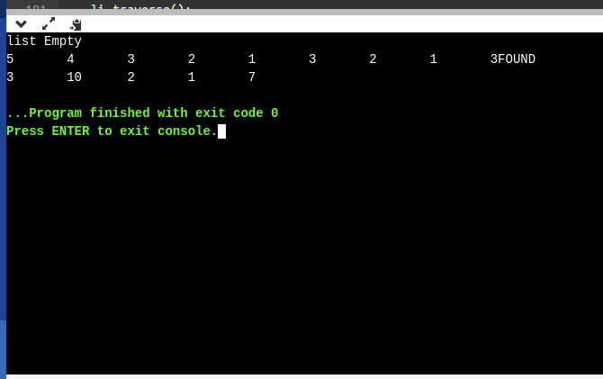

Q.2. Implement stack and queue data structures using linked lists.

1. Implementation of stack data structure using linked list

=> The attached cpp and header files are link_stack.cpp and link_stack.h.

Output:

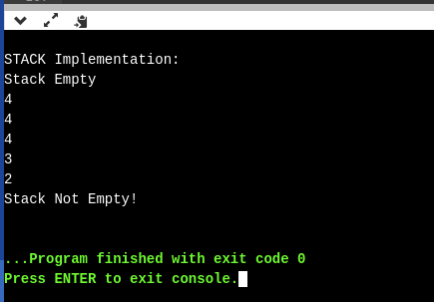

2. Implementation of Queue data structure using linked list

=> The attached cpp and header files are link_queue.cpp and link_queue.h.

Output:

