F

**Introduction:**

Looking for a smarter, faster, and more efficient way to handle your legal needs? What if you could have an AI model that acts as a personal lawyer, analyzing cases and providing reliable legal advice? Introducing AI Advocate the ultimate solution legal challenges.

**Description of the Idea:**

- AI-powered lawyer: Reliable legal advice and strategies driven by artificial intelligence.

- Comprehensive case analysis: Accurate results, related articles, and previous similar cases.

- Access to outcomes: Insight into case outcomes for informed decisions.

**Problem Statement:**

- Traditional legal processes are complex and time-consuming, resulting in high costs and prolonged battles.

- Affordability barriers limit access to legal services for many individuals and businesses.

- AI-powered lawyer offers quick, comprehensive, and affordable legal solutions, addressing accessibility and efficiency issues in the legal industry.

**Objective(s):**

- Develop AI model for legal analysis: Create advanced AI capable of analyzing judicial cases for precise legal advice.

- Implement user-friendly platform: Integrate AI into a client-friendly platform for case submission and legal guidance.

- Enhance accessibility and efficiency: Cut costs and time in legal research, offering thorough case analyses and strategies for favorable outcomes. Continuously update AI with feedback and new legal data for innovative and efficient legal support.

**Implementation Plan:**

- Develop comprehensive database system

- Create AI model for accurate legal advice

- Build user-friendly platform

- Integrate AI model with platform

- Test and refine system

- Launch and market solution, highlighting benefits

**AI Advocate: Winning Legal Strategies at Your Fingertips**

**Marwa Zeineddine, Sajed Hamdan**

**College of Arts and Sciences/ Computer Science**

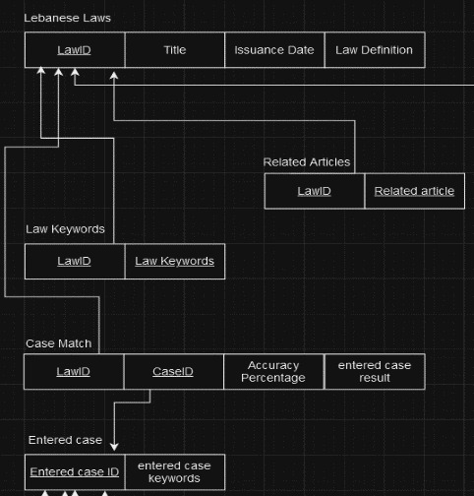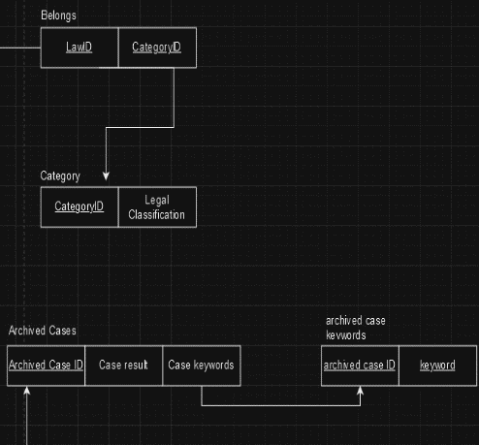

**Conclusion:**

- Introducing AI Counselor: The ultimate solution for modern legal challenges.

- AI-powered lawyer offers accurate legal advice, comprehensive case analyses, and related articles in a user-friendly platform.

- Significantly reduces time and costs of legal research and analysis, leading to favorable case outcomes and informed decisions.

- Continuous improvements and client feedback integration make AI Counselor the future of legal services, revolutionizing the legal industry.

**Visuals: (ER diagram and Schema)**

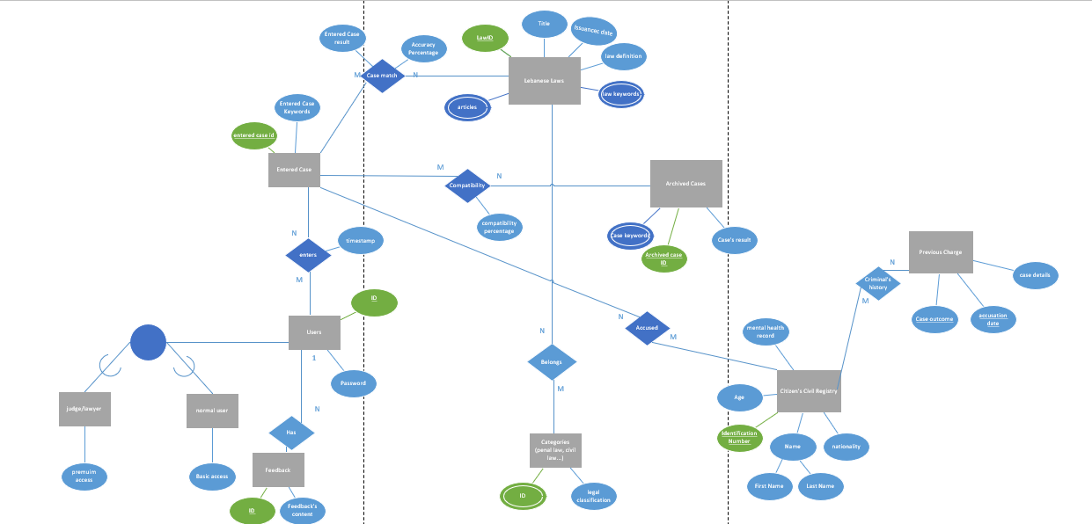

**Expected Outcomes:**

- Development of intelligent bot: Goal to create an AI-powered bot capable of solving diverse legal cases using provided data.

- Accurate and reliable legal advice: System designed to offer precise legal counsel in a user-friendly format, based on thorough case analysis.

- Support for legal decision-making: Aim to assist lawyers and legal professionals with informed decision-making by providing time and resource-saving solutions.

**Target Audience:**

Our AI-powered lawyer targets both law students, enabling them to engage with real-life cases during their studies, and legal professionals, including lawyers and judges, providing them with a tool for delivering accurate and dependable legal advice to clients.

**Key Features/Benefits:**

- Detailed individual information: Enhanced precision in assessing each person's status for more accurate results.

- Insights from past cases: Improved legal advice accuracy over time through insights from previous interactions.

- Identification of relevant legal statutes: Ensures legal advice is grounded in sound legal principles for increased client success.

- Accurate case outcome prediction: Informed decision-making and reduced time and costs associated with legal research and analysis.

- Overall, these features offer precise case analysis, insights from past cases, adherence to legal principles, and tailored strategies, leading to favorable outcomes.