**Team: Sajed Hamdan, Marwa Zeineddine.**

**Abstract**

The legal landscape demands efficient analysis of cases and the provision of relevant judgments. In response, we propose a comprehensive database system tailored to Lebanese law. This system serves as a tool to streamline case analysis and provide timely judgments within Lebanon's legal framework.

**Introduction**

In the intricate world of law, the ability to swiftly analyze cases and deliver pertinent judgments is critical. However, the sheer volume and complexity of legal data often pose challenges for legal professionals. To address this, our project endeavors to develop a database system specifically crafted for Lebanese law. This system is designed to serve as a central hub for legal professionals, offering efficient case analysis tools and facilitating the retrieval of relevant legal provisions. By leveraging advanced database technologies and adhering to Lebanese legal nuances, the system aims to revolutionize legal practice in Lebanon, promoting efficiency, transparency, and informed decision-making.

**The Need for Efficient Legal Case Analysis**

In Lebanon, as in many other jurisdictions, legal professionals grapple with an ever-growing volume of legal cases spanning various domains of law. Whether it's civil, criminal, or Sharia law, the need for efficient case analysis remains constant. However, traditional methods of legal research and case analysis often prove time-consuming, leading to delays in judgment delivery and potentially compromising the quality of legal outcomes. Therefore, there arises a pressing need for a more efficient approach to legal case analysis, one that harnesses the power of technology to navigate the complexities of Lebanese law with precision and accuracy.

**Introducing the Legal Case Analysis System**

Our proposed legal case analysis system represents a pioneering solution to the challenges faced by legal professionals in Lebanon. At its core, the system comprises a meticulously structured database, meticulously organized into several interconnected entities. The Laws entity serves as the foundation, housing a comprehensive repository of Lebanese laws ranging from the Constitution to criminal, civil, and Sharia laws. Each law entry is richly detailed, encompassing vital information such as title, description, enactment date, relevant articles, and associated keywords or tags. This structured approach facilitates efficient data management and retrieval, empowering legal professionals with swift access to pertinent legal provisions.

**Streamlined Case Management and Analysis**

The system's capabilities extend beyond mere data storage, offering tools for case management and analysis. Legal cases submitted by professionals are seamlessly integrated into the system through the Cases entity, each meticulously cataloged and indexed for efficient retrieval and analysis. Complementing this is the Case Keywords entity, which extracts and stores keywords from case descriptions, enabling swift and accurate retrieval of relevant cases based on user-defined queries or specific legal terms. By leveraging advanced search and matching functionalities, the system ensures precision and accuracy in matching legal cases with pertinent laws, thereby facilitating comprehensive case analysis.

**Enhancing Efficiency and Transparency**

Through its robust mechanisms for user feedback and system improvement, the system fosters a culture of continuous refinement and enhancement. The Feedback entity serves as a conduit for users to provide invaluable insights into the accuracy and utility of the system's responses, enabling continuous improvement. Additionally, the History entity records all user interactions, providing invaluable insights into system usage patterns and performance metrics. By promoting transparency and accountability, the system aims to enhance legal efficiency, transparency, and education.

**Conclusion**

In conclusion, the proposed legal case analysis system represents a pioneering endeavor to revolutionize legal practice in Lebanon. By leveraging advanced database technologies and adhering to Lebanese legal nuances, the system offers unparalleled efficiency, accuracy, and utility to legal professionals across diverse domains. Through seamless data management, retrieval, and analysis, the system stands poised to empower legal professionals with the tools and insights necessary to navigate the complexities of Lebanese law effectively, thereby fostering enhanced legal efficiency, transparency, and education.

**ER:**

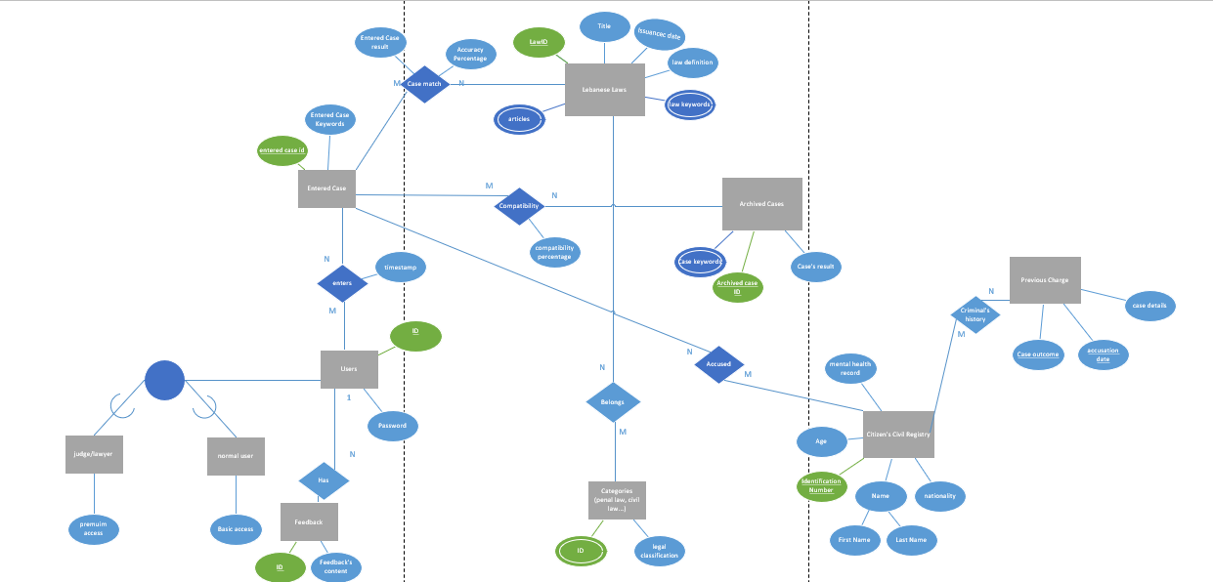

**Relational Schema:**

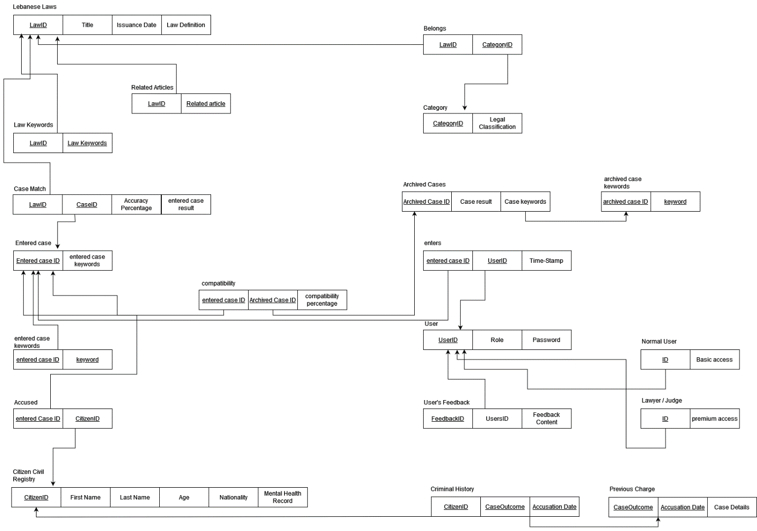

**Business Requirements:**

The legal case analysis system is a sophisticated database solution meticulously designed to facilitate the in-depth analysis of legal cases and the provision of relevant judgments in accordance with Lebanese law. At its core lies a series of interconnected entities structured within a comprehensive database schema, each serving a distinct yet interconnected purpose.

This system is composed of laws (Articles of the Constitution (, and each law has a title, date of enactment, description, articles, keywords and uniquely identified by their ID. A law might have several articles to refer to and would have many keywords for detection.

Each law or several laws can match to one or many cases, each case have a unique identifier, case result, and keywords for detection.

We keep track of the accuracy of matching between each law and case.

This system holds users that are uniquely identified by their usernames, having a type (lawyer, judge, normal user) and a password to secure his account. Users’ entries (that are new cases) is the way the user interacts with the system, once a new case entry is entered it will be stored beside the initial cases we have.

In addition, a user has feedback to help us improve our system and know the complaints. Feedbacks are uniquely identified by their ID’s and has a description.

A law belongs to a category, and a category might have several laws example: some laws are characterized as civil laws others as penal laws and so on.

This system holds all the citizens information from their special identification number, to their age, name (composed of first name and last name), nationality, and their medical history.

A citizen might be a criminal that is related to a certain case, the system will hold this citizen examine his reports and info to suggest the law that should be taken into consideration when dealing with the case, example: Sami is a 17 years old who have stolen a huge amount of money from someone, the system will visit Sami’s record and spot that he is under 18 looking at his entered age, and so the law that should be held to Sami is different than the law that is held for an over 18 citizen. Another example is: Hadi is a 25 years old Lebanese citizen having a severe mental issue that makes him take unthoughtful actions, have shot his friend while playing with him. Here Hadi isn’t going to be judged as a normal grown up as he has a mental health issue, so a specific law would apply to him looking into his provided information.

The same citizen might attempt many crimes which would open to him many cases.

**Expert’s Feedback:**

As we sent our Final ER to our customer which is (Mr. Antoinne Kanaan (a lawyer at HAQQ company)) he addressed the following issues that have been solved.

* The archived cases and the entered case where the same entity we thought that as the archived cases will be updated every time a case is entered. Mr. antoinne suggested that the if the user entered a case that is already stored in our archived cases, why should be recalculate the result from scratch we can just compare and fetch the archived case that matches result and give it to the user.
* When a person has previous charges the system can detect how it can deal with this criminal more precisely and so we created the criminal’s previous charges table, that stores all the criminals previous accused charges, keeping track of the accusation date and the case’s result.

These were the only details Mr. Antoinne pointed out, he was satisfied with the final result addressing our project by the words “great work and a very unique idea that can really help our future judicial system.

**The 5 Main Queries:**

First Query, there is an input to put the identification number of any civilian and itll get the previous charges of this citizen.

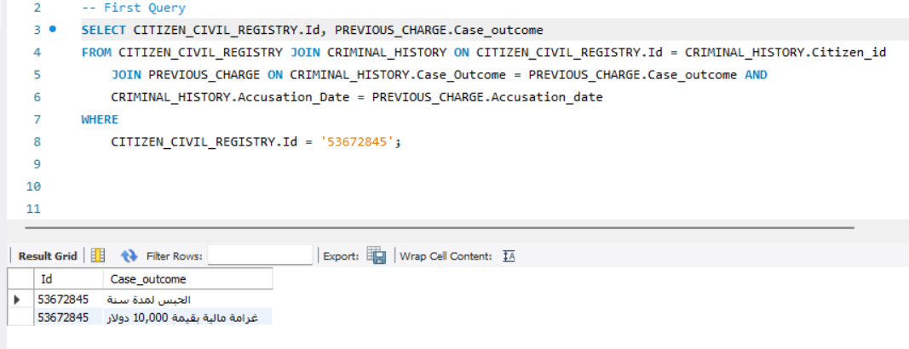

Another query, that gives the archived cases that are similar to the provided case, based on the interactions of users with the system.

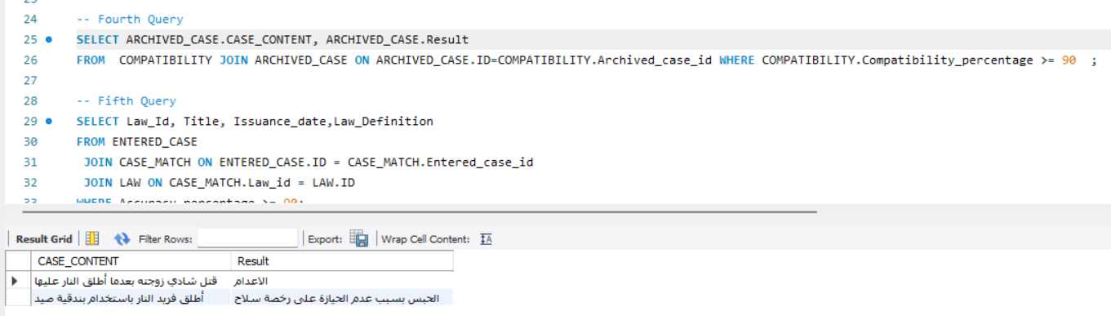

Another Query is a query that compares the laws with the case to look for their compatibility and provide the law that we should work with on this provided case.

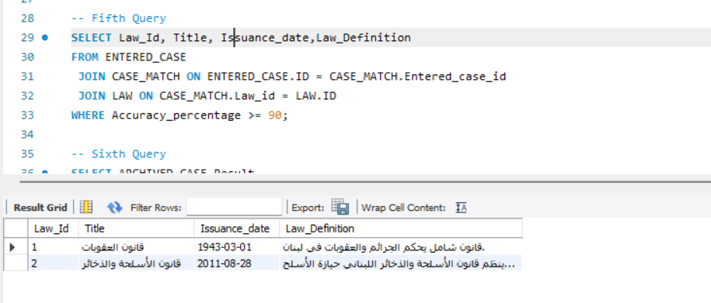

Another Query is a Query that provides the user with related articles based on the law that he is using, defining the law and teaching him to use this law.

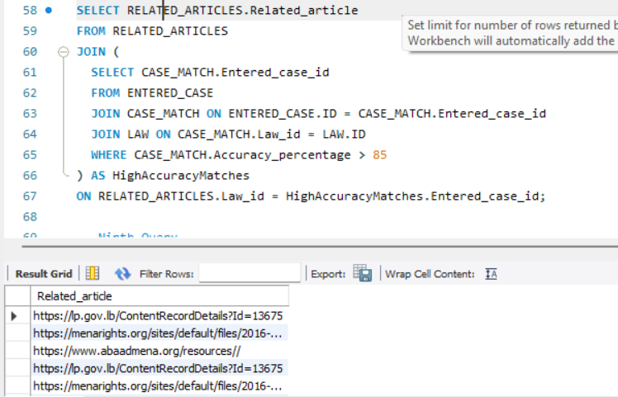

Another Query is a Query that displayed all the Identification numbers of the citizens who have mental health issues or are mentally stable.

