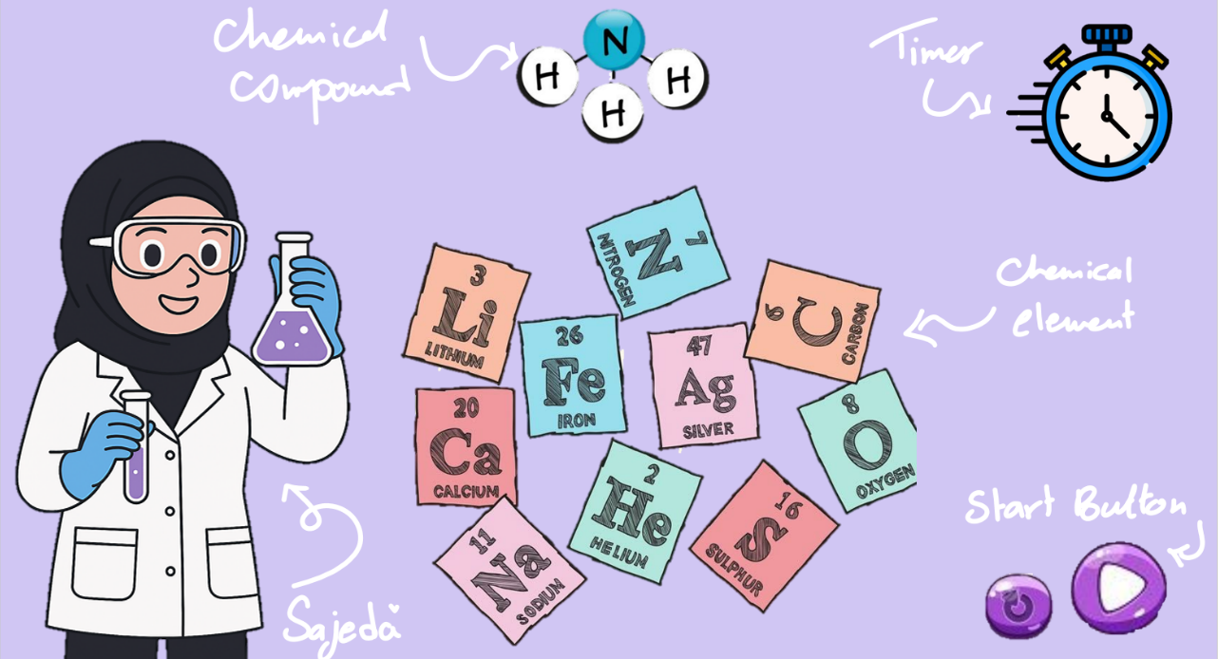
Chemical Chaos
User Stories for Chemical Chaos
- As a player, I want to see the target compound for each level so that I know what molecule I’m supposed to build.
- As a player, I want to see a grid filled with scattered atoms so that I can interact with them to form the correct molecule.
- As a player, I want to click or move atoms easily so that I can arrange them into the required structure.
- As a player, I want a countdown timer on each level so that I feel pressured to complete the molecule on time.
- As a player, I want each level to increase in difficulty so that the game becomes more challenging and fun.
- As a player, I want a clear message when I win so that I know I completed the molecule correctly.
- As a player, I want a clear message when I lose so that I understand I ran out of time or built the wrong molecule.
As a player, I want the atoms to have distinct colors or icons so that I can quickly differentiate between them.
- As a player, I want a restart button so that I can try the level again if I lose.
- As a player, I want to move to the next level automatically after winning so that the game flow feels smooth.
- As a player, I want to read simple instructions before I start so that I understand how the game works.
Pseudocode:
1) Define the required variables used to track the state of the game
level // current level
score // current score
timer // countdown timer for the level
maxLevels // total number of levels
labGrid // 2D array representing the lab grid
atomPool // available atoms for the level
targetCompound // molecule to build for current level
moleculeBuiltCorrectly // boolean flag

2) Store cached element references
gridUI // DOM element for lab grid
timerUI // DOM element for timer display
scoreUI // DOM element for score display
messageUI // DOM element for messages (success/failure)
buttons // all interactive buttons (atoms, rotate, reset)

3) Initialize game state on page load
Function initializeGame()

4) Render the game state to the user
Function renderGameState():

5) Handle game over logic
Function checkGameOver()
6) Handle player clicks
7) Reset functionality
Function resetGame():
level = 1
score = 0
moleculeBuiltCorrectly = false
loadLevel(level)
renderGameState()

