README
Screenshot/Logo: 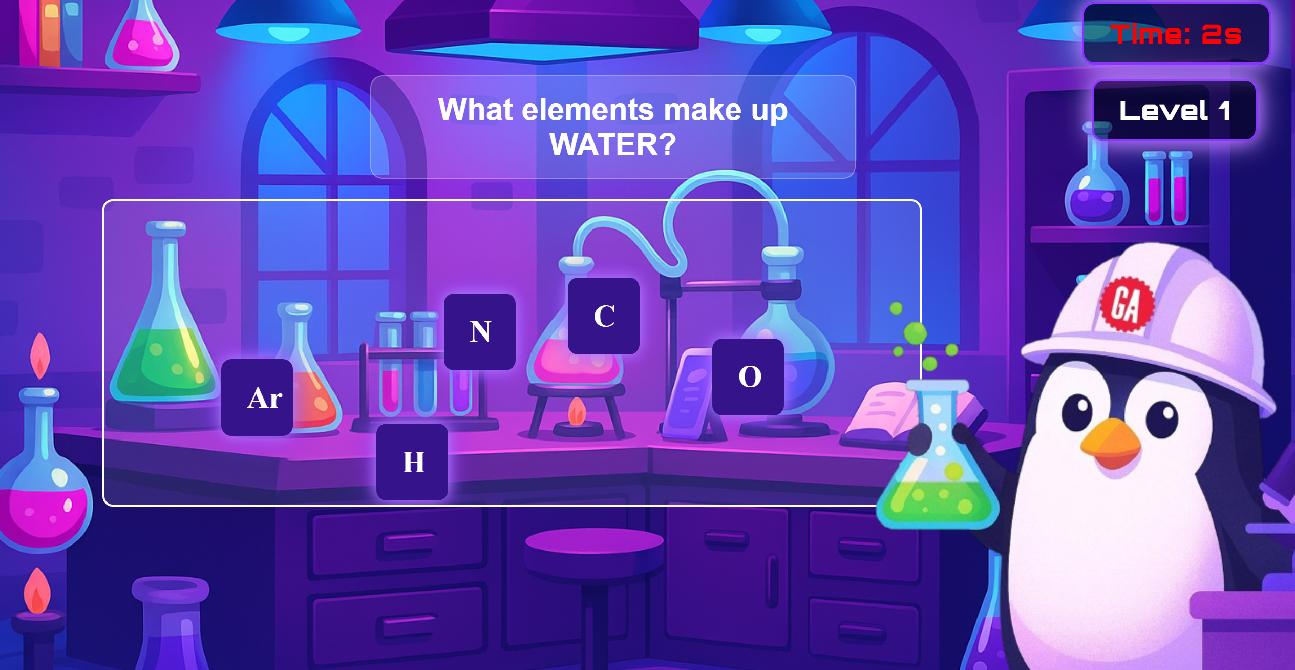
Your game's name:
- Project Title: Chemical Chaos Game
- Brief Description:
Chemical Chaos is an interactive educational game that immerses players in the role of a chemical engineer working in a high-tech laboratory. The primary objective is to stabilize the lab's reactor by assembling chemical compounds from scattered atoms within a limited time frame. Each level presents a new compound to build, with increasing complexity and stricter time constraints. Players must use speed, strategy, and precision to prevent the reactor from entering "Chemical Chaos Mode".This project emphasizes problem-solving, logical thinking, and foundational programming concepts such as state management, user interaction, and event handling.
I chose this concept to merge education with entertainment, offering a fun and engaging way for students and enthusiasts to learn chemistry basics while developing critical thinking and reaction skills.

Getting started:
- Game link :https://sajedahussain.github.io/Chemical-Chaos-Game/
- Instructions:
  - Drag and drop the correct atoms into the reaction zone to form the target compound.
  - Complete the molecule before the timer runs out to avoid triggering "Chemical Chaos Mode."
  - Progress through levels by successfully assembling increasingly complex compounds.

Attributions:
- Font: google font
- Buttons: Button by mrtqzbek11 made with CSS | Uiverse.io
- Creating pic: Microsoft Copilot: Your AI companion

Technologies used:
- JavaScript
- HTML
- CSS

Next steps:
- Score & Nickname System: Implement a scoring system with personalized nicknames to track player progress.
- Global Leaderboard: Develop a competitive leaderboard where players can compare scores and achievements worldwide.
- Player Rankings: Introduce rankings and tiers (e.g., Beginner, Chemist, Master) to encourage replayability and competition.

