

**CookCraft - Documentation**

Sajeel Haider (21L-5302)

Ahmad Abdullah (21L-5330)

Waleed Asif (21L-7602)

Iteration # 4

May 5th, 2024

1. **Project Introduction:**

**Title:** CookCraft - A Comprehensive Meal Planner and Recipe Platform

**Overview:**

CookCraft is an innovative mobile application designed to streamline the process of meal planning and cooking, particularly for individuals with busy lifestyles or specific dietary restrictions. By leveraging a user-friendly interface and a robust backend, CookCraft offers a seamless integration of recipe discovery, meal planning, grocery shopping, and community engagement.

**Objective:**

The primary objective of CookCraft is to simplify daily meal preparation challenges faced by individuals looking to maintain a healthy diet amidst busy schedules. The app aims to minimize the time and effort spent on meal planning and grocery shopping while maximizing the nutritional value and personalization of daily meals.

**Features:**

CookCraft encompasses several key functionalities:

**Recipe and Meal Database:** Users can browse and search a comprehensive database of recipes, each tagged with detailed nutritional information and user-generated ratings.

**Personalized Meal Planning:** The app allows users to create, modify, and schedule meal plans tailored to their dietary preferences and restrictions.

**Grocery List Automation:** Based on selected recipes or meal plans, the app automatically generates grocery lists, helping users shop more efficiently.

**Community Interaction:** Users can engage with a community of like-minded individuals, sharing recipes, tips, and culinary experiences.

**Admin Dashboard:** For app administrators, a dashboard provides insights into app usage, user engagement, and content management.

**Target Audience:**

CookCraft is targeted towards anyone who enjoys cooking and wants to manage their meal planning more efficiently. This includes busy professionals, health-conscious individuals, culinary enthusiasts, and families looking to streamline their cooking processes.

**Significance:**

With an increasing focus on healthy living and dietary management, CookCraft provides a crucial tool for users to maintain control over their diets without compromising on variety or taste. The platform not only helps in managing dietary needs but also fosters a community of users who can share and learn from each other, making healthy eating a more accessible and enjoyable experience.

**Innovation:**

CookCraft stands out by integrating features like AI-driven recipe recommendations based on user preferences and available ingredients, a rating system to ensure recipe quality, and customization options that cater to diverse dietary needs. These features are designed to enhance user engagement and satisfaction, making CookCraft a leading app in the meal planning category.

1. **User Stories:**

1. **Sprint 1: Foundation and Basic Functionalities**

1. **Profile Creation:**

As a daily app user/creator,

I want to maintain and manage my profile

So that I can consume new recipes and share mine with the world.

**Sub User Stories:**

Profile Setup: As a new user, I want to set up my profile with personal preferences and dietary restrictions so that the app can offer personalized recipe suggestions.

Profile Editing: As an existing user, I want to edit my profile to update my preferences and dietary restrictions so that the recipe suggestions remain relevant to my current needs.

1. **Recipe Exploration:**

As an individual with or without dietary restrictions,

I want to explore new recipes that fit my lifestyle and interest

So that I can enjoy meals that are both delicious and safe for me.

**Sub User Stories:**

Filter Recipes: As a user, I want to filter recipes based on ingredients, cooking time, and dietary needs so that I can quickly find recipes that match my preferences.

Save Recipes: As a user, I want to save recipes for later so that I can easily find them when I'm ready to cook.

1. **Creator Mode:**

As a creator and an enthusiast for cooking,

I want to showcase my talent and interest to the world

So that I can get feedback and satisfaction in helping others.

**Sub User Stories:**

Publish Recipes: As a creator, I want to publish my recipes on the platform so that I can share my culinary creations with the community.

Receive Feedback: As a creator, I want to receive feedback on my recipes so that I can improve and refine my cooking based on community input.

1. **Sprint 2: Enhanced Meal Planning and User Interactivity**

1. **Meal Plan Management**

As a health-conscious individual,

I want to create, add, or drop meal plans

So that I can adapt my eating habits to match my current dietary goals.

**Sub User Stories:**

**Create Meal Plans:** As a user, I want to create meal plans that fit my dietary restrictions and preferences so I can follow a consistent diet regimen.

**Modify Meal Plans:** As a user, I want to modify existing meal plans by adding or removing meals so that I can adjust to new nutritional information or changing tastes.

**Delete Meal Plans:** As a user, I want to delete meal plans that I no longer use to keep my meal planning interface clean and organized.

1. **Cooking Tips and Techniques**

As a beginner cook,

I want access to cooking tutorials and recipes

So that I can learn cooking skills and make varied dishes confidently.

**Sub User Stories:**

Access to Tutorials: As a user, I want to watch cooking tutorials on YouTube linked through the app so I can visually learn cooking techniques.

Recipe Information at Fingertips: As a user, I want detailed recipes including step-by-step instructions so I can follow along easily and prepare dishes correctly.

1. **Sprint 3: Advanced Functionalities and Administrative Tools**

1. **Admin Dashboard:**

As an app admin,

I want to have a dashboard

So that I can analyze app usage, track the number of users, and monitor daily visits.

**Sub User Stories:**

Dashboard Access: As an admin, I want to access a dashboard to view real-time analytics on user activities and community engagement so I can make informed decisions.

Community Management: As an admin, I want to manage community posts regarding meals and recipes to ensure the content quality and relevance.

1. **Rating System:**

As a user,

I want to rate meals and recipes

So that I can influence the community's meal choices and help others make informed decisions.

**Sub User Stories:**

Submit Ratings: As a user, I want to submit ratings for meals and recipes to share my experience and feedback.

View Ratings: As a user, I want to see ratings for meals and recipes to choose the best options based on community feedback.

1. **Grocery List Generation:**

As a user,

I want the app to generate grocery lists based on my meal choices

So that I can shop efficiently and effectively.

**Sub User Stories:**

Automatic List Generation: As a user, I want the app to automatically generate a grocery list from my selected meals to streamline my shopping process.

Customize Grocery Lists: As a user, I want to customize grocery lists by adding or removing items to suit my needs.

1. **Design:**
2. Pencil Design

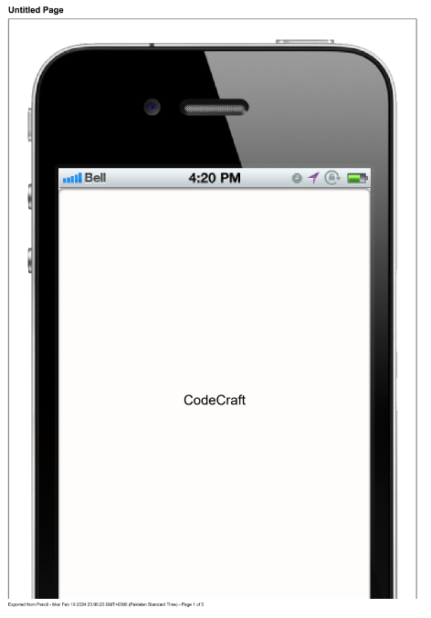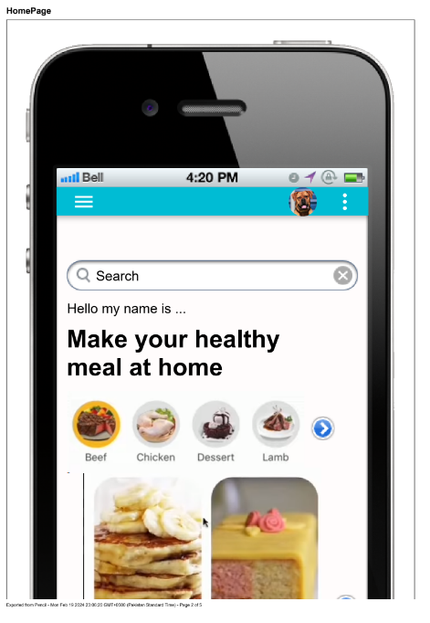

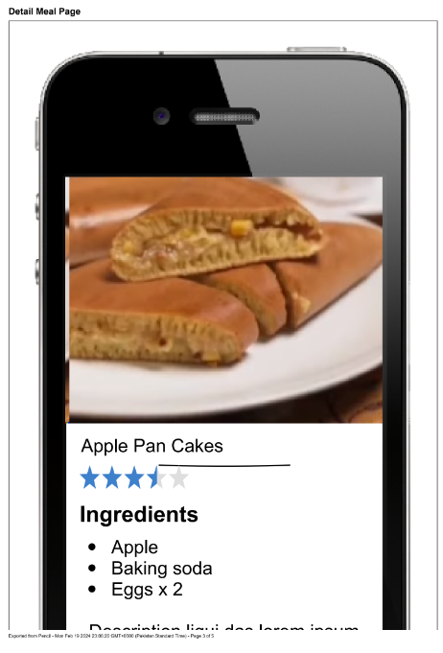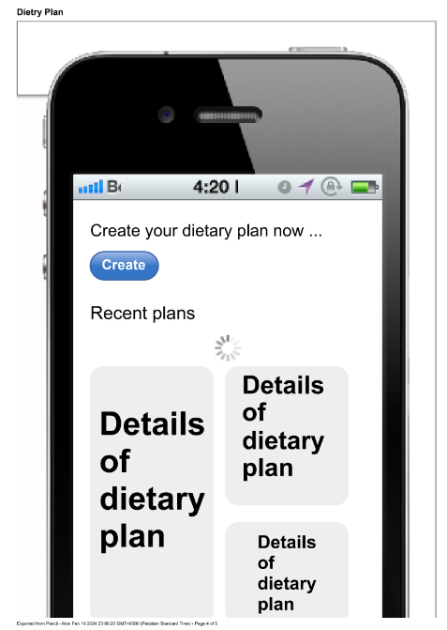

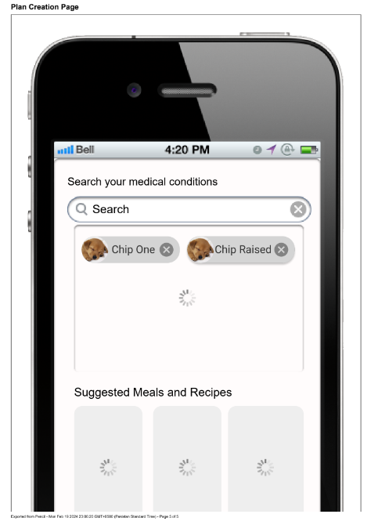

1. UML Diagram

**Component Diagram**

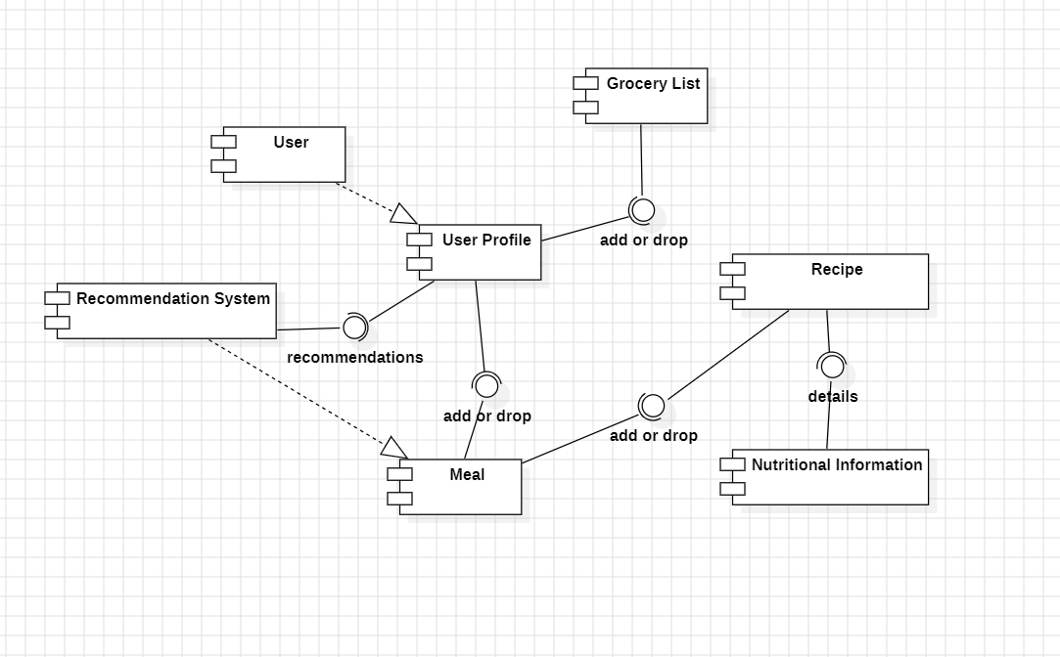

**Data Flow Diagrams**

**L-0**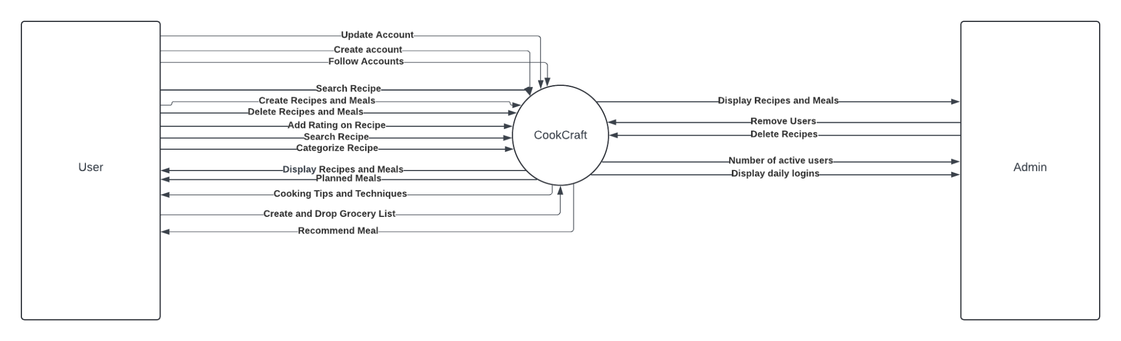

**L-1**

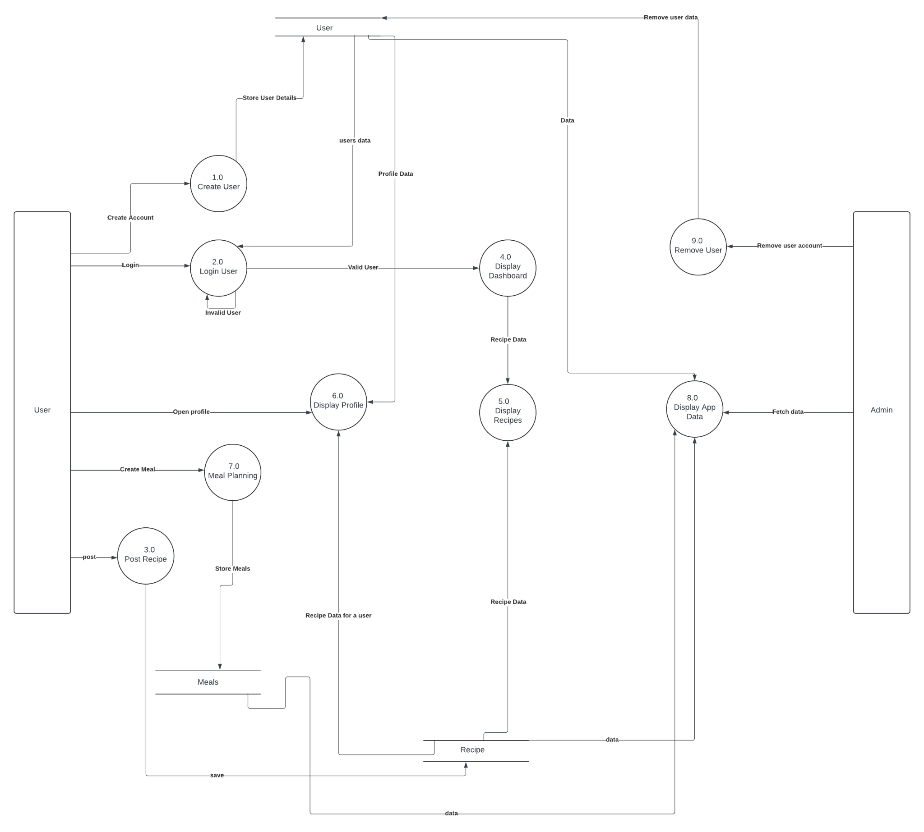

**L-2**

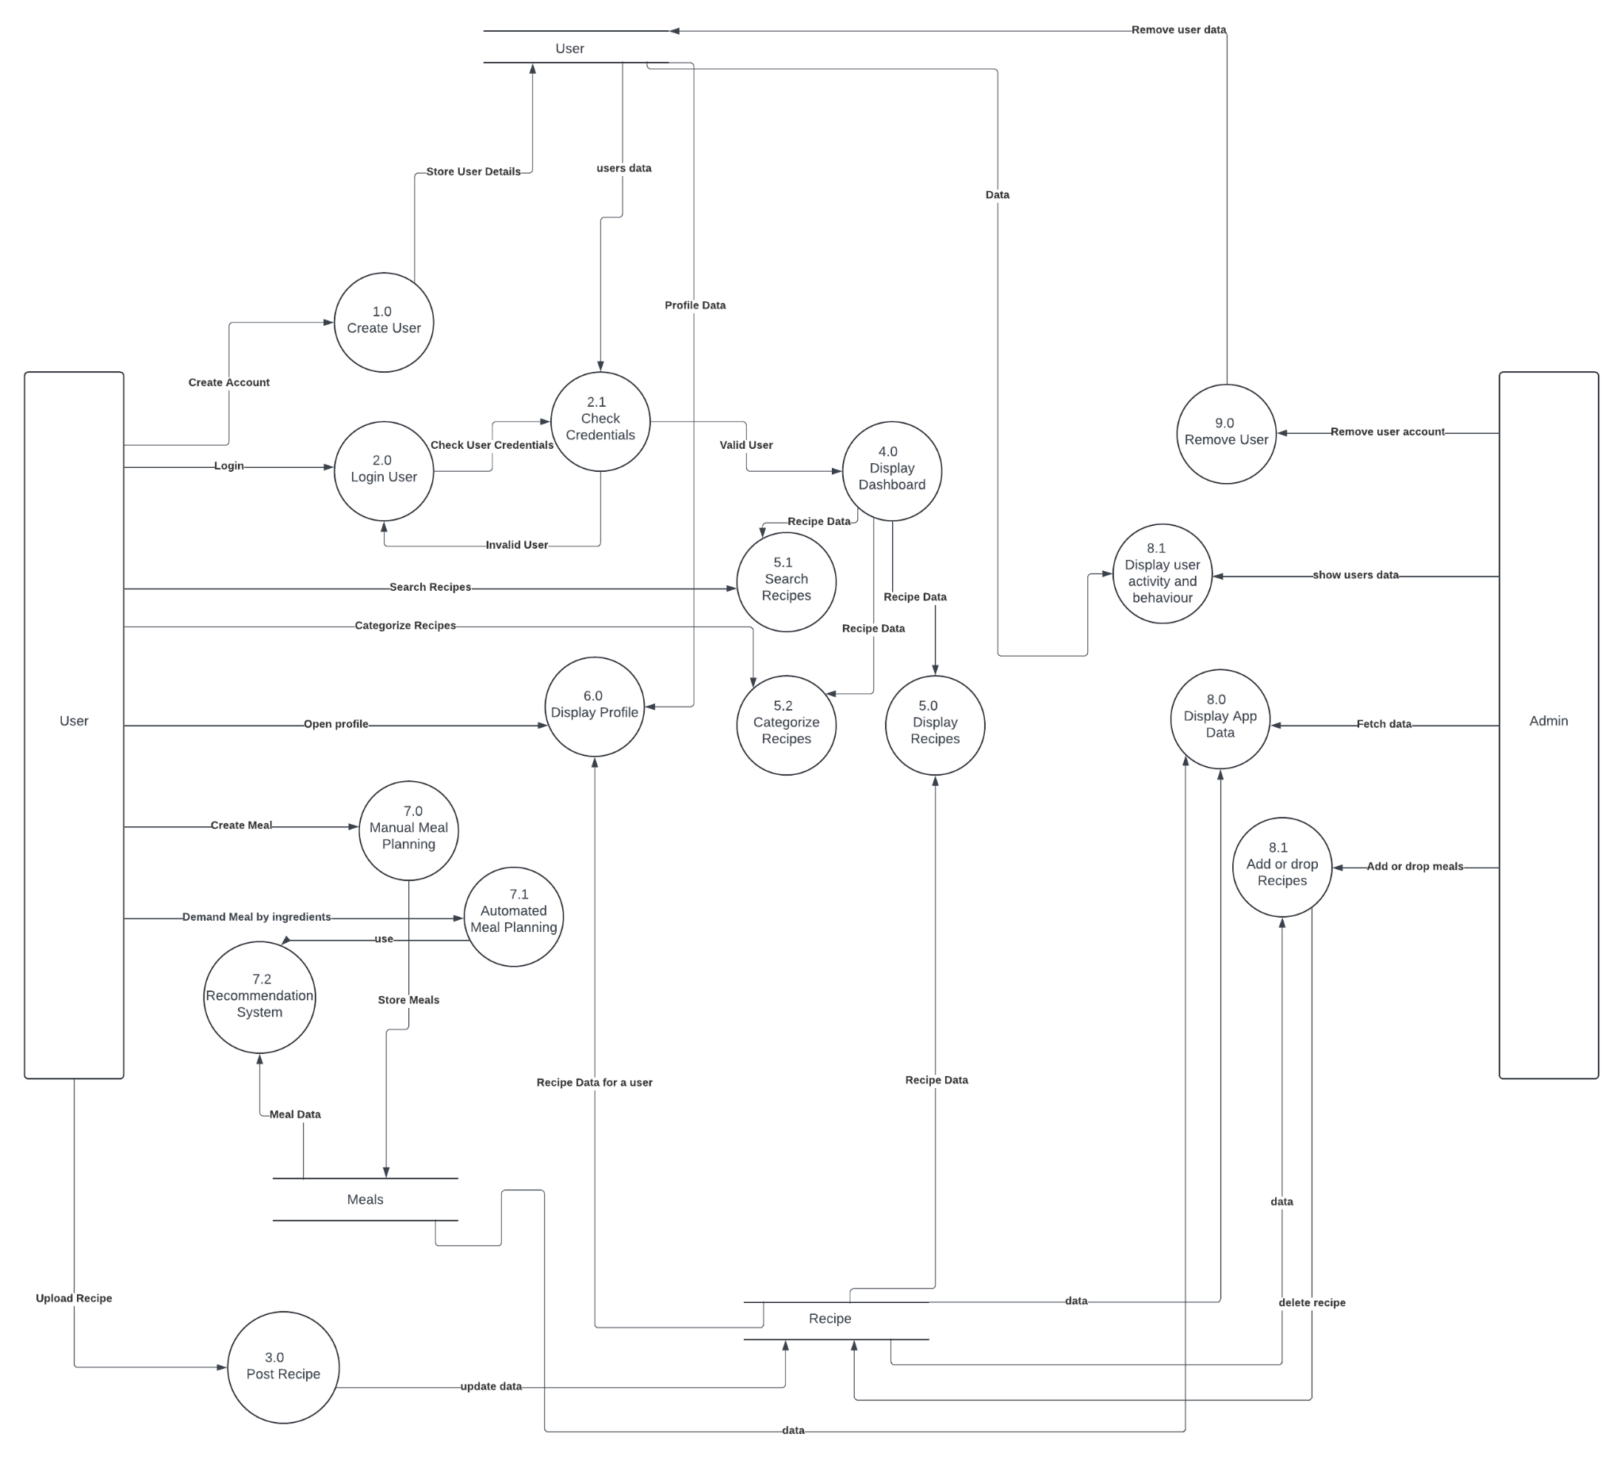

**Activity Diagram**

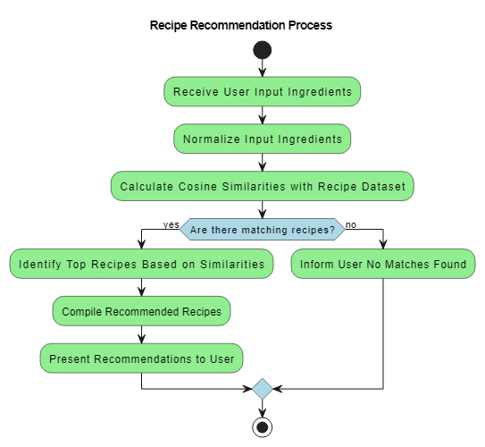

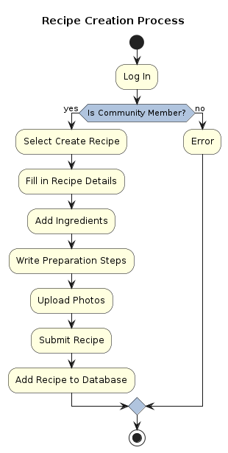

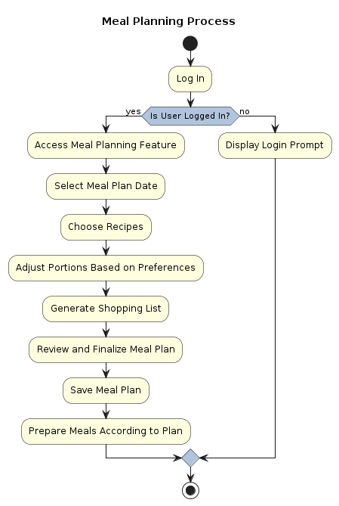

**Class Diagram**

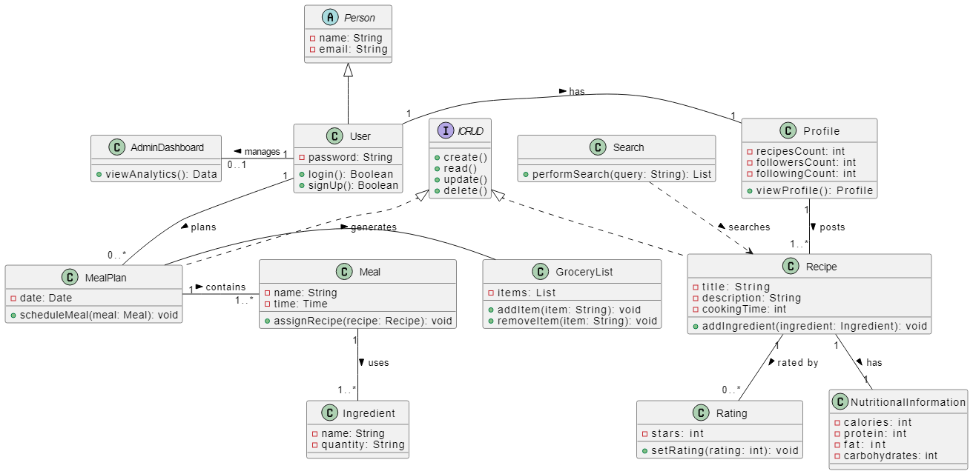

**Use Case Diagrams**

**UC-01**

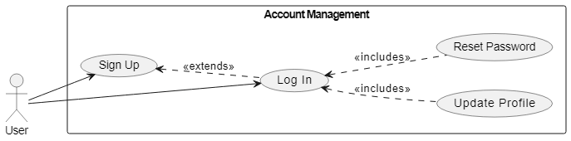

**UC-02**

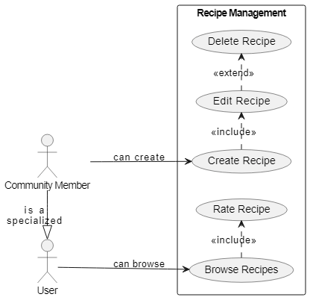

**UC-03**

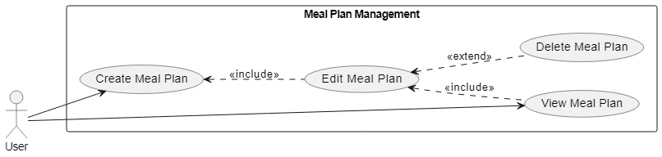

**UC-04**

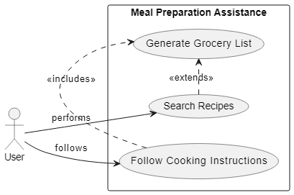

**UC-05**

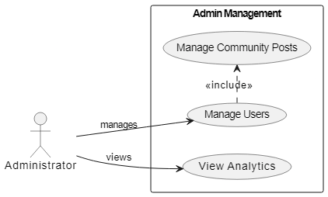

**Sequence Diagrams** 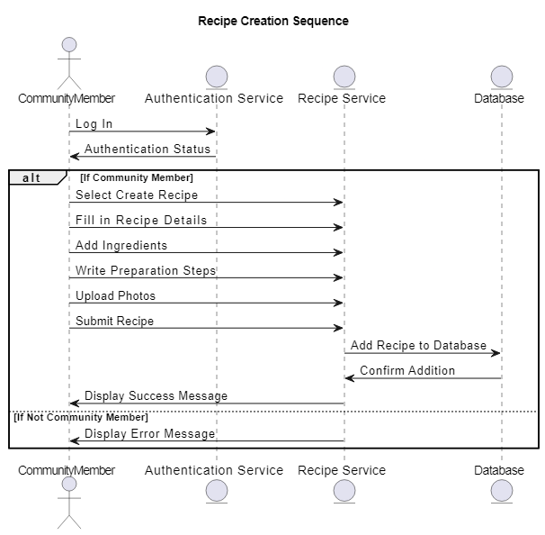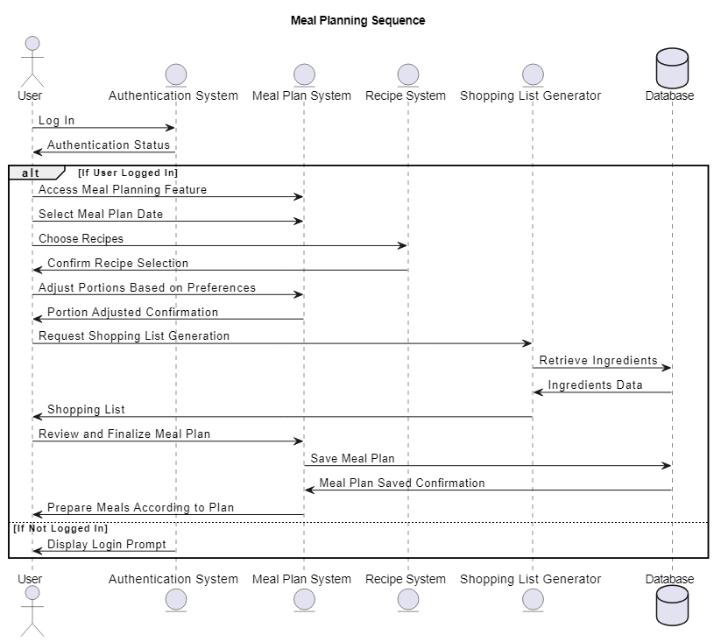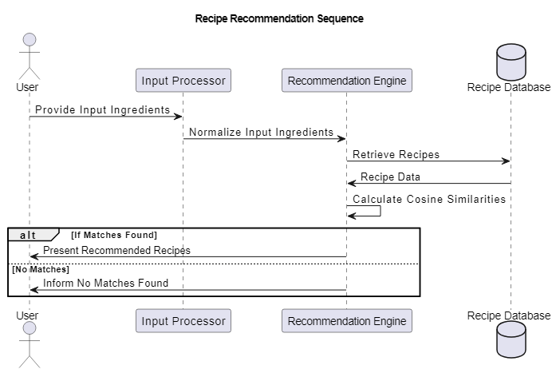

**Sprint 1: Recipe and Meal Database & Creator Mode**

1. **Recipe and Meal Database:**

**Interface Design:**

A searchable database interface displaying recipes in a grid or list format.

Each recipe card includes an image, brief description, cooking time, and user ratings.

Filters for dietary restrictions, ingredients, and cooking time are prominently placed at the top or side.

**Interaction Design:**

Users can click on a recipe card to get detailed information including step-by-step instructions, nutritional values, and user comments.

Filters dynamically update the list of recipes displayed based on the selected criteria.

1. **Creator Mode:**

**Interface Design:**

A creation tool interface that includes text fields for recipe title, preparation steps, and ingredient lists.

Drag-and-drop functionality for adding images and videos of cooking steps.

**Interaction Design:**

Creators can submit their recipes through a form that includes fields for cooking time, servings, and category tags.

Once submitted, recipes undergo a review process visible to the user through a status indicator (e.g., pending, approved).

**Sprint 2: Meal Plan Management & Cooking Tips and Techniques**

1. **Meal Plan Management:**

**Interface Design:**

A calendar-based interface where users can plan and visualize their meals for the week.

Each day provides an option to add meals for breakfast, lunch, dinner, and snacks.

**Interaction Design:**

Users can drag and drop recipes from their saved list or directly from the database into specific meal slots on the calendar.

The system automatically adjusts the grocery list based on meals added to the plan, which users can view and modify.

1. **Cooking Tips and Techniques:**

**Interface Design:**

A dedicated section for cooking tutorials linked with YouTube, featuring a curated list of video tutorials.

Thumbnails for each video along with brief descriptions and viewer ratings.

**Interaction Design:**

Users can watch videos within the app interface without being redirected to external sites.

They can bookmark videos, rate them, and submit comments or questions directly below each tutorial.

**Sprint 3: Admin Dashboard & Rating System**

1. **Admin Dashboard:**

**Interface Design:**

A comprehensive dashboard providing real-time metrics such as active users, daily sign-ups, most viewed recipes, and user engagement levels.

Graphs and charts visualize data trends over time, with filters for date ranges and user demographics.

**Interaction Design:**

Admins can interact with the data through dynamic elements like drill-down capabilities for detailed analysis.

Alerts and notifications for unusual activities or milestones reached within the app ecosystem.

1. **Rating System**

**Interface Design:**

Integrated rating stars or scales on every recipe and meal plan page, allowing users to quickly submit their ratings.

Hover tooltips explain what each star rating means (e.g., 1 star = poor, 5 stars = excellent).

**Interaction Design:**

Users can change their rating by revisiting the recipe and adjusting the stars.

The system calculates and updates the average rating displayed to all users in real-time.

1. **Architecture:**

**High-Level Architecture Components:**

1. **Client Layer (Frontend):**

**Technology:** Uses a combination of React Native for mobile development to ensure cross-platform compatibility with both iOS and Android.

**Components:**

**User Interface**: Provides interactive and visually appealing interfaces for user interactions with the app's features like browsing recipes, managing meal plans, viewing tutorials, and interacting with the community.

**Client-Side Logic**: Handles client-side validation, temporary data storage for session management, and dynamic content updates.

1. **Server Layer (Backend):**

**Technology:**

Node.js with Express framework, offering a lightweight and efficient server-side platform.

**Components:**

**API Endpoints:** Facilitates communication between the client app and the server, handling requests such as user authentication, data retrieval, data storage, and more.

**Business Logic:** Processes commands, performs calculations, and makes decisions based on the app's functional requirements and user requests.

1. **Database**

**Technology:**

MongoDB, a NoSQL database, ideal for handling diverse data types that the app manages, such as user profiles, recipes, meal plans, and community interactions.

**Components:**

**Data Storage:** Securely stores all user data, recipes, meal plans, ratings, and admin metrics.

**Data Retrieval**: Efficiently fetches data as requested by other components of the application, ensuring fast load times and real-time updates.

1. **External Integrations**

**Technologies**:

Integrations with third-party services like YouTube API for cooking tutorials and possibly other APIs for additional features like nutritional data or grocery delivery services.

**Components:**

**Service Hooks:** Connects to external services to extend the functionality of the app without storing all data locally, such as fetching video content or external recipe data.

1. **Security Layer**

**Components:**

**Authentication:** Manages user login and sign-up processes, employing OAuth for social media integrations and JWT (JSON Web Tokens) for maintaining user sessions.

**Authorization:** Ensures users can only access features and data relevant to their permissions within the app.

**Data Encryption:** Secures sensitive data both in transit and at rest, protecting user information and application integrity.

1. **Analytics and Monitoring**

**Tools:**

Use of tools like Google Analytics for tracking user interactions and custom backend logic for monitoring app performance and usage patterns.

**Components:**

**User Behavior Tracking:** Collects data on how users interact with the app to inform UX improvements and marketing strategies.

**Performance Monitoring:** Keeps track of system performance, helping to quickly identify and resolve any issues with app speed or reliability.

**Architectural Diagram:**

While a textual description provides an overview, an architectural diagram would visually represent these components and their interactions, typically involving:

A three-tier architecture model diagram showing the Client, Server, and Database layers.

Connectivity arrows showing data flow between client devices, server endpoints, and the database.

External integration touchpoints like APIs for YouTube and other services.

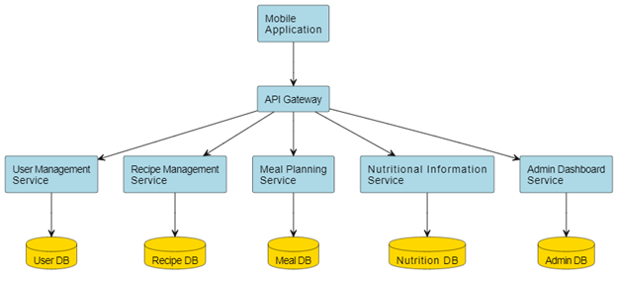

1. **Screen Shots:**

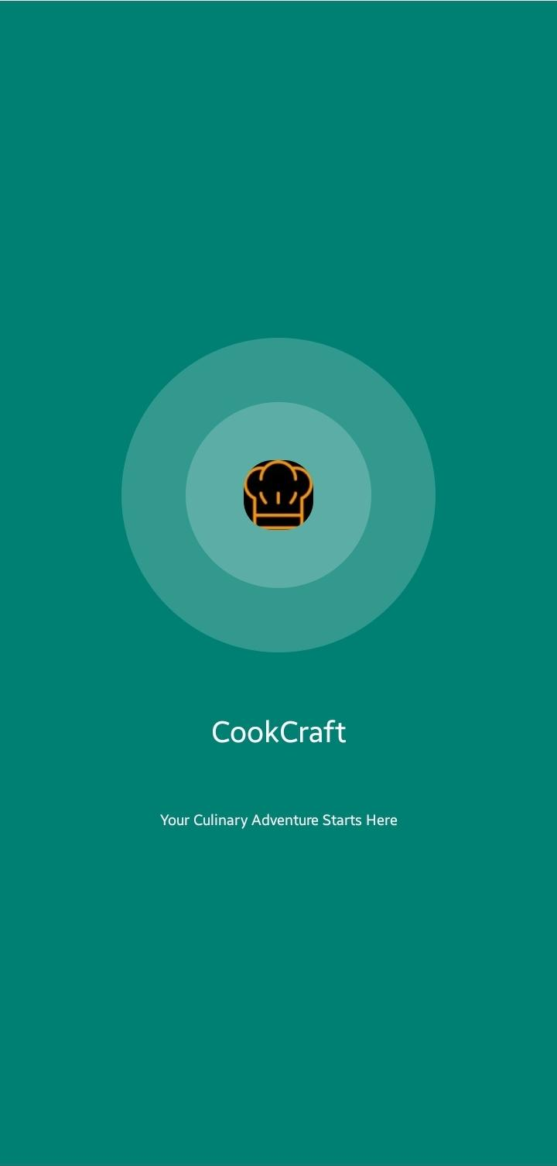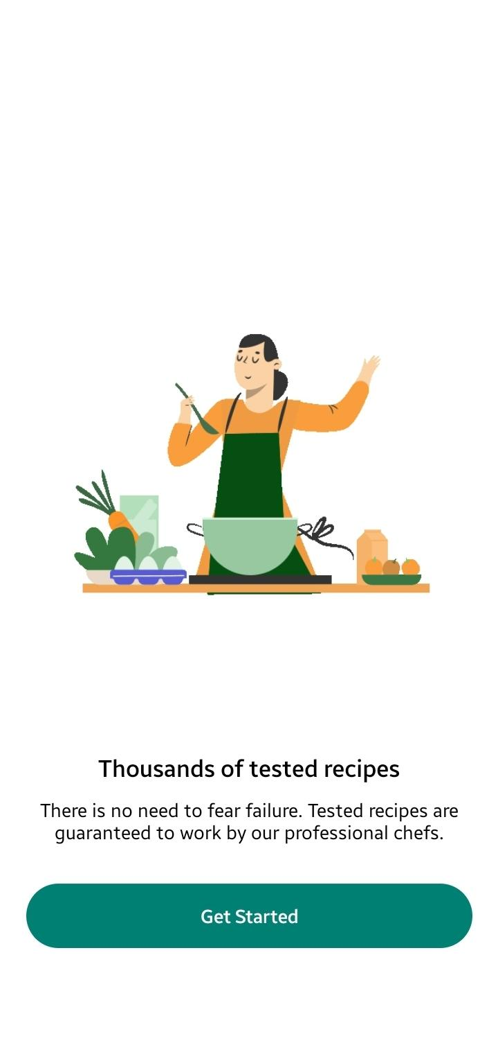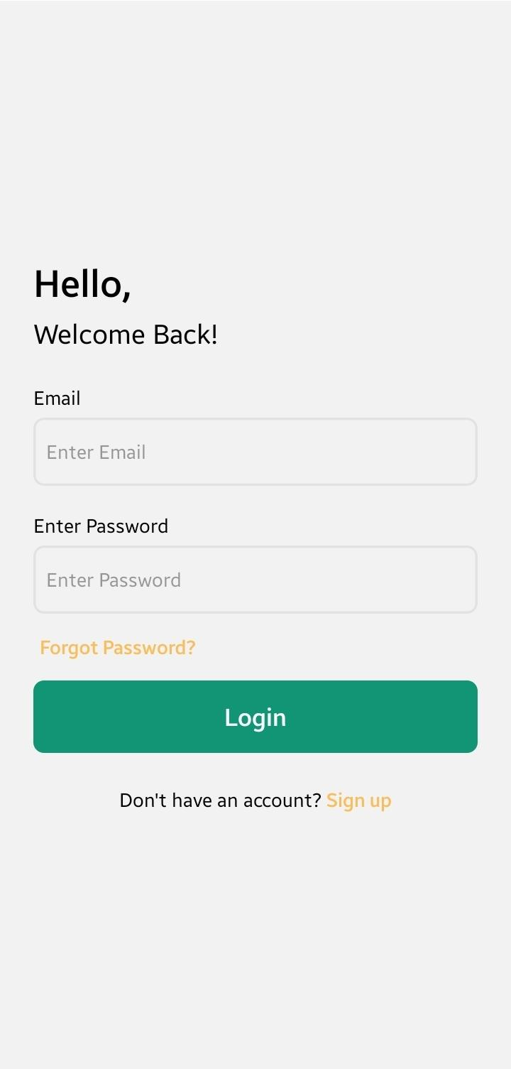

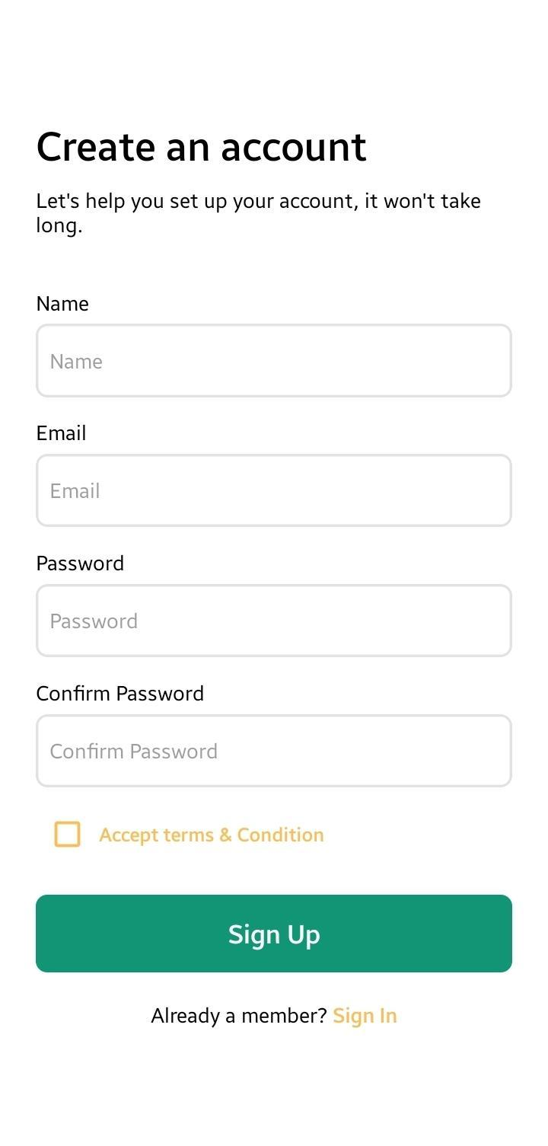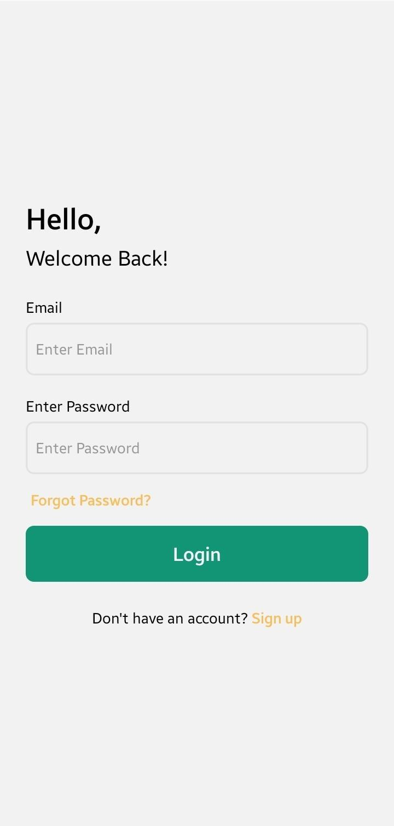

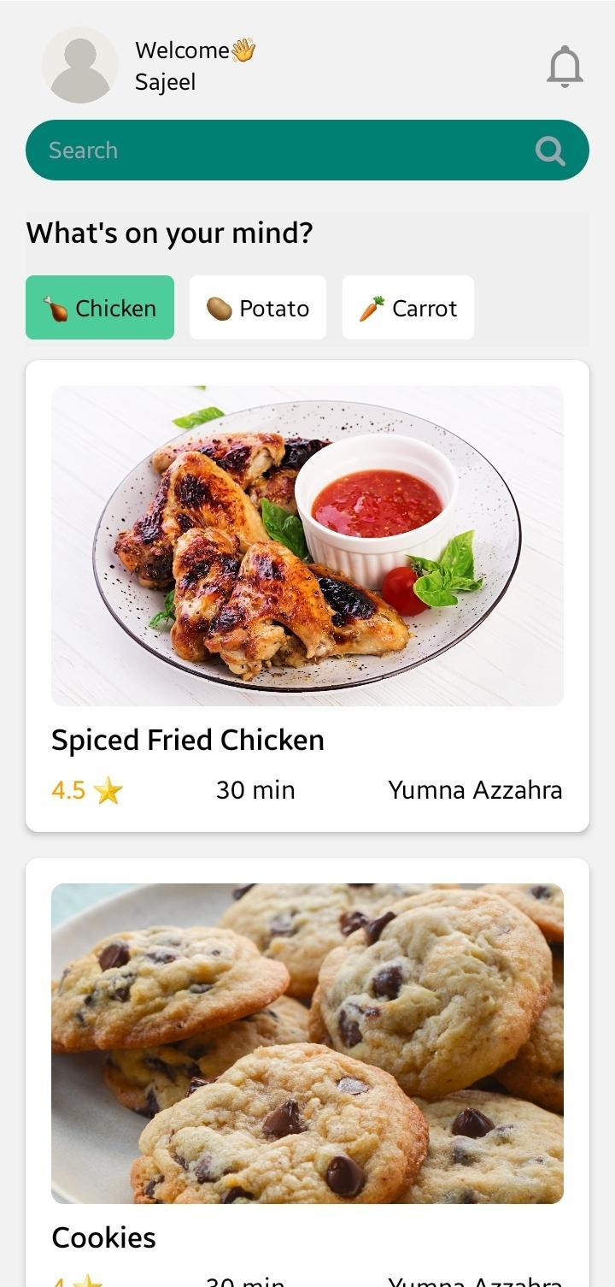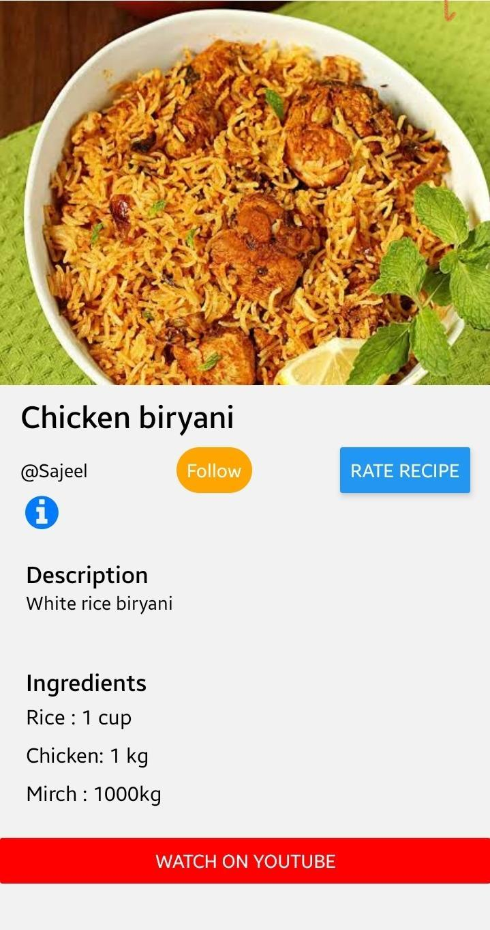

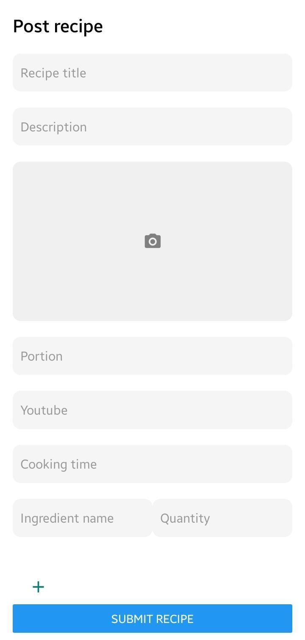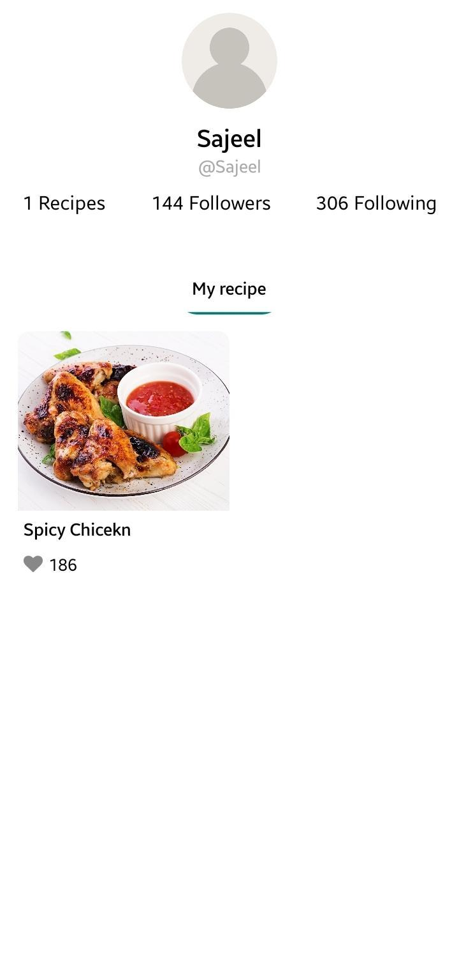

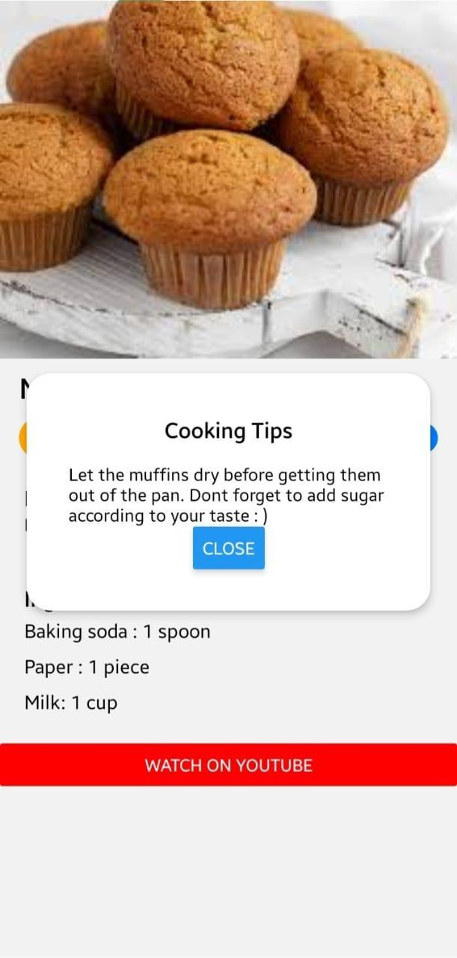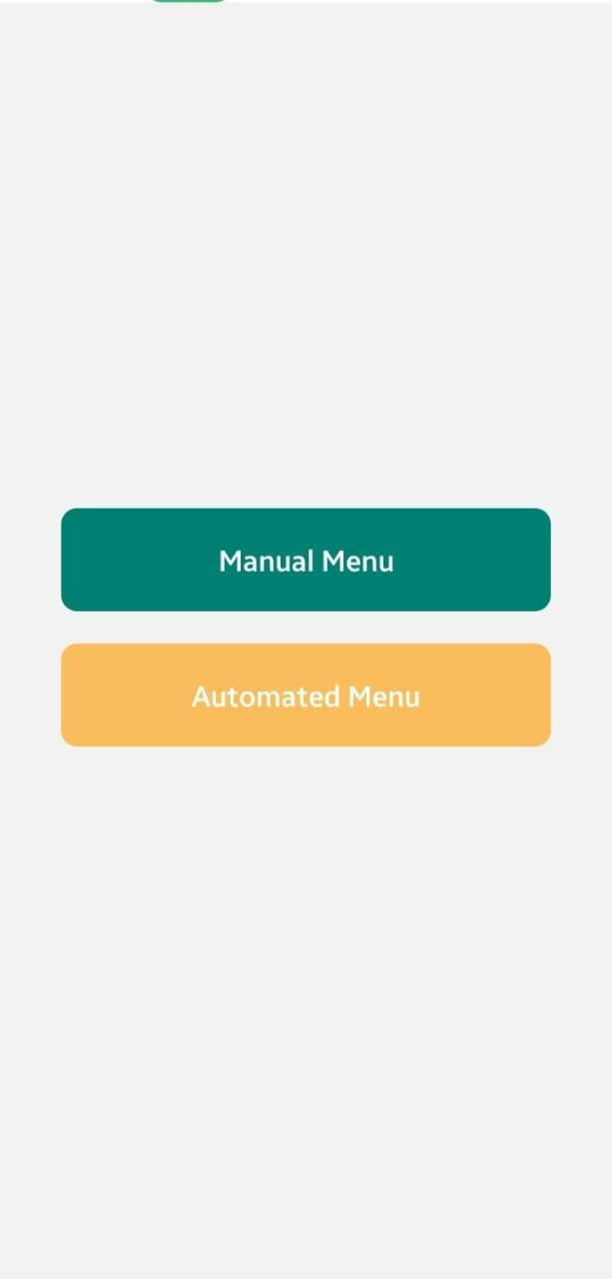

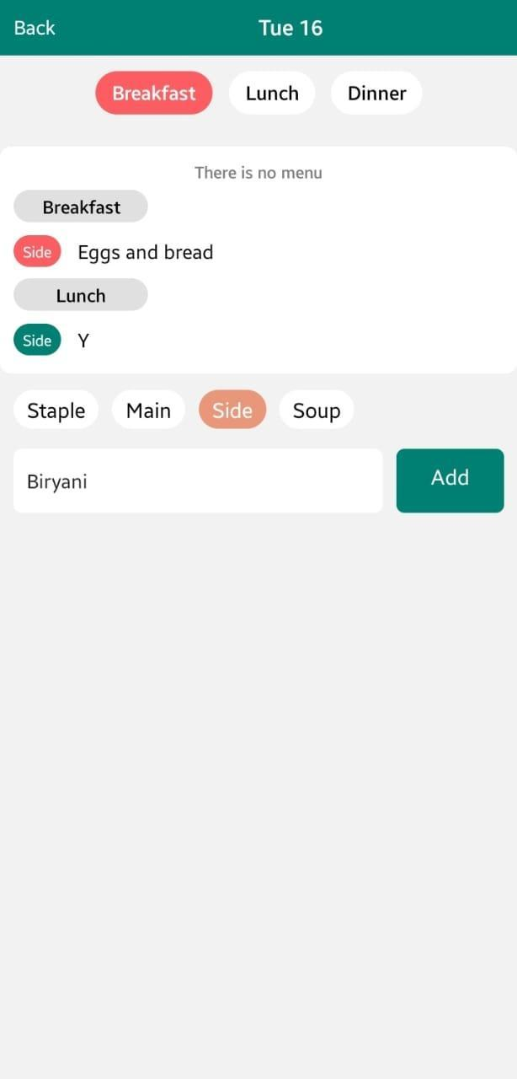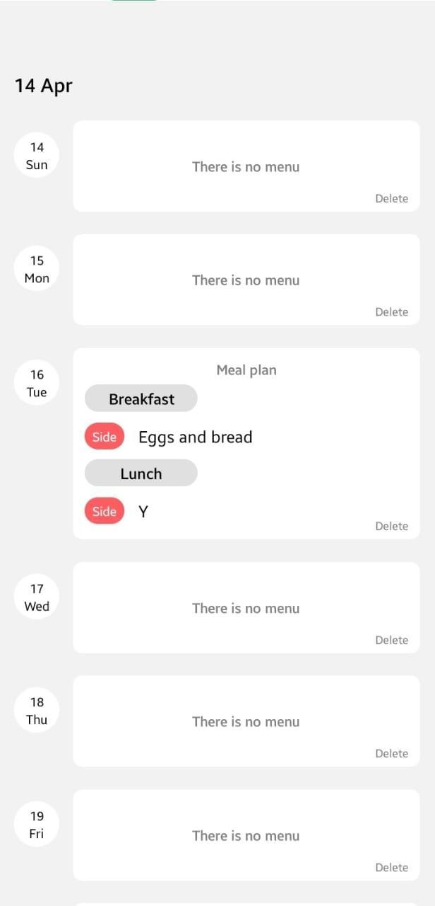

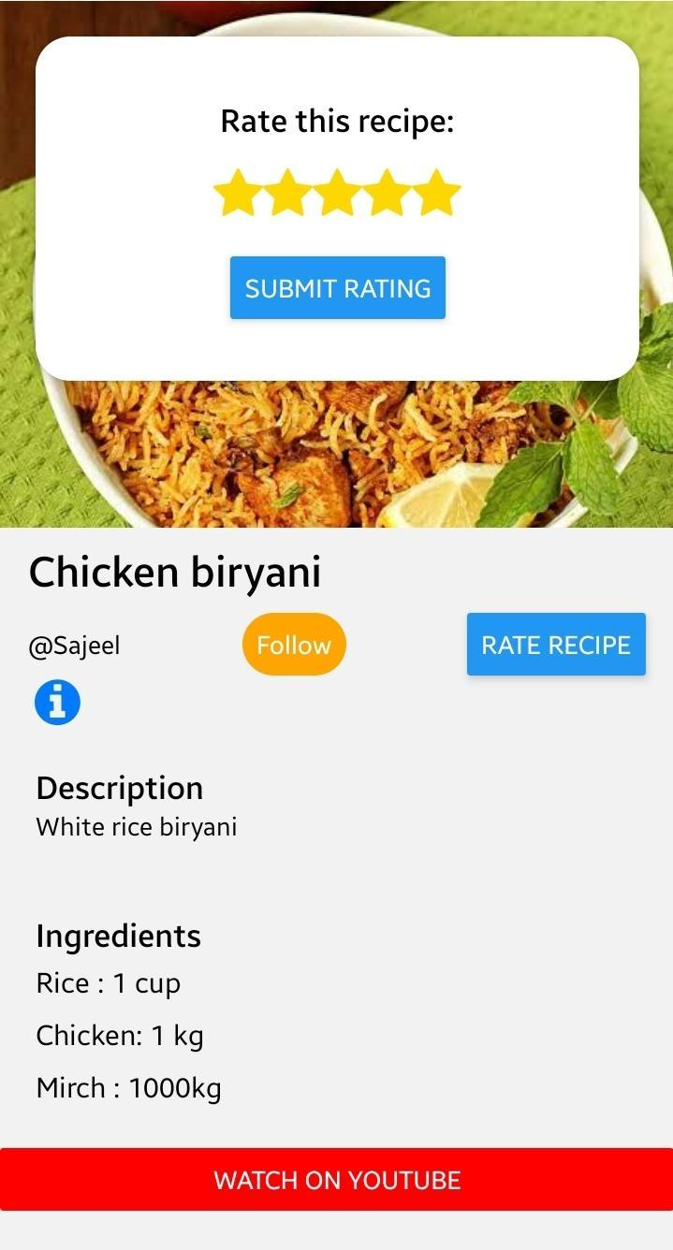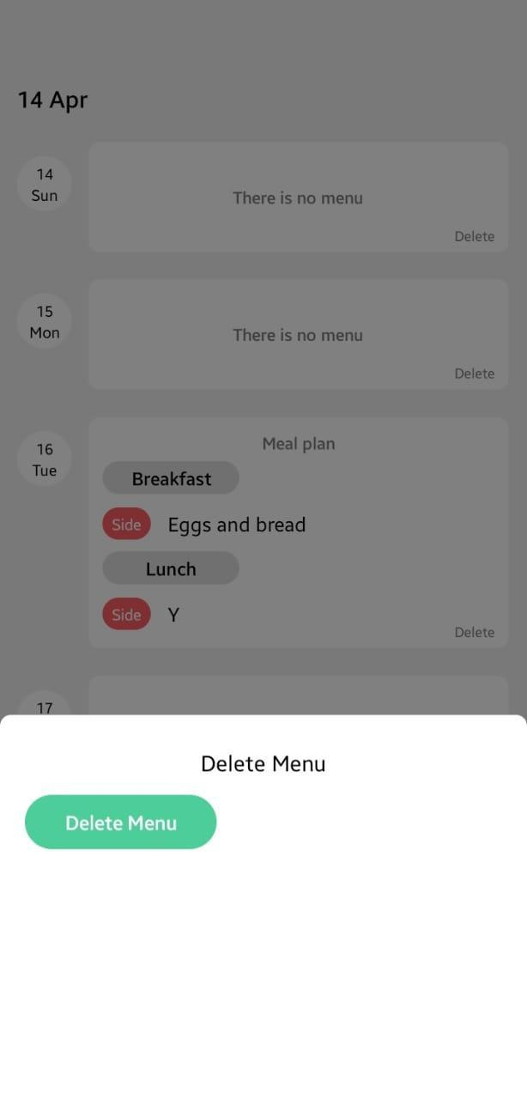

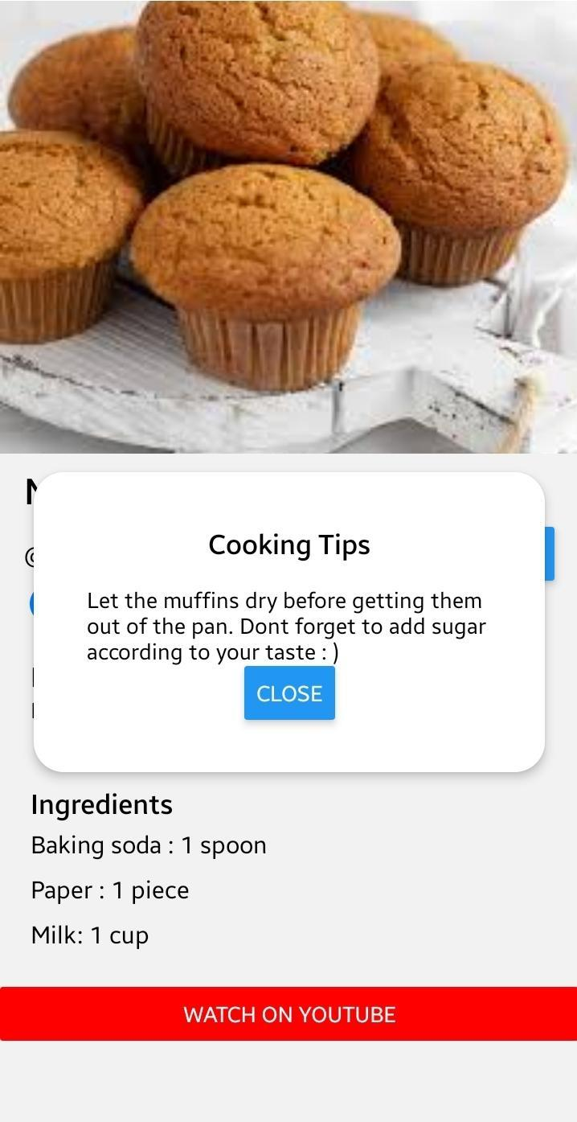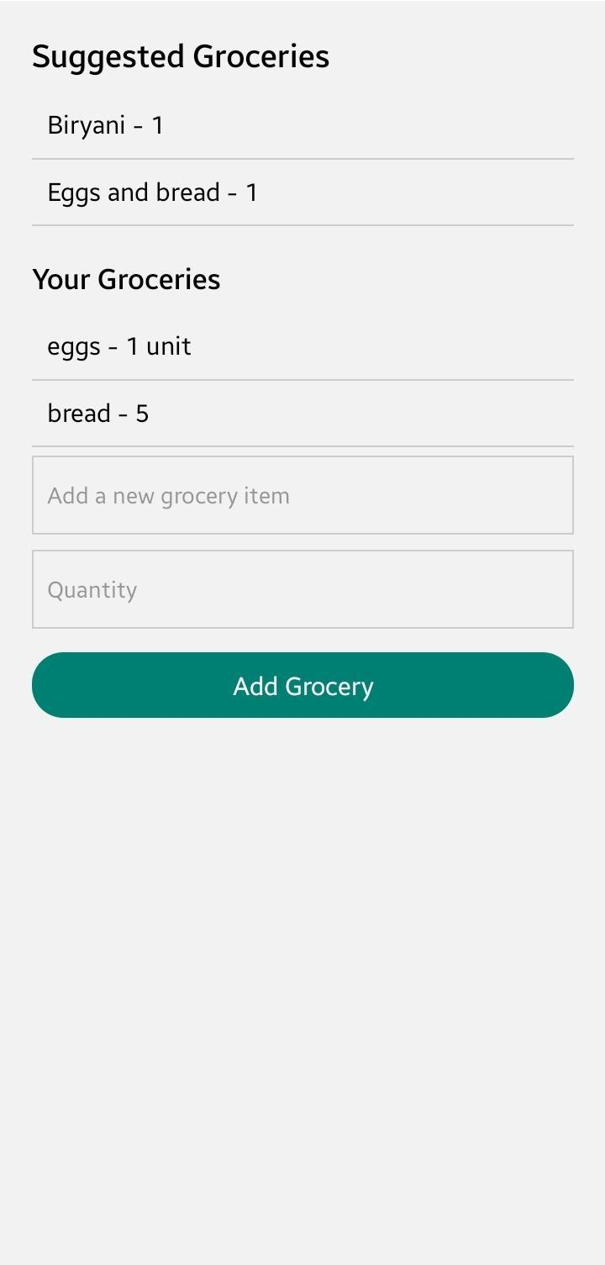

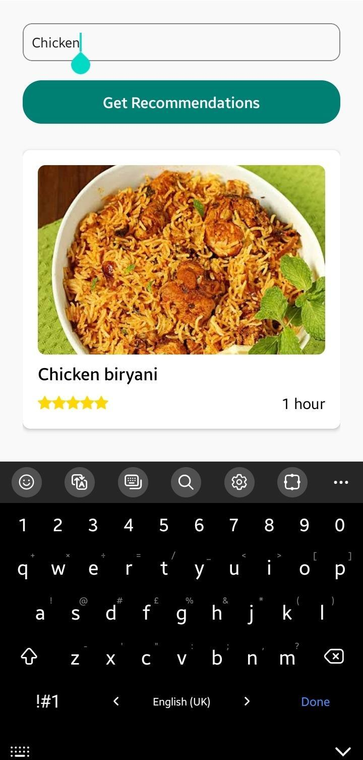

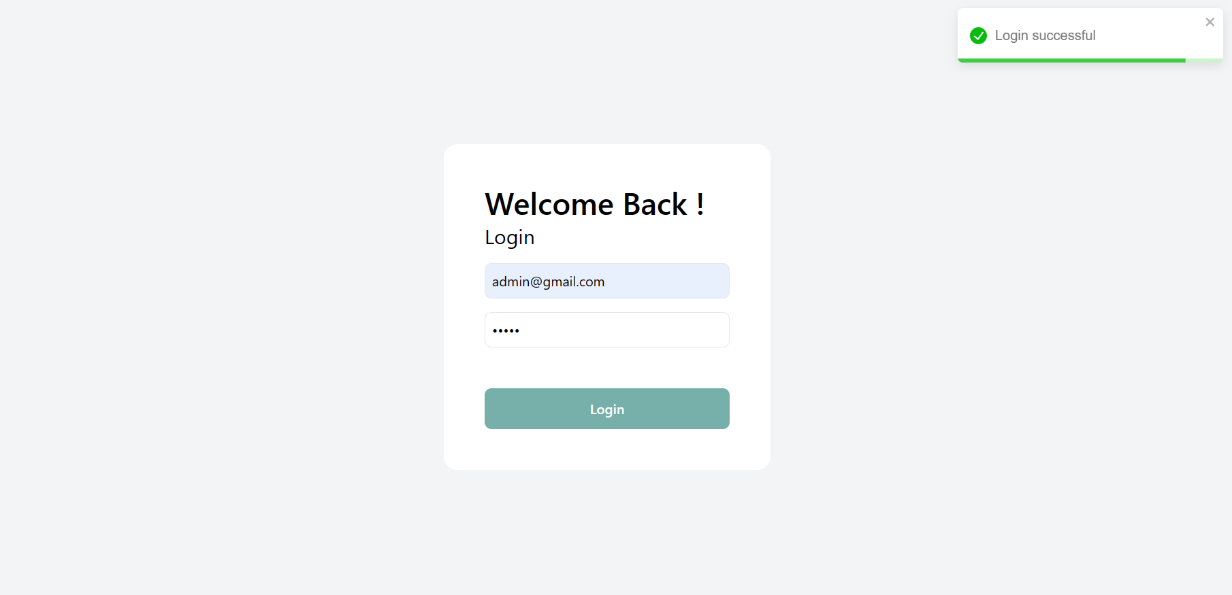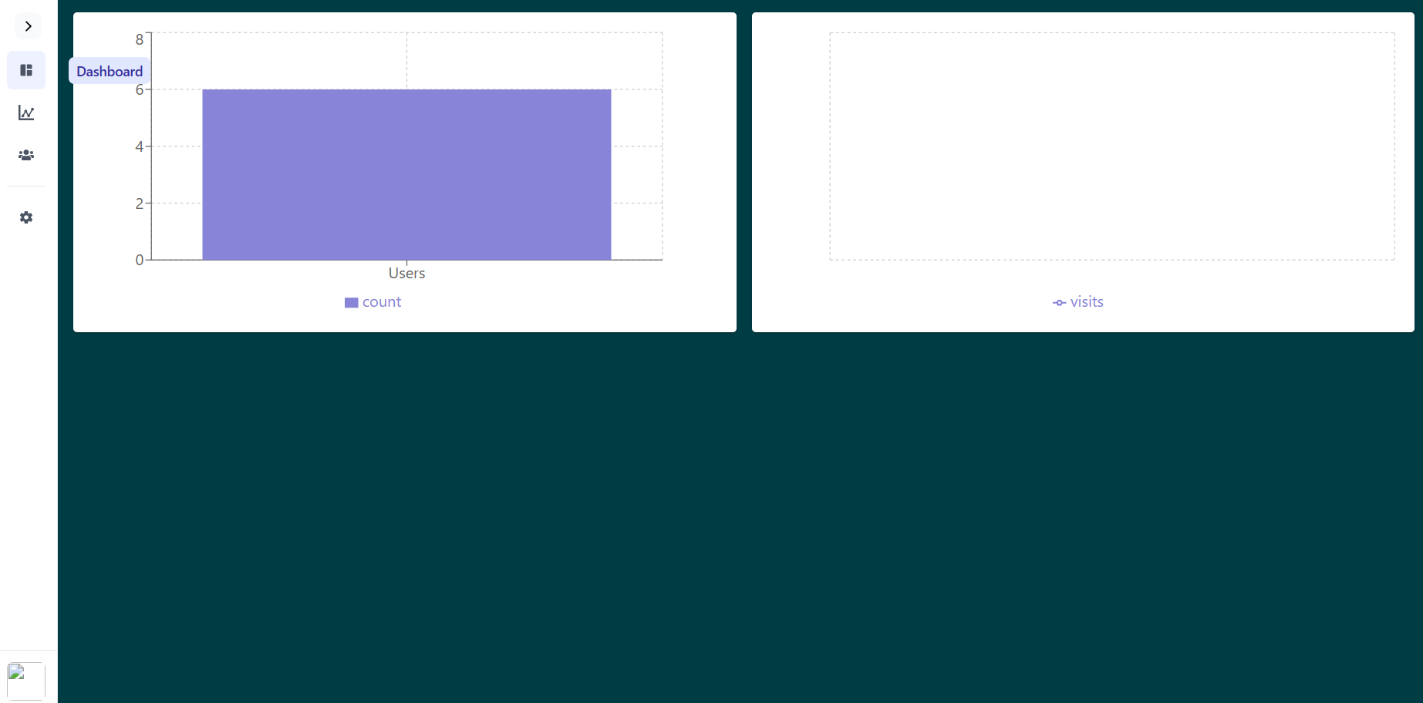

1. **Product Burndown chart:**

1. **Trello board Screenshots:**

We are using trello as project management tool which includes boards frontend to be done, backend to be done, frontend done, backend done and database construction

Here is the link to [Trello](https://trello.com/b/1C8kjebz/cookcraft)

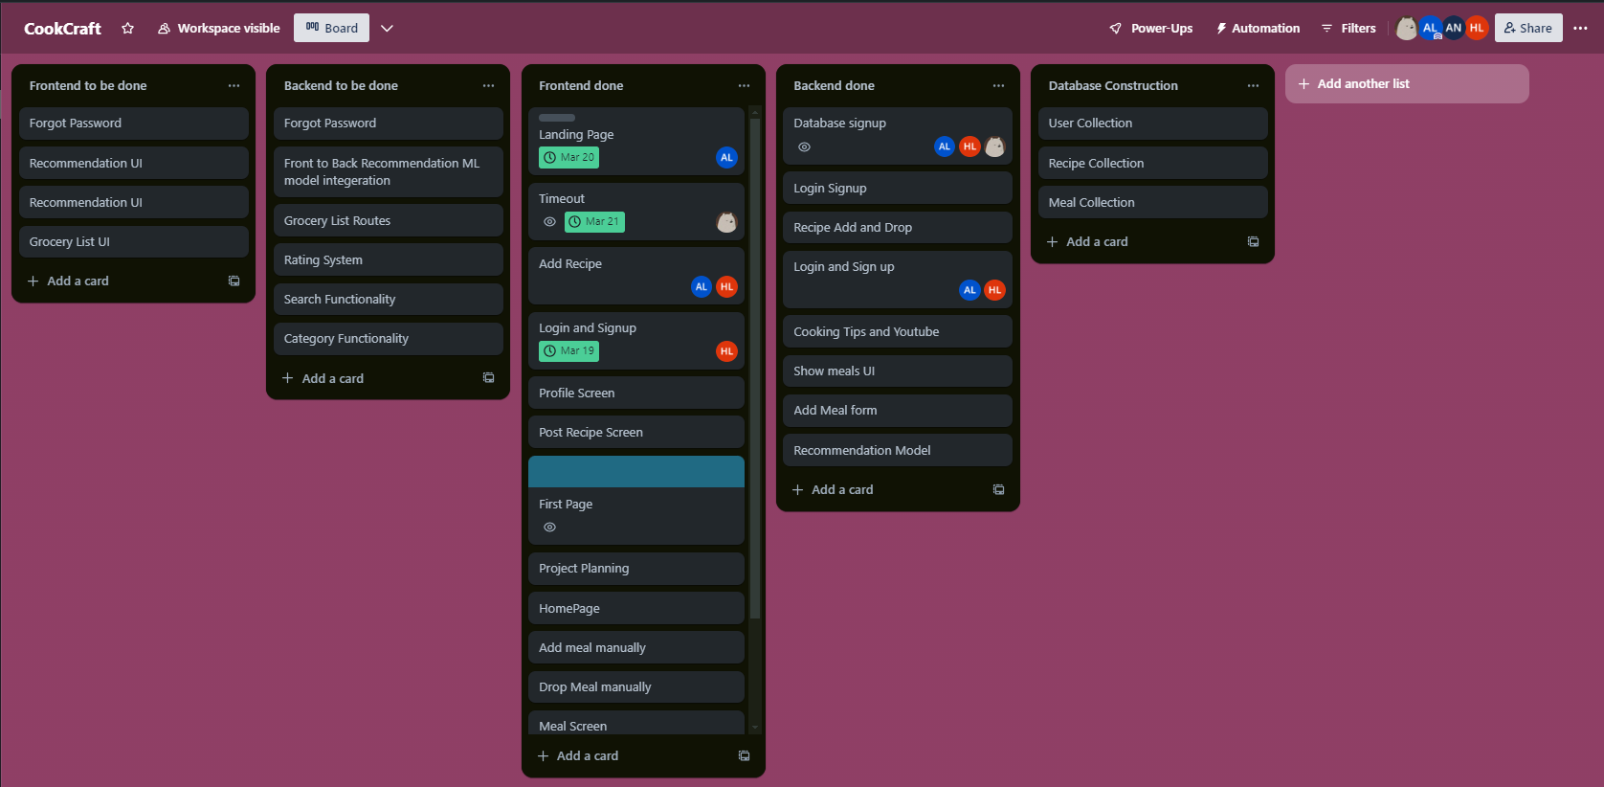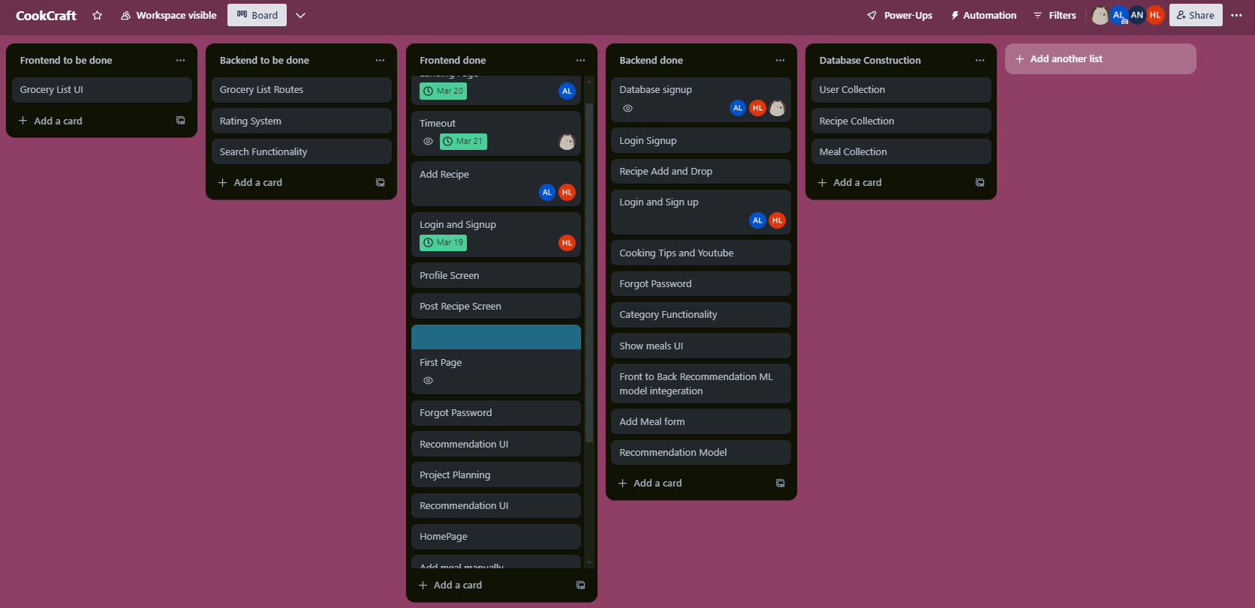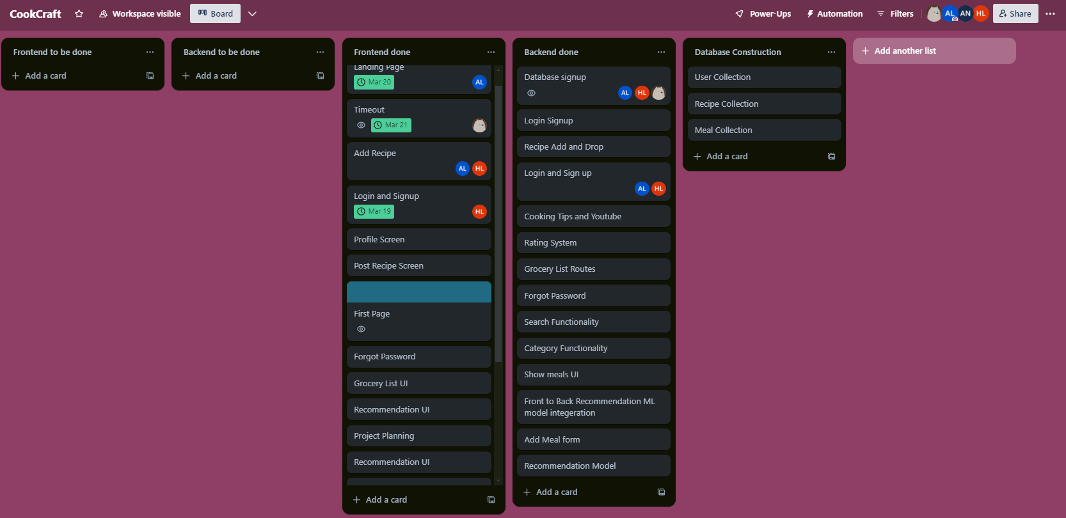

1. **Boundary Value Analysis:**

| Test Case ID | Field | Input | Expected Result | Reason |
| --- | --- | --- | --- | --- |
| TC01 | Email | user@ | Fail | Missing domain; invalid email format |
| TC02 | Email | user@example | Fail | No top-level domain; invalid email format |
| TC03 | Email | user@example.com | Pass | Valid email format |
| TC04 | Password | Abc123 | Fail | Below minimum length requirement (assuming min 6) |
| TC05 | Password | Abc12345 | Pass | Meets minimum length requirement |
| TC06 | Password | 30-character password | Pass | Tests upper boundary if max length is 30 |
| TC07 | Password | 31-character password | Fail | Exceeds maximum length boundary if max is 30 |
| TC08 | Email | user@example.co | Fail | Empty input; mandatory field |
| TC09 | Email | user@example.com | Pass | Correctly formatted email |
| TC10 | Password | 123456 | Pass | Exactly at minimum length boundary (assuming min 6) |

1. **Work Division:**

**Sajeel Haider (Lead):** Tasked with team management, managing trello, creating frontend pages for meal planning and details page. Diagrams (Component, Sequence, Data Flow)and assuring quality throughout the app. Admin Dashboard and Rating System

**Ahmad Abdullah (Developer):** Diagrams (Activity, Architecture)Focused on the development at the backend side, API construction, database construction and frontend (Landing page). Machine Learning (AI) recommendation model Search and Filter Functionality

**Waleed Asif (Tester):** Responsible for the backend development. APIs and backend to frontend linking. Diagrams (Use Case, Class Diagrams) also for conducting thorough testing of the app, backend coding and frontend (Login Signup Screens). Grocery List Generation

1. **Lesson learnt:**

**Project Planning and Management:** The iterative Agile approach was crucial for integrating changes and feedback efficiently. Effective sprint planning helped balance task estimation and resource allocation, keeping the development on track.

**Team Collaboration and Communication:** Regular meetings and the use of collaborative tools like Trello and Git were key in maintaining open communication and smooth workflow among team members.

**Technical Skills Development:** The project served as a valuable platform for the team to adapt to new technologies and refine problem-solving skills through real-world application challenges.

**User-Centric Design and Testing**: Emphasizing user experience in design and conducting extensive testing ensured that the application met user needs and maintained high quality.

**Documentation and Reporting:** Keeping detailed documentation and regular project reporting proved essential for internal clarity and stakeholder engagement, facilitating effective decision-making.

**Handling Feedback and Iterations:** Being responsive and adaptable to user and stakeholder feedback was instrumental in the app’s iterative improvement and in meeting project specifications.

**Risk Management:** Early identification and mitigation of potential risks helped avoid major setbacks and learning from mistakes was crucial for continual improvement and risk prevention.