COIMBATORE INSTITUTE OF ENGINEERING AND TECHNOLOGY
NARASIPURAM 641109

ANNUAL DAY CELEBRATIONS – 2026

- Class Topper’s list
Criteria: Department wise previous even and present odd semester (no history of arrears) average toppers (for first years, only odd semester results to be considered)
Two from each I, II, III and IV years
Two from I and II-year MBA
- Best outgoing Awardees:
Criteria: No History of arrears, No disciplinary action, Sports, Attendance, Curricular and Co-curricular activities with copies of certificates.

Principal

COIMBATORE INSTITUTE OF ENGINEERING AND TECHNOLOGY
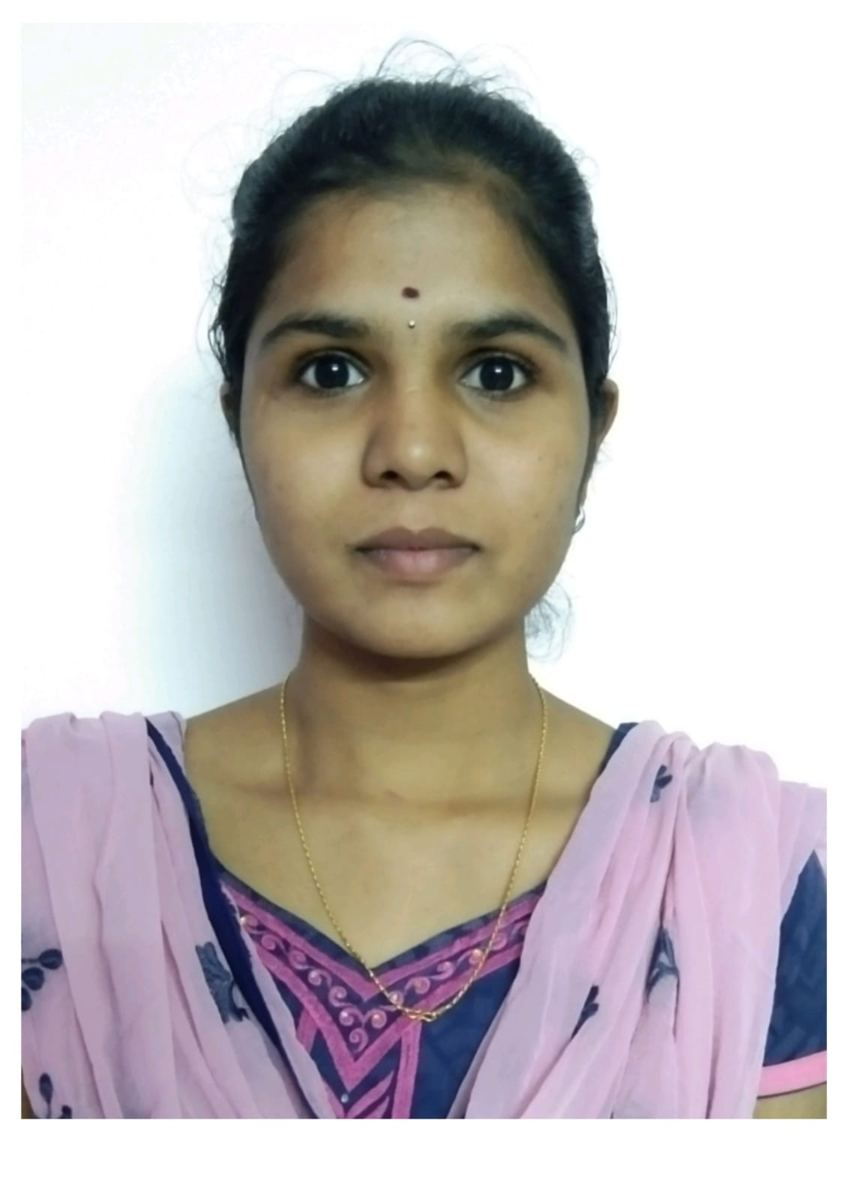
NARASIPURAM 641109
Criteria for Best Outgoing Student
(Only students with no history of arrears should be considered)
Name of the department:
Name of the student:
Register Number:

S.No | Criteria | Marks | Eligible Marks
1 | Academic Performance  Percentile (Eg. 8.4 CGPA means 84 marks) | 100
2 | Contact class Character through stay in college(discipline)Max.Marks:5 | 5
3 | Participation in NSS, YRC, Cultural, Blood Donation, etc., (Max. Marks 10)
 | Red cross/YRC | 3
 | Blood Donation | 3
 | NSS | 4
4 | Cultural (Max. Marks 10)
 | Inter-collegiate Level | 5
 | Intra-collegiate Level | 5
5 | Sports (Max. Marks 15)
 | National Level (min 1 – 5 marks, 2-10 marks, 3 and more-15 marks) | 15
 | State and University Level (min 1 – 3 marks, 2-6 marks, 3 and more-10 marks) | 10
 | Zonal and Inter-zonal Level (min 1 – 2 marks, 2-4 mark, 3 and more – 5 marks) | 5
6 | Project/Paper Presentation (Max. Marks 15)
 | Premises like NIT, IIT (min 1 – 5 marks, 2-10 marks 3 and more -15 marks) | 15
 | National Level (min 1 – 3 marks, 2-6 marks, 3 and more-10 marks) | 10
 | State Level (min 1 – 2 marks, 2-4 mark, 3 and more – 5 marks) | 5
7 | Member’s in Professional Bodies (Max. Marks 5)  (SAE/CSI/IEEE/ISTE)
 | More than 2 | 5
 | Any 2 | 4
 | One | 2
8 | Involvement in Class/College Representation (Max. Marks 5)
 | Class | 2
 | College | 3
 | Both | 5
9 | Attendance (Current Academic Year) (Max. Marks 5)
 | 75-80 | 2
 | 80-85 | 4
 | Above 85 | 5
Total Marks |  | 160

Class Advisor HOD

