gcloud container clusters create-auto hello-cluster –region=northamerica-northeast1
gcloud container clusters get-credentials hello-cluster –region=northamerica-northeast1
(the above- This command configures kubectl to use the cluster you created. )
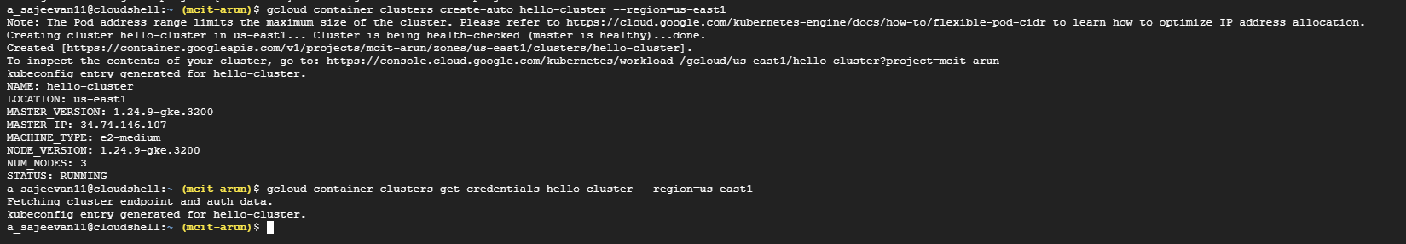
kubectl create deployment hello-server --image=us-docker.pkg.dev/google-samples/containers/gke/hello-app:1.0
(This Kubernetes command, kubectl create deployment, creates a Deployment named hello-server. The Deployment's Pod runs the hello-app container image.​
In this command:​
- --image specifies a container image to deploy. In this case, the command pulls the example image from an Artifact Registry repository, us-docker.pkg.dev/google-samples/containers/gke/hello-app. :1.0 indicates the specific image version to pull. If you don't specify a version, the image with the default tag latest is used.)
kubectl expose deployment hello-server --type LoadBalancer --port 80 --target-port 8080

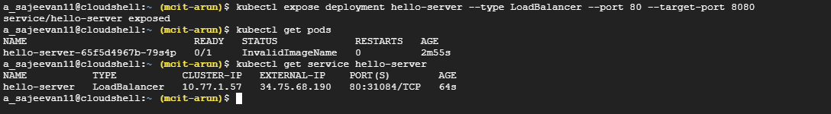
exposing = users can access on the internet

delete process is
