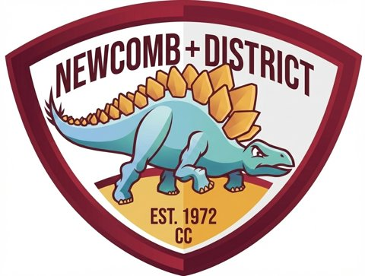 | My club account  Member guide | My Account  Newcomb and District Cricket Club | 28 September 2026

Your club account keeps your details, website purchases, raffle tickets, interests and club updates in one place. It uses the same sign-in as Dino Coach. This guide explains how to create your account, what each section does and how the club handles your information.

1 At a glance
TOPIC | HOW IT WORKS
Where | www.ndcc.com.au/club-account, or My Account in the website menu
Sign-in | Email address and password of at least 8 characters
Confirmation | Confirm your email address before you first sign in
Purchases | Website orders and raffle tickets placed with your sign-in email
Dino Coach | Same sign-in; see your team, rank and points
Your data | Download your data or ask the club to delete your account
Not included | PlayHQ player registration and membership payment are separate

TIP Open your club account
www.ndcc.com.au/club-account

2 Create your account and sign in

■ Create your account
1 Open www.ndcc.com.au/club-account and select Create an account.
2 Enter your email address and a password of at least 8 characters, then select Create account.
3 Open the confirmation email and follow the link. Check your spam folder if it does not arrive, or select Resend confirmation email.
4 Sign in, open My details, enter your full name and what you are interested in, accept the privacy statement and select Save my details.
If the committee already holds a club record with your email address, it is linked to your new account automatically. Check your details and accept the privacy statement to finish.

■ Forgotten password
Enter your email address on the sign-in form and select Reset password. Open the most recent reset email on the same device, enter your new password twice and select Set new password.
IMPORTANT Already playing Dino Coach?
Your Dino Coach sign-in is your club account. Sign in with the same email address and password; there is no need to register again.

3 Your dashboard
SECTION | WHAT YOU CAN DO
Overview | Balance owing, quick links, upcoming events and latest club news
My purchases and tickets | Website orders, event purchases and raffle tickets
Dino Coach | Your team, rank and points, or a link to join (while Dino Coach is running)
My interests | Choose club news topics and ways you might help
My details | Contact details, sign-in email, data download and deletion request
Volunteer tools | Record trailer raffle cash sales (active members only)

■ Overview
Balance owing shows any amount still due on your website orders, with a Pay balance link for each order. What would you like to do? links to events and tickets, club meals, apparel and merchandise, newsletters, player registration, social membership, Pot Club and volunteering. While a club prize wheel is running, a Spin the Wheel card also appears.

■ My interests
Tick the topics you would like to hear about and the areas where you might help. Every choice is optional and records your interest only; it does not book you for a shift. Club emails about your interests are sent only if you tick the email consent box. You can untick it or select Unsubscribe from club emails at any time. Order receipts and account security emails are separate.

■ Volunteer tools
Once the club confirms your membership as active, Volunteer tools lets you record trailer raffle cash sales. Record cash only after collecting it, then hand the money to the club.

4 Purchases, tickets and payments
My purchases and tickets lists website orders placed with your sign-in email. Purchases made under a different email address do not appear. Use the Purchase type menu to switch between orders and event purchases and raffle tickets.
YOU WILL SEE | MEANING
Total, Paid and Balance | What the order cost, what has been paid and what remains
Your ticket numbers | Raffle ticket numbers, shown once payment is confirmed
Bank transfer selected | The club is awaiting confirmation of your transfer
Pay apparel balance | Pay the remaining apparel balance by card
Payment options / bank deposit | Other ways to pay an outstanding balance
Contact the club about this purchase | The order needs review or has been refunded

IMPORTANT Receipts
For a receipt or help with an older purchase, contact the club and quote your order reference.

5 Your details, privacy and your data
SETTING | WHAT HAPPENS
Save my details | Updates your name, optional phone number and interest in playing or social membership
Change my sign-in email | Confirm the change from your inbox; orders under the old email no longer show
Download my data | Saves your details, interests and website purchases as a JSON file
Request account deletion | Sends a request to the club; you can add an optional reason

Deletion is actioned by the club rather than instantly. Order, payment and raffle records are kept as the club's financial records. Your contact details are private and are not a public member directory. Creating an account does not subscribe you to unrelated marketing.
Your club account does not replace PlayHQ player registration or membership payment. The club confirms membership and playing registration separately.

6 Help and links
PAGE | ADDRESS
My club account | www.ndcc.com.au/club-account
Dino Coach | www.ndcc.com.au/fantasy
Events | www.ndcc.com.au/events
Merchandise | www.ndcc.com.au/merchandise
Privacy statement | www.ndcc.com.au/privacy
Contact the club | www.ndcc.com.au/contact

TIP Need help?
Use Ask about my account under My details, or contact the club through www.ndcc.com.au/contact.

