Test Driven Development (TDD)

“Product Construction or Implementation Phase”

Tools: Visual Studio Code

Framework: Javascript – React

Test automation framework: jest

Required Installations:

For Testing: npm install --save-dev jest

For Generating Test Report: npm install jest-html-reporter --save-dev

Flows of Process (FOP)

1. In client-server folder create a *__test__* folder to add all the test file

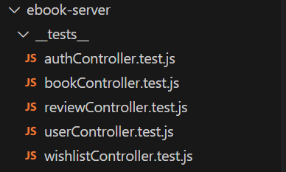

2. Install jest by running the command *npm install --save-dev jest*

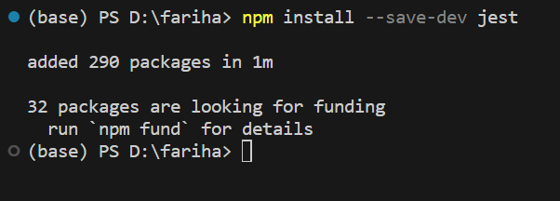

3. Add type = module to allow test file to access model and controller files

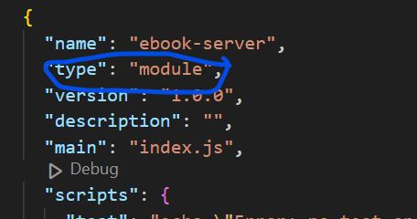

4. In *__test__* folder create individual unit test file to test individual model and controllers of different features.

authController.test.js

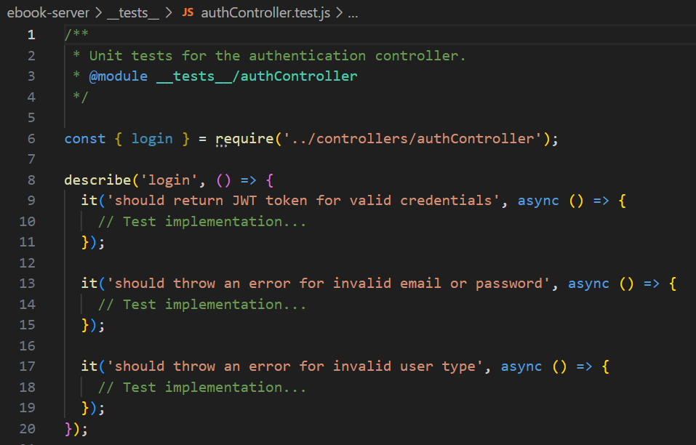

bookController.test.js

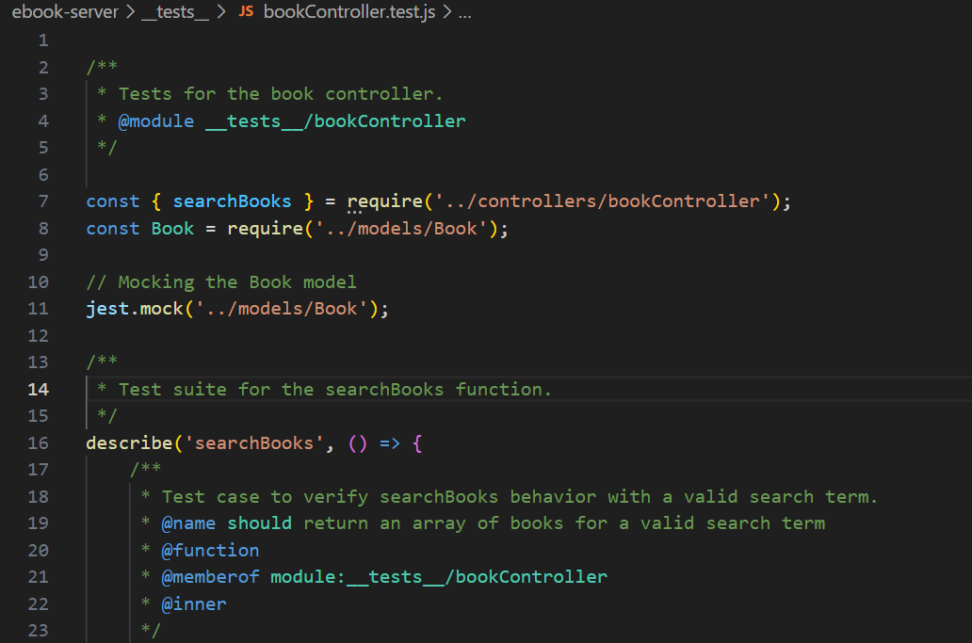

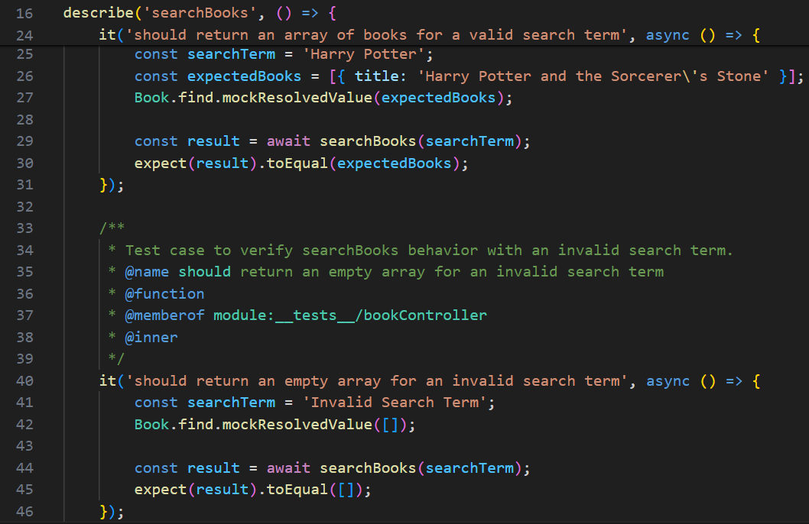

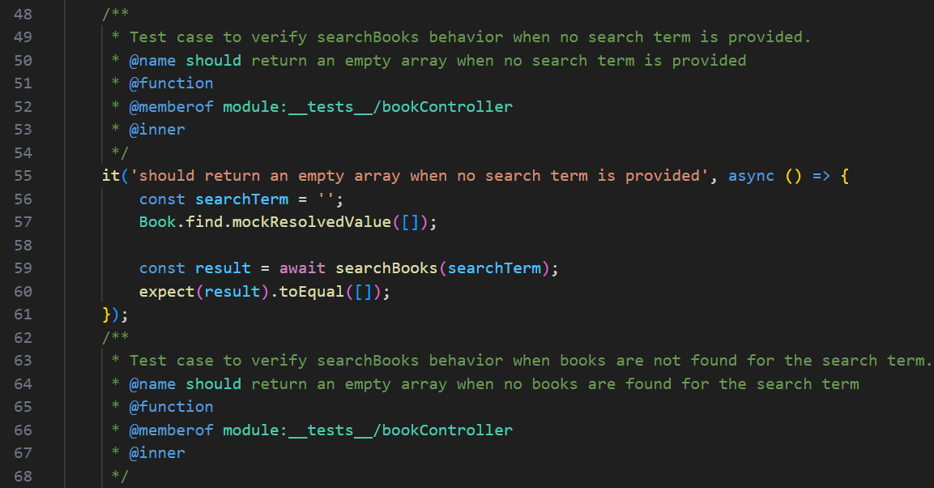

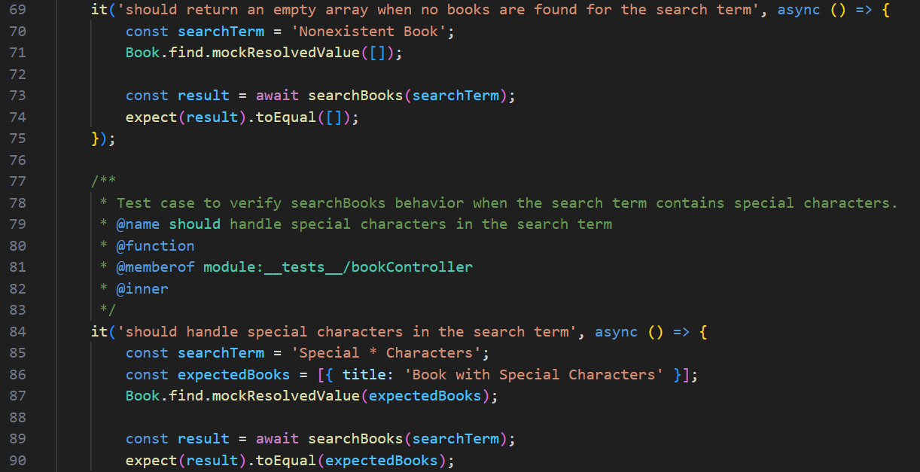

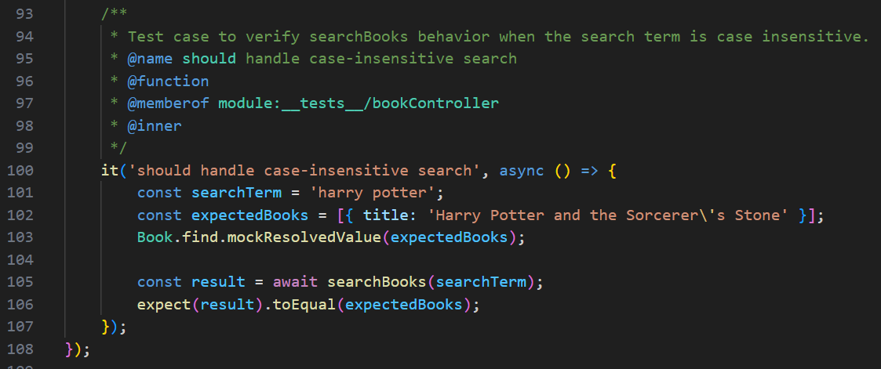

reviewController.test.js

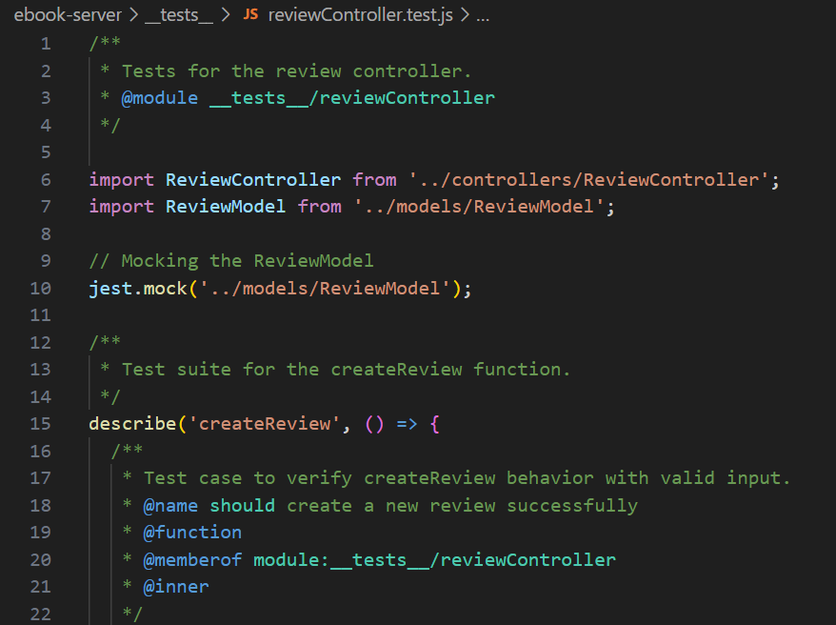

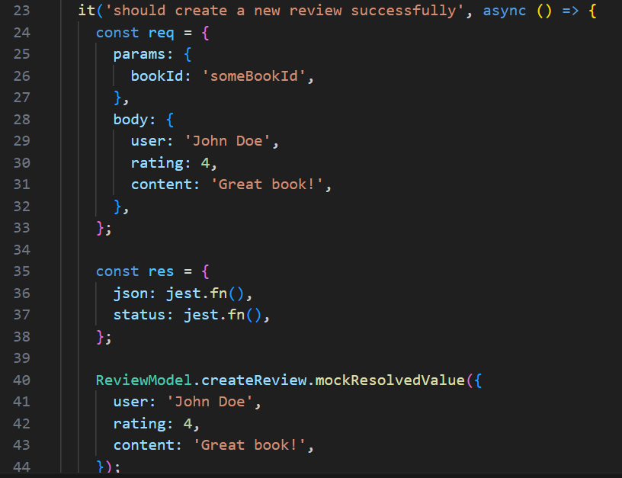

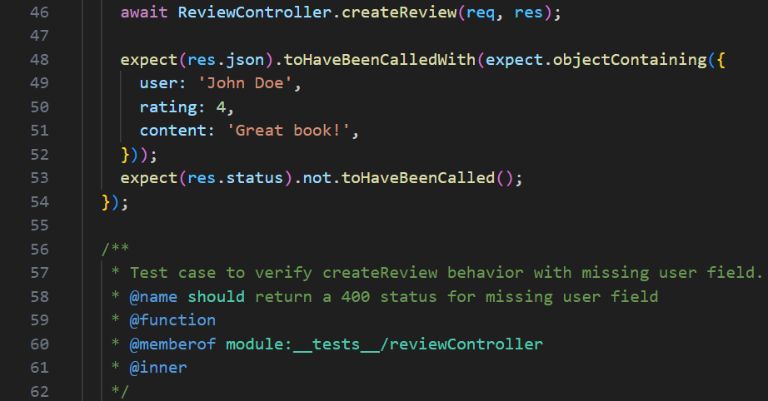

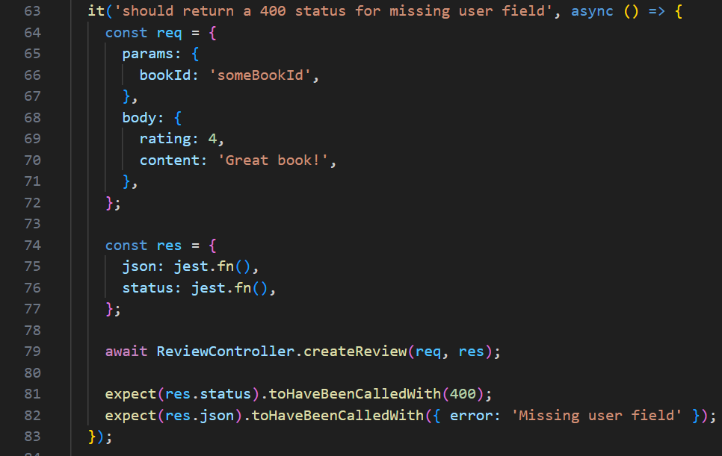

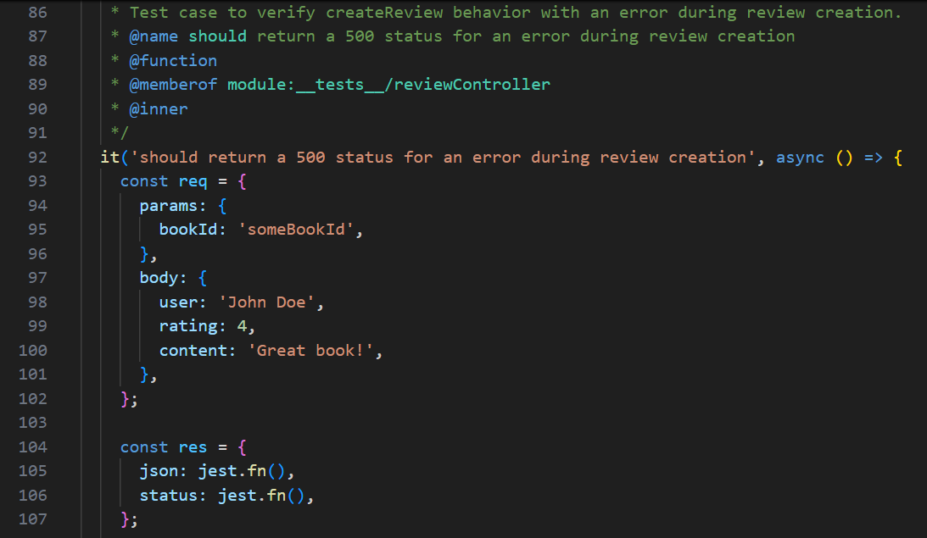

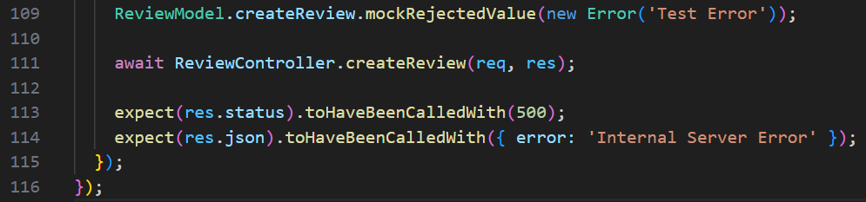

userController.test.js

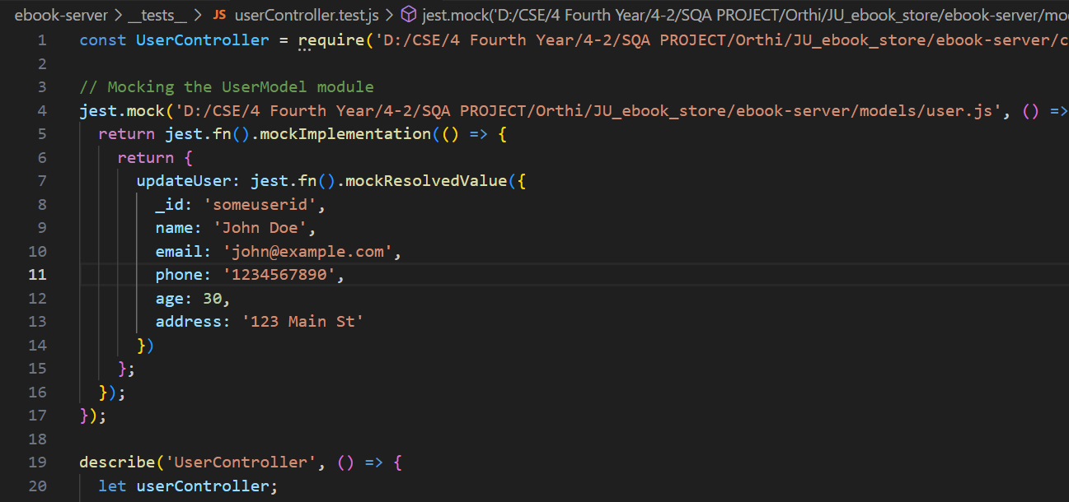

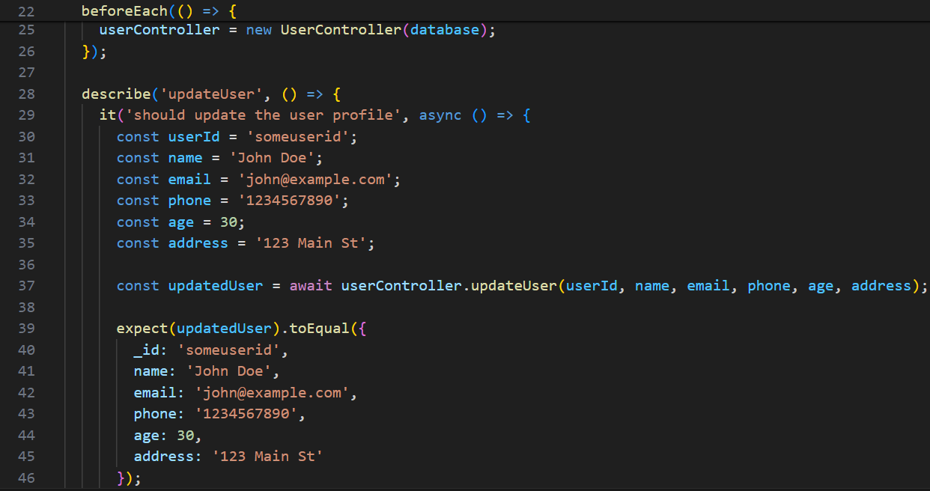

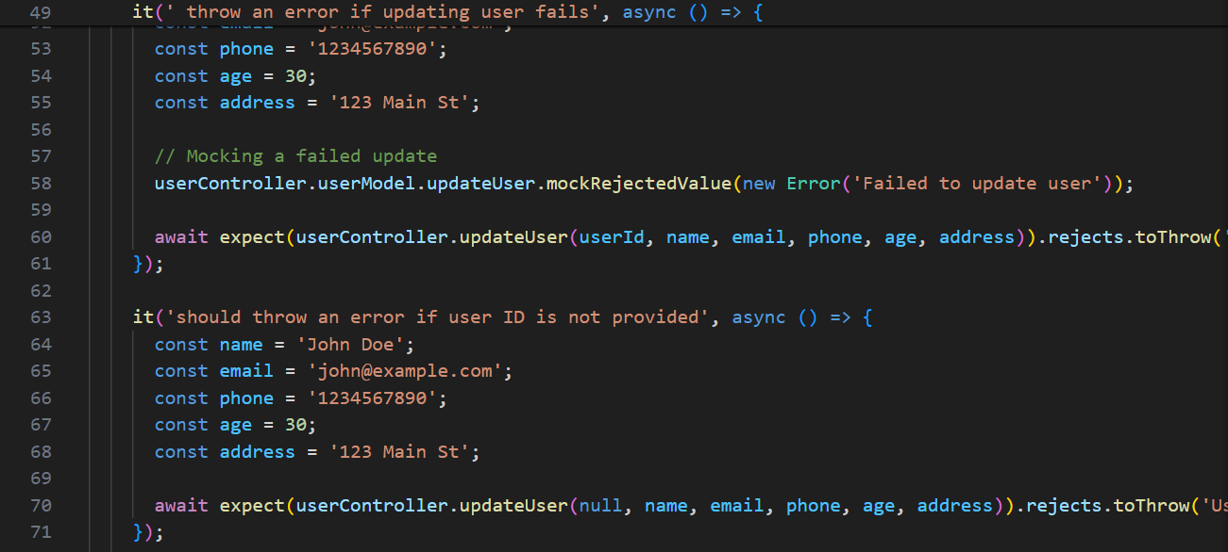

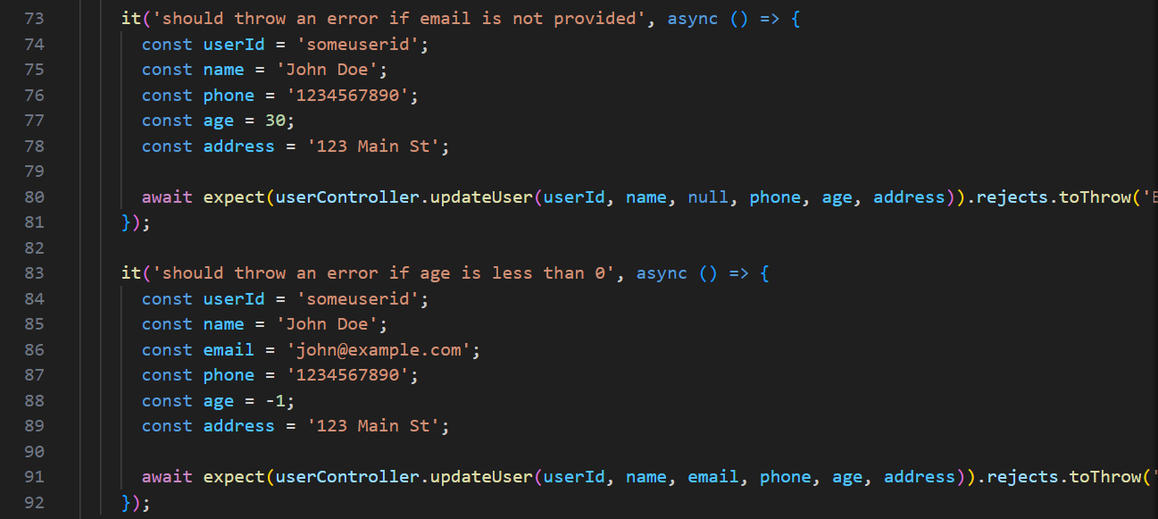

wishlistController.test.js

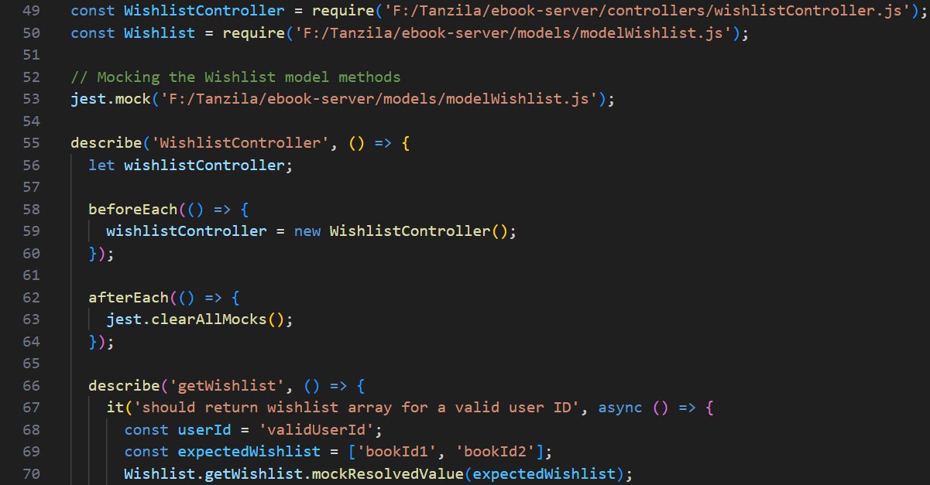

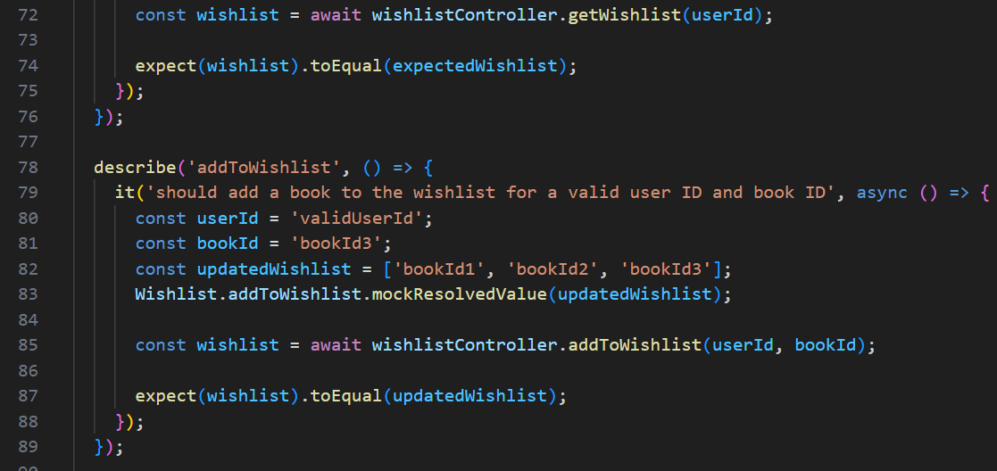

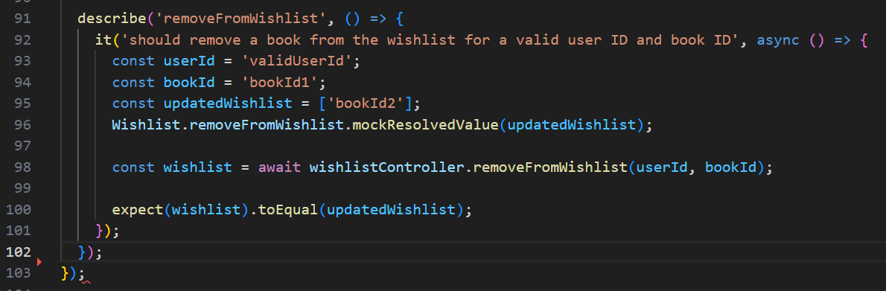

5. To run individual test file hit the below command in terminal

*npx jest modelnameController.test.js*

6. Checking the individual test report for each controller: hit command

*npx jest bookController.test.js*

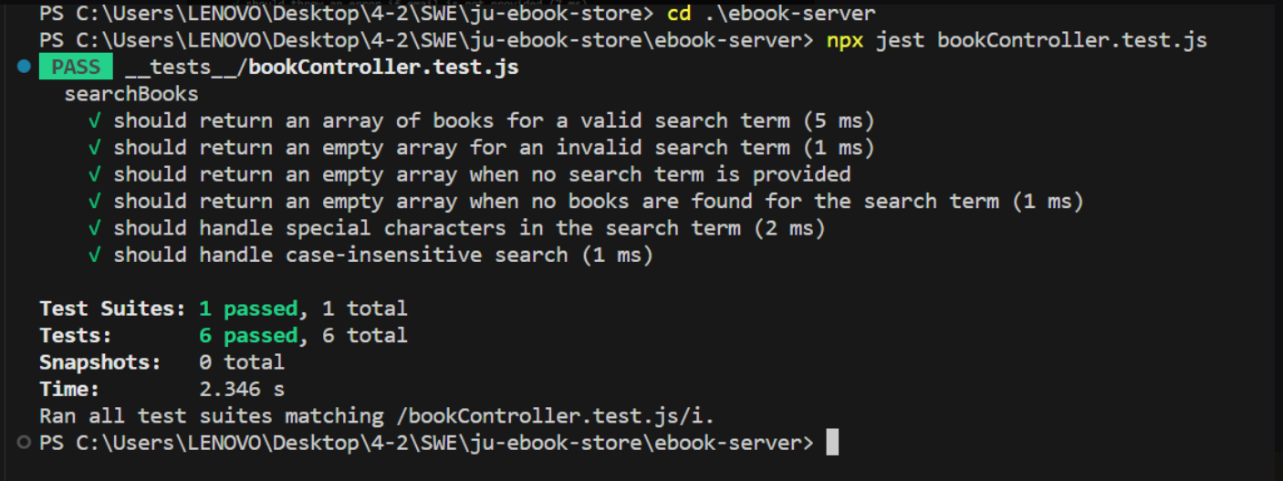

*npx jest reviewController.test.js*

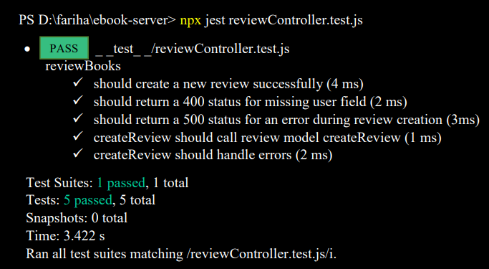

*npx jest userController.test.js*

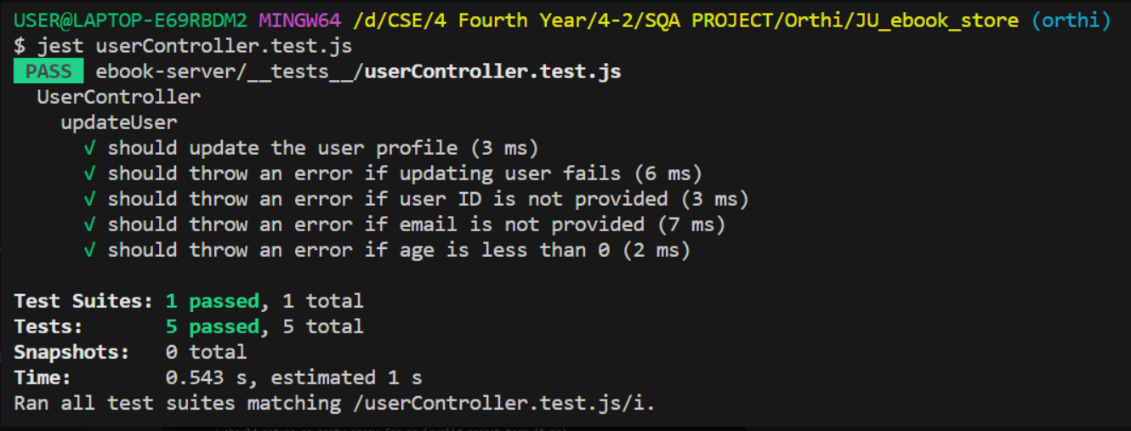

*npx jest wishlistController.test.js*

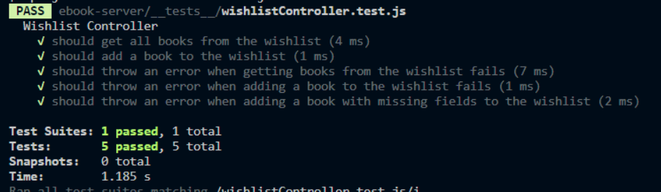

6. Conclusion

To get the final test report hit the command:  *npm i jest-html-reporter*

Here is our final unit testing report

