**North Western University, Khulna**



**Project Title: Online Voting System.**

**Course title: Software Engineering (Sessional) Final Report**

**Course code: CSE-434**

**GitHub Link: ** https://github.com/Mallick-Sourav/online-voting-system/blob/main/online-voting-system.rar

**Department: Computer Science and Engineering**

**Group:B5**

**Student Name & ID:**

|  |  |
| --- | --- |
| **Student Name** | **Student ID** |
| **1.Chandan Sourav Mallick** | **20201065010** |
| **2.Fatema Zahan Shayla** | **20201059010** |
| **3.Tasmin Jabin Rasa** | **20201045010** |
| **4.Isfat Ara Hasan Ema** | **20201112010** |

**Submission Date :** **Teacher’s Signature:**

|  |  |  |  |  |  |  |
| --- | --- | --- | --- | --- | --- | --- |
|  | Name | ID | **Contribution of this project** | Email | Phone | Remarks |
| 1 | Chandan Sourav Mallick | 20201065010 | Architectural Model Design | [Souravmallick31913@gmail.com](mailto:Souravmallick31913@gmail.com) | 01611577228 |  |
| 2 | Fatema Zahan Shayla | 20201059010 | Frontend Design | fatemazahanshayla@gmail.com | 01908292640 |
| 3 | Tasmin Jabin Rasa | 20201045010 | Backend Design | tasminjabinrasa@gmail.com | 01716679136 |
| 4 | Isfatara Hasan Ema | 20201011210 | Connection to database. | isfatarahasanema@gmail.com | 01314587990 |

**Executive Summary**

Our application is an online voting system through which a voting process can be completed easily online. Through this web application, a voter can cast his/her vote and the candidate can select his/her group and photo. If a person is not a voter then he/she has to register first to vote and to register the person to be voted i.e. candidate for the post of the voter. Then the voter can vote with his phone number and password. A voter can vote only once. In this case, separate phone numbers, passwords, and photos will be uploaded to identify both the voter and the candidate so that everyone can be easily identified if an anonymous user wants to vote. If he can't then he has to register first ie register and can only vote.

**Table of Contents Page No.**

1.1. Goals and Objectives of the project ---------------------------------------------------04

1.2. Scope of the work ------------------------------------------------------------------------04

1.2.1. Current situation and context---------------------------------------------------------04

1.2.3. Competing products (available in market) -----------------------------------------04

1.3. System overview--------------------------------------------------------------------------

1.4. Structure of the document ---------------------------------------------------------------05

1.5. Terms, Acronyms, and Abbreviations Used -----------------------------------------05

2. Requirement Specifications

2.1. Stakeholders for the system --------------------------------------------------------------06

2.2. Use case diagram with Graphical and Textual Description-------------------------06

2.3. Activity Diagram---------------------------------------------------------------------------08

2.4. Static model – class diagram-------------------------------------------------------------09

2.5. Dynamic model – sequence diagram----------------------------------------------------10

**3. Architecture**

3.1. Architectural model/style used-----------------------------------------------------------11

3.1.1. Rationale for choosing your architectural model/style-----------------------------11

3.2. Data Base Architecture--------------------------------------------------------------------11

3.2.1. Entity-Relationship (E-R) Diagram---------------------------------------------------11

3.3. Technology, software, and hardware used----------------------------------------------11

**4. Design**

4.1. Component level design following pattern----------------------------------------------12

4.2. GUI (Graphical User Interface) design--------------------------------------------------12

**Acknowledgment-------------------------------------------------------------------------------**13

**References -------------------------------------------------------------------------------------** (13-14)

**List of Figures**

1.Activity Diagram--------------------------------------------------------------------------08

2.Static model – class diagram ------------------------------------------------------------09

3.Dynamic model – sequence diagram ---------------------------------------------------10

4.Data Base Architecture -------------------------------------------------------------------

5.Component level design following pattern --------------------------------------------

6.GUI (Graphical User Interface) design -----------------------------------------------12

List of Tables

We did not use any table content in our project

**1. INTRODUCTION**

**1.1.Goals and Object of the project**

An online voting system is a software platform that allows groups to securely conduct votes and elections. High –quality online voting systems balance ballot security, accessibility and the overall requirements of an organization’s voting event. Online voting tools and online election voting systems help us make important decisions by gathering the input of your group in a way that’s systematic and verifiable. It’s a good idea to use an online voting system to:

1. To look at the current system of voting in traditional way.
2. Investigate the other kinds of technologies that are live in voting process.
3. Analysis the system.
4. Design the new system.
5. Develop the database of the system.
6. Develop the front end of the system.
7. Test the system.
8. Implementation of the system.

Goals of online voting system:

1. Simplified election organization.
2. Resource –efficient type of participation.
3. Minimize mistakes.
4. Increase voter turnout with convenient.
5. Design and implement a low cost automated real time system.

1.2.Scope of the work: Online voting System has a good scope in future due to following reasons:

1.voter can vote from anywhere for his/her constituency.

2. Vote count will make easy &fast.

3. Invalid vote will be rejected.

4. It checks voter have voted or not.

5. It Increase the voting percentage.

6. It makes easy voting by Avoiding problems like security, booth capturing.

The voting system can be used for casting votes during the elections held in colleges, University etc. In this system the voter do not have to go to the polling booth to cast their vote. They can use their personal computer to cast their votes. There is a database which is maintained in which all the name of the voters with their complete information is stored. The system Administrator registers the voters by simply filling a registration form to register the voters. After registration ,the voter is assigned a secret voter ID with which he/she can use to login to the system and cast his/her vote. After the user successfully registers themselves ,a link is sent on their respective E-mail ID’s . The link is a key for the activation of the account of the user. The account is activated only after the user clicks on that link. The site will be activated only on the day of voting. Once the user logs in ,they will be provided with a One Time Password which has to be entered by the user before casting his/her vote. The password will be destroyed after casting of their respective vote. A receipt of the vote will be sent to the user on their E-mail IDs.

**1.4**.Structure of the document

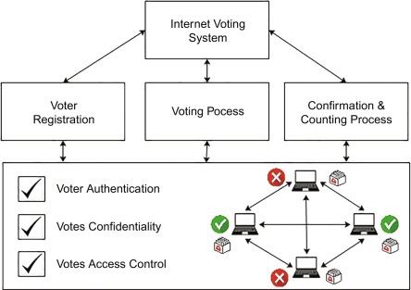

1.5.Terms, Acronyms & Abbreviations Used :

1. E-Voting = Electronic Voting
2. VVPAT Machines= Voter Verified paper Audit Trail
3. BV = Biometric Verification
4. NADRA = National Database and Registration Authority

**2. Requirement Specification**

An online voting system is a software platform that allows groups to securely conduct votes and elections. High-quality online voting systems balance ballot security, accessibility and overall requirements of an organization’s voting event.

**2.1 Stakeholders for the E-voting system**

**Everyone who has an interest or influence in the upcoming election is a stakeholder in an election administration process.** In most elections, candidates, the old board of directors, honorary members, sponsors, friends or media representatives are stakeholders. They all have a legitimate interest in the election and can influence the outcome of the election. Involve these groups early on in central steps of the election administration process to get them on a side.

**2.2 Use case diagram with graphical and Textual Description**

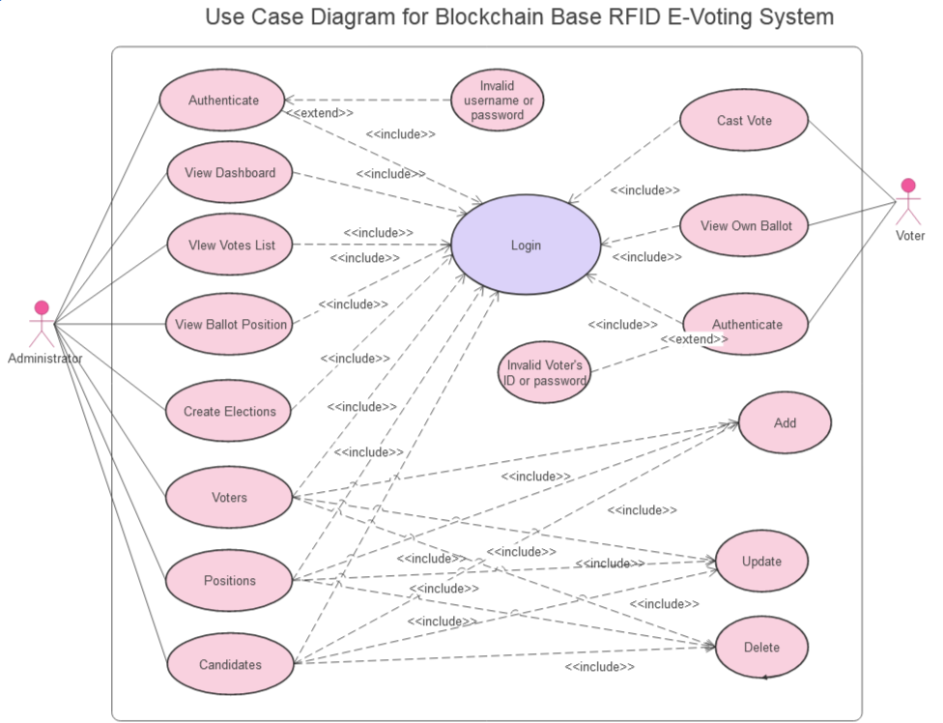

**Figure-1**: Case diagram for block chain base RFID E-voting system

An administrator selects the create ballot task from the administrator session options list. The administrator then selects the appropriate election to create a ballot. The admin is presented with a list of election candidates which can be placed on the ballot. The admin selects the candidates that should appear on the ballot and presses 'ok' or 'cancel'. If 'cancel' is pressed the task is ended and the administrator session is presented. If 'ok' is selected then a ballot is created. If the task fails for any reason, an error screen is displayed and the admin is asked if he/she would like to perform the task again, continuing until the task completes or the admin cancels the task. If completed the admin is asked if he/she would like to save the changes, If the admin answers

"no", the changes are discarded. if the answer is "yes" the changes are saved. The admin is then returned to the administrator session.

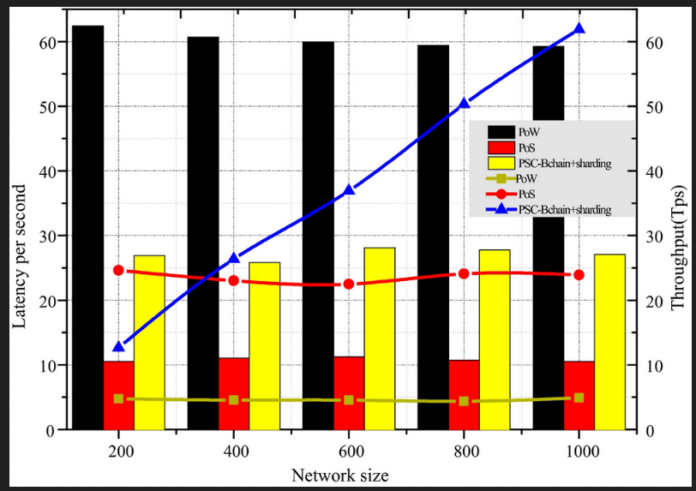

**Figure-2**: Graphical presentation of Comparison of the performance evaluation

Voting is a process inherent to all democratic societies. Many experts consider paper balloting to be the only acceptable way to secure and guarantee each person's right to cast a vote [1]. However, this approach is vulnerable to mistakes and exploitation. Interestingly, owing to the advancement of technology, modern day voters can exercise their democratic right and duty on-line[[2](https://onlinelibrary.wiley.com/doi/10.4218/etrij.2019-0362#etr212337-bib-0002)], track the status of the votes they cast, verify the precise time they were cast, and check when they will be counted. At the same time, e-voting fraud, such as remote absentee ballot manipulation, is common these days. Several recent examples include the vote fraud controversy in the 2019 elections in North Carolina and the server wipe in the 2017 elections in Georgia [[4](https://onlinelibrary.wiley.com/doi/10.4218/etrij.2019-0362#etr212337-bib-0004)]. Previous studies showed that the vulnerabilities of centralized ballot storage in e-voting systems are exploited to influence elections. As a result, voters' lack of confidence in the authorities may reach crisis proportions [[5](https://onlinelibrary.wiley.com/doi/10.4218/etrij.2019-0362#etr212337-bib-0005), [6](https://onlinelibrary.wiley.com/doi/10.4218/etrij.2019-0362#etr212337-bib-0006)].

Blockchain has attracted considerable attention and has found application in enterprise software employed across various business sectors [[7](https://onlinelibrary.wiley.com/doi/10.4218/etrij.2019-0362#etr212337-bib-0007)], for example, in cryptocurrencies [[8](https://onlinelibrary.wiley.com/doi/10.4218/etrij.2019-0362#etr212337-bib-0008)], supply chain management [[9](https://onlinelibrary.wiley.com/doi/10.4218/etrij.2019-0362#etr212337-bib-0009)], healthcare [[10](https://onlinelibrary.wiley.com/doi/10.4218/etrij.2019-0362#etr212337-bib-0010)], smart contracts [[11](https://onlinelibrary.wiley.com/doi/10.4218/etrij.2019-0362#etr212337-bib-0011)], and financial services [[12](https://onlinelibrary.wiley.com/doi/10.4218/etrij.2019-0362#etr212337-bib-0012)] as shown in Figure [1](https://onlinelibrary.wiley.com/doi/10.4218/etrij.2019-0362#etr212337-fig-0001). Analogously, the adoption of blockchain technology in e-voting systems enables every single vote to be audited/tracked in real time, which would be difficult if not impossible to achieve with prior e-voting systems [[5](https://onlinelibrary.wiley.com/doi/10.4218/etrij.2019-0362#etr212337-bib-0005), [13](https://onlinelibrary.wiley.com/doi/10.4218/etrij.2019-0362#etr212337-bib-0013), [14](https://onlinelibrary.wiley.com/doi/10.4218/etrij.2019-0362#etr212337-bib-0014)].

**2.3 Activity diagram of online voting system**

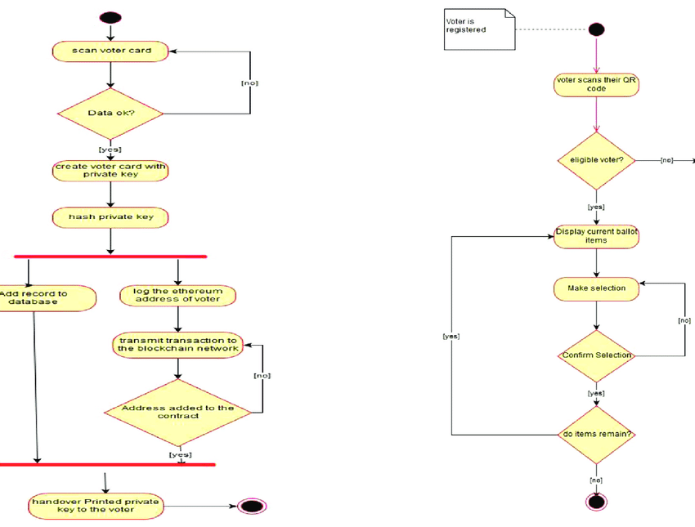

**Figure-3** : Activity diagram of online voting system

**2.4 Static Model- Class Diagram**

Class diagram for online voting system:

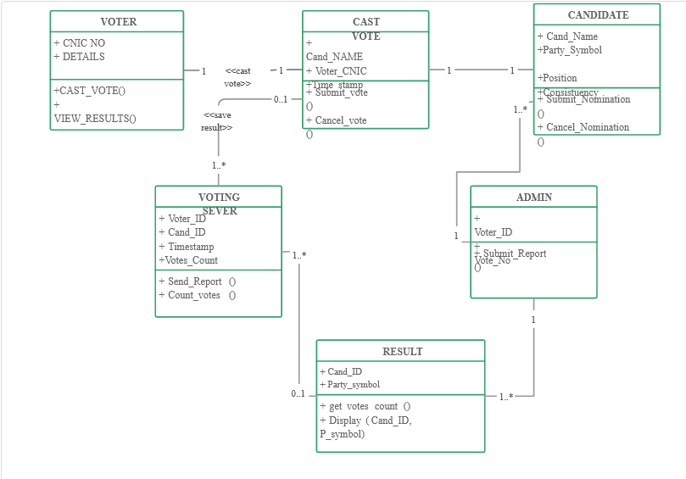

**Figure-4**: Class diagram for online voting system

**2.5 Dynamic model-Sequence diagram for E-voting system**

The conventional voting scheme employs paper-based ballot to verify votes. This voting scheme is insecure due to the attributed shortcomings including ballot stuffing, ballot snatching and voter's impersonation. In this paper, we present the design and development of secure e-voting to ensure a free, fair and credible election

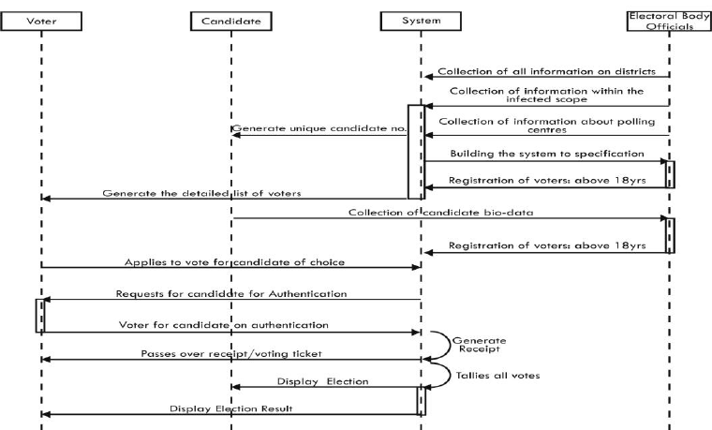

**Figure-5**: sequence diagram for online voting system

The system‘s service like sequence diagram to show how an object in a system interacts; demonstrate the total control flow of the step by step actions and activities that defines an object is shown in the above figure.

**3. Architecture**

3.1. Architectural model/style used

3.1.1. Rationale for choosing your architectural model/style

3.2. Data Base Architecture

3.2.1. Entity-Relationship (E-R) Diagram

3.3.Technology,software and hardware used

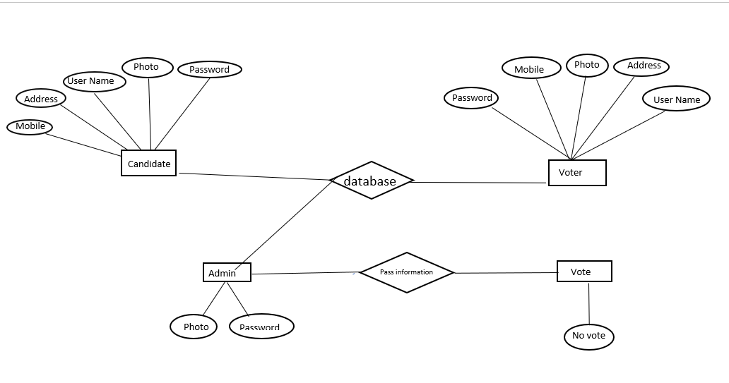

**Technology:**

-HTML,CSS,PHP,MySQL

**Software:**

- Operating System: Windows

-Microsoft Visual Studio, XAMPP

**Hardware Used:**

-Chipset: intel CORE i5

- Storage:1 Tera Hard Disk, RAM-8GB

- Primary Display: QVGA TFT LCD or larger, 16 Bit colour or Better

- Mouse

- Keyboard

**4.Design**

4.1. Component level design following pattern

4.2. GUI (Graphical User Interface) design

**Login Page:**

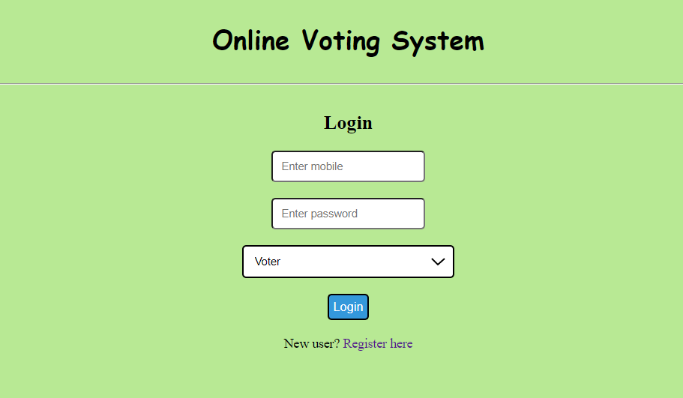

**Register:**

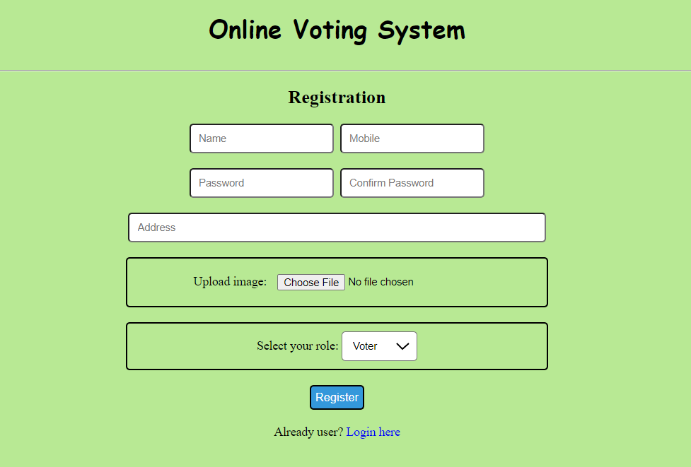

**Voter Page:**



Acknowledgment

We worked hard to complete our project but we thank him who contributed the most to our efforts, his contribution is undeniable inspiration and confidence we were able to complete it mainly because he guided us. Whenever we have a problem we go to him and he is perfect to solve it. Tried and solved the problem so it is the highest honor for him who did this with us is our respected **Abu Naim Khan Sir** we are very thankful to him and his only contribution behind the complete development of our application.

**References**

1*J. Epstein*, Are all types of internet voting unsafe?,*IEEE Secur. Priv.11* (*2013*), *3*–4.

2*R. Araújo* et al., *Remote electronic voting can be efficient, verifiable and coercion-resistant*, in *Proc. Int. Conf*. Financial Cryptography Data Security (*Barbados*), *2016*, pp. *224*–232.

3*A. Blinder*, *Election fraud in north carolina leads to new charges for republican operative* ,*2019*, Accessed Aug. 2019, available at [*https://www.nytimes.com/2019/07/30/us/mccrae-dowless-indictment.html*](https://www.nytimes.com/2019/07/30/us/mccrae-dowless-indictment.html)

4*F. Bajak*, *Georgia election server wiped after suit filed* ,*2017*, Accessed Aug. 2019, available at [*https://www.pbs.org/newshour/politics/georgia-election-server-wiped-after-suit-filed*](https://www.pbs.org/newshour/politics/georgia-election-server-wiped-after-suit-filed)

5*R. Michael Alvarez*, *I. Levin*, and *Y. Li*, Fraud, convenience, and e-voting: How voting experience shapes opinions about voting technology, *J. Inform. Technol.Politics15* (*2018*), *94*–105.

6*J. Paul Gibson* et al., A review of e-voting: The past, present and future, *Ann. Telecommun.71* (*2016*), *279*–286.

7*A. Karamchandani* et al., Perception-based model for analyzing the impact of enterprise blockchain adoption on scm in the indian service industry, *Int. J. Inform. Manage.52* (*2019*), *102019*.

8*A. Klarin*, The decade-long cryptocurrencies and the blockchain rollercoaster: Mapping the intellectual structure and charting future directions, *Res. Int. Business Finance51* (*2020*), *101067*.

9*Z. Wang* et al., Blockchain-based framework for improving supply chain traceability and information sharing in precast construction, *Automat. Constr.111* (*2020*), *103063:1*–11.

10*S. Tanwar*, *K. Parekh*, and *R. Evans*, Blockchainbased electronic healthcare record system for healthcare 4.0 applications, *J. Inform. Secur. Appl.50* (*2020*), *102407:1*–13.

11*A. Singh* et al., Blockchain smart contracts formalization: Approaches and challenges to address vulnerabilities, *Comput. Secur.88* (*2020*), *101654:1*–16.

12*M. Zachariadis*, *G. Hileman*, and *S. V. Scott*, Governance and control in distributed ledgers: Understanding the challenges facing blockchain technology in financial services, *Inf. Organ.29* (*2019*), *105*–117.

13*K.-H. Wang* et al., A review of contemporary e-voting: Requirements, technology, systems and usability, *Data Sci. Patt. Recogn.1* (*2017*), *31*–47.

14*M. K. Alomari*, E-voting adoption in a developing country, *Transform. Gov. People Process Policy10* (*2016*), *526*–547.