|  |
| --- |
|  |
| Student Information System User Manual |
|  |
|  |

|  |
| --- |
|  |

Table of Contents

Getting Started 2

Log In 3

The Interface 4

Student 5

Add Students 5

Manage Students 6

Course 7

Add Course 7

Manage Course 8

Result 9

Add Result 9

Manage Result 10

Close 11

# Getting Started

**Computer Requirements**

Before open the system, make sure your computer meets the following requirements:

* Windows95 or higher.
* 32 MB RAM
* 500KB disk space
* Pentium 166 MHz or faster (200 MHz recommended)
* Internet connection – at minimum a 56K modem connection
* Following Internet browsers: mozilaFirefox 49.0 version
* NetBeans 8.1/NetBeans8.2 and JDK.

## Log In

To close

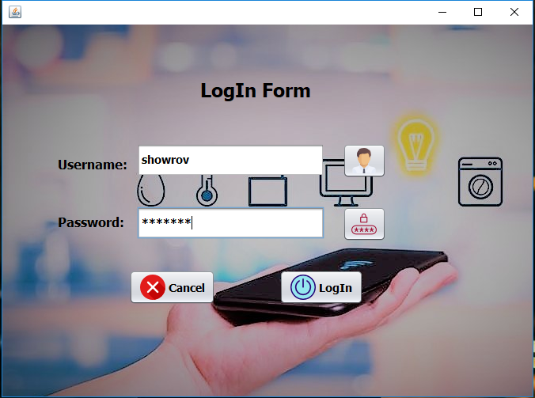

To proceed log in and go to next step

To Cancel Log in.

**Username:** In this tab you have to enter admin user name.

**Password:** In this tab you have to enter password.

# The Interface

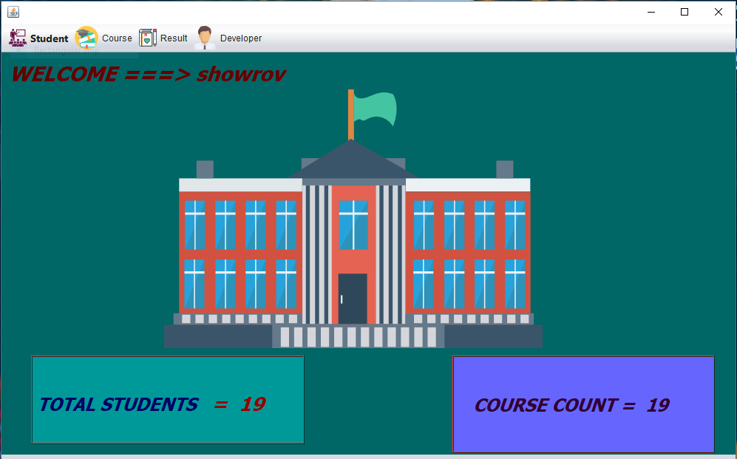

**Total Students:** Number of students enroll in this system.  
**Course Count:** Number of course included In this system.

**Student:**

**Course:**

**Result:**

# Student

Click Student tab. A new Tab will open.

* **Add Students:** Click add students to add new students info.
* **Manage Students:** Click manage students to edit existing students info.

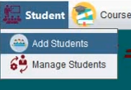

## Add Students

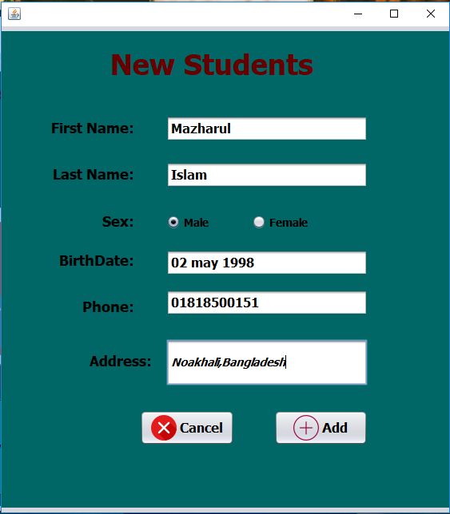

Click **Add Students**  a new windows will pop up. Fill up the informations. Then press save the info or to cancel it.

## Manage Students



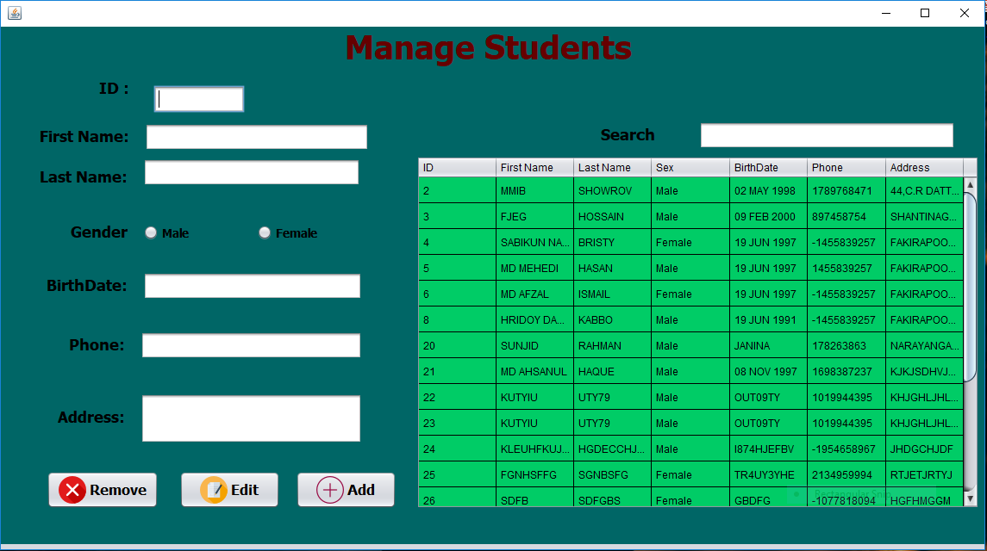

Click **Manage Window**  a new windows will pop up. Use **Search** tab to locate wanted student info. Then fill up the Information form and Click  to save the information. To delete the student info.

# Course

Click Course tab. A new Tab will open.

* **Add Course:** Click add course to add new course info.
* **Manage Course:** Click manage course to edit existing course info.

## Add Course

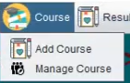

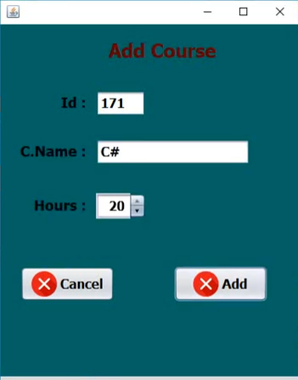

Click  a new window will be pop out. Fill up the info and press **Add** to save the info or **Cancel** to cancel it.

## Manage Course



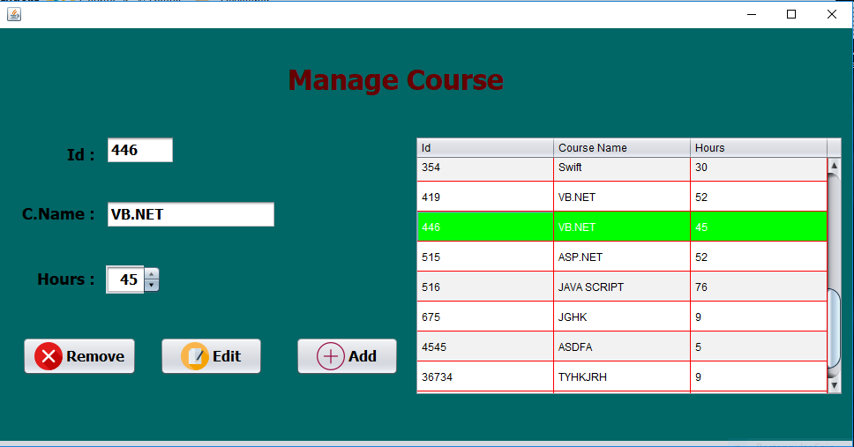

Click  a new window will be pop out. List of Available course will be **Display** here. Clickin on of them will bring out its info. Edit its info and press  to save it or  to delete the course.

# Result

Click Result tab. A new Tab will open.

* **Add Result:** Click add result to add new result.
* **Manage Result:** Click manage result to edit existing result.

## Add Result

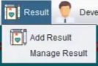

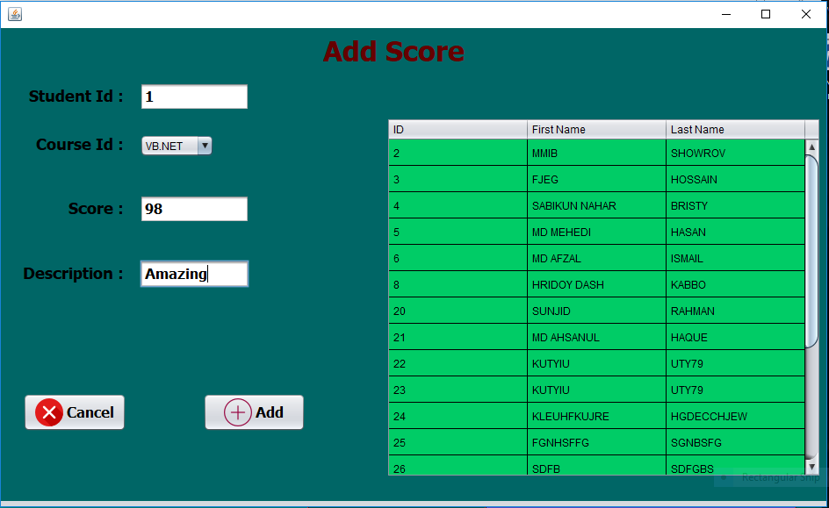

Click  a new window will be pop out. List of Available Students will be **Display** here. Clickin on of them will bring out its info. Choose the **course** to add score then enter score and add comment on **Description** tab. Then press save the info or to cancel it.

## Manage Result



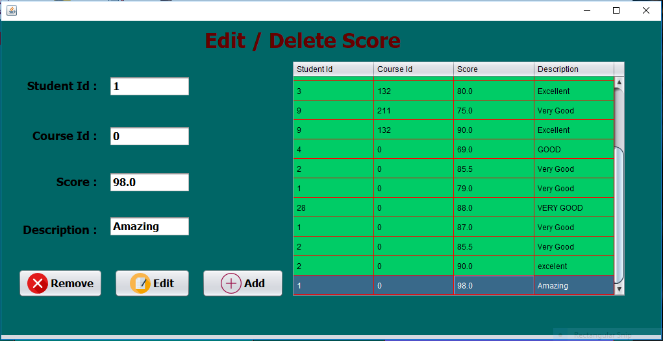

Click  a new window will be pop out. List of Available Student and there result will be **Display** here. Clickin on of them will bring out its info. Edit its info and press  to save it or  to delete the course.

# Close



To **close** the system simply press the cross button in the right top corner.